Question 1 – Identify minimum 20 functional requirements
Answer:
Functional Requirements:
Req. ID | Req. Name | Req. Description | Priority (1-10)
FR001 | Multi-factor Authentication | Implement multi-factor authentication (MFA) for user login using at least two independent factors (e.g., password and SMS code). | 9
FR002 | Product Search | Farmers can search for products categorized under fertilizers, seeds, and pesticides. | 8
FR003 | Product Details | Farmers can view detailed product descriptions including ingredients, usage instructions, and specifications. | 8
FR004 | Manufacturer Verification | Manufacturers must verify their identity and product authenticity before listing products. | 7
FR005 | User-friendly Interface | Application features a user-friendly interface with intuitive navigation elements. | 7
FR006 | Save Favourites/Wishlist | Farmers can save products as favourites and create Wishlist’s for future reference. | 6
FR007 | Order Notifications | Manufacturers receive notifications for new orders placed through the platform. | 7
FR008 | Order Management | Manufacturers can manage order fulfilment processes within the application. | 8
FR009 | Real-time Order Updates | Users receive real-time updates on order status (processing, shipping, delivery). | 9
FR010 | Secure Payment Gateway | Application integrates a secure payment gateway supporting multiple methods. | 9
FR011 | Product Feedback | Users can provide feedback on products, including ratings and reviews. | 6
FR012 | Analytics Tracking | Platform includes analytics to track user activity, product popularity, and sales trends. | 8
FR013 | Product Comparison | Farmers can compare products based on features, prices, and reviews. | 6
FR014 | Notification System | Application provides notifications for new products, promotions, and updates. | 5
FR015 | Search Filters | Farmers can filter search results by price range, product type, and brand. | 7
FR016 | Multi-language Support | Platform supports multiple languages to cater to diverse user backgrounds. | 5
FR017 | Customer Support | Application provides customer support including FAQs, chat, and email assistance. | 6
FR018 | Real-time Product Updates | Manufacturers can update product information (e.g., pricing, availability) in real-time. | 7
FR019 | Data Security | Application ensures data security by encrypting sensitive user information. | 9
FR020 | Order History | Farmers have access to historical order information and invoices for reference. | 6
Non-Functional Requirements:
Req. ID | Req. Name | Req. Description | Priority (1-10)
NFR001 | System Uptime | The application shall achieve a minimum uptime of 99.9% to ensure availability for users. | 8
NFR002 | Page Load Speed | Product pages shall load within 3 seconds on average to optimize user experience. | 7
NFR003 | Cross-platform Compatibility | The platform shall be compatible with major web browsers (e.g., Chrome, Firefox, Safari) and mobile platforms (iOS, Android). | 7
NFR004 | Data Protection Compliance | The application shall comply with relevant data protection regulations (e.g., GDPR, CCPA). | 9
NFR005 | Scalability | The platform shall be scalable to accommodate increasing numbers of users and products. | 8
NFR006 | Concurrent User Support | The application shall support concurrent user sessions without performance degradation during peak times. | 8
NFR007 | Secure API Integration | The application shall implement secure APIs for integration with external systems. | 7
NFR008 | Accessibility | The user interface shall comply with WCAG 2.1 guidelines for accessibility. | 6
NFR009 | Security Audits | The application shall undergo regular security audits and vulnerability assessments. | 9
NFR010 | Responsive Design | The platform shall maintain consistent usability across different devices and screen sizes. | 6

Question 2 – Make wireframe and prototypes
Answer:
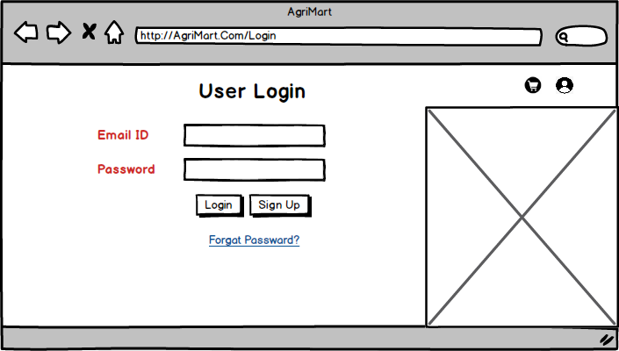
Wireframe –
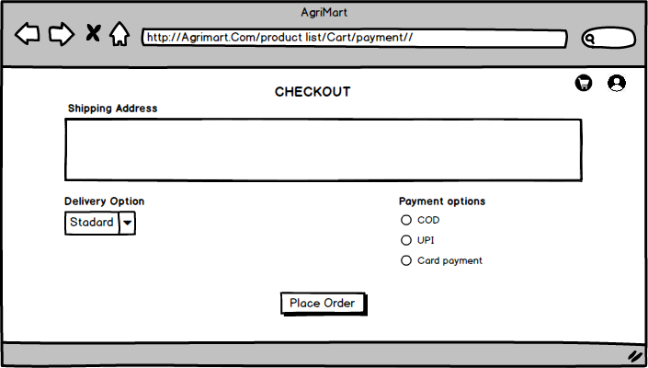
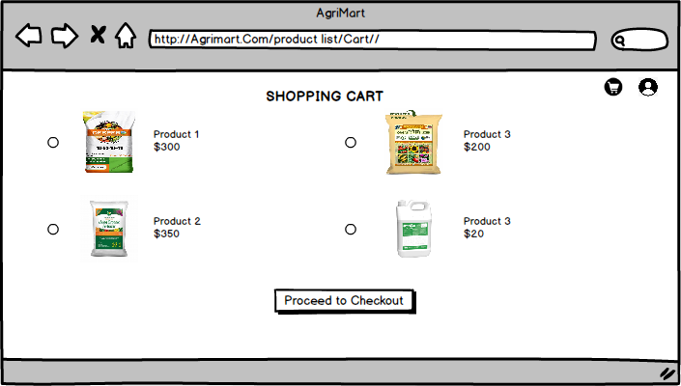
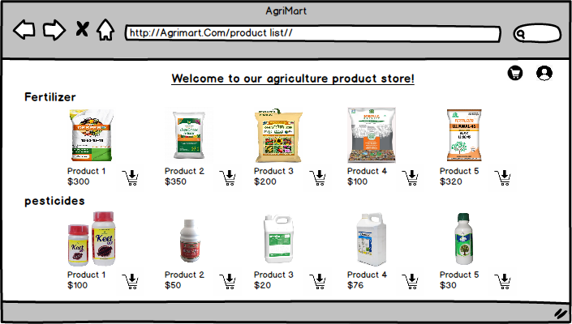
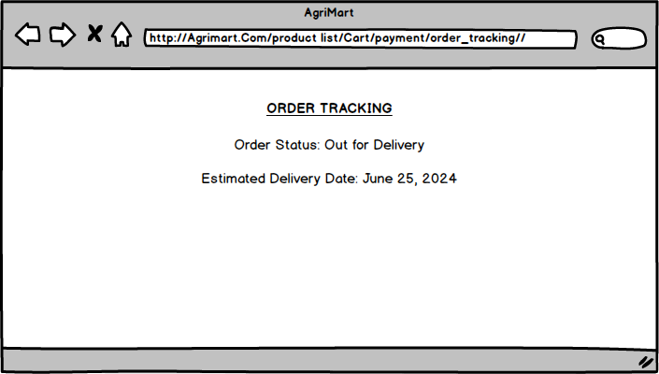
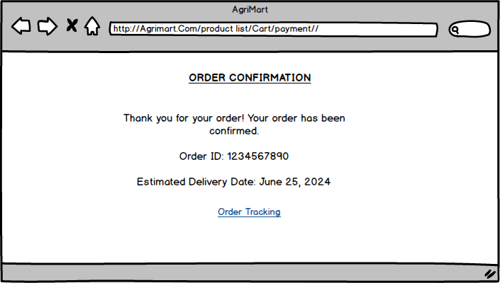
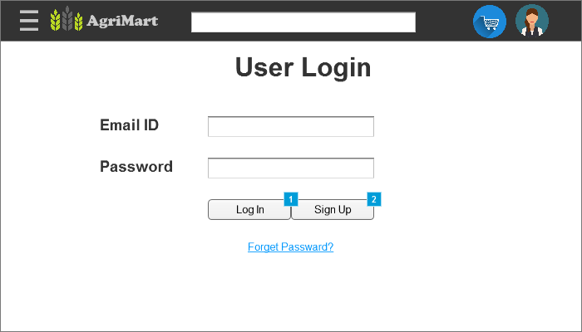
Prototype:
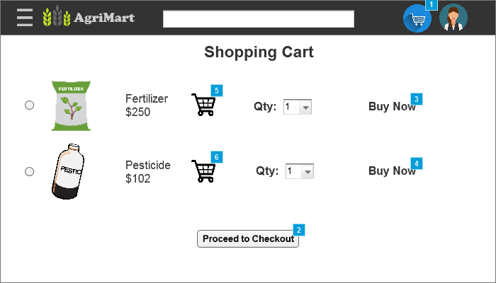
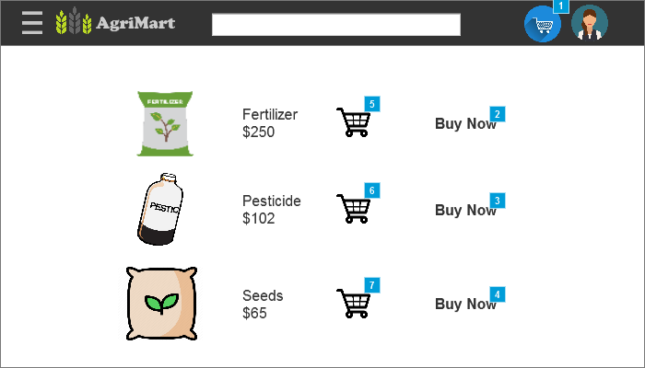
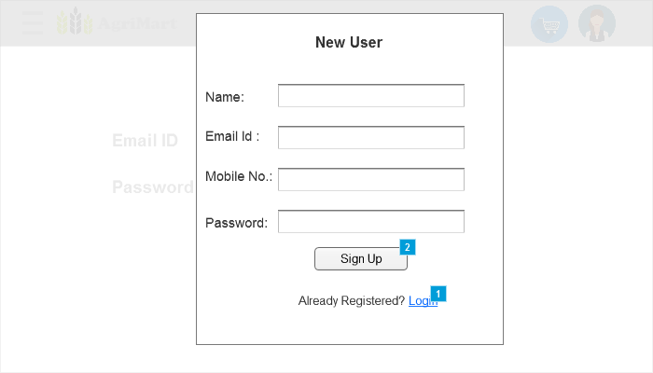
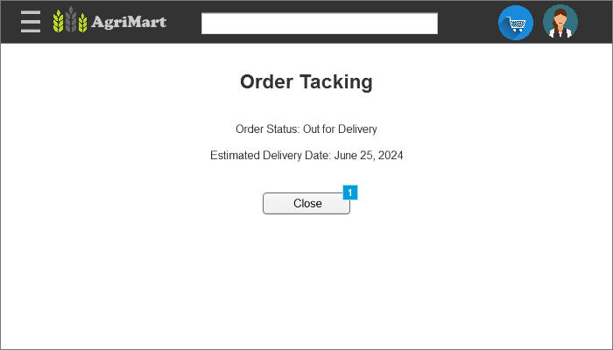
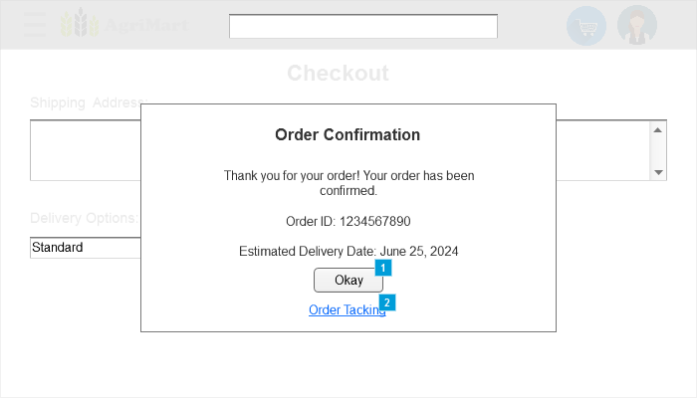
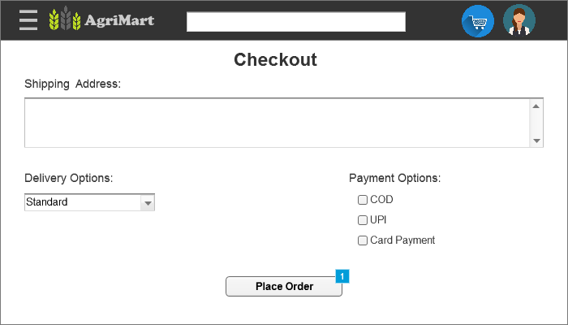
Link - Login Page
Question 3 – Make a note of the Tools, which you are using for above concepts.
Answer:
Balsamiq:
Balsamiq is a rapid wireframing tool for creating low-fidelity mock-ups of user interfaces. It features a sketch-like aesthetic, extensive UI component library, interactive prototyping, and supports collaboration. Balsamiq helps teams quickly iterate on design concepts, communicate ideas clearly, and gather feedback early in the design process. It's ideal for creating prototypes of websites, mobile apps, or desktop applications, emphasizing functionality over visual details.
Azure:
Azure is Microsoft's cloud computing platform offering a wide array of services including computing, storage, networking, AI, IoT, and more. It enables businesses to build, deploy, and manage applications and services globally, with scalability, flexibility, and strong integration capabilities. Azure is used for diverse purposes from application development and data management to AI and IoT solutions, providing robust infrastructure and security features.
Microsoft Visio:
Microsoft Visio is a diagramming and vector graphics application used to create diagrams, flowcharts, organizational charts, floor plans, and other visual representations of data. It provides a wide range of templates and shapes to quickly create professional-looking diagrams. Visio integrates with other Microsoft Office applications and supports collaboration through Microsoft 365, making it a versatile tool for visualizing and communicating complex information in businesses and organizations.
___________________________________________________________________________
Question 4 – A business analyst’s key responsibilities are to keep track of the requirements and make sure that no requirement is missed. Mr. Henry and peter have approached you regarding the current status of the project. How will you tackle this situation?
Answer:
RTM - RTM (Capstone P1P3).xlsx
___________________________________________________________________________
Question 5 – Prepare 10 Test Case Documents
Answer:
Test case ID | PRJ001TC001 | Test Case Name | Login
Project ID | PRJ001 | Project Name | Online Agriculture product store
PM ID | PM001 | PM Name | Mr. Vandanam
Test Strategy ID | PRJ001TS001 | Tester ID | 384
Test Plan ID | PRJ001TP001 | Tester Name | Mr. Jason
Test Schedule ID | PRJ001TSCH001 | Tester Name | Mr. Jason
Scenario | Verify that a registered user can successfully login with valid credentials
Link to that page:
Input Data | Set 1:  Chandar194  Chandar@2024  Magare194@gmail.com | Set 2:  Puspak88  Puspak@98  Puspak@gmail.com | Set 3:  989876  Puspak#66  Puspak@gamail.com | Set 4:  Vivel897  789809676  Vivel78@yahoo.com
Expected Behaviour | Login | Login | Invalid Credential | Login
Actual Behaviour | Login | Login | Invalid Credential | Login
Comments
Result (Pass/Fail) | Pass | Pass | Pass | Pass
__________________
Test case ID | PRJ001TC002 | Test Case Name | New Registration
Project ID | PRJ001 | Project Name | Online Agriculture product store
PM ID | PM001 | PM Name | Mr. Vandanam
Test Strategy ID | PRJ001TS001 | Tester ID | 384
Test Plan ID | PRJ001TP001 | Tester Name | Mr. Jason
Test Schedule ID | PRJ001TSCH001 | Tester Name | Mr. Jason
Scenario | The Registration Process for New user.
Link to that page:
Input Data | Set 1:  Chandar Magare  Chandar194  Chandar@2024  Magare194@gmail.com  1523548790  Pune, India | Set 2:  Puspak Jahale  Puspak88  Puspak@98  Puspak@gmail.com  122455863215  Mumbai, India | Set 3:  Puspak Jahale  989876  Puspak#66  Puspak@gamail.com  5896741236  Kerala, India | Set 4:  Vivel K  Vivel897  789809676  Vivel78@yahoo.com  9856457585  Nashik, India
Expected Behaviour | Sign Up | Invalid Credential | Invalid Credential | Sign Up
Actual Behaviour | Login | Invalid Credential | Invalid Credential | Login
Comments
Result (Pass/Fail) | Pass | Pass | Pass | Pass
__________________

Test case ID | PRJ001TC003 | Test Case Name | Search Product
Project ID | PRJ001 | Project Name | Online Agriculture product store
PM ID | PM001 | PM Name | Mr. Vandanam
Test Strategy ID | PRJ001TS001 | Tester ID | 384
Test Plan ID | PRJ001TP001 | Tester Name | Mr. Jason
Test Schedule ID | PRJ001TSCH001 | Tester Name | Mr. Jason
Scenario | Check the search functionality by entering a product name. (We can search by name and having 5 filter i.e. price, discount, brand, product category & Delivery time…. all 5 are optional… it will give as 15 result)
Link to that page:
Input Data | Set 1:  Phosphatic  1000-2000  Up to 20%  XYZ  Fertilizer  3 Days | Set 2:  Potassic  1500-2000  Up to 30%  XYZ  Fertilizer  4 Days | Set 3:  Algicide  1500-2000  Up to 15%  XYZ  Pesticide  1 Days | Set 4:  Miticide  500-2000  Up to 30%  XYZ  pesticide  2 Days
Expected Behaviour | 15 Result Found | 15 Result Found | 15 Result Found | 15 Result Found
Actual Behaviour | 15 Result Found | 15 Result Found | 15 Result Found | 15 Result Found
Comments
Result (Pass/Fail) | Pass | Pass | Pass | Pass
__________________
Test case ID | PRJ001TC004 | Test Case Name | Browse Product
Project ID | PRJ001 | Project Name | Online Agriculture product store
PM ID | PM001 | PM Name | Mr. Vandanam
Test Strategy ID | PRJ001TS001 | Tester ID | 384
Test Plan ID | PRJ001TP001 | Tester Name | Mr. Jason
Test Schedule ID | PRJ001TSCH001 | Tester Name | Mr. Jason
Scenario | Verify browsing through product categories.
Link to that page:
Input Data | Set 1:  Fertilizers | Set 2:  Pesticides | Set 3:  Seeds | Set 4:  NA
Expected Behaviour | Product Displayed | Product Displayed | Product Displayed | Product Displayed
Actual Behaviour | Product Displayed | Product Displayed | Product Displayed | Product Displayed
Comments
Result (Pass/Fail) | Pass | Pass | Pass | Pass
__________________
Test case ID | PRJ001TC005 | Test Case Name | Add to Wishlist
Project ID | PRJ001 | Project Name | Online Agriculture product store
PM ID | PM001 | PM Name | Mr. Vandanam
Test Strategy ID | PRJ001TS001 | Tester ID | 384
Test Plan ID | PRJ001TP001 | Tester Name | Mr. Jason
Test Schedule ID | PRJ001TSCH001 | Tester Name | Mr. Jason
Scenario | Test adding a product to the Wishlist. (More than one product should be selected to add to Wishlist)
Link to that page:
Input Data | Set 1:  XYZ | Set 2:  YZC  JKL  BNM | Set 3: | Set 4:  GGH  HYR
Expected Behaviour | Product added to Wishlist | Product added to Wishlist | No Product added | Product added to Wishlist
Actual Behaviour | Product added to Wishlist | Product added to Wishlist | No Product added | Product added to Wishlist
Comments
Result (Pass/Fail) | Pass | Pass | Pass | Pass
__________________
Test case ID | PRJ001TC006 | Test Case Name | Checkout
Project ID | PRJ001 | Project Name | Online Agriculture product store
PM ID | PM001 | PM Name | Mr. Vandanam
Test Strategy ID | PRJ001TS001 | Tester ID | 384
Test Plan ID | PRJ001TP001 | Tester Name | Mr. Jason
Test Schedule ID | PRJ001TSCH001 | Tester Name | Mr. Jason
Scenario | Test different checkout payment methods (COD, UPI, Card).
Link to that page:
Input Data | Set 1:  Cash on Delivery | Set 2:  UPI  Vivek9876@YUPI  98567 | Set 3:  Debit Card  457846894566  744  Chandar Magare | Set 4:  Credit Card  7898096764585  985  March 2028  Suresh Madhe
Expected Behaviour | Order Confirmed | Payment Done & Order Confirmed | Invalid Credential | Payment Done & Order Confirmed
Actual Behaviour | Order Confirmed | Payment Done & Order Confirmed | Invalid Credential | Payment Done & Order Confirmed
Comments
Result (Pass/Fail) | Pass | Pass | Pass | Pass
__________________
Test case ID | PRJ001TC007 | Test Case Name | Delivery Tracking
Project ID | PRJ001 | Project Name | Online Agriculture product store
PM ID | PM001 | PM Name | Mr. Vandanam
Test Strategy ID | PRJ001TS001 | Tester ID | 384
Test Plan ID | PRJ001TP001 | Tester Name | Mr. Jason
Test Schedule ID | PRJ001TSCH001 | Tester Name | Mr. Jason
Scenario | Test Delivery tracking (It should contain 3 letter and 10 Number)
Link to that page:
Input Data | Set 1:  XYZ1234567894 | Set 2:  XYZ1234598567 | Set 3:  12345647885 | Set 4:  CPT123526489
Expected Behaviour | Order Status | Order Status | Invalid Tracking ID | Order Status
Actual Behaviour | Order Status | Order Status | Invalid Tracking ID | Order Status
Comments
Result (Pass/Fail) | Pass | Pass | Pass | Pass
__________________
Test case ID | PRJ001TC008 | Test Case Name | Notification
Project ID | PRJ001 | Project Name | Online Agriculture product store
PM ID | PM001 | PM Name | Mr. Vandanam
Test Strategy ID | PRJ001TS001 | Tester ID | 384
Test Plan ID | PRJ001TP001 | Tester Name | Mr. Jason
Test Schedule ID | PRJ001TSCH001 | Tester Name | Mr. Jason
Scenario | At every status pp should get email notification. (At Login, New Registration, Checkout, Order Delivered)
Link to that page:
Input Data | Registration:  Chandar Magare  Chandar194  Chandar@2024  Magare194@gmail.com  1523548790  Pune, India | Login:  Chandar194  Chandar@2024  Magare194@gmail.com | Order Confirmation:  XYZ Item  Quantity: 1  Total Amount: $100.00 | Delivery Tracking:  CPT123526489
Expected Behaviour | Email Received | Email Received | Email Received | Email Received
Actual Behaviour | Email Received | Email Received | Email Received | Email Received
Comments
Result (Pass/Fail) | Pass | Pass | Pass | Pass
__________________
Test case ID | PRJ001TC009 | Test Case Name | Product Comparison
Project ID | PRJ001 | Project Name | Online Agriculture product store
PM ID | PM001 | PM Name | Mr. Vandanam
Test Strategy ID | PRJ001TS001 | Tester ID | 384
Test Plan ID | PRJ001TP001 | Tester Name | Mr. Jason
Test Schedule ID | PRJ001TSCH001 | Tester Name | Mr. Jason
Scenario | Verify that users can compare two or more than two products side by side. (Comparison should be between same category product.)
Link to that page:
Input Data | Set 1:  Fertilizer A X Fertilizer B | Set 2:  Fertilizer A X Fertilizer B X Fertilizer C | Set 3:  Seeds A Brand X Seeds B Brand | Set 4:  Pesticides A X Fertilizer A
Expected Behaviour | Comparison Table | Comparison Table | Comparison Table | Invalid
Actual Behaviour | Comparison Table | Comparison Table | Comparison Table | Invalid
Comments
Result (Pass/Fail) | Pass | Pass | Pass | Pass
__________________
Test case ID | PRJ001TC009 | Test Case Name | Manufacture Connect
Project ID | PRJ001 | Project Name | Online Agriculture product store
PM ID | PM001 | PM Name | Mr. Vandanam
Test Strategy ID | PRJ001TS001 | Tester ID | 384
Test Plan ID | PRJ001TP001 | Tester Name | Mr. Jason
Test Schedule ID | PRJ001TSCH001 | Tester Name | Mr. Jason
Scenario | Verify that users can connect with manufacture for their query/question. (Email, Mobile No., Name, Product ID and question/Query is necessary on connect window)
Link to that page:
Input Data | Set 1:  Chandar Magare  Magare69@gmail.com  4578963215  PRID0005  Question | Set 2:  Jusprit Sanga  Sanga768@gmail.com  5648759615  PRID0045  Query | Set 3:  Vivek K  VVK786@gmail.com  846578953  KIY0069  Question | Set 4:  Kumara K  mjk@yahoo.com  3256897415  BLY00659  Question
Expected Behaviour | Reply Back from Manufacturer | Reply Back from Manufacturer | Reply Back from Manufacturer | Reply Back from Manufacturer
Actual Behaviour | Reply Back from Manufacturer | Reply Back from Manufacturer | Reply Back from Manufacturer | Reply Back from Manufacturer
Comments
Result (Pass/Fail) | Pass | Pass | Pass | Pass
___________________________________________________________________________
Question 6 – After the requirements are thoroughly explained to the entire project team by business analyst, the Database architects have decided to do the database design and also to represent the in-flow and out-flow of data. Draw database schema and ER diagram
Answer:
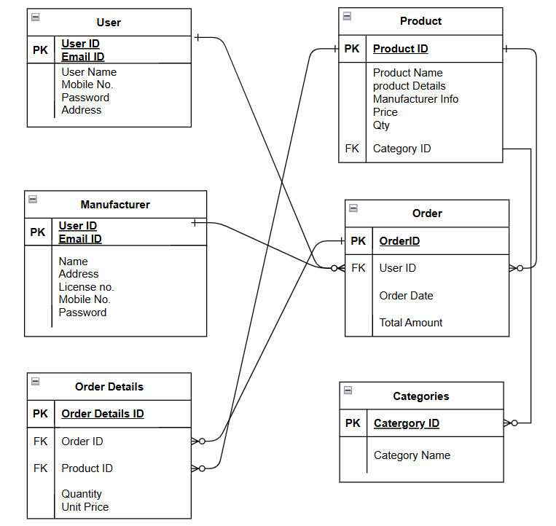
Question 7 – What is a data flow diagram? Draw a data flow diagram to represent the in-flow and out-flow of data when a Farmer is placing an order for the product
Answer:
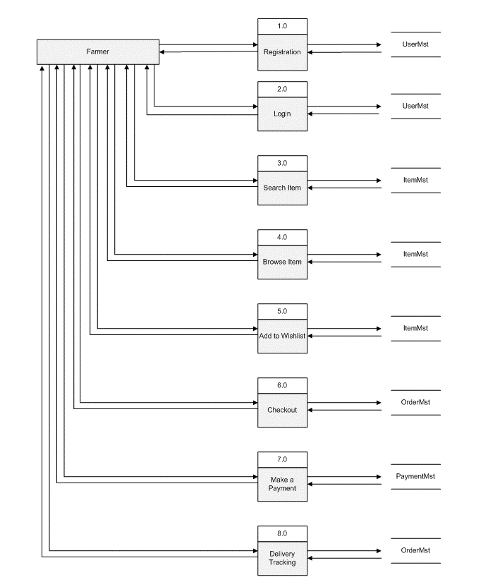

___________________________________________________________________________
Question 8 – Due to change in the Government Taxation structure. we should change the Tax structure How do you handle change requests in a project?
Answer:
1. Scope of Change Request:
The change request involves adjusting the taxation structure due to new government regulations. As a Business Analyst (BA), I would document the specifics of the change request, including what exactly needs to be updated (e.g., tax rates on products sold through the online store).
Looking at the change request, its belonging to the checkout step, while billing for the payment, so the change request is inside the project scope. Because the taxes is the thing which continuously changing think.
2. Impact analysis/assessment.
I will Work closely with the development team (including Mr. Karthik, Ms. Juhi, and other relevant technical members) to understand the system's current tax handling mechanisms and the effort required to make the necessary changes, also will take there advise is this technically and operationally feasible to implement the new taxation structure.
We will do impact analysis to understand how will its impact on the project structure.
Impact Analysis:
- Evaluate Impact: Analyse how implementing the new taxation structure would impact the project in terms of:
- Development Effort: How much time and resources will be needed to make the changes?
- Operational Impact: Will there be any disruptions to the current functionality or user experience?
- Cost Implications: Are there additional costs associated with implementing these changes?
- Stakeholder Communication: Discuss the potential impacts with stakeholders such as Mr. Pandu (Financial Head), Mr. Dooku (Project Coordinator), and Mr. Henry (the sponsor). They need to understand the implications in terms of budget, timeline, and project goals.
3. Prioritization and Approval:
- Prioritize the Change: We will Assess the urgency and importance of the change request compared to other pending changes or project tasks.
- Seek Approval: We Will Present the change request along with the impact assessment to the project sponsor or steering committee for approval. Obtain formal approval before proceeding with implementation.
4. Change Planning:
- Develop Change Plan: I will Create a detailed plan outlining how the change will be implemented. This includes tasks, responsibilities, timelines, and communication strategies.
- Allocate Resources: I will Determine what resources (human, financial, technological) are needed to implement the change effectively.
5. Change Implementation:
- Execute the Change: Implement the approved changes following the change plan. Ensure all stakeholders are informed of the changes and their roles in the implementation process.
- Monitor Progress: Continuously monitor the implementation to ensure it is proceeding as planned and address any issues or deviations promptly.
6. Verification and Validation:
- Verify Results: We Will Validate that the implemented changes have achieved the desired outcomes and have not introduced any unintended consequences.
- Test if Necessary: Depending on the nature of the change, conduct testing or validation to ensure functionality and compliance.
7. Change Communication:
We will Keep all stakeholders informed throughout the change process. Provide updates on progress, milestones, and any adjustments to project plans resulting from the change.
8. Documentation and Closure:
- Document Changes: Also, we need Update project documentation, including plans, schedules, budgets, and risk registers, to reflect the approved changes.
- Formal Closure: Once the change has been successfully implemented and verified, formally close the change request process.
9. Post-Implementation Review:
Conduct a review to analyse how effectively the change was managed and identify opportunities for improvement in handling future change requests.
___________________________________________________________________________
Question 9 – As the project is in process, Ben and Kevin have contacted you. The reason is to inform you that they want the Farmers to sell their crop yields through this application i.e. Farmers should be able to add their crop yields or products and display to general public and should be able to sell them. They also want to introduce Auction system for their Crop yields. As a BA, what will be your response? Is this a change request or an enhancement???
Answer:
In this case, the primary objective is to connect farmers to manufacturers. However, Ben and Kevin have communicated their desire for farmers to sell their crop yields through this application. This falls outside the scope of the current project and cannot be considered a change request but rather an enhancement.
Change Request vs Enhancement
1. Change Request:
- Nature of the Change: Introducing a completely new functionality (allowing farmers to sell their crop yields and implementing an auction system) that was not originally planned or scoped in the initial project requirements.
- Impact Assessment: This change request would likely impact several aspects of the project, including:
- Scope: It expands the scope of the project to include e-commerce features and auction functionality.
- Timeline: It may extend the project timeline to accommodate development, testing, and deployment of new features.
- Resources: Additional resources (development effort, testing, possibly new integrations) may be required.
- Budget: There could be cost implications associated with implementing and maintaining these new features.
2. Enhancement:
- Improvement of Existing Functionality: Enhancing the application to allow farmers to list and sell their products directly and to introduce an auction system could also be seen as enhancing the existing marketplace functionality.
- Aligning with Stakeholder Needs: It meets the stakeholders' desire to improve the application's utility and market reach by allowing farmers more direct involvement.
Response as a BA
1. Documentation and Assessment:
- Document the specific details provided by Ben and Kevin regarding the desired functionalities (adding crop yields, selling products, auction system).
- Conduct an impact assessment to understand the implications on scope, timeline, resources, and budget.
2. Consultation:
- Consult with the project sponsor or steering committee to review and approve the change request.
- Discuss with the development team to evaluate technical feasibility and resource requirements for implementing these new features.
3. Planning and Implementation:
- If approved, collaborate with the development team to create a detailed plan for integrating the new functionalities into the existing application.
- Ensure that requirements are clear, and that testing and validation plans are established to maintain application integrity.
4. Communication:
- Keep stakeholders informed throughout the process, providing updates on progress, any adjustments to timelines or resources, and anticipated benefits of the new functionalities.
___________________________________________________________________________
Question 10 – Come up with estimations – How many Manhours required
Answer:
Analysis:
- According to the case study, the project duration is 18 months, and the current team size is approximately 11 FTE.
- Since we have all the trained resources, there is no need to hire any new FTE or engage a trainer.
- Given that the project structure is already in place, there is no requirement for new or enhanced infrastructure.
Man-Hour Estimations:
- Requirements Gathering and Analysis:
  - Business Analysis: 100-150 hours
  - Requirements Documentation: 50-100 hours
- System Design:
  - High-Level Design: 100-150 hours
  - Detailed Design: 100-150 hours
- Architecture and Backend Development:
  - Architecture Definition: 150-200 hours
  - Backend Development (Java): 1000-1200 hours
- Frontend Development:
  - UI/UX Design: 150-200 hours
  - Frontend Development: 600-800 hours
- Database Design and Implementation:
  - Database Design: 100-150 hours
  - Database Implementation: 100-150 hours
- Testing:
  - Test Planning and Strategy: 100-150 hours
  - Test Case Development: 100-150 hours
  - System Testing (including functional and non-functional): 300-400 hours
- Deployment and Integration:
  - Deployment Planning: 100-150 hours
  - Integration Testing: 200-300 hours
- Project Management and Coordination:
  - Project Management: 300-400 hours
  - Stakeholder Meetings and Communication: Ongoing throughout the project
Total Man-Hour Estimation: Adding up the estimated ranges for each phase,
- Total Estimated Man-Hours: Approximately 3200-4000 hours
Project Size Classification: Based on the estimated man-hours,
- Medium Project: 3000 - 10000 man-hours
This estimation aligns with the Medium Project category under the V-Model SDLC approach. It covers all essential phases from requirements gathering to deployment and includes adequate testing and project management efforts. Adjustments may be necessary based on specific project requirements, team experience, and any additional iterations or changes during development.
Top of Form
Bottom of Form
Question 11 – Project has finally completed all the stages i.e., design, development, testing etc. Now, it is the role of a business analyst to contact the client for testing of the final product and have to successfully complete it. How are you going to handle this situation? And once it is done, what will be the process to close the project? Explain UAT Acceptance process
Answer:
Handling the final stages of the project as a Business Analyst (BA) involves ensuring that the client, in this case Mr. Henry and his committee, conducts User Acceptance Testing (UAT) successfully and that the project is closed effectively. Here’s how I would handle these responsibilities:
User Acceptance Testing (UAT) Process:
1. Preparation:
- Document UAT Plan: Prepare a detailed plan outlining the scope, objectives, and procedures for UAT. This plan should be shared with Mr. Henry and his committee for review and approval.
- Prepare Test Cases: Work with the testing team (Mr. Jason and Ms. Alekya) to finalize UAT test cases based on functional requirements and user stories. Ensure these test cases cover all critical scenarios and user workflows.
2. Execution:
- Facilitate UAT Sessions: Coordinate with Mr. Henry and his committee to schedule UAT sessions. Provide necessary support and guidance during these sessions.
- Monitor Testing Progress: Stay engaged throughout UAT to address any issues or questions that may arise. Monitor progress against the predefined test cases and ensure thorough testing.
3. Issue Resolution:
- Manage Feedback: Document any issues or feedback identified during UAT. Facilitate discussions between the testing team, development team, and stakeholders to resolve issues promptly.
- Track Resolutions: Ensure that all reported issues are addressed and retested before final acceptance.
4. Sign-Off:
- Obtain Sign-Off: Once UAT is successfully completed and all issues are resolved to the satisfaction of Mr. Henry and his committee, facilitate the formal sign-off process. This sign-off indicates acceptance of the product as meeting the agreed-upon requirements and readiness for deployment.
Project Closure Process:
1. Documentation:
Gather all project-related documentation, including requirements, designs, test cases, and UAT results. Ensure these documents are organized and accessible for future reference.
2. Financial Closure:
Work with Mr. Pandu, the Financial Head, to review project expenditures against the allocated budget (2 Crores INR). Ensure all financial transactions are documented and accounted for.
3.Formal Closure:
Obtain formal sign-off from Mr. Henry and his committee acknowledging successful completion of the project. This sign-off signifies the closure of the project and transition to ongoing support and maintenance phases, if applicable.
User Acceptance Testing (UAT) Acceptance Process:
User Acceptance Testing (UAT) is crucial to ensure that the developed product meets the business requirements and is fit for use by end-users. Here’s a detailed process for UAT acceptance:
1. Preparation:
- BA and testing team prepare UAT plan, including objectives, scope, test cases, and acceptance criteria.
- Test environment is set up to replicate production conditions.
2. Execution:
- End-users (Mr. Henry, Peter, Kevin, Ben, and their committee) perform UAT based on predefined test cases.
- They execute typical workflows and scenarios to validate functionality, usability, and performance.
3. Issue Reporting:
- Users report any issues, bugs, or deviations from expected behavior encountered during testing.
- BA coordinates with the development team to address reported issues promptly.
4. Resolution and Retesting:
- Development team fixes reported issues and updates the system accordingly.
- Retesting is performed to ensure that fixes are effective and do not introduce new issues.
5. Acceptance Decision:
- Once all issues are resolved satisfactorily, users (Mr. Henry and his committee) review the system again to verify that it meets their expectations.
- They provide formal sign-off indicating acceptance of the product for deployment.
6. Documentation:
- BA documents the UAT results, including test cases executed, issues identified, resolutions applied, and final acceptance decision.
- This documentation serves as a record of compliance with requirements and readiness for deployment.
___________________________________________________________________________
Question 12 – Explain Project closure document
Answer:
Sr. No. | Points | Details
1 | Did the Client Signed off on the UAT Testing
 | Date Of the signoff | 30/06/2025
 | Name of the resource | Mr. Ben
2 | objective of the project
 | Facilitate Access to Agricultural Products | Achieved
 | User-friendly web/mobile application | Achieved
 | Establish a direct communication channel between farmers and agricultural product manufacturers | Achieved
 | CSR Commitment | Achieved
3 | Functionalities of the project
 | Product listing and catalogue management for fertilizers, seeds, and pesticides. | Achieved
 | User registration and secure authentication. | Achieved
 | Wishlist and ordering system with checkout functionality. | Achieved
 | Order management and real-time tracking. | Achieved
 | Secure payment gateways. | Achieved
 | Feedback and review system for products and user experience | Achieved
4 | Funding
 | Amount Approved | 2 Crore INR
 | Amount Utilized | 1.8 Crore INR
5 | Overall Project Information
 | Escalations
 | Customer Satisfaction | High
6 | Value to the company
 | Positive/Negative | 92%  Revenue Generation  Brand Enhancement  Increased clients  Trained employees  Customer Loyalty

