QUESTION 1 - What is the difference between Brainstorming and JAD Sessions?
ANS:
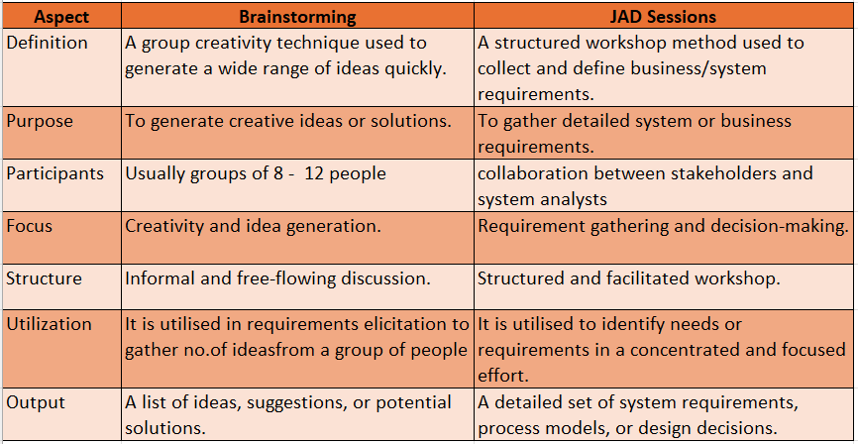
QUESTION 2 - Why Document Analysis is one of the compulsory technique we use in a Project?
ANS:
Document Analysis is an important gathering technique in a project. It is mainly used to understand the existing documentation. This is one of the compulsory elicitation technique for any project.
You may have documentation about your current system which could provide some of the input for the new system requirements. Such documentation (if it exists) could include interface details, user manuals, and software vendor manuals.
Generally, we have 3 stages:
- Prepare a document analysis:
- Evaluate which existing system documentation are relevant and appropriate to be studied.
- Analyse the document:
- Study the material and identify relevant business details
- Document business details as well as questions for follow up with the subject matter experts.
- Post document analysis wrap-up:
- Review and confirm the selected details with subject matter experts
- Obtain answers to follow up questions
QUESTION 3 - In Which Context we will use Reverse Engineering?
ANS:
Reverse engineering is one of the elicitation techniques used in the project. The reverse engineering used in the situations where the software for an existing system has a little outdated documentation and it is necessary to understand what the system actually does, reverse engineering is used.
There are two categories of reverse engineering:
Black box reverse engineering: The system/product is studied without examining its internal structure.
White box reverse engineering: The inner working of the system /product is studied
CONTEXTS:
Software Maintenance – To understand and modify legacy systems when documentation is missing.
Legacy System Replacement – Understanding old technologies to develop replacements.
Software Debugging – Identifying hidden logic or dependencies in compiled software.

QUESTION 4 - What is the difference between Brainstorming and Focus Groups?
ANS:
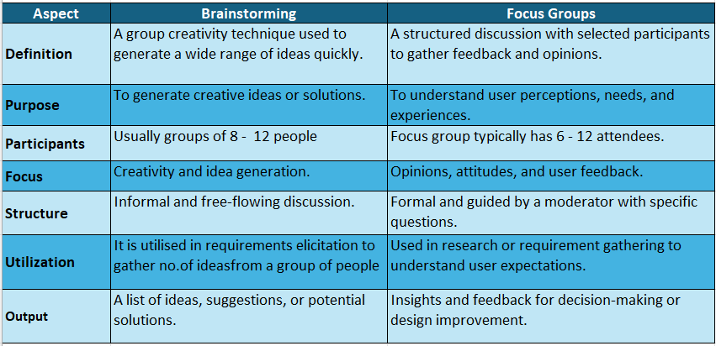

QUESTION 5 - Observation Technique – Explain both Active and Passive approaches
ANS:
Observation:
Observing, shadowing users or even doing part of their job, can provide information of existing processes, inputs and outputs. The main advantage is that it is useful if the user is not able to clearly explain what they do or their requirements for the new system. Can see ideas for improving processes or removing unnecessary activities from the new system.
Disadvantage is that this is Relatively slow, which is focused on existing processes rather than the new system processes.
Passive/Invisible:
In this approach, the business analyst observes the subject matter expert working through the business routine but does not ask questions. The business analyst writes notes about what he/she sees, otherwise stays out of the way as invisible. The BA waits until the entire process has been completed before asking any questions.
Active/Visible:
In this approach, while the business analyst observes the current process and takes notes he/she may dialog with the worker. When the BA has questions as to why something is being done as it is, questions can be asked right away, even if it breaks the routine of the person being observed.

QUESTION 6 - How do you conduct the Requirements Workshop
ANS:
A requirement Workshop is a structured way to capture requirements. A workshop may be used to scope, discover, define, prioritize and reach closure on requirements for the target system.
- Prepare
- Conduct
- Wrap up

QUESTION 7 - In which context, Interview Technique can be conducted by a BA ? How may approaches are there in conducting Interviews? (Structured – Unstructured) Explain them. Explain the difference between Open Ended Questions and Closed-ended Questions
ANS:
An interview is a systematic approach to elicit information from a person or group of people in an informal or formal setting by talking to the person. Interviews of users and stakeholders are important in creating wonderful software. We have to understand the perspective of every interviewee, in order to properly address and weigh their inputs.
The main advantage of this is technique is that it’s easy, because it can be done with minimal preparation. Interviews of individuals and small groups require less planning and scheduling effort than large workshops.
Disadvantage is that Conflicts and inconsistencies between stakeholder information need to be resolved in additional interviews. Also, this technique does not allow different stakeholders to hear and elaborate upon the information being relayed.
Structured Interview:
A structured interview is a standardized job interview process in which the interviewer asks a predetermined set of questions to all candidates in a consistent manner.
Unstructured Interview:
An unstructured interview is an interview in which the questions asked are not predetermined or standardized.
Open Ended Questions:
These are the questions that encourage interviewee to provide detailed free form responses rather than simple yes or no answers. These questions typically begin with words like "who," "what," "where," "when," "why," or "how."
Closed ended questions:
These questions are that which can be answered with a specific, limited set of response options or a brief response such as "yes" or "no."

QUESTION 8 - Questionnaire Technique – Where we will use? Give one example
ANS:
A questionnaire technique involves using a structured set of written questions to collect information or opinions from individuals. The questions are designed to gather specific data, and Stakeholders provide their answers.
This technique is commonly used in surveys, research studies, and data collection efforts to gather standardized and quantifiable information from a target audience.
Questions should be based on high priority risks. Questions should be direct and unambiguous. Once the survey is ready, notify the participants and remind them to participate.
Example: Companies use this technique in market research to gather customer preferences, opinions and behaviour

QUESTION 9 - How to Sort the Requirements – Where we will use? Give one example
ANS:
Sorting the Requirements is basically categorizing the requirements based on their importance, relevancy. This is crucial step in requirement engineering process. This helps in identifying the most critical and high priority requirements for the development or implementation of product
Example: While building a product we divide requirements based on the features or phases of product, based on the importance of requirements

QUESTION 10 – Prioritize the Requirements – –Where we will use? Give one example
ANS:
Prioritising Requirements is where the identified requirements are ranked based on importance or urgency for development process. Factors that influence prioritisation are Importance, Urgency, Risk, cost, benefit, time and Strategy
3 main actors are
- Customers
- Developers
- Business owners
We have multiple techniques for Prioritisation.
- 100$ test
- MoSCoW
- Top 10 Requirements
- Numerical assignment
Example: Prioritising technique is mostly used in scrum for refinement of product backlog items (user stories)

QUESTION 11 - Weekly status reporting – How we will drive?
ANS:
Weekly status report is a summary of all work done during a week and how these activities contributed to the completion of a task or a project, or how each one brings the team closer to the achievement of their targets.
Questionnaire that can be asked in a weekly status report include:
What have you been working on recently
What have you

QUESTION 12 - Meeting Minutes Document – prepare one Sample
ANS:
A Meeting Minutes Document is a written record of everything discussed, decided, and planned during a meeting. It serves as an official summary for future reference.
Meeting minutes are notes that are taken during a meeting to record what happens in the meeting. These notes typically highlight the key issues that are discussed in the meeting. Meeting minutes should indicate the time, date and setting of the meeting.

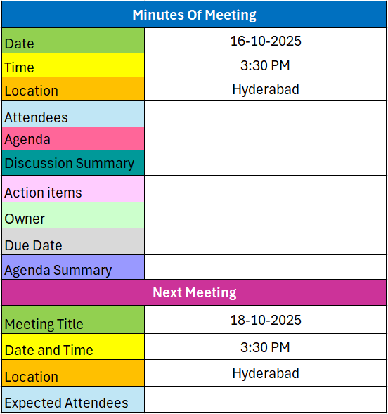

QUESTION 13 - Change Tracker – Document - – prepare one Sample
ANS:
Change tracker document is a document that is used by the project team to log and track change requests made throughout the life of the project. Change management is one area of project management which will cause serious problems if it is not carefully managed. Its purpose is to
- To track all changes in a structured way.
- To communicate changes clearly to the team and stakeholders.
- To avoid confusion or duplication of work.
- To assess the impact of changes on time, cost, and resources.
- To ensure accountability by assigning responsibility for each change.

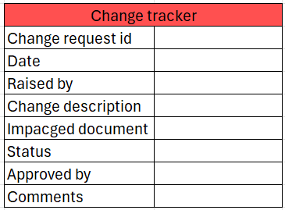

QUESTION 14 - Difference between Traditional Development Model and Agile Development Models
ANS:
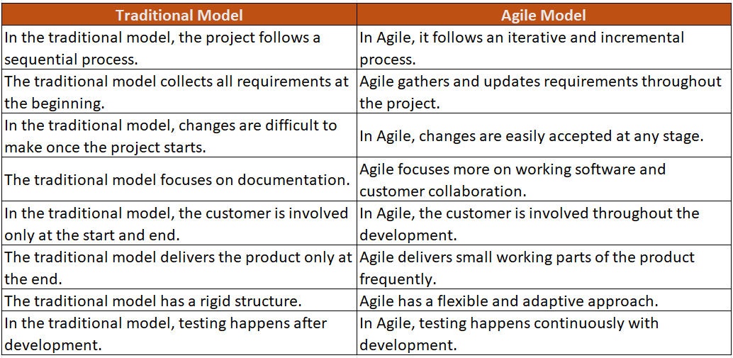

QUESTION 15 - Explain Brainstorming Technique – Where to use?
ANS:
This is used to generate creative ideas and solutions through group discussions. It is a media where people can freely express their ideas, thoughts and suggestions without criticism or judgment. This is mostly done in an informal way with minimal documentation
The basic idea behind brainstorming is to find a conclusion for a specific problem by gathering a list of ideas spontaneously contributed by its members.
This technique is most commonly used in below aspects
- Idea Generation:
Brainstorming is used to gather many creative ideas from different team members. It encourages free thinking and helps discover new and innovative concepts.
- Project Planning:
Brainstorming is used to gather many creative ideas from different team members. It encourages free thinking and helps discover new and innovative concepts.
- Problem solving:
Brainstorming helps identify the root cause of a problem and find possible solutions. The team discusses all ideas and selects the best one to solve the issue.
- Team building:
It improves teamwork by allowing everyone to share ideas openly and feel included. This builds trust and better communication among team members.
- Innovative development:
Brainstorming is used to create new features, services, or process improvements. It combines multiple ideas to come up with innovative solutions.

QUESTION 16 - What reports Accounts Departments will generate (minimum 5 reports)?
ANS:
Reports generated by account department can differ from every organization some of the common reports are as below.
- Financial Statements:
Income statements, balance sheets, and cash flow statements may be generated to provide an overall financial snapshot of the project's financial health
- Budget Reports:
Provide an overview of the project budget, including planned vs. actual expenses
- Expense Reports:
Detail the project-related expenses incurred, including itemized lists of costs such as travel, supplies, services, and other expenditures.
- Cost Analysis:
Breakdown of costs associated with different project components, tasks, or departments. This analysis aids in identifying areas of overspending or cost savings opportunities.
- Cash Flow Reports:
Provide insights into the timing and amounts of cash inflows and outflows related to the project

QUESTION 17 - What is the structure of the message/mail communicated from the HR department to the employee in case the Loan is rejected?
ANS:
Subject: Important Notification Regarding Loan Application Status

Dear [Employee's Name],
I hope this message finds you well. We would like to inform you regarding the recent status of your loan application. After a careful review of your application, we regret to inform you that your loan application has been rejected at this time.
As you already taken a loan in which 70% payment is withstanding. Until the outstanding amount is cleared we can’t provide you any more loans
Thank you for your understanding, and we appreciate your continued dedication to [Company Name].

Best Regards,
[Your Name]
HR Department
TTS Company
[Contact Information]

QUESTION 18 - What is the structure of the message/mail communicated from the HR department to the employee in case the Loan is approved?
ANS:
Subject: Loan Approval Notification

Dear [Employee Name],
I am pleased to inform you that your recent loan application has been approved by the HR department. We will be releasing the amount of XXXXXX Rs to your salary account on 30/01/2024
Please arrange the following documents before 25/01/2024
- Aadhar Card
- Pan Card
- Bank statement of last 3 months
Loan Details:
- Loan Amount: [Amount]
- Interest Rate: [Rate]
- Repayment Term: [Term]
- Loan Recovery date: [DD/MM/YYYY]
- Last Instalment: [DD/MM/YYYY]
Please review the attached loan agreement for all terms and conditions. If you have any questions or concerns, feel free to reach out to the HR department. Your agreed-upon monthly repayment amount will be deducted directly from your salary.
Thank you for choosing TTS Company for your financial needs. We wish you all the best in utilizing this opportunity wisely.

Best Regards,
[Your Name]
HR Department
TTS Company
[Contact Information]

QUESTION 19 - Design a sample report on the Loans applications Received by the accounts department
ANS:
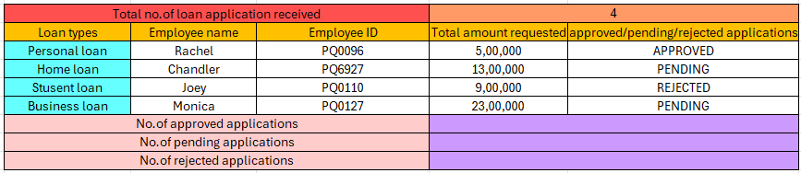

QUESTION 20 - Which reporting Tools we will use for generating reports
ANS:
Microsoft Excel : It is a widely used spreadsheet application that allows users to store, organize, and analyse data using charts, tables, pivot tables, and formulas. It is ideal for small to medium-scale reporting and quick data analysis.
Power BI : It is a business intelligence tool that connects to multiple data sources to create interactive dashboards, real-time reports, and dynamic visualizations, helping organizations make informed decisions.
Tableau : It is a powerful data visualization platform that can handle large datasets and create visually appealing, interactive dashboards. It is commonly used for advanced business intelligence reporting, uncovering trends, and presenting complex data in an easy-to-understand format.

