Question 1:

4 Quarterly Audits are planned Q1 , Q2, Q3, Q4 for this Project What is your
knowledge on how these Audits will happen for a BA ?

Answer :
Quarterly audits for a Business Analyst (BA) in a project are conducted to ensure process compliance, documentation integrity, and traceability of requirements. Here’s what typically happens in each quarter from a BA's perspective:

Q1 Audit (Months 1–3): Focus on Initiation & Requirements

Objective: Ensure a strong foundation for the project.

checklist:

Requirements Gathering Documentation (interviews, surveys, workshops with stakeholders like Peter, Kevin, Ben)

Business Requirement Document (BRD) or Product Requirements

Stakeholder Analysis

Meeting minutes & sign-offs

Traceability Matrix (start of it)

Auditors check for:

Adequate stakeholder involvement

Proper documentation formats.

Q2 Audit (Months 4–6): Focus on Requirement Analysis & Design Readiness

Objective: Validate correctness and completeness of requirements.

checklist:

Finalized Functional Requirement Specification (FRS)

Process Flow Diagrams, Use Cases, User Stories

RequirementsTraceability Matrix

Change Request Logs if any revisions occurred

Auditors check for:

Requirement clarity, feasibility, testability

Business-technical alignment

BA's support to design team.

Q3 Audit (Months 7–12): Focus on Development & Testing Alignment

Objective: Ensure requirements are being built and tested as planned.

checklist:

JAD session report

End user manual preparation

BA and Developer MOM

Test case summary

Auditors check for:

Is each requirement mapped to a test case?

Continuous update of the Traceability Matrix

Q4 Audit (Months 13–18): Focus on UAT & Closure

Objective: Verify project outcome against original requirements.

checklist:

User Acceptance Testing (UAT)

Documentation of UAT Feedback and issue resolution

Business Sign-off Reports

Auditors check:

Was the solution delivered as per documented requirements?

Any open issues or gaps?

BA’s role in handover and documentation archiving.

Question 2
Before the Project is going to Kick Start, The Committee asked Mr Karthik to submit BA Approach Strategy Write BA Approach strategy (As a business analyst, what are the steps that you would need to follow to complete a project – What Elicitation Techniques to apply, how to do Stakeholder Analysis RACI/ILS, What Documents to Write, What process to follow to Sign off on the Documents, How to take Approvals from the Client, What Communication Channels to establish n implement, How to Handle Change Requests, How to update the progress of the project to the Stakeholders, How to
take signoff on the UAT- Client Project Acceptance Form ).

Here is a comprehensive Business Analyst (BA) Approach Strategy tailored for the Online Agriculture Products Store project under the CSR initiative. This approach outlines how I, as the BA, will lead and contribute throughout the sdlc lifecycle to ensure successful delivery.

As a BA, I will act as a bridge between stakeholders (Committee, Peter, Kevin, Ben, Mr. Henry) and the technical team (APT IT Solutions) by ensuring that the solution built is aligned with the actual business needs and goals of the project.

Elicitation Techniques to apply:
Workshops
One-on-One Interviews
Observation
Document Analysis
Brainstorming and Surveys/Questionnaires
Stakeholder Analysis:

Stakeholder analysis can be done by using the RACI matrix involving identifying stakeholders and defining their roles and responsibilities within a project. - Identify Stakeholders, Define Roles and Responsibilities, Create the RACI Matrix, Assign RACI Roles.

Documents to Write:
1. Business Requirements Document (BRD)
2. Functional Requirements Specification (FRS)
3. Use Case Document / User Stories
4. Process Flow Diagrams (BPMN)
5. Non-Functional Requirements Document
6. Requirements Traceability Matrix (RTM)

Process to follow to Sign off on the Documents :
Sign Off to be taken on SRS as this is the primary and important document. Sign off can be taken by using E-mail confirmation from the client.
Send documents to committee via email or stakeholder portal
Schedule walkthrough meeting Capture feedback and apply version control

Communication Channels to establish and implement :
Regular Meetings.
Weekly status meetings.
Bi-weekly sprint reviews.
Monthly stakeholder updates.

Handle Change Requests :
Change Request Form.
Do Impact Analysis.
Approval Process.
Documentation.

Progress Reporting :
Rtm status
Weekly Status Reports.
Monthly Review Meetings.

User Acceptance Testing (UAT) & Client Sign-off:
Conduct UAT Workshops.
Collect feedback using a structured UAT Checklist.
Fix issues and retest if required.
Submit Client Project Acceptance Form.
Get formal sign-off on:
UAT completion.
System Readiness.
Business Goals Fulfilment.

Question 3:

Explain and illustrate 3-tier architecture?

Answer:
Three-tier architecture is a software design pattern that separates an application into three logical layers:
1. Presentation Tier (Client Layer)
2. Application Tier (Business Logic Layer)
3. Data Tier (Database Layer)

Tiers Explained:
1. Presentation Tier (Client Layer/UI)

What it does:
Displays information to users and accepts user inputs.
Users interact directly with this layer.

Examples:
Web: HTML/CSS/JavaScript frontend
Mobile App UI (Android/iOS)

2. Application Tier (Business /Backend Logic Layer)

What it does:
Processes user input, applies business rules, and handles communication between UI and Data tiers.

Examples:
Java, Python, .NET backend

3. Data Tier (Database Layer)

What it does:
Stores, retrieves, and manages data.

Examples:
SQL (MySQL, PostgreSQL).

Online Agriculture Product Store

Presentation Tier:
Web/Mobile interface for farmers and vendors.

Application Tier:
Java backend with Spring Boot APIs handling product listing, ordering, payments.

Data Tier:
MySQL database storing user info, products, orders, inventory.

Question 4
BA Approach Strategy for Framing Questions
Business Analyst should keep What points in his/her mind before he frames a Question to ask Stakeholder

Answer
Before framing questions to the stakeholder, a Business Analyst should keep the following frameworks, models, and tools in mind to ensure the questions are focused, effective, and lead to actionable insights:

1. 5W 1H Technique (Basic Analysis Questions)

Question Type Purpose

What To understand what the stakeholder wants or expects
Why To understand the reason behind the requirement
When To capture timelines and urgency
Where To identify where the process happens (context)
Who To identify the actors involved in the process
How To understand how the process or function should work

This approach gives a complete requirement view and avoids missing details.

2. SMART Questions Principle

Questions should aim to derive SMART requirements:

Specific – What exactly is needed?

Measurable – How will success be measured?

Achievable – Is the feature/requirement doable within scope?

Relevant – Does it align with business goals?

Time-bound – By when is it needed?

3. RACI Matrix Awareness

A BA should also consider the roles and responsibilities:

RACI Element Framing Questions To Know

Responsible Who will do the task?
Accountable Who will sign off on it?
Consulted Who must be consulted before action?
Informed Who must be kept informed?

This helps avoid ambiguity in stakeholder roles and keeps communication structured.

4. 3-Tier Architecture Awareness

While framing technical or process-related questions, the BA must distinguish between:

Tier Questions Should Target...

Presentation Tier What UI/UX features do users expect?
Business Logic Tier What business rules or logic should apply?
Data Tier What data should be captured, stored, and retrieved?

5. Use Cases, Specs, and Diagrams Understanding

Questions should align with use case modeling:

What actors are involved? (e.g., Farmer, Manufacturer)

What are their goals?

What steps/events occur?

What are the exceptions or alternative flows?

This helps in preparing:

Use Case Diagrams

Use Case Specifications

Activity Diagrams

Wireframes or Page Mockups

6. Keep User Interface (Page Designs) in Mind

Frame questions to understand:

What the user journey should look like

What screens they expect

What functional elements (search bar, filter, payment gateway) they need

Before asking questions, a good BA does a pre-analysis:
Reads available documents, understands business goals, identifies gaps, and frames questions to close those gaps.

Question 5
As a Business Analyst, What Elicitation Techniques you are aware of? ( BDRFOWJIPQU)

Answer:

Elicitation Techniques (BDRFOWJIPQU)

B — Brainstorming
What: Fast group technique to generate many ideas/requirements without judgment.
Sub-types:
- Free-form brainstorming — open, creative session.
- Structured brainstorming — timed rounds, each person contributes in turn.
- Round-robin / Nominal Group Technique — people write ideas, then vote/prioritize.
- When to use: Early discovery, scope/feature generation, solving tricky UX or business problems.
- Outputs: Idea lists, prioritized idea clusters, raw requirement candidates.
- Pros / Cons: Quick and creative; can be dominated by vocal participants and produce many low-quality ideas.
- Example (project): Workshop to list all possible farmer pain-points and features (offline ordering, languages, local price comparisons).

D — Document Analysis
What: Examine existing artifacts (policies, reports, forms, system docs) to extract requirements or constraints.
Sub-types:
- Business document review (SOPs, contracts, CSR docs)
- Technical document review (legacy system specs, DB schemas)
- Regulatory / compliance review (agri regulations)
- When to use: When migrating/enhancing systems or to understand compliance and existing processes.
- Outputs: Requirements trace, constraints list, gap analysis.
- Pros / Cons: Low cost and factual; may be outdated or incomplete.
- Example: Review vendor invoices and procurement records to define product metadata and pricing rules.

R — Requirement Workshops (including JAD as a style)
What: Facilitated group sessions to elicit, validate and prioritize requirements collaboratively.
Sub-types:
- Requirement elicitation workshops
- Validation workshops (review & signoff)
- Prioritization workshops (MoSCoW/dot voting inside workshop)
- When to use: To build consensus among stakeholders and resolve conflicts quickly.
- Outputs: Agreed BRD sections, prioritized backlog, action items.
- Pros / Cons: Great for alignment; needs skilled facilitation and careful planning.
- Example: A half-day workshop with Mr. Henry, Peter, Kevin, Ben and a manufacturer rep to agree on payment modes and login flow.

F — Focus Groups
What: Moderated discussion with a representative group of users to capture opinions and reactions.
Sub-types:
- Homogeneous focus group (all farmers)
- Heterogeneous focus group (farmers + small dealers)
- When to use: To evaluate features, concepts, or user preferences; good for UX/acceptance insight.
- Outputs: Thematic insights, prioritized user needs, qualitative data.
- Pros / Cons: Rich qualitative insight; not statistically representative.
- Example: Gather 8–10 local farmers to discuss ease of search/filtering and payment preferences.

O — Observation (Job Shadowing)
What: Watch users perform real work to discover implicit behavior and unspoken needs.
Sub-types:
- Passive observation — quiet watching without interference.
- Active observation — observe and ask clarifying questions while watching.
- Time-motion studies — record task durations and steps.
- When to use: When users can’t easily describe their process or there’s a complex workflow.
- Outputs: As-is process maps, pain points, data capture requirements.
- Pros / Cons: Reveals hidden needs; time consuming and potentially intrusive.
- Example: Shadow a farmer purchasing fertilizer at a local shop to see steps and information they rely on.

W — Workshops (broader collaborative sessions)
What: Broader than focused requirement workshops — could include prototyping, design thinking, or solutioning.
Sub-types:
- Design workshops (UI/UX)
- Prototyping workshops (hands-on with mockups)
- Solution workshops (high-level architecture / integrations)
- When to use: To co-create solutions and speed decisions.
- Outputs: Wireframes, consensus designs, backlog items.
- Pros / Cons: Fast alignment and tangible artifacts; need good facilitation and materials.
- Example: Co-design session to create the product detail page with farmers and a UX designer.

J — JAD (Joint Application Development)
What: A formalized, structured workshop technique that tightly couples business and development stakeholders facilitated to define requirements quickly.
Sub-types:
- Requirements JAD
- Design JAD
- When to use: Complex systems with heavy business/IT interaction and need rapid consensus.
- Outputs: Detailed functional descriptions, agreed process flows, action logs.
- Pros / Cons: Highly effective for convergence; resource-intensive and requires scheduled availability of busy people.
- Example: A two-day JAD to define checkout/payment integration and refund flows with dev, BA, PM, and payment gateway rep.

I — Interviews / Interface Analysis
What: One-on-one or small group interviews to elicit detailed info; interface analysis examines system-to-system connections.
Sub-types:
- Structured interviews (scripted questions)
- Semi-structured interviews (guided, flexible)
- Unstructured interviews (open conversation)
- Interface analysis (APIs, data exchange points)
- When to use: To gather deep, detailed requirements from key stakeholders.
- Outputs: Interview transcripts, user stories, requirements list.
- Pros / Cons: Deep insights and clarifications; time consuming and can be biased by the interviewee.
- Example: Interview Mr. Henry to capture business KPIs and interview a manufacturer to learn product data fields required.

P — Prototyping
What: Build a mock UI/UX or partial system model to validate requirements and surface gaps.
Sub-types:
- Paper/proof-of-concept sketches (very low fidelity)
- Clickable wireframes (mid fidelity)
- High-fidelity interactive prototypes (near real UI)
- Throwaway vs evolutionary prototypes
- When to use: When stakeholders struggle to describe UI/UX or flows; to validate assumptions.
- Outputs: Wireframes, clickable prototypes, feedback logs.
- Pros / Cons: Tangible feedback and faster validation; can lock stakeholders to visual details too early.
- Example: A clickable mockup of the product search → detail → cart flow shown to farmers for feedback.

Q — Questionnaires / Surveys
What: Structured set of questions distributed to many users to collect quantitative/qualitative data.
Sub-types:
- Closed-ended (multiple choice, Likert scales)
- Open-ended (free text)
- Hybrid (mix of both)
- When to use: When stakeholders are numerous or geographically dispersed and you need broad input.
- Outputs: Survey results, statistics, prioritized preferences.
- Pros / Cons: Efficient for scale; low response quality if badly designed.
- Example: Short SMS or WhatsApp survey to 500 farmers asking preferred payment methods and delivery windows.

U — Use Cases / User Stories (requirements modeling)
What: Structured descriptions of system behavior from a user’s perspective; use cases are detailed flows, user stories are agile-style short statements.
Sub-types:
- Use cases (actor, main flow, alt flows, exceptions)
- User stories (As a … I want … so that …)
- Acceptance criteria / scenarios (Gherkin style: Given/When/Then)
- When to use: To translate elicited needs into implementable functional requirements.
- Outputs: Use case docs, user stories in backlog, acceptance criteria.
- Pros / Cons: Clear for dev/test handover; use cases can become too verbose if not managed.
- Example: Use case “Place Order” with steps for guest checkout, registered checkout, and COD flow; user story: As a farmer I want to search by seed type so I can find products quickly.

Question 6:

Which Elicitation Techniques can be used in this Project and Justify your selection of Elicitation Techniques?

Answer:
1. Elicitation Techniques Used in This Project & Justification

1. Prototyping
Definition:
Prototyping involves creating a preliminary version of the system (wireframes, mock-ups, or clickable demos) to gather feedback from stakeholders.
Sub-types:
- Throwaway/Rapid Prototyping: Quick mock-ups for immediate feedback, discarded after validation.
- Evolutionary Prototyping: Prototype continuously improved to become part of the final system.
- Incremental Prototyping: Developed in pieces, each prototype addresses a specific functionality.
Justification for this project:
- Farmers and manufacturers may not be technical; showing mock-ups of login, product catalog, search, payment, and delivery tracker helps them visualize the system and give precise feedback.
- Helps validate UI/UX and ensure stakeholder expectations (e.g., buy-later list, search filters) are captured correctly.

2. Use Case Specifications (Use Case Specs)
Definition:
Use cases describe how users interact with the system to achieve a goal.
Sub-types:
- Brief Use Case: High-level description of interaction.
- Casual Use Case: Simple steps, less formal.
- Fully Dressed Use Case: Detailed steps, actors, pre/post conditions, exceptions, and business rules.
Justification for this project:
- Captures functional requirements like login, product search, product upload, payment, and order tracking.
- Ensures developers know exactly how users will interact with the system.

3. Document Analysis
Definition:
Examining existing documents to extract information about processes, products, and policies.
Sub-types:
- Business Process Documents (e.g., current farming product procedures)
- Product Catalogs from manufacturers
- Forms and reports used by farmers
Justification for this project:
- Helps collect accurate details of fertilizers, seeds, and pesticides from manufacturers to populate the application.
- Ensures nothing is missed in the product catalog and specifications.

4. Brainstorming
Definition:
A group discussion to generate ideas and uncover hidden requirements.
Sub-types:
- Unstructured Brainstorming: Open discussion, free idea generation.
- Structured Brainstorming: Facilitator guides discussion, prioritizes ideas.
Justification for this project:
- Used with stakeholders Peter, Kevin, and Ben to gather ideas about search options, payment methods, email confirmations, and delivery tracking.
- Helps uncover requirements not explicitly mentioned by the client.

5. Interviews
Definition:
Direct conversation with stakeholders to gather detailed information.
Sub-types:
- Structured Interviews: Predefined questions.
- Unstructured Interviews: Open-ended discussion.
- Semi-structured Interviews: Mix of predefined questions and open discussion.
Justification for this project:
- Used when meeting Mr. Henry to understand his expectations.
- Also used with stakeholders (Peter, Kevin, Ben) to gather specific requirements such as login, product search, payment gateway, and delivery tracking.

6. Observation
Definition:
Watching how users currently perform tasks to gather requirements.
Sub-types:
- Direct Observation: Observer watches user activity in real-time.
- Shadowing: Observer follows the user over a period to understand workflow.
Justification for this project:
- Observing farmers in their day-to-day operations can help understand how they purchase fertilizers, seeds, and pesticides.
- Helps design features like easy navigation, search, and buy-later options based on real usage.

7. Surveys
Definition:
Collecting information from multiple stakeholders through structured questionnaires.
Sub-types:
- Open-ended Surveys: Stakeholders can freely describe their needs.
- Closed-ended Surveys: Stakeholders select from predefined options.
Justification for this project:
- Useful to gather broader feedback from multiple farmers or manufacturers on preferred products, payment methods, and delivery preferences.
- Can validate initial requirements before finalizing system features.

2. Business & Stakeholder Requirements Identified
ID | Requirement Type | Description
BR001 | Business Requirement | Farmers should be able to search for available products in fertilizers, seeds, and pesticides.
BR002 | Business Requirement | Manufacturers should be able to upload and display their products in the application.
BR003 | Stakeholder (Kevin) | Farmers should be able to browse product catalog and use a search option.
BR004 | Stakeholder (Peter) | Users should be required to log in to add items to cart or wishlist. New users can register with email ID and secure password.
BR005 | Stakeholder (Ben) | Payment gateway should support COD, credit/debit card, and UPI.
BR006 | Stakeholder (Kevin) | Users should receive email confirmation regarding their order.
BR007 | Stakeholder (Kevin) | Users should be able to track delivery status through the system.

3. Mapping Elicitation Techniques to Each Requirement
Requirement ID | Elicitation Techniques Used
BR001 | Interviews, Prototyping, Use Cases
BR002 | Brainstorming, Interviews, Prototyping
BR003 | Interviews, Prototyping
BR004 | Interviews, Use Cases, Prototyping
BR005 | Interviews, Document Analysis
BR006 | Interviews, Use Case Specs
BR007 | Interviews, Prototyping, Observation

Question 7:

Make suitable Assumptions and identify at least 10 Business Requirements.

Answer:

Assumptions Made
- The platform is being developed for both mobile and web users.
- Users include farmers, fertilizer/seed/pesticide manufacturers, and delivery agents.
- System will support multilingual interface for ease of use in rural areas.
- Delivery tracking will be integrated with third-party logistics providers.
- Email and SMS notifications are available.
- Platform will support digital payments and Cash on Delivery (COD).

Business Requirements (BRs)
ID | Business Requirement
BR001 | Farmers should be able to browse and search for products such as fertilizers, seeds, and pesticides using category and keyword filters.
BR002 | Farmers must be able to create an account, log in securely using email/mobile, and manage their profile.
BR003 | Farmers should be able to add products to a cart or buy-later list for future consideration.
BR004 | Manufacturers should have the ability to register, log in, and upload/manage product listings (including name, image, price, category, availability).
BR005 | The system should provide multiple payment options – COD, Credit/Debit Cards, UPI, and Net Banking.
BR006 | Once an order is placed, the system should generate an order confirmation email/SMS and display the summary to the user.
BR007 | The system should allow users to track their orders in real time with estimated delivery dates and current status.
BR008 | Admins should be able to approve or reject manufacturer registrations and product listings.
BR009 | The application should support multilingual options (at least English, Hindi, and Telugu initially) for farmers.
BR010 | The platform should generate monthly reports for the admin, including sales statistics, most purchased products, user growth, and transaction volume.

Question 8:

List your assumptions

Answer:

List of Assumptions
- User Types Are Defined:
The primary users of the system are:
  - Farmers (buyers)
  - Manufacturers (sellers of fertilizers, seeds, and pesticides)
  - Admins (platform management)
  - Delivery agents (optional, or third-party logistics)
- Internet Access Is Available in Rural Areas:
Farmers in remote villages have basic internet connectivity and access to smartphones or computers.
- Multi-Device Access:
The application will be developed for both web and mobile platforms (Android-first priority).
- Languages Needed:
The system needs to support multi-language capability, starting with English, Hindi, and Telugu, to meet regional needs.
- Digital Literacy Is Basic:
Most users are non-technical, so the UI/UX must be simple, intuitive, and icon-driven.
- Manufacturers Are Responsible for Product Listings:
Only manufacturers can upload and manage their products, pricing, and stock availability.
- Secure User Authentication:
All users will register using their email and password, with optional mobile number and OTP verification for added security.
- Order Delivery Is Outsourced:
Logistics and delivery tracking will be managed via third-party integrations or basic manual status updates by vendors.
- Payment Gateway Will Be Integrated:
A third-party secure payment gateway will be used to support UPI, Cards, Net Banking, and COD.
- CSR Budget Is Fixed & Timeline Is 18 Months:
The project is funded under CSR, and the delivery is expected to be within 18 months. All major functionalities are expected to be live before UAT.
- Regulatory and Legal Compliance:
Any government norms related to agricultural product selling, e-commerce, or data privacy will be complied with by default.
- Notifications Will Be Sent via Email & SMS:
Users will receive order updates and confirmations through registered email and mobile number.

Question 9:
Give Priority 1 to 10 numbers ( 1 being low priority – 10 being high priority) to these Requirements after discussions with the stakeholders

Answer:

Part 1: Priority Assignment for Requirements
After discussing with stakeholders (Mr. Henry, Peter, Kevin, Ben), here is the updated priority list (1 = Low, 10 = High) based on business impact, frequency of use, and user expectations:
Moscow technique has been used for prioritising requirements
Req ID | Req Name | Req Description | Priority
BR001 | Farmer Search for Products | Farmers should be able to search for available products in fertilizers, seeds, pesticides | 8
BR002 | Manufacturers upload Products | Manufacturers should be able to upload and display their products in the application | 8
BR003 | User Registration & Login | Users (farmers & manufacturers) should be able to register/login securely | 10
BR004 | Product Browsing & Catalog | Farmers should be able to browse products by categories | 9
BR005 | Add to Cart & Wishlist | Farmers should be able to add products to cart or a buy-later list | 7
BR006 | Payment Options | COD, UPI, Cards, Net Banking should be supported | 9
BR007 | Order Confirmation Email | System should send confirmation after order placement | 6
BR008 | Delivery Tracking | Farmers should be able to track order delivery status | 8
BR009 | Admin Product Approval | Admin should approve/reject product listings by manufacturers | 5
BR010 | Multilingual Support | App should support English, Hindi, Telugu initially | 4

Part 2: Converting Requirements into UML & Mockups
As a Business Analyst, after finalizing the requirements and priorities, the next step is to translate them into artifacts that the project team (developers, testers, designers) can understand and implement.

UML Diagrams to Use:
Diagram | Purpose | Used For Requirements
Use Case Diagram | Visualize user roles and interactions | BR001–BR010
Activity Diagram | Shows the flow of operations, like placing an order | BR005–BR008
Class Diagram | Define entities like User, Product, Order, Payment | BR002, BR006, BR008
Sequence Diagram | Shows step-by-step interaction between objects | BR003 (login), BR006 (payment)
State Diagram | Shows states of an order (Placed → Shipped → Delivered) | BR008
Screen Mockups to Prepare:
Screen | Requirement Covered
Login & Registration | BR003
Product Catalog | BR001, BR004
Search & Filters | BR001
Product Detail Page | BR002
Cart & Wishlist | BR005
Payment Page | BR006
Order Confirmation Page | BR007
Delivery Tracker | BR008
Admin Panel | BR009
Language Selector UI | BR010

Question 10:
Draw use case diagram
Answer:

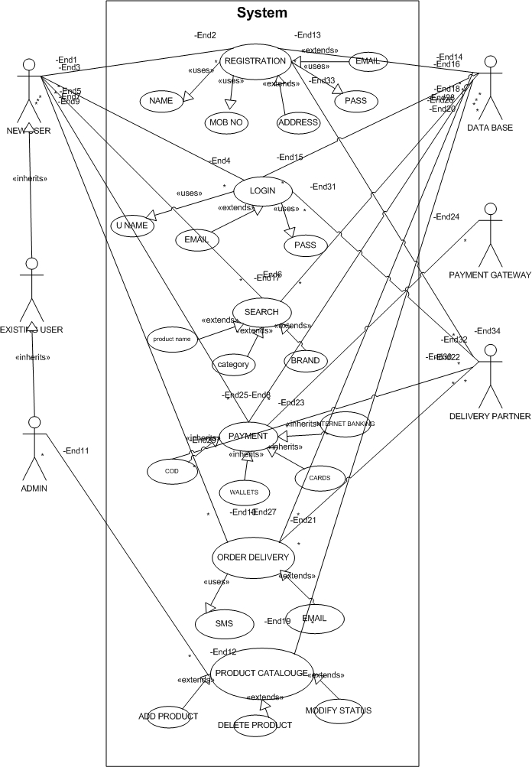
Question 11:
Prepare use case specs for all use cases
Answer:

Use Case Specification: User Registration
Use Case ID | UC001
Use Case Name | User Registration
Created by | Rinay
Date Created | July 10, 2025
Last Updated | July 10, 2025
Last Revision | July 10, 2025
Actor | Farmer, Manufacturer
Description | This use case describes how users register into the app by providing basic details like email, mobile, and password.
Pre-condition | User has internet access and has not yet registered.
Post-condition | System stores user details and redirects them to login page.
Normal Flow / Happy Path
Step 1: User opens the application
Step 2: Clicks on “Register”
Step 3: Enters email, phone, and password
Step 4: System validates data and checks for duplicates
Step 5: System creates account and redirects to login page
Step 6: System sends registration confirmation via email/SMS
Alternative Flow
- If email already exists, show "Email already registered"
- If mandatory fields are empty, show "Please fill all fields"
- If validation fails, highlight the issue (e.g., invalid email) | | Exceptions | If internet connectivity is lost, system shows “Check your internet connection” | | Frequency of Use| High | | Assumptions | User has basic digital literacy and mobile/email access |

Use Case Specification: Search Products
Use Case ID | UC002
Use Case Name | Search Products
Created by | Rinay
Date Created | July 10, 2025
Actor | Farmer
Description | Allows farmers to search fertilizers, seeds, and pesticides based on category, name, or filter.
Pre-condition | User is logged into the app
Post-condition | Relevant products are shown on the screen
Normal Flow
Step 1: User navigates to the “Search” bar
Step 2: Enters product name or selects category
Step 3: System shows matched results
Step 4: User selects a product for more info
Alternative Flow
- If no product found, show “No results found”
- If search is empty, show top recommended items | | Exceptions | If backend server is unavailable, show “Unable to fetch results” | | Frequency of Use| Very High | | Assumptions | Product catalog is already available in the system |

Use Case Specification: Add Product to Cart
Use Case ID | UC003
Use Case Name | Add Product to Cart
Actor | Farmer
Description | Users can add selected products to their cart for checkout
Pre-condition | User must be logged in
Post-condition | Product is saved to the cart
Normal Flow
Step 1: User clicks “Add to Cart” on product page
Step 2: System checks product availability
Step 3: If available, adds to cart and confirms
Alternative Flow
- If out of stock, show “Product currently unavailable”
Exceptions | If session is expired, redirect user to login
Frequency of Use | High
Assumptions | Inventory and stock info is up to date

Use Case Specification: Make a Payment
Use Case ID | UC004
Use Case Name | Make a Payment
Actor | Farmer
Description | Handles order payment through UPI, Card, COD
Pre-condition | Items in cart and delivery details are filled
Post-condition | Payment is processed successfully
Normal Flow
Step 1: User clicks “Proceed to Pay”
Step 2: Selects payment method
Step 3: Enters payment details (if applicable)
Step 4: System confirms payment and places order
Alternative Flow
- If payment fails, offer retry or alternate payment options
- If user selects COD, skip online gateway | | Exceptions | If payment gateway is down, show alert message | | Frequency of Use| Medium | | Assumptions | Payment gateway is integrated and secure |

Use Case Specification: Track Delivery
Use Case ID | UC005
Use Case Name | Track Delivery
Actor | Farmer
Description | Allows users to track the shipping status of their orders
Pre-condition | User has placed an order
Post-condition | Order status is displayed
Normal Flow
Step 1: User opens “My Orders”
Step 2: Clicks “Track Delivery”
Step 3: System fetches order status from delivery API
Step 4: Shows delivery status and estimated time
Alternative Flow
- If order is canceled, show “Order canceled”
- If not yet shipped, show “Order not yet dispatched” | | Exceptions | If tracking system is down, show fallback message | | Frequency of Use| Medium | | Assumptions | Integration with delivery partner API exists |

Question 12
Activity diagrams
Answer:
1. User Registration – Detailed Activity Diagram
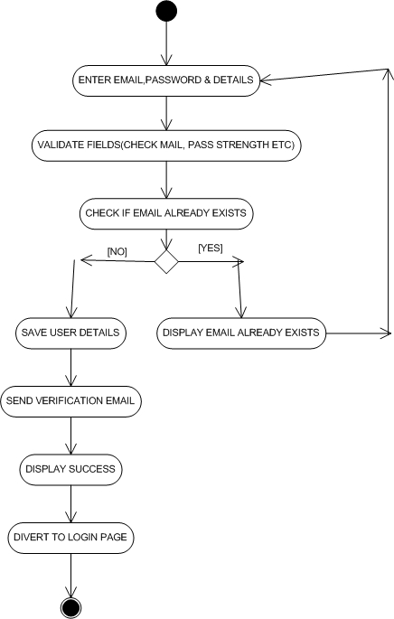

2. Search Products – Detailed Activity Diagram
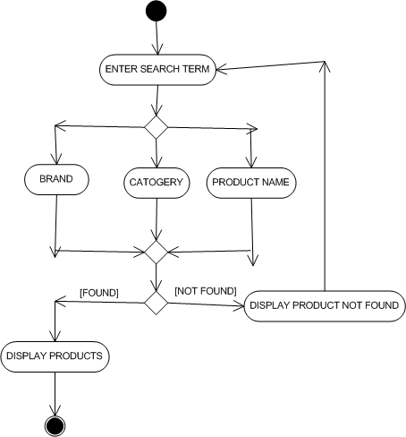

3. Add Products to Cart – Detailed Activity Diagram
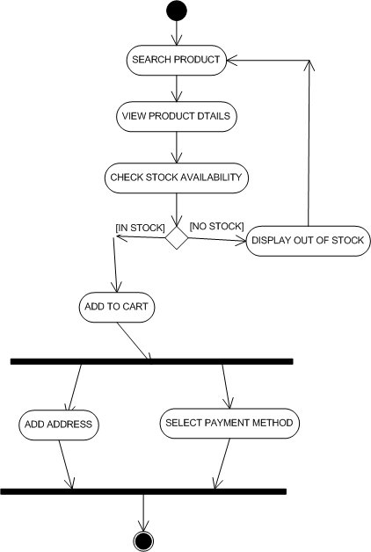

4. Making a Payment – Detailed Activity Diagram
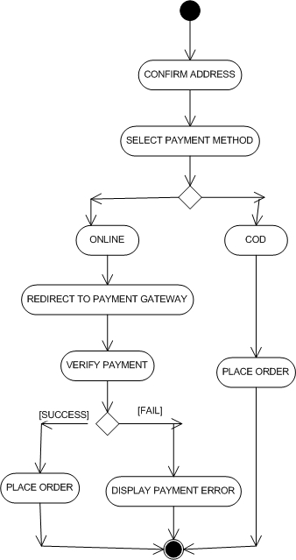
5. Delivery – Detailed Activity Diagram

