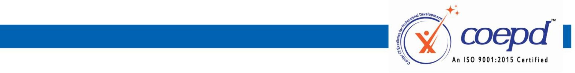

Requesting For Tools Installation

I SUDHARSAN S, enrolled for Business Analyst Training with COEPD, hereby voluntarily declare that, I completed BA Workshop sessions. I request COEPD to support me in installing the tools in my system.

I understood that,

- Tools Installation will done only one time through Coepd portal. In case of losing application from system, Coepd is not responsible for re-installation.
- Tools installation support is complementary to the training
- COEPD is not liable for any damages caused during the installation process
- These Tools are Trail Versions and works during the trial period only.
- COEPD will install the tools only in the OS supported by Microsoft, and will not be responsible for the other OS’s like MAC, Linux etc.,
- Aspirant should buy the actual license after the expiry of trail period.

Signature of the student: 
Name of the Student: SUDHARSAN S
Batch Start date: 19/07/2025
Request Date: 01/07/2025


3rd Floor, Sahiti Arcade, Beside S.R. Nagar Police Station, S.R. Nagar, Hyderabad - 500038 www.coepd.com info@coepd.com

