Document 1- Business case document template
➢ Why is this project initiated?
- Traditional learning methods are limited to physical classrooms, making it difficult for students in remote areas to access quality education.
- Teachers face challenges in tracking student performance, delivering personalized learning, and managing study materials effectively.
- Increasing demand for digital learning platforms that are flexible, user-friendly, and accessible anytime, anywhere.
- COVID-19 and post-pandemic scenarios have accelerated the adoption of e-learning solutions, creating a strong need for LMS platforms.
- Organizations and educational institutions require a centralized system to manage learning resources, training videos, assignments, and assessments.
- This project aligns with CSR objectives by empowering students, teachers, and institutions with affordable and scalable digital education tools.

➢ What are the current problems?
> Limited Access to Education: Students in remote areas lack access to quality teachers and study material.
> Inefficient Learning Methods: Traditional classroom-based teaching makes it difficult to provide personalized learning experiences.
> No Centralized Platform: Study materials, training videos, assessments, and progress tracking are scattered and unorganized.
> Communication Gaps: Lack of real-time communication between teachers, students, and parents.
> Difficulty in Monitoring Performance: Teachers struggle to evaluate students’ learning outcomes effectively.
> Lack of Flexibility: Students cannot access courses at their own pace and convenience.
> High Operational Costs: Institutions spend more on physical infrastructure, printing, and manual assessments.

➢ With this project how many problems could be solved?
- Most of the current challenges like lack of accessibility, no centralized system, poor tracking, communication gaps, and high costs will be solved.
- Around 70–80% of the existing problems in traditional learning can be eliminated with LMS adoption.
- Remaining challenges (like internet availability in rural areas) may still need external support.

➢ What are the resources required?
- People – Product Owner, Business Analyst, Project Manager, Developers, UI/UX Designers, Testers, DBA, Security Specialists, Cloud Engineers.
- Technology – Java, Python, Django, React.js, MySQL, Cassandra, AWS/Azure/Google Cloud, OAuth/JWT, Power BI, Jira.
- Budget – ₹2 Crores INR allocated for 18 months.
- Time – 18 months development + training & deployment phase.
- Others – Training, infrastructure (servers, networks), stakeholder workshops.

➢ How much organizational change is required to adopt this technology?
- Moderate organizational change is needed.
- Teachers and students must adapt to digital learning instead of traditional methods.
- Training will be required to familiarize users with the LMS portal.
- Administrative processes (manual records, paper-based assessments) will be shifted to digital format.

➢ Time frame to recover ROI?
- Expected ROI recovery: 2–3 years after deployment.
- LMS reduces costs in physical infrastructure, training materials, and manual work.
- Additional savings through scalability (more students can join without higher costs).
- Long-term benefit: Increased student performance, institutional efficiency, and CSR value.

➢ How to identify Stakeholders?
Stakeholders can be identified by:
- Analyzing Impact – Who will benefit or be affected (Students, Teachers, Institutions).
- Decision-making Power – Who makes key decisions (Management, Product Owner, Sponsors).
- Involvement in Development – Internal team (BA, PM, Developers, Testers, Cloud Engineers).
- CSR Committee – Mr. Henry (Sponsor), Mr. Pandu (Finance Head), Mr. Dooku (Project Coordinator).
- External Users – End-users like students, parents, and educators.

2 . Business Analyst Strategy Document
BA Approach Strategy
1. Requirement Elicitation Techniques
To gather requirements effectively, I will use:
- Brainstorming: With teachers, students, and admins to identify needs.
- Interviews: One-on-one sessions with stakeholders to capture detailed requirements.
- Workshops (JAD sessions): Collaborative requirement sessions with the committee and IT team.
- Use Case & User Story Mapping: To define functional and non-functional requirements.
- Surveys/Questionnaires: To gather inputs from larger groups (students/teachers).

2. Stakeholder Analysis
- Identify Stakeholders: Sponsor (Mr. Henry), Committee Members (Mr. Pandu, Mr. Dooku), Delivery Team (APT IT Solutions), End-Users (Students, Teachers, Admins).
- Stakeholder Mapping (RACI Matrix):
  - R (Responsible): Developers, QA, UI/UX designers.
  - A (Accountable): Project Manager, Product Owner.
  - C (Consulted): BA, Testers, Security Specialists, Cloud Engineers.
  - I (Informed): Students, Teachers, Sponsors, CSR Committee.
- ILS (Interest, Level, Support): Categorize stakeholders based on their influence and support to manage expectations.

3. Documents to Prepare
- Business Requirement Document (BRD) – High-level requirements from stakeholders.
- Functional Requirement Specification (FRS) / System Requirement Specification (SRS) – Detailed functional and technical requirements.
- Use Cases / User Stories – For developers and testers.
- Change Request Document (CRD) – To track scope or requirement changes.
- Status Reports – Weekly/bi-weekly project updates.
- UAT Plan & UAT Sign-off Form – For end-user testing and acceptance.

4. Document Sign-off Process
- Share draft documents with stakeholders.
- Conduct review sessions for clarifications.
- Apply corrections based on feedback.
- Obtain formal sign-off from Product Owner, Sponsor, or Steering Committee.

5. Approvals from Client
- Present documents and project updates in review meetings.
- Use formal sign-off forms or email confirmations.
- Approvals logged in project repository (Jira/Confluence/SharePoint).

6. Communication Channels
- Formal Channels: Email, weekly status reports, review meetings.
- Collaboration Tools: Jira, MS Teams, Confluence for real-time updates.
- Workshops & Demos: Regular sprint demos (if Agile) or milestone reviews (if Waterfall).
- Stakeholder Updates: Weekly/bi-weekly reporting to sponsors and committee.

7. Handling Change Requests
- Maintain a Change Request Register.
- Evaluate change impact on time, cost, scope.
- Discuss with Project Manager & Product Owner for approval.
- Update BRD/SRS documents accordingly.
- Re-baseline project plan if needed.

8. Progress Tracking & Updates
- Maintain project dashboards (Power BI, Jira burndown charts).
- Weekly progress reports shared with committee.
- Highlight risks, dependencies, and blockers early.
- Monthly steering committee meetings for high-level updates.

9. UAT & Project Acceptance
- Conduct User Acceptance Testing (UAT) with students, teachers, and admins.
- Collect feedback and document issues in UAT log.
- Fix reported defects before go-live.
- Prepare UAT Sign-off Form and obtain client acceptance.
- Final handover and closure report submitted to client.

Document 3- Functional Specifications
Field | Details
Project Name | Learning Management System (LMS)
Customer Name | CSR Committee (on behalf of Students & Teachers)
Project Version | V1.0
Project Sponsor | Mr. Henry (CSR Sponsor)
Project Manager | APT IT Solutions – Project Manager
Project Initiation Date | 01-Aug-25

Functional Requirement specifications:

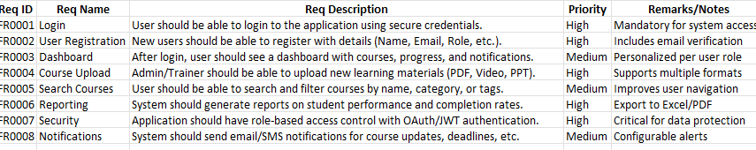
Document 4- Requirement Traceability Matrix
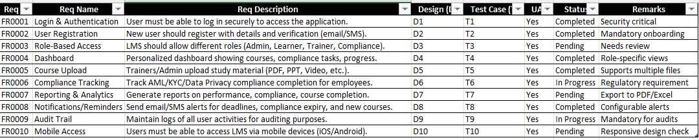

5.Business Requirement Document (BRD)

1. Document Revisions

Date | Version Number | Document Changes | Author
05/02/20XX | 0.1 | Initial Draft | Business Analyst
12/02/20XX | 0.2 | Updated requirements section | Business Analyst
20/02/20XX | 0.3 | Added design specifications | Solution Architect
05/03/20XX | 0.4 | Incorporated stakeholder feedback | Project Manager
15/03/20XX | 1 | Final Version – Approved | Sponsor / Client

2. Approvals
Role | Name | Title | Signature | Date
Project Sponsor | Mr. Henry | CSR Initiative Head
Business Owner | Mr. Pandu | Financial Head
Project Manager | Mr. Vandanam | Project Manager
System Architect | Ms. Juhi | Senior Java Developer
Development Lead | Mr. Teyson | Java Lead Developer
User Experience Lead | Ms. Lucie | UI/UX Designer
Quality Lead | Ms. Alekya | QA Lead
Content Lead | Mr. Kevin / Ben | Domain Expert (Farming/Learning Content)

3. RACI Chart for This Document The RACI chart identifies the persons who need to be contacted whenever changes are made to this document. RACI stands for responsible, accountable, consulted, and informed. These are the main codes that appear in a RACI chart, used here to describe the roles played by team members and stakeholders in the production of the BRD. They are adapted from charts used to assign roles and responsibilities during a project.( RACI Can be made for IT side[Project stakeholder] as mentioned above, apart from that Can also Be made for Client side[Business Stakeholder]). The following describes the full list of codes used in the table:

Codes Used in RACI Chart * Authorize document. R A S Responsible Accountable Supports document C I Consulted Informed RACI Chart Name Has ultimate signing authority for any changes to the Responsible for creating this document. Accountable for accuracy (for example, the project manager) of this document Provides supporting services in the production of this Provides input (such as an interviewee). Must be informed of any changes.

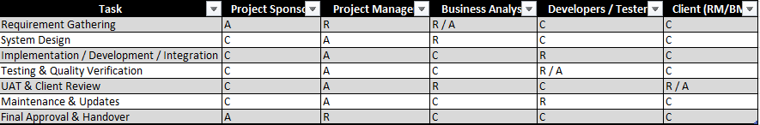

4. Introduction
4.1. Business Goals
The primary goals of the organization are to:
- Enhance digital presence by providing seamless IT solutions.
- Improve customer experience through mobile applications and online services.
- Streamline organizational operations with automated systems.
- Support e-learning and HR operations with user-friendly platforms.
Need:
There is a business need to modernize current operations and provide a unified IT solution for mobile, e-learning, and HR management to increase efficiency, scalability, and user satisfaction.

4.2. Business Objectives
The key business objectives are to provide an IT solution for:
- Mobile Applications for both Android and iOS platforms.
- E-Learning Management System (LMS) for training, learning content delivery, and progress tracking.
- HR Management System (HRMS) to streamline employee management, payroll, and administrative functions.

4.3. Business Rules
The solution will follow these organizational policies and rules:
- Data privacy and security policies in compliance with industry standards (e.g., GDPR/ISO27001).
- User access rights and role-based authentication.
- Content approval workflows before publishing training material.
- HR policies related to employee records and payroll confidentiality.
- Adherence to mobile app store regulations (Google Play / Apple App Store).

4.4. Background
The project was initiated to address the following business challenges:
- Lack of a unified platform for learning, HR management, and mobile accessibility.
- Manual processes leading to inefficiencies and errors.
- Increased demand from users/employees for mobile-first solutions.
- Need for a scalable solution that supports future organizational growth.
Expected Benefits:
- Reduced operational costs through automation.
- Improved employee productivity and learning engagement.
- Enhanced decision-making through real-time analytics and reports.
- Stronger customer and employee satisfaction.

4.5. Project Objective
The main objective of this project is to develop an integrated IT solution that:
- Provides user-friendly mobile applications for Android and iOS.
- Delivers an efficient E-Learning Management System to support training and skill development.
- Implements an HRMS for efficient employee lifecycle management.
- Ensures seamless integration with existing systems and compliance with business objectives.

4.6. Project Scope
4.6.1. In-Scope Functionality
The current project will include:
- Development of Android and iOS mobile applications.
- Design and deployment of an LMS (courses, progress tracking, reporting).
- Implementation of HRMS (employee database, payroll, leave management).
- Role-based access control for different user types.
- Integration with organizational email and notification systems.
4.6.2. Out-of-Scope Functionality
The following functionalities are not included in this project:
- Integration with third-party financial/banking systems.
- Advanced AI-based learning personalization (future phase).
- Hardware procurement (devices/servers not part of scope).
- Multi-language support (only English is included in this phase).

  - .Assumptions [List all assumptions requirements are based on]
The following assumptions have been made while defining the requirements for this project:
- Stakeholders will be available for timely requirement gathering and feedback sessions.
- End users will have access to compatible devices (Android/iOS smartphones, laptops, desktops) to use the mobile apps, LMS, and HRMS.
- Internet connectivity will be available to all users for accessing the portal and mobile applications.
- The organization’s existing IT infrastructure (servers, databases, email systems) is sufficient and compatible for integration.
- Security, compliance, and data privacy policies will remain consistent throughout the project timeline.
- Third-party services (e.g., app stores, email servers) will be available and functioning as expected.
- Any scope changes will follow the formal change request process.
- The project budget and timelines will remain approved and stable during execution.
- Training and onboarding of users will be supported by the client/organization.
- Only English language support is required in the current phase (multi-language support is out of scope).

- Constraints [List all Constraints]
The following constraints have been identified for this project:
- Time Constraint – The project must be completed within the agreed timeline as per the project plan.
- Budget Constraint – The project must remain within the approved budget, without additional unapproved costs.
- Technology Constraint –
  - Mobile applications must be developed only for Android and iOS platforms.
  - Only the defined LMS and HRMS technologies can be used; no new tools outside approved stack.
- Scope Constraint –
  - Advanced AI-based personalization is not included in this phase.
  - Multi-language support is not included (English only).
- Regulatory / Compliance Constraint –
  - Must comply with data protection standards (e.g., GDPR, ISO27001).
  - Must comply with app store (Google Play/Apple App Store) submission guidelines.
- Resource Constraint – Limited availability of key resources (SMEs, developers, testers) may restrict parallel development.
- Integration Constraint – Integration is limited to existing organizational systems (e.g., email, HR database); no third-party banking/financial systems will be integrated.
- Hardware Constraint – Procurement of new devices/servers is not part of the current project phase.

7. Risks
The following potential risks have been identified for this project:
- Scope Creep Risk – Uncontrolled changes or additions to project scope may affect timeline and budget.
- Technology Risk – Issues with compatibility, performance, or unexpected technical limitations in LMS, HRMS, or mobile applications.
- Resource Risk – Limited availability of skilled resources (developers, testers, SMEs) may delay deliverables.
- Stakeholder Risk – Lack of timely feedback or approvals from stakeholders could cause delays.
- Integration Risk – Difficulties in integrating the new systems with existing infrastructure (e.g., email, HR database).
- Compliance Risk – Failure to comply with data privacy/security regulations (GDPR, ISO27001) or app store requirements.
- Adoption Risk – End users may resist adoption of the new systems due to lack of training or comfort with technology.
- Timeline Risk – Project delays due to unforeseen dependencies or extended testing cycles.
- Operational Risk – System downtime, server issues, or internet outages impacting accessibility.
- Financial Risk – Budget overruns if additional resources or changes are required outside the approved scope.

8.Business Process Overview [This describes the overall process flow from each phase]
Business Process Overview
The overall business process for this project is designed to streamline organizational operations and enhance user experience across mobile applications, e-learning, and HR management. The process flow covers the following phases:
1. Preparation Phase
- Identify business needs and requirements.
- Define scope, objectives, and success criteria.
- Allocate resources and finalize project plan.
2. Development Phase
- Design and develop mobile applications (Android & iOS).
- Configure and customize the E-Learning Management System (LMS).
- Implement the HR Management System (HRMS).
- Ensure role-based access and integration with existing systems.
3. Testing & Revision Phase
- Conduct functional, integration, and user acceptance testing (UAT).
- Identify bugs, gaps, or process inefficiencies.
- Revise and refine the solution based on stakeholder feedback.
4. Deployment Phase
- Deploy mobile apps to app stores (Google Play, Apple App Store).
- Roll out LMS and HRMS to employees and end users.
- Set up user accounts, roles, and permissions.
5. Training & Learning Phase
- Provide user training through tutorials, workshops, and online learning content.
- Deliver training videos, documentation, and FAQs to support adoption.
- Establish helpdesk support for queries and issues.
6. Nurturing & Continuous Improvement Phase
- Monitor system performance and user feedback.
- Collect data for analytics and reporting.
- Implement updates, patches, and feature enhancements.
- Ensure compliance with evolving policies and regulations.

8.Business Process Overview
8.1. Legacy System (AS-IS / Current State)
Brief Explanation (Current State):
- The current system is a legacy platform with limited features.
- After login, users enter CRN and search details.
- The process does not provide any alerts or advanced notifications.
- The flow ends by directly showing the result.
- Lacks structured guidance (like preparation, learning, or nurturing).
- Challenges: Inefficient, no risk alerts, minimal user engagement.
8.2. Proposed Recommendations (TO-BE / Future State with CRMnext)

future state system will be enabled with CRMnext to provide a structured and guided user experience.
After login, users will move through well-defined phases: Preparation → Revision → Learning → Training Videos → Capstone Project → Nurturing Process.
At each phase, users receive alerts, guidance, and resources to improve productivity and skill development.
The nurturing process ensures continuous improvement beyond the training.
The final result will be Skill Development, Certification, and Project Readiness, supported by CRMnext’s intelligent workflows.
Benefits: Enhanced user engagement, structured learning, efficiency, and real-time tracking.

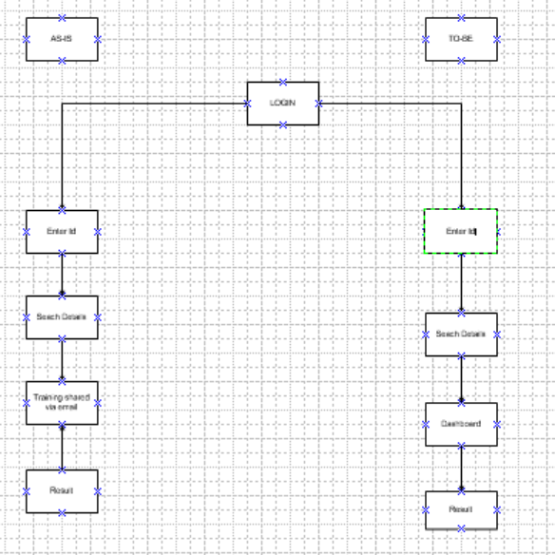

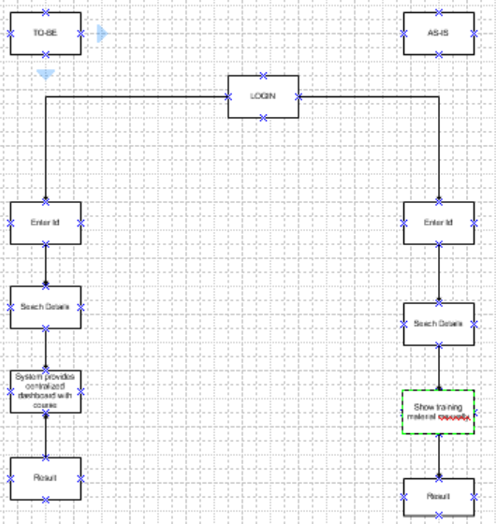

9. Business Requirements
ID | Requirement | Priority | Notes
BR01 | User-friendly portal with secure login and role-based access | High | Ensures data privacy and accessibility for students, trainers, and admins
BR02 | Preparation & Revision modules | High | Helps users strengthen concepts and track progress
BR03 | Learning content with interactive study material | High | Provides structured e-learning experience
BR04 | Training videos & recorded sessions | High | Supports flexible and on-demand learning
BR05 | Capstone Project submission & evaluation system | Medium | Encourages practical knowledge and real-world problem solving
BR06 | Nurturing process (continuous mentoring, feedback, support) | Medium | Ensures long-term skill development
BR07 | Automated notifications & alerts (reminders, deadlines, updates) | High | Keeps users engaged and informed in real-time
BR08 | Progress dashboards for learners and instructors | High | Allows monitoring of performance and learning outcomes
BR09 | Compliance with academic / institutional guidelines | Medium | Ensures that all processes follow required policies and standards

10. Appendices
10.1. List of Acronyms
- BA – Business Analyst
- BRD – Business Requirement Document
- CRM – Customer Relationship Management
- LMS – Learning Management System
- KYC – Know Your Customer
10.2. Glossary of Terms
- AS-IS: Current state of the process/system
- TO-BE: Future improved state of the process/system
- Capstone Project: Final project to apply learning into practice
- Nurturing Process: Continuous mentoring and guidance for learners
10.3. Related Documents
- Project Charter
- Business Requirement Document (BRD)
- Use Case Documentation
- Process Flow Diagrams

