1Q. Use case diagram:
A use case is a high level diagram. The main purpose of the diagram is to identify the requirement. a use case diagram is an actor specific. A use case diagrams are designed to explain how an external user are interacting with the system.
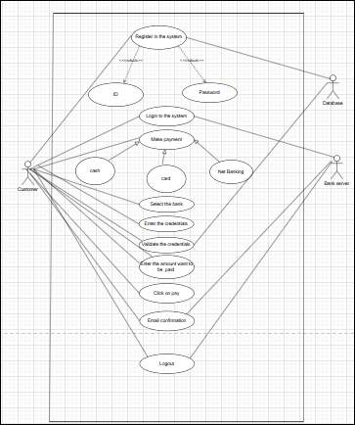

2Q.
Boundary classes:

Boundary class that acts as an interface between a system and its external environment such as, uses other systems or devices it handles interactions like uses input output display and managing communications with external entities actives as a gateway for system internal logics.

- The following are the feature of the boundary class;

1 This class is more easy to be changed then the entity or control class.

2 The attribute of this class and screen layout are defined at the basic design.
`
3 In class diagram, there are cases that the stereotype (boundary) is added.

4 in a class diagram, there are cases that is shown by following icon.



Controller class:

The controller class acts as an intermediately, handling user input, interacting with the model (data) and updating the view (user interface accordingly)

In a simple way, whenever the user sends a request for the something then it always go through the controller.

The followings are the feature of the control class.

1 This is a class to achieves use case in the use case diagram.
2 In a class diagram, there are cases that is shown
By the following icon.



Entity class:

The entity class is a class that has data.

The class that is offend is used to model business data in data base or object module serving as a blue print for individual instances of those entity’s.

The following are the features of entity class:

1 This is class is to related to DOA (data oriented approach).

2 In the class diagram, there are classes that the stereotype(entity) is added.

3 In a class diagram entity class is shown as below



3Q 3 TIER ARCHITECTURE

Application Layer:

Payment option boundary
Card payment boundary
Wallet payment boundary
Cash payment boundary
Net banking payment boundary

Business Logic layer:

Payment initiated controller
Card payment controller
Wallet payment controller
Cash payment controller
Net banking payment controller

Data layer:

Customer
Payment
Card
Wallet
Server

4Q
Domain modelling:

Domain model is also known as conceptual modelling. A conceptual model depicts the concepts (idea, thing, or object) that are easy identifiable in the problem description.
Domain model is a conceptual representation that defines the structure, relationships, and behavior of entities with in specific problem domain.
Customer |  |  |  |  |  |  |  | Bank
Customer ID | customer name | contact details | address | account number |  |  | bank name | Location | branch code
 | Payment |  |  |  |  |  |  | Account
payment ID | account | payment date | status |  |  |  | account number | account type | balance | account holder name
 |  | Net Banking Services |  |  |  |  |  | Authentication
 | authentication | funds transfer | transaction list | account management |  |  | User name | password | OTP
 |  |  |  | Transaction
 |  | Transaction ID | Recipient details | amount | under stamp

5Q. Sequence diagram:
A sequence diagram is type of interaction diagram used in software engineering and system design to illustrate how processes operates with one another and in what order.

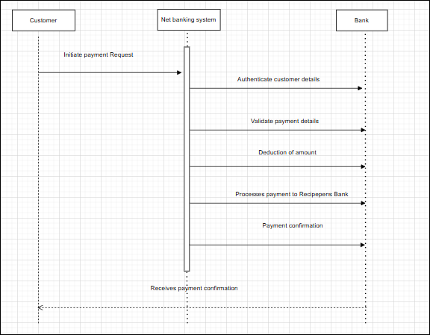

6Q. Conceptual model

Conceptual model for the payment process done by a customer using a net banking provides a high-level understanding of the key concepts of a relationships involved in the payment transaction. It helps in visualizing the overall structure and flow of the payment process.
A conceptual model is the high level representation of a system that helps in understanding, visualizing and communicating the essential aspects of a domain.
It provides a clear and simplified view of the domain, making it easier to understand.
The key concepts of conceptual; model are:
Entities – customer, product, order and payment.
Attributes – customer id, name, email, phone number.
Relationship – ex: customer placing an order.

7Q
MVC (Model-View-Controller):
To identify classes from use case diagram, we apply MVC rules on each use case to derive classes.

1 MODEL:

The model class knowns about all the data that need to be displayed. It is model who is aware about all the operations that can be applied to transform that class. It represents the data of an application. the model represents enterprise data and the business rule that govern access to and updates of this data. This represents database (table in DB) all model classes are represents as Entity Classes.

Entity class, data base classes, persistent class (back end designers)

2 VIEW:

The view represents the presentation of the application. The view class refers to the model. Its uses the query methods of the model of type obtain the contents and renders it. The view is not dependent on the application logic.it remains same if there any modification in the business logic. View class is the data required by query. view class is represented as boundary class or from class.

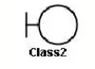Boundary class or form class.

Actor speak to system and vice versa through boundary

Authentic information between boundary and entity class

3 CONTROLLER:

Whenever the user sends a request for something then it always go through the controller. The controller is responsible for intercepting the request from view and passes it to the model for the appropriate action. After the action has been taken on the data, the controller is responsible for directing appropriate view to the user. GUI’s the views of the controllers often work very closely together.

Controller class or transient class (given to front end designers)
Controller class is working based on the user’s command. / understand the command request given by user through boundary / form class.

MVC Architecture:

1 combination of one actor and use case results in one boundary class
2 combinations of two actors and a use case results in two bindery classes.
3 combinations of three actors and use case results in three boundary classes and so on.
Note. Only one primary actor is to be considered with a use case.
4 Use case will result in a controller class.
5 each actor will result in one entity class.

8Q. BA contributions in project:

Stages in water fall model:
- Requirement gathering analysis:
This is the initial stage of the project where is an involvement of the BA. BA is responsible for preparing BRD document (Business requirement document)
- Designing:
In this phase the architect will start designing the system based on the business analyst inputs and requirement documents. The BA helps him to clear the doubts about the requirements.
- Coding:
This page is quite lengthy as the core development starts in this phase. Developer start product development based on the requirement document prepared by the BA developer may ask question to BA regarding the requirement and he needs to answer the question as and when required.
- Testing:
After coding, the testing will start, in this phase BA helps the testing learn to understand the requirements so that they will build proper functional test cases.BA has to review whether the test cases covering the whole functionality.
- Deployment:
Once the code is developed and tested, it is ready to deploy in the production environment. The BA will verify the product is delivered as per the requirements and it is meeting the business needs.
- Maintenance:
Once the implementation is done the team has to give support by installing patches, handling change requests, etc.
A BA is the person who knows every nook and corner of the project.so every change request has to reviewed by him and based on his inputs and reports the team will respond.

Stages | Activities | Artefacts and Recourses
pre project | Enterprise Analysis - SWOT analysis, GAP analysis, market research, feasibility study, root cause e analysis, decision analysis, strategy analysis enterprise architectural frameworks, project scope and business case writing risk analysis, | Business case SOW(statement of work)pop (purchase order) sr BA, business architects presales consultants.
Planning & estimations& Assessment Flash card - 2 Flash card-45 Project kick off ( Big picture plan) | 1 understand assumptions and constraints along with Business rules and business goals 2 plan package for big projects 3 understand the project plan from PM 4 BA conducts stake holder analysis 5 plan BA approach strategy ( req, gathering techniques, communication req,mgnmt documents to follow ,tools, to use ,change request handling methodology)for this project | PM sr.BA
Requirements gathering Flash- 39 | 1 stake holders identify and documents 2 client gives BRD or BA prepared BRD by interacting with client - brainstorming document analysis, revers engendering, interviews, workshops, focus groups, observations, questionnaires. 3 prototyping cans be used by BA to make the client give more specific requirements 4 sort the gathering requirements (avoiding duplicate reqs, grouping into similar functionality or into modules) 5 prioritize requirements - Moscow 6 validate Requirements. | BA PM
Requirement analysis FLASH card - 40 | 1 Draw UML diagrams(use case and activity diagram) 2 prepare functional requirements from business requirements 3 All Architects comes up with technical requirements (SSD) 4 SRS will have functional requirements and technical requirements 5 takes signoff on SRS from client SRS is the first legal binding Doc between the business and the technical team 6 BA prepared RTM from SRS before Design phase starts. (B A is the owner of RTM) 7 BA traces how requirements are deal in each phase of development life cycle from design till UAT | Functional requirements specification SSD (supplementary support document) SRS( software requirement specification) RTM ( Requirement traceability matrix) BA PM solution Architect DB- Architect NW- Architect
Design Flash card - 41 | 1 From use case diagram , test manager or B A will prepare test case 2 communicates with client on the design and solution documents ( updates status to client and make them understand how the solution would look like prepare them to drive UAT) 3 BA will initiate the preparation of end user manuals 4 updates RTM 5 from use case diagram solution architect recommends architectures of the IT solution 6 DB architect use persistence classes (Entity classes) and comes up with ER diagrams or DB schema 7 GUI designer will look into transient classes and designs all possible screens for the b IT solutions | Solution Document design document - HDD- ADD BA PM Solution - Architect DB- Architect NW- Architect GUI- Designer Test manager
Coding Flash card - 42 | 1 BA Organize JAD Sessions 2 BA clarifies queries of Technical team during coding 3 Developers refer Diagrams and transient (controller classes) of BA code their unit 4 Update end user manuals 5 Update RTM 6 Conducts regular status meetings with technical team and the client tuning client for participation in UAT | LDD - CDD Application Development Team BA PM
Testing Flash card - 43 | 1 BA prepares test case from use cases or assists test manager to do so 2 BA performs high level testing 3 BA Prepares client for UAT 4 Test data is required by BA from client 5 Update end user manuals 6 updates RTM 7 Take signoff from client on client project Acceptance from | Test concerning Documents Application with less errors Testing team BA PM Client
Development and implementation Flash card - 44 | 1 Forward RTM to client or the PM which should be attached to the project closure document 2 coordinates to complete and share END user manuals 3 plans and organize training sessions for end users 4 prepares lesions learned from the project ( to take precautions for coming projects) | -----------------------------------

9Q.
Conflict management:
Conflict management refers to the process of handling and resolving conflicts or disagreements that arise between individuals or groups within an organization.
The Thomas – killmann conflict more instrument (TKI) is a widely used technique for understanding and managing conflict.
The Thomas-killmann technique helps individual understand their preferred handling conflict handling styles and provides insights into whwn each mode might be appropriate.
Effective conflict management involves recognizing the existence of conflict, actively listening to the concerns of all party’s involving, seeking common ground, and working towards collaborative solutions that meets the need of everyone.
5 steps of conflict management:
1 Identify the conflict
2 Discuss the details
3 Agree with the root problem
4 Check for every possible solution for the conflict
5 negotiate the solution to avoid future conflict

In the Thomas kilmann conflict mode instrument(TKI), conflict management styles are plotted on a graph with two axes. X-axis(cooperativeness) and y- axis(Assertiveness). The model uses these axes to describe five conflict management styles: avoiding, competing, accommodating, compromising, and collaborating.

X-axis(Cooperativeness):
- Represents the degree to which someone is willing to meet the needs or concerns of another party
- High cooperativeness indicates a strong willingness to satisfy the other party’s needs.
- * Low cooperativeness: suggest a reluctance to prioritize the other party’s needs.
Y-axis(Assertiveness):
- Represents the degree which someone willing to assert their own needs or concern
- High assertiveness indicates a strong willingness to push for one own needs.
- Low assertiveness suggests a reluctance to prioritize one’s own needs.

The Five Conflict Management styles:

Avoiding:
Low assertiveness and low cooperativeness (sidestepping or ignoring the conflict)

Competing:
High assertiveness, low cooperativeness (satisfying one’s own concern at the expenses of the other party)

Accommodating:
Low assertiveness, high cooperativeness (prioritizing the other party needs).

Compromising:
Moderate assertiveness and moderate cooperativeness (find a middle ground)

Collaborating: High assertiveness and high cooperativeness (working together find a solution the satisfied both parties).

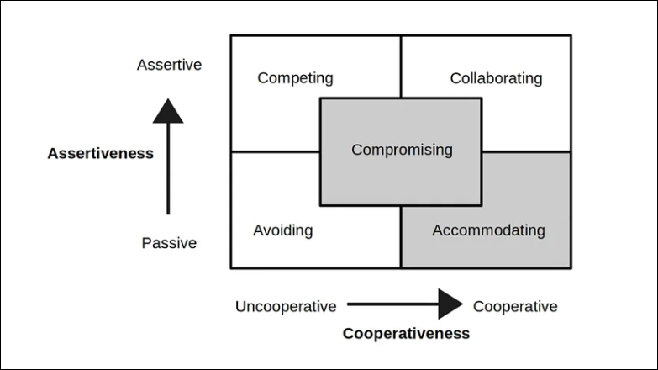

10Q Reasons for project failure:

1 Improper requirements gathering:
Improper requirements gathering can lead to project failure, delayed timelines and increased costs.

2 continuous change in requirements:
Continuous changes in requirements mean that the needs and specifications for a project, product, or process are evolving and not fixed.

3 lack of user involvements:
Lack of user involvement in projects can lead to failures because it results in a lack of commitment from users, potential hostility towards the final product.

4 Lack of educative support:
A lack of education support refers to situations where there is insufficient funding, resources, or systemic assistance to ensure effective and equitable education for all students, regardless of their background or location.

5 Unrealistic exceptions: It's a situation where the expectation doesn't align with reality.

6 Improper planning: Improper or poor planning can lead to a variety of negative consequences, including wasted time, resources, and effort, as well as increased risks and potential project failure.

11Q. Challenges faced by BA in a project:
A business analyst works along with technical team and acts as a liaison between stakeholders of client and the technical Team. He is the face of the technical team to the client and all client communication will happen through a business analyst. The business analyst understands business problems and opportunities in the context of the requirements and recommends of the solutions that enable the organization to achieve its goals.
Challenges faced in projects for BA:
1.Unclear or changing requirements:
Business stakeholders frequently request revision for requirements even after they have been finalized and approved. As experienced by business analyst
Its might happen more once. Even for the react requirement making its one o0f the most frequent issues these adjustments could have on impact on the business analyst effort as well as the total project effort, cost, schedule.
Possible solution: A change in the implementation cycle might impact the delivery process even if their approaches that like agile, accept change. Business analysts and other essential stakeholders must therefore determine how the difference may be implemented in the best way.
2.Managing stakeholder Expectations:
One of the essential success criteria for every project is stakeholder involvement
Stake holder’s lack of cooperation:
Occasionally, you may encounter one more stakeholders who are unwilling to cooperate it could cause delays sign off problems, and even approval.
Possible solution:
May record the requirement discussions, particularly significant decision made. and distributes then to all stakeholders to the meeting minutes, before the schedule requirements session. They may ask everyone who wasn’t t present to review the points. this will reduce like hood miscommunication and reopening requirements items that have already been closed
4.Scope creep:
If any project cannot be completed within budget and time constraints, we say the scope creeps.
Possible solutions:
Establish a detailed scope document that outline project goals deliverables and constraint from the outset
Develop a formal system for managing changes including change requests impact assessments and approvals
Maintain open communication with stakeholders to ensure everyone understand the project scope and proposed changes.
5.Time and resource constraints:
Time resources constraints present significant challenges for business analyst (BA). Often leading to unrealistic deadlines, limited scope, and difficulty in managing multiple projects.
a. Time constraints:
Unrealistic deadlines:
BA frequently work under tight deadlines, which can lead to rushed analysis and potentially lower quality deliverables
Insufficient time can hinder through data analysis and impact the development of robust solutions.
b. Resource constraints:
Budget limitations:
Budget constraints can impact the tools and resources available for analysis for potentially hindering the quality and scope of work.
Lack of skilled personnel:
Insufficient or specialized can limit the scope of analysis and affect the quality of deliverables.
6.Quality Assurance and testing:
Quality assurance (QA) and testing face numerous challenges, particularly when business analyst (BA) are involved.

- Inadequate information on user stories:
Missing details in user stories can lead to incomplete test coverage.

- Lack of communication and collaboration:
Poor communication between QA, BAs, and developers can lead to misunderstanding and delays.

- Collaboration with QA on Test plan development:
Bas can work with QA to identify key functionalities, potentials risks. And prioritize testing efforts.

7.Documentation and knowledge management:
Effective documentation and knowledge management are crucial for organization to retain expertise, enhance collaboration and drive innovation.
The purpose and scope of document to ensure relevance and focus.
Use standardized templates and formats for consistency and ease of use.
- Knowledge management:
Identify capture and document knowledge from experts and stakeholders
Use taxonomies, tags, and catagerious to facilitate search and retrieval.

8.Technology constraints and complexity:

Technology constraints and complexity can impact projects and organization in various ways.

Existing technical issues or outdated systems that hinder progress.
Integration challenges with existing system, platforms or tools.

- Complexity:
Intricate system with many interconnected components.
Combining multiple systems, platforms, or tools.

12Q Document naming standards:

All documents will be named using some standards

Like [project ID] [Document Type] V[X]D[Y]. ext

EX: PROJ123-BRDREQ-1.0-2025-05-07.DOC

13Q DOS and don’ts as Business analyst:

Never say NO to client
There is NO word called as ‘’BY DEFAULT’’
Never imagine anything in terms of GUI (Graphical User Interface)
Question the existence of existence /question everything in the world
Ex: what client gives is not always correct
Consult an SME for clarification in requirements
Every problem of client is unique. No two problems of different client are same. May be the approach, technology, place of use, local laws may be varied to make (problems) to be different
Go to client with a plain mind with no assumption. Listen carefully and completely until client is done and then you can ask your queries. Please do not interrupt the client, when he/she is giving you the problem. Maximum try to extract the leads to solution from the client itself. Never try to give solutions to client straight away with your previous experience and assumptions. Try to concentrate on the important and truly required requirements. don’t be washed away by add on functionalities or don’t imagine solutions on screen basis.

14Q difference between packages and sub systems:

- Packages:

In Business Analysis (BA)packages and subsystem refers to organizing and structuring requirements and components of a system.
Packages group related requirements, use cases, or components.

Helps manage complex system by breaking them down into smaller, more manageable pieces.
Packages collection of components which bare not reusable in nature.

Ex: Application development companies work on packages.

- Subsystems

Subsystems are smaller systems that work together to from a larger system

Each subsystem typically has its own functionality and may interact with other subsystem.

Subsystems is collection of components which are reusable in nature.

Ex: Product development companies work on sub systems.

Q15 Camel-casing:

Camel casing is a naming convention used in computer programming and characterize by removing spaces between words and capitalizing the first letter of each word except for the first word. The name ‘’camel casing ‘’ is derived from the appearance of the resulting string, which resembles the humps of camel.
By using camel casing, developers can create meaningful and ridable names that are easier to understand and follow coding standards.it promotes consistency within the codebase and improves collaboration among team members.

Q16 Illustrate Development:
Development server refers to a dedicated environment or server that is used to during the software development process.

It provides a platform for developers and testers to build, test, and debug application before they are deployed to a production environment. The development server typically replicates the target production environment to ensure compatibility and accurate testing.

Read-only Access
Collaborative Access
Limited configuration Access

Q17 Data mapping:

Data mapping is the processes of connecting data from one source to another. It’s like creating a guide or map that shows how data in one place corresponded to data in another place. This especially Important when you are moving data between different systems or database to ensure that the data stays consistent accurate.

Data mapping is the process of establishing a relationship or connection between data elements in two or more different data sources or data formats. It corresponds to or transformation into data in another source .data mapping is commonly used in data integration, data migration, and data transformation processes.
The purpose of data mapping is to ensure that data can be accurately and effectively transferred, converted, or transformed between different systems, database, or formats. It involves identifying the source data elements, determine their meaning and structure, and mapping them to corresponding target data elements.

18Q API integration
API integration in the case of application Data format is DD-MM-YYYY.
An API, or Application programming interface, is a set of rules and tools that allows different software application to communicate with each other.
It defines the methods and data formats that applications can use to request and exchange information.
An API (Application programming interface) is set of rules and protocols that allows different software application to communicate and interface will each other.
Establish API Communication: set up API communication between your application other application to exchange data.

- Data formatting: when sending date data from your application to the other application, convert the date from the dd-mm-yyyy format to the mm-dd-yyyy format. This can be achieved by extracting the day, month and year components from the date and rearranging them according to the target format.

- Date parsing: When receiving date data from the other application, parse the mm-dd-yyyy formatted date into your application, dd-mm-yyyy format. Again you will need to extract the day, month and year components and rearrange them accordingly.

- Data validation: Perform data validation and ensure that the converted data remains valid after the format conversation. Check for edge cases, such as invalid dates or date ranges that might be affected by the format conversion. And handle them appropriately.

