Document 6- Please prepare a use case diagram, activity diagram and a use case specification document
Use Case Name | Description | Actors | Basic Flow | Alternate Flow | Exceptional Flows
Automated Reminders | System sends reminders to employees for pending timesheet submissions. | Primary: System Scheduler  Secondary: Employee | Identify pending → Fetch emails → Send reminder | Reminder sent via in-app notification | Email server failure → retry or log error
Escalation Notifications | Notify reporting manager when employee fails to submit timesheet after reminders. | Primary: System  Secondary: Manager | Check reminder status → Identify escalations → Notify manager | Escalation sent to alternate contact | Incorrect manager mapping → log for admin correction
Manager Dashboard | Manager views timesheet status of team in real-time. | Primary: Manager | Login → Access dashboard → View submission stats | Filter by date/team/member | Dashboard not loading → show maintenance message
Role-Based Access | Users can only access features assigned to their roles. | Primary: Admin  Secondary: All Users | Login → Verify role → Grant relevant access | Temporary elevated access by Admin | Unauthorized access → redirect or deny access
Timesheet Data Export | Managers/HR can export timesheet data in preferred format. | Primary: Manager, HR | Select period → Choose format → Generate & download | Auto-schedule reports for weekly download | Export service down → retry or alert admin
Audit Log Generation | System logs key actions like submissions, approvals, and escalations. | Primary: System  Secondary: Auditor | Capture events → Store logs securely → View logs | Export logs for compliance | Log service failure → queue and retry
Integration with HRMS | Sync employee data and hierarchy from HRMS system. | Primary: System  Secondary: HR Admin | Connect to HRMS → Fetch data → Sync records | Scheduled batch sync at night | HRMS API error → skip record and log failure
Predictive Compliance Engine | Predict potential non-compliant users based on history. | Primary: System  Secondary: Compliance Officer | Load historical data → Run prediction → Display risk scores | Weekly prediction updates | Data model failure → fallback to manual reports

Use Case Name | Pre-Conditions | Post-Conditions | Assumptions | Constraints | Dependencies
Automated Reminders | Timesheet period open; user records exist | Reminders sent and logged | Users have valid email addresses | Email must follow format and be sent during business hours | Mail server, employee directory
Escalation Notifications | Reminder window expired; timesheet still pending | Escalation sent to manager | Correct reporting structure is configured | Only after specific grace period | Reporting hierarchy, notification system
Manager Dashboard | Manager logged in with access rights | Dashboard data displayed | Manager role mapped correctly | Real-time updates may be limited to batch refresh | Database, role management service
Role-Based Access | User authenticated and role assigned | Access limited as per role definition | Role definitions are accurate and updated | Roles cannot be changed dynamically during session | User directory, access control service
Timesheet Data Export | Valid export request made by authorized user | Data downloaded in selected format | Data is complete and available | Export file format must match allowed types (CSV, XLS) | Reporting module, timesheet DB
Audit Log Generation | User/system action performed | Entry logged securely | Logging system is active | Log cannot be altered or deleted by end users | Logging service, secured storage
Integration with HRMS | HRMS system accessible; API keys active | Employee data updated | HRMS contains accurate and up-to-date employee records | Sync can only occur during maintenance window | HRMS API, network, employee master
Predictive Compliance Engine | HRMS API, network, employee master | Risk score generated | Sufficient past data for meaningful prediction | Model retraining interval fixed; interpretability required | ML model, analytics service, timesheet data

Use Case Name | Inputs & Outputs | Business Role | Misc. Info
Automated Reminders | Input: User deadlines  Output: Reminder notifications | - Reminders must trigger 24 hours before due date  - Only active employees receive reminders | Scheduled via CRON or batch job
Escalation Notifications | Input: Missed deadlines  Output: Alert sent to reporting manager | - Escalation only if user hasn’t submitted timesheet post 48 hrs of reminder | Based on user’s reporting hierarchy from HRMS
Manager Dashboard | Input: Team timesheet data  Output: Summary and status visuals | - Only managers with mapped team IDs can access  - Data shown must be real-time or near real-time | May include charts, filters, date-range search
Role-Based Access | Input: User login credentials  Output: Access to permitted features only | - Each role (Employee, Manager, Admin) has defined access levels | Controlled through an access control matrix
Timesheet Data Export | Input: Date range, format selection  Output: Downloadable file | - Only authorized roles can export  - File must be encrypted if includes sensitive data | Supports CSV, XLS; includes header, timestamp
Audit Log Generation | Input: User/system actions  Output: Logged entry with timestamp | - Logs are immutable  - Logs must be retained for 5 years | Stored securely with access via admin role only
Integration with HRMS | Input: Employee master data  Output: Synced user profile info | - Sync only allowed during maintenance window  - No duplicate employee IDs allowed | API-based integration with token authentication
Predictive Compliance Engine | Input: Past timesheet behavior  Output: Risk score or alert recommendation | - Manual overrides must be logged  - Scores must be explainable and compliant with internal policy | Powered by ML model; periodic model retraining planned

USE CASES
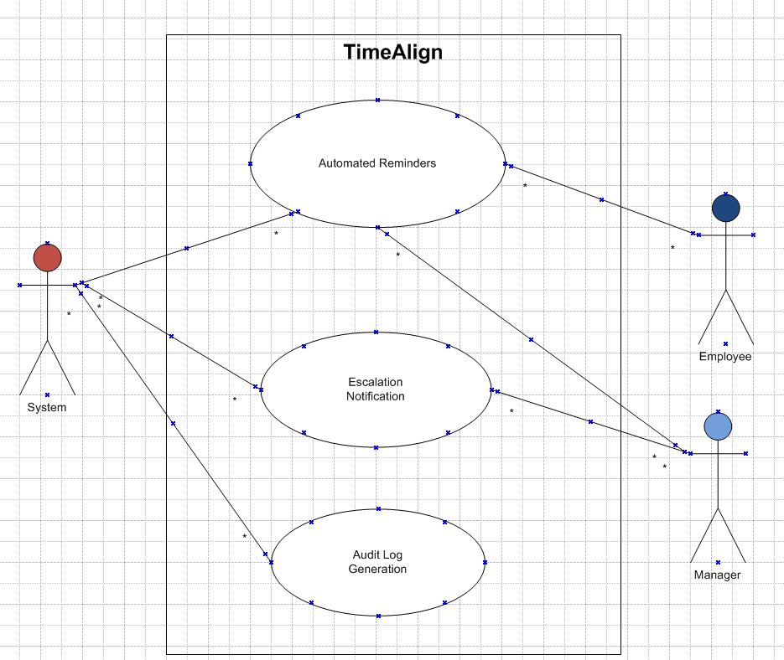

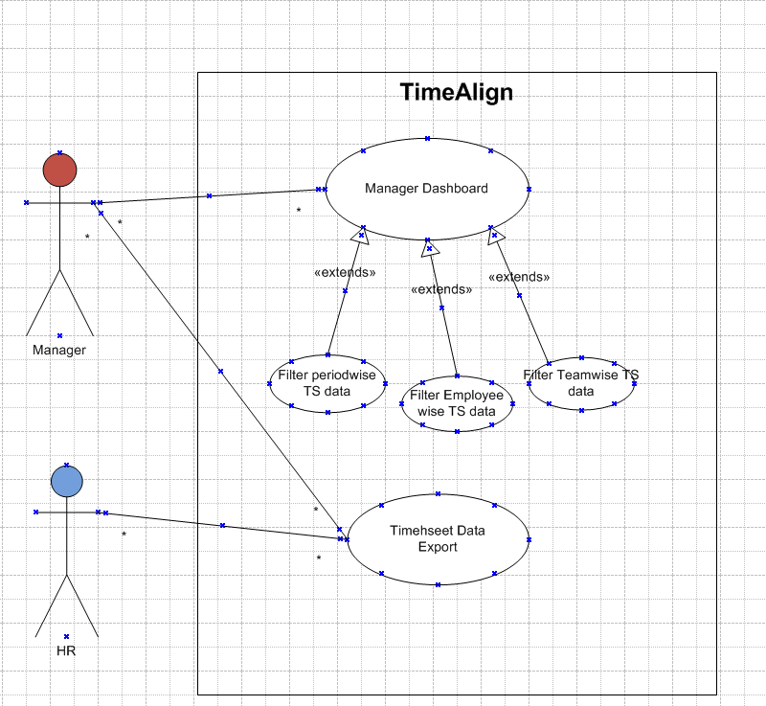

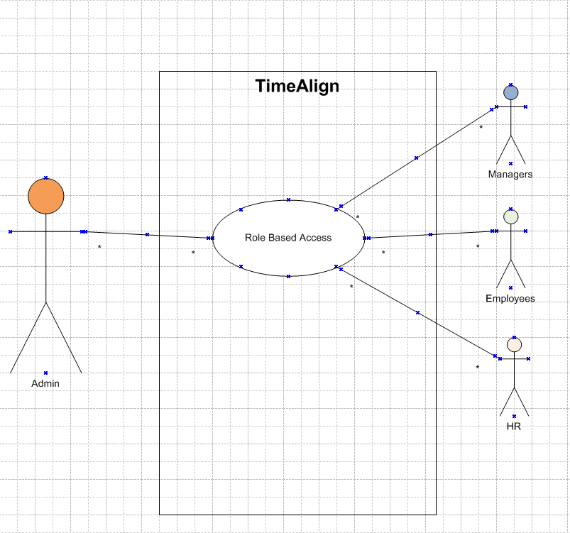

Activity Diagaram
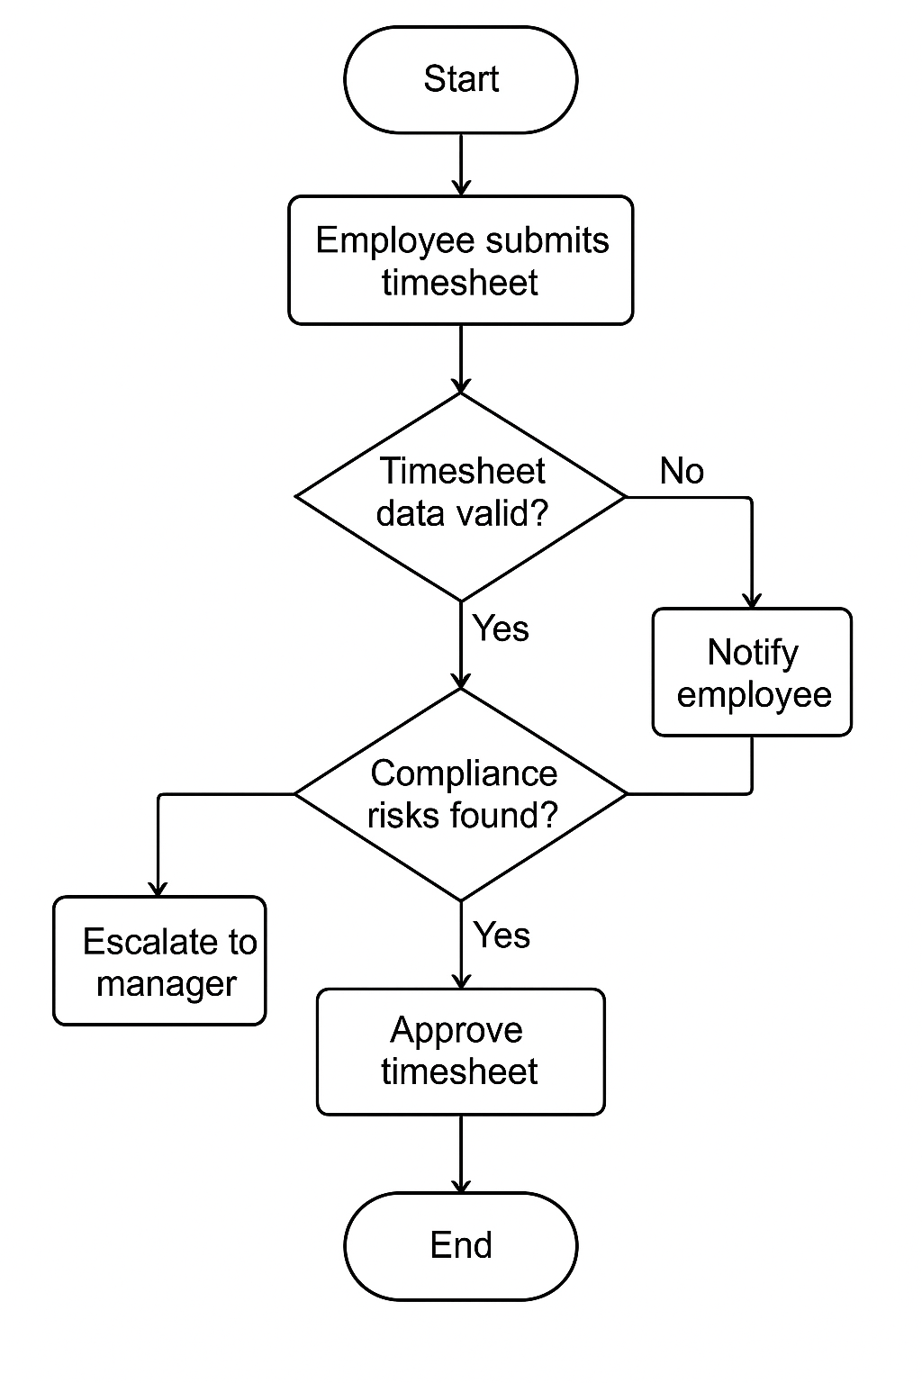

Document 7 : Screen And Pages
- Home Screen
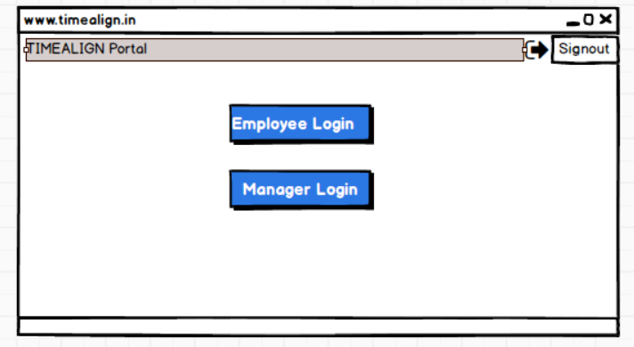

2) Employee Login Screen
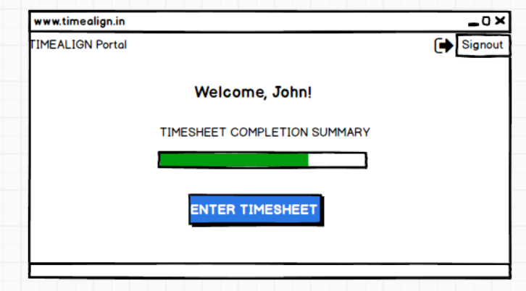

3)Manager Login Screen

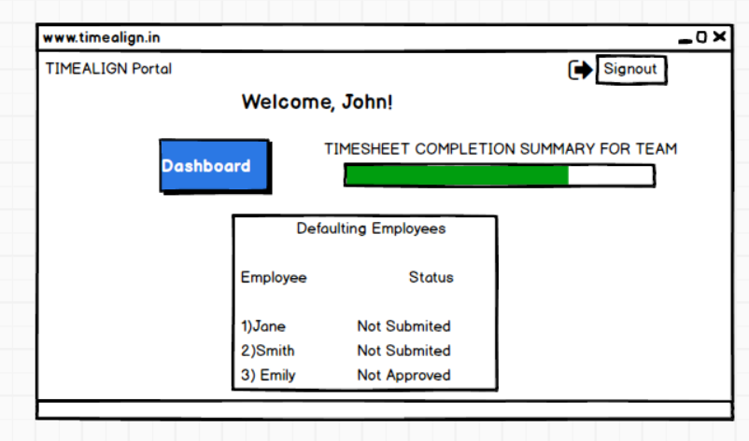

4)Dashboard Screen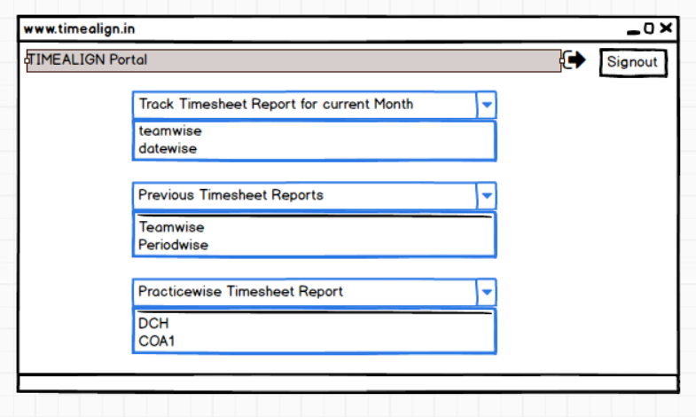

5) Export Functionality

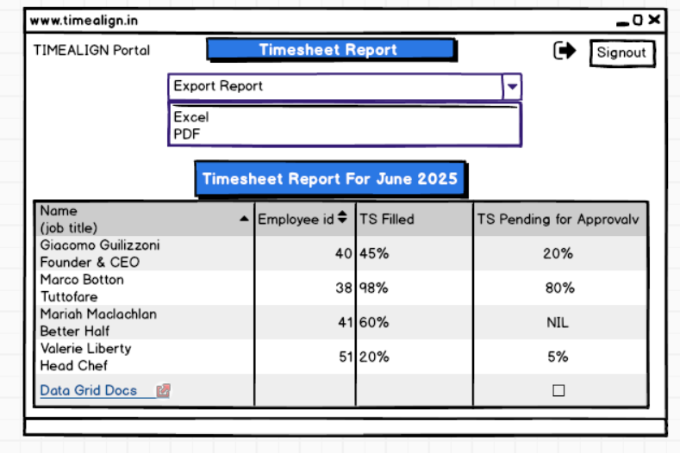
Document 8- Tools-Visio and Axure Write a paragraph on your experience using Visio and Axure for the project.
For this project, I primarily used Microsoft Visio and Balsamiq to support documentation and visualization of business requirements. Visio was instrumental in designing professional and clear use case diagrams, activity diagrams, and other UML artifacts, which helped communicate the system’s behaviour to stakeholders and the development team. Additionally, I used Balsamiq to create low-fidelity wireframes of key application screens. Its simple drag-and-drop interface made it easy to design mock-ups quickly and focus on layout and functionality without getting into visual details. Together, these tools enhanced collaboration across teams and ensured that both functional and non-functional requirements were well-understood during the Waterfall project lifecycle.

Document 9 – Business Analyst Experience.
As a Business Analyst, I was actively involved across key phases of the project lifecycle, particularly in requirement gathering and requirement analysis. Below is a summary of my experience:

1. Requirement gathering :
- I adopted the MoSCoW technique to categorize and prioritize requirements into Must Have, Should Have, Could Have, and Won’t Have. This helped manage stakeholder expectations effectively.
- During this phase, the client was intermittently unavailable, so I proactively identified alternative points of contact from their end to avoid project delays and collected the necessary inputs in a timely manner.
- I applied the FURPS model (Functionality, Usability, Reliability, Performance, and Supportability) to validate and evaluate the completeness and quality of gathered requirements.
- I identified and eliminated several redundant and duplicate requirements, ensuring clarity and avoiding confusion during later phases.
- I used prototyping techniques to help stakeholders better visualize the requirements, which encouraged more precise and practical inputs.

2. Requirement Analysis:
- I created various UML diagrams, including use case diagrams and activity diagrams, to clearly illustrate the functional requirements and process flows.
- These diagrams were shared with the cross-functional team for discussion. As a BA, I handled feedback from team members, facilitated discussions, and incorporated necessary modifications based on collaborative inputs.
- I was responsible for preparing detailed Business Requirement Specification (BRS) and Software Requirement Specification (SRS) documents, aligning them with both business needs and technical feasibility.

3. Design:
- Derived test cases directly from use case diagrams to ensure traceability.
- Engaged with the client to finalize design and solution documents.
- Authored both positive and negative test cases, ensuring coverage of all potential scenarios.
- Emphasized the importance of not missing test cases, as omissions can affect downstream development.
- Created relevant test data and ensured the RTM (Requirement Traceability Matrix) was continuously updated to reflect design decisions.

4. Development:
- Facilitated JAD (Joint Application Development) sessions to align development goals.
- Acted as the bridge between the technical team and business, clarifying requirements during implementation.
- Addressed conflicts or lack of cooperation by engaging in one-on-one discussions, promoting a healthy team environment.
- Encouraged developers to refer to visual diagrams (UML, activity flows) while coding.
- Coordinated regular meetings between the client and development team, handled attendance challenges by recording sessions and conducting follow-ups.

5. Testing:
- Prepared test cases using earlier use case documentation as a base.
- Participated in high-level functional testing to validate core business flows.
- Coordinated with the client to obtain realistic test data.
- Kept the RTM up-to-date and ensured complete coverage.
- Obtained client sign-off post testing and supported User Acceptance Testing (UAT) readiness.

6. Deployment:
- Sent the finalized RTM to the client, attaching it to the project closure document.
- Coordinated the creation and distribution of end-user manuals.
- Organized and facilitated training sessions for business users and stakeholders.
- Ensured full participation in training, tracked attendance, and addressed gaps proactively.

