Document 6- Please prepare a use case diagram, activity diagram and a use case specification document.
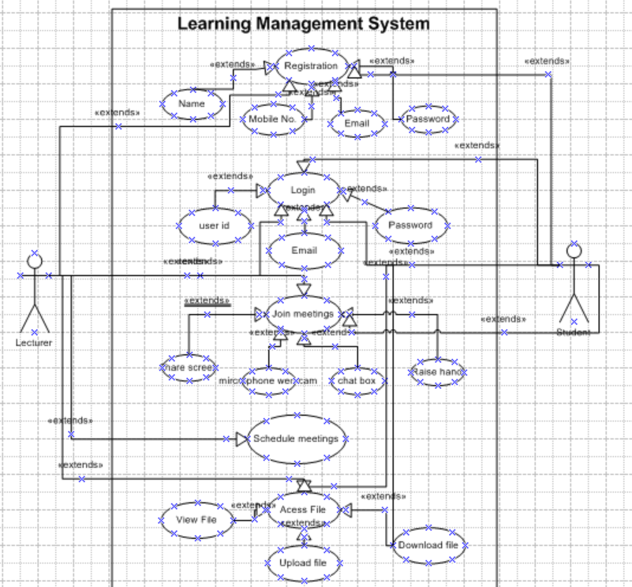

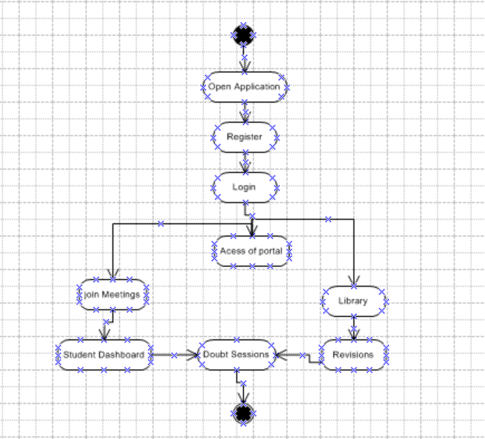

Use Case Diagram
Actors:
- Primary Actor → Customer
- Secondary Actors → Payment Gateway, Restaurant System
Use Cases:
- Login/Register
- Search Restaurant/Dish
- Add to Cart
- Make Payment
- Logout

Activity Diagram (High-Level Flow)
- User opens Home Page
- User logs in
- User searches restaurant/dish
- User selects dish → adds to cart
- User proceeds to payment
- Payment gateway validates transaction
- Order confirmed & sent to restaurant
- User logs out

Use Case Specification Document
1. Use Case Name
Place Food Order (Login → Search → Add to Cart → Payment → Logout)
2. Use Case Description
This use case describes how a customer logs in, searches for restaurants/dishes, adds items to the cart, makes payment, and logs out.
3. Actors
- Primary Actor: Customer
- Secondary Actors: Payment Gateway, Restaurant System
4. Basic Flow
- Customer opens SCRUM Foods app.
- Logs in with credentials.
- Searches for restaurant/dish.
- Selects dish & adds to cart.
- Proceeds to payment.
- Payment gateway confirms transaction.
- Order is placed & confirmation sent.
- Customer logs out.
5. Alternate Flow
- Customer may checkout as guest without login.
- Customer may save payment details for faster checkout.
6. Exceptional Flows
- Invalid login credentials.
- Restaurant not found.
- Payment failed.
- Network error during checkout.
7. Pre-Conditions
- Customer has internet access.
- App is installed & functional.
8. Post-Conditions
- Order placed successfully OR
- Failure message is displayed (with retry option).
9. Assumptions
- Customer has valid account/payment method.
- Restaurant is active & accepting orders.
10. Constraints
- Order only within serviceable area.
- Limited payment methods.
11. Dependencies
- Internet connectivity.
- Third-party payment gateway.
- Restaurant’s order management system.
12. Inputs and Outputs
- Inputs: Login credentials, search query, dish selection, payment details.
- Outputs: Order confirmation, receipt, logout success message.
13. Business Rules
- Customers must log in/register before ordering (unless guest checkout is enabled).
- Payments must be authorized before order is sent.
- Cart cannot be empty at checkout.
14. Miscellaneous Information
- App supports notifications for order status.
- Customer service available via in-app chat.
Document 7- Screens and pages Please follow the following steps to create the mock-ups 1. Kindly use balsamic or Axure. 2. Always start with a home page of an application. 3. Take a feature and follow it to the end a. Eg: Home page of SCRUM Foods b. Select Login- Create a login page c. Let’s assume, you want to search a restaurant d. Search page- Type the restaurant name and select the dish e. Add to cart page f. Payment page g. Logout page

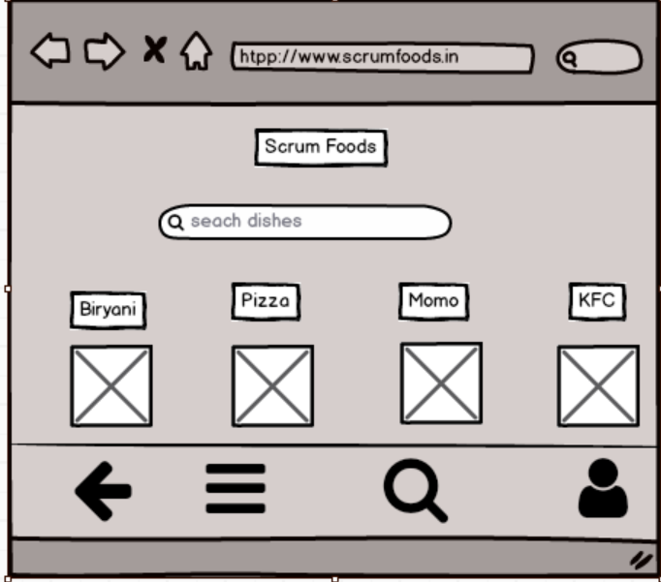
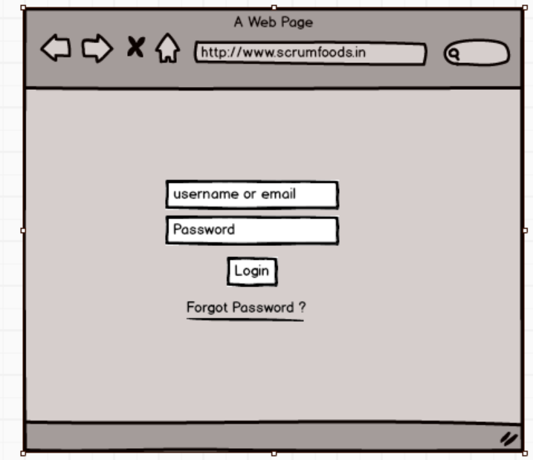
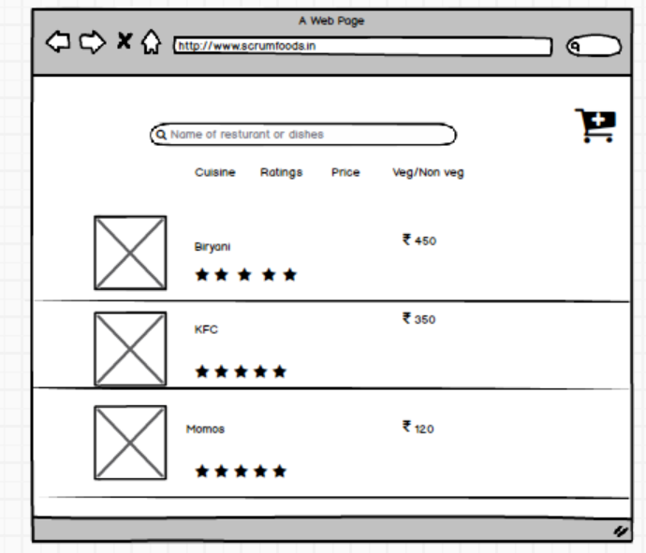

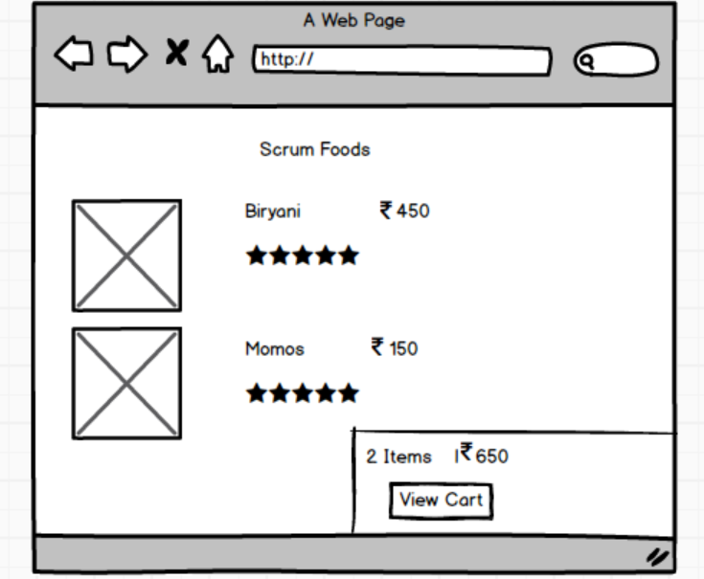

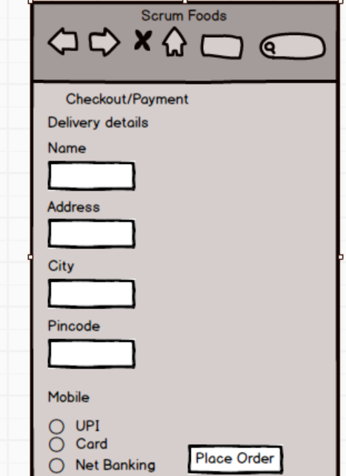

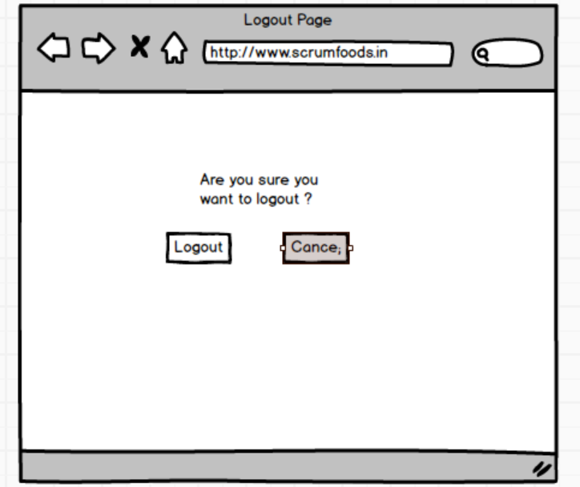
Document 8 – Tools: Visio and Axure
During the project, I used MS Visio to design various diagrams such as Use Case Diagrams, Activity Diagrams, and Process Flowcharts. Visio made it easy to represent both the AS-IS and TO-BE processes clearly, with professional-quality visuals that improved stakeholder understanding. It also helped in maintaining consistency across all workflow diagrams.
For prototyping, I used Axure, which allowed me to create interactive wireframes and mock-ups of the portal. This gave stakeholders a real-time experience of how the system would look and function before development. Axure’s drag-and-drop components, linking, and interactive features were useful in demonstrating user navigation and validating requirements early in the lifecycle.
Both tools together helped bridge the gap between business requirements and technical design, ensuring clarity, accuracy, and alignment throughout the project.
Document 9- BA experience
My experience as BA in following phases:
- Requirement gathering:
- Requirement Analysis:
- Design:
- Development:
- Testing:
- Deployment:

Answer : . Requirement Gathering
- Conducted stakeholder interviews, brainstorming sessions, and workshops.
- Prepared questionnaires and documented business needs.
- Created AS-IS process flow diagrams and identified gaps.
2. Requirement Analysis
- Analyzed collected requirements for feasibility and alignment with project goals.
- Classified them into functional and non-functional requirements.
- Maintained a requirement traceability matrix (RTM) for tracking.
3. Design
- Collaborated with UI/UX designers and technical architects.
- Prepared use case diagrams, activity diagrams, wireframes, and mock-ups.
- Ensured design matched both user expectations and business goals.
4. Development
- Acted as a bridge between developers and stakeholders.
- Clarified doubts and explained requirements to the development team.
- Participated in sprint planning and daily stand-ups (Agile methodology).
5. Testing
- Prepared test scenarios and UAT cases.
- Coordinated User Acceptance Testing with stakeholders.
- Validated that the final product met the TO-BE process and requirements.
6. Deployment
- Ensured smooth transition from legacy system (AS-IS) to new system (TO-BE).
- Supported the deployment team in production release.
- Provided training, user manuals, and post-deployment support.

