Question 5 - Elicitation Techniques
As a Business Analyst, What Elicitation Techniques you are aware of? BDRFOWJIPQU
Brainstorming – here a set of people like project team members, end users and client who is give the project to the team to work, will gather and discus different ideas, constrains of the process and the solution for the issue in a small time period. Goal is to get more ideas to perform.
Types – Structured and un-structured brainstorming.
Above mentioned is un-structured brainstorming.
In structured brainstorming we follow some methodology in doing the brainstorming like.
Brain writing – here the participant will write the ideas and it is being shared and discussed. To make the introvert also to share ideas.
Reverse brainstorming – here the discussion will be on the problems than discussing ideas of the process.
Star bursting – 5w1h question to ensure we understand the entire problem before discussion.
Nominal group technique – individual idea is being taken, discussion on the idea happens then the team go for voting to approve or not.
Round bin – one person one idea at a time like this everyone will share their idea and discuss on it.
Rapid idea – the discussion happens with in a time frame. This helps in more idea in short time.
Document Analysis – here we verify the available document to get the relevant requirement and information for doing the project in a better way. (BRD, FRD etc.)
Business and system documents – which explain about what is the project and what are the specification that needs to be in the project is called business document. BRD.
Process and workflow documents - Any documents that describe a business process how it is happened is called process document. FRD,
User documentation – document created for end-users, such as user guides and manuals for the current application. Use case document
Reverse engineering – it is like analyzing the finished project to understand its functionality and operations.
static analysis (examining without running) and dynamic analysis (examining while running)
Static Analysis – Disassembling converting the machine code language in to human readable language and understanding the program flow.
Dynamic analysis – debugging the code to step through the code line by line to understand the flow.
Focus group – here the end user farmers are focused to discuss about their need and expectation to get the proper requirement from them.
Thematic analysis - This is a widely used method that involves identifying, analyzing, and reporting patterns within the process that our focus.
Discourse analysis - This type of analysis examines how language is used in social contexts and goes beyond simple word analysis to understand more about the process.
Narrative analysis - This approach focuses on the stories that people tell and how they process is going on.
Observation – it is like job shadowing. To watch the farmer day to day work and know their exact need and help them to get it as much as possible.
Active - The observer becomes an active member of the group and they work together with the target and get the real time information. He has a structured plan with specific behaver, time and place to begin with.
Passive - The observer remains separate from the group and does not participate but he observes and collect details by using methods like mechanical or electronic devices. More flexible and open-ended, with no fixed plan.
Workshop – here the client, project team members and the work experts SME will be involved to identify the problem and get a solution out of it.
JAD – joint application development – here the team who is going to perform the project, IT staff, client come together and identify the system requirement.
Interviews – direct face to face interaction with the stakeholders and get the proper needs, problems and expectation.
Prototyping – here we create a simplified version of the system and allow the stakeholder to work in it and get the fees back of the performance and implement it in the main project. This helps you to get the clear understanding of the need and the expectation of the client.
Low-Fidelity Prototypes - These are simple, basic representations of the product Hand-drawn sketches of the product and Visual narratives of how users will interact with the product.
High-Fidelity Prototypes - Functional Prototypes that’s explains Interactive models that simulate the product's behavior. Clickable prototypes that mimic the look and feel of the final product.
Questionnaires – here a written tool used to collect information form the large set of stakeholders, this will give you more options on the requirement.
Use case – this will explain how the use is going to use the system. This says the functional requirement in a structured way in detail and the expected outcome.

Question 12
Activity diagram

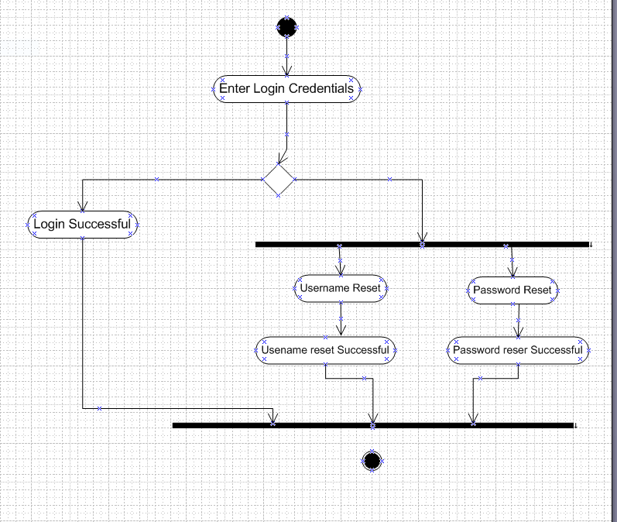

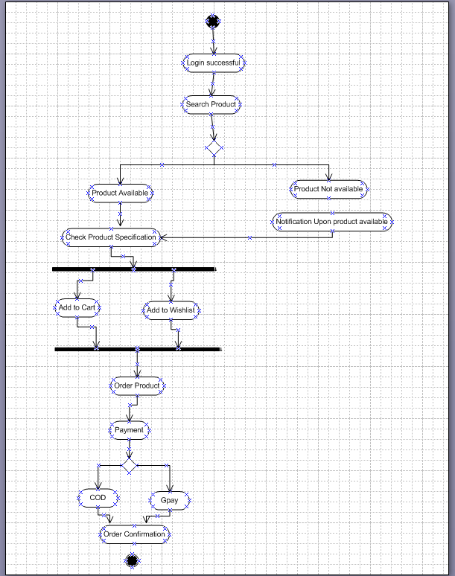
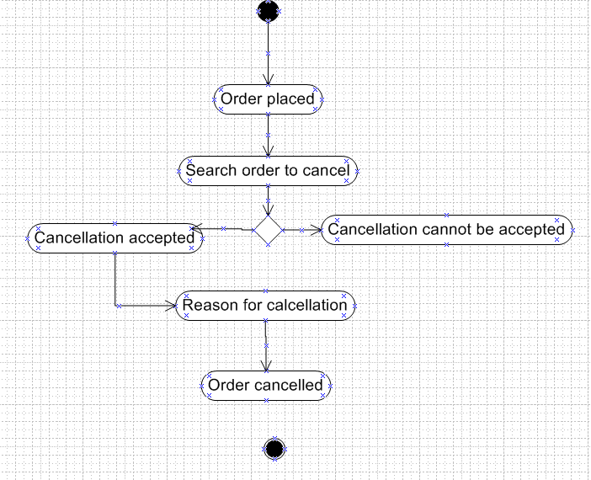

Question 10
Use case diagram

