Question 1 – Audits
Answer – 5 Quarterly Audits
Stage | Requirement Gathering Phase
Completed | Quarter 1
Checklist
 | BRD Template
 | Elicitation Results Report
 | Email Communication – To, CC, BCC

Stage | Requirement Analysis Phase
Completed | Quarter 2
Checklist
 | UML Diagram
 | Functional Requirements Mapping
 | Technical Requirements Mapping
 | Sign off on SRS
 | RTM Document Version Control
 | Email Communication – To, CC, BCC

Stage | Design Phase
Completed | Quarter 3
Checklist
 | Document evidence on client communication
 | Utilization of Tools
 | Email Communication – To, CC, BCC

Stage | Development Phase
Completed | Quarter 4
Checklist
 | JAD Session Report
 | End User Manual preparation document
 | Email Communication – To, CC, BCC

Stage | Testing Phase
Completed | Quarter 5
Checklist
 | Test Case Summary
 | Training Report to End User
 | Lessons Learnt Document
 | Email Communication – To, CC, BCC

Question 2 – BA Approach Strategy
Answer – BA Approach Strategy
- Elicitation Technique – We can use Joint Application Development (JAD) Technique as we are using V– Model in which customer involvement is more. So, we can use this technique so that the errors are less, and the user is directly involved in the project. We can also create a Focus Group as our customer base and products are defined.
- Stakeholder Analysis – We can use RACI Matrix to do Stakeholder Analysis. In this technique we must identify who is Responsible who is Accountable who is to be consulted and who is to be informed.
- Documents – Business Requirement Document which would contain high level requirements after interacting with client, Functional Requirement Specification, Solution Requirement Specification at Requirement Analysis Phase, Solution Document in Design Phase and Test Concerning Document in Test phase.
- Sign off – We must take Sign off on SRS (Sofware Requirement Specification) from client in Requirement Analysis Phase. In the User Acceptance Testing Phase, we must take sign off from client on Client Project Acceptance Form.
- Approvals – We must get approval from the client by signing off on the above important documents.
- Communication Channels - by way of brainstorming sessions, JAD, document analysis, reverse reengineering, interviews, workshops, focus group, observation and questionnaires. We will prepare the SDD (system design documents) - HDD (High level design documents) /ADD (application design documents).
- Handle Change Request – We will Initially perform the Feasibility study to accept the change and then Impact analysis to measure change to project and finally Effort Estimation to implement the change in the project.
- Update Progress of the Project to Stakeholders - by using the use case diagrams from test cases and submitting the SDD (system design documents) to them to make them understand the design and solutions. We will also conduct regular status meetings for participation in UAT (user acceptance testing). We will update the end user manuals and RTM (requirement traceability metric).
- Sign off on UAT – After doing Testing before implementation in User Acceptance Testing Phase we must get sign off from client on Client Project Acceptance form.

Question 3 – 3 – Tier Architecture
Answer - Three-tier architecture is a well-established software application architecture that organizes applications into three logical and physical computing layers:
- the Application layer, or user interface.
  - In our case study this layer will consist of Desktop/ Tablet for using the online store application to buy products.
- The Business Logic Layer, where data is processed.
  - In this layer information will be taken from the application layer and database layer to process the order.
- The database layer, where the data associated with the application is stored and managed.
  - This layer will store all data related to the online store like availability of products.

Question 4 – BA Approach Strategy for framing questions.
Answer - As a BA one should have the following approach strategy for framing questions: -
- Requirement gathering techniques should be used.
- Use the 5W 1H model: - The tool is used to extract requirements from the client like why, where, what, Who, When and How.
- Confirm that the requirement is SMART (Specific, Measurable, Attainable, Realistic, Traceable / Time Bound) before accepting it for development.
- Stakeholder analysis must be done using the RACI matrix i.e., who is Responsible, Accountable, Consulted and Informed.
- Refer to the 3-tier architecture: -Application layer, Business logic layer and database layer.
- UML diagrams like Use cases, use case specs and activity diagrams.
- Models like Domain model, Conceptual model, Data model, and ER diagram.
- Screens and pages as per matured functional requirement.
- Sign offs to be taken on all documents, diagrams, SDLC stages from the responsible stakeholders.
- Lastly, we should remember that the information gathered should fit into the above or else it would be treated as just information or as a non-functional requirement.

Question 5 – Elicitation Techniques
Answer – Elicitation Techniques: -
- Brainstorming – It is an effective way to generate a lot of ideas on a specific issue and then determine which idea is the best solution.
- Document Analysis – It is done through reading a document and then understanding the Product/Process/Project.
- Reverse Engineering – It is the process of extracting knowledge or design information from anything man – made and re-producing it or re-producing anything based on the extracted information.
- Focus Group – It is the process to elicit ideas and attitudes about a specific product, service or opportunity in an interactive group environment.
- Observation – It is the process of observing, shadowing users or doing a part of their job can provide information of existing process, inputs and outputs.
- Workshop – It is a structured approach to capture requirements used to scope, discover, define, prioritize and reach closure on requirements for the target system.
- JAD (Joint Application Development) - It is an extended, facilitated workshop. It involves collaboration between stakeholders and system analysts to identify needs or requirements in a concentrated and focused effort.
- Interview – It is a systematic approach – posting relevant questions w.r.t software application and documenting the response.
- Prototyping – Showing the sample of a working model is prototyping.
- Questionnaire – It is for obtaining requirements from user/stakeholder who have minor inputs or are geographically remote.
- Use Case Specs - It gives a use case description from name to conditions to constraints, dependencies, business rules, inputs and outputs and other information.

Question 6 – This Project Elicitation Techniques
Answer – This Project Elicitation Techniques
- Prototyping – Prototyping will help stakeholders to visualize the system and identify problems early on. This will ease us to gather requirements in new domains like e-commerce.
- Use Case Specs – Use case specs technique is an elaborate technique which would help us identify constraints, dependencies, business rules etc. Early in the project.
- Document Analysis – Document Analysis will provide us with a lot of information and make it easy to transfer to a new system requirements document.
- Brainstorming – Brainstorming technique will help us by making it efficient for users/stakeholders to define their requirements which can also help us come up with innovative ideas and requirements.

Question 7 – 10 Business Requirements
Answer – 10 Business Requirements
- BR001 – Farmers should be able to search for available products in fertilizers, seeds, pesticides.
- BR002 – Manufacturers should be able to upload and display their products in the application.
- BR003 – Login option should be available for all its users using email id and password.
- BR004 – Farmers should be able to browse through the products catalogue.
- BR005 – New User should be able to create new account by submitting their email id and creating a secure password.
- BR006 – Farmers should be able to make payment from the Payment Gateway which should include Cash-on-delivery (COD), Credit/Debit card and UPI options.
- BR007 – User should get email confirmation regarding their order status.
- BR008 – User should be able to track the whereabouts of their order.
- BR009 – Farmers should be able to add product to cart.
- BR010 – Farmer should be able to add product to buy later list.

Question 8 – Assumptions
Answer – Assumptions
- Assumption 1 - Farmers will have technical knowledge to order and pay online.
- Assumption 2 – Farmers will prefer online shopping over local vendor.
- Assumption 3 – Farmers will have Google account for log in.
- Assumption 4 – Farmers will have Bank Accounts to do payments using UPI, Debit/credit card.
- Assumption 5 – Farmers will have decent network coverage for shopping, tracking and payments.
- Assumption 6 – Location Provided by farmer will have a postal code.

Question 9 – This Project Requirements Priority
Answer – This Project Requirements Priority
Req ID | Req Name | Req Description | Priority
BR001 | Search | Farmers should be able to search for available products in fertilizers, seeds, pesticides. | 8
BR002 | Upload and Display | Manufacturers should be able to upload and display their products in the application. | 8
BR003 | Login | The login option should be available for all its users using email id and password. | 7
BR004 | Browse | Farmers should be able to browse through the products catalogue. | 5
BR005 | Registration | New User should be able to create new account by submitting their email id and creating a secure password. | 7
BR006 | Payment Processing | Farmers should be able to make payment from the Payment Gateway which should include Cash-on-delivery (COD), Credit/Debit card and UPI options. | 7
BR007 | Email Confirmation | Users should get email confirmation regarding their order status. | 4
BR008 | Track Order | Users should be able to track the whereabouts of their order. | 3
BR009 | Add product | Farmers should be able to add products to carts. | 2
BR010 | Buy later | Farmer should be able to add product to buy later list. | 1

Question 10 – Use Case Diagram
Answer – Use Case Diagram
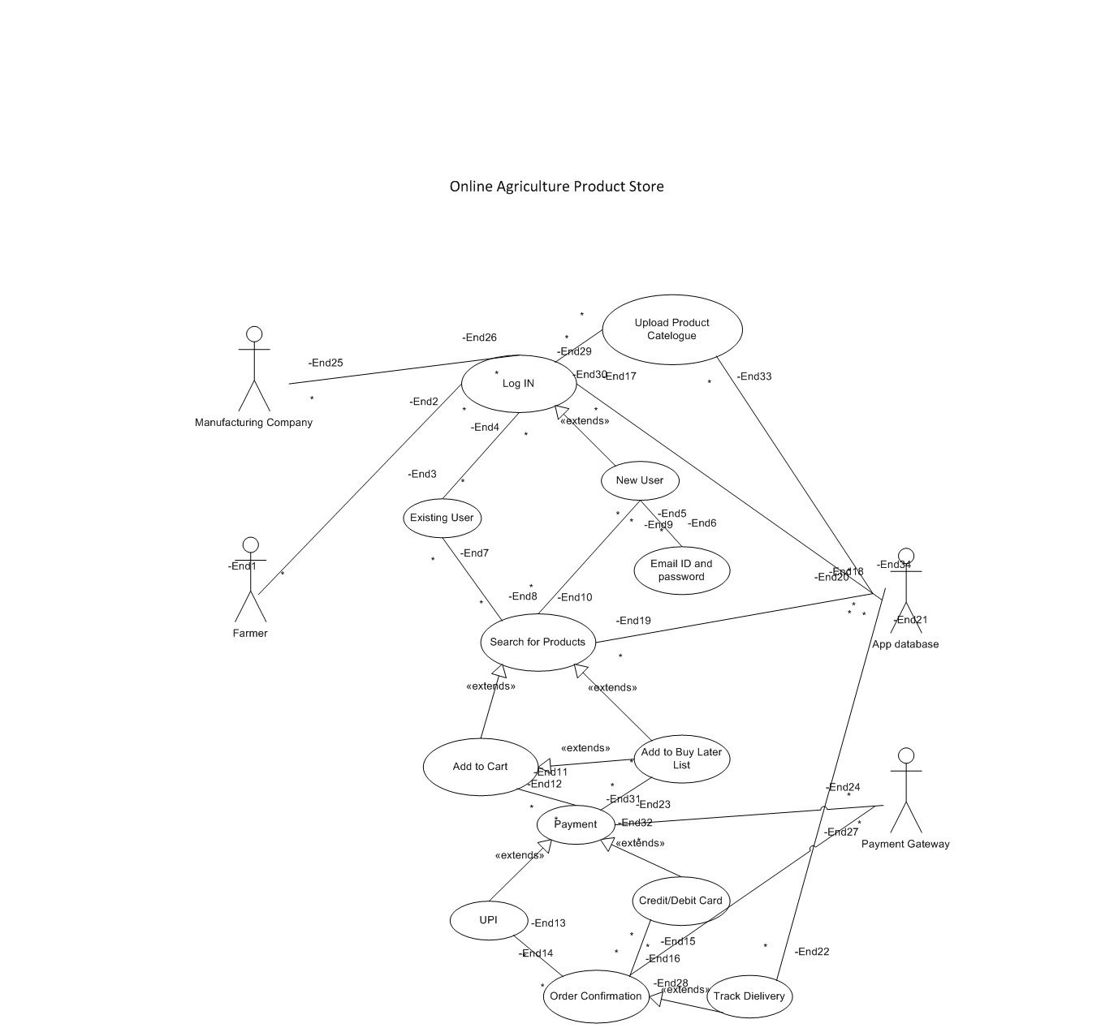

Question 11 - Use Case Specs
Answer – Use Case Specs
Use Case Name | User Log In
Brief Description | This Use case describes how user logs IN into the Web Portal/ Application of the Online Agriculture Store
Actors | Farmers, Manufacturers and App Database
Pre - Condition | - There is Active internet connection at Users Place.  - User has device – Mobile/ Computer etc. to log IN.
Basic Flow | - User Uses device to Log IN.  - Existing User gets Logged IN using email id and password.  - New User is Registered using email Id and password.
Alternate Flow | - Existing User Inputs either wrong email id or password.  - It will display forgotten email id or password.  - New User inputs weak password.  - It will display Weak password.  - New User after Registration inputs wrong email id or password for log in.  - It will display forgotten email id or password.
Post - Condition | - Successfully Logged in for both existing and new users.  - Failure to log in for both existing and new users.

Use Case Name | Search for Product
Brief Description | This Use case describes how user Searches for Product into the Web Portal/ Application of the Online Agriculture Store.
Actors | Farmers and App Database
Pre - Condition | - There is Active internet connection at Users Place.  - User has device – Mobile/ Computer etc. to log IN.  - Users have basic ideas on how to surf the internet.
Basic Flow | - User Uses device to Log IN.  - User Searchers for a Product in the Web Portal/Application.
Alternate Flow | - User Inputs either wrong email id or password.  - It will display forgotten email id or password.  - User Searches for a Product but the Product is unavailable.  - It will display “Not Found.”  - User Searches for a Product but the Product is out of stock.  - It will display “Out of Stock.”
Post - Condition | - Successfully Searching for the desired Product.  - Failure to get desired Product.

Use Case Name | Add to Cart
Brief Description | This Use case describes how user Searches for Product into the Web Portal/ Application of the Online Agriculture Store and adds the product to cart or buy later list.
Actors | Farmers and App Database
Pre - Condition | - There is Active internet connection at Users Place.  - User has device – Mobile/ Computer etc. to log IN.  - Users have basic ideas on how to surf the internet.
Basic Flow | - User Uses device to Log IN.  - User Searchers for a Product in the Web Portal/Application.  - User Adds the Product to Buy Later list.  - User adds the Product to Cart.
Alternate Flow | - User Inputs either wrong email id or password.  - It will display forgotten email id or password.  - User Searches for a Product but the Product is unavailable.  - It will display “Not Found.”  - User Searches for a Product but the Product is out of stock.  - It will display “Out of Stock.”  - User Adds the Product to Cart but the Product is out of stock.  - It will display “Out of Stock” or “Add to Buy Later List.”
Post - Condition | - Successfully adding the desired product to cart.  - Failure to add the desired Product to cart.

Use Case Name | Payment
Brief Description | This Use case describes how the user Pays for a Product.
Actors | Farmers, Payment Gateway and App Database
Pre - Condition | - There is Active internet connection at Users Place.  - User has device – Mobile/ Computer etc. to log IN.  - Users have basic ideas on how to surf the internet.  - Bank Server is not down.
Basic Flow | - User Uses device to Log IN.  - User Searchers for a Product in the Web Portal/Application.  - User adds the Product to Cart.  - User Pays for the Product using UPI, debit/credit card.  - Order is Confirmed.  - Order ID is generated.
Alternate Flow | - User Adds the Product to Cart but the Product is out of stock.  - It will display “Out of Stock” or “Add to Buy Later List.”  - User Pays for the Product but Payment is failed due to wrong UPI id or credit/debit card details.  - It will display “Wrong Credentials.”
Post - Condition | - Successfully paying for the desired product.  - Failure to pay for the desired Product.

Use Case Name | User Product Catalogue.
Brief Description | This Use case describes how user logs IN into the Web Portal/ Application of the Online Agriculture Store and upload Product Catalogue.
Actors | Farmers, Manufacturers and App Database
Pre - Condition | - There is Active internet connection at Users Place.  - User has device – Mobile/ Computer etc. to log IN.
Basic Flow | - User Uses device to Log IN.  - Existing User gets Logged IN using email id and password.  - New User is Registered using email Id and password.  - Manufacturers upload the Product Catalogue.  - Product Details are updated and are displayed on the Wep Portal/Application.
Alternate Flow | - Existing User Inputs either wrong email id or password.  - It will display forgotten email id or password.  - New User inputs weak password.  - It will display Weak password.  - New User after Registration inputs wrong email id or password for log in.  - It will display forgotten email id or password.  - Manufacturers Fails to upload desired information.  - It will display “Incomplete Information.”
Post - Condition | - Successfully Logged in for both existing and new users.  - Failure to log in for both existing and new users.  - Successfully Uploading of Information.  - Failure in Uploading Information.

Question 12 – Activity Diagrams.
Answer – Activity Diagrams
- Add to Cart
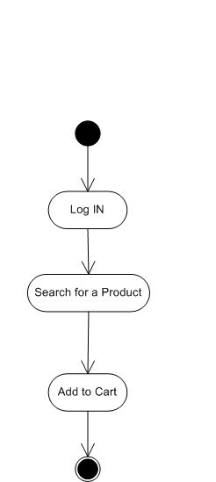

- Payment
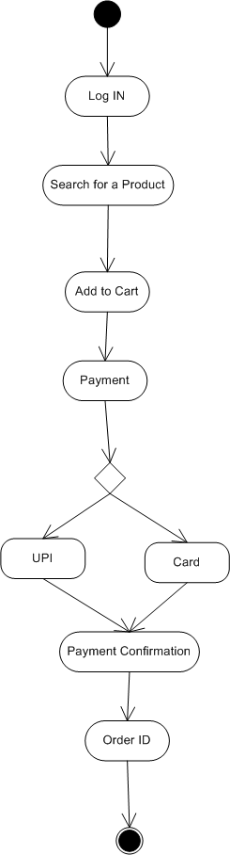

- Delivery
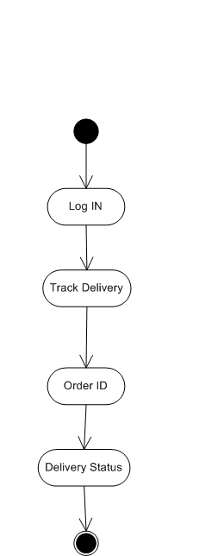

- Cancellation
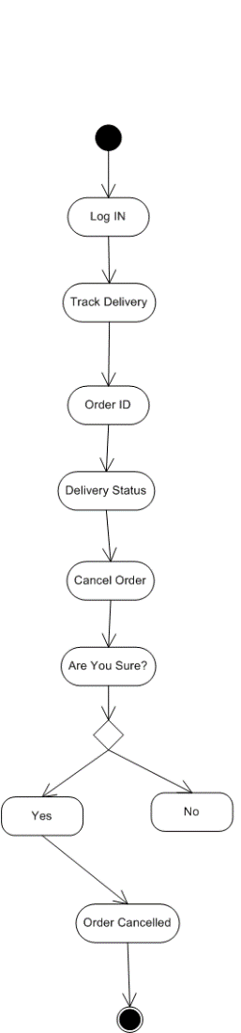

- Customer Profile
