Req ID | Req Name |  |  | Req Description |  | Priority
FR0001 | Farmer Registration |  |  | Farmers should be able to register with the application. |  | 8
FR0002 | Farmer Search for Products |  |  | Farmers should be able to search for available products in fertilizers, seeds, pesticides. |  | 8
FR0003 | Manufacturer Registration |  |  | Manufacturers should be able to create an account in the application. |  | 8
FR0004 | Manufacturer Product Upload |  |  | Manufacturers should be able to upload products (fertilizers, seeds, pesticides). |  | 9
FR0005 | Login/Authentication |  |  | All users should be able to log in with valid credentials. |  | 10
FR0006 | View Product Details |  |  | Farmers should be able to view detailed information about products. |  | 8
FR0007 | Add to Cart |  |  | Farmers should be able to add products to a shopping cart. |  | 9
FR0008 | Wishlist Functionality |  |  | Farmers should be able to add products to a buy-later list. |  | 7
FR0009 | Place Order |  |  | Farmers should be able to place orders after selecting products. |  | 10
FR0010 | Payment Gateway Integration |  |  | Farmers should be able to pay via UPI, Card, or COD. |  | 10
NFR0101 |  | Page Loading Time | Each page should load within 2 seconds. |  | 9

NFR0102 | WCAG 2.1 Compliance | The system must meet Web Content Accessibility Guidelines WCAG 2.1. | 8

NFR0103 | Secure Data Handling | All user data should be encrypted in transit and at rest. | 10

NFR0104 | High Availability | The application should maintain 99.9% uptime. | 9

NFR0105 | Email Delivery Speed | Confirmation emails must be delivered within 1 minute. | 8

NFR0106 | Mobile Responsiveness | The app must function fully on mobile browsers and devices. | 9

NFR0107 | Concurrent Users | The system must support 500 concurrent users without performance degradation. | 8

NFR0108 | Session Timeout | User sessions should expire after 15 minutes of inactivity. | 7

NFR0109 | Multi-language Support | The system must support at least 2 languages (e.g., English and Hindi). | 7

NFR0110 | Audit Logging | All admin activities should be logged for audit purposes. | 9

Q2.Minimum 5 page designs - 15 Marks Make wireframe and prototypes

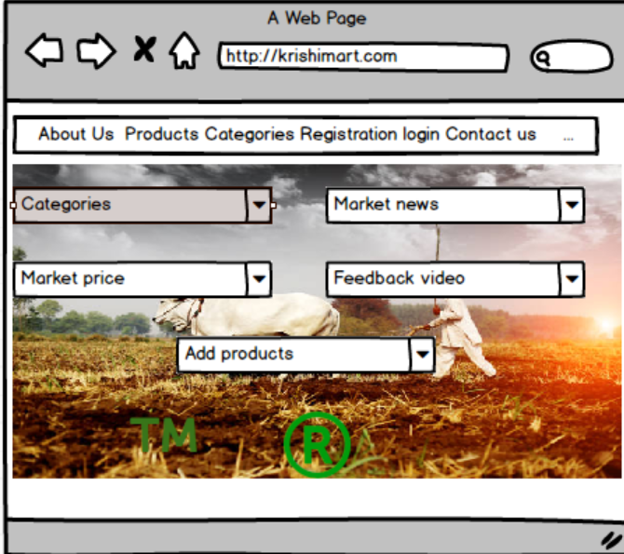

Question 3 – Tools (Visio, Balsamiq) –
Make a note of the Tools, which you are using for above concepts.
To design the wireframes and develop prototypes for the Online Agricultural Product Store, the following tools are commonly recommended and/or used:

1. Microsoft Visio
- Purpose: Used for creating Use Case Diagrams, Activity Diagrams, and System Architecture Diagrams.
- Why Used:
  - Supports UML diagram standards.
  - Easy drag-and-drop interface for modelling business processes.
  - Suitable for documentation and presentation to stakeholders.

2. Balsamiq Mock-ups
- Purpose: Used for designing low-fidelity wireframes for application screens.
- Why Used:
  - Mimics hand-drawn wireframes for clarity and focus on structure over design.
  - Helps clients and development teams understand the layout and flow.
  - Quick to iterate and modify as per feedback.

Question 4 – RTM

Req ID | Req Name | Req Description | Design (D1) | Test Case (T1) | Test Case (T2) | Test Case (T3) | Test Case (T4) | UAT
FR0001 | Farmer Registration | Farmers should be able to register with the application | ✔️ | ✔️ |  |  |  | ✔️
FR0002 | Farmer Search for Products | Farmers should be able to search for available products in fertilizers, seeds, etc. | ✔️ | ✔️ | ✔️ |  |  | ✔️
NFR0101 | Page Loading Time | Each page should load within 2 seconds | ✔️ |  | ✔️ | ✔️ |  | ✔️
NFR0102 | WCAG 2.1 Compliance | The system must meet Web Content Accessibility Guidelines (WCAG 2.1) | ✔️ |  |  | ✔️ | ✔️ | ✔️
Question 5 – 10 Test Case Documents

Test Case ID | Test Scenario | Test Steps | Expected Result | Actual Result | Status
Test Case 1
TC_ID | TC001
Scenario | Farmer Registration
Steps | 1. Go to Registration Page  2. Enter valid email, password, confirm password  3. Click Register
Expected | User account should be created and confirmation message displayed
Actual | Pending
Status | Not Executed
Test Case 2
| TC_ID | TC002 |
| Scenario | Login with valid credentials |
| Steps | 1. Go to Login Page <br> 2. Enter registered email and password <br> 3. Click Login |
| Expected | User should be successfully logged in |
| Actual | Pending |
| Status | Not Executed |

Test Case 3
| TC_ID | TC003 |
| Scenario | Login with invalid credentials |
| Steps | 1. Enter incorrect email/password <br> 2. Click Login |
| Expected | System should show error: “Invalid credentials” |
| Actual | Pending |
| Status | Not Executed |

Test Case 4
| TC_ID | TC004 |
| Scenario | Search for product using search bar |
| Steps | 1. Enter “Fertilizer” in search bar <br> 2. Click search |
| Expected | Related fertilizer products should be displayed |
| Actual | Pending |
| Status | Not Executed |

Test Case 5
| TC_ID | TC005 |
| Scenario | Add product to cart |
| Steps | 1. Browse a product <br> 2. Click “Add to Cart” |
| Expected | Product should be added to shopping cart |
| Actual | Pending |
| Status | Not Executed |

Test Case 6
| TC_ID | TC006 |
| Scenario | Proceed to Checkout |
| Steps | 1. Go to cart <br> 2. Click “Checkout” |
| Expected | Checkout page should load with delivery and payment options |
| Actual | Pending |
| Status | Not Executed |

Test Case 7
| TC_ID | TC007 |
| Scenario | Place Order with UPI |
| Steps | 1. Select UPI option <br> 2. Enter valid UPI ID <br> 3. Click Place Order |
| Expected | Order should be placed, and confirmation displayed |
| Actual | Pending |
| Status | Not Executed |

Test Case 8
| TC_ID | TC008 |
| Scenario | Page loading performance |
| Steps | 1. Open any product page |
| Expected | Page should load in less than 2 seconds |
| Actual | Pending |
| Status | Not Executed |

Test Case 9
| TC_ID | TC009 |
| Scenario | Accessibility Compliance Check |
| Steps | 1. Use screen reader and keyboard navigation <br> 2. Check color contrast |
| Expected | Should pass WCAG 2.1 standards |
| Actual | Pending |
| Status | Not Executed |

Test Case 10
| TC_ID | TC010 |
| Scenario | Email confirmation after placing order |
| Steps | 1. Place order <br> 2. Check email |
| Expected | Email should be sent with order details |
| Actual | Pending |
| Status | Not Executed |

Question 6 – DB Design –After the requirements are thoroughly explained to the entire project team by business analyst, the Database architects have decided to do the database design and also to represent the in-flow and out-flow of data.
Database Schema (Tabular Design)
🔷 User
Column Name | Data Type | Constraints
user_id | INT | PRIMARY KEY
name | VARCHAR(100) | NOT NULL
email | VARCHAR(100) | UNIQUE, NOT NULL
password | VARCHAR(100) | NOT NULL
user_type | VARCHAR(50) | CHECK ('Farmer', 'Manufacturer')

🔷 Product
Column Name | Data Type | Constraints
product_id | INT | PRIMARY KEY
name | VARCHAR(100) | NOT NULL
category | VARCHAR(50) | CHECK ('Fertilizer', 'Seed', 'Pesticide')
price | DECIMAL(10,2) | NOT NULL
manufacturer_id | INT | FOREIGN KEY → User(user_id)
stock_quantity | INT | NOT NULL

🔷 Cart
Column Name | Data Type | Constraints
cart_id | INT | PRIMARY KEY
user_id | INT | FOREIGN KEY → User(user_id)
created_at | DATETIME | DEFAULT CURRENT_TIMESTAMP

🔷 CartItem
Column Name | Data Type | Constraints
cart_item_id | INT | PRIMARY KEY
cart_id | INT | FOREIGN KEY → Cart(cart_id)
product_id | INT | FOREIGN KEY → Product(product_id)
quantity | INT | NOT NULL

🔷 Order
Column Name | Data Type | Constraints
order_id | INT | PRIMARY KEY
user_id | INT | FOREIGN KEY → User(user_id)
total_amount | DECIMAL(10,2) | NOT NULL
order_date | DATETIME | DEFAULT CURRENT_TIMESTAMP
status | VARCHAR(50) | DEFAULT 'Pending'

🔷 OrderItem
Column Name | Data Type | Constraints
order_item_id | INT | PRIMARY KEY
order_id | INT | FOREIGN KEY → Order(order_id)
product_id | INT | FOREIGN KEY → Product(product_id)
quantity | INT | NOT NULL
price | DECIMAL(10,2) | NOT NULL

🔷 Payment
Column Name | Data Type | Constraints
payment_id | INT | PRIMARY KEY
order_id | INT | FOREIGN KEY → Order(order_id)
payment_type | VARCHAR(50) | CHECK ('UPI', 'Card', 'COD')
payment_status | VARCHAR(50) | DEFAULT 'Pending'

🔷 Delivery
Column Name | Data Type | Constraints
delivery_id | INT | PRIMARY KEY
order_id | INT | FOREIGN KEY → Order(order_id)
delivery_status | VARCHAR(50) | DEFAULT 'Preparing'
tracking_number | VARCHAR(100) | NULLABLE
estimated_delivery | DATE | NULLABLE
ERD
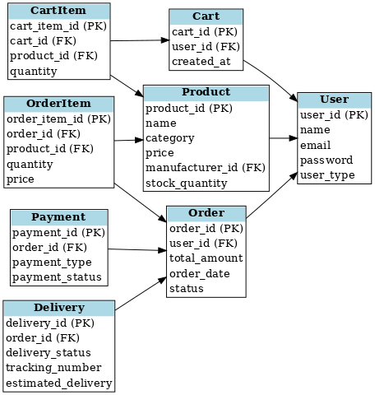

Question 7 – Data Flow Diagram - 3 Marks What is a data flow diagram? Draw a data flow diagram to represent the in-flow and out-flow of data when a Farmer is placing an order for the product

A Data Flow Diagram (DFD) is a graphical representation that shows how data moves through a system. It illustrates the inputs, processes, data stores, and outputs involved in a system without going into technical details (like code or hardware).

Key Components of a DFD:
- External Entities:
  - Represent outside systems or users that interact with the system (e.g., Farmers, Payment Gateway).
  - Symbol: Rectangle
- Processes:
  - Represent the operations or functions where data is processed.
  - Symbol: Circle or Rounded Rectangle
- Data Stores:
  - Represent where data is stored within the system.
  - Symbol: Open-ended Rectangle
- Data Flows:
  - Represent the movement of data between entities, processes, and data stores.
  - Symbol: Arrow

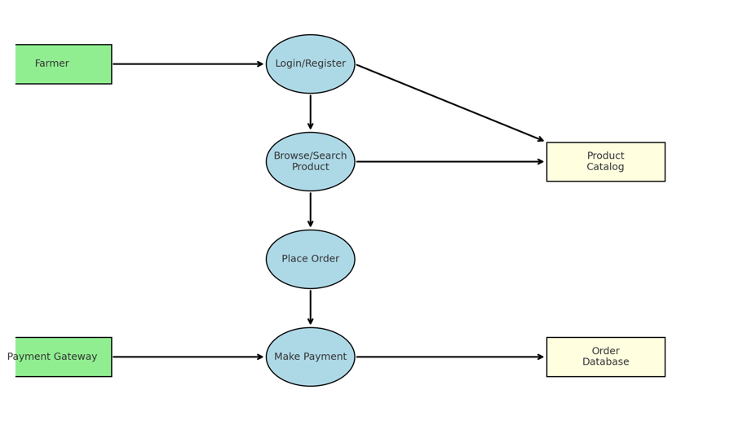

Question 8 – Change Request - 10 Marks Due to change in the Government Taxation structure . we should change the Tax structure How do you handle change requests in a project?

