Waterfall Document 2
Document - 6
1. Use case name: Google Account Recovery
2. Use case Description:
A user attempts to sign into their Google account but cannot remember their password unable to access their account.
3. Actors:
- Primary Actors: Users: user
- Secondary Actors: Google System
4. Basic Flows:
The user navigates to the Google account recovery page an initiates the recovery process.
- Provide information:
The user provides email address associated with Google account, recovery phone number and answer security questions.
- Verification code:
As user provides recovery email and phone number, they will receive an verification code and user will be enter into recovery page.
- Reset password:
Upon successfully verification the user can reset password in the recovery page and user is given access to their account.
5. Alternative flows:
- No recovery information:
If user has no recovery information or unable to provide The required information, Google may offer further assistance , such as requesting for more hyomotion or potentially disabling the account temporarily for security reason.
- Account Disabled:
If the account is disabled, the user may need to contact Google support team.
6. Exceptional flow:
- Incorrect information:
If the user provides in correct information during the recovery process, goggle may ask them to try again or offer further assistance.
- Suspicious Activity:
If Google detects suspicious recovery request, it it may delay the recovery process or required additional verification steps.

7. Pre condition:
- The user has a Google account
- The user has previously provided recovery information (email, phone number).
8. Post Condition:
* The user successfully regains access to their goggle account.
* The users account is secure and protected.
9. Assumptions:
* Percentage of successful Google account recoveries.
* Time taken to complete the account recovery process.
10. Constraints:
* Time constraints:
Google account recoveries have taken limit if an account is detected google, will provides 30 days of recovery window, which it is becomes permanently detected.
- Recovery Options:
The availability of recovery options like alternative email address and phone number is crucial for successful account recovery. If the user do not have there set up may be more challangimg to regain access to user account.
- Delayed Recovery Request:
Google may dale delayed recovery request as a security measure especially if user has extra security measure like
2 step verification this delay help protest against account high jacking.

11 Dependencies:
Account information:
This includes the email address, associated phone numbers.
- Security questions: there are personalized questions you set while creating an account.
- Two step verification:
If enabled you all needs to use a code sent to your phone or another device to verify the user identity.

12. Input and output:
Input in this protect primarily consist of information provided by the user to verify the identify and regain access.
- Account information:
This includes the original Gmail address the full name associated with the account.

- Previous login information :
The system might request information about the devices and locations where the users logged in previously.
Output in this protect is mainly about successful recovery to users account.

- Account Access;
The user is granted access to their Google account and its associated services as well.
- Passwords reset :
The system will provide instructions for user’s passwords to ensure secure further access.
- Confirmation and successful recovery.
A message confirming the recovery process is completed and user can now access their account.

13. Business Rule:
General account recovery:

Start with Google account recovery page explore related like security questions, verifications, code and alternative email address.
- Google workspace:
If user is managing Google workspace admin for them recovery policies.
- Review Google is terms and services:
- Google terms and services and privacy policies contain general guidelines about account management and security related to recovery process.
- * security best practices:
Always follow goggles recommonddded security practise when recovering an account including user story’s passwords, enabling.
2 step verification on always being aware of suspicious activity on the account.

14. Miscellaneous Information:
Miscellaneous Expenses:
- Any minor, non- securing and may not be easily budget for.
- While individually small, that they can accumulate and input the overall project budget.
Miscellaneous refers to items or information that don’t nearly fit into project categories or cost.
This can include various expenses, files or tasks, that aren’t directly related to core project activities.

Activity diagram:

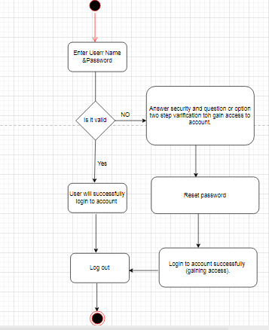

Use Case Diagram:

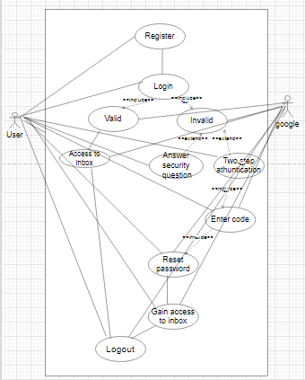

Document 7 – screens and pages:

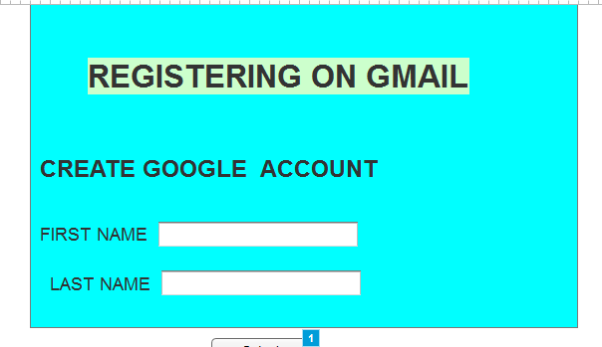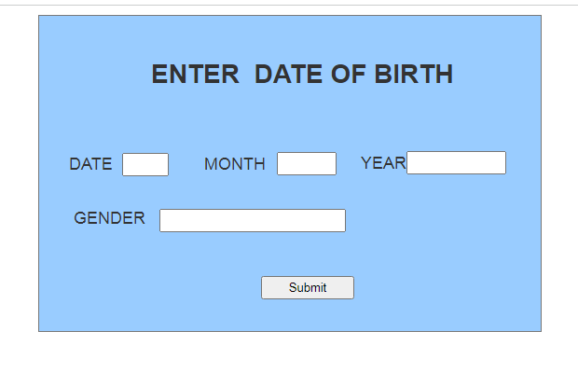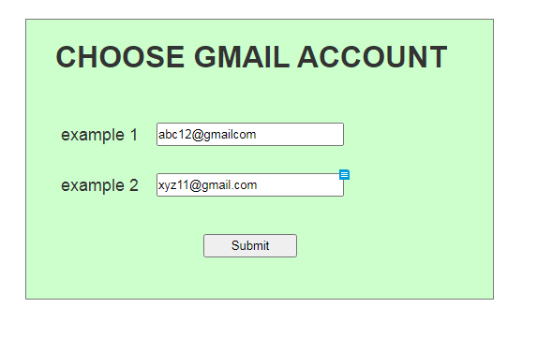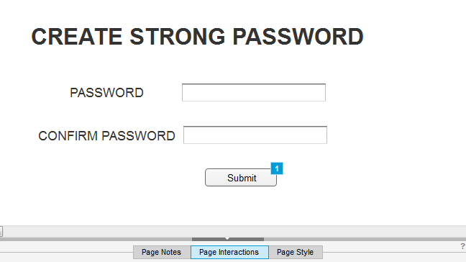
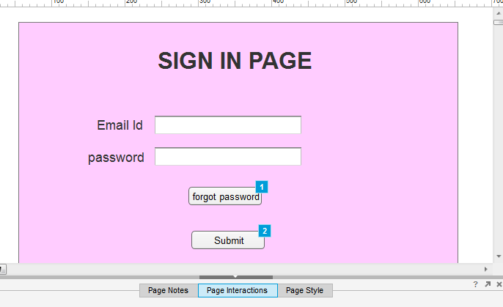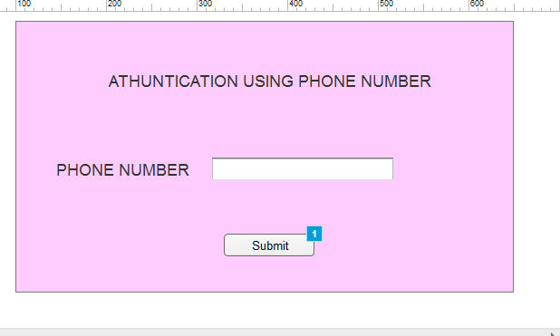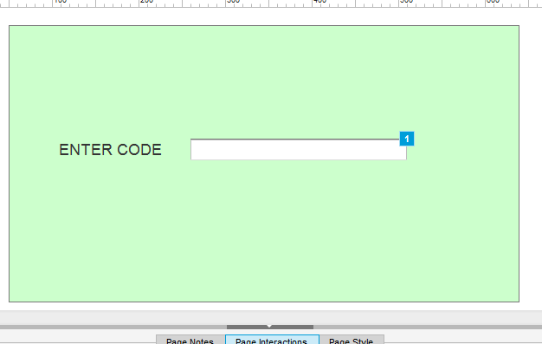
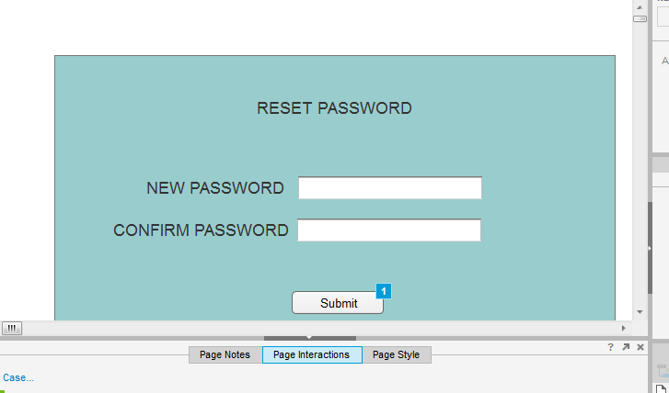
Document -8
Ms Visio:
MS Visio is used for mainly creating diagrams and flowcharts . it is drawing tool which made the account recovery flowchart a visual understanding of the process flow. Also ms Visio i have visual representation of complex information in this application users can the customized shapes with in text, images, to create unique detailed design.
AXURE:
It is an advanced prototyping tool used creates high interactive wireframes of proto types project. In the wire frames te basic outline of project design for understand what is the recovery up gradation
Used and hour is the visual representation will be in more simple words it is a skeleton outline of the design giving an idea prototyping more interactive more visual representation of the design which allows the user to interact with the user face and experience it is functionality Balsamic is a rapid wire framing tool used to create mock-ups and prototyping user for interface in the project using Balsamic i have created a visual representation of how does the recovery of emails happens if any uses lost access with two steps authentication.

Document 9

1 Requirement Gathering:
I have initially understood the project, identified the stakeholders, the business problem, oppurtunities, documentation, business needs, requirement elicicationetc.
In this project i have mainly used. Brainstorming technique in the requirement elicitation process.
- To prioritize requirement for the development process i have used Moscow technique. Also removed repeated and duplicate document.

Requirement Analysis:

In the requirement analysis as a BA draw UMLB diagram (use case ) and activity diagram also prepared functional verifications such as password reset options also prepared SRS document t (software specification) document ) which is a comprehensive document that outlines. The functionality feature and performance criteria of the software that is being development technical requirement also prepared BRS (BUSINESS REQUIREMENT SPECIFICATON). Which outline the business goals objectives and project requirements.
Requirement traceability matrix to track the requirements through out the project life cycle ensuring that the are met and requirement once looked.
The UML diagrams are communication to stakeholders as well as to the team and also consider their input if required made necessary corrections.

3 DESIGNS:
The design phase in Google account recovery project focus on creating a user friendly and secure system for the users’ to regain access to their accounts. This phase involves during the recory flow, determining the methods and planning the interface for the recovery process.
By using MS Visio , balsamic as a BA i have create use case diagrams and test case and communicated them with the client on the design and solution documents, also updated the status to the client and make them understand how the solution would look like as a BA i have also prepared the end user manuals and updated RTM made sure that all the requirements are met.

4 DEVELOPMENTS:

AS a BA in the development stage i have organized JAD session ( joint application development)which can efficiently gather comprehensive and accurate system requirement in this stage as BA i have taken responsibility and clarifying quarries of technical team during coding. Here i have also updated the end user manuals with any changes made by the developers and also updated the RTM. Here as the project in the development states meetings are conducted with technical team and the client also encouraging the client for participated in UAT.

5 TESTING;
In the stage i have prepared test case from user case and also assist test manages also high level testing in conducted. Also involve the client in teh testing phase and test data is request from the client , if any changes the end user manual the updated and also updated RTM also in this stage a signoff from the client is taken on client project acceptance form.

6. DEPLOYMENT:
In the project closure document the updated RTM is also attached. User manual os shared to the client and also trainings are conducted for the end users. In this sessions it is made sure that all the candidate are involved and attending the meeting.

