liza rani nayak
Capstone project 2
Scrum Project Implementation

Q1- Agile manifesto
The agile manifesto outlines the key values and principles guiding agile software development . it focuses on flexibility , collaboration, and customer satisfaction.
Agile values –
4 main values
- Individuals and interaction over processes and tools
- Working software over comprehensive documentation
- Customer collaboration over contract negotiation
- Responding to change over following a plan
While there is value in the items on the right , we value the items on the left more.
12 main principles –
- Customer satisfaction through early and continuous delivery of valuable software.
- Welcome changing requirements , even late in development
- Delivery working software frequently ( from a couple of weeks to a couple of months )
- Business people and developers must work together daily.
- Build projects around motivated individuals and trust them
- Face to face communication is the most effective method.
- Working software is the primary measure of progress
- Promote sustainable development with constant pace
- Continuous attention to technical excellence and good design enhances agility
- Simplicity – the art of maximizing the amount of work not done – is essential
- The best architectures , requirements, and designs emerge from self-organizing teams
- Regularly, the team reflects on how to become more effective , then tunes and adjusts its behaviour accordingly
Q2-User Stories- Acceptance Criteria-BV-CP
User story no.1 | Tasks 2 |  | Priority high
As a customer
I want to register
so that I can create an account
BV:500 |  | CP:2
Acceptance criteria
Registration screen
Name , email , password ,mobile , address fields
Click on registration button
Send success message after registration to the user

User story no.2 | Tasks 2 |  | Priority high
As a customer
I want to login
So that I can access my account
BV:500 |  | CP:2
Acceptance criteria
Valid credentials
Login button
Redirect to home page

User story no.3 | Tasks 3 |  | Priority High
As a customer
I want to reset my password
So that I can recover my account
BV:500 |  | CP:2
Acceptance criteria
Forgot password link
Email verification
Reset success message

User story no.4 | Tasks 2 |  | Priority high
As a customer
I want to view restaurants list
So that I can choose where to order from
BV:500 |  | CP:3
Acceptance criteria
Display list with name , rating , open/ close status

User story no.5 | Tasks 2 |  | Priority medium
As a customer
I want to search restaurants
So that I can quickly find desired once’s.
BV:200 |  | CP:2
Acceptance criteria
Search bar
Filter by cuisine
Auto suggest results

User story no.6 | Tasks 3 |  | Priority high
As a customer
I want view menu
So that I can pick food to order
BV:500 |  | CP:3
Acceptance criteria
Display dish name
Price availability and order

User story no.7 | Tasks 3 |  | Priority high
As a customer
I want to add items to cart
So that I can review before purchase
BV:500 |  | CP:2
Acceptance criteria
Add remove buttons
Cart item count updates dynamically

User story no.8 | Tasks 3 |  | Priority medium
As a customer
I want to update cart quantity
So that I can adjust my order
BV:200 |  | CP:2
Acceptance criteria
Plus/ minus buttons update total amount instantly

User story no.9 | Tasks 3 |  | Priority medium
As a customer
I want to view the total bill
So that I know the final price
BV:200 |  | CP:2
Acceptance criteria
Auto calculated with tax and delivery charge

User story no.10 | Tasks 2 |  | Priority high
As a customer
I want to add delivery address
So that the order is sent to my location
BV:500 |  | CP:2
Acceptance criteria
Address field , pin code validation

User story no.11 | Tasks 2 |  | Priority high
As a customer
I want to choose payment mode
So that I can pay easily
BV:500 |  | CP:3
Acceptance criteria
Radio buttons for UPI
Card , COD ; confirmation button

User story no.12 | Tasks 2 |  | Priority high
As a customer
I want to track order in real time
So that I can see delivery progress
BV:500 |  | CP:5
Acceptance criteria
Map tracking with ETA and delivery boy details

User story no.13 | Tasks 3 |  | Priority low
As a customer
I want to contact delivery boy
So that I can ask for updates
BV:100 |  | CP:1
Acceptance criteria
Show delivery boy name , photo , phone number

User story no.14 | Tasks 2 |  | Priority medium
As a customer
I want to view my order history
So that I can reorder easily
BV:200 |  | CP:2
Acceptance criteria
Table showing date , items , total and reorder button

User story no.15 | Tasks 3 |  | Priority low
As a customer
I want to rate my order
So that I can give feedback
BV:100 |  | CP:2
Acceptance criteria
Star rating (1-5) and comments filed.

User story no.16 | Tasks 3 |  | Priority medium
As a customer
I want to apply coupons
So that I can save money
BV:200 |  | CP:2
Acceptance criteria
Coupon field , validation and show discount applied

User story no.17 | Tasks 2 |  | Priority high
As a customer
I want to receive notifications
So that I stay updated
BV:500 |  | CP:2
Acceptance criteria
SMS/email / push notification for status changes

User story no.18 | Tasks 2 |  | Priority medium
As a customer
I want to request a refund
So that I can get money back if an issue occurs
BV:200 |  | CP:3
Acceptance criteria
Refund from with reason , auto generate issue ID

User story no.19 | Tasks 2 |  | Priority medium
As a customer
I want to chat with support
So that I can solve issues
BV:200 |  | CP:3
Acceptance criteria
Chat window
Live chat with regional admin

User story no.20 | Tasks 3 |  | Priority low
As a customer
I want to logout
So that I can secure my account
BV:100 |  | CP:1
Acceptance criteria
Logout button
Redirect to home screen

User story no.21 | Tasks 2 |  | Priority high
As a restaurant owner
I want to register my restaurant
So that I can receive my order
BV:500 |  | CP:3
Acceptance criteria
Registration form
Verification email

User story no.22 | Tasks 2 |  | Priority high
As a restaurant owner
I want to upload menu items
So that I can customers can order
BV:500 |  | CP:3
Acceptance criteria
Add dish name description, price image

User story no.23 | Tasks 2 |  | Priority medium
As a restaurant owner
I want to update menu
So that I can change price and availability
BV:200 |  | CP:2
Acceptance criteria
Edit update and save buttons
Success messages

User story no.24 | Tasks 2 |  | Priority high
As a restaurant owner
I want to view customer orders
So that I can prepare food
BV:500 |  | CP:2
Acceptance criteria
Table with order id
Customer name , status

User story no.25 | Tasks 2 |  | Priority medium
As a restaurant owner
I want to update order status
So that customer know progress
BV:200 |  | CP:2
Acceptance criteria
Dropdown accepted
Preparing ready

User story no.26 | Tasks 3 |  | Priority medium
As a restaurant owner
I want to view restaurant revenue report
So that I can track sales
BV:200 |  | CP:3
Acceptance criteria
Date filter , table format , expert to Excel

User story no.27 | Tasks 3 |  | Priority low
As a restaurant owner
I want to add item slots
So that customer see opening hours
BV:100 |  | CP:2
Acceptance criteria
Add form to time
Update confirmation

User story no.28 | Tasks 3 |  | Priority low
As a restaurant owner
I want to respond to reviews
So that I can engage with customers
BV:100 |  | CP:2
Acceptance criteria
Reply text box under reviews
User story no.29 | Tasks 2 |  | Priority medium
As a restaurant owner
I want to pause the order
So that I can pause the new orders during rush hours
BV:200 |  | CP:2
Acceptance criteria
Toggle button to disable new orders

User story no.30 | Tasks 3 |  | Priority medium
As a restaurant owner
I want to assign delivery boys to order
BV:200 |  | CP:3
Acceptance criteria
Dropdown of available delivery boys

User story no.31 | Tasks 2 |  | Priority high
As a admin
I want to approve reject restaurants
So that only verified one listed
BV:500 |  | CP:2
Acceptance criteria
Approve reject button
Notification to owner

User story no.32 | Tasks 2 |  | Priority medium
As a admin
I want to view all users
So that I can manage them
BV:200 |  | CP:3
Acceptance criteria
List of customers , restaurants, delivery boys

User story no.33 | Tasks 2 |  | Priority medium
As a admin
I want to generate overall revenue reports
So that I can monitor growth
BV:200 |  | CP:3
Acceptance criteria
Select data range export in excel

User story no.34 | Tasks 2 |  | Priority medium
As a regional admin
I want to approve regional restaurants
So that I can monitor them
BV:200 |  | CP:3
Acceptance criteria
Region dropdown
Performance report

User story no.35 | Tasks 2 |  | Priority medium
As a regional admin
I want to view regional revenue
So that I can analyse performance
BV:200 |  | CP:3
Acceptance criteria
Display chart
Table by region

User story no.36 | Tasks 3 |  | Priority medium
As a regional admin
I want to respond to refund request
So that I can resolve issues
BV:200 |  | CP:3
Acceptance criteria
Refund id search
Approve and reject with remarks

User story no.37 | Tasks 3 |  | Priority low
As a regional admin
I want to chat with customers for refund queries
BV:100 |  | CP:2
Acceptance criteria
Chat window
Issue id display

User story no.38 | Tasks 2 |  | Priority low
As a admin
I want to send system wide notifications
So that user get updates
BV:100 |  | CP:2
Acceptance criteria
Message box , selection reception type send
User story no.39 | Tasks 2 |  | Priority low
As a admin
I want to deactivate accounts
So that inactive users are removed
BV:100 |  | CP:2
Acceptance criteria
Deactivated toggle
Confirmation message

User story no.40 | Tasks 2 |  | Priority medium
As a regional admin
I want to view system analytics dashboard
So that I can monitor KPIs.
BV:200 |  | CP:3
Acceptance criteria
Charts for totals orders , revenue , user growth

Q3. What is epic? Write 2 epics
Definition of Epic:
An Epic is a large, complex user story that cannot be completed within a single sprint.
It usually represents a major business feature or functionality that is later divided into multiple smaller user stories for easier implementation.
In short:
Epic = Big User Story → Divided into multiple smaller user stories.
Example 1: Epic – Online Food Ordering
Epic ID: E01
Epic Name: Customer Online Food Ordering System
Description:
As a Customer, I want to browse restaurants, add food to my cart, and place an order so that I can get food delivered to my location.
Includes User Stories:
1. View list of restaurants
2. View restaurant menu items
3. Add items to cart
4. Apply discount coupons
5. Place order and choose payment method
Business Value (BV): 1000
Complexity Points (CP): 8
Reasoning:
High BV because it’s a core business feature; moderately high CP due to multiple screens, integrations, and validations.
Example 2: Epic – Restaurant Management
Epic ID: E02
Epic Name: Restaurant Dashboard and Order Management
Description: As a Restaurant Owner, I want to manage menu items, track orders, and view revenue reports so that I can efficiently handle operations.
Includes User Stories:
1. Add/update/delete menu items
2. View and manage customer orders
3. Assign delivery boys
4. View restaurant revenue reports
5. Manage operating hours
Business Value (BV): 800
Complexity Points (CP): 7
Reasoning:
Essential for partner restaurants to function; technically complex due to data handling, reporting, and integrations.
•BV (Business Value): Indicates business importance
•CP (Complexity Points): Indicates developer effort
Q4-What is the difference between BV and CP
BV (Business value ) | CP(Complexity Points )
BV meaning measures how important or valuable a user story is to the business. | CP meaning measures how difficult or time consuming it is to develop that user story.
BV estimated by stakeholders / product owner | CP estimated by scrum developers / team
Purpose helps in prioritizing stories that bring more business benefits. | Purpose helps in estimating effort and sprint planning.
Ex- login feature = BV 500 ( high importance) | Ex- login feature = CP 2 ( simple to build )
Product backlog
All User Stories are collected and maintained in a prioritized list called the Product Backlog .It contains every feature, enhancement, bug fix, and task needed for the Scrum Foods project — each with its BV and CP for planning and sprint execution.
Q5- Explain about Sprint
Sprint -A Sprint is a fixed time-boxed iteration in Scrum, usually lasting 2 weeks, during which a Scrum Team develops and delivers a potentially shippable product increment.
• Sprint Duration: 2 Weeks
→ Your sprint value: 2 Weeks
• Scrum is a subunit of Sprint.
Each Scrum (or Daily Scrum) lasts 1 day and helps the team track progress and remove obstacles.
→ Your scrum value: 1 Day
Key Points:
1.Sprint Duration: 2 Weeks
2.Purpose: To deliver a working product increment that adds business value.
3.Scrum as a Subunit of Sprint:
•Scrum Duration: 1 Day
•It includes daily stand-up meetings (Daily Scrum) to track progress and resolve issues.
4.PBI (Product Backlog Item): Each user story selected for the sprint.
5.Task: The unit of work done by one developer during the sprint.
6.WIP (Work in Progress): Tasks currently being developed or tested.
Sprint example –
PBI | TASKS | WIP | Done
Customer login feature | Create login UI , connect API , test functionality | API integration | UI design completed

A Sprint provides structure to the Agile process — ensuring continuous progress, regular delivery, and frequent feedback. It allows the Scrum team to focus, adapt, and deliver value to the customer within a fixed timeframe.
Q6- – Explain Product backlog and sprint back log
Product Backlog
•The Product Backlog is a master list of all features, enhancements, bug fixes, and requirements needed for the project.
•It is maintained by the Product Owner and represents everything that might be needed in the product.
•Each item in the backlog is written as a User Story with details like Acceptance Criteria, Business Value (BV), and Complexity Points (CP).
•The items are prioritized based on business value — high-value stories are taken up first.
Example (Scrum Foods):
User registration, payment gateway integration, order tracking, restaurant approval, etc., will all be part of the Product Backlog.
Sprint Backlog
•The Sprint Backlog is a subset of the Product Backlog.
•It contains the specific User Stories that the team commits to complete in one Sprint (2 weeks).
•These stories are selected during the Sprint Planning Meeting, where all 8 Scrum Developers discuss how many stories they can deliver within the sprint.
•It includes tasks under three stages: To Do, Work in Progress (WIP), and Done.
Example (Scrum Foods Sprint 1):
•PBI 1: User Registration
•PBI 2: Customer Login
•PBI 3: View Orders
Sprint Planning Meeting
•Conducted before each sprint begins.
•The Scrum Team reviews the Product Backlog and selects user stories for the upcoming sprint based on priority and capacity.
•They also consider feedback from the Sprint Retrospective to improve planning and delivery.
Scrum (Daily Stand-Up) Meeting
At the end of every Scrum (1 day), all developers meet to discuss:
1.What task did you work on in this Scrum?
2.What task will you work on next Scrum?
3.Any challenges or impediments faced?
4.When will you complete the user story?
Q7- What is impediments log? write 2 impediments
Impediments Log

All challenges faced by the Scrum team during the sprint are recorded in an Impediments Log.
It ensures transparency, accountability, and faster resolution of blockers that might delay the sprint goal.
Once the Sprint is Completed
1.From the Done state of the Sprint Backlog, we create a Product Increment and deliver it to the client.
2.Sprint Retrospective Meeting:
•Only Scrum Developers participate.
•They discuss the challenges faced and add them to the Impediments Log.
•Lessons learned are documented for use in the next Sprint Planning Meeting.
3.Sprint Review Meeting:
•Includes all stakeholders (Scrum Developers, Product Owner, Scrum Master, Client, and 3rd-party reviewers).
•They discuss:
•Velocity — how many CP were completed in this sprint.
•Sprint Burndown Chart — used to assess sprint progress and performance.
Example:
ID | Impediment description | Impact | Resolution
1 | Delay in database integration due to missing credentials | Blocked backend testing | Product owner provide access to dev server
2 | API error during mobile app testing | Blocked frontend testing | Developer fixed endpoint and retested successfully

Question 8 – Explain Velocity of the Team
It is the measure of how many complexity points (CP) are covered or completed in this sprint by the scrum team . it represents the teams overall performance and productivity for that sprint. 27 CP are in this sprint .
Question 9 – Draw Sprint Burn Charts n Product Burn Down Charts

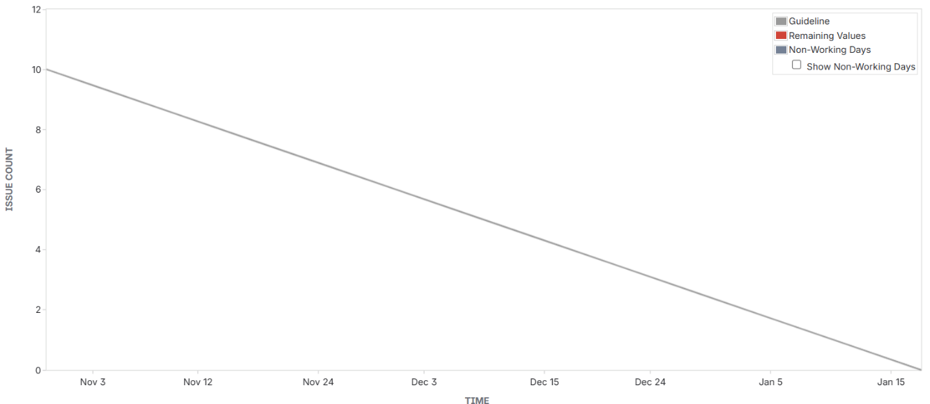
Burndown chart-
Burnup Chart-
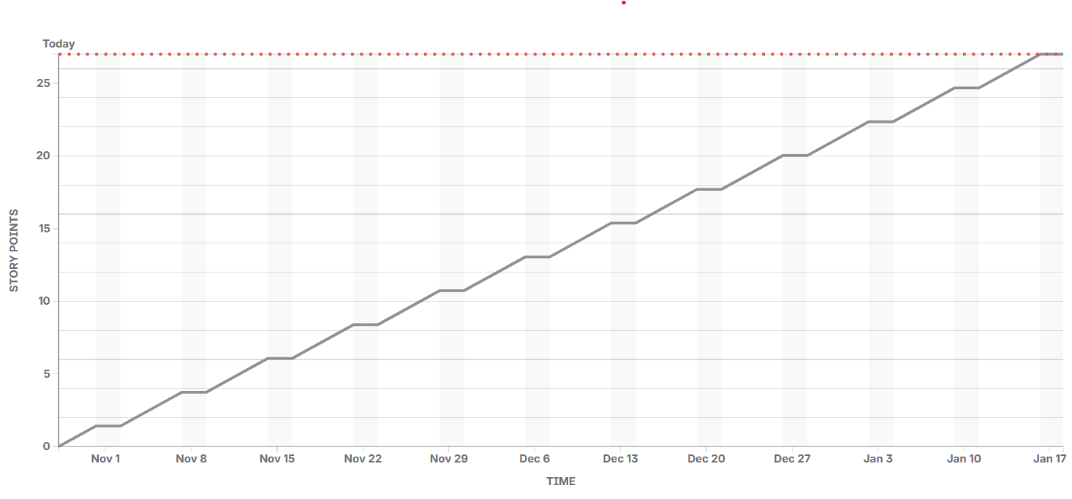
Sprint Burn down chart –
Sprint burn down chart shows how much work is remaining in the sprint day by day . it’s known as the sprint burndown chart. Its maintain by scrum master . it’s a daily graph. Its shows how much work remaining .
Product burn down chart –
Product burn down chart shows the overall progress of the entire product back log across multiple sprints . its known as product burn down chart.
Q.10 – Explain about Product Grooming
Product Grooming (or Backlog Refinement) is a continuous process in which the Scrum team — including the Product Owner, Scrum Master, and Developers — reviews, updates, and prioritizes the Product Backlog to ensure all user stories are clear, estimated (BV & CP), and ready for the next sprint.

Q.11 – Explain the roles of Scrum Master and Product Owner
Scrum Master:
•The Scrum Master is the facilitator and coach for the Scrum team.
•Ensures the team follows all Agile and Scrum principles properly.
•Conducts Daily Stand-up Meetings, Sprint Planning, Sprint Review, and Retrospective Meetings.
•Removes impediments or challenges faced by the team.
•Acts as a bridge between the Product Owner and Developers, ensuring smooth communication.
Product Owner:
•The Product Owner (PO) represents the client or stakeholder.
•Responsible for creating and managing the Product Backlog.
•Defines User Stories, assigns Business Value (BV), and prioritizes them based on business needs.
•Ensures the team is building the right product that delivers maximum business value.
Q.12 – Explain all Meetings Conducted in Scrum Project
In a Scrum Project, several meetings (also called Scrum Ceremonies) are conducted to ensure smooth communication, planning, and progress tracking throughout the sprint.
1️ Sprint Planning Meeting
•Conducted before the sprint starts.
•All Scrum Developers, Scrum Master, and Product Owner participate.
•The team selects how many User Stories they can complete in the sprint (based on CP and Velocity).
•These selected stories move from Product Backlog → Sprint Backlog.
2️ Daily Scrum (Stand-up Meeting)
•Conducted every day (15 minutes).
•Each Scrum Developer answers 3 questions:
1.What did I work on yesterday?
2.What will I work on today?
3.Are there any challenges or impediments?
•Helps the team stay aligned and identify blockers early.
3️ Sprint Review Meeting
•Conducted at the end of the sprint.
•All stakeholders (Scrum Team, Product Owner, Client, Reviewers) participate.
•he team demonstrates the product increment (completed user stories).
•Velocity and CP covered (27 CP) are discussed.
4️ Sprint Retrospective Meeting
•Conducted after the Sprint Review.
•Only Scrum Developers and Scrum Master attend.
•They discuss:
•What went well?
•What challenges were faced?
•What can be improved in the next sprint?
5️ Product Grooming (Backlog Refinement) Meeting
• Conducted regularly during the project.
• Product Owner and Scrum Team review the Product Backlog.
• They refine, split, and re-prioritize user stories, and assign BV and CP values.
Q.13 – Explain Sprint Size and Scrum Size
Sprint Size:
•Sprint Size means the duration of one sprint, which defines how long the team works to complete selected user stories.
•It is usually 2 to 4 weeks depending on the project.
Scrum Size:
•Scrum Size refers to the number of Scrum Developers (team members) working in the Scrum team.
•Ideally, a Scrum team has 8 members for effective communication and performance.
Q.14 – Explain DOR and DOD
DOR (Definition of Ready):
•DOR means a User Story is ready for development.
•It has all required details like description, acceptance criteria, BV, CP, and dependencies clearly defined.
•Only stories meeting the DOR are moved into the Sprint Backlog.
DOD (Definition of Done):
• DOD means a User Story is completely finished.
• The code is developed, tested, reviewed, and accepted by the Product Owner.
• It meets all acceptance criteria and is ready for delivery or demo.
Q.15 – Explain Prioritization Techniques and MVP
1️.Prioritization Techniques:

Prioritization techniques help the Product Owner decide which user stories or features should be developed first based on Business Value (BV), urgency, and customer needs.

Common techniques include:
•MoSCoW Method:
•M – Must Have (critical features)
•S – Should Have (important but not urgent)
•C – Could Have (nice to include)
•W – Won’t Have (not needed now)
Kano Model:
•Focuses on customer satisfaction by classifying features into Basic, Performance, and Excitement (Delighter) needs.
WSJF (Weighted Shortest Job First):
•Formula: BV ÷ CP (Complexity Points)
•Helps deliver high-value, low-effort items first.
2️.MVP (Minimum Viable Product):
•MVP is the simplest usable version of a product that delivers core features and provides value to users early.
•It allows teams to test ideas, gather feedback, and make improvements in future releases.
Example:
In a food delivery app, the MVP includes:
• User registration
• Menu display
• Order and payment system
Advanced features like reviews or chat can come later.
Q.16 – Difference between Business Analyst n Product Owner
Business Analyst | Product Owner
Focuses on understanding business needs and documenting requirements. | Focuses on maximizing product value and managing the product backlog.
Gathers, analyses , and communicates requirements between stakeholders and the team. | Prioritizes user stories, defines vision, and ensures the team builds the right product.
Provides insights and recommendations but usually does not make final decisions.  Works closely with users, clients, and the Product Owner. | Has final decision-making power on what goes into the product.  Works with stakeholders and Scrum team to deliver business value.
Ensure requirements are clear and complete. | Ensure the product delivers maximum value to the business and users.
Q.17 – Prepare a sample Resume of 3yrs exp Product Owner

Name: Liza rani nayak
Email: nayaklizarani13@gmail.com
Mobile: +91-6372819184
Location: Hyderabad, India
Professional Summary:
Results-driven Product Owner with 3 years of experience in Agile and Scrum environments. Skilled in defining product vision, prioritizing backlog, and collaborating with cross-functional teams to deliver high-value software solutions. Strong understanding of business requirements, user stories, and sprint planning.
Key Skills:
•Agile & Scrum Methodology
•Product Backlog Management
•User Story Creation & Prioritization (BV & CP)
•Sprint Planning & Review
•Stakeholder Management
•Requirement Gathering & Analysis
•Jira & Confluence
•Communication & Team Leadership
Professional Experience:
Product Owner – Scrum Foods Pvt. Ltd.
Jan 2022 – Present
Responsibilities:
•Defined and maintained the product backlog with over 50 user stories.
•Collaborated with Scrum Master and 8 Scrum Developers during sprint planning.
•Prioritized features based on Business Value (BV) and Complexity Points (CP).
•Conducted Sprint Review and Retrospective meetings.
•Coordinated with clients to refine requirements and deliver the MVP successfully.
•Ensured all stories met DOR and DOD criteria before and after sprint execution.
•Increased team velocity from 20 CP to 27 CP per sprint through efficient backlog grooming.
Education:
Bachelor of business administration (BBA)
Presidency collage Berhampur – 2022
Certifications:
•Certified Scrum Product Owner (CSPO) – Scrum Alliance
•Agile Business Analyst – COEPD
Tools & Technologies:
•Jira, Trello, Confluence
•MS Excel, PowerPoint, Visio
•Slack, Microsoft Teams
Achievements:
•Delivered 6 successful sprints with consistent on-time delivery.
•Improved customer satisfaction by 25% through clear prioritization and MVP focus.
•Recognized as “Best Product Owner of the Quarter” in 2024.

