QUESTION 1 - Draw a Use Case Diagram
Ans:
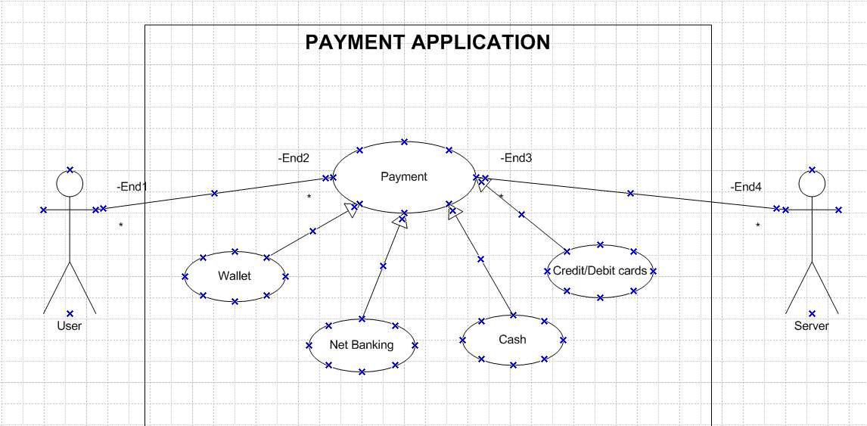
Payment options are neither exclude nor include it can be named under generalization as all cash, card, wallet, net banking are payment types

QUESTION 2 - Derive Boundary Classes, Controller classes, Entity Classes.
Ans:
Entity Class:
Entity classes represent the core business objects or concepts that the system manages. They encapsulate the data and business logic related to the system's domain. They often have attributes and methods related to the core business operations.

Entity Class, Persistent class
Boundary class:
Boundary classes represent the interaction points between the system and its external entities, such as users or external systems, they are responsible for handling input and output.

Boundary Class or FORM Class
Controller class:
Controller classes mediate between the boundary classes and the entity classes. They handle the flow of control and coordinate the system's behaviour. Controllers receive input from the boundary classes, process it, and interact with the entity classes to perform the necessary actions

Controller class or transient class

DIAGRAM:
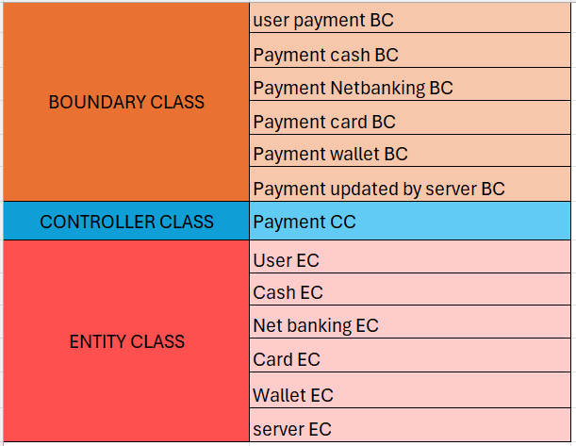

QUESTION 3 - Place these classes on a three tier Architecture
Ans:
Guidelines to place identified MVC Classes in 3 tier Architecture:
- Place all entity classes in DB Layer
- Place primary actor associated Boundary Class in Application layer
- Place Controller class in Application Layer
- If governing body influence or reusability is there with any of remaining boundary classes, place them in business logic layer else place them in application layer

Customer payment Payment Pay by cash
(Boundary class) (Controller Class) (Boundary class)
______________________________ApplicationLayer_________________________________
Pay by card pay by wallet pay by net banking
(Boundary Class) (Boundary Class) (Boundary Class)
______________________________Business logic layer________________________________

User Wallet Net banking Card Cash Server
(Entity Class)
_____________________________Data base Layer___________________________________

QUESTION 4 - Explain Domain Model for Customer making payment through Net Banking
Ans:
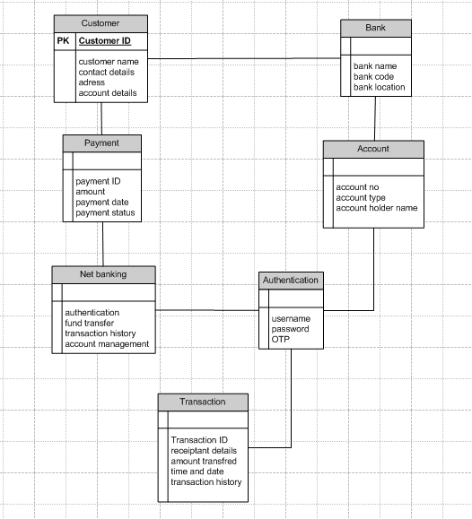

Domain Model is a visual representation connecting the relationship between different entities and components in Database, this incorporates both behavior and data in those entities.
QUESTION 5 - Draw a sequence diagram for payment done by Customer Net Banking
Ans:
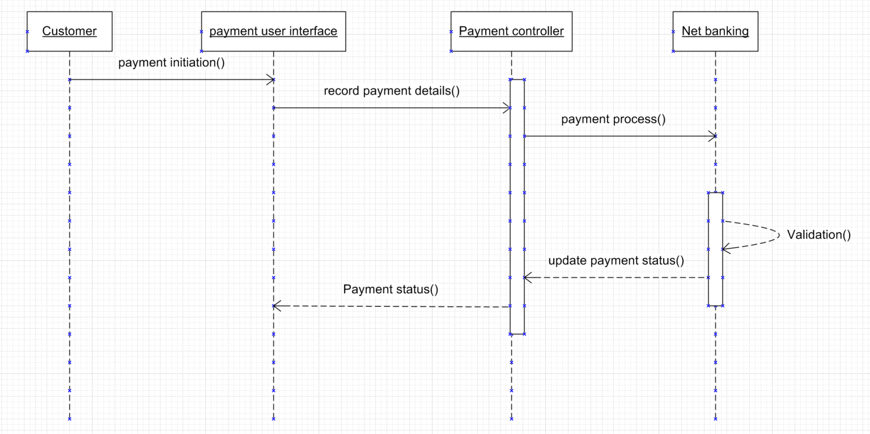

QUESTION 6 - Explain Conceptual Model for this Case
Ans:
A conceptual model is a high – level representation of a system that helps in understanding, visualizing and communication the essential aspects of a domain. It provides a clear and simplified view of the domain making it easier to understand
In our case study customer using net banking provides a high level understanding of key concepts and relationships involved in the payment transaction. It helps to visualize the overall structure and flow of the payment process. Concept is that a customer can make a payment either by Card or by Wallet or by Cash or by Net banking.

Q7. What is MVC architecture? Explain MVC rules to derive classes from use case diagram and guidelines to place classes in 3-tier architecture
Ans:
MVC Architecture indicates (model – view – controller) it is used to identify the classes from the usecase diagram. Classes are basic building blocks of code. There are 3 types of classes

Model:
Model class knows about all the data that need to be displayed, and which is aware about all the operations that can be applied to transform that class. It only represents the data of application.
View:
The view represents the presentation of the application the view class refers to the model. Views are created by the data which is collected by the model component, but these data aren’t taken directly but through the controller. It only interacts with the controller.
Controller:
The controller is the component that enables the interconnection between the views and the model, so it acts as an intermediary it just tells the model what to do. Controller class is working based on the user’s command.
MVC Rules:
- Combination of one actor and an usecase results in one boundary class
- Combination of two actors and an usecase results in two boundary classes
- Combination of three actors and an usecase results in three boundary classes and so on….
NOTE: Only one primary actor is to be considered with a usecase
- Usecase will result in a controller class
- Each actor will result on one entity class
Guidelines to place classes in 3-tier architecture:
- Place all entity classes in DB Layer
- Place primary actor associated Boundary Class in Application layer
- Place Controller class in Application Layer
- If governing body influence or reusability is there with any of remaining boundary classes, place them in business logic layer else place them in application layer.

Q8. Explain BA contributions in project (Waterfall Model – all Stages)
Ans:
In Waterfall Model, a Business Analyst (BA) plays a crucial role in each stage:
- Requirement Gathering:
- Stakeholders identify
- Client gives BRD or BA prepares BRD by interacting with Client — Elicitation techniques (Brainstorming, Document Analysis, Reverse engineering, Interviews, workshops, Focus Groups, Observation, Questionnaires).
- Prototyping for more specific requirements
- Sort the gathered Requirements
- Prioritize requirements — MoSCoW
- Validate Requirements - FURPS
- Requirement analysis:
- Draws UML Diagrams (Use case and Activity Diagrams)
- Prepares Functional Requirements from Business Requirements
- Technical teams comes up with Technical Requirements (Supplementary Support Doc)
- SRS (Software Requirements Specification) will have Functional Requirements and Technical Requirements
- Takes Signoff on SRS from Client.
- BA prepared Requirements Traceability Matrix from SRS (BA owns RTM).
- Design:
- From Use case Diagram, Test Manager or BA will
- prepare Test Cases
- Communicates with Client on the design and
- Solution documents (updates Status to Client and
- make them understand how the solution would look
- like to prepare them to drive UAT)
- Preparation of End user manuals by BA
- updates RTM
- Implementation (Coding):
- BA organizes JAD Sessions
- BA clarifies queries of Technical Team during Coding
- Developers refer to Diagrams drawn by BA and code their unit
- Update End user manuals
- Update RTM
- Conducts regular Status meetings with technical team and the Client and tuning Client for participation in UAT
- Testing:
- BA Prepares Test Cases from Use Cases
- BA performs high level testing
- BA prepares Client for UAT
- Test Data is requested by BA from Client
- Updates End User Manuals
- Updates RTM
- Take signoff from Client on Client Project
- Acceptance form
- Deployment and implementation:
- Forwards RTM to Client attached to the Project Closure Document
- Coordinates to complete and share End User Manuals
- Plans and Organizes Training Sessions for End Users
- Prepares Lessons learned from this project

Q9. What is conflict management? Explain using Thomas – Kilmann technique
Ans:
Conflict Management:
Conflict management means handling disagreements or clashes between people in a smart way so that things don’t get worse. The aim isn’t to completely avoid conflicts, but to deal with them calmly so that work goes on smoothly and relationships stay good.
Thomas–Kilmann Technique:
This model explains that people handle conflicts in different ways based on two things:
- Assertiveness: How much you care about your own needs.
- Cooperativeness: How much you care about others’ needs.
From these, there are five main conflict resolution strategies:
- Competing (High Assertive, Low Cooperative)
- You try to win the argument without thinking much about others.
- Example: A manager forces their decision without listening to others.
- Collaborating (High Assertive, High Cooperative)
- You and others work together to find a win–win solution.
- Example: Two teams discuss and come up with an idea that benefits both.
- Compromising (Medium Assertive, Medium Cooperative)
- Both sides give up something to meet in the middle.
- Example: Two teams agree to share resources equally.
- Avoiding (Low Assertive, Low Cooperative)
- You ignore or delay the conflict instead of solving it.
- Example: A student stays quiet in a group discussion to avoid an argument.
- Accommodating (Low Assertive, High Cooperative)
- where an individual neglects their own concerns to satisfy the concerns of the other party.
- Example: You agree with your friend’s idea just to maintain harmony.
HIGH
COLABORATING
COMPETING
ASSERTIVENESS

COMPROMISING
AVOIDING
ACCOMODATE

LOW
COOPERATIVENESS
HIGH
LOW

Q10. List down the reasons for project failure
Ans: The reasons for project failure:
- Improper requirement gathering
- Continuous change in requirement
- Lack of user involvement
- Lack of executive support
- Unrealistic expectations
- Improper planning

Q11. List the Challenges faced in projects for BA
Ans:
- Changing Requirements
- Stakeholder Management
- Lack Of Stake Holder Involvement
- Managing Conflicts and Negotiation
- Project Communication
- Time And Resource Constraints
- Resistance To Change

Q12. Write about Document Naming Standards
Ans:
Naming Standards for documents in a project is very essential for maintaining the clarity and consistence. There are some aspects which we must remember while naming the documents
- File name should be short
- Include unique identifiers
- Include the numbers for better understanding
All documents will be named using some standards like [Project ID] [Document Type] V [x] D [y]. ext.
Example: PQ789BRDV1D2.docx
PQ789BRD1.2.docx

Q13. What are the Do’s and Don’ts of a Business analyst
Ans:
- Never say NO to Client
- There is NO word called as “BY DEFAULT”
- Never imagine anything in terms of GUI
- Question the existence of existence / question everything I the world
- Consult an SME for Clarifications in Requirements
- Go to Client with a plain mind with no assumptions.
- All mails should be acknowledged
- All project mails should be copied to Project Manager
- BA should follow the decisions taken by Project Manager
- Listen carefully and completely until Client is done and then you can ask your Queries.
- Do not interrupt the Client, when he/ She is giving you the problem.
- Maximum Try to extract the leads to Solution from the Client itself.
- Never try to give Solutions to Client straight away with your previous experience and assumptions.
- Try to concentrate on the important and truly required Requirements.

Q14. Write the difference between packages and sub-systems
Ans:
Packages:
A Package is a collection of components which are not reusable in nature. Packages allow us to partition our system into logical groups and then to relate these logical groups. It can be too confusing or difficult to handle all the classes and their connections at the same time. A package is shown as a large rectangle with a small rectangle or "tab" attached to its top, left side
Example (from Payment Scenario):
A package named Payment Methods can contain:
- Card Payment class
- Wallet Payment class
- Cash Payment class
- Net Banking Payment class
These classes inside the package perform actions like payWithCard(), payWithWallet() — not the package itself.
Subsystems:
Sub Systems are Collection of components which are reusable in nature. These are larger and contain multiple packages or modules. Subsystems help divide a system into smaller parts, so teams can work on specific functions without focusing on the whole system. Subsystems can allow the addition of new features or the modification of existing ones without affecting the entire system.
- A business processing subsystem responsible for implementing business functionality
- A data subsystem responsible for implementing data storage functionality.
Example (from Payment Scenario):
A subsystem named Payment Processing may:
- Contain methods like processPayment(), validatePaymentMethod(), generateReceipt()
- Internally call the right class from Card Payment, Wallet Payment, etc., to complete the payment
The subsystem itself performs actions and coordinates between payment types.

Q15. What is camel-casing and explain where it will be used
Ans:
Entire first word will be in lowercase and subsequent words first letter should be in Upper Case. There will be no gap between words.
Example: camelCaseExample(), turnLeftAndSlowDown()
Usage:
- In programming (variables, methods, classes).
- Document/file naming.
- Database field names.

Q16. Illustrate Development server and what are the accesses does business analyst has?
Ans:
It is a type of server that is designed to use in development and testing of programs, websites, software or applications for software programs. It provides a run-time environment, to perform debugging, testing and development. This is typically a replica of target production environment to ensure accurate testing and compatibility
A BS need following access
- Read-Only Access
- Limited Write Access for Testing
- Access to Test Environments

Q17. What is Data Mapping
Ans:
Data mapping is the process of linking data fields from one source to another. It’s like creating a guide or map that shows how data in one place corresponds to data in another place. This is especially important when you are moving data between different systems or database to ensure that the data stays consistent and accurate
If you do not map the Data it will be impossible to retrieve the data for example if you search for any item and data is not mapped then it would take so much of time to show results since the request need to check with all databases when not mapped so there will be so much of delay is showing the product.

Q18. What is API. Explain how you would use API integration in the case of your application Date format is dd-mm-yyyy and it is accepting some data from Other Application from US whose Date Format is mm-dd-yyyy
Ans:
- API stands for Application Programming Interface.
- It is a software intermediary that allows the two applications to communicate with each other.
- It is the set of rules, protocols and tools that define how different software application should interact with each other.
- API allows sharing of only necessary information and keeps the internal system details hidden, which helps the system security.
For the above scenario,
Establish API communication- set up API communication between your application and other applications to exchange data.
Do Data formatting- while sending the data from one application to other, convert the date format from dd-mm-yyyy to mm-dd-yyyy.
While receiving the data from other applications, parse the data and extract the date, month and year and re-arrange them accordingly.
Perform Data Validation and ensure that the converted date remains in a valid format.

