DOCUMENT REVESION

DATE | VERSION NO. | DOCUMENT CHANGE
8-09-2025 | 0.1 | INITIAL

APPROVALS
Role | Name | Title | Signature | date
Project sponsor | Swapna satam | VP
Business Owner | Anil Mehra | Head Retail-
Project Manager | Rina shah | IT product manager
System architecture | S | Led solution architecture
Development lead | Sachin Patil | Technical lead- digital initiatives
User experience lead | Swati Jain | UI/UX Designer
Quality lead | Priya Thomas | QA manager
Content lead | Jagan T Reddy | Documentation and training specialist

RACI MATRIX
NAME | POSITION |  | * | R | A | S | C | I
SUSMITA DEVI | BUSINESS ANALYST |  |  | YES
ANIL MEHRA | BUSINESS OWNER |  | YES |  |  |  |  | YES
RINA SHAH | PROJECT MANAGER |  |  |  | Y |  |  | YES
SAXHIN PATIL | DEV LEAD |  |  | YES
AKSHAY | STAKEHOLDER |  |  |  |  | YES
PRIYA THOMAS | QA LEAD |  |  | YES

Introduction
Business Goals- The milk products manufacturing company ABC Pvt. Ltd. operates multiple manufacturing plants and warehouses across the country. The company produces paneer, butter, packaged milk, and ice-cream (chocolate and vanilla).
Currently, the organization faces challenges in tracking finished goods inventory across different plants and warehouses and in ensuring timely delivery to customers such as distributors, retailers, and institutional buyers.
The ultimate goal of the company is efficient inventory management, quick and reliable delivery and streamlined operations.
Business Objectives- The business objectives is to provide an IT solution by building a software system where the company can easily track and monitor inventory across multiple locations, automatically track inventory levels, orders and sales in real time to reduce manual errors. Gain clear visibility of excess, slow moving stock or nearby expiry stock for better-decision making. Ensure timely and accurate delivery of orders on time to distributors, retailers and partners.
Business Rules
The following business rules will govern the design and functioning of the proposed inventory and delivery management system for ABC Pvt. Ltd.
- Inventory Rules- All finished goods must be tag with match no, manufactured date, expiry date. Perishable products must follow FIFO (First in first out). The system must generate alerts for products nearing expiry. Damaged or expired products must be blocked from delivery and moved into wastage records.
- Orders and delivery rules- Orders will be confirmed if sufficient stock is available at nearest warehouse. If stock is unavailable at the nearest then system must automatically reassign the order to the next warehouse. All orders must be delivered within the agreed timelines. Delivery vehicles must maintain required storage conditions. Frozen and refrigerated.
- Customers and partner rules- only authorized distributors and retailers may place bulk orders in the system. Order cancellation or returns must follow company policy and will not be accepted for expired items. Credit limits for B2B customers must be validated before approving large orders.
- Compliance quality audit rules- All inventory and delivery process must follow with FSSAI guidelines. Cold chain standard must be maintained during storage and transport. The system must maintain audit documents for inventory ad order movements.
Background- The ABC Pvt. Ltd is a milk product manufacturing company who produces products like packaged milk, paneer, butter and ice cream for distribution to retailers.
Over the time the company faced several challenges in its operations.
- Inefficient finished products inventory management- stock was being tracked manually and on fragmented systems, leading to discrepancies and lack of real- time visibility.
- Wasted due to expiry
- Delivery delays- Orders were not routed from the nearest warehouse or unaware of the stock limits in different warehouse.
- Limited reporting and forecasting- Management had no real time view of slow moving, excess, or fast-selling products, making demand planning difficult.
To overcome these challenges, the project was proposed to deliver an integrated software system that can manage finished goods inventory across all locations and ensure the quickest possible delivery to customer.
Project Objective
The objective of this project is to design and implement a centralized Inventory and delivery Management System for ABC PVT. LTD that will address the identity business challenges and align with the company’s organizational goal
The key Objectives are:
- Centralized inventory system- Develop a system to track and monitor finished goods inventory across all manufacturing plants and warehouse. Implement batch tracking, expiring monitoring, and FIFO.
- Automated order management- Provide functionality for capturing, processing, and validating customer codes. Ensure automated warehouse allocation based on product availability and proximity to the customer
- Optimized Delivery Process- Integrate delivery scheduling and route optimization features to ensure timely order fulfillment. Enable real-time delivery tracking and digital proof of delivery.
- Reporting and Analysis- Develop dashboards and reports for sales, stock management, wastage and demand trends. Provide management insights to support forecasting and decision-making.
- System integration and compliance- Ensure compatibility with existing financial/ERP systems for billing and invoicing. Maintain compliance with food safety standards and cold-chain regulations.

Project Scope
The scope of this project is to design and implement an Inventory and Delivery Management System for ABC Pvt. Ltd. to manage finished goods stock and ensure timely delivery to customers. The system will initially focus on finished goods (paneer, butter, milk, and ice-cream) while providing scalability for future product additions.
In-scope functionality
- Finished goods inventory management, order management, delivery management, reporting and analysis, system integration.
Out-scope functionality
- Raw material inventory management, direct B2C portal or mobile app for end customers, AI based demand forecasting and predictive analysis, advanced CRM management.
Assumptions
The following assumptions are made for the successful implementation of the inventory and delivery management system for ABC PVT. LTD
- Product line- The system will initially mange finished goods: paneer, butter, packaged milk, and ice cream. Future product additions can be configured in the system without redevelopment
- Raw material inventory will be handled by separate system, not included in this project scope.
- The primary customers are distributors, wholesalers, and is a B2B.
- All plants and warehouses have reliable internet connectivity to update inventory in real time. Required hardware (servers, handled devices, barcode will be provided). Delivery vehicle are equipped to maintain cold-chain conditions.
- Warehouse will follow all the food standard safety measurements.
- The system will integrate with the company’s ERP/ finance software for billing and invoicing
CONSTRAINTS
The implementation of the Inventory and Delivery Management System for ABC Pvt. Ltd. is subject to certain constraints. The project must be completed within a defined timeframe, as delays may impact upcoming seasonal demand for products such as ice-cream. The budget allocated for this phase restricts development to core functionalities only, with advanced features like raw material tracking, B2C applications, or AI-driven analytics deferred to future phases. From a technology perspective, the system will depend on the company’s existing ERP and finance systems for billing and invoicing, and uninterrupted internet connectivity at manufacturing plants and warehouses is essential for real-time data synchronization. There are also operational constraints, as delivery timelines may be affected by external factors such as road conditions, vehicle availability, or transport restrictions, which are outside the system’s control. Finally, all processes must adhere to regulatory compliance, specifically FSSAI guidelines and cold-chain standards, and any changes in government regulations may require system updates or modifications.
RISK
- Risk involved associated with system downtime or server failure disrupts inventory tracking and order processing.
- Integrating issue with existing warehouse or logistics system.
- Misalignment between business team and technical team
- Non –compliance with food safety rules.
- Business Overview
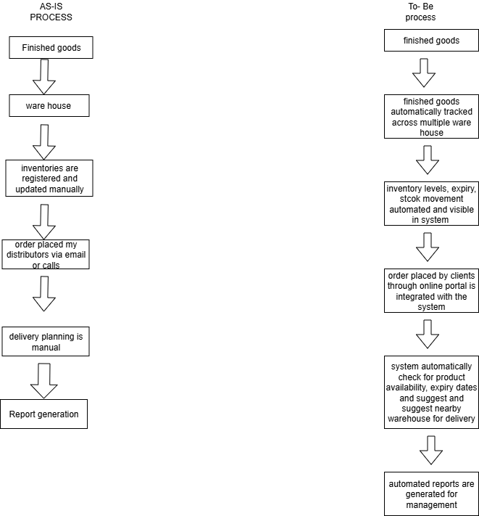

Business Requirements
BR ID | BR STATEMENT | CATEGORY | PRIORITY
BR001 | The system must allow real time tracking of finished goods across multiple warehouse | Functional | high
BR002 | The system must level stocks levels automatically after goods are dispatched or received | Functional | high
BR003 | The system must alert for low-stock, over stock and near-expiry stock | Functional | medium
BR004 | The system must support order placement through online portal by the customers | Functional | high
BR005 | The system must provide delivery planning and timely scheduling to the customer | Functional | low
BR006 | The system must ensure data accuracy, audit trail, and regulatory compliance | Non-functional | high
BR007 | The system should provide role-based access to manager and staff | Non-functional | medium

Process flow diagram
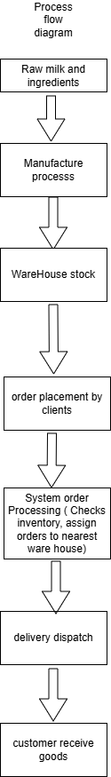

Assignment 2
Dear MR…
I hope this mail finds you well.
My name is Susmita Devi, and I will be working with you as the Business Analyst for your assigned project. My role will be to collaborate with you, your team, and the technical team to understand your business needs, gather project requirements, and ensure that the solution aligns with your organizational goals.
I will facilitate discussions, document requirements, clarify objectives, and support you throughout the project lifecycle to ensure the final product delivers maximum value to your organization.
Over the coming days, I would like to schedule initial discussions with you and the key stakeholders to begin the business understanding process. These sessions will help us clearly define the project scope, identify challenges, and establish a roadmap for successful implementation.
I look forward to working with you on this initiative.
Warm regards,
Susmita Devi
Business Analyst

BRD
Ticketing system of customer care
Business Goal
The company ZEROHA wants to provide a quick customer query support to resolve the issues faced by the company clients. They want an automated ticketing system that accept a customer raised query, assign it to a help desk, resolve/escalated and close the query.
Project Objectives
The business objective of this project is to enable customer to raise issue through their account. The system automatically generated a ticket with unique id no and assign it to a help desk customer support representative. The customer support employee contacts the customer via the registered no or email id to resolve the issue. If the issue cannot be resolved at the first level, the ticket is escalated to a higher specialized support group or manager. Once the query is resolved the ticket status id updated as “ Closed” and an automated confirmation is send to the client.
Business rules
Each ticket must have a unique ID. Tickets must be assigned to a support representative within defined SLA (1 HR). Tickets unresolved within the SLA are auto-escalated to the manager. A ticket is considered closed only after confirmation is sent to the customer.
RACI CHART
NAME | POSITION | * | R | A | S | C | I
SUSMITA DEVI | BUSINESS ANALKYST |  | YES |  |  | YES
RAJESH MEHTA | PROJECT MANAGER | YES |  | YES |  |  | YES
ANJALI SHARMA | CUSTOMER SUPPORT HEAD | YES |  |  |  |  | YES
PRATEEK DWIVEDI | SUPPORT AGENTS |  |  |  | YES | YES
SACHN PATIL | DEVELOPMENT LEAD | YES | YES |  |  |  | YES
VENKATESHWAR IYAR | STAKEHOLDER | YES |  |  |  | YES | YES

Project Scope
In scope
- Customer login and ticket creation
- Automatic ticket ID generation and assignment
- Escalation of unresolved tickets to higher-level managers
- Notifications via email for status updates and closure
- Reporting for number of tickets raised, resolved, pending.
Out scope
- Integration with third-party CRMs.
- AI-based chatbots or automated responses (future scope)
- Mobile application support (Phase 2
Assumptions
- Customers will have valid login credentials and account to raise and track their support tickets
- All tickets will be raised only through the system (not via manual calls/emails outside the system).
- Customer support representatives and managers will be trained to use the ticketing system.
- Email services will be available and reliable for sending automated notifications.
- Internet connectivity will be available for customers and employees to access the system
- Escalation rules (time limits and hierarchy) will be predefined and agreed upon before implementation
Constraints
- The project must be implemented within the allocated budget and timeline agreed by management
- The system will only be available via web application in the initial phase; mobile app support is out of scope for Phase 1.
- Integration with third-party systems (e.g., CRM, Chabot, analytics) is not included in the current phase
- The system depends on internet availability; offline ticket creation is not supported.
- Notifications are limited to email in the current scope; SMS/WhatsApp integration may be considered in the future
- SLA (Service Level Agreement) timelines for ticket resolution must align with company policy and may vary across issue categories
Risks
The implementation of the Customer Support Ticketing System is subject to several risks. From a technical perspective, system downtime, server failures, or disruptions in email services may affect ticket creation and communication, while scalability issues could arise if ticket volumes increase significantly. On the business side, delayed ticket resolution or failure to follow escalation procedures may reduce customer satisfaction and harm the company’s reputation, and there is also a risk of low adoption if support staff continue relying on manual processes. Finally, requirement-related risks include incomplete or unclear requirements leading to gaps in functionality, frequent changes in business rules such as escalation timelines impacting project delivery, and possible misalignment between business stakeholders and the technical team, which may result in rework and delays.
Business requirement
BR ID | BR STATEMENT | CATEGORY | PRIORITY
BR001 | Allow customer to raise queries through their account | Functional | high
BR002 | Automatically assign tickets to available customer care executive | funational | high
BR003 | Allow customer care executive to for escalation mechanism to route unresolved tickets to high level managers | functional | medium
BR004 | Track and display the ticket status as new, assigned, in progress, closed | functional | low
BR005 | Allow customer executive to connect the client via call or email through the system | functional | high
BR006 | Send automated email to customer at key stages – ticket created, ticket resolved | functional | medium
BR007 | Provide reporting and dashboards for monitoring ticket raised, resolved, pending and escalated | functional | medium
BR008 | System should be available 99% of the time to avoid disruption of customer support services | Non-functional | high
BR009 | Secure customer data with proper authentication and authorization controls | Non functional | high

SRS
Ticketing system of customer care
Purpose
The purpose of this document is to define the software requirements for the Customer Support Ticketing System. The system will allow customers to raise issues or queries, generate unique tickets, assign them to support staff, escalate unresolved tickets, and notify customers upon resolution.
Descriptions
Users Needs
Customers- Raise tickets, track status, receive notification
Customer support- resolve tickets assigned to them
Managers- handle escalations, monitor support team.
Administrators- configure system, manage user roles, and generate reports.

Assumptions
- The system will be deployed in secured server
- All users will have reliable internet connectivity to access the system
- Customers and employees will have valid log in credentials
- Email services will always be available
- SLAs rules and regulations will be pre-defined and stored in the system database
- The system will store data in centralized database with proper backup mechanism.
- Each ticket will have one active status at any given time.
- The system will be scalable enough to handle increasing ticket volumes with minor configuration change.

System features and requirement
- Functional Requirements
REQ ID | REQD NAME | REQD DESCRIPTIONS
FR001 | RAISE TICKET | CUSTOMER CAN RAISE TICKET BY LOGIN TO THEIR ACCOUNT> RAISE TICKET OPTION> BY DESCRIBING THE ISSUE> A UNIQUE ticket ID is generated
FR002 | Ticket assignment | System automatically assigns tickets to customer executive. Assign ticket records- assign date, assign time, and employee name
FR003 | TICKET LIFECYCLE | The ticket must pass through statuses: new, assigned, in progress, escalated, resolved, and closed. Status change must be login in the history
FR004 | ESCALATION | TICKETS unresolved within 24 hours is allowed to escalate to managers
FR005 | NOTIFICATION | Customer receives email updates for ticket creation, escalation and closure.
FR006 | REPORTING AND DASHBOARDS | Managers and admins can view reports: ticket raised, resolved, pending and escalated.

- Non-Functional requirement
Reqd id | Reqd name | Reqd description
NR001 | Performance | System should handle at least 500 concurrent users
NR002 | Security | Role- based access. Encrypted communication
NR003 | AVAILABILITY | System must provide 99% uptime
NR004 | Usability | User interface must simple and intituitive.

- Entity-relationship diagram of ticketing diagram

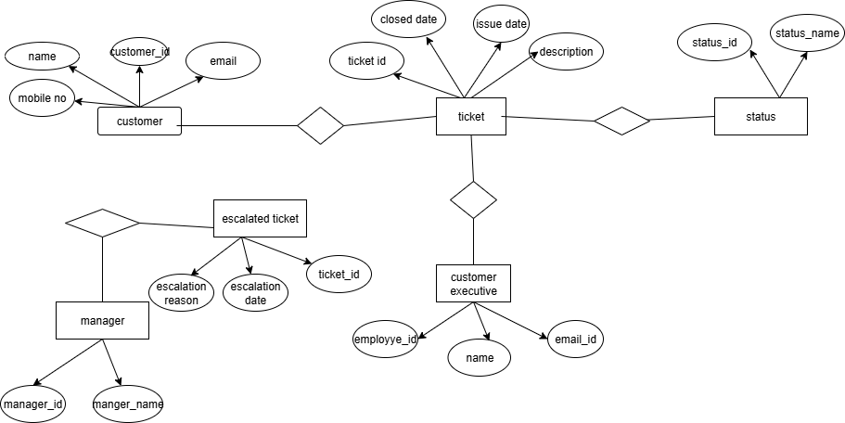

- User-story of shopping from ecommerce

User Story: 1 | Task- 2 |  | Priority highest
As a customer i want to register into the website
So that I can the browse the website
BV 200 |  | CP 3
Acceptance criteria
name, email id or mobile no. must be provided, otp verification of email id and mobile no. user should be able to create password

User Story: 2 | Task- 3 |  | Priority medium
As a customer
I want to login into the website
So that I can browse and place orders

BV 500 |  | CP 5
Acceptance criteria
user must login through his email id/ mobile no, password.
User should be able to retrieve his password through Forgot password.
Invalid credentials should show an error

User Story: 3 | Task- 2 |  | Priority highest
As a customer I want to place an order
So that I can buy the products

BV 100 |  | CP 13
Acceptance criteria
– user can select product and proceed to checkout
User can add/edit their delivery address,
System should be able to capture name, address and payment method
Order confirmation email or message sent to the customer

User Story: 4 | Task- 2 |  | Priority medium
As a customer
I want to view the list of products
So that I can select a range of products

BV 200 |  | CP 5
Acceptance criteria- displayed with categories.
User can filter and search product.
Product must show name, price and availability

User Story: 5 | Task- 2 |  | Priority low
As a customer
I want to add the products in the wish list
So that I can buy it later

BV 50 |  | CP 2
Acceptance criteria- user can add a product to wish list.
User can remove a product from wish list.

User Story: 6 | Task- 5 |  | Priority highest
As a Customer
I want to make payments online
So that I can complete my purchase successfully

BV 500 |  | CP 8
Acceptance criteria- can select multiple payment mode (e.g. card, net banking, upi)
User should get a payment confirmation

User Story: 7 | Task- 2 |  | Priority low
As a customer
I want to track my order
So that I get the deliver status

BV 20 |  | CP 3
Acceptance criteria- order id track. Status update as (processing, shipped, out for delivery, delivered)

User Story: 8 | Task- 5 |  | Priority high
As a customer
I want to cancel my order before my purchase
So that I can manage my purchases

BV 500 |  | CP 3
Acceptance criteria- cancellation option available until shipped

User Story: 9 | Task- 2 |  | Priority low
As a customer
I want to return my product after receiving
So that I can accept only good quality or right product
.
BV 20 |  | CP 8
Acceptance criteria- user can return up to 7 days after receiving
Refund of amount to account within 3 days
.

User Story: 10 | Task- 2 |  | Priority medium
As a customer
I want to add remove multiple quantity of products
So that I can increase, decrease quantity
BV 50 |  | CP 3
Acceptance criteria- customer increase, decrease quantity of products.
System automatically adjust price accordingly .
If stock exceeds, system should show an msg

User Story: 11 | Task- 2 |  | Priority low
As a customer,
I want to rate and review
So that other customer can make a decision

BV - 20 |  | CP 5
Acceptance criteria- user should be able to describe and edit and delete review later, rate should be out 5 stars, and upload picture

User Story: 12 | Task- 2 |  | Priority low
As a customer
I want to view the review of the products
So that I can make a firm decision of the product quality
BV 20 |  | CP 3
Acceptance criteria- overall review summary, review per customer, list of review as per the ratings

