Capstone Project 1 (Part 3/3)

Online Agriculture Product Store

Question 1: Identify minimum 20 functional requirements
Answer:
- Functional Requirements:
  - Functional requirements describe the behavior and information that the solution will manage. They describe the capabilities the system will be able to perform in terms of behaviors and operations.
  - Functional requirements define what the system should do. They describe the specific actions, behaviors, and features that enable users to perform operations.
  - In this project, functional requirements will explain how farmers, manufacturers, and admins will interact with the Online Agriculture Product Store - such as registration, browsing products, placing orders, and tracking deliveries.
- Non Functional Requirements:
  - Non Functional Requirements captures conditions that do not directly relate to the behavior or functionality of the solution, but rather describe environmental conditions under which the situation must remain effective or qualities that the systems must have.
  - They are also known as quality or supplementary requirements. These can include requirements related to the capacity, speed, security, availability and the information architecture and presentation of the user interface
  - In this project, they ensure that the application loads fast, is secure for online payments, and remains easy to use even in rural low-bandwidth areas.
Req ID | Req Name | Req Description | Priority
FR0001 | Farmer Registration | Farmers should be able to register with the application using Email ID / Phone Number/Google Account and create a secure password. | 10
FR0002 | Farmer Search for Products | Farmers should be able to search for fertilizers, seeds, and pesticides using keywords and filters. | 9
FR0003 | Manufacturer Registration | Manufacturers should register with business name, GSTIN, and contact details for verification. | 10
FR0004 | Product Upload | Manufacturers should upload product details such as name, SKU, description, price, stock, and images. | 10
FR0005 | Product Approval Workflow | Admin should review and approve products uploaded by manufacturers before publishing. | 9
FR0006 | Product Catalog Browsing | Farmers can browse all listed products with category, sorting, and pagination. | 9
FR0007 | Product Details Page | Displays complete product info- manufacturer, safety info, stock, and price. | 8
FR0008 | Add to Cart | Farmers can add products to a shopping cart and modify quantities. | 9
FR0009 | Wishlist / Buy Later | Farmers can add items to a wish list for future purchases. | 7
FR0010 | Checkout Process | System allows reviewing cart, adding address, selecting delivery, and proceeding to payment. | 10
FR0011 | Payment Gateway | Integrates secure payment via UPI, Credit/Debit Cards, and COD. | 10
FR0012 | Order Generation | System creates order ID, calculates taxes, and generates invoice for successful orders. | 9
FR0013 | Email & SMS Notifications | Sends notifications for registration, order confirmation, payment, and delivery updates. | 9
FR0014 | Delivery Tracking | Farmers can track the current status and expected delivery date. | 9
FR0015 | Manufacturer Dashboard | Allows managing products, editing details, and viewing sales reports. | 8
FR0016 | Admin Dashboard | Enables admins to monitor users, transactions, and approve products. | 8
FR0017 | Returns & Refunds | Farmers can request product returns or refunds within a policy window. | 7
FR0018 | Product Reviews & Ratings | Farmers can rate and review purchased products; manufacturers can view feedback. | 6
FR0019 | Purchase History | Farmers can view order history and reorder previous products. | 8
FR0020 | Multilingual Interface | Supports multiple languages (English + local language) for accessibility. | 7

Non Functional Requirements:
Req ID | Req Name | Description | Priority
NFR0101 | Fast Loading | Every page (Home, Cart, Checkout) should open quickly — within 2 seconds. | 9
NFR0102 | Easy to Use | The app and website should be simple so even first-time users can use them easily. | 10
NFR0103 | Always Available | The system should work most of the time without going down (around 99 % uptime). | 9
NFR0104 | Safe and Secure | All passwords and payment details should be kept private and protected. | 10
NFR0105 | Mobile Friendly | The design should fit well on mobile phones, tablets, and computers. | 9
NFR0106 | Works in Low Internet | The system should still run properly even with slow or weak internet. | 8
NFR0107 | Reliable Payments | Payment should not fail unnecessarily; if it fails, users can retry easily. | 8
NFR0108 | Language Support | Farmers should be able to choose English or a local language for ease. | 7
NFR0109 | Quick Help Support | If users face issues, support should reply within 24 hours. | 6
NFR0110 | Secure Data Backup | All user and order data should be safely backed up daily. | 8

Question 2: Make wireframe and prototypes

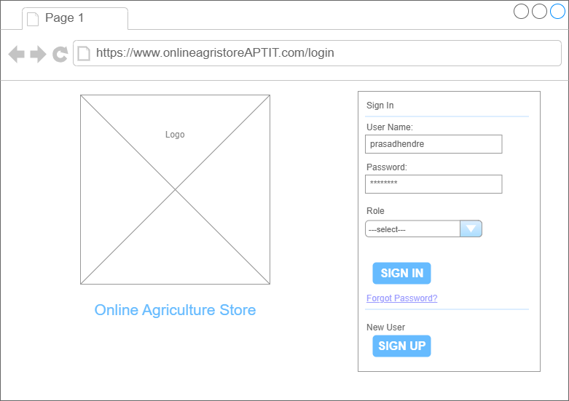
Login Page

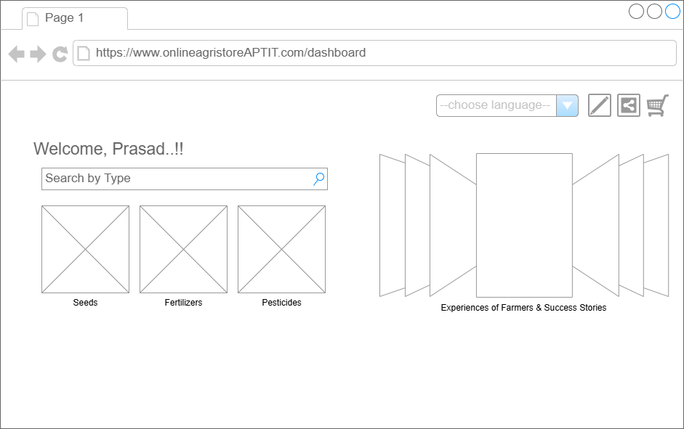
Homepage/Dashboard
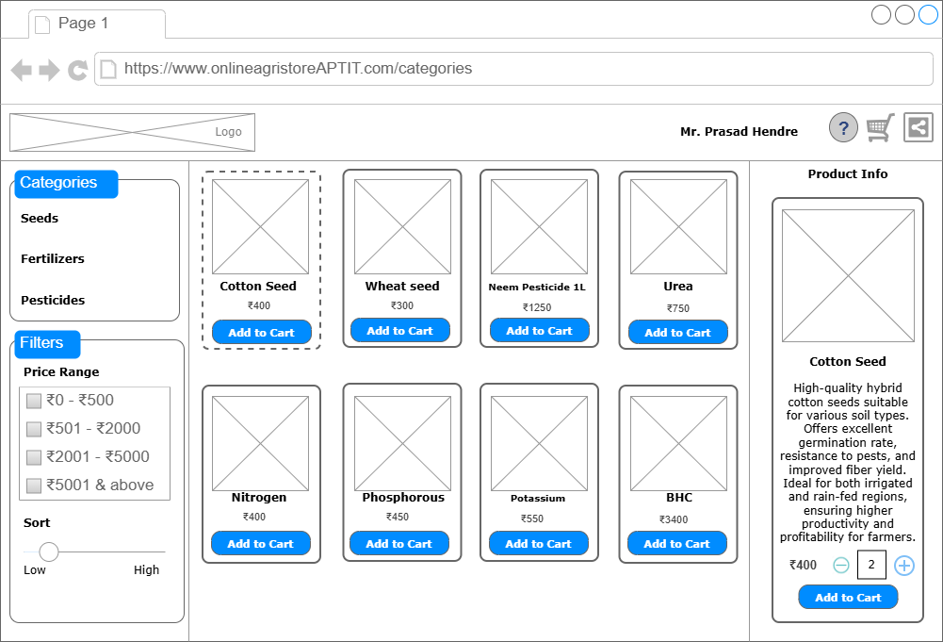
Product Screen Page
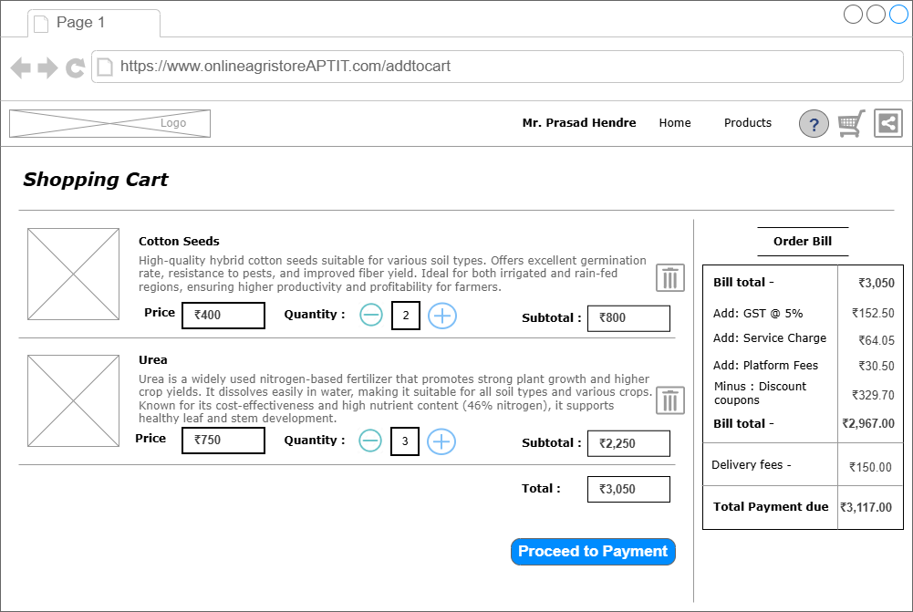
Shopping Cart Screen
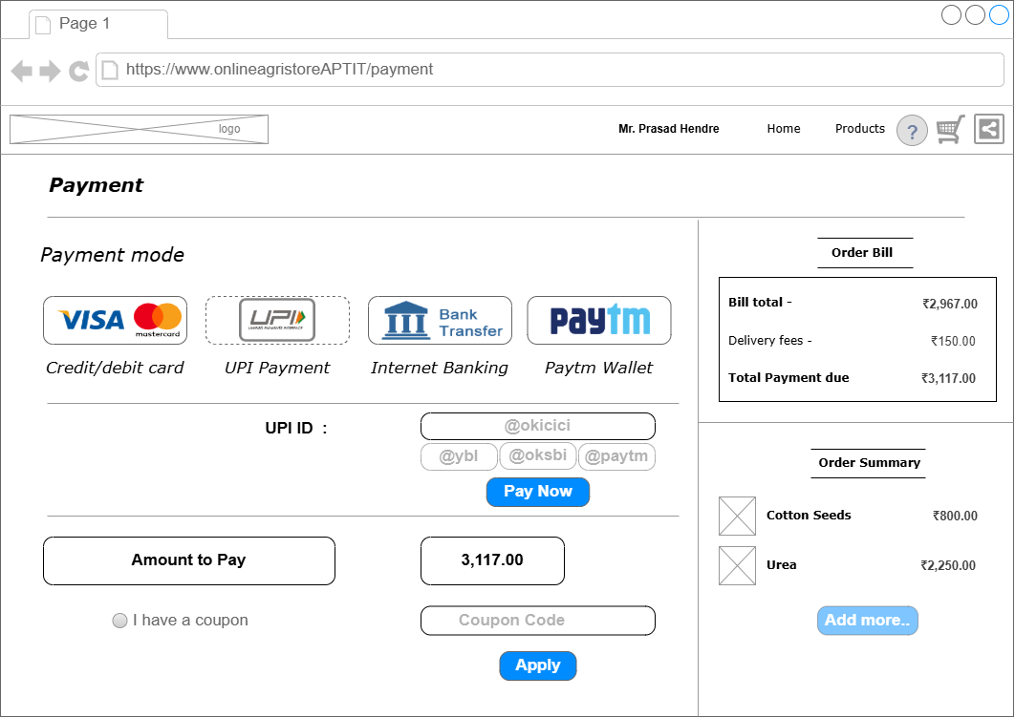
Payment Screen
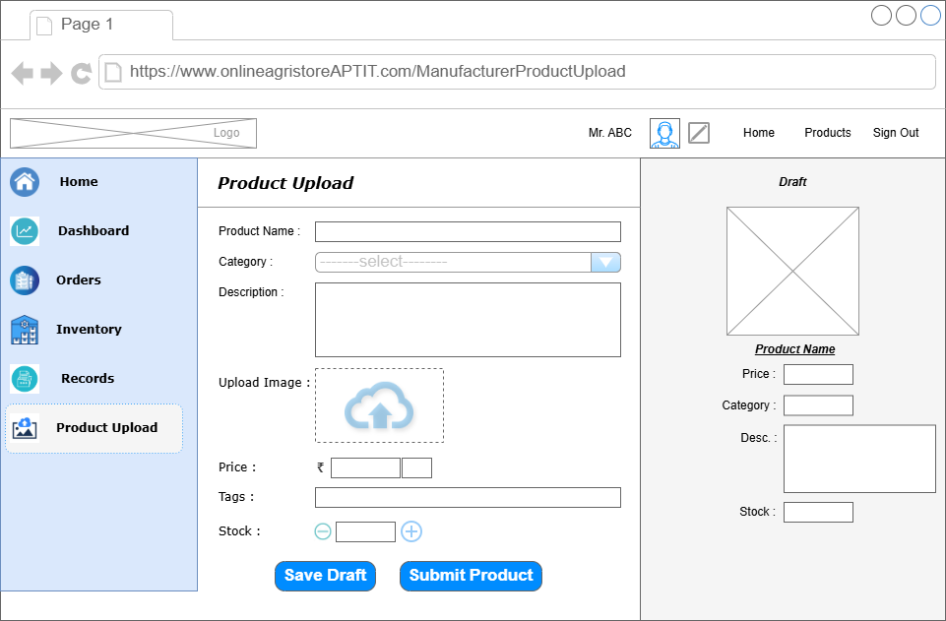
Manufacturer Product Upload
Below is the Prototype Link of Azure Prototype.rp

Question 3: Make a note of the Tools, which you are using for above concepts.
Answer:
For making the Use case and Activity diagrams I have used Microsoft Visio and for making wireframes and prototypes, I have used Axure RP Pro and Draw.io. Below is my understanding of the tools.
1. Microsoft Visio
Microsoft Visio is a tool used to make clear and organized diagrams that explain how a system or process works. I used Visio to draw use case diagrams, activity diagrams for the Online Agriculture Product Store project. It helped me show the relationship between farmers, manufacturers, and the system in an easy-to-understand way. The ready-made shapes and templates in Visio made it simple to create neat and professional diagrams. These diagrams make it look simple for the stakeholders to understand the process and usage of the system. The diagrams created in Visio can also be used for the IT development team for better clarity on the system requirements. Overall, Visio would help me communicate complex ideas in a simple and well-presented manner.
2. Draw.io
Draw.io is a free, easy-to-use online tool that helped create flowcharts and diagrams quickly. I would use Draw.io to prepare simple system diagrams and mock-ups for discussion. It allowed me to draw easily using drag-and-drop features and make changes instantly based on feedback. Because it works directly in the web browser, I could access my diagrams anytime without installing any software. It can be used to share the diagram with internal stakeholders for any review and updates. I found it very handy converting concepts into clear visuals. Overall, Draw.io will be perfect for making quick and simple diagrams that would support the project discussions and planning.
3. Axure RP Pro
Axure RP Pro is a tool used to design and show how screens or pages of a website or app will look and work before they are actually built. I used it to create sample designs (mock-ups) for key pages of the system. It helped in showing what users will see on the screen and how they can move from one page to another. This will make it easy for everyone, especially non-technical members, to understand how the final system would appear. The tool also allowed me to explain features like buttons, menus, and order steps clearly. It will help developers and testers visualize the layout and make sure everything will be user-friendly. Overall, Axure RP Pro would be very useful for designing a simple and practical user experience for the farmers who will use this application.
Using Microsoft Visio, Draw.io, and Axure RP Pro together will help me plan, design, and explain the Online Agriculture Product Store project more clearly. These tools will make it easy to show both the process flow and the look of the system, even to people without a technical background. It will also improve teamwork, understanding, and presentation of the project at every stage.

Question 4: A business analyst’s key responsibilities are to keep track of the requirements and make sure that no requirement is missed. Mr. Henry and peter have approached you regarding the current status of the project. How will you tackle this situation? Prepare RTM
Answer:
A Requirement Traceability Matrix (RTM) is used by a Business Analyst to track whether each requirement has been properly designed, developed, and tested.
If Mr. Henry or Peter ask about the project status, I would show them this RTM to confirm that every functional and non-functional requirement is covered in the design, development, and testing stages.
It helps ensure that no requirement is missed, and all features are progressing as per the project plan.
Req ID | Req Name | Req Description | Design | Code | UT (Unit Testing) | CT (Component Testing) | ST (System Testing) | UAT (User Acceptance Testing)
FR0001 | Farmer Registration | Farmers should be able to register using email/phone and password. | Complete | Complete | Complete | Complete | Complete | Incomplete
FR0002 | Search Products | Farmers should be able to search for fertilizers, seeds, and pesticides. | Complete | Complete | Complete | Complete | Incomplete | Incomplete
FR0003 | Manufacturer Registration | Manufacturers can register with company and GST details. | Complete | Complete | Complete | Incomplete | Incomplete | Incomplete
FR0004 | Product Upload | Manufacturers can upload product details and stock. | Complete | Complete | Complete | Complete | Complete | Incomplete
FR0005 | Product Approval | Admin should review and approve products before display. | Complete | Complete | Complete | Incomplete | Incomplete | Incomplete
FR0006 | Product Catalog | Farmers can browse and filter products by category and price. | Complete | Complete | Complete | Complete | Complete | Incomplete
FR0007 | Product Details Page | Shows full product info like price, stock, and safety instructions. | Complete | Complete | Complete | Incomplete | Incomplete | Incomplete
FR0008 | Add to Cart | Farmers can add and update products in the cart. | Complete | Complete | Complete | Complete | Incomplete | Incomplete
FR0009 | Wishlist / Buy Later | Farmers can save items for later purchase. | Complete | Complete | Complete | Complete | Incomplete | Incomplete
FR0010 | Checkout Process | Farmers can confirm address, delivery, and payment. | Complete | Complete | Complete | Complete | Complete | Complete
FR0011 | Payment Options | Supports UPI, Cards, and Cash on Delivery. | Complete | Complete | Complete | Complete | Complete | Complete
FR0012 | Order Generation | System should generate order ID and invoice for every order. | Complete | Complete | Complete | Complete | Incomplete | Incomplete
FR0013 | Notifications | Send email/SMS confirmation after registration and orders. | Complete | Complete | Complete | Complete | Complete | Complete
FR0014 | Delivery Tracking | Farmers can track order progress and delivery status. | Complete | Complete | Complete | Complete | Incomplete | Incomplete
FR0015 | Manufacturer Dashboard | Manufacturers can manage inventory and view orders. | Complete | Complete | Complete | Incomplete | Incomplete | Incomplete
FR0016 | Admin Dashboard | Admin can approve products and manage users. | Complete | Complete | Complete | Complete | Complete | Incomplete
FR0017 | Returns & Refunds | Farmers can request product returns or refunds. | Complete | Complete | Complete | Complete | Incomplete | Incomplete
FR0018 | Product Reviews | Farmers can rate and review purchased products. | Complete | Complete | Complete | Complete | Incomplete | Incomplete
FR0019 | Purchase History | Farmers can view and reorder previous items. | Complete | Complete | Complete | Complete | Complete | Incomplete
FR0020 | Multilingual Support | Application supports English and local language. | Complete | Complete | Complete | Complete | Complete | Complete
NFR0101 | Page Loading Time | Each page should load within 2 seconds. | Complete | Complete | Complete | Complete | Complete | Complete
NFR0102 | Easy to Use | System should be simple and user-friendly for farmers. | Complete | Complete | Complete | Complete | Complete | Complete
NFR0103 | Always Available | Application should work 99% of the time. | Complete | Complete | Complete | Complete | Incomplete | Incomplete
NFR0104 | Safe & Secure | Passwords and payment data must be protected. | Complete | Complete | Complete | Complete | Complete | Complete
NFR0105 | Mobile Friendly | Website and app should adjust to different screen sizes. | Complete | Complete | Complete | Complete | Complete | Complete
NFR0106 | Works on Low Internet | System should function smoothly with slow connections. | Complete | Complete | Complete | Complete | Incomplete | Incomplete
NFR0107 | Reliable Payments | Payment should complete without frequent failures. | Complete | Complete | Complete | Complete | Complete | Complete
NFR0108 | Language Support | System should support English and local language. | Complete | Complete | Complete | Complete | Complete | Complete
NFR0109 | Quick Help Support | Users should receive help responses within 24 hours. | Complete | Complete | Complete | Complete | Incomplete | Incomplete
NFR0110 | Secure Data Backup | Data should be backed up daily for safety. | Complete | Complete | Complete | Complete | Complete | Incomplete

Question 5: Prepare 10 Test Case Documents
Answer
A Test Case Document is a detailed record prepared by testers to verify that every function of the system works as expected.
It defines the input data, testing steps, expected results, and actual outcomes for each feature.
These documents help ensure that all requirements are properly tested, and any issues are identified early.
Well-written test cases also make it easier for both developers and stakeholders to understand whether the system meets business needs.
- Test Case Document 1: Farmer Registration
Test Case ID | OAPS_TC001 | Project ID | OAPS001
Project Name | Online Agriculture Product Store | Tester Name | Ms. Alekya
Test Case Name | Farmer Registration | PM Name | Mr. Vandanam
Scenario | Verify that a farmer can register successfully with valid inputs.

Input Data | Set 1 | Set 2 | Set 3
Name | Ramesh | Suresh | Anita
Email | ramesh@gmail.com | suresh@yahoo.com | anita@outlook.com
Phone | 9876500011 | 9876500022 | 9876500033
Password | Test@123 | Test@234 | Test@345
Confirm Password | Test@123 | Test@234 | Test@345
Role | Farmer | Farmer | Farmer
Expected Behavior | Account created and OTP sent | Account created and OTP sent | Account created and OTP sent
Actual Behavior | As expected | As expected | As expected
Comments | Registration successful | Registration successful | Registration successful
Result | Pass | Pass | Pass

- Test Case 2: Farmer Login and Forgot Password
Test Case ID | OAPS_TC002 | Project ID | OAPS001
Project Name | Online Agriculture Product Store | Tester Name | Ms. Jason
Test Case Name | Farmer Login and Forgot Password | PM Name | Mr. Vandanam
Scenario | Verify login and forgot password functions.

Input Data | Set 1 | Set 2 | Set 3
Email | ramesh@gmail.com | suresh@yahoo.com | anita@outlook.com
Password | Test@123 | Wrong@123 | Blank
Forgot Password | No | Yes | Yes
Expected Behavior | Login successful | Error shown, reset link sent | Reset link sent
Actual Behavior | Works fine | Works fine | Works fine
Comments | Functionality OK | Reset email received | Reset working
Result | Pass | Pass | Pass

- Test Case 3: Product Search
Test Case ID | OAPS_TC003 | Project ID | OAPS001
Project Name | Online Agriculture Product Store | Tester Name | Ms. Alekya
Test Case Name | Product Search | PM Name | Mr. Vandanam
Scenario | Check that product search shows correct results with filters

Input Data | Set 1 | Set 2 | Set 3
Keyword | Urea | Cotton Seed | Neem
Category | Fertilizer | Seed | Pesticide
Price Range | 100-300 | 200-500 | 150-350
Expected Behavior | Relevant fertilizers displayed | Relevant seeds displayed | Relevant pesticides displayed
Actual Behavior | As expected | As expected | As expected
Comments | Works perfectly | All filters applied correctly | Correct results shown
Result | Pass | Pass | Pass

- Test Case 4: Product Upload by Manufacturer
Test Case ID | OAPS_TC004 | Project ID | OAPS001
Project Name | Online Agriculture Product Store | Tester Name | Ms. Jason
Test Case Name | Manufacturer product upload | PM Name | Mr. Vandanam
Scenario | Verify manufacturer can upload products.

Input Data | Set 1 | Set 2 | Set 3
Product Name | ABC | DEF | GHI
Price | 400 | 350 | 500
Stock | 50 | 25 | 60
Expected Behavior | Product saved as Pending | Product saved as Pending | Product saved as Pending
Actual Behavior | Working Fine | Working Fine | Working Fine
Comments | Uploaded Successfully | Uploaded Successfully | Uploaded Successfully
Result | Pass | Pass | Pass

- Test Case 5: Admin Product Approval
Test Case ID | OAPS_TC005 | Project ID | OAPS001
Project Name | Online Agriculture Product Store | Tester Name | Ms. Alekya
Test Case Name | Admin Product Verification | PM Name | Mr. Vandanam
Scenario | Verify admin can approve or reject products

Input Data | Set 1 | Set 2 | Set 3
Product ID | 101 | 102 | 103
Action | Approve | Approve | Rejected
Expected Behavior | Product approved and published | Product approved and published | Product rejected and hidden
Actual Behavior | As Expected | As Expected | As Expected
Comments | Approval Reflected | Approval Reflected | Rejection successful
Result | Pass | Pass | Pass

- Test Case 6: Add to Cart and Wishlist
Test Case ID | OAPS_TC006 | Project ID | OAPS001
Project Name | Online Agriculture Product Store | Tester Name | Ms. Jason
Test Case Name | Add to Cart and Wishlist | PM Name | Mr. Vandanam
Scenario | Verify adding products to cart or wishlist.

Input Data | Set 1 | Set 2 | Set 3
Product | Urea | Cotton Seed | Neem Oil
Quantity | 2 | 1 | 3
Action | Add to cart | Add to Wishlist | Add to cart
Expected Behavior | Product approved and published on Cart | Product approved and added to wishlist | Product rejected and hidden from cart
Actual Behavior | Working fine | Working fine | Working fine
Comments | Cart updated | Wishlist updated | Cart updated
Result | Pass | Pass | Pass

- Test Case 7: Checkout and Payment (UPI)
Test Case ID | OAPS_TC007 | Project ID | OAPS001
Project Name | Online Agriculture Product Store | Tester Name | Ms. Alekya
Test Case Name | Checkout and Payment (UPI) | PM Name | Mr. Vandanam
Scenario | Verify successful payment using UPI.

Input Data | Set 1 | Set 2 | Set 3
UPI ID | ramesh@upi | suresh@hdfc | anita@axis
Amount | 350 | 600 | 500
Expected Behavior | Payment success; order confirmed | Payment success; order confirmed | Payment success; order confirmed
Actual Behavior | As Expected | As Expected | As Expected
Comments | Invoice generated | Order ID created | Order email received
Result | Pass | Pass | Pass

- Test Case 8: Checkout and Payment (COD)
Test Case ID | OAPS_TC008 | Project ID | OAPS001
Project Name | Online Agriculture Product Store | Tester Name | Ms. Jason
Test Case Name | Checkout and Payment (COD) | PM Name | Mr. Vandanam
Scenario | Verify order placement through Cash on Delivery.

Input Data | Set 1 | Set 2 | Set 3
Payment Mode | COD | COD | COD
Product | Urea | Neem Oil | Cotton Seed
Address | Pune | Nashik | Mumbai
Expected Behavior | Order placed successfully | Order placed successfully | Order placed successfully
Actual Behavior | As expected | As expected | As expected
Comments | Payment method recorded | Order confirmed | COD confirmed
Result | Pass | Pass | Pass

- Test Case 9: Delivery Tracking
Test Case ID | OAPS_TC009 | Project ID | OAPS001
Project Name | Online Agriculture Product Store | Tester Name | Ms. Alekya
Test Case Name | Delivery Tracking | PM Name | Mr. Vandanam
Scenario | Verify that farmers can track orders

Input Data | Set 1 | Set 2 | Set 3
Order ID | ORD101 | ORD102 | ORD103
Status | Packed | Shipped | Delivered
Expected Behavior | Status displayed correctly | Status displayed correctly | Status displayed correctly
Actual Behavior | As expected | As expected | As expected
Comments | Works fine | All updates visible | Tracking accurate
Result | Pass | Pass | Pass

- Test Case 10: Return and Refund
Test Case ID | OAPS_TC010 | Project ID | OAPS001
Project Name | Online Agriculture Product Store | Tester Name | Ms. Alekya
Test Case Name | Return and Refund | PM Name | Mr. Vandanam
Scenario | Verify return request and refund confirmation.

Input Data | Set 1 | Set 2 | Set 3
Order ID | ORD101 | ORD102 | ORD103
Reason | Damaged | Wrong Item | Expired Product
Refund Method | UPI | Card | COD Refund
Expected Behavior | Refund initiated | Refund initiated | Refund initiated
Actual Behavior | As expected | As expected | As expected
Comments | Mail confirmation received | Refund processed | Refund processed
Result | Pass | Pass | Pass

Question 6: After the requirements are thoroughly explained to the entire project team by business analyst, the Database architects have decided to do the database design and also to represent the in-flow and out-flow of data. Draw database schema and ER diagram
Answer
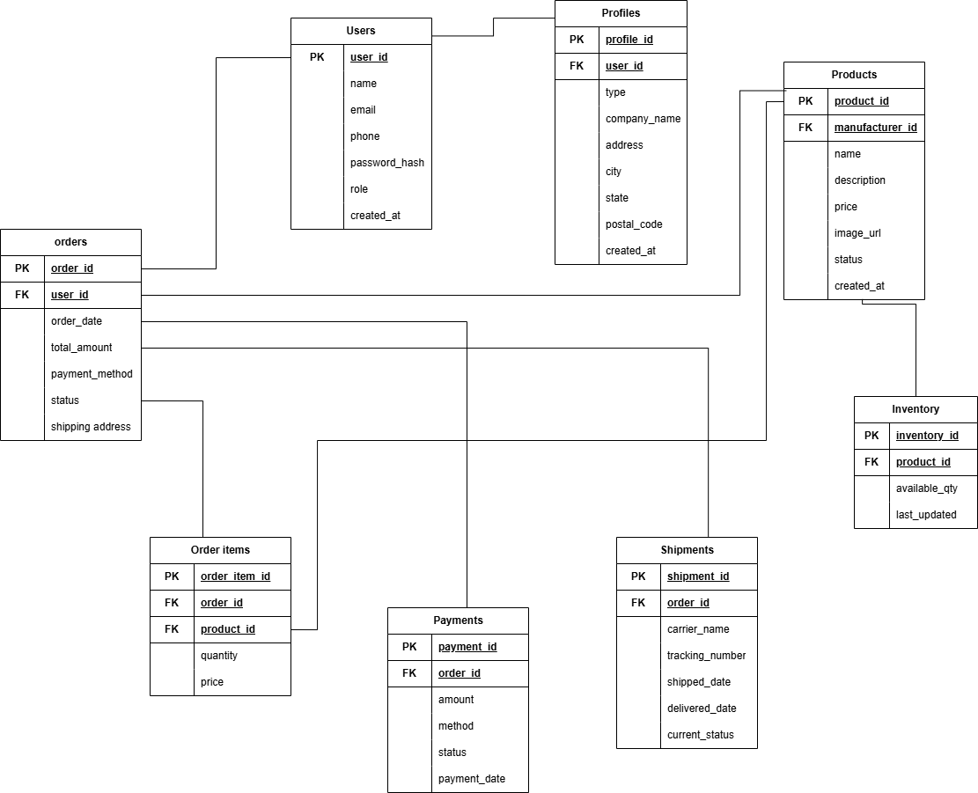

Question 7: What is a data flow diagram? Draw a data flow diagram to represent the in-flow and out-flow of data when a Farmer is placing an order for the product
Answer
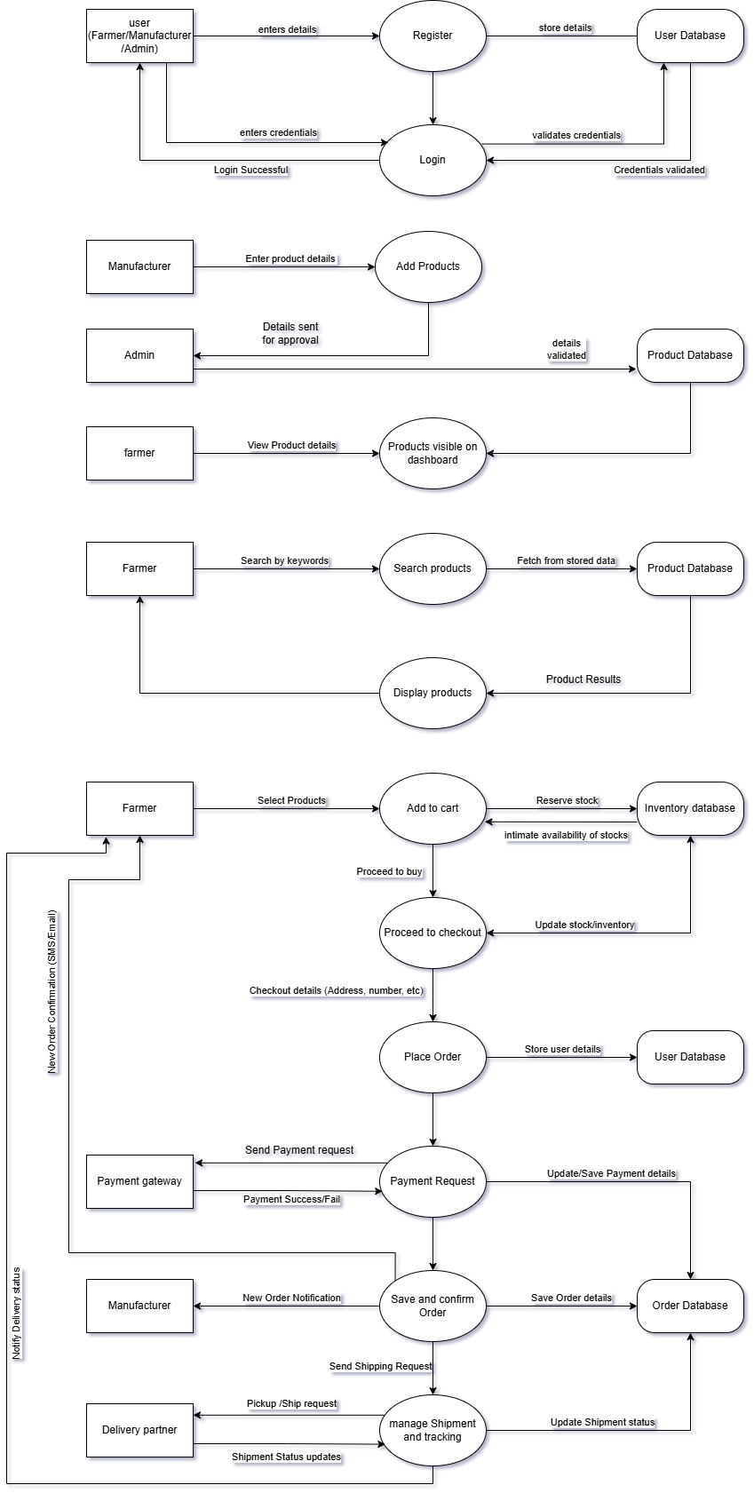

Question 8: Due to change in the Government Taxation structure. we should change the Tax Structure How do you handle change requests in a project?
Answer
When a change occurs — such as an update in the Government Taxation Structure — it directly affects project deliverables, system design, or calculations (like GST, tax slabs, or pricing).
To handle such changes efficiently, we follow a structured Change Control Process.
Steps to Handle a Change Request:
- Change Identification & Logging
  - Any change request (CR) raised by the client, stakeholder, or legal compliance team is first logged in a Change Request Form or Change Register.
  - In this case, the Finance Head or Business Analyst records the taxation structure change details.
- Impact Analysis
  - The Business Analyst and Technical Team analyze the impact on existing modules — for example, payment, billing, invoices, or tax reports.
  - The analysis covers scope, schedule, cost, risk, and resources
- Change Review & Approval
  - The Change Control Board (CCB) or the Project Steering Committee reviews the request.
  - Based on the impact report, they decide whether to approve, reject, or defer the change.
- Update of Project Documents
  - Once approved, all related documents such as SRS (Software Requirement Specification), Design Documents, and Test Cases are updated to include the new tax rules.
  - Version control is maintained for transparency.
- Implementation & Testing
  - Developers modify the tax calculation logic in the system.
  - Testers verify the new tax computation through regression testing to ensure no existing features are broken.
- Client Communication & Deployment
  - The Project Manager communicates the final change to the client and ensures deployment after successful testing.
  - Release notes are shared mentioning the new tax rates and calculation changes.
- Post-Implementation Review
  - After deployment, the change is monitored to ensure smooth functioning and compliance with the new government tax structure.
The Government here introduces a new Taxation Structure for agricultural products.
I would log a CR & perform impact analysis on order and payment modules, gets approval from the CCB, updates documentation, and ensures changes are tested and deployed within the next sprint.
Change Requests are handled through a systematic Change Management Process involving identification, analysis, approval, documentation, implementation, and review. This ensures that government or client-driven changes (like taxation updates) are implemented without disturbing existing project timelines and quality.

Question 9: As the project is in process, Ben and Kevin have contacted you. The reason is to inform you that they want the Farmers to sell their crop yields through this application i.e. Farmers should be able to add their crop yields or products and display to general public and should be able to sell them. They also want to introduce Auction system for their Crop yields. As a BA, what will be your response? Is this a change request or an enhancement???
Answer
As a Business Analyst, my first step would be to acknowledge Ben and Kevin’s new requirement and document it clearly.
I would thank them for their valuable input and explain that this request adds a new business capability that was not part of the original project scope.
This feature — allowing Farmers to sell their own crop yields and introducing an Auction System — represents a major addition to the existing functionalities of the Online Agriculture Product Store.
The original system was designed only for purchasing agricultural inputs (fertilizers, seeds, pesticides) from manufacturers.
Now, the proposed feature extends the system into a marketplace and bidding platform, changing its business model from a one-way purchase system to a two-way trading platform.
Therefore, this is classified as an Enhancement
- A Change Request is raised when we need to modify or correct an existing feature or rule (e.g., changing tax calculation logic, delivery process, etc.).
- An Enhancement, however, means adding a new functionality or module that provides additional value beyond the original agreed scope.
In this case:
- The “Crop Selling” and “Auction” modules are new functional modules,
- They require new database tables, new user interfaces, and business logic,
- And would likely need additional budget, resources, and timelines.
As a BA, my response would be:
- Document the Requirement Clearly:
Capture all details of the new feature — what kind of crops, who can bid, auction time limits, pricing logic, etc.
- Conduct Impact Analysis:
Assess how this addition affects the project scope, budget (2 crores), and timeline (18 months).
- Discuss with Project Manager & CCB:
Present the impact analysis to the Change Control Board (Mr. Henry, Mr. Pandu, Mr. Dooku).
- Obtain Approval & Update Scope:
If approved, treat it as a new enhancement phase or version 2.0 of the application.
Update SRS, UML diagrams, database schema, and testing documents accordingly.
- Communicate to Stakeholders:
Inform Ben and Kevin about the approval status, estimated cost, and delivery schedule for the enhancement.
Conclusion:
The new request from Ben and Kevin to enable Farmers to sell crops and introduce an Auction system is an Enhancement, not a simple Change Request.
It adds new capabilities and changes the business model of the application, requiring scope revision, budget re-estimation, and formal approval through the change management process.

Question 10: Come up with estimations – How many Man-hours required
Answer
Man-hours are the required efforts by the resources to complete a project.
Man-hours represent the total amount of working time contributed by all team members towards completing the project. It helps in understanding the total effort and resource utilization required for successful delivery.
There are 3 types of projects:
Small: upto 500 hours
Medium: upto 1000 hours
Large: upto 1500 hours

Analysis:
- The total team size for this project is 15 members.
- Each team member is expected to work 8 hours per day and 5 days a week.
- Therefore, total man-hours per week are calculated as:
15 members × 8 hours/day × 5 days/week = 600 man-hours per week.
- These 600 hours reflect the total productive effort that the entire team can deliver in one week.
- The work includes various phases such as requirement analysis, design, development, testing, deployment, and project management.
- With this capacity, project managers can schedule and distribute tasks efficiently to ensure balanced workload among all resources.
- Considering this weekly availability, timelines and milestones for each phase of the project can be effectively planned and monitored.

Question 11: Project has finally completed all the stages i.e., design, development, testing etc. Now, it is the role of a business analyst to contact the client for testing of the final product and have to successfully complete it. How are you going to handle this situation? And once it is done, what will be the process to close the project? Explain UAT Acceptance process
Answer:
UAT stands for User Acceptance Testing, which is a final phase in software development where end-users test the software to ensure it meets their needs and real-world business requirements before it is released
Planning:
In this step, a clear plan or blueprint is made for how the User Acceptance Testing (UAT) will be carried out.
The Business Analyst prepares a list of all features that need to be tested and defines what results will be considered acceptable.
All the necessary arrangements such as test data, environment, access, and timelines are finalized.
The main purpose of this step is to ensure everyone knows what will be tested, when, and by whom, before the UAT begins.
Designing:
In this stage, the test cases are created.
These test cases are simple step-by-step scenarios that show how a real user (like a farmer or manufacturer) will use the system.
Each test case includes what the user will do, what input they will give, and what output or response they should get.
The idea is to test all possible real-life situations to make sure the system behaves correctly and is easy to use.
UAT Testers:
The UAT testing team usually includes the actual end users or client representatives who will use the system after it goes live.
For this project, people like Mr. Henry, Peter, Kevin, and Ben would act as testers.
They try out all the important functions such as login, product search, payment, and delivery tracking.
Their feedback helps confirm that the system truly meets the farmers’ needs and works well in a real-world environment.
Bug Fixing:
During UAT, if the testers find any mistakes, missing features, or problems, they report them to the project team.
The developers and testers work together to fix these issues quickly.
Once the problems are fixed, the same steps are tested again to confirm everything works smoothly.
This stage ensures that the final version of the software is stable, error-free, and user-friendly.
Sign-Off:
After all testing is completed and the system works as expected, the client gives a formal approval or sign-off.
This sign-off means the client is satisfied with the system and agrees that it is ready to be launched for real use.
All key stakeholders (like Mr. Henry, Mr. Pandu, and Mr. Dooku) review the final outcome and confirm that all requirements are met.
Once this sign-off is received, the system is officially declared “Ready to Go Live”, and the project can be closed successfully.
Thus, the UAT process helps the client and end users test the system before it is made live.
It ensures that the final product is working correctly, easy to use, and meets all business expectations.
After the sign-off, the project is formally completed, and the solution is ready for real-time use by farmers and companies.

Question 12: Explain Project closure document
Answer:
A Project Closure Document (also known as a Project Closure Report) is a formal document prepared at the end of a project to summarize its key outcomes, deliverables, challenges, and lessons learned.
It confirms that the project has met all objectives, all deliverables have been handed over, and the client has officially accepted the final product.
It also records the overall performance of the team, how risks were handled, and how effectively resources were used.
This document acts as a final record for stakeholders and provides valuable insights that can be applied in future projects.
Points to be included in the Project Closure Document are:
- Project Overview:
Gives a brief summary of the project’s goals, duration, scope, and what the project aimed to achieve.
- Achievements:
Lists all the major accomplishments and milestones completed successfully during the project (for example, completion of all modules and UAT sign-off).
- Lessons Learned:
Highlights what worked well and what challenges were faced, so that future projects can avoid similar issues.
- Quality Assurance:
Describes the testing and quality control measures taken to ensure that the final product meets all required standards.
- Resource Utilization:
Summarizes how manpower, time, and budget were used efficiently throughout the project.
- Risk Management:
Lists the key risks identified during the project and explains how they were handled or minimized.
- Challenges:
Mentions difficulties or obstacles faced (like timeline delays, technical issues, or requirement changes) and how the team resolved them.
Below is a sample of the same.
S.No | Points to Include | Details | Reference Link / Document
1 | Did the client sign off on the UAT Testing? | Yes, signed off successfully | —
 | Date of Sign-off | 10th October 2025 | —
 | Client Representative | Mr. Henry (SOONY Company) | —
 | Business Analyst | Prasad Hendre | —
 | Project Manager | Mr. Vandanam | —
 | UAT Summary | All modules tested and approved by client during final UAT round | —
2 | Objectives of the Project | To build an online platform for farmers to purchase fertilizers, seeds, and pesticides easily from manufacturers. | Business Requirement Document
 | User Friendliness | Achieved — Simple interface and clear navigation | —
 | Customer Satisfaction | Achieved — Positive feedback from farmers during UAT | —
 | Return on Investment (ROI) | Expected ROI within first 6 months of launch | —
3 | Functionalities Worked On | Login module, Product catalog, Search, Payment gateway, Delivery tracking | Functional Design Document
 | Secure Payment Processing | Achieved — Integrated UPI, Credit/Debit, COD | —
 | Product Upload (Manufacturer) | Achieved — Verified manufacturers can upload product details | —
 | Order Tracking | Achieved — Farmers can track delivery in real-time | —
4 | Infrastructure | — | —
 | Software Installed | Achieved | —
 | Hardware Purchased | Achieved | —
5 | Funding | — | —
 | Amount Approved | ₹2 Crores | Finance Plan Document
 | Amount Utilized | ₹2 Crores | Project Expense Report
6 | Overall Project Information | — | —
 | Total Duration | 18 Months | Project Plan
 | Total Man-hours | 47,520 Man-hours | Estimation Sheet
 | Team Members | 15 (BA, Developers, Testers, Admins) | Resource Plan
 | Escalations | 50 total | _
 | Customer Satisfaction Level | High (positive UAT feedback and early adoption expected) | —
7 | Value to the Company | Positive impact — Improved market presence and CSR reputation | —
 | Business Growth | Platform expected to reach 1 lakh farmers within first year | —
 | Employee Learning | Team gained experience in large-scale agricultural software projects | —
 | Future Opportunities | Possible Phase 2 with “Crop Selling and Auction System” enhancement | —
8 | Project Status (Final) | Completed successfully and approved by client | Project Closure Report
9 | Prepared By | Prasad Hendre, Business Analyst | —
10 | Approved By | Mr. Henry (Client), Mr. Vandanam (PM) | —
11 | Date of Closure | 25th October 2025 | —

