Document 1: Business Case Document Template
Project Initiation:
The NICE ACTIMIZE project was initiated to address the current inefficiencies and inaccuracies of the application. By creating a secure, user-friendly portal, the project aims to streamline the screening of the alerts, reduce errors, ultimately enhancing the overall efficiency and satisfaction of the analysts using it.
Current Problems:
The current version of the software is slow, time-consuming to perform each alert, and prone to errors, leading to significant inefficiencies for the analysts using it. Generating comprehensive and real time transaction reports is challenging, These issues result in frustration and decreased productivity for the makers and checkers.
Problem Solution:
Enhancing the NICE ACTIMIZE, into a secure portal, will address the current inefficiencies. The portal will:
- Latency Improvement : Getting a faster response from the application , so that high volume alerts can be addressed easily.
- Enhance Accuracy: Minimize errors with automated checks and validations.
- Improve Reporting: Provide easy access to comprehensive and timely reports.
- Enable Remote Access: Allow the analysts to enter and manage the high risk alerts from any location, increasing flexibility and convenience.
Required Resources:
The successful implementation of the project will require resources including:
1. Human Resources
- Project Manager: Oversees the project.
- Business Analyst: Gathers and analyzes requirements.
- Developers: Build the portal.
- UI/UX Designers: Design user interfaces.
- Testers: Ensure functionality and reliability.
- IT Support: Handle deployment and support.
- Trainers: Provide user training.
2. Technical Resources
  - Development Tools
  - Design Tools
  - Testing Tools
  - Hosting Infrastructure: Servers, database systems.
  - Security Tools: Data protection software.
3. Financial Resources
- Budget: For salaries, software licenses, hardware, and training materials.
4.Physical Resources
- Workspace: Offices or remote setups.
- Hardware: Computers, servers, networking equipment.
5. Documentation and Training Materials
- User Manuals: Guides for portal use.
- Training Programs: Structured training sessions
Organizational Change:
1. Process Changes
- Automated Reporting: Reports and data analysis are generated automatically.
2. Training and Support
- User Training: Comprehensive training for the analysts using the application.
- Ongoing Support: Dedicated support team for user assistance.
3. Roles and Responsibilities
- New Roles: Potential creation of Leads/SMEs to improve the process.
- Adjusted Roles: Functional lead and project manager incorporate portal usage into daily tasks.
4. Communication and Collaboration
- Enhanced Communication: Improved channels between analysts and the client on- shore.
- Stakeholder Involvement: Increased involvement in planning and rollout.
5. Technology Integration
- IT Infrastructure: Upgrading to support the project.
- Data Management: New protocols for data entry, storage, and security.
ROI Timeframe:
The expected ROI timeframe for NICE ACTIMIZE is approximately 12-24 months, with tangible benefits and cost savings becoming evident within the first year and full ROI realized by the end of the second year.
Stakeholder Identification:
- Executive Sponsor – Chief Compliance Officer
- Business Owner – AML Operations Lead
- Project Manager – PMO
- Business Analyst
- IT Integration Lead & QA/Test Lead
- NICE Actimize Professional Services (vendor)
Project Team
- Project Manager: Leads the project, ensuring it stays on schedule and within budget.
- Business Analyst: Gathers requirements and ensures they meet stakeholders' needs.
- Developers: Design and build the ACTIMIZE portal.
- UI/UX Designers: Create an intuitive and user-friendly interface.
- Testers: Ensure the portal is functional and free of defects.
Document 2: Business Analyst Approach Strategy
- Project Initiation:
- Understand the project objectives, scope, and constraints.
- Identify key stakeholders and establish communication channels.
- Conduct a preliminary assessment of business needs and requirements.
- Elicitation Techniques:
  - Interviews - Conduct one-on-one interviews with stakeholders, team leads to gather detailed requirements and insights.
  - Surveys and Questionnaires :Distribute surveys to a larger group of stakeholders, to collect quantitative data on needs and expectations.
  - Focus Groups : Organize focus group sessions to discuss challenges and potential solutions collaboratively.
  - Workshops :Facilitate workshops with key stakeholders to brainstorm ideas, define requirements, and prioritize features.
  - Observation :Observe makers while they perform the alerts and areas for improvement.
  - Document Analysis: Review existing documentation, such as grading policies, current systems, and workflow diagrams, to understand the current state and identify gaps.
  - Prototyping : Develop and present prototypes of the GradeHub portal to stakeholders for feedback and refinement of requirements.
  - Brainstorming : Conduct brainstorming sessions with the project team and stakeholders to generate ideas and identify innovative solutions.

- Stakeholder Analysis using RACI/ILS:
  - Identify stakeholders and their roles using RACI (Responsible, Accountable, Consulted, Informed) or ILS (Influencer, Leader, Supporter) matrices.
  - Determine each stakeholder's level of involvement and expectations regarding the project.
  - Need to use this analysis to allocate responsibilities, manage expectations, and ensure effective communication.

Stakeholder | Responsible (R) | Accountable(A) | Consulted (C) | Informed (I)
Functional Manager | R |  | C | I
IT Staff | R |  | C | I
Vendors | R |  |  | I
Project Manager | R | A
Business Analyst | R
UI/UX Designers | R
Testers | R
Trainers | R
4. Documents to Write:
● Business Requirements Document (BRD)
● Functional Requirements Specification (FRS)
● Use Case Documents
● User Stories
● Test Plan
● User Acceptance Testing (UAT) Plan
● Training Materials
● Project Management Plan
5. Document Sign-off Process:
● Share draft documents with stakeholders for review and feedback.
● Incorporate feedback and revisions as necessary.
● Obtain formal sign-off from stakeholders indicating their acceptance of the documents.
● Maintain version control to track changes and updates.
6. Client Approvals:
● Present finalized documents to the client for approval.
● Provide explanations and clarifications as needed to ensure understanding.
● Obtain formal approval from the client through signed agreements or email confirmation.
7. Communication Channels:
● Establish regular meetings with stakeholders to discuss project progress, issues, and
updates.
● Utilize email, project management software, and collaboration tools for asynchronous
communication.
● Maintain an open-door policy for stakeholders to raise concerns or provide feedback.
8. Change Request Handling:
● Establish a formal change management process to capture, assess, and prioritize
change requests.
● Evaluate the impact of proposed changes on scope, timeline, and budget.
● Obtain approval from the Change Control Board before implementing changes.
9. Progress Reporting to Stakeholders:
● Provide regular updates on project milestones, deliverables, and risks.
● Use status reports, dashboards, and presentations to communicate progress
effectively.
● Highlight achievements, challenges, and upcoming tasks to keep stakeholders
informed.
10. UAT - Client Project Acceptance:
● Coordinate User Acceptance Testing (UAT) with the client to validate that the software meets requirements.
● Provide clear instructions and test cases for the client to execute during UAT.
● Obtain sign-off on the UAT - Client Project Acceptance Form once the client confirms satisfaction with the software functionality.
Document 3- Functional Specifications
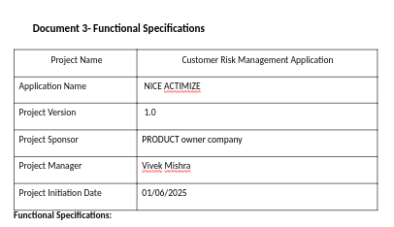
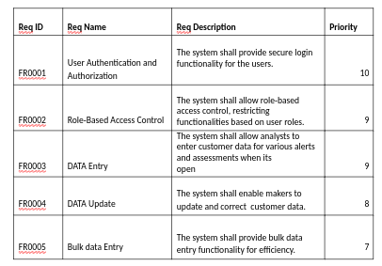
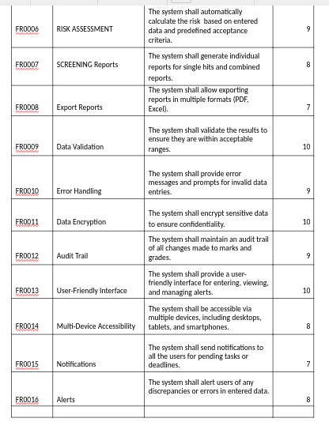

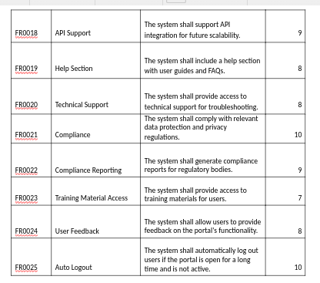
PROCESS FLOW DIAGRAM FOR NICE_ACTIMIZE :
