Document 1- Business case document template
1. Project Initiation
Why is this project initiated?
This project is initiated to streamline and automate the payment transaction processing system. Currently, payment transactions are received through emails in Excel sheets or PDF documents, leading to several inefficiencies, including:

Manual Processing Delays – Reviewing and processing transactions manually takes time and increases turnaround time.
High Risk of Errors – Manual data entry and validation increase the chances of human errors, resulting in incorrect payments or missing transactions.
Lack of Real-Time Tracking – There is no centralized system to track transaction statuses, approvals, or rejections in real-time.
Compliance & Security Risks – Handling sensitive payment data over emails increases security vulnerabilities and makes it harder to ensure compliance with financial regulations.
Scalability Issues – As transaction volumes grow, the current process becomes increasingly inefficient and difficult to manage.
By developing an automated application, the organization can improve efficiency, accuracy, security, and scalability while reducing operational costs.

2. Current Problems
What are the current problems?
anual email-based processing is inefficient.
Risk of errors in Excel/PDF files.
Lack of real-time tracking and reporting.
Security and compliance concerns.

3. Problem Resolution
With this project, how many problems could be solved?
Automated processing and validation.
Centralized system for transaction tracking.
Reduced human errors and increased efficiency.
Improved compliance and security.

4. Resource Requirements
What are the resources required?
Human Resources: Development team, business analysts, testers, project managers.
Technology: Software framework, database, servers/cloud infrastructure.
Financial Resources: Budget estimation for development, deployment, and maintenance.

5. Organizational Change
How much organizational change is required to adopt this technology?
Changes in job roles and responsibilities.
Employee training and onboarding requirements.
Adoption strategy to ensure a smooth transition.

6. ROI and Time Frame
Time frame to recover ROI?
Cost of development and deployment.
Time and efficiency gains.
Expected cost savings due to automation.
Projected timeline for break-even.

7. Stakeholder Identification
Internal Stakeholders: Finance department, IT team, compliance officers, executive leadership.
External Stakeholders: Banks, payment processors, vendors.
Methods to engage stakeholders: Meetings, surveys, workshops.

Document 2: BA Strategy

Requirement Elicitation-
Interviews:
One-on-one discussions with stakeholders to gather detailed requirements.
Workshops:
Group sessions to identify business needs and potential solutions.
Surveys & Questionnaires:
Collecting input from a larger audience.
Document Analysis:
Reviewing existing documentation (Excel reports, emails, policies) to understand the current process.
Prototyping:
Creating wireframes/mockups to visualize the solution before development.

Stakeholder Analysis (RACI/ILS)
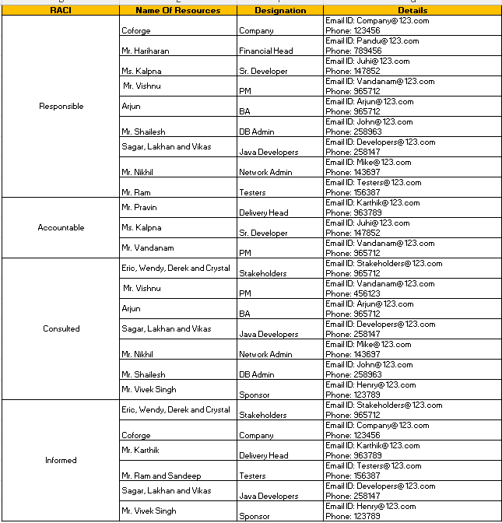

Documents to write:
Business Case Document – Justification of the project initiation.
Business Requirements Document (BRD) – To Capture high-level business needs.
Functional Requirements Specification (FRS) – Details system functionalities.
Process Flows & Use Cases – Defines workflows and user interactions.
Data Flow Diagrams (DFD) – Illustration data movement within the system.
Traceability Matrix – Ensures all requirements are met during development.
User Acceptance Test (UAT) Plan – Defines test scenarios and acceptance criteria.

Document Sign-Off Process
- Documents will be reviewed internally with the project team.
- Formal review sessions will be conducted with stakeholders.
- Any feedback will be incorporated, and the revised document will be sent for approval.
- Sign-off will be obtained via email confirmation or digital signature.

Client Approvals & Communication Plan
- Regular status meetings to present updates and gather feedback.
- Define a structured review timeline for each document.
- Maintain a change request process to address modifications.
- Client approvals will be documented via formal sign-off forms.

Communication Channels
- Meetings: Weekly stand-ups, bi-weekly stakeholder meetings.
- Emails: Official communication and approval tracking.
- Project Management Tools (JIRA, PowerBI, tableau, SQL): Track progress and issues.
- Collaboration Platforms (MS Teams, Slack): Real-time discussions
Change Request Management
- Establish a Change Control Board (CCB) for reviewing and approving changes.
- Use a Change Request Form (CRF) to document requested modifications.
- Evaluate changes for impact on scope, timeline, and budget.
- Obtain necessary approvals before implementing changes.
Project Progress Updates
- Weekly Status Reports to stakeholders.
- Monthly Steering Committee Meetings to discuss project health.
- Risk and Issue Log Updates to track challenges.
- Live Dashboards for real-time tracking (if applicable).
UAT & Client Project Acceptance
- Prepare UAT Test Cases covering all business scenarios.
- Conduct UAT Workshops with key users.
- Capture feedback and log any defects.
- Retest after fixes and obtain final confirmation.

Sign-Off on UAT & Client Project Acceptance
- Prepare a Client Project Acceptance Form summarizing test results.
- Obtain written confirmation (email or document signature) from the client.
- Officially transition to deployment and support phase.

Document 3- Functional Specifications
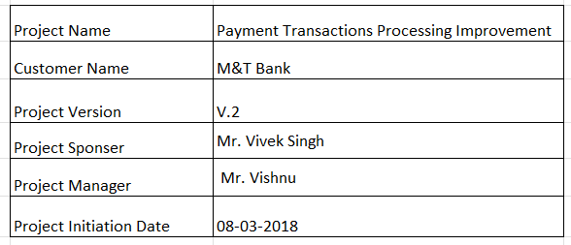
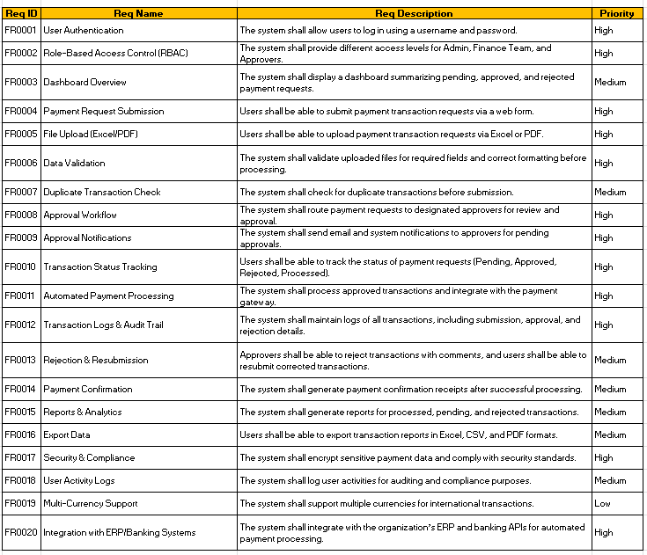

Document 4- Requirement Traceability Matrix
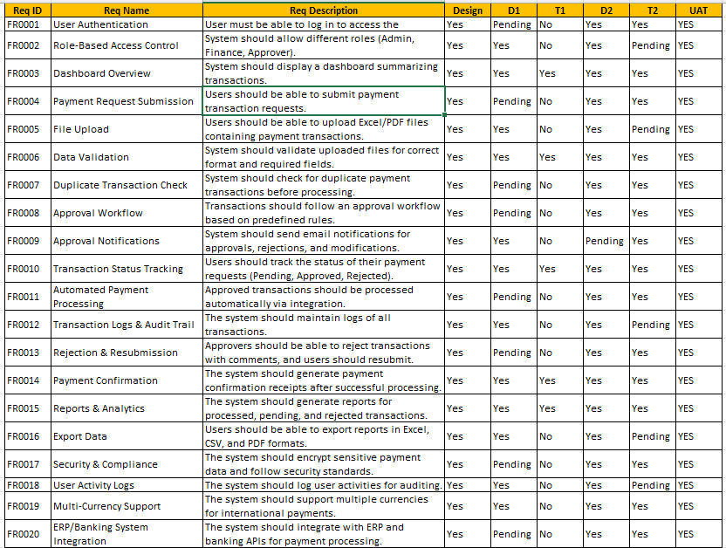

Document 5- BRD Template
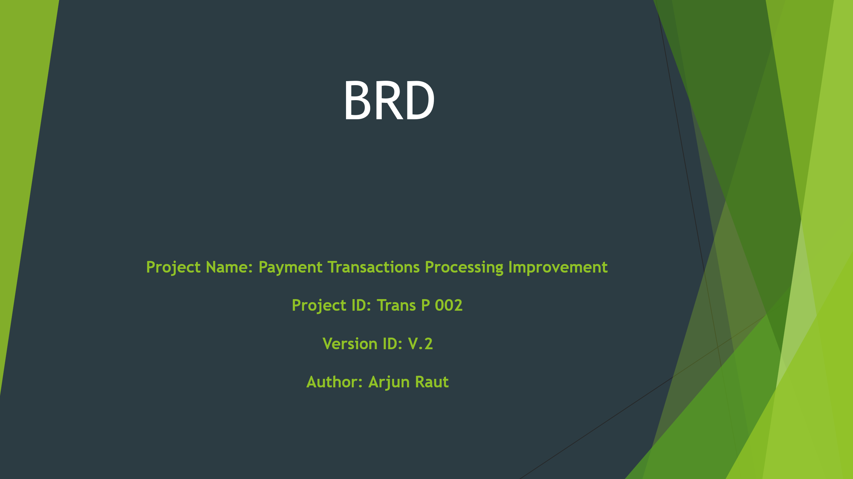

  - Document Revisions
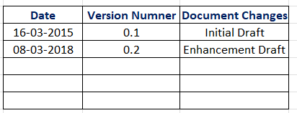

  - Approvals
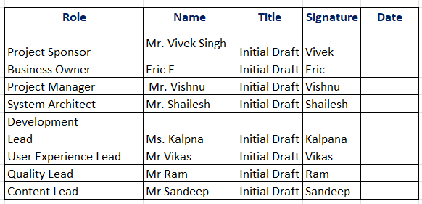

  - RACI Chart for This Document

4. Introduction
4.1 Business Goals
- Eliminate missed or delayed payment transaction postings.
- Improve visibility and tracking of incoming transaction requests.
- Enhance operational efficiency and accountability.
4.2 Business Objectives
- Automate the intake and processing of payment transaction documents.
- Centralize transaction tracking and status updates.
- Provide audit trails and reporting capabilities.

4.3 Business Rules
- All incoming transaction documents must be logged before processing.
- Only authorized users can mark transactions as completed.
- Transactions must be processed in the order received unless escalated.
4.4 Background
Currently, payment requests arrive via email and are stored in Outlook folders. Manual tracking leads to missed or unprocessed transactions, especially when emails are mistakenly moved to the "Completed" folder.
4.5 Project Objective
To build a centralized application that captures, tracks, and manages payment transaction requests from email attachments, ensuring no request is missed or delayed.

4.6 Project Scope
4.6.1 In Scope Functionality
- Integration with Outlook to fetch Excel/PDF attachments.
- Dashboard to view, assign, and track transaction requests.
- Status updates and audit logs.
- User authentication and role-based access.
4.6.2 Out Scope Functionality
- Payment gateway integration.
- Mobile application development.
- Historical data migration.
📌 5. Assumptions
- Users have access to Microsoft Outlook and Office 365.
- All transaction requests are received in standard formats (Excel/PDF).
- Sufficient infrastructure is available for hosting the application.
⛓️ 6. Constraints
- Limited budget and timeline.
- Dependency on Outlook API and document parsing tools.
- User adoption and training requirements.

⚠️ 7. Risks
Technological Risks
- Outlook API limitations or changes.
- Document parsing errors due to inconsistent formats.
Skills Risks
- Limited experience with automation tools or APIs.
Political Risks
- Resistance from users accustomed to manual processes.
Business Risks
- Missed transactions due to system downtime.
Requirements Risks
- Scope creep from additional feature requests.
Other Risks
- Data privacy concerns with email content processing.
🔄 8. Business Process Overview
8.1 Legacy System (AS-IS)
- Emails with transaction documents are manually reviewed.
- Users pick requests from Outlook folders.
- Risk of missing or duplicating transactions.

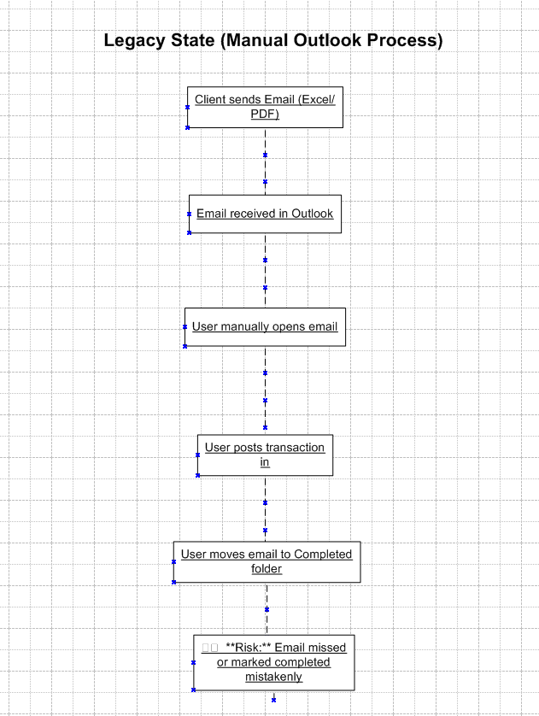

8.2 Proposed Recommendations (TO-BE)
- Automated ingestion of documents from Outlook.
- Centralized dashboard for tracking and assignment.
- Notifications and reporting to ensure timely processing.

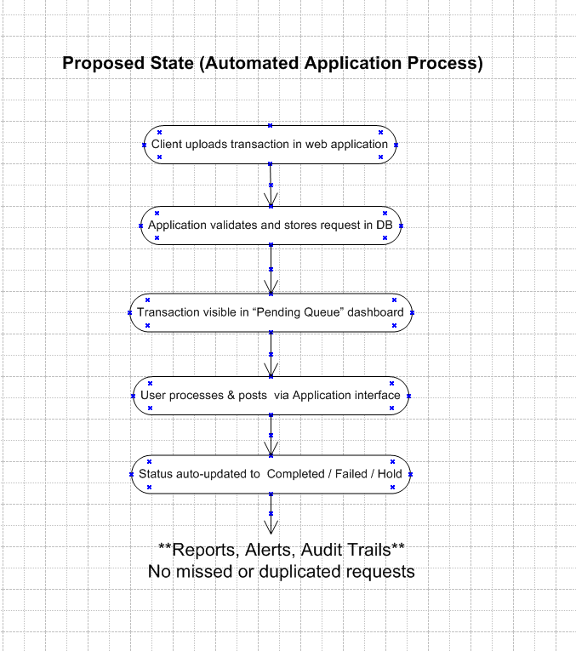
📋 9. Business Requirements
- Ability to fetch and parse Excel/PDF attachments from Outlook.
- Dashboard to display transaction requests with status.
- User roles: Admin, Processor, Viewer.
- Audit trail for each transaction.
- Notification system for pending or overdue requests.
📎 10. Appendices
10.1 List of Acronyms
- API: Application Programming Interface
- PDF: Portable Document Format
- RASCI: Responsible, Accountable, Supportive, Consulted, Informed
10.2 Glossary of Terms
- Transaction Request: A payment instruction received via email.
- Dashboard: A user interface showing transaction statuses.
- Audit Trail: A log of actions taken on each transaction.
10.3 Related Documents
- Outlook Integration Guide
- Document Parsing Standards
- User Training Manual (TBD)

