Q.1 BPM analysis for the MR Henry online Agriculture product

1. Goal
farmers in remote areas to conveniently purchase agricultural products (fertilizers, seeds, pesticides) directly from companies through a web/mobile app, removing dependency on middlemen and ensuring timely access to farm essentials at there door step

2. Inputs
- • Problems and requirements shared by stakeholders (Villager friends )
- • Product inventory details and rquiremnt fertilizer, seed, and pesticide companies
- • CSR funding by Mr. Henry
- • Technical team
- • Inventory
- • Payment section
- • Device access (smartphones for mobile users, desktops for companies)

3. Outputs
- Accessibility
- • User friendly app for farmers
- • Vendor portal for product listing and order management
- • Order tracking
- • Training content (video, audio, guides) for farmer onboarding
- • Pilot implementation in selected villages according to location

4. Activities
- • Requirement elicitation from farmer stakeholders
- Development
- • Integrating vendor product listings and company onboarding
- Testing
- • Farmer awareness and onboarding via local workshops or in-app guides
- • App development
- • Monitoring usage and collecting feedback
- • Iterating enhancements

5. Value
- • Accessibility: Farmers can access critical farm inputs at their fingertips
- • Affordability: Reduction in costs due to direct purchase (no middlemen)
- • Empowerment: Encourages self-reliance among rural farmers
- Customer satisfaction.
- • Scalability: Platform can expand beyond one region or product type
- • Digital Adoption: Promotes digital literacy and e-commerce in rural India
- Social csr impact

Q .2 SWOT Analysis for the MR Henry online Agriculture product

Strengths
- Wealthy product owner
- Helping nature
- Stakeholder support
- In house demand

Weaknesses
- Village
- Less Awareness .
- Decencies on vendors
- Lack of digital Knowledge

Opportunities
- More opp outside village
- Growth
- Productivity in agri sector

Threats
- Change in customer demand
- Middlemen
- Less awareness
- Completion

Q.3 Feasibility Analysis for the MR Henry online Agriculture product.

Feasibility Dimensions
 | Details
Technology] | Development – Java  - Automation  Website development  - APIs: REST APIs for mobile/web interaction  - Security:
Hardware Feasibility | - Client Side: Mobile phones (Android-focused app for farmers), Desktops/laptops for companies  - Server Side: Cloud infrastructure  - Admin Side: Development and testing  - Connectivity: network guildline
Software Feasibility | - Development ToolsReact/Flutter  - Testing Tools: Automation  - CI/CD: Jenkins (if needed for automation)
Resource Feasibility | - Project Sponsor: Mr. Henry  - Stakeholders: Peter, Kevin, Ben (Farmer Reps)  - Project Manager: Mr. Vandanam  - Developers: Juhi (Sr. Dev), Teyson, Lucie, Tucker, Bravo (Java Devs)  - Network Admin: Mr. Mike  - DB Admin: Mr. John  - Testers: Jason & Alekya  - BA (You): Requirement, user stories, UAT coordination
Budget Feasibility | - Project Funding: CSR-funded by Mr. Henry  - Development & Testing: In-house resources, minimal external hiring  -
Time Feasibility | - Total Duration: 18 Months  • 0–3 Months: Requirement Gathering Mockups, Planning  • 4–9 Months: Core Development (App development )  • 10–11 Months: Add Pesticides & Company-Farmer Communication  • 13–15 Months: QA Testing,  • 16–18 Months: Deployment, Farmer Training, Pilot Run  - Methodology: Agile (Sprint-based delivery for flexibility)

Q.4Gap Analysis:
Current State: The Villager are facing the difficulties in their day to life like procuring fertilizers and buying seeds and lack of pesticides and many other agricultural related products.
Desired State:
To have an online agricultural product store to facilitate remote farming to buy agricultural product by web / mobile App form and companies and communicate directly.

Purpose: Facilitate Farmers to buy Agri product from anywhere from the given app.

Q. 5 Risk Analysis :
Internal risk
- Dependencies on External vendors
- Variety related to location and region
- Lack of awareness for technology and adaptation of technology
- Scope of literacy
External risk:
- Intense coemption
- Vendor inventory
- Market demand
BA Risk:
- Required gathering
- Stakeholder Analysis
- Desisting App
- Region language problem
Project based :
- Scope
- Stakeholder risk

Q. 6 Stakeholder Analysis – RACI Matrix
R = Responsible
A = Accountable
C = Consulted
I = Informed
Tasks / Activities | Mr. Henry | Peter, Kevin, Ben | Mr. Karthik (Delivery Head) | Mr. Vandanam (PM) | BA (You) | Dev Team (Juhi, Teyson, Lucie, Tucker, Bravo) | Testers (Jason, Alekya) | DB Admin (John) | Network Admin (Mike)
 | A | C | I | I | I | I | I | I | I
 | I | C | I | A | R | I | I | I | I
 | A | C | A | R | R | I | I | I | I
 | C | C | C | A | R | C | I | I | I
 | I | I | I | A | C | R | I | C | C
 | I | I | I | A | C | R | I | C | I
 | I | I | I | A | C | R | I | I | I
 | I | I | I | A | C | C | R | I | I
 | I | I | I | A | I | I | I | C | R
 | A | C | I | R | C | I | I | I | I
 | A | I | C | R | I | I | I | I | I

Q7. Business Case Document
1. Why the Project Was Initiated
The Online Agriculture Products Store project was initiated as part of a Responsibility (CSR) initiative by Mr. Henry, businessman. During a visit to his hometown, Mr. Henry learned from his childhood friends—Peter, Kevin, and Ben—who are farmers in a remote village, about the various challenges they face in procuring essential agricultural supplies such as fertilizers, seeds, and pesticides.
2. What Are the Current Problems?
Currently, farmers in remote villages face significant difficulties in accessing basic agricultural products due to:
- Limited or no access to agricultural stores in nearby areas
- High dependency on middlemen leading to increased product cost
- Lack of direct communication channels with manufacturing companies
- Poor transportation infrastructure and long travel times to urban centers
- Limited awareness of product availability
3. What Problems Can Be Solved?
The proposed online platform will address the following problems:
- Provide a digital marketplace where farmers can buy fertilizers, seeds, and pesticides directly
- Eliminate intermediaries, reducing product costs for farmers
- Facilitate real-time communication between farmers and suppliers
- Offer doorstep delivery options in remote locations
- Improve transparency in pricing and product availability
- Promote digital literacy and technology adoption among rural farmers
4. What Resources Are Required?
The project will require the following resources:
Question 8 – Four SDLC Methodologies
Waterfall Model
Linear and sequential development process
Each phase must be completed before moving to the next
Phases: Requirements → Design → Implementation → Testing → Deployment → Maintenance
Best for: Simple, well-defined projects.

Iterative Model
Focuses on repeating cycles (iterations); evolves the system through repeated refinement

Best for: Complex projects where full requirements are not known upfront
Agile Methodology
Emphasizes flexibility, collaboration, and customer feedback Developed in short iterations (sprints)

Popular Agile frameworks: Scrum, Kanban, XP
Best for: Projects with changing or unclear requirements

Spiral Model
Combines iterative development with risk assessment
Focuses on risk analysis at every phase
Best for: Large, complex, and high-risk projects

Q. 9 Waterfall Model
Description:
A linear and sequential SDLC model where each phase must be completed before the next begins.
Phases:
Requirements
Design
Implementation
Testing
Deployment
Maintenance

. Rational Unified Process (RUP) Description:
A disciplined iterative software development process created by Rational (now IBM). Focuses on phases, disciplines, and roles.
Phases:
Inception
Elaboration
Construction
Transition

3. Spiral Model
🔹 Description:
A risk-driven, iterative model combining features of Waterfall and Prototyping. Each loop represents a development phase.
🔄 Phases in Each Spiral Loop:
Determine Objectives
Identify Risks & Mitigation
Development & Testing
Planning Next Iteration

Question 10 – Waterfall Vs V-Mode

Models

Waterfall  1 low cost  Development completed than testing starts  Move in linear and sequential pattern  Less customer involvement  Very rigid  Low risk project  Phases Req. → Design → Implementation → Testing → Deploy | V model  Expensive  Development proceed with testing at each stage  Don’t move in linear manner  More interactive  Agile  High risk project  Phases  Req. ↔ Acceptance Testing  Design ↔ System Testing  Code ↔ Unit Testing

Question 11 – Justify your choice
V model - Best suitable for Large and complex project.
Every development stage gets tested as its completed
Iteration possible
Structured, but testing is embedded throughout the process for better quality and risk control.
Question 12 – Gantt Chart
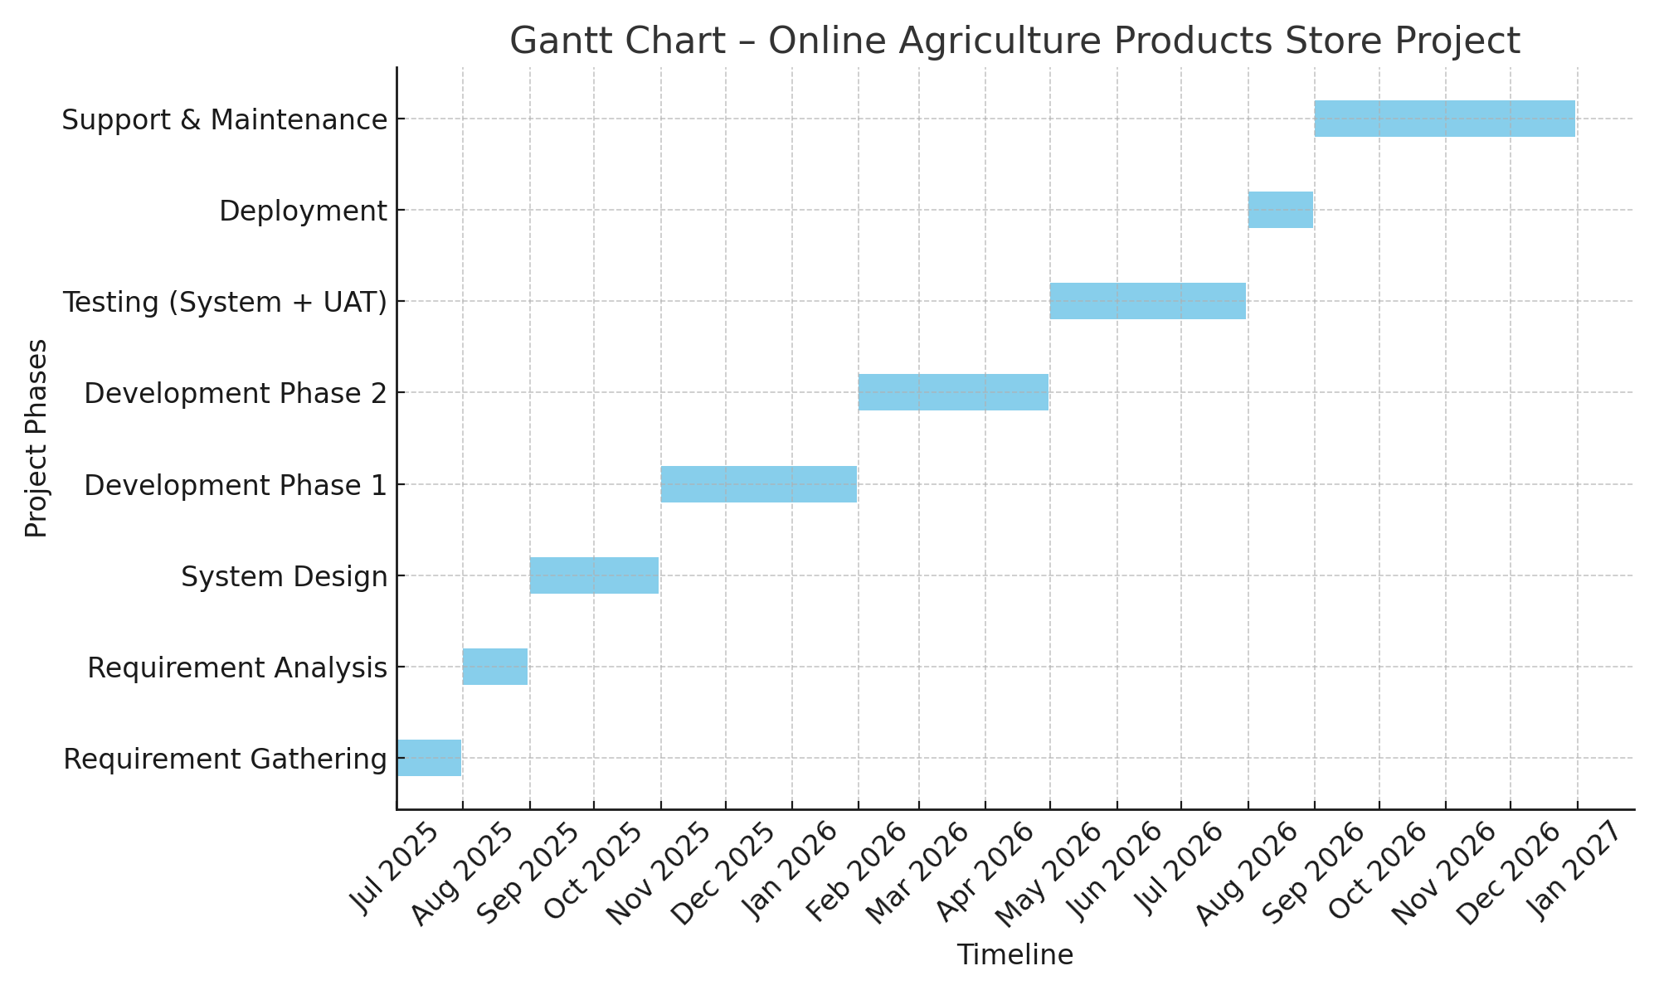

Q . 13 Fixed Bid Vs Billing
Fixed BID  Fixed time and cost  Fixed deliverables  Scope is well defined  Well planed projects  Not suitable for scope vary projects | Billing  1.Limited flexibility  Agile methodology  Time based billing changed  Allows iteration  Continuous development, enhancement, or support is needed

Q 14 Preparer Timesheets of a BA in various stages of SDLC
Task | Start time | End time | Duration
Identify the stakeholder meeting | 10.00 am | 11.am | 1 hour
Client interaction | 11.am | 12.00 | 1 hour
Document Business Requirements Document (BRD) | 12.00 | 2.00 | 2hour
Requirement Storing | 2.00 | 3.00 | 1 hour
Team meeting | 4.00 | 5.00 | 1 hour

