Document 6- Please prepare a use case diagram, activity diagram and a use case specification document

Use Case 1: Submit Loan Application
- Use Case Name:
Submit Loan Application

- Use Case Description:
This use case allows the Loan Officer to input applicant details into the system for loan processing.
- Actors:
- Primary Actor: Loan Officer
- Secondary Actor: Applicant (indirectly, via data provided)
4️. Basic Flow:
- Loan Officer selects “Submit Application.”
- System displays the application form.
- Loan Officer enters applicant details.
- System validates data and stores it in the database.
5️. Alternate Flow:
- Data pre-population from existing records if available.
6️. Exceptional Flows:
- Missing mandatory fields → System highlights missing fields.
- Database unavailable → Error message displayed.
7️. Pre-Conditions:
- Loan Officer is authenticated.
- Applicant data is available.
8️. Post-Conditions:
- Loan application data is stored in the system.
9️. Assumptions:
- Loan Officer has complete and accurate applicant details.
10. Constraints:
- Data format must comply with regulatory standards.
1️1. Dependencies:
- Database availability.
12. Inputs and Outputs:
- Inputs: Applicant data
- Outputs: Application confirmation
13. Business Rules:
- Mandatory fields must be completed.
- Data validation rules should apply.
14. Miscellaneous Information:
- Integration with KYC systems if needed.

Use Case 2: Validate Loan Data
1️. Use Case Name:
Validate Loan Data
2️. Use Case Description:
Ensures all required applicant information is complete and correct before further processing.
3. Actors:
- Primary Actor: System
- Secondary Actor: Loan Officer
4. Basic Flow:
- System reviews submitted data.
- Validates fields based on pre-defined rules.
- Flags any missing or incorrect data.
- Returns validated status.
5️. Alternate Flow:
- Manual override by Loan Officer.
6️. Exceptional Flows:
- Inconsistent data → Validation fails → Error message displayed.
7. Pre-Conditions:
- Application data is submitted.
8️. Post-Conditions:
- Data marked as valid or invalid.
9️. Assumptions:
- Validation rules are up-to-date.
10. Constraints:
- Regulatory compliance (e.g. KYC).
1️1. Dependencies:
- Validation service is functional.
1️2. Inputs and Outputs:
- Inputs: Application data
- Outputs: Validation status
1️3. Business Rules:
- Fields cannot be empty.
- Dates must be in correct format.
1️4. Miscellaneous Information:
- Error logs maintained.

Use Case 3: Predict Loan Default Risk
1️. Use Case Name:
Predict Loan Default Risk
2️. Use Case Description:
System calculates risk score using the predictive model to estimate likelihood of default.
3️. Actors:
- Primary Actor: System
- Secondary Actor: Loan Officer
4️. Basic Flow:
- System fetches validated application data.
- Predictive Model processes the data.
- System generates a risk score and presents it to the Loan Officer.
5️. Alternate Flow:
- Manual risk evaluation if model unavailable.
6️. Exceptional Flows:
- Predictive model service down → System alerts IT support.
7️. Pre-Conditions:
- Data is validated.
- Predictive model is deployed.
8️. Post-Conditions:
- Risk score is stored and available for review.
9️. Assumptions:
- Model is trained and updated.
10. Constraints:
- Model accuracy is dependent on data quality.
11. Dependencies:
- Model service availability.
1️2. Inputs and Outputs:
- Inputs: Applicant financial data
- Outputs: Risk score
13. Business Rules:
- Score thresholds guide approval or rejection.
14. Miscellaneous Information:
- Scores logged for audit.

Use Case 4: Review Prediction Output
1️. Use Case Name:
Review Prediction Output
2️. Use Case Description:
Loan Officer reviews the risk score and recommendations provided by the system.
3️. Actors:
- Primary Actor: Loan Officer
- Secondary Actor: Risk Analyst
4️. Basic Flow:
- Loan Officer views risk score on dashboard.
- Reviews details.
- Makes initial decision.
5️. Alternate Flow:
- Risk Analyst supports review in complex cases.
6️. Exceptional Flows:
- Score missing or corrupted → System prompts for manual review.
7️. Pre-Conditions:
- Risk score is generated.
8️. Post-Conditions:
- Officer decision recorded.
9️. Assumptions:
- Officer understands risk interpretation.
10. Constraints:
- Decision timeframes defined by policy.
11.Dependencies:
- Risk score availability.
12. Inputs and Outputs:
- Inputs: Risk score
- Outputs: Decision
13. Business Rules:
- Approval thresholds apply.
14. Miscellaneous Information:
- Officer notes stored.

Use Case 5: Approve/Reject Loan Application
1️. Use Case Name:
Approve/Reject Loan Application
2️. Use Case Description:
Loan Officer makes final decision to approve or reject the application.
3️. Actors:
Primary Actor: Loan Officer
4️. Basic Flow:
Officer selects application.
Reviews risk score and data.
Chooses approve or reject.
System records decision.
5️.Alternate Flow:
Application escalated for manual review.
6️.Exceptional Flows:
System failure → Decision stored offline.
7️.Pre-Conditions:
Risk score available.
8️.Post-Conditions:
Decision logged in system.
9️.Assumptions:
Officer has authority to decide.
10.Constraints:
Regulatory compliance.
1️1.Dependencies:
Data availability.
1️2. Inputs and Outputs:
Inputs: Application, risk score
Outputs: Decision status
1️3. Business Rules:
Officer’s decision may override system recommendation.
1️4.Miscellaneous Information:
Audit trail maintained.

Use Case 6: Manage Predictive Model
1️.Use Case Name:
Manage Predictive Model
2️.Use Case Description:
Risk Analyst manages deployment, activation, and monitoring of the predictive model.
3️.Actors:
Primary Actor: Risk Analyst
4️.Basic Flow:
Analyst accesses model management console.
Uploads or activates model.
Monitors model performance.
5️.Alternate Flow:
Model rollback if performance degrades.
6️.Exceptional Flows:
Model upload fails → System logs error.
7️.Pre-Conditions:
Risk Analyst is authenticated.
8️.Post-Conditions:
Model is active.
9️.Assumptions:
Analyst trained on model deployment.
10. Constraints:
Security measures enforced.
1️1.Dependencies:
System admin access.
1️2. Inputs and Outputs:
Inputs: Model file
Outputs: Model status
1️3.Business Rules:
Model versioning tracked.
1️4. Miscellaneous Information:
Models stored securely.

Use Case 7: Monitor Model Performance
1️.Use Case Name:
Monitor Model Performance
2️.Use Case Description:
Risk Analyst reviews model performance to ensure accuracy and compliance.
3️.Actors:
Primary Actor: Risk Analyst
4️.Basic Flow:
Analyst selects performance dashboard.
System shows metrics.
Analyst interprets data.
5️.Alternate Flow:
Analyst requests re-training.
6️.Exceptional Flows:
Data incomplete → System alerts.
7️.Pre-Conditions:
Model is active.
8️.Post-Conditions:
Performance status updated.
9️.Assumptions:
Accurate logs available.
10. Constraints:
Model monitoring schedule enforced.
1️1.Dependencies:
System logs.
1️2.Inputs and Outputs:
Inputs: Model metrics
Outputs: Performance report
1️3.Business Rules:
Alerts for thresholds exceeded.
1️4. Miscellaneous Information:
Reports archived.

USE CASE DIAGRAM:
Use case diagram 1:

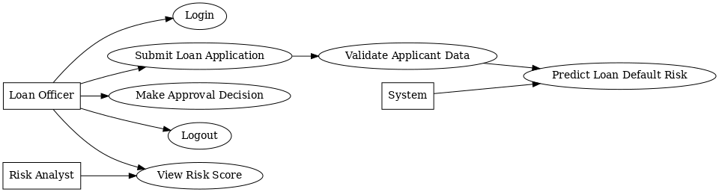

Use case diagram 2:
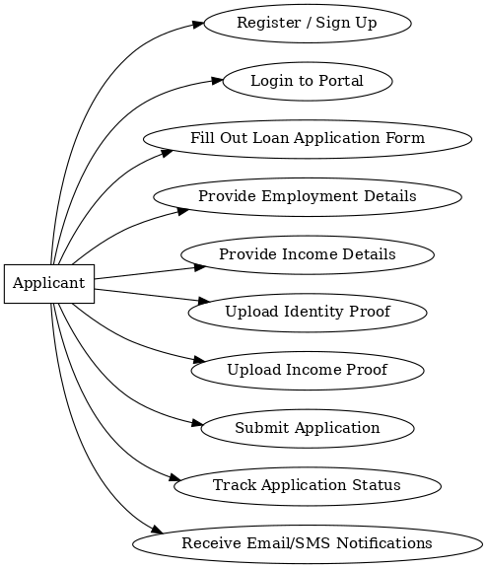

ACTIVITY DIAGRAM:
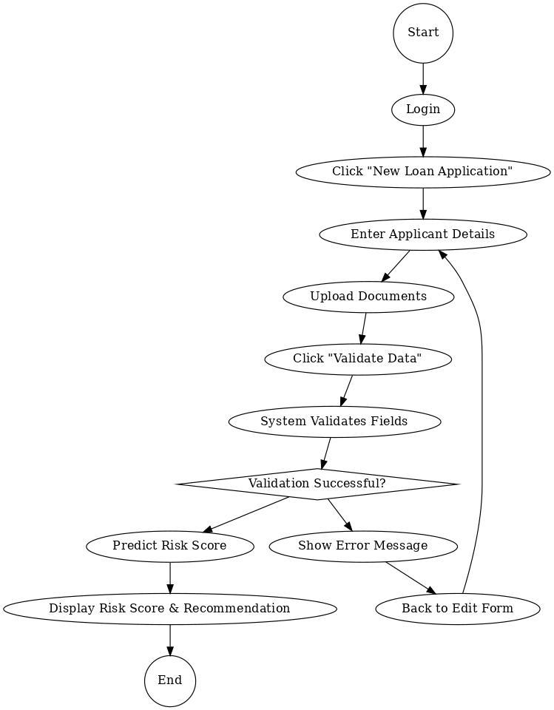
Document 7- Screens and pages

  - Home Page

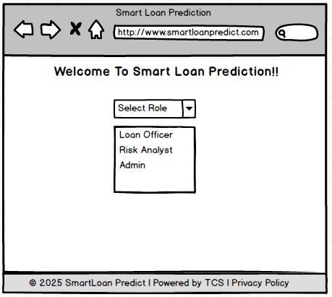

  - Login Page
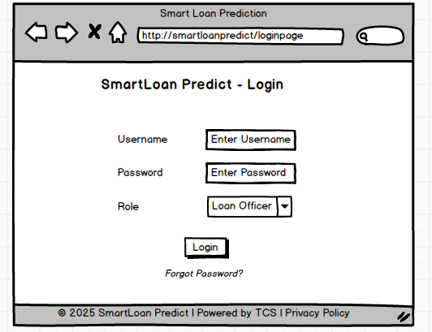

  - Loan Officer’s Home Page

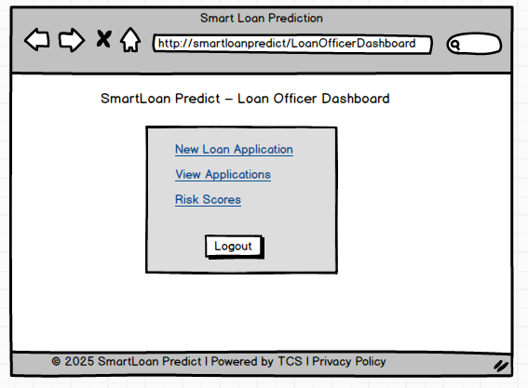

  - New Loan Application
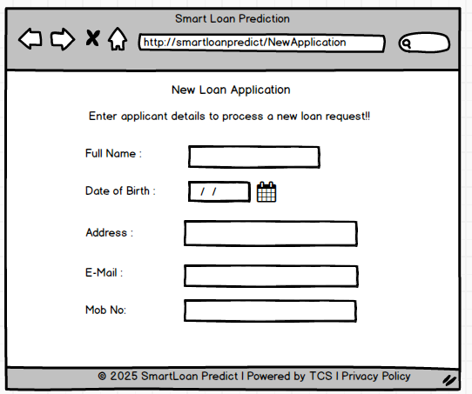
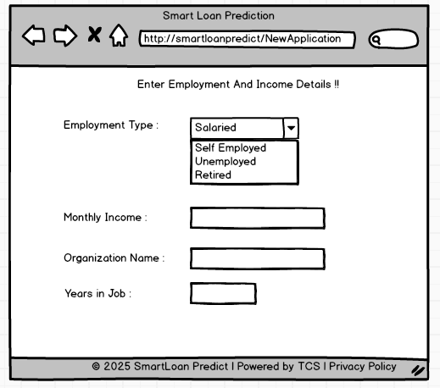

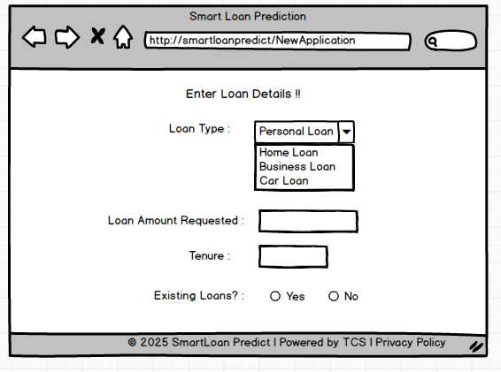

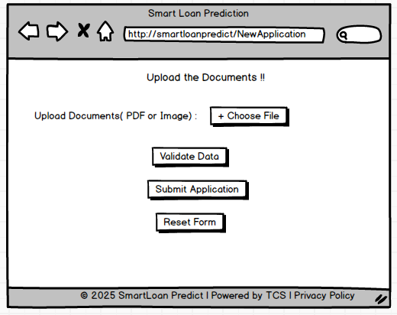
Document 8- Tools-Visio and Axure Write a paragraph on your experience using Visio and Axure for the project.
For this project, I primarily used Microsoft Visio and Balsamiq to support documentation and visualization of business requirements. Visio was instrumental in designing professional and clear use case diagrams, activity diagrams, and other UML artifacts, which helped communicate the system’s behaviour to stakeholders and the development team. Additionally, I used Balsamiq to create low-fidelity wireframes of key application screens. Its simple drag-and-drop interface made it easy to design mock-ups quickly and focus on layout and functionality without getting into visual details. Together, these tools enhanced collaboration across teams and ensured that both functional and non-functional requirements were well-understood during the Waterfall project lifecycle.

Document 9 – Business Analyst Experience.
As a Business Analyst, I was actively involved across key phases of the project lifecycle, particularly in requirement gathering and requirement analysis. Below is a summary of my experience:

1. Requirement gathering :
- I adopted the MoSCoW technique to categorize and prioritize requirements into Must Have, Should Have, Could Have, and Won’t Have. This helped manage stakeholder expectations effectively.
- During this phase, the client was intermittently unavailable, so I proactively identified alternative points of contact from their end to avoid project delays and collected the necessary inputs in a timely manner.
- I applied the FURPS model (Functionality, Usability, Reliability, Performance, and Supportability) to validate and evaluate the completeness and quality of gathered requirements.
- I identified and eliminated several redundant and duplicate requirements, ensuring clarity and avoiding confusion during later phases.
- I used prototyping techniques to help stakeholders better visualize the requirements, which encouraged more precise and practical inputs.

2. Requirement Analysis:
- I created various UML diagrams, including use case diagrams and activity diagrams, to clearly illustrate the functional requirements and process flows.
- These diagrams were shared with the cross-functional team for discussion. As a BA, I handled feedback from team members, facilitated discussions, and incorporated necessary modifications based on collaborative inputs.
- I was responsible for preparing detailed Business Requirement Specification (BRS) and Software Requirement Specification (SRS) documents, aligning them with both business needs and technical feasibility.

3. Design:
- Derived test cases directly from use case diagrams to ensure traceability.
- Engaged with the client to finalize design and solution documents.
- Authored both positive and negative test cases, ensuring coverage of all potential scenarios.
- Emphasized the importance of not missing test cases, as omissions can affect downstream development.
- Created relevant test data and ensured the RTM (Requirement Traceability Matrix) was continuously updated to reflect design decisions.

4. Development:
- Facilitated JAD (Joint Application Development) sessions to align development goals.
- Acted as the bridge between the technical team and business, clarifying requirements during implementation.
- Addressed conflicts or lack of cooperation by engaging in one-on-one discussions, promoting a healthy team environment.
- Encouraged developers to refer to visual diagrams (UML, activity flows) while coding.
- Coordinated regular meetings between the client and development team, handled attendance challenges by recording sessions and conducting follow-ups.

5. Testing:
- Prepared test cases using earlier use case documentation as a base.
- Participated in high-level functional testing to validate core business flows.
- Coordinated with the client to obtain realistic test data.
- Kept the RTM up-to-date and ensured complete coverage.
- Obtained client sign-off post testing and supported User Acceptance Testing (UAT) readiness.

6. Deployment:
- Sent the finalized RTM to the client, attaching it to the project closure document.
- Coordinated the creation and distribution of end-user manuals.
- Organized and facilitated training sessions for business users and stakeholders.
- Ensured full participation in training, tracked attendance, and addressed gaps proactively.

