04 BA Mock - Case study
A company with multiple manufacturing plants and warehouses across the country manufactures ice-cream and milk products.
They want to build software to achieve two goals:
>Manage the Inventory
>Ensure Quickest Delivery to the Customers
Assignment 1:
1. Please make a BRD which can be presented to the client along with complete development
and resource plan.
Project Name: Smart Inventory Management System (SIMS)
Project ID: SIMS-INV-001
Version ID: 1.0
Author: [Your Name]
1. Document Revisions
Date | Version | Changes Made
8/9/2025 | 0.1 | Initial Draft
9/9/2025 | 1 | Final BRD Submission
2. Approvals
Role | Name | Title | Signature | Date
Project Sponsor | TBD | Senior Director
Business Owner | TBD | Operations Head
Project Manager | TBD | PMO
System Architect | TBD | Enterprise Architect
Development Lead | TBD | Technical Lead
Quality Lead | TBD | QA Manager
3. RACI Chart
Name | Position | R | A | S | C | I
Business Owner | Operations Head |  | A |  | C | I
Project Manager | PMO | R |  |  |  | I
System Architect | Enterprise Architect |  |  | S | C
Development Lead | Technical Lead | R |  |  |  | I
QA Lead | QA Manager |  |  | S |  | I

4. Introduction
4.1 Business Goals
The organization aims to modernize its inventory ecosystem to ensure real-time visibility, optimized stock levels, and reduction of wastage across multiple plants and warehouses. This initiative supports improved efficiency in supply chain operations and enables faster fulfillment of customer orders.
4.2 Business Objectives
Implement a centralized inventory management system that integrates manufacturing units, warehouses, and distribution centers.
Provide real-time stock updates to avoid understocking/overstocking.
Enable predictive demand planning using consumption and seasonal trends.
Streamline warehouse operations with barcode/RFID scanning.
Ensure system accessibility via mobile and web-based applications.
4.3 Business Rules
All inventory transactions must be digitally logged and auditable.
Expiry-date-based inventory rotation (FIFO/FEFO) is mandatory for dairy and ice-cream products.
Warehouse managers must approve stock adjustments before system updates.
Access controls will restrict data visibility based on user roles.
4.4 Background
Currently, inventory tracking is manual or semi-digital, leading to discrepancies, product expiries, and delayed deliveries. To overcome these issues, management has proposed a unified IT solution that provides end-to-end visibility of inventory across all operational nodes.
4.5 Project Objective
The project’s objective is to design, develop, and implement an intelligent inventory management system that aligns with business needs, reduces manual errors, and supports seamless customer delivery.
4.6 Project Scope
In Scope
Inventory tracking across plants, warehouses, and distribution centers.
Real-time stock visibility dashboard.
Barcode/RFID-based stock movement.
Forecasting and demand planning module.
Integration with order management and delivery systems.
Out of Scope
HR and payroll management.
Manufacturing machinery automation.
Third-party logistics integration in Phase 1.
5. Assumptions
Users have access to internet-enabled devices.
All warehouses will adopt standardized stock-keeping units (SKUs).
Adequate training will be provided to warehouse staff.
6. Constraints
Budgetary limits may restrict advanced AI features in Phase 1.
Data migration from legacy systems may be time-consuming.
Seasonal product demand variations could affect system performance.
7. Risks
Risks are potential factors that may impact the successful implementation of the Integrated Inventory Management System. Each risk is analyzed for likelihood, impact, and an appropriate mitigation/handling strategy.
7.1 Technological Risks
Risk ID | Description | Likelihood | Impact | Strategy
Tech-01 | Integration with existing ERP or order management systems may fail or take longer than planned. | Medium | High | Mitigate: Perform early API testing, use middleware solutions, involve ERP vendor support.
Tech-02 | Barcode/RFID scanners may not work uniformly across different warehouses due to hardware compatibility. | Medium | Medium | Mitigate: Conduct pilot testing at select sites before full rollout; standardize scanner procurement.
Tech-03 | Centralized system may face downtime during peak demand (summer season). | Low | High | Avoid/Mitigate: Deploy load balancing and cloud scalability; run stress tests pre-go-live.
7.2 Skills Risks
Risk ID | Description | Likelihood | Impact | Strategy
Skill-01 | Warehouse staff may lack technical knowledge to operate barcode/RFID-based system. | High | Medium | Mitigate: Conduct hands-on training, create user manuals, and appoint local system champions.
Skill-02 | Shortage of IT staff to maintain system after implementation. | Medium | High | Mitigate: Hire/train additional IT support, consider managed services for maintenance.
7.3 Political Risks
Risk ID | Description | Likelihood | Impact | Strategy
Pol-01 | Resistance from regional warehouse managers accustomed to manual methods. | Medium | Medium | Mitigate: Involve managers in design workshops, highlight efficiency benefits, provide incentives.
Pol-02 | Lack of management support if system ROI is not immediately visible. | Low | High | Accept/Mitigate: Set realistic expectations, provide phased ROI reporting after rollout.
7.4 Business Risks
Risk ID | Description | Likelihood | Impact | Strategy
Biz-01 | System downtime during migration could disrupt deliveries to customers. | Medium | High | Mitigate: Plan migration during off-peak hours, keep manual backup process ready.
Biz-02 | Budget reallocation may reduce scope or delay implementation. | Low | High | Transfer/Mitigate: Document ROI, present phased rollout to leadership for incremental funding.
Biz-03 | Customer dissatisfaction if deliveries are impacted during transition. | Medium | High | Mitigate: Communicate with distributors/customers; use fallback manual dispatch temporarily.
7.5 Requirements Risks
Risk ID | Description | Likelihood | Impact | Strategy
Req-01 | Incomplete capture of warehouse-specific needs may lead to gaps in functionality. | Medium | High | Mitigate: Conduct detailed stakeholder workshops; validate requirements with pilot runs.
Req-02 | Forecasting module may not align with actual seasonal demand patterns. | Medium | Medium | Mitigate: Calibrate system with historical sales data; refine forecasting algorithm iteratively.
7.6 Other Risks
Risk ID | Description | Likelihood | Impact | Strategy
Other-01 | Cybersecurity breaches or unauthorized access to sensitive stock data. | Low | High | Avoid/Mitigate: Implement role-based access, two-factor authentication, regular audits.
Other-02 | Power/network outages in remote warehouses may delay updates. | Medium | Medium | Mitigate: Provide offline data entry option with sync feature; explore backup power solutions.
Other-03 | Regulatory non-compliance in cold-chain management for dairy products. | Low | High | Mitigate: Ensure system tracks storage temperature logs; align with FSSAI regulations.
8. Business Process Overview
This section provides a detailed understanding of the current (AS-IS) state of the iView application used by bank staff and the recommended improvements (TO-BE) being implemented
8.1 AS-IS Process (Current State)
Currently, inventory management in the company’s manufacturing plants and warehouses is manual and fragmented, with little system integration. The following describes the typical flow:
- Order Capture
- Customer orders are received through phone, email, or distributor visits.
- Orders are recorded in spreadsheets or legacy tools at the sales desk.
- Production Planning
- Weekly or monthly production plans are created in Excel based on historical demand and manager judgment.
- No real-time demand forecasting or automated material requirement planning (MRP).
- Procurement & Raw Material Check
- Raw material availability is checked manually.
- If materials are insufficient, procurement teams call/email suppliers. This causes delays and uncertainty.
- Manufacturing & Quality Control (QC)
- Production batches of ice-cream and milk are created.
- QC checks (temperature, fat, SNF) are noted on paper forms.
- Any non-conformance requires manual escalation, delaying decisions.
- Inventory Recording
- Finished goods are moved to cold storage.
- Stock entries are updated manually in registers or spreadsheets.
- Expiry and batch details are not consistently tracked.
- Dispatch Preparation
- Warehouse staff pick stock manually, often relying on printed expiry sheets.
- FEFO (First Expiry, First Out) is not always followed, leading to wastage.
- Delivery & Documentation
- Delivery challans and invoices are prepared manually.
- Customer feedback about delays or wrong deliveries is managed ad hoc.
Pain Points in AS-IS:
- Frequent stock mismatches between plants and warehouses.
- High wastage due to expired products (especially ice-cream).
- Manual QC and expiry tracking increase errors.
- No real-time visibility of inventory levels.
- Delays in dispatch and poor customer satisfaction.
AS-IS Process Flow
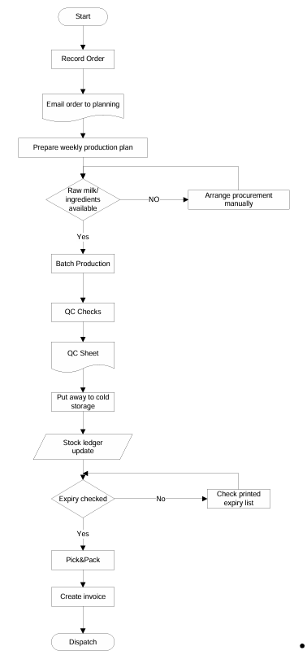

8.2 TO-BE Process (Proposed System)

The Smart Inventory Management System (SIMS) will replace manual and fragmented processes with an integrated, automated, and real-time solution. The TO-BE flow is as follows:

- Order Capture & Planning
- Customer orders are directly captured in the IMS via web or mobile portal.
- IMS auto-generates a production plan based on historical sales, seasonality, and safety stock.
- The system runs MRP checks against raw materials and auto-triggers purchase requests when shortages are identified.
- Manufacturing & Quality Control (QC)
- Each production batch is assigned a barcode/RFID label at creation.
- QC results are entered digitally into IMS, with automatic alerts for non-conformance.
- Approved batches are marked “Ready for Storage.”
- Inventory Recording & Storage
- Finished goods are scanned into IMS when moved to cold storage.
- The system assigns optimal storage locations and logs batch/expiry details automatically.
- Real-time stock updates are visible to management, sales, and warehouse staff.
- Dispatch Preparation (FEFO & Compliance)
- IMS generates picking lists based on FEFO (First Expiry, First Out).
- Warehouse staff use barcode scanners to confirm picks, ensuring accuracy.
- If any item breaches temperature requirements, the system automatically triggers a quarantine and investigation process.
- Delivery & Documentation
- Dispatch dock scanning updates the IMS, decrements inventory, and auto-generates e-waybills
- and invoices.
- GPS and transport integration allow shipment tracking.
- Proof of Delivery (POD) is captured digitally and synced into the IMS.
Benefits in TO-BE:
- Single source of truth for inventory across all plants and warehouses.
- Automated expiry tracking ensures FEFO compliance and reduces wastage.
- Real-time visibility improves decision-making.
- QC data stored digitally enhances compliance with food safety regulations.
- Faster order processing and reduced delivery delays improve customer satisfaction.
- Forecasting helps prevent both stockouts and over-production
TO-BE Process flow: 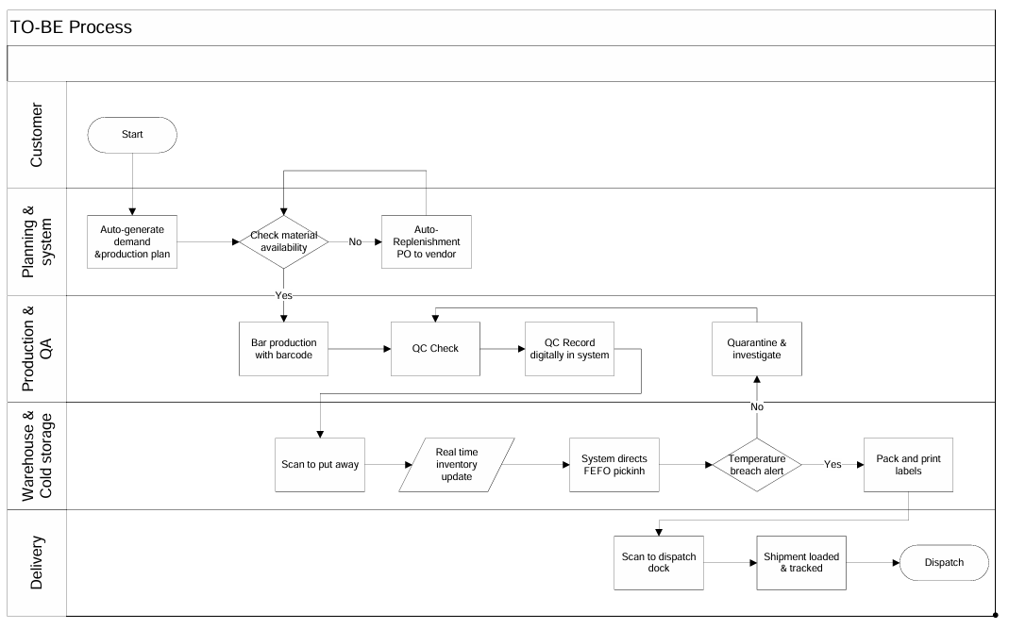
2. Prepare process flow diagram using your imagination.
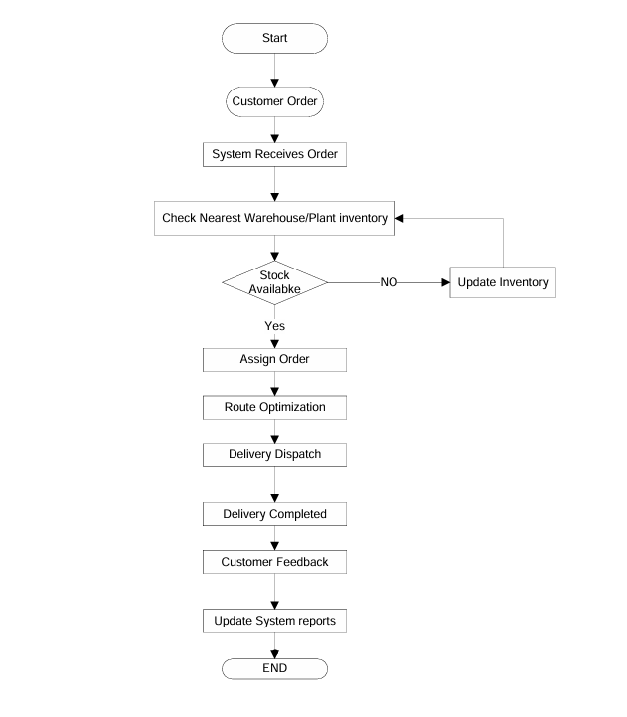
Assignment 2:
1. Write an introduction letter to a client introducing yourself as a business analyst in charge of working with the client and his team to start the business understanding process.
Introduction Letter
Subject: Introduction – Business Analyst for Upcoming Project
Dear Coepd,
I am Likhitha, the Business Analyst assigned to work with you and your team for the upcoming project. My role will be to bridge the gap between your business needs and the technical team, ensuring that the solution we build aligns with your goals.
Over the coming weeks, I will collaborate closely with your stakeholders to gather requirements, document processes, and create structured specifications for development. I look forward to understanding your vision and translating it into a successful solution.
Best Regards,
Likhitha
Business Analyst

2. Prepare a brief BRD and SRS for a project- Horoscope or Ticketing system or online store.

3. Make an ERD of creating a support ticket/Ticketing life cycle.
4. User story of shopping from ecommerce.

