Assignment 1
BRD TEMPLATE

Contents
1. Document Revisions
2. Approvals
3. RASCI Chart for This Document
Codes Used in RASCI Chart
RASCI Chart
4. Introduction .
4.1. Business Goals
4.2. Business Objectives
4.3. Business Rules
4.4. Background
4.5. Project Objective
4.6. Project Scope
4.6.1. In Scope Functionality
4.6.2. Out Scope Functionality
5. Assumptions
6. Constraints
7. Risks
Technological Risks
Skills Risks
Political Risks
Business Risks
Requirements Risks
Other Risks
8. Business Process Overview
8.1. Legacy System (AS-IS)
8.2. Proposed Recommendations (TO-BE)
9. Business Requirements
10. Appendices
10.1. List of Acronyms
10.2. Glossary of Terms
10.3. Related Documents

- Document Revisions

Date | Document Version | Document Changes
01/09/2025 | 1.0 | Create a document for inventory management and order delivery system.  In this we work on the management of complete stock in warehouse stock should be in sufficient quantity also we have to manage the order of stock when require  We are creating application for faster delivery to customer so that we can give best survice to customer . if our service is best then we get best raing and review .

- Approvals

Role | Name | Title | Signature | Date
Project Sponser | Inventory Management and delivery |  |  | 1/9/2025
Project owner | John Smith
Project Manager | Anthony
System Archiutecture | System Designer
Developemtn Team | Developers
Use Experience Lead | Team Members
Quality Lead | Team members
Content Lead | John Anthony and members

3 . RACI Chart for this Document

The RACI chart identify the person to whom we have to contact once the changes take place in the document The Main role of RACI chart is to describe the role of Stakeholders in the production of BRD document RACI stands for
Responsible
Accountable
Consultant
Informed

Codes Used in RACI Chart

Responsible Who is Responsible for creating the document
Accountant Accountable for Accuracy of this project
Support Provide Supporting Services in the production of this document
Consultant Provides Input
Informed Must be informed of any change

RACI Chart

RACI Matrix for Project
RACI | Name of the Person | Designation
Responsible | Development Team | Developers
 | Testing Team | Testers
 | Mr John | Project Manager
Accountable | Mr John | Project Manager
Consultant | All Members | Team Members
 | Development Team | Developers
Informed | Mr. John | Project Manager

4. Introduction

4.1 :- Business Goals

There are two goals behind this project One is inventory Management
Maintain the complete record of stock in ware house for delivery as well as for maintain sufficient stock in hand to manage any order. And second one is delivery of order to customer we have to minimize the total time taken for nay delivery to customer

4.2 Business Objective

Maintain a record of inventory so that we have sufficient stock for order .
Manage the delivery time so that order deliver in minimum time allotted

4.3 Busniess Rule

As the project is related to warehouse and item are milk product so we have to ensure and maintain the record as per date such as Date of Manufacturing and Date of expiry in all items . So that we can deliver only healthily item to customer

4.4 Background

We are creating an application that will track the record of all inventory in ware house also check the status of stock in and stock out . We are giving feature of timely delivery of any order so that customer will be happy and once customer will be happy it will be win win situation for us

4.5 Project Objective

To come up with the application which keep the track of all inventory available in stock and ensure timely arrange the stock when required
Also come up with Application that deliver the order with in time .

4.6 Project Scope

We are going to Create a project in which as per client we are giving feature of Inventory Management and Product delivery to customer

In Scope Functionality
As we are on initial stage of our project we are creating project for
Inventory Management
Quickest delivery to Customer

Out Scope Functionality
We are not adding any feature for rating or review
We have not added Google review

5. Assumptions

Requirements which are not real which may happen comes under Assumptions There are many type of requirement such as functional non functional in those requirement there are Assumption .

Assumptions 1 A user should enter Detail of complete stock
Assumptions 2 A user enter all his detail such as stock in and stock out for delivery .
Assumptions 3 User should keep the record of stock as per mention date
Assumptions 4 User should have sufficient knowledge for access application .
Assumptions 5 User must have sufficient knowledge for using all milk mde items and validity

6. Constraints

Constraints are the Rules and Laws which are follows and which needs to be followed. For every project we are following certain rules such as steps which are used
Login
Search
Display
Offers
Results
Budget
Time

As this information display step by step that are called Constraints.

7. Risks

In every project there are different different as risk . Risk could affect the success and failure of the project. Risk Analysis is conducted to identify the risk as when we work on any project definitely risk factor is their. There are different types of risk depends upon the condition Such as Operational Risk , Reputational Risk , Technical , Legal , etc
- Teclnological Risks :- This risk involves risk related to technology time to time updation in technology and new technology issues that could affect the project
- Skills Risk :- This risk is related to staff that the staff is perfectly skilled or not in other words we can say product expertise
- Political Risk :- If there is any political force connect to project then that affect the project
- Business Risks :- It generally define business implication if the project is canceled
- Requirement Risk :- In this Area we check all the requirement which are not correctly defines . We list down the list of all such requirement which are not correctly defines
- Other Risk :- Wastage of item should be their if we keep extra inventory in our stock as these are milkmaid product so have limited life
- Internal Risk :- Server Availability , Easy to access ,Website should be user friendly , Security should not Breach
- External Risk :- Security Breach , Overview , Better presentation .
- BA Risk :- This risk involves Improper Requirement Gathering which will Majorly effects our Project , Rates should be competitive , Response in Market , better ranking and rating to particular product , Proper Domain Knowledge
- Process Risk :- For booking any order steps should be easy so that user can easily place and order again rates should be competitive , product catalog contains complete features and result should be healthily .
- Projects Based Risk :- Scope Risk should be their Project should be complete in given budget and timeframe , These risk are specific to project itself

8. Business Process Overview

TO BE Proposed Recommendation and As is Legacy System

is AS IS ( Present ) and the future state that is TO BE ( Future State ) or we can say Current State and desired State

AS IS :- At present we are maintain the record physically and maintain written record of the same via pen and paper . So we require more man power and human work to maintain the record of the same .

TO Be :- Desired state is we have to create an application in which we maintain the record of our Inventory , In stock , out Stock , Wether we have to place order to maintain suffient stock with us all things become online . So it will becone easy to maintain and save manpower . Work becone easy for Onwer and workers

Business Process Flow Shows the complete prcoess flow follows in this project

9. Business Requirement

Req ID | Req. Name | Req. Description | Priority
BR001 | User Search for item required | User Should able to search for the item | 2
BR002 | User login the Screen | User Should able to login using login id and password | 1
BR003 | Product information | User Should get details of product Information | 4
BR004 | Email Confirmation | Customer should get email confirmation | 6
BR005 | Searching for offers in CRN | User should search for different item as needed | 3
BR006 | Add offer if accepted | User finalize for the offer accept the same | 5

10. Appendices

10.1 List of Acronyms

Acronym | Description
Cust | Customer
UAT | User Acceptance Testing
D1 | Design 1
D2 | Desgin 2
T1 | Testing 1
T2 | Testing 2

Glossary of Terms
Term | Defination
Inventory Management | Keep record of Stock

Related Document

Document Name | Description | Reference Linkl
Funtional Specification Document ( FSD) | Define details functional requirement | FSD Document
Business Requirement Document ( BRD) | Capture overall business needs and bjectives | BRD Document
Requirement Tracibilty Matrix (RTM) | Define functional and Non Functional requirement | RTM Document
Process Flow Fiagram ( Activity Diagram ) | As IS and TO Be Process flow for Project | Activity Diagram
Use Case Diagram ( Use Case Diagram ) | Complete Business process flow | Use Case Diagram

Q.2
Process flow Diagram is created to understand the complete process we are following during any activity . Here we are searching for status of our inventory stock and customer place an order . Here we explain step by step procedure in process flow diagram . What process we are exactly for complting any activity . it shows the diagramatical representation of our process

Assignment 2

Deepti Soni
Infosys Company
10/09/25

Mr Anthony
XYZ Company

Dear Anthony ,

I am Deepti Soni the Business Analysis assign to lead the business understand process for the project Inventory Management. I am excited to work with you and your team to deliver a solution for your needs.
I have 5 Yr of experience in Business Analysis and I have did success work in project through effective requirements gathering and stakeholder management.
Understand the business objective
Identify key stakeholders
Understanding the requirements

I would like to schedule a meeting to understand the requirement in detail and discuss about project scope , timeline and expectation
Please feel free to contact ( 8085126275 ) me to arrange a meeting
Thanks for considering our services

Best Regards
Deepti Soni
Anthony
Assignment 2

- 1 SRS Document

Ticketing System
Software Requirement Specification
Sep, 11 2025

Acceptance

Client Representative

Software Requirement Specification

Version | Date of Release | Release By | Reviewed by |  | Approved By |  |  | Reason for revision
 |  |  | Name | Date | Name | Date
10 | 11/09/25 | Deepti | John | 12/09/25 | Anthony |  | 12/09/25 | Just checking

Software Requirement Specification

Table of content

1.0 Introduction
1.1 Overview
1.2 Acronyms and Definitions
1.3 Operational Requirements
1.4 References
1.5 Design and Implementation
1.6 Assumed Factors

2.0 System Overview
2.1 Current System
2.2 Proposed System
2.3 Benefits and Proposed System

3.0 UI Requirement
3.1 Project Content
3.2 Functional and non Functional requirement

4.0 Other Parameters
4.1 Acceptance

1.0 Introduction

We are working on Online Ticket System and creating a system by which we can book the ticket from any where no need to visit station for reservation also no need to visit to agent . we can book the ticket online

1.1 Overview

If we have to book and reservation we have to visit railway station or to a agent for reservation but now we are creating application by which we can book our ticket any time from any where using login credential for that we just create login by entering complete details as required and then we can use this application for reservation .

1.2 Acronyms and Definition

Term | Description
Credentials | Id and Password used for login

1.3 Operational Requirement

Under operational requirement we have Hardware requirement , Software requirement , Time ,Budget , Technology all parameters related to project .

1.3.1 Software Requirement

Application working properly , Network availability is as per requirement

1.3.2 Hardware Requirement

Best Network and infrastructure

1.4 References

Proposal

Creating a Application for ticket booking so that we can book ticket sitting from home only . Anyone can access application while creating his own login credentials and access the same

User Requirement Document

Details related to person whose ID is created required such as Name , Address DOB , Email id .

1.5 Design and implementation constrains

Design Constraints
- System should provide a user friendly interface to book tickets
- System should response quickly
- System should design to handle large volume of users
- System should ensure the security
- System should access various device such as laptop , desktop , mobile etc
Implementation

- System should be build using a specific technology
- System should follow SQL to store data of Customer
- System should integrated to a payment gateway
- System should comply with regulation
- System should be easy to access with minimum time

1.6 Assumed Factors that could effect the requirement stated in SRS

- Different operating system may effect the system functionality
- Integration with third party gateway for payment
- The system ability to handle large number of data
- System Response include maintenance and downtime may impact overall performance

2.0 System Overview

2.1 Current System :-

Manual visit station and booking ticket
Manage Long queue and time management
Limited availability of tickets
Physically fill the form

2.2 Proposed System

Automated online system
Allow customer to purchase online ticket
Provide real time availability of ticket
We can book ticket from any where
Provide real time access for booking
Any one can plan journey by checking the availability

2.3 Benefits of Proposed System

Customer can book ticket 24*7
Customer can book ticket of his own choice
Probability of errors become less
Customer can plan journey according the availability
Online system handle large number of data
System enable payment option and offer discount to customer
Time saver No need to go anywhere book ticket from any where any time
No need to carry physically ticket we can show the same in mobile

3.0 UI Requirements

User Interface requirements are application should be user friendly , easy to access
System should be optimize for various device Laptop , Desktop and phone
System should be clear and design in a way that can be accessed easily
Information page will display complete information Personal and for booking coach , seat , preferences ets
System should provide feedback mechanism

3.1 Project Contents

It involve details for online ticket booking and the benefits we get while booking online tickets

- Booking Details can we choose
- Personal Details should be entered
- Ticket details
- Preferences as required
- Auto upgrade facility
- 24 * 7 access
- Any movement we can book ticket
- At any emergency we can get support

3.2 Functional and Non Functional Requirement

Functional requirement define the actual behavior , function or operation of the system . They describe what the system should do , Necessary Task action or activities to achieve objective.
Req ID | Req Name | Req Description
FR001 | User Login | User Should able to login
FR002 | User Registration | User id should be registered
FR003 | User Search for ticket | User Search for the Ticket
FR004 | User add details | User Add details for ticket booking
FR005 | User process payment | User should process for payment
FR006 | SMS for Payment | User Must receive SMS for Payment
FR007 | Ticket Confirmation | User ticket is booked
FR008 | Ticket download | System allow user to download and print ticket
FR009 | Event Details | User must enter all detail source station destination
FR010 | Sms and Email Confirmation | User receive sms and mail confirmation for ticket booking
FR0011 | Cancelation and refund | User can cancel the ticket and get refund
FR0012 | Seat Selection | User can choose seat as per avilabiltiy
FR0013 | Ticket Availabilty | User should check the avilability of ticket
FR014 | Atuto upgrade | User Should set for Auto uprade facility in case of waiting ticket

The Non Functional requirement mainly describes quality and attributes of the system , Focusing on how the system should perform
Req ID | Req Name | Req Description
NFR001 | Usability | The Application must have initiative user friendly
NFR002 | Performance | The Application must load page in 3 Second
NFR003 | Security | The Application must ensure secure authentication
NFR004 | Compact ability | The Application should be Compatible with major browser
NFR005 | Response Time | The Application should response the user
NFR006 | Web Content | The system must meet web content
NFR007 | Visibility | The system screen must be clear user friendly
NFR008 | Accessibility | The Application should be easily access by user
NFR009 | Result | The Application perform result with in second
NFR010 | Timesaver | The Application mustr be time saver and fast

4.0 Other Parameters

We should ensure the look and feel of application should be attractive and user friendly .Easy to understand because the public which is using this application not necessary have sufficient knowledge for application . Network availability and payment mode should be clear .

4.1 Acceptance
Before acceptance user must check

Prototype
Application
Documentation
BRD TEMPLATE

Contents
1. Document Revisions
2. Approvals
3. RASCI Chart for This Document
Codes Used in RASCI Chart
RASCI Chart
4. Introduction .
4.1. Business Goals
4.2. Business Objectives
4.3. Business Rules
4.4. Background
4.5. Project Objective
4.6. Project Scope
4.6.1. In Scope Functionality
4.6.2. Out Scope Functionality
5. Assumptions
6. Constraints
7. Risks
Technological Risks
Skills Risks
Political Risks
Business Risks
Requirements Risks
Other Risks
8. Business Process Overview
8.1. Legacy System (AS-IS)
8.2. Proposed Recommendations (TO-BE)
9. Business Requirements
10. Appendices
10.1. List of Acronyms
10.2. Glossary of Terms
10.3. Related Documents

- Document Revisions

Date | Document Version | Document Changes
01/09/2025 | 1.0 | Creating a project for online ticket booking portal which will help every public to use single platform for ticket booking through various mode laptop , desktop and mobile . It will become easy to acess 24*7 . it will save time and manpower

- Approvals

Role | Name | Title | Signature | Date
Project Sponser | Inventory Management and delivery |  |  | 01/09/2024
Project owner | John Smith |  |  | 01/09/2024
Project Manager | Johny |  |  | 01/09/2024
System Archiutecture | System Designer |  |  | 20/09/20254
Developemtn Team | Developers |  |  | 30/09/2024
Use Experience Lead | Team Members |  |  | 30/09/2025
Quality Lead | Team Members |  |  | 30/09/2025
Content Lead |  |  |  | 30/09/2025

3 . RACI Chart for this Document

The RACI chart identify the person to whom we have to contact once the changes take place in the document The Main role of RACI chart is to describe the role of Stakeholders in the production of BRD document RACI stands for
Responsible
Accountable
Consultant
Informed

Codes Used in RACI Chart

Responsible Who is Responsible for creating the document
Accountant Accountable for Accuracy of this project
Support Provide Supporting Services in the production of this document
Consultant Provides Input
Informed Must be informed of any change

RACI Chart

RACI Matrix for Project
RACI | Name of the Person | Designation
Responsible | Development Team | Developers
 | Testing Team | Testers
 | Mr John | Project Manager
Accountable | Mr John | Project Manager
Consultant | All Members | Team Members
 | Development Team | Developers
Informed | Mr. John | Project Manager

4. Introduction

4.1 :- Business Goals

Create a Application through which person a book online ticket using portal and access the same via Mobile , Laptop and Desktop . No need to visit station for railway reservation we can book the same from any where any time .

4.2 Business Objective

While using this application

We can Save time
Check the status and plan journey
We can help other
We can book ticket any time 24*7
Paper work reduce

4.3 Busniess Rule

Their should be basic knowledge of booking the ticket so that we can use the application . AS we are processing online payment so we should ensure that we are using the applicaion that ahould be safe and secure.

4.4 Background

Creating an application from where we can book online ticket no need to visit staiton and fill the form for reservation . So this will save time and resources .
Any time we can plan journey and book the ticket we can acess this portal any time and check the status of PNR and vacant seats from source to destination

4.5 Project Objective

Update our self as that we can change ourself according to time and generation
Educate the person for digital india , So we are moving towards digital mode for maximum things . By this application we can book ticket so no need to fill any form or visit station and stand in a queue .

4.6 Project Scope

We are going to Create a project in which as per client we are giving feature of
Online Tieket booking

In Scope Functionality
As we are on initial stage of our project we are creating project for Online Reservation . So that it will become easy to book ticket from any where any time we can access the application 24*7 . It is very simple and easy applciation abd we can proceed payment once we enter detail for the same

Out Scope Functionality
We are not giving the feature for waiting ticket means if we have waiting ticket which is booked online and it not get confirmed so we can’t travel or it is called WT

5. Assumptions

Requirements which are not real which may happen comes under Assumptions There are many type of requirement such as functional non functional in those requirement there are Assumption .

Assumptions 1 A user should enter Detail of for any booking
Assumptions 2 A user enter for auto upgrade facility
Assumptions 3 User should keep the record of his booking via PNR
Assumptions 4 User should have sufficient knowledge for access application .
Assumptions 5 User must have sufficient knowledge of online Payment

6. Constraints

Constraints are the Rules and Laws which are follows and which needs to be followed. For every project we are following certain rules such as steps which are used
Login
Search
Check status
Avilabilty
Time and budget
Results

As this information display step by step that are called Constraints.

7. Risks

In every project there are different different as risk . Risk could affect the success and failure of the project. Risk Analysis is conducted to identify the risk as when we work on any project definitely risk factor is their. There are different types of risk depends upon the condition Such as Operational Risk , Reputational Risk , Technical , Legal , etc
- Teclnological Risks :- This risk involves risk related to technology time to time updation in technology and new technology issues that could affect the project
- Political Risk :- If there is any political force connect to project then that affect the project
- Business Risks :- It generally define business implication if the project is canceled
- Requirement Risk :- In this Area we check all the requirement which are not correctly defines . We list down the list of all such requirement which are not correctly defines
- Internal Risk :- Server Availability , Easy to access ,Website should be user friendly , Security should not Breach
- External Risk :- Security Breach , Overview , Better presentation .
- BA Risk :- This risk involves Improper Requirement Gathering which will Majorly effects our Project , Rates should be competitive , Response in Market , better ranking and rating to particular product , Proper Domain Knowledge
- Projects Based Risk :- Scope Risk should be their Project should be complete in given budget and timeframe , These risk are specific to project itself

8. Business Process Overview
TO BE Proposed Recommendation and As is Legacy System

AS IS ( Present ) and the future state that is TO BE ( Future State ) or we can say Current State and desired State

AS IS :- Currently we visiting railway station for reservation / Ticket booking we requirem more time and paper work for going railway station and booking the ticket . And if there is any change in journey so again we have to visit station and cancel the ticket

TO BE :- While using online Portal we can book ticket online only we have to create one time our login cridentials and with the help of that we can book ticket any time we require and also in case of any changes we can cancel the ticket .

Business Process Flow Shows the complete prcoess flow follows in this project

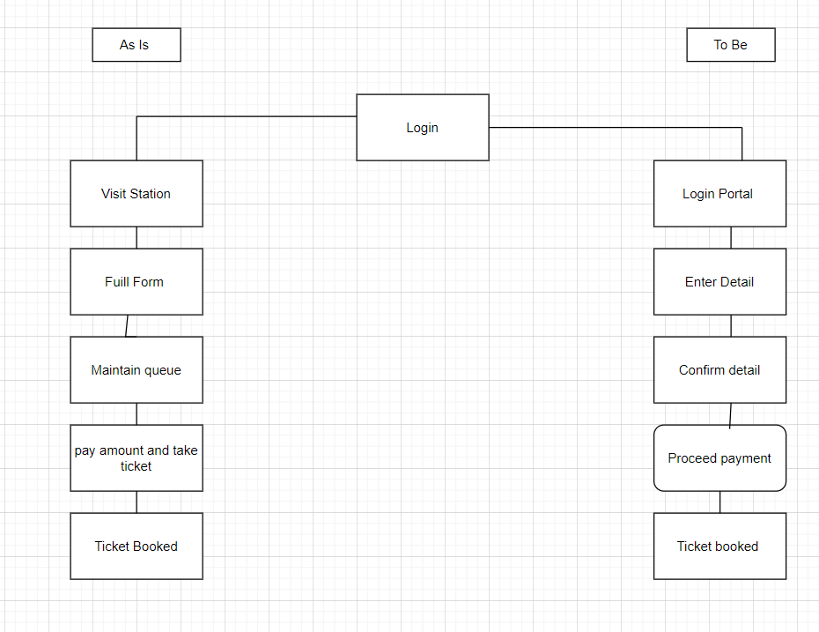

9. Business Requirement

Req ID | Req. Name | Req. Description | Priority
BR001 | User Search for ticket required | User Should able to search for the ticket | 2
BR002 | User login the Screen | User Should able to login using login id and password | 1
BR003 | Tciekt Confirmation | User Should get details of product Information | 4
BR004 | Email Confirmation | User should get email confirmation | 6
BR005 | Searching for premium tatkal quata | User should search for different station as needed | 3
BR006 | Add Autoupgrade if accepted | User finalize and accept the same | 5

10. Appendices

10.1 List of Acronyms

Acronym | Description
Cust | Customer
UAT | User Acceptance Testing
D1 | Design 1
D2 | Desgin 2
T1 | Testing 1
T2 | Testing 2

Glossary of Terms
Term | Defination
Wc | Without Ticket

Related Document

Document Name | Description | Reference Linkl
Funtional Specification Document ( FSD) | Define details functional requirement | FSD Document
Business Requirement Document ( BRD) | Capture overall business needs and bjectives | BRD Document
Requirement Tracibilty Matrix (RTM) | Define functional and Non Functional requirement | RTM Document
Process Flow Fiagram ( Activity Diagram ) | As IS and TO Be Process flow for Project | Activity Diagram
Use Case Diagram ( Use Case Diagram ) | Complete Business process flow | Use Case Diagram

Q.3 ERD for creating a support system ticketing life cycle

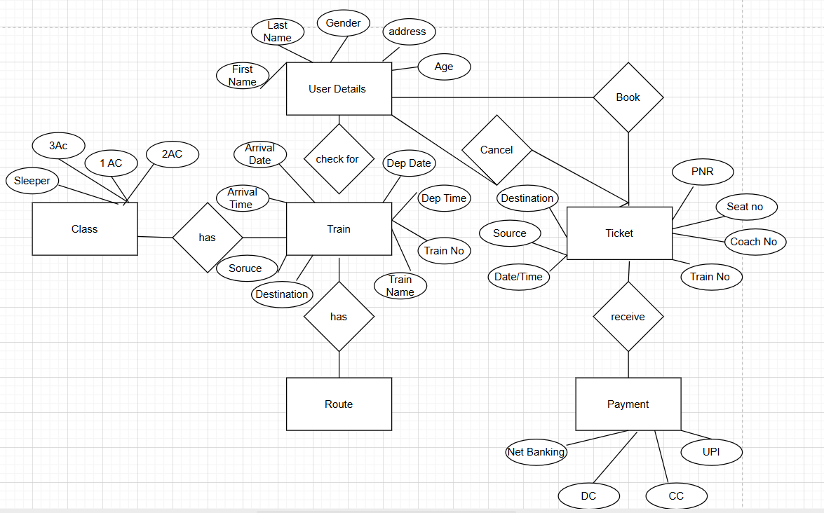

User Story of Shopping from E Commerce
User Story No 01 | Tasks 2 |  | Priority High
AS A User
I WANT TO Create Login Cridentials
SO THAT I CAN access the application
BV 500 |  | CP :01
ACCEPTANCE CRITERIA
Login Screen enter cridentials
User Must input correct details for login
User can access login screen

User Story No 02 | Tasks 2 |  | Priority Medium
AS A User
I WANT TO Search for item
SO THAT I CAN check the quality
BV 300 |  | CP :01
ACCEPTANCE CRITERIA
Google review rating
online feedback submission
it should be seen for any product

User Story No 03 | Tasks 2 |  | Priority Medium
AS A User
I WANT TO register my mail id
SO THAT I Can get notification for my order
BV 200 |  | CP :01
ACCEPTANCE CRITERIA
User can login through Email
Password Protected
Email id should be unique

User Story No 04 | Tasks 2 |  | Priority Medium
AS A user
I WANT TO register my Mobile no
SO THAT I CAN get notificatin on my booking
BV 200 |  | CP :01
ACCEPTANCE CRITERIA
User can get status on mobile
Details should be secure
Password Protected

User Story No 05 | Tasks 2 |  | Priority Medium
AS A CUSTOMER
I WANT TO VIEW CATELOG
SO THAT I CAN PLAN FOR SHOPPING
BV 200 |  | CP :01
ACCEPTANCE CRITERIA
Check the list , Price then plan for it
Details of complete catelog must be seen
After looking comoplet catelog plan shoppung

User Story No 06 | Tasks 2 |  | Priority Medium
AS A CUSTOMER
I WANT TO ADD PRODUCT INTO CART
SO THAT I CAN PURCHASE THEM LATER
BV 200 |  | CP :01
ACCEPTANCE CRITERIA
List down the selected item and then plan accordingly
Select the item and add in cart
Then finalize before booking the orde

User Story No 07 | Tasks 2 |  | Priority Medium
AS A CUSTOMER
I WANT TO RESET MY CRIDENTIAL
SO THAT I CAN TRAKC MY ACCOUNT
BV 200 |  | CP :01
ACCEPTANCE CRITERIA
Remember the login credentials once changed
so that we can easily access
Need to change cridential for security purpose

User Story No 08 | Tasks 2 |  | Priority Medium
AS A ADMINISTRATOR
I WANT TO MANAGE PRODUCT
SO THAT I CAN ENSURE ACCURATE STOCK
BV 200 |  | CP :01
ACCEPTANCE CRITERIA
Maintain record of stock so that no one should suffer
Complete stock need to maintain
Stokc in and stock out

User Story No 09 | Tasks 2 |  | Priority Medium
AS AN ADMINISTRATOR
I WANT TO MANAGE PRODUCT INVENTORY
SO THAT I CAN ENSURE ACCURATE STOCK

BV 200 |  | CP :01
ACCEPTANCE CRITERIA
Enusre proper record of stock
so it will easy to deliver

User Story No 10 | Tasks 2 |  | Priority Medium
AS AN ADMINISTRATOR
I WANT TO HANDLE ORDER
SO THAT I CAN PROVIDE GOOD SERVICES
BV 200 |  | CP :01
ACCEPTANCE CRITERIA
Keep and maintain record of prompt service
Best Service give us rating and google review

User Story No 11 | Tasks 2 |  | Priority Medium
AS A USER
I WANT TO CHECK ORDER STATUS ON MOBILE
SO THAT I CAN VERIFY ORDER
BV 200 |  | CP :01
ACCEPTANCE CRITERIA
Keep record on mobile so it will be handy
After login in application we can check the record of our order
We can easily track online only

User Story No 12 | Tasks 2 |  | Priority Medium
AS A CUSTOEMR
I WANT TO VIEW MY ORDER HISTORY
SO THAT I CAN TRACK MY PAST PURCHASE
BV 200 |  | CP :01
ACCEPTANCE CRITERIA
Keep istory of our order and booking
We can plan according to earlier test

User Story No 13 | Tasks 2 |  | Priority Medium
AS A CUSTOMER
I WANT TO ADD PROMO CODE AND OFFER
SO THAT I CAN SAVE MONEY ON MY PURCHASE
BV 200 |  | CP :01
ACCEPTANCE CRITERIA
Use and apply promo code for discount and save money
It will increase our customer
Now a days every one interest for discount so they will happy with promo code

User Story No 14 | Tasks 2 |  | Priority Medium
AS An ADMINISTRATOR
I WANT TO ADD ITEM
SO THAT I CAN EXPAND SHOPPING
BV 200 |  | CP :01
ACCEPTANCE CRITERIA
List down the item need to be added
First we addd item so it will be easy to finalize the item which needs to be finalize
We can easily select from own seletion

User Story No 15 | Tasks 2 |  | Priority Medium
AS AN ADMINISTRATOR
I WANT TO EDIT THE EXISTING PRODUCT
SO THAT I CAN UPDATE PRODUCT IFORMATION
BV 200 |  | CP :01
ACCEPTANCE CRITERIA
Edit the Exiting product
Change are refleting in catelog
Time to time changes will attractive for customers

User Story No 16 | Tasks 2 |  | Priority Medium
AS AN ADMINISTRATOR
I WANT TO DELETE PRODUCT
SO THAT I CAN UPDATE CATELOG
BV 500 |  | CP :01
ACCEPTANCE CRITERIA
Administrator can delete the product
Should remove product from catelog
The Product will no loger visible to user

User Story No 17 | Tasks 2 |  | Priority Medium
AS A ADMINISTRATOR
I WANT TO VIEW AND MANAGE ORDER
SO THAT I CAN MAINTAIN SUFFIECIENT STCOK
BV 200 |  | CP :01
ACCEPTANCE CRITERIA
The Adminitractor can update product invetory level
The system Track product stock level
System alerts when the stock level is low

User Story No 18 | Tasks 2 |  | Priority Medium
AS A REASTAURANT ONWER
I WANT TO SET PACKAGE POLICY
SO THAT I CAN TRACK THE FEEDBACK AND RESPONSE
BV 100 |  | CP :01
ACCEPTANCE CRITERIA
Google review rating
online feedback
submission should be their

User Story No 19 | Tasks 2 |  | Priority Medium
AS AN ADMINISTRATOR
I WANT TO MANAGE AND VIEW ORDER
SO THAT I CAN TRACK QUALITY AND QUANTATIY OF STOCK
BV 200 |  | CP :01
ACCEPTANCE CRITERIA
The administrtor can view and manage order
System display order quality and price
System can update order status

User Story No 20 | Tasks 2 |  | Priority Medium
AS A CUSTOMER
I WANT TO COTACT CUSTOMER SUPPORT
SO THAT I CAN GET HELP IN MY ORDER
BV 200 |  | CP :01
ACCEPTANCE CRITERIA
The User can contact customer support
Contact detials should be clearly mention on website
User can easily get contact details for any support

User Story No 21 | Tasks 1 |  | Priority Medium
AS A ADMINTRATOR
I WANT TO RESPONSE CUSTOMER QUERY
SO THAT I CAN PROVIDE GOOD CUSTOMER SERVICES
BV 100 |  | CP :01
ACCEPTANCE CRITERIA
Take care of customer query defiantly rating should be good
Customer Support channel an also support normal query

User Story No 22 | Tasks 2 |  | Priority Medium
AS A ADMINSTRATOR
I WANT TO TRACK ORDER
SO THAT I CAN RESOLVE THEM EFFECTIVELY
BV 200 |  | CP :01
ACCEPTANCE CRITERIA
The administrator and view and track order status
Checnk status and ensure timely dilevery

User Story No 23 | Tasks 2 |  | Priority Medium
AS A ADMINISTRATOR
I WANT TO CREATE PROMOTION AND DISCOUNT
SO THAT I CAN GIVE INCENTIVE TO SALES
BV 200 |  | CP :01
ACCEPTANCE CRITERIA
Administrator keep record of Promotion and Discount
Also their will be incentive for the same

User Story No 24 | Tasks 2 |  | Priority Medium
AS A ADMINISTRATOR
I WANT TO MANAGE PRICING
SO THAT I CAN SEE COMPITIION
BV 200 |  | CP :01
ACCEPTANCE CRITERIA
Manage Market competition
Time to time uptdate price list
Add offer and discount in every item

User Story No 25 | Tasks 2 |  | Priority Medium
AS A CUSTOMER
I WANT TO SORT THE PRODUCT
SO THAT I CAN CHOOSE EASILY
BV 200 |  | CP :01
ACCEPTANCE CRITERIA
Arrange the stock
Arrange so that easy to choose

User Story No 26 | Tasks 2 |  | Priority Medium
AS A CUSTOMER
I WANT TO MY ACCOUNT INFORMATION
SO THAT I CAN KEEP DETAIL UPDATED
BV 200 |  | CP :01
ACCEPTANCE CRITERIA
Bank account should be update so helpful in refund and cancelation
Bank information should pertains to user only
Bank information should be correct

User Story No 27 | Tasks 2 |  | Priority Medium
AS A CUSTOMER
I WANT TO REVIEW RATING
SO THAT I CAN SELECT PRODUCT
BV 200 |  | CP :01
ACCEPTANCE CRITERIA
Maintain record of our product so it will improve google rating
We get item how is the response of product

User Story No 28 | Tasks 2 |  | Priority Medium
AS A ADMINSTRATOR
I WANT TO ENSURE SECURE PAYMENT PROCESSING
SO THAT I CAN PROTECT CUSTOMER DATA
BV 200 |  | CP :01
ACCEPTANCE CRITERIA
Secure Payment system should be there with all mode and offers
We can process paymnt through any mode they are safe to use

User Story No 29 | Tasks 2 |  | Priority Medium
AS A ADMINSTRATOR
I WANT TO ANALYSIZE CUSTOEMR BEHAVIOUR
SO THAT I CAN IMPROVE MY EFFORTS
BV 200 |  | CP :01
ACCEPTANCE CRITERIA
Customer feedback and rating is must for growth
Maintain complain and feedback form or portal
Also we can maintain quenaires for better response

User Story No 30 | Tasks 2 |  | Priority Medium
AS A ADMINISTRATOR
I WANT TO VIEW MY SALES REPORT
SO THAT I CAN SEE BUSINESS PERFORMANCE
BV 200 |  | CP :01
ACCEPTANCE CRITERIA
Keep record of sale report for business growth and performance
We can Keep track of our profit

User Story No 31 | Tasks 2 |  | Priority High
AS A CUSTOMER
I WANT TO CHECK GOGLE RIVIEW
SO THAT I CAN PLAN FOR SHOPPING
BV 500 |  | CP :01
ACCEPTANCE CRITERIA
Google review and rating should be their
Keep record of ratings
We have to maintain procper record of review

User Story No 32 | Tasks 2 |  | Priority Medium
AS A CUSTOMER
I WANT TO GET REFUND STATUS
SO THAT I CAN GET MY PAYMENT BACK
BV 100 |  | CP :01
ACCEPTANCE CRITERIA
IF Order is not as per policy it should be return
Keep record of Refund policy with terms and conditions

User Story No 33 | Tasks 2 |  | Priority Medium
AS A CUSTOMER
I WANT TO RETURN ITEM
SO THAT I CAN RESOLVE ISSUE
BV 200 |  | CP :01
ACCEPTANCE CRITERIA
Return request avilable
System validate return
Proper terms and conditions should be their for return policy

User Story No 34 | Tasks 1 |  | Priority Medium
AS A CUSTOMER
I WANT TO RECEIVE INVOICE
SO THAT I CAN KEEP RECORD OF PURCHASE
BV 100 |  | CP :03
ACCEPTANCE CRITERIA
Invocie generated Automatically
Download pdf invocie
Proper set up should be their to download and print invoice

User Story No 35 | Tasks 2 |  | Priority Medium
AS A REGISTERED USER
I WANT TO LOGIN SECURILY
SO THAT I CAN ACCESS MY ACCOUNT SAFELY
BV 200 |  | CP :03
ACCEPTANCE CRITERIA
User can sign in
User can easily access
Auto logout after inactivity

User Story No 36 | Tasks 2 |  | Priority Medium
AS A DELIVERY BOY
I WANT TO UPDATE MY NUMBER IN RECORD
SO THAT I CAN GET RECORD
BV 200 |  | CP :01
ACCEPTANCE CRITERIA
Details should be update in record
Mobile number should be correct

User Story No 37 | Tasks 1 |  | Priority Medium
AS A DELIVERY BOY
I WANT TO ACTIVATE MOBILE DATA
SO THAT I CAN TRACK THE ADDRESS
BV 200 |  | CP :01
ACCEPTANCE CRITERIA
Mobile data should be on and details are undated online
Delivery boy have knowledge how to actie Gprs to track status

User Story No 38 | Tasks 2 |  | Priority Medium
AS A CUSTOEMER
I WANT TO CREATE PERSONAL ACCOUNT
SO THAT I CAN KEEP RECORD OF SAME
BV 100 |  | CP :01
ACCEPTANCE CRITERIA
Details should be safe and secure and maintain privacy
Login cridential should be their for security
Password should be case sensitive

User Story No 39 | Tasks 1 |  | Priority Medium
AS A CUSTOMER
I WANT TO RECEIVE ORDER STATUS ON SMS
SO THAT I CAN TRACK THE ORDER
BV 200 |  | CP :01
ACCEPTANCE CRITERIA
Ensure mobile number update for recoerd customer will get updates on sms
Mobiel number is mandatory for sms delivery

User Story No 40 | Tasks 1 |  | Priority Medium
AS A CUSTOMER
I WANT TO RECEIVE ORDER CONFIRMATION ON MAIL
SO THAT I CAN TRACK THE ORDER
BV 100 |  | CP :01
ACCEPTANCE CRITERIA Ensure email id is updated for updates
Customer will receive update on mail
First email id shoud be created and registered with su

