Document 6- Please prepare a use case diagram, activity diagram and a use case specification document.

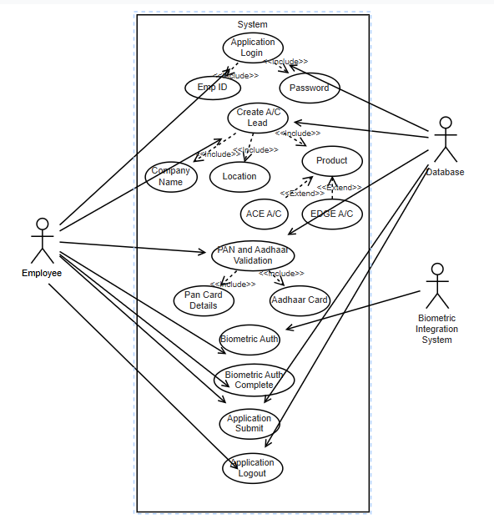
Use case specification

Use Case Name
Employee Login and Creation of New A/C Lead Application

2. Use Case Description
This use case describes the process by which a Bank Employee Login and process for online bank account through Application.

3. Actors
- Primary Actors:
  - Employee
Secondary Actors:
  - Bank Database
  - Bank Server
  - Biometric Integration System

4. Basic Flow
- The Employee log in to application through his Emp id and Password.
- The Employee starts to create lead through filling details.
- The Employee Pan and Aadhaar details for validation cust profile.
- The Bank Server validates the information and creates a new Application.
- The Biometric Integration system Authenticate of Aadhaar details.
- The Employee clicks on the Form Submit to complete created application.
- The user logout into the from the application.

5. Alternate Flow
Employee Login to Application
  - User is not able to login and redirected to forgot "Username/Password" page.
  - The Employee will change password and relogin to application

6. Exceptional Flows
Invalid Registration Details
  - The Application detects invalid or incomplete Customer Profile details.
  - The Application prompts the Employee to correct the information and resubmit the customer profile details.
Existing Relation in Bank
  - The system identifies that the customer already having relation with Bank.
  - The system prompts the pop-up and redirect to home page.

7. Pre-Conditions
- The Employee has access to the application.
- The onboarding Application is Connected with network and operational.

8. Post-Conditions
- The user has a registered and login on the Application.
- The user has knowledge of process.

9. Assumptions
- User have a valid Emp ID and Domain password.
- Users have internet access to login and create Leads.
- Cust will provide accurate details.
- Cust will provide biometric authentication to validate customer details

10. Constraints
- Customer details and demographic details forms must comply with data privacy regulations.
- System should handle a high volume of concurrent application creation.
- Application should follow regulation and comply KYC and AML guidelines.

11. Dependencies
- Email service for sending confirmation and activation emails.
- Social media authentication services if registering through social media.

12. Inputs and Outputs
- Inputs:
  - Employee Login details (Emp Id, password)
  - Create Application and form submission
- Outputs:
  - Confirmation of Details
  - Account Login to system
  - Update the created leads and tracking of application

13. Business Rules
- Employee must provide employee ID for Login.
- Password must meet security criteria (e.g., minimum length, complexity).
- Users can Create, track and follow up Lead.

14. Miscellaneous Information
- System should get support if login error to application.
- System should provide accessibility of customer validation on time.

Employee Login Activity
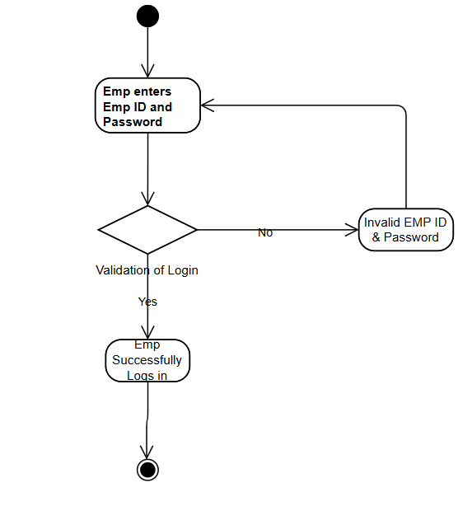

Create Lead Activity
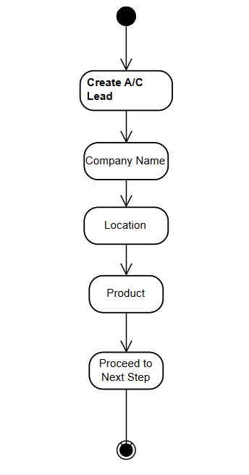

Cust Demographic details Page(Contact and ID proof) Activity
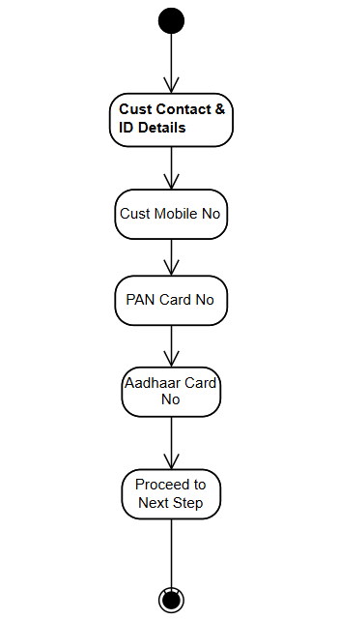

Biometric Authentication Activity
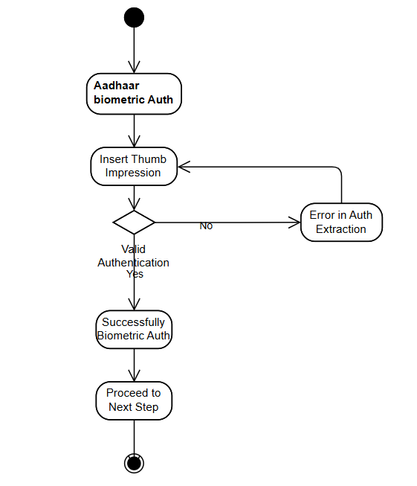

Account kit deliverable and Form submission activity

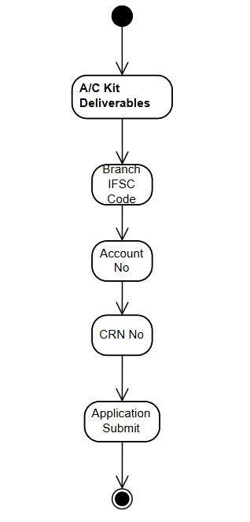

Document 7- Screens and pages

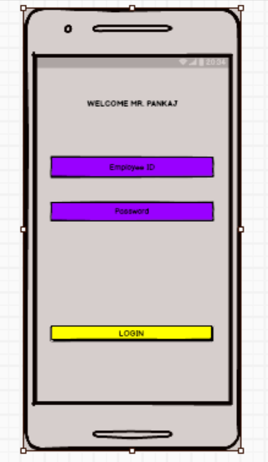

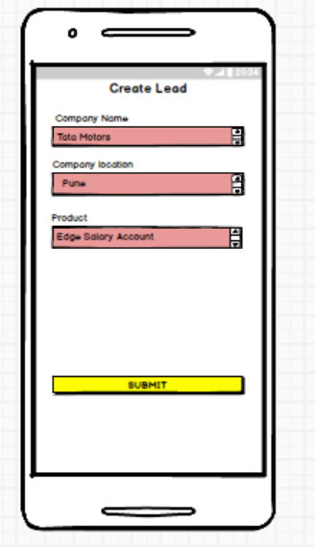

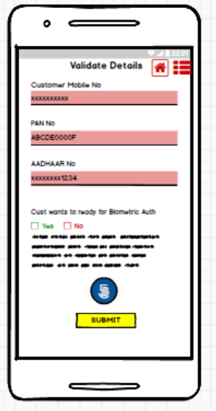

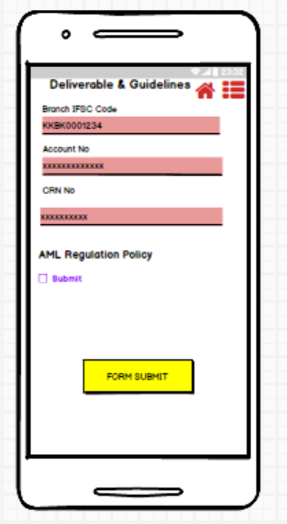

Document 8- Tools-Visio and Axure
Write a paragraph on your experience using Visio and Axure for the project.
Visio- To prepare a practical, flexible, easy to make, easy to understand flow chart or organizational chart the ultimate choice, in most cases, will be Microsoft Visio, an innovative way to visualize a business process. Visio enables you to learn about organizational setup, flow of documentation, and procedures along with cause and effect diagrams, the more important is that the diagram is self explanatory for presentation purpose.
Axure- Microsoft Azure is the perfect public cloud platform.. Microsoft Azure keeps adding features/products according to the need and business requirements. The virtual machines are the most advanced feature from Azure, we are using this most of the time and I can say this is fully scalable and provide great flexibility to our cloud infrastructure and the applications. The deployment of this platform was really quick unlike the other cloud platforms and on the Infrastructure and the applications. The deployment of this platform was really quick unlike the other cloud platforms and on the other hand, this also comes with seamless integration options with the third-party platforms and applications

Balasmiq- Balsamiq is primarily used for low-fidelity wireframing, meaning it helps create simple, visual representations of user interfaces (UIs) to facilitate early-stage design ideation, communication, and feedback. It's a tool designed for rapidly sketching out ideas for websites, apps, and other digital products before diving into detailed design or development. Balsamiq focuses on the initial phases of UI/UX design, where the focus is on layout, content structure, and functionality, rather than aesthetics or specific details.

Document 9- BA experience
My experience as BA in following phases:
1. Requirement Gathering
- Conducting interviews and workshops with stakeholders to elicit requirements.
- Using techniques like brainstorming, surveys, and focus groups to gather comprehensive information.
- Documenting detailed requirements in the form of user stories and use case diagrams.
- Ensuring all requirements were captured accurately and reviewed with stakeholders for validation.
2. Requirement Analysis
- Analysing and modelling requirements using tools like UML diagrams, flowcharts, and data models.
- Prioritizing requirements based on business value, feasibility, and impact.
- Collaborating with technical teams to ensure requirements were technically viable and aligned with project scope.
- Creating requirement traceability matrices to track requirements throughout the project lifecycle.
3. Design
- Contributing to the creation of high-level design documents that outline system architecture and data flow.
- Ensuring the design met business needs and adhered to industry best practices.
- Participating in design review meetings to provide input from a business perspective.
- Documenting detailed functional specifications and user interface designs.
4. Development
- Acting as a liaison between the development team and stakeholders to clarify requirements.
- Reviewing development progress and providing feedback to ensure alignment with requirements.
- Updating requirement documents to reflect any changes or new insights gained during development.
- Assisting in creating test plans and test cases based on the requirements.
5. Testing
- Reviewing and validating test plans and test cases to ensure comprehensive coverage of requirements.
- Participating in various testing activities such as unit testing, integration testing, and user acceptance testing (UAT).
- Identifying and documenting defects, and working with the development team to resolve them.
- Ensuring all requirements were tested and met before the system went live.
6. Deployment
- Preparing deployment plans and coordinating with various teams for a successful rollout.
- Conducting training sessions and creating user manuals to help users understand the new system.
- Monitoring the deployment process to quickly address any issues or concerns.
- Gathering feedback post-deployment to identify areas for improvement and ensure user satisfaction.

