PROFILE

CONTACT
\. 9599445158

IZII Kirty400@gmail.com


Q Gurgaon, Haryana
"Ambitious and detail-oriented professional with 8 years of experience in German language expertise, complemented by beginner knowledge of SAP ERP and a strong foundation in various industries. Certified in Azure 900 and Office 365, with multiple awards for outstanding German language skills."

WORK EXPERIENCE

Accenture India
Cloud ops administrator Analyst
2021 - PRESENT

SKILLS

- German language
- Azure-900
- Provide helpdesk support to end User
- Quality analysis
- Technical troubleshooting
- Hardware and software configuration
- Knowledge of Incident management, mobile device, office 365, Service now, Bmc remedy, Active directory. SAP
- conduct German Interview

- SAP ERP
- Office 365
- Customer support
- spanish language ( beginner level)
- Advance Excel

Ericsson India

Network engineer, German

- Event and Incident Management
- Network Alarm Monitoring and trouble ticket creation (1st Level)
- Training new resources,
- MOP preparation
2019- Oct 2021

2017-2019

LANGUAGES

- English (Fluent)
- German (Fluent)
- Spanish (Basic)
- Hindi (fluent)
Vaco- binary Semantic, (Google)

- Handled transition of projects of Google Shopping pertaining to comprehensive assessments of promotions for leading Ecommerce Merchants across France, the United Kingdom, the United States, Australia, and India, taking actionable steps
based on detailed analysis.

EDUCATION

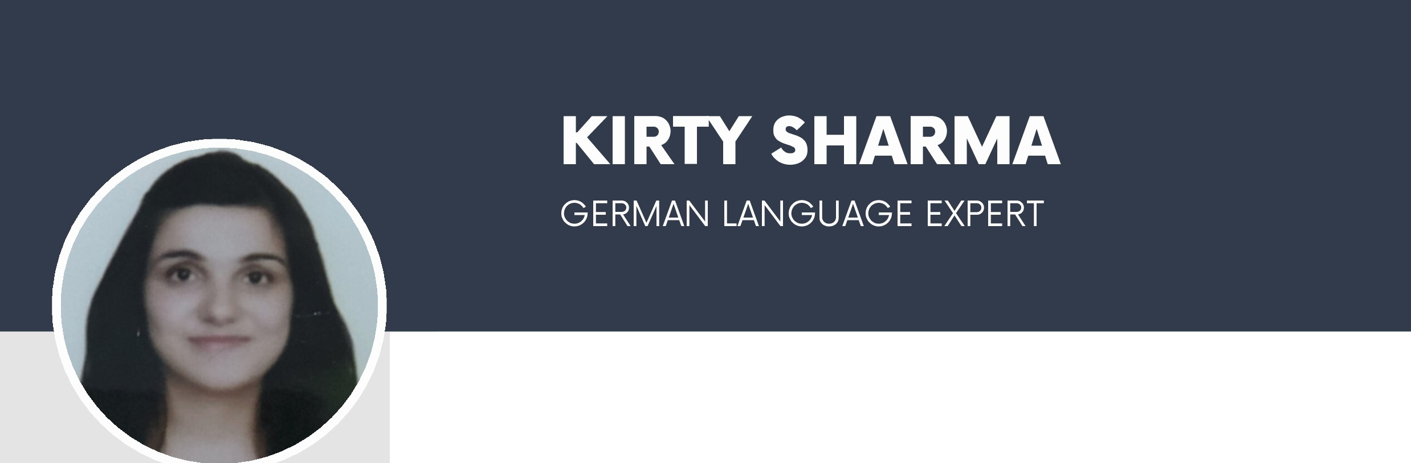

B.A (Hons.) German language

University of Delhi
2013-2016

