A company is having manufacturing plants and warehouses in various parts of the country. They
manufacture ice-cream and milk products. They want to build software to achieve two goals.
- Manage the inventory
- Quickest delivery to the customers
Assignment 1:
- Please make a BRD which can be presented to the client along with complete development and resource plan.
- Prepare process flow diagram using your imagination.
Assignment 2:
- Write an introduction letter to a client introducing yourself as a business analyst in charge of
working with the client and his team to start the business understanding process.
- Prepare a brief BRD and SRS for a project- Horoscope or Ticketing system or online store.
- Make an ERD of creating a support ticket/Ticketing life cycle.
- User story of shopping from ecommerce.
Assignment 2
1. Business Requirement Document (BRD)
Project Title: Inventory & Delivery Optimization System for Dairy Products
Objective:
- Efficiently manage inventory across multiple plants and warehouses
- Enable quickest delivery to customers using smart logistics
Stakeholders:
- Operations Manager
- Warehouse Supervisor
- Delivery Team
- IT Development Team
- Customers
Business Requirements:
- Real-time inventory tracking
- Automated stock alerts
- Route optimization for deliveries
- Integration with GPS and maps
- Customer order tracking and notifications
- Dashboard for analytics and reporting
Functional Requirements:
- Inventory module (Add, update, track stock)
- Delivery module (Assign routes, track vehicles)
- Order management system
- Notification system (SMS/email updates)

- Admin panel for configuration
Non-Functional Requirements:
- High availability and scalability
- Secure data handling
- Mobile responsiveness
- Development Plan:
Phase | Duration | Activities
Requirement Gathering | 2 weeks | Workshops, interviews
Design | 2 weeks | Wireframes, architecture
Development | 6 weeks | Backend, frontend, APIs
Testing | 2 weeks | Unit, integration, UAT
Deployment | 1 week | Production setup
Maintenance | Ongoing | Bug fixes, updates

Resource Plan:
- 1 Business Analyst
- 1 Project Manager
- 2 Backend Developers
- 1 Frontend Developer
- 1 QA Engineer
- 1 DevOps Engineer
2. Process Flow Diagram (Simplified)

Assignment 2
1. Introduction Letter
Subject: Introduction as Business Analyst for Your Project
Dear TechNova Solutions Pvt. Ltd.,
I hope this message finds you well. My name is Isha Joshi and I will be your Business Analyst for the upcoming project. I’m excited to collaborate with you and your team to understand your business needs and translate them into actionable solutions.
Our first step will be a series of discussions to gather requirements, identify pain points and define success metrics. I look forward to working closely with you to ensure the software we build aligns perfectly with your goals.
Warm regards,
Isha Joshi
Business Analyst
jisha9421@gmaill.com

2. Brief BRD & SRS – Ticketing System
BRD Summary:
- Objective: Build a system to manage support tickets
- Users: Customers, Support Agents, Admins
- Requirements:
  - Ticket creation and tracking
  - Status updates (Open, In Progress, Closed)
  - Priority tagging
  - Notifications and escalations
SRS Summary:
- Functional Requirements:
  - Login/Registration
  - Create/View/Edit ticket
  - Assign ticket to agent
  - Comment thread on ticket
- Non-Functional Requirements:
  - Secure access
  - Fast response time
  - Audit logs

3. ERD – Support Ticket Lifecycle
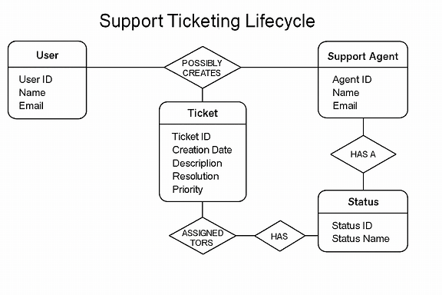
4. User Story – Ecommerce Shopping
Title: Shopping from an Online Store
As a registered user, I want to browse products, add items to cart, and make secure payments, so that I can conveniently purchase items from the comfort of my home.
Acceptance Criteria:
- User can search and filter products
- Cart updates dynamically
- Checkout includes address and payment
- Confirmation email is sent post-purchase

