- Write Agile Manifesto:
The Agile manifesto has 4 values and 12 principles:
Agile Values:
Individuals and interactions over processes and tools
– People deliver value, not tools.
Working software over comprehensive documentation
– Deliver usable product increments instead of heavy documents.
Customer collaboration over contract negotiation
– Continuous communication with customers provides better outcomes.
Responding to change over following a plan
– Agile values adaptability and continuous improvement.
Agile Principles (12)
- Satisfy the customer through early and continuous delivery.
- Welcome changing requirements even late in development.
- Deliver working software frequently.
- Business people and developers must work together daily.
- Build projects around motivated individuals.
- Face-to-face conversation is the best communication.
- Working software is the primary measure of progress.
- Agile promotes sustainable development.
- Continuous attention to technical excellence improves agility.
- Simplicity is essential.
- The best architectures and designs emerge from self-organizing teams.
- Teams reflect regularly and adjust behavior accordingly.

2. User Stories- Acceptance Criteria-BV-CP
Here is the 40 user stories for a Scrum Food Delivery App, which an example structure including BV, CP and AC. The stories covers the main actors as listed Customer, Delivery Boy, Restaurant Owner, Regional Admin, Admin and Business Owner.

- User Story: As a delivery boy, I want to register in Scrum Foods so that I can deliver orders.
Acceptance Criteria: Registration screen, fields for name, ID, Password, register button, Success notification.
BV-100
CP-2
- User Story: As a restaurant owner, I want to view orders so that I can track them.
Acceptance Criteria: List with order info, real-time updates.
BV-500
CP-2
- User Story: As a customer I want to add my address so that delivery reaches me.
Acceptance Criteria: Address text fields, only 5 kms radius allowed, correct details validation.
BV-500
CP-2
- User Story: As a customer, I want to select payment mode so I can pay as I wish.
Acceptance Criteria: Select for payment process, process payment, confirmation message.
BV-500
CP-3
- User Story: As an admin, I want to view restaurants for registration approval.
Acceptance Criteria: Restaurant List, Approval/Reject Notification.
BV-500
CP-2
- User Story: As a customer, I want to view pricing before ordering.
Acceptance Criteria: Menu displays prices.
BV-50
CP-1
- User Story: As a customer, I want to contact delivery boy for order status.
Acceptance Criteria: Show contact info and location for order tracking.
BV-50
CP-1
- User Story: As a restaurant owner, I want to provide time slots for opening/closing.
Acceptance Criteria: Enter/Edit opening/closing times, submit, confirmation notification.
BV-100
CP-2
- User Story: As a Business Owner, I want to view restaurant revenue reports.
Acceptance Criteria: Select report, date filter, region filter, download format-Excel/PDF.
BV-200
CP-3
- User Story: As a regional Admin, I want to manage regional restaurants and their performance.
Acceptance Criteria: List, date range, generate/download report.
BV-200
CP-3
- User Story: As an admin, I want to see regional revenue reports.
Acceptance Criteria: Filter by region, display, download-PDF/Excel.
BV-200
CP-2
- User Story: As a customer, I want to chat with regional admin to request refunds.
Acceptance Criteria: Chat interface, textbox, submit, issue ID, success massage.
BV-200
CP-2
- User Story: As a customer, I want to register and login to the app.
Acceptance Criteria: Registration/login screen, validations, successful notification.
BV-400
CP-2
- User Story: As a customer, I want to search and view available restaurants.
Acceptance Criteria: Search bar, filter options, result list.
BV-300
CP-2
- User Story: As a customer, I want to view restaurant menu.
Acceptance Criteria: Menu listings, pricings and categories.
BV-200
CP-1
- User Story: As a customer, I want to order food.
Acceptance Criteria: Select item, add to cart, check out, confirmation.
BV-600
CP-3
- User Story: As a delivery boy, I want to view assigned orders.
Acceptance Criteria: List assigned, status updates.
BV-500
CP-2
- User Story: As a delivery boy, I want to update order status.
Acceptance Criteria: Mark as picked up, delivered, returned etc.
BV-150
CP-2
- User Story: As a restaurant Owner, I want to verify delivery boys.
Acceptance Criteria: Verification module, approve/reject notification.
BV-160
CP-2
- User Story: As a restaurant owner, I want to view customer feedback.
Acceptance Criteria: Feedback listing, rating filter.
BV-80
CP-1
- User Story: As a Delivery boy, I want to accept/reject order requests.
Acceptance Criteria: Accept/reject buttons, status tracking.
BV-90
CP-2
- User Story: As a customer, I want to provide feedback on delivery.
Acceptance Criteria: Feedback screen, rating bar, comments.
BV-50
CP-1
- User Story: As an admin, I want to manage user complaints/issues.
Acceptance Criteria: Complaint log/view/resolve/close items.
BV: 100
CP-2
- User Story: As a Business owner, I want to view overall platform revenue.
Acceptance Criteria: Revenue Dashboard, Date filters.
BV-100
CP-2
- User Story: As a customer, I want to receive notifications about order status.
Acceptance Criteria: Notification system on app/mobile.
BV-50
CP-1
- User Story: As a delivery Boy, I want to view payment history.
Acceptance Criteria: Payment details, amount, date.
BV-50
CP-1
- User Story: As a restaurant owner, I want to view orders by time slot.
Acceptance Criteria: Filter order by time/dashboard.
BV-60
CP-2
- User Story: As a regional admin, I want to manage delivery boys.
Acceptance Criteria: Delivery boys profiles.
BV-120
CP-2
- User Story: As a customer, I want to cancel the order before it dispatched.
Acceptance Criteria: Cancel button, refund rules, confirmation.
BV-90
CP-2
- User Story: As a customer, I want to view estimated delivery time.
Acceptance Criteria: Display ETA, update based on location.
BV-50
CP-2
- User Story: As a Delivery Boy, I want to raise issues during delivery.
Acceptance Criteria: Issue form, description, submit status.
BV-80
CP-1
- User Story: As a restaurant owner, I want to receive payments from platform/admin.
Acceptance Criteria: Payment transfer screen, status updates.
BV-150
CP-1
- User Story: As a customer, I want to apply coupons/discount codes during checkouts.
Acceptance Criteria: Coupon code entry, validation, apply to total.
BV-100
CP-2
- User Story: As an admin, I want to approve/reject restaurant.
Acceptance Criteria: Registration list, Approve/reject notification.
BV-50
CP-1
- User Story: As a regional admin, I want to track customer feedback status.
Acceptance Criteria: Feedback, dashboard analytics.
BV-50
CP-1
- User Story: As a Business Owner, I want to view refund amounts issued.
Acceptance Criteria: Refund listing, filters by region/date.
BV-50
CP-1
- User Story: As a Delivery Boy, I want to view feedback from customers for my deliveries.
Acceptance Criteria: Feedback listing, rating, comments.
BV-50
CP-1
- User Story: As a regional admin, I want to view payment made to restaurants.
Acceptance Criteria: Payment Statement, download option.
BV-50
CP-1
- User Story: As a customer, I want to log out securely.
Acceptance Criteria: Logout option, confirmation, session cleared.
BV-50
CP-1
- User Story: As a Business owner, I want system usage analytics for reporting.
Acceptance Criteria: Usage Dashboard, export reports.
BV-120
CP-2

Question 3– What is epic? Write 2 epics

Epic is a large body of work that cannot be completed in a single point.
Its broken down into multiple user stories.
Represents a high-business requirements.
Help Product Owners, BA and Agile teams plan and prioritize work.

Ex- User Management is an epic. Stories inside may include: User login, password reset, role management, user profile update etc.

EPIC 1: Product searching & Filtering:
Enables users to quickly find the right items using search and advanced filters such as price, category and availability.
EPIC 2: User Registration and Authentication:
Provide secure registration, login, password recovery, and two factor authentication to allow user to access the platform safely.

Question 4 –What is the difference between BV and CP
Business Value (BV) | Complex Value (CP)
Assigned by stakeholders | Assigned by developers
Reflects importance to business | Reflects effort to develop
Helps prioritize features | Helps estimate Sprint capacity
Measured in rupee like units | Measured in story points

Question 5 –Explain about Sprint

A Sprint is a fixed timeboxed iteration in Scrum during which the Scrum team works to deliver a potentially shippable product increment.
It is the core development cycle in Agile.
- Sprint has fixed duration (Never extended)
- Work inside the Sprint cannot change once committed.
- The team selects user stories during Sprint Planning.
- At the end of the sprint, the team demonstrates completed work in the Sprint review.
- Team conducts a Sprint Retrospective to improve processes.

A Sprint helps the team to deliver value early, incrementally and consistently.

Sprint Duration: Agreed duration is 2 weeks.
Scrum-Subunit of Sprint: Each Sprint (2 weeks) broken into multiple Scrums (Daily iterations)
After every day’s development, the team meets in the Daily Scrum Stand-up meetings.

PBI-Product Backlog Item:
Anything that delivers value to the product.
Ex: User stories, Enhancements, Bugs, Technical tasks.
PBI sits in the product backlog prioritized by Product Owner.

WIP (Work in Progress)
- Shows tasks currently being developed.
- Used for daily tracking.

Sprint Backlog:
Contains selected user stories for the Sprint.
Represents what needs to be developed.

Question 6 – Explain Product backlog and sprint back log

Product Backlog: A complete list of all users stories for the entire project prioritized by the product owner.
Sprint Backlog: A list of selected user stories and tasks chosen by the team for the current Sprint.

Daily Scrum Meeting:
Everyday developers answer:
- What did I do?-Explain progress made yesterday/previous day.
- What will I do?-Explains what the developer to do next.
- Any Challenges/impediments? When you will complete the user story?-They provide the commitment on when the story will be completed.

Question 7 – What is impediments log? write 2 impediments
A impediments log is a document or tracker used in Agile/Scrum to record anything that is blocking or slowing down the progress of the team.
Sample Impediment 1: Development team is unable to proceed with the API integration because the vendor has not yet shared the API documentation.
Impact: User authentication module is delayed-Sprint goal at risk.
Owner: Scrum Master/BA to follow up with the vendor.
Status: Open
Sample Impediments 2: Test environment is frequently down due to server issues.
Impact completion: QA team cannot execute test cases-delay in testing.
Owner: IT infrastructure team.
Status: In progress.

Question 8 – Explain Velocity of the Team
Velocity is the measure of how many Complexity Points (CP)or story points a Scrum team completes in one Sprint. Only the completed user stories are counted.

Question 9 – Draw Sprint Burn Charts n Product Burn Down Charts

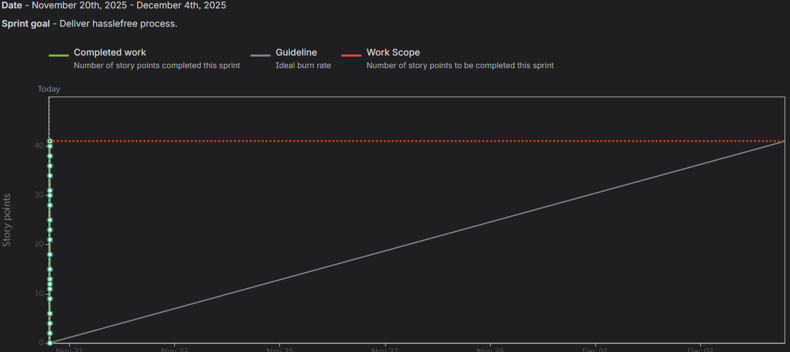

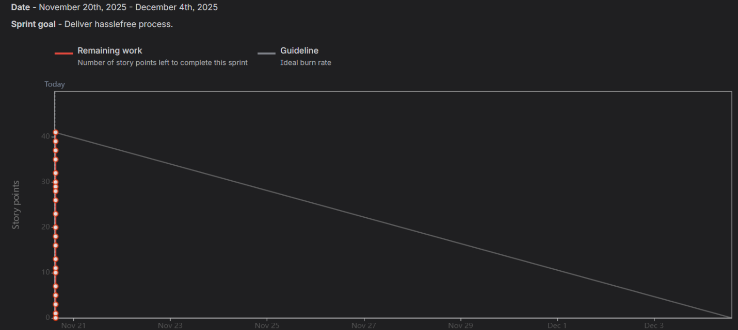

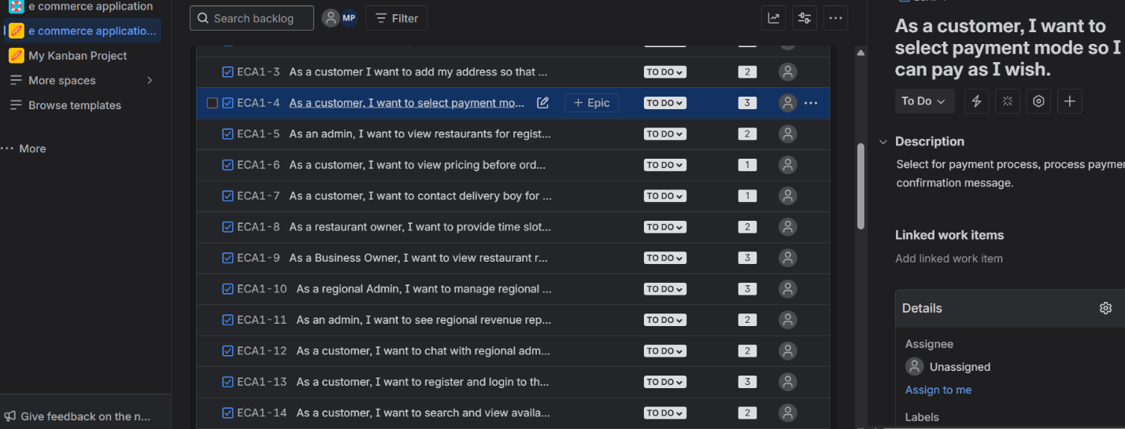

Question 10 – Explain about Product Grooming
This also called Backlog Grooming or Backlog refinement, is a continuous activity where the Product owner and Scrum Team review, update and refine the Product Backlog to ensure its clean, organized and ready for future Sprints.
Its helps the team to maintain a well-structured and prioritized backlog.

Question 11 – Explain the roles of Scrum Master and Product Owner
Scrum Master: The Scrum master is the leader of the Scrum team.
The main responsibility is to ensure that the scrum framework is followed properly and team remains productive.
Ensure scrum process in followed.
Removes Impediment.
Facilitates Scrum Ceremonies (Sprint planning, Daily Scrum, Sprint review/retrospective)
Finally the Scrum improves the team’s efficiency, removes blockers and enables smooth Scrum execution.
Product Owner: The voice of the customer and business.
Owns and manages the product backlogs.
Defines product vision.
Makes Businesss decisions.
The product owner maximizes product value by managing the backlog and ensuring the team builds the right features.
Question 12 – Explain all Meetings Conducted in Scrum Project

Sprint Planning: Select user stories and creates Sprint Backlog.
Daily Scrum: 15-minutes daily progress updates.
Sprint review: Demonstration of completed work.
Sprint retrospective: Internal meeting to discuss improvements.
Backlog grooming: Ongoing refinement of the product backlog.

Question 13 – Explain Sprint Size and Scrum Size

Sprint Size=2 Weeks- Total duration of one sprint.( Collection of Daily Scrum )
Scrum Size=1 day-Daily development cycle inside a sprint. (Smallest unit of planning inside a Sprint)

Question 14 – Explain DOR and DOD
Definition of Ready (DOR): It’s a checklist that ensures a User Story is completed and ready to be take into the Sprint.
A user story must meet DOR criteria before developers start working on it.
Definition of Done (DOD): It is a checklist that confirms a User story is 100% completed according to the quality standards.
A user story must meet DoD criteria before it is moved to Done in the Sprint Backlog.

Question 15 – Explain Prioritization Techniques and MVP
Prioritization Techniques helps the Product owner decides which user stories should be developed first based on business needs, customer value and urgency.
Techniques used- Moscow, Rice Scoring etc.

MVP-Minimum Viable Product: is the smallest and simplest version of the product that delivers the core value to customers with the minimum features.
MVP-is the smallest usable version of the product that delivers core value with minimum features.
Question 16 – Difference between Business Analyst n Product Owner
Business Analyst:
- Focuses on analysis and documentation.
- Supports PO.
- Collects and clarifies requirements.
- Creates, BRD, FRD, Uses cases.
- No final decision making power
- Work across multiple projects.
Product Owner:
- Focuses on product vision and business value.
- Leads the product.
- Prioritize requirements.
- Creates backlog and user stories.
- Final authority on product decisions.
- Dedicated owner of the product.
Question 17 – Prepare a sample Resume of 3yrs exp Product Owner
Name:XXXXXXXX
Location: Chennai, India
Phone: +91-XXXXXXXXXX
Email: yourmail@email.com
LinkedIn: (Add link)

PROFILE SUMMARY
Product Owner with 3 years of experience in Agile–Scrum environments. Skilled in managing product backlogs, writing user stories, prioritizing business requirements, supporting sprint planning, and coordinating with developers, QA, and stakeholders. Strong in requirement analysis, customer understanding, and delivering incremental product value.

KEY SKILLS
- Product Backlog Management
- User Stories & Acceptance Criteria
- Sprint Planning & Prioritization
- Agile–Scrum Methodology
- Stakeholder Communication
- MVP Definition
- Release Planning
- Jira / Azure DevOps
- Wireframes & Requirement Analysis

WORK EXPERIENCE
Product Owner | XYZ Solutions Pvt. Ltd. | 2021 – Present
Responsibilities
- Maintained and prioritized the product backlog for multiple features.
- Defined clear user stories, acceptance criteria, and sprint goals.
- Collaborated with developers, testers, Scrum Master, and stakeholders.
- Participated in sprint planning, sprint review, and product grooming.
- Accepted completed work based on DoD and quality standards.
- Coordinated UAT with business users and handled feedback.
- Supported release planning and roadmap creation.
Achievements
- Delivered 6+ product releases successfully.
- Improved backlog clarity, reducing requirement gaps.
- Increased sprint predictability using better estimation & prioritization.

PROJECTS
Scrum Foods – Online Food Delivery App
- Created 40+ user stories covering registration, restaurant modules, orders, payment, tracking, and reporting.
- Defined MVP and supported incremental releases.
Internal CRM System
- Managed onboarding, ticket lifecycle, and reporting features.

EDUCATION
B.Sc. Nutrition & Dietetics (2008)
Madras University

TOOLS
Jira • Azure DevOps • Trello • Confluence • MS Excel • Figma

STRENGTHS
Communication • Decision Making • Prioritization • Quick Learning • Collaboration

