Mr. Henry has given this project through his Company SOONY. In SOONY Company, Mr Pandu is Financial Head and Mr Dooku is Project Coordinator. Mr. Henry , Mr Pandu , and Mr Dooku formed one Committee and gave this project to APT IT SOLUTIONS company for Budget 2 Crores INR and 18 months Duration under CSR initiative. Peter, Kevin and Ben are helping the Committee and can be considered as Stakeholders share requirements for the Project. Mr Karthik is the Delivery Head in APT IT SOLUTIONS company and he reached out to Mr Henry through his connects and Bagged this project. APT IT SOLUTIONS company have Talent pool Available for this Project. Mr Vandanam is project Manager, Ms. Juhi is Senior Java Developer, Mr Teyson, Ms Lucie, Mr Tucker, Mr Bravo are Java Developers. Network Admin is Mr Mike and DB Admin is John. Mr Jason and Ms Alekya are the Tester. And you joined this team as a BA.

Question 1 – Audits - 5 Marks
4 Quarterly Audits are planned Q1 , Q2, Q3, Q4 for this Project What is your knowledge on how these Audits will happen for a BA ?
Stage | Audit Report (Requirement gathering phase)
Completed | Completed 10 weeks
Checklist | Checklist BRD Template
 | Elicitation result report
 | Duplicate requirement report
 | Grouping of functionalities/ features -client sign
 | Email communication – to C

Stage | Audit Report (Requirement gathering phase)
Completed | Quarter 2- Audit Report (Requirement analysis phase)
Checklist | UML diagram
 | Business to functional requirement mapping
 | Client signoff- document
 | RTM document version Control
 | Email communication – to CC, BCC

Stage | Quarter 3- Audit Report Design Phase
Completed | 7 weeks
Checklist | Checklist Utilization of tool
 | Document evidence on client communication
 | Stakeholder MOM
 | Email communication – to CC, BCC

Stage | Quarter 4 Audit Report (Development)
Completed | 20 weeks
Checklist | JAD session report
 | End user manual preparation document
 | BA and developer MOM
 | Email communication – to CC, BCC

Stage | Quarter 5- Audit Report (Testing)
Completed | 20 weeks
Checklist | Checklist Test Case summary
 | Training report to end user
 | Lesson learnt document
 | Email communication – to CC, BCC

Question 2 – BA Approach Strategy - 6 Marks

Before the Project is going to Kick Start, The Committee asked Mr Karthik to submit BA Approach Strategy Write BA Approach strategy (As a business analyst, what are the steps that you would need to follow to complete a project – What Elicitation Techniques to apply, how to do Stakeholder Analysis RACI/ILS, What Documents to Write, What process to follow to Sign off on the Documents, How to take Approvals from the Client, What Communication Channels to establish n implement, How to Handle Change Requests, How to update the progress of the project to the Stakeholders, How to take signoff on the UAT- Client Project Acceptance Form ) Your Team Project Manager - Mr Vandanam Senior Java Developer - Ms. Juhi Java Developers - Mr Teyson, Ms Lucie, Mr Tucker, Mr Bravo Network Admin - Mr Mike DB Admin - Mr John.

Answer
- Elicitation Techniques to Apply
- Interview: Conduct individual or group interviews with key stakeholders like Mr. Henry Peter, Kevi and Ben to gather detailed requirements.
- Workshops - Arrange collaborative workshops involving farmers, manufacturers, and developers to capture high-level requirements and clarify expectations
- Survey/questionnaires - Use these to gather feedback from farmers in different areas, especially regarding features they would like to see in the app.
- Document Analysis - Review existing documents related to agriculture products, regulations, and online commerce for a deeper understanding of the domain.
- Stakeholder Analysis
- RACI Matrix - Develop a RACI matrix to define the roles and responsibilities of stakeholders. For example, the committee (Mr. Henry, Mr. Pandu, Mr. Dooku) will be Accountable, the farmers will be Consulted, and the development team (APT IT Solutions) will be Responsible for execution.
- Identify Stakeholders - Key stakeholders are Mr. Henry, the committee members (Mr. Pandu and Mr. Dooku), Peter, Kevin, Ben (farmers), and APT IT Solutions' technical team (Project manager, developers)
- Stakeholder Engagement Strategy - Prioritize engagement based on influence and interest. For example, high-priority stakeholders like Mr. Henry and the farmers will need frequent updates and involvement in decision-making.
- Documents to Write

- Business Requirements Document (BRD): Captures the high-level business requirements, objectives, and the problem statement
- Functional Requirements Specification (FRS) - Defines performance, scalability, and security aspects of the system.
- Use Case Diagrams and Process Flows - Visual representations of user interactions, especially for farmers, manufacturers, and the admin panel.
- Use Case Diagrams and Process Flows - Visual representations of user interactions, especially for farmers, manufacturers, and the admin panel.
- Test Cases - Prepare a list of test cases to validate the functionalities and user experiences during the User Acceptance Testing (UAT) phase.
- Process to Follow for Sign-off on Documents
- Review with Stakeholders - : Ensure all major documents (BRD, FRS) are reviewed with stakeholders (committee, project manager, key users).
- Document Approval Cycle - Share the final versions via email or a document repository. Secure formal sign-offs from the committee through documented approvals or a project management tool.
- Taking Approvals from the Client
- Formal Meetings - Schedule formal meetings to review key milestones and documents (BRD,FRD)
- Change Request Management - Keep the client informed about changes via documented requests and approvals to avoid scope creep. Use tools like Jira or emails for tracking.
- Sign-off Process - Ensure that the client signs off at key stages (requirements, development, UAT) through formal approval forms.
- Communication Channels to Establish and Implement –
- Emails and Official Communication - Use email for formal communication with the committee and stakeholders.
- Daily Standups - Conduct daily or weekly standup meetings with the technical team (developers, testers, etc.) to monitor progress.
- How to Handle Change Requests –
- Change Request Form - Create a standardized change request form that documents the requested changes, their impact on the timeline and budget, and the approval process.
- Impact Analysis - Perform an impact analysis for every change request and review it with the committee before making adjustments.
- Change Control Board - Establish a change control board (CCB) comprising key stakeholders who approve or reject change requests.
- How to Update Progress to Stakeholders –
- Weekly Status Reports - Send weekly status reports to stakeholders, highlighting progress, risks, issues, and upcoming milestones.
- Monthly Steering Committee Meetings - Schedule monthly meetings with the committee to present the overall project health, timelines, and any critical risks or changes.
- How to Take Sign-Off on the UAT - Client Project Acceptance Form
- UAT Preparation - Ensure that the application is thoroughly tested before UAT begins, with test cases mapped to the requirements.
- Client UAT Involvement - During the UAT phase, the committee and key users (E.G., Farmers) should be involved in testing and feedback sessions.
- UAT Sign-Off - After successful UAT completion, the client will sign the project acceptance form. This can be a formal document that certifies the acceptance of the final product and marks the projects as complete.

Question 3 – 3-Tier Architecture –

Explain and illustrate 3-tier architecture?

Ans – Three- tier architecture also known as multi-layer architecture. It is software design pattern that divides an application in to three interconnected layers.
1 . presentation or application layer
2. business logic layer
3. data base layer

- Application – we have front end screen, pages, companies’ specific logic and functionality
- Business logic layer – all reusable components frequently changing components governing body is added here. example – payment gate way, emails
- Data base layer – all data base components which connecting to the server.

- Application layer –
  - Purpose – this layer is responsible for the user interface & user experience. It handles all interaction with user and present data to them
  - Components – web browser, mobile printer, screen, pages validation on page.
  - Responsibility – Displaying information to the user, capturing user inputs, sending request to the business logic layer.
- Business logic layer –
  - Purpose – this layer contains the business rules and logic. It processes user request from the application layer and make decisions based on the business rules.
  - Components – API, Server-side application and middle ware.
  - Responsibilities – validating user inputs, processing data and implementing business logic and communicating with the data base layer to fetch & modify data.
- Data base layer –
  - Purpose- this layer manages data storage and retrieval. It ensures data integrity and provides access to the data base.
  - Components – data management system example- SQL, MY SQL
  - Responsibility – sorting and manage database, performing crud (create, read, update and delete) operation
  - Ensuring data security and integrity.

Question 4 – BA Approach Strategy for Framing Questions – 10 Marks

Business Analyst should keep What points in his/her mind before he frames a Question to ask to the Stakeholder (5W 1H – SMART – RACI – 3 Tier Architecture – Use Cases, Use case Specs, Activity Diagrams, Models, Page designs.

Ans –
- 5W1H
5 W
- Who -
- What
- Where
- When
- Why
1H
- How

- Who – Need to Identify stakeholders required questions. Who will the primary user What (Farmers & Manufacturer)
- What- Define specific requirements from farmers & Manufacturer view. What type of products needs to be listed (Fertilizers, seeds, pesticides). What functions are essential for the application.
- Where – understand the uses. Where user access the application (Mobile application or desktop application. Do we need to consider specific geographical constraints.
- When – Clarity time line. When do farmers typically need these products? What is the time line for project mile stone?
- Why – Explore the farmers underlying. Why is this application important for farmer and what specific problems are we trying to solve.
- How – investigate process and method. How do farmers currently source their products? How will the application facilitate

- SMART-
- S - Specific
- M – Measurable
- A - Achievable
- R – relevant
- T – Time bound

- Specific – Ensure clarity and precision.
Question – What specific features should the application have for product search?
- Measurable – Enable quantified outcome. How many product do you except to be available at launch?
- Achievable – assess feasibility
Is it realistic for farmers to use mobile devises for this application
- Relevant – align with project, Goal.
How does this application fit in to the farmers on daily routine.
- Time bound – Set deadlines
When do we except to place your first order through the application.

- RACI Matrix-
- R – Responsible
- A - Accountable
- C – Consultant
- I – Informed

- R – Responsible- The person or people who actually complete the task or deliverable
- A – Accountable – The person ultimately responsible for the correct and through completion of the task. This role has the final say and is answerable for the outcome.
- C- Consulted – the people who are consulted for their expertise or input before a decision is made or action is taken’
- I – informed – The people who are kept in the loop about the progress of the task, but are not actively involved in the decision-making process.

- 3 Tier Architecture –
- Application layer – Focus on user experience. Need to identify which key features are more important for the user interface.
- Database Layer – Gather data management.
What type of date do we need to sore for product and users.
- Business layer – Inquire about business rules.
What rules should govern the listing and ordering of product.

- Use cases and use case specification
- Use cases – it refers to a description of how a farmer and manufacturer interacts with the system to achieve a specific goal.
- Use case specification – it provides a detailed description behaviour of a system from a user’s perspective.
- Activity diagram and models- It is a type of UML( Unified Modelling Language) Diagram that visually represent the workflow of a system or process
For Mr. Henry’s Online Agriculture products store case study an activity diagram would illustrate how farmers interact with the system to browse, Select and Purchase agricultural products and how the system processes this action.

- Page Design – After the requirement gathering and requirement analysis process, we can start the page design along with the software designing process.

Question 5 – Elicitation Techniques - 6 Marks

As a Business Analyst, What Elicitation Techniques you are aware of? (BDRFOWJIPQU)

- Brainstorming
- Document analysis
- Requirement workshop
- Focus group
- Observation
- Interview
- Joint application development
- Prototyping
- Questionnaires
- Use cases

- Brainstorming – Gathering group to generate a wide rang of idea and solution quickly
Brainstorming can be done either individually or groups. Idea collected can then be.
- Documents Analysis – Reviewing existing documentation to extract relevant information and understand current process.
- Requirement workshop – facilitated sessions where stakeholder come together to discuss and define requirement collaboratively.
- Focus group – Engaging a small group of stakeholders to discuss their needs & perspective on a particular topic or product.
- Observation – watching user in their environment to understand workflows and identify needs based on their actual behaviour.
- Interview – conducting one to one discussion or small group discussions together in to depth information from stake holders.
- Joint application development (JAD session)- Collaborative workshop that involve stakeholder and developer to refine requirements and solutions.
- Prototyping – creating preliminary version of the application to visualize and validate requirements with users.
- Questionnaires – Distributing survey to gather information from a larger audience which can be help identify trends and requirements.
- Use cases – Defines scenarios that describe how user will interact with the system, which helps to clarify requirements.

Question 6 – This project Elicitation Techniques - 5 Marks

Which Elicitation Techniques can be used in this Project and Justify your selection of Elicitation Techniques?

Prototyping
Use case Specs
Document Analysis
Brainstorming

Fertilizers, seeds, pesticides details from the manufacturers and should be able to display them to the Farmers.
To gather the business requirements from the client, you went to SOONY and met Mr. Henry. When Mr. Henry was asked about the project and what are they expecting from the project, Mr. Henry stated that he is expecting to have a login for all its users (fertilizers, seeds, pesticides manufacturers and Farmers) , a product catalog of fertilizers, seeds, pesticides, a search option to search for products, payment process, and delivery tracking.
After doing the stakeholder analysis, you have found out that Peter, Kevin, Ben are the key stakeholders and you have scheduled an appointment to meet them. After meeting with them and trying to gather the stakeholder requirements, Kevin said that, a Farmer should be able to browse through the products catalog once they visit the website and need to have a search option so that they can search for any product they need. Peter said that, if a farmer wants to buy any product or add them to buy-later list, they need to login first using their email id and password. If it is a new user, then they can create a new account by submitting their email ID and creating a secure password. Ben added saying that, Farmers needs to have an easy-to-use payment gateway which should include cash-on-delivery (COD), Credit/Debit card and UPI options so that the user’s experience should be better. Kevin mentioned that, a user gets an email confirmation regarding their order status. A delivery tracker to track the whereabouts of their order

Identify Business Requirements (which includes Stakeholder Requirements)
BR001 – Farmers should be able to search for available products in fertilizers, seeds, pesticides
BR002 – Manufacturers should be able to upload and display their products in the application

- Prototyping – Prototype is the model version of a product. It is used as an early , in expensive sample of a product that helps to test its features or identify defects so improvement can be made in final version.
Prototype provides the opportunities together valuable feed back from stakeholder, partners or customers about the project or product. This information can be used to build a product that meet all the requirements.

Prototype Phase
- Information gathering
- Designing
- Developing testing and user feed back
- Final product development
- Use case specification – A use case specification is a detailed textual documentation that describes a user interaction with system to achieve a specific goods, including precondition post condition the basic flow of events and any alternative or exception scenario.
- Document analysis - In project management document analysis is the process of systematically reviewing existing document to gather essential information, identify requirements and understand the project.
- Brainstorming – Brainstorming techniques are methods for generating a large quantity of creative idea around a specific topic, often following principle like deferring judgement, encouraging wild idea, building on other suggestion focusing on quantity over quality.
Justification

I would use below elicitation techniques
- Prototyping
- Use case specification
- Brainstorming

Prototyping – Prototyping enables visualization, feedback and refinement of the user interface and functionalities ensuring a user-friendly application.
Use case specification – usecase specification help in capturing the specific interaction and functionalities required for the online store facilitating effective communication and between farmer & manufacturer.
Brainstorming – brainstorming encourages active participation from stakeholders and facilitates the generation of diverse idea and requirements ensuring comprehensive coverage of stake holders needs.

Question 7 – 10 Business Requirements- 10 Marks

- BR001 – Farmers should be able to search for available products in the categories of fertilizers. Seeds and pesticides.
- BR002 – Manufacturers should be able to create accounts and upload product details (fertilizers, seeds, pesticides) to the platform.
- BR003 – The platform should support user authentication with login features for both farmers and manufacturers.
- BR004 – New users (farmers and manufacturers) should be able to register by providing basic information, including email, password, and location.
- BR005 – Farmers should be able to add products to a "buy-later" list and manage their shopping carts.
- BR006 – The platform should support multiple payment options, including Credit/Debit Cards, UPI, and Cash on Delivery (COD).
- BR007 – Farmers should receive email confirmations regarding the order status after making purchases.
- BR008 – A delivery tracking system should be implemented to allow farmers to track their orders once they have been shipped.
- BR009 – The system should have a product search function with filters (e.g., by category, price, manufacturer) to make it easy for farmers to find the products they need.
- BR010 – The platform should be accessible via both web and mobile applications and be designed with a user-friendly interface for non-technical users in remote areas.

Question 8 –Assumptions- 5 Marks

Assumptions are as below

- The application will be accessible via both web and mobile devices.
- User-friendliness is a priority as many users may not be tech-savvy.
- The system must include functionalities for browsing, searching, and purchasing products, as well as a delivery tracking system.
- Manufacturers will upload product information, and the platform will facilitate communication between them and the farmers
- The Application would be developed within the given timeframe and decided budget.
- There is no unethical work involved while working on this project
- The logistics and delivery will be done seamlessly in all the location of the users.

Question 9 – This project Requirements Priority - 8 Marks

Give Priority 1 to 10 numbers ( 1 being low priority – 10 being high priority) to these Requirements after discussions with the stakeholders

Once the requirements are finalized, as a business analyst, one of the major roles is to act as a liaison between the client and the project team. To gather the requirements correctly from the client side and then to deliver those requirements to the project team in a way they understand.
To make the project team understand the requirements, you need to convert those requirements into UML diagrams and screen mock-ups.

Req ID | Req Name | Req Description | Priority
BR001 | Farmer Search for Products | Farmers should be able to search for available products in fertilizers, seeds, pesticides | 7
BR002 | Manufacturers upload their Products | Manufacturers should be able to upload and display their products in the application | 8
BR003 | User Authentication | The platform should support user authentication with login features for both farmers and manufacturers | 9
BR004 | New User Registration | New users (farmers and manufacturers) should be able to register by providing basic information, including email, password, and location | 9
BR005 | Shopping Cart and Buy-Later List | Farmers should be able to add products to a "buy-later" list and manage their shopping carts | 7
BR006 | Multiple Payment Options | the platform should support multiple payment options, including Credit/Debit Cards, UPI, and Cash on Delivery (COD). | 8
BR007 | Order Confirmation via Email | Farmers should receive email confirmations regarding the order status after making purchases. | 10
BR008 | Delivery Tracking System | A delivery tracking system should be implemented to allow farmers to track their orders once they have been shipped | 10
BR009 | Product Search with Filters | The system should have a product search function with filters (e.g., by category, price, manufacturer) to make it easy for farmers to find the products they need. | 7
BR010 | Web and Mobile Accessibility | The platform should be accessible via both we band mobile applications and be designed with a user-friendly interface for non-technical users in remote areas. | 9

Question 10 – (minimum 5) Use Case Specs - 15 Marks

Prepare use case specs for all use cases

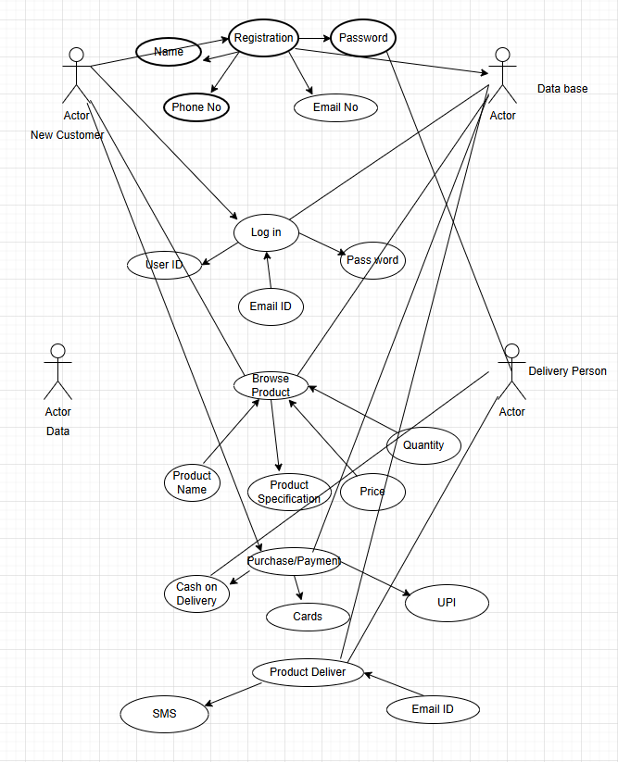

Question 11 – (minimum 5) Use Case Specs - 15 Marks
Farmer and Manufacturer
Use case ID | UC01
User case name | Log in ||Last updated by
Created by | Mr. Harish
Date created | 25-09-2025 ||Last revision date
Actor | Farmer, Manufacturer
Description | This use case allows a user to access the system by entering their credentials
Pre-condition | The user must be registered in the system with valid login credentials.
Post- condition | The user is successfully logged into the system and can access their account
Basic flow | 1. The user selects the "Login" option.  2. The system prompts the user to enter their phone number/email ID and password.  3. The user enters their credentials.  4. The system verifies the credentials.  5. Upon successful verification, the user is logged in and redirected to the dashboard
Alternative flow | If the credentials are incorrect, the system displays an error message and asks the user to re-enter their credentials.  Then user Can log in with other medium like log in with google
Exceptions | If the system is down or the server is unavailable, the user will be notified, and they will not be able to log in
Frequency of use | High
Assumptions | The user has already created an account.

Use case ID | UC02
User case name | New User Registration ||Last updated by
Created by | Mr. Harish
Date created | 25-09-2025 ||Last revision date
Actor | Farmer, Manufacturer
Description | The farmer and Manufacturer registers as a new user in the system
Pre-condition | The farmer has not registered before and has a valid Phone number/Email ID.
Post- condition | The farmer is registered in the system
Basic flow | 1. Farmer clicks on “New User".  2. Farmer enters Phone number/Email ID.  3. System verifies the data and registers the farmer.
Alternative flow | If the Phone number/Email ID is invalid, the system prompts for re-entry
Exceptions | Server errors or communication failures may prevent registration
Frequency of use | Occurs once for new users.
Assumptions | Farmers are familiar with the registration process.

Use case ID | UC03
User case name | Perform Online Purchase ||Last updated by
Created by | Mr. Harish
Date created | 25-09-2025 ||Last revision date
Actor | Farmer
Description | This use case covers the process where a farmer makes an online purchase of a product.
Pre-condition | The farmer is logged in and has browsed available products
Post- condition | The farmer successfully places an order for a product.
Basic flow | 1. Farmer browses available products.  2. Farmer selects a product and checks availability.  3. Farmer places an order.  4.Farmer makes a payment via UPI/Cards or chooses Cash on Delivery
Alternative flow | If the product is out of stock, the system notifies the farmer and suggests alternatives.
Exceptions | Payment gateway failure, product unavailability, or network issues.
Frequency of use | High
Assumptions | The farmer is familiar with online purchasing.

Use case ID | US04
User case name | Browse Products ||Last updated by
Created by | Mr. Harish
Date created | 25-09-2025 ||Last revision date
Actor | Farmer
Description | This use case describes how the farmer can browse available products on the system
Pre-condition | The farmer is logged in.
Post- condition | The farmer views the available products
Basic flow | 1. Farmer selects the "Browse Products" option.  2. Farmer Enter Keyword about Product.  3. The system displays available products.
Alternative flow | None
Exceptions | System failure or no products available
Frequency of use | Medium
Assumptions | Products are regularly updated.

Use case ID | US04
User case name | Upload Product Details ||Last updated by
Created by | Mr. Harish
Date created | 25-09-2025 ||Last revision date
Actor | Manufacturer
Description | This use case describes the process where the manufacturer uploads product details.
Pre-condition | The manufacturer is logged into the system.
Post- condition | Product details are successfully uploaded and displayed on the system
Basic flow | 1.Manufacturer logs in and navigates to upload product details.  2. Manufacturer fills in product details (name, price, availability, etc.).  3. The system validates the details and uploads the product.
Alternative flow | If there are missing details, the system prompts the manufacturer to fill in the necessary fields.
Exceptions | Server issues may prevent the upload.
Frequency of use | High
Assumptions | The manufacturer has all the necessary product details.

Question 12 – (minimum 5) Activity Diagrams - 15 Marks

Registration User Login

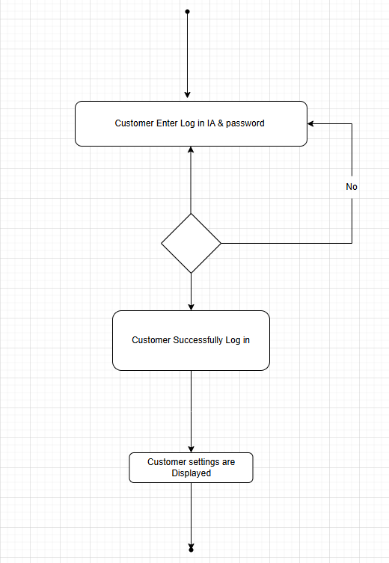

Search/ Brouse Product:

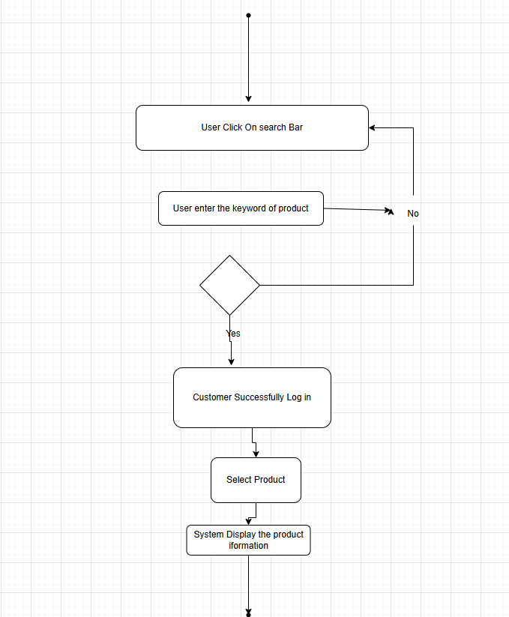

Add To Cart

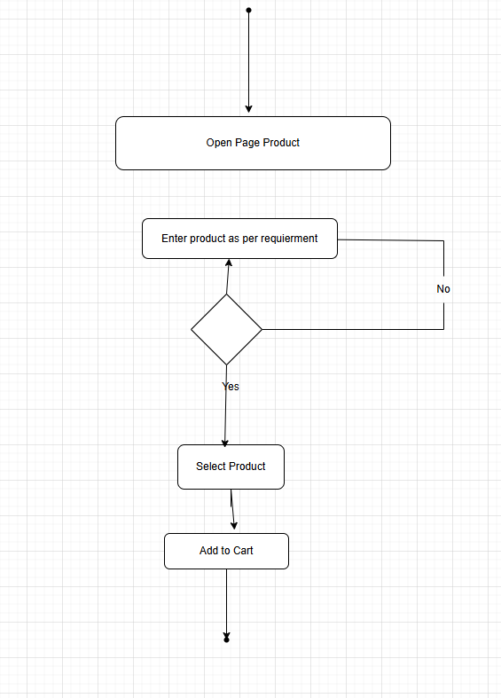

Payment

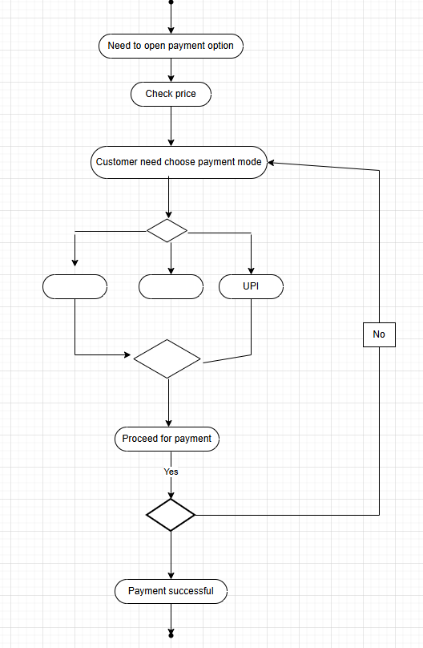

Delivery

