Nurturing Process - Capstone Project1 – Part -3/3 V2D2 Aug 2024

Question 1 . Identify minimum 20 functional requirements Example : Functional requirement: When an order is fulfilled, the local printer shall print a packing slip. Non-Functional Requirement: Packing slips shall be printed on both sides of 4”x 6” white paper, the standard size for packing slips used by local printers.
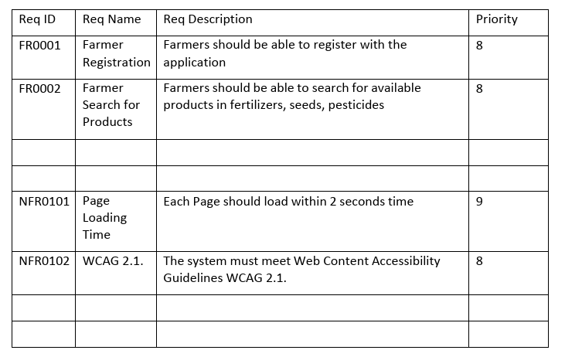

Answer > Functional Requirements (FRs)
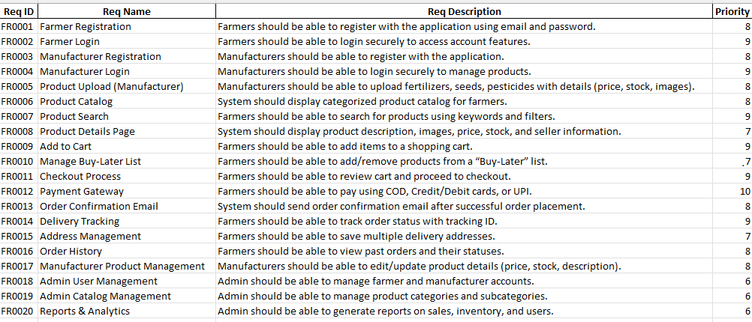

Non Functuional requirements
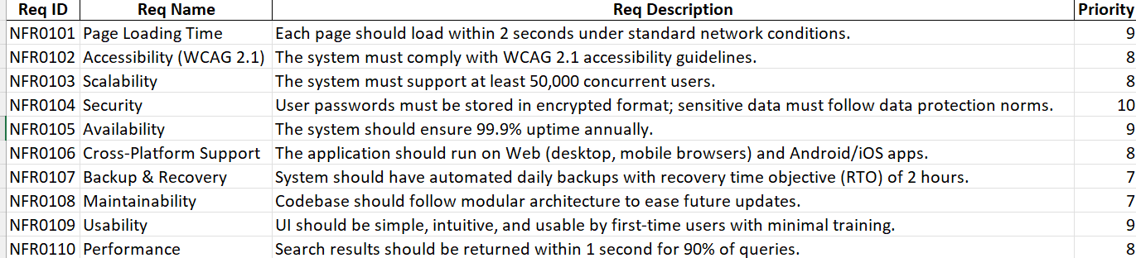

Question 2–Minimum 5 page designs - 15 Marks Make wireframe and prototypes
Answer. 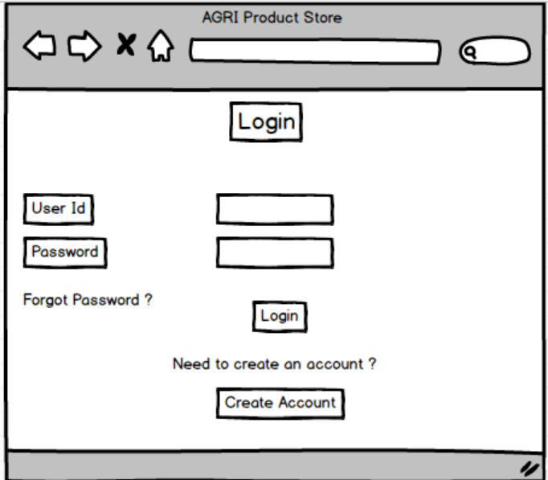

Prototype 1 – Login / Registration Page
- Add Text Inputs → Username, Password.
- Add Buttons → Login, Register, Forgot Password.
- Add a Logo placeholder on top.

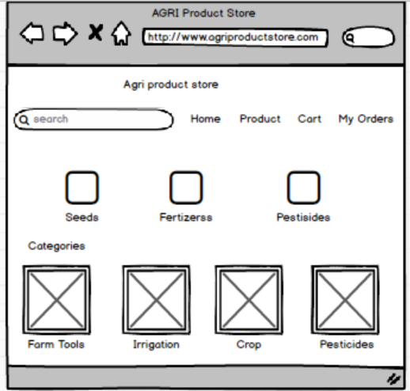

Prototype 2 – Home / Dashboard
- Top Bar → Logo + Search Bar.
- Navigation Menu → Home, Products, Cart, My Orders, Profile.
- Big Banners → “Seeds”, “Fertilizers”, “Pesticides”.
- Quick Links / Categories Grid → show 3–4 sample product categories.

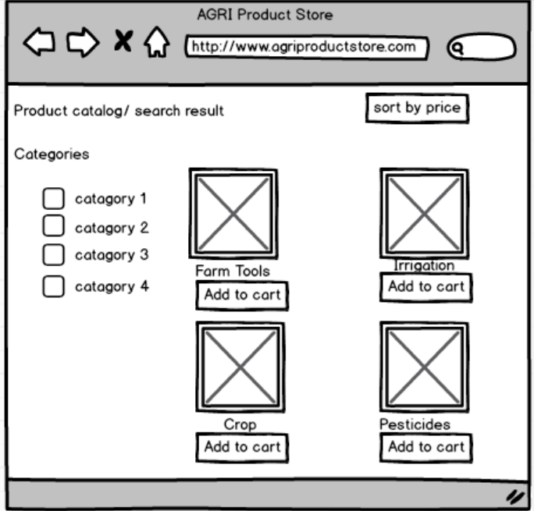
3. Product Catalog / Search Results Page
- Sidebar (left)
Category checkboxes.

- Main area:
Product cards with image placeholder, name, price, Add to Cart button.
- Dropdown (top-right): Sort by Price / Popularity.

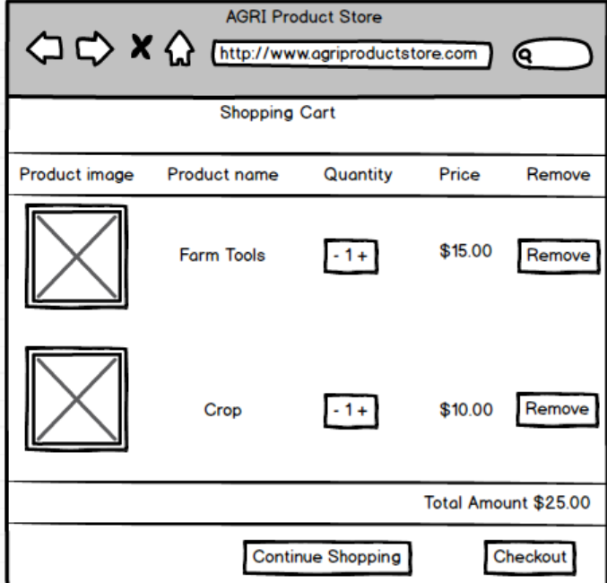
4. Shopping Cart Page
- Table layout:
Product Image, Product Name, Quantity (spinner), Price, Remove button.
- Total Amount (bottom).
- Buttons: Continue Shopping, Checkout.

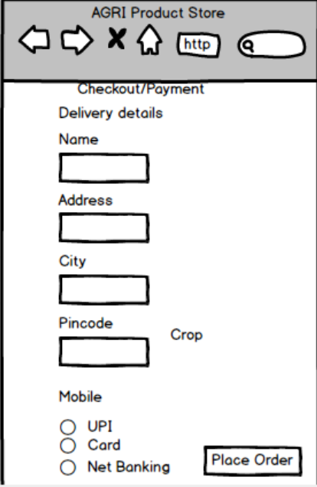
5. Checkout / Payment Page
- Delivery details form: Name, Address, City, Pincode, Mobile.
- Payment options: Radio buttons (UPI, Card, Net Banking, COD).
- Button: Place Order.

Question 3 – Tools (Visio, Balsamiq) - 15 Marks Make a note of the Tools, which you are using for above concepts.

Answer . As a Business Analyst, I have used the following tools to design and represent the concepts in the project:
1. Microsoft Visio
- Purpose:
Used for creating Use Case Diagrams, Activity Diagrams, Data Flow Diagrams (DFD), and Process Flows.
- Why Used:
  - Provides professional diagramming features.
  - Helps to represent system processes, actors, and workflows clearly.
  - Easy to export diagrams for project documentation.

2. Balsamiq Mockups
- Purpose:
Used for designing Wireframes and Prototypes of application screens like Login, Home Page, Product Catalog, Product Details, and Checkout.
- Why Used:
Simple drag-and-drop interface for quick mockups.
Provides UI elements like buttons, text boxes, drop-downs, grids, which help in visualizing user interaction.
Enables stakeholders to validate the look and feel of the system before actual development.

3. MS Excel & MS Word
- Purpose:
Excel: Used for preparing Functional Requirements (FRs) and Non-Functional Requirements (NFRs) sheets in tabular form.
Word: Used for preparing project documentation like BA Approach, Business Case, Feasibility Study, and Requirement Notes.

Conclusion:
- Visio was mainly used for diagramming and workflows.
- Balsamiq was used for wireframes & prototypes.
- Excel/Word supported in requirements management and documentation.

As a Business Analyst for the Online Agriculture Products Store project, I used Balsamiq Mockups to design the wireframes and prototypes.
Tool Used: Balsamiq Mockups
- Purpose:
To create low-fidelity wireframes and interactive prototypes for the application screens.
- Why Chosen:
Provides a drag-and-drop interface for quick design.
Contains pre-built UI components like buttons, text boxes, dropdowns, grids, checkboxes, etc.
Helps in visualizing the user journey (Login, Home, Catalog, Product Details, Checkout).
Easy to make changes based on stakeholder feedback.
Ensures that both technical teams and non-technical stakeholders understand the system design.
Usage in Project:
Using Balsamiq, I created the following prototypes for the Online Agriculture Products Store:
- Login / Registration Screen
- Home / Dashboard Screen
- Product Catalog / Search Results Screen
- Product Details Screen
- Checkout / My Orders Screen
Conclusion:
Balsamiq Mockups was selected as the primary tool since it allows quick creation of wireframes and prototypes, making the requirement visualization process simple, clear, and stakeholder-friendly.

Question 4 – RTM - 6 Marks A business analyst’s key responsibilities are to keep track of the requirements and make sure that no requirement is missed. Mr. Henry and peter have approached you regarding the current status of the project. How will you tackle this situation?
Answer>
As a Business Analyst, my responsibility is to ensure that all requirements are tracked from initiation to delivery and none of them are missed.
When Mr. Henry and Peter approached me regarding the current project status, I would tackle the situation by preparing and showing them the Requirement Traceability Matrix (RTM).

🔹 Steps I would follow:
- List all requirements (Functional & Non-Functional).
Example: Farmer Registration, Product Search, Add to Cart, Payment, etc.
- Map requirements with project artifacts
Design documents (D1, D2…)
Test cases (T1, T2, T3, …)
UAT (User Acceptance Testing)
- Show traceability
Each requirement ID (like FR001, FR002) is linked to its corresponding design, test cases, and UAT.
- Highlight current status
Completed, In-progress, Pending.
- Communicate clearly
This shows Mr. Henry and Peter that their requirements are being tracked and tested properly, ensuring transparency.

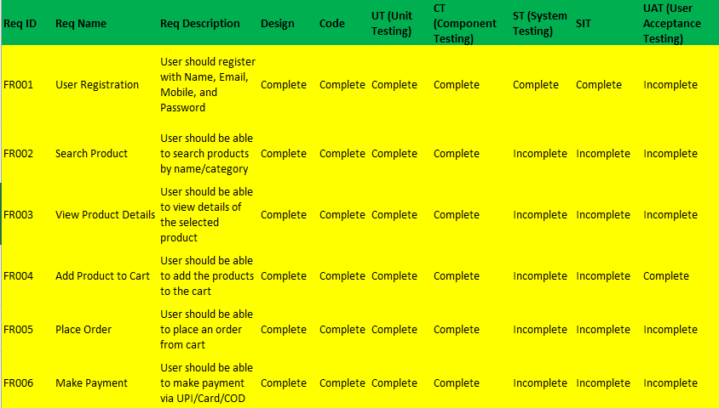
Question 5 – 10 Test Case Documents - 10 Marks Prepare 10 Test Case Documents
Answer
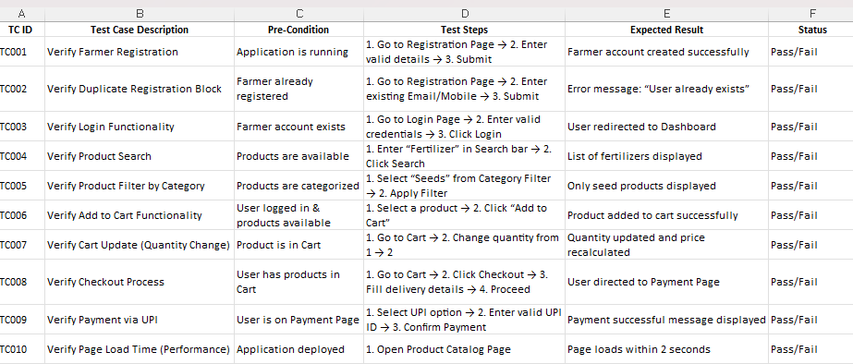
Question 6 – DB Design – 8 Marks After the requirements are thoroughly explained to the entire project team by business analyst, the Database architects have decided to do the database design and also to represent the in-flow and out-flow of data. Draw database schema and ER diagram
Ans 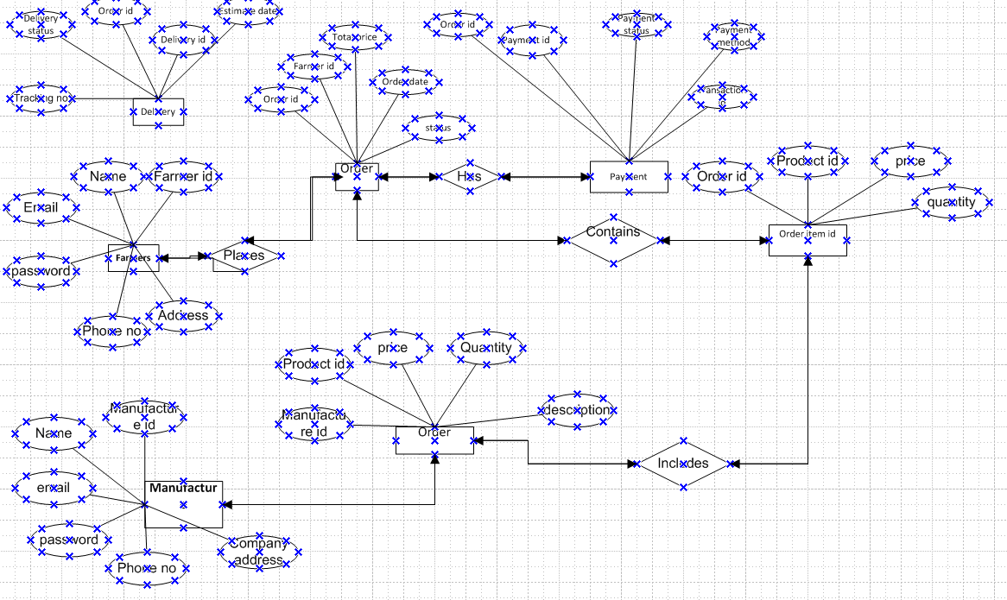

]Question 7 – Data Flow Diagram - 3 Marks What is a data flow diagram? Draw a data flow diagram to represent the in-flow and out-flow of data when a Farmer is placing an order for the product
Answer >

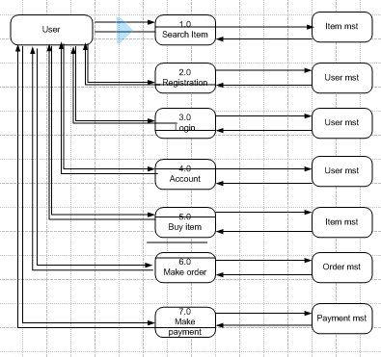

Question 8 – Change Request - 10 Marks Due to change in the Government Taxation structure . we should change the Tax structure How do you handle change requests in a project?
Ans > Handling change requests in a project, especially for a critical update like Government Taxation structure, involves a structured approach to ensure the change is well-managed without disrupting project success. Here is the typical process to handle change requests:
1. Receive and Document the Change Request
- Capture the change request in a formal Change Request Form or Change Log.
- Include details like nature of change, reason (e.g., taxation update), requester, date, and impact expectations.
2. Analyze the Change Request
- Assess the impact on project scope, timeline, budget, resources, and quality.
- Evaluate technical feasibility and risks related to implementing the tax structure change.
- Engage relevant stakeholders including Finance, Legal, and Project Team for impact review.
3. Review by Change Control Board (CCB) or Steering Committee
- Present the change request and impact analysis to the CCB.
- Discuss benefits, costs, risks, and alignment with project/business goals.
- Approve, reject, or request modifications to the change.
4. Update Project Documentation
- If approved, update requirement documents, design specifications, project plan, and budget.
- Communicate changes to the project team and stakeholders.
5. Plan and Implement the Change
- Update system design and development to incorporate new tax rules.
- Adjust testing plans to validate taxation functionality.
- Ensure proper version control and documentation of changes.
6. Testing and Validation
- Perform thorough testing including regression tests to confirm no negative impact on existing features.
- Validate tax calculations per new government regulations.
7. Deployment and Communication
- Deploy changes in a controlled manner.
- Communicate updates to end-users and support teams about the tax structure change.
8. Monitor and Review
- Monitor the system post-implementation for any issues.
- Gather user feedback for any adjustments.

Question 9 – Change Request Vs an Enhancement - 5 Marks
As the project is in process, Ben and Kevin have contacted you. The reason is to inform you that they want the Farmers to sell their crop yields through this application i.e. Farmers should be able to add their crop yields or products and display to general public and should be able to sell them. They also want to introduce Auction system for their Crop yields. As a BA, what will be your response? Is this a change request or an enhancement???

Answer> This request from Ben and Kevin to enable farmers to sell their crop yields and to implement an auction system is an enhancement, not a simple change request.

Explanation:
- Change Request typically refers to modifications or corrections to existing functionalities or requirements within the original scope. For example, correcting a bug, changing payment methods, or updating tax structure fits under change requests.
- Enhancement means adding new features or capabilities that extend the original scope of the project. The request to allow farmers to become sellers of their crop produce and add an auction system introduces new functionality that was not part of the original system, which focused mainly on farmers purchasing agricultural inputs like seeds, fertilizers, and pesticides.

My Professional Response as a Business Analyst:
- Acknowledge the request and appreciate Ben and Kevin's valuable inputs to broaden the platform.
- Explain the difference: Communicate clearly that this is an enhancement that will require impact analysis on project scope, timeline, budget, and resources.
- Conduct impact analysis: Work with technical teams, finance, and stakeholders to assess the feasibility and resources required.
- Follow formal process: Document the enhancement request and present it to the Change Control Board or project stakeholders for approval.
- Manage expectations: Explain that such an enhancement may extend timelines or require additional budget, and the final decision will depend on priority and approval.
- Plan accordingly: If approved, incorporate it into future phases or project milestones.

Question 10 – Estimations - 6 Marks Come up with estimations – How many Manhours required
Answer> Manhours measure the total effort required by the project team to complete the project successfully. Projects are typically categorized by manhour requirements:
- Small: Up to 500 hours
- Medium: Up to 1000 hours
- Large: Up to 1500 hours

Analysis for This Project
- The project duration is 18 months, and the team size comprises 15 experienced members, including developers, testers, admin, BA, and coordinators.
- Given the scope of building the online agriculture product store—covering user registration, product catalog, search, order processing, payment, delivery tracking, and the enhancement to add auction capabilities—this fits into a medium-sized project.
- Infrastructure and resources are already in place; hence, no extra hours are needed for training or setup.
- Considering development, testing, deployment, and stakeholder communication, the predicted effort is up to 1000 manhours.

Question 11 – UAT – 6 Marks Project has finally completed all the stages i.e., design, development, testing etc. Now, it is the role of a business analyst to contact the client for testing of the final product and have to successfully complete it. How are you going to handle this situation? And once it is done, what will be the process to close the project? Explain UAT Acceptance process

Answer > UAT Acceptance Process
Planning:
Blueprints are created to implement UAT testing for every feature and set the minimum acceptance standards. This ensures all aspects that need to be tested are covered.
Designing:
Test cases are designed to simulate all real-world scenarios and possible uses of the software. These test cases help in identifying issues from an end-user perspective.
UAT Testers:
A team made up of end-users (clients or representatives) participates in UAT. They are briefed on how to execute the test cases and what functionalities to validate.
Bug Fixing:
Any bugs or issues identified during UAT testing are communicated to the development team. The team fixes these issues to make the software error-free and ready for users.
Sign Off:
Once all bugs are resolved and the software meets the client’s requirements, the client and key stakeholders indicate their acceptance by signing off.
This formal sign-off means the application is ready for 'Go Live' and the project can be officially closed.

Question 12 – Project Closure Document - 6 Marks Explain Project closure document
Answer > A Project Closure Document is a formal document that summarizes the key outcomes, lessons learned, and final details of a completed project. It serves as a comprehensive record of the project’s accomplishments, challenges, and overall performance, providing valuable insights for stakeholders and future projects.
Points to be included in the Project Closure Document:
- Project Overview: Brief summary of the project objectives & scope.
- Achievements: What goals and deliverables were successfully met.
- Lessons Learned: Insights gained during the project to improve future projects.
- Quality Assurance: Summary of quality standards maintained and tested.
- Resource Utilization: How effectively resources were used.
- Risk Management: Description of risks encountered and how they were mitigated.
- Challenges: Issues faced during the project and their resolutions.
This document ensures a formal end to the project, enables knowledge transfer, and provides a foundation for continual improvement in future projects.

