A customer can make a payment either by Card or by Wallet or by Cash or by Net banking.
Q1. Draw a Use Case Diagram –

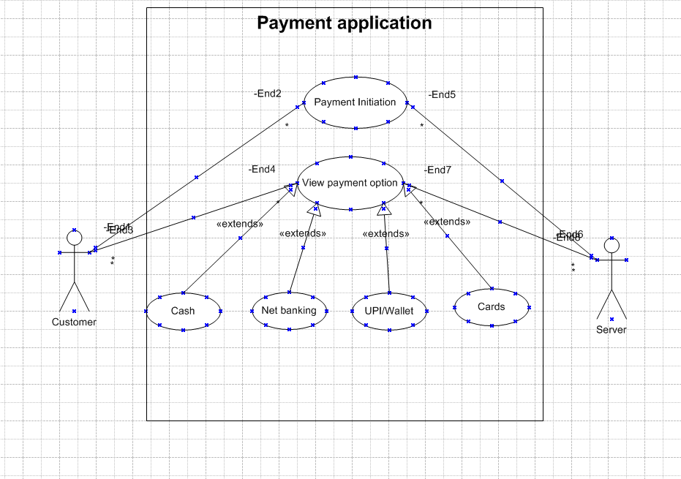

Q2. Derive Boundary Classes, Controller classes, Entity Classes-
Boundary, Controller, and Entity classes are fundamental concepts in software architecture, particularly within design patterns like Model-View-Controller (MVC) and are often used in Object-Oriented Analysis and Design (OOAD).
Boundary Classes- Boundary classes are the interaction points between the system and external actors — such as users, other systems, or devices. They define how data enters and leaves the system.
Purpose:
To receive input from the actor (user or system).
To display information back to the actor.
To translate user actions into operations that the system can process.
Key Characteristics:
They do not contain business logic.
hey only handle communication, validation, and presentation.
One boundary class often corresponds to one use case or interface screen.
Example- Use Case- Login, Boundary Classes- Login Form, Login Page, Login API
Controller Classes- Controller classes act as the brain or middleman between Boundary and Entity classes. They control the flow of data and coordinate actions for a particular use case.
Purpose:
To receive requests from Boundary classes.
To apply logic or validations.
To call appropriate Entity classes for data manipulation or storage.
To send responses back to the Boundary classes.
Key Characteristics:
Each controller handles one specific use case (e.g., “Place Order”, “Login”).
It doesn’t store data permanently — just processes it.
It often contains the workflow logic of the application.
Example- Use Case- Login, Controller Classes- Login Controller.
Entity Classes- Entity classes represent the core business objects or data elements of the system.
They contain both data and business rules related to that data.
Purpose:
To store information that the system needs to remember.
To represent real-world objects in the business domain.
To contain business logic or rules (like calculations, constraints, etc.).
Key Characteristics:
These classes are usually linked to database tables.
They are persistent — data remains even after the system stops.
Multiple controllers can use the same entity.
Example- Business Concept- Customer Details, Entity Class- Customer.

Q3. Place these classes on a three tier Architecture.
The three-tier architecture is a well-structured design model that separates an application into three logical layers:
Presentation Layer – user interface
Business Logic Layer – processing and control
Data Layer – data storage and management
Each layer has a specific role and communicates only with the layer directly adjacent to it.
- Presentation Layer → Boundary Classes
- This layer defines how the user or external system interacts with the application.
- Boundary classes are placed here because they handle input and output operations (e.g., user forms, screens, APIs).
- They do not contain business logic or data management responsibilities.
Example:
Login Page, Product Search Page, Order Form, Payment Page.
- Business Logic Layer → Controller Classes
- This layer acts as a mediator between the user interface and the data layer.
- Controller classes belong here because they process user requests, apply rules, and coordinate communication between boundary and entity classes.
- They ensure that the correct data and operations are performed in response to user actions.
Example:
Login Controller, Order Controller, Product Controller, Payment Controller.
3. Data Layer → Entity Classes
- This layer is responsible for data management and persistence.
- Entity classes belong here because they represent core business objects (like customers, products, or orders) and directly interact with the database.
- They contain the structure of data and may implement some business rules or validation.
Example: Customer, Product, Order, Payment.

Q4. Explain Domain Model for Customer making payment through Net Banking-
A Domain Model is a conceptual diagram that shows the main objects (entities) in a system, their attributes, and their relationships. It helps us understand the business logic and how different parts of the system interact.
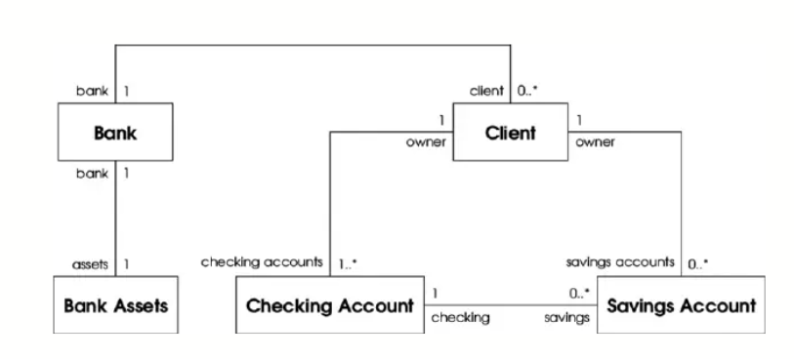

Q5. Draw a sequence diagram for payment done by Customer Net Banking
A sequence diagram is a type of UML interaction diagram that visually represents how objects interact over time. It shows the order of messages exchanged between objects, with time progressing vertically down the diagram. These diagrams are used to illustrate the flow of a specific scenario, like a user logging into an application, to understand and visualize the sequence of operations.
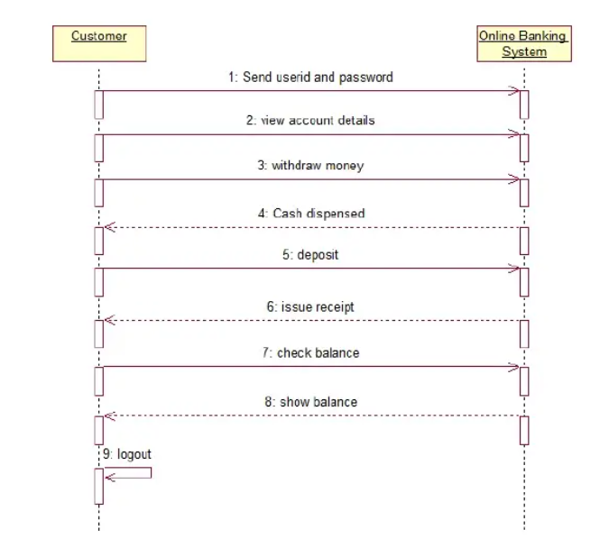

Q6. Explain Conceptual Model for this Case
A conceptual model for a payment made by a customer using net banking provides a high-level representation of the key concepts and their relationships in such a system. It offers a clear, abstract view of the main elements and their interactions. Here's an explanation of a conceptual model for this scenario:
Concepts in the Conceptual Model:
1 Customer:
Description: Represents an individual or entity who wants to make a payment through net banking.
Attributes: Customer ID, Name, Contact Information, User Credentials, etc.
2 Bank Account:
Description: Represents a customer's bank account that is used for making payments.
Attributes: Account Number, Bank Name, Balance, Account Holder Name, Bank Credentials, etc.
3 Payment:
Description: Represents a payment transaction initiated by the customer.
Attributes: Payment ID, Amount, Payment Date, Status, Payment Method, Payment Recipient, etc.
4 Payment Method:
Description: Represents the specific method chosen by the customer for making a payment, in this case, "Net Banking."
Conceptual Model Relationships:
1 Customer has Bank Account:
Description: A customer can have one or more bank accounts.
Cardinality: One customer can have many bank accounts (One-to-Many relationship).
2 Payment is Associated with Bank Account:
Description: A payment transaction is linked to a specific bank account from which the funds will be transferred.
Cardinality: Many payments can be associated with one bank account (Many-to-One relationship).
3 Payment is Made Using a Payment Method:
Description: A payment is made using a specific payment method, such as "Net Banking."
Cardinality: Many payments can use the same payment method.
Conceptual Model Behaviour /Interactions:
1 Customer Registration for Net Banking:
Description: A customer registers for net banking services with their bank. This interaction allows the customer to access their bank accounts and initiate payments.
2 Customer Selects Bank Account:
Description: The customer selects a specific bank account from their list of registered bank accounts to make a payment.
3 Customer Initiates Payment:
Description: The customer initiates a payment by providing payment details, including the recipient, payment amount, and any additional information.
4 Bank Account Balance Check:
Description: The system checks the balance of the selected bank account to ensure there are sufficient funds to complete the payment.
5 Payment Processing:
Description: The payment is processed, which involves debiting the customer's bank account and transferring the funds to the recipient's account.
6 Payment Confirmation:
Description: The system confirms the success or failure of the payment, providing the customer with a payment confirmation.
7 Payment Status Check:
Description: The customer can check the status of a payment to verify whether it has been processed successfully
Q7. What is MVC architecture? Explain MVC rules to derive classes from use case diagram and guidelines to place classes in 3-tier architecture –
MVC (Model-View-Controller)
is a software architectural pattern used in the design and organization of applications, especially those with user interfaces. It separates the application into three interconnected components: Model, View, and Controller. This separation helps manage complexity, improve maintainability, and enables different teams to work on different aspects of an application simultaneously.
MVC Components:
Model:
Represents the application's core data and business logic.
It does not depend on the user interface (View) or user interactions (Controller).
In the context of a use case diagram, Model classes are derived from the domain-specific concepts and business logic of your application. They encapsulate data and implement business rules.
View:
Represents the presentation and user interface components.
It displays the data to the user and provides a way for the user to interact with the application.
In the context of a use case diagram, View classes can represent various UI components, screens, or pages used in your application.
Controller:
Acts as an intermediary between Model and View.
It receives user input from the View, processes it, communicates with the Model to update data, and updates the View to reflect changes.
In the context of a use case diagram, Controller classes represent the control and flow of user interactions, managing use cases, and coordinating actions between the View and the Model.
Deriving Classes from a Use Case Diagram (MVC Rules):
Model Classes:
Identify the domain-specific entities, objects, and data that your application deals with. These will become your model classes.
From your use case diagram, look for actors or use cases that involve data processing and encapsulate this logic into Model classes.
Define classes that represent these entities and any additional classes to handle business rules and data storage.
View Classes:
Identify the parts of your use case diagram that are related to user interfaces, screens, or UI components.
Create View classes to represent these UI components, screens, or pages.
View classes should be responsible for rendering data from the Model and capturing user input for passing to the Controller.
Controller Classes:
Identify the use cases and user interactions on your use case diagram.
Create Controller classes that correspond to these use cases.
Controller classes should encapsulate the logic for managing and coordinating the interactions between the View and Model, ensuring that user input is appropriately processed and data is updated in the Model.
Guidelines to Place Classes in 3-Tier Architecture:
In a 3-tier architecture (Presentation, Application/Business Logic, and Data tiers), you can organize your classes as follows:
Presentation Tier (UI Layer):
Place View classes in the presentation tier. These classes handle the rendering of user interfaces and interactions with the user.
Controllers may also be located in this tier since they are responsible for controlling user interactions.
Application/Business Logic Tier:
Place Controller classes in this tier. They coordinate and manage user interactions, act as intermediaries between the View and Model, and implement application-specific business logic.
Model classes, which represent data and business logic, should also reside in this tier. This tier contains the application's core logic and data manipulation.
Data Tier (Persistence Layer):
For applications that require data storage or external data access, place data access components, repositories, or services in the data tier.
These components are responsible for interacting with databases, external services, or data sources.
Q8. Explain BA contributions in project (Waterfall Model – all Stages) –
1 Requirement Gathering and Analysis-
- This is the most important stage for a BA.
- The BA interacts with stakeholders, clients, and end users to understand their business needs and problems.
- Prepares BRD (Business Requirement Document), FRD (Functional Requirement Document), or SRS (System Requirement Specification).
- Conducts meetings, interviews, and workshops to collect detailed requirements.
- Ensures all requirements are clear, complete, and testable.
- Helps in requirement validation and sign-off from stakeholders.
2 System Design-
- BA supports the design team by clarifying business requirements.
- Ensures the design aligns with business goals and functional needs.
- Participates in review sessions for design documents or wireframes.
- Helps in creating use cases, process flows, and data models to guide developers.
- Verifies if proposed design solutions meet the end-user expectations.
3 Development-
- Developers start coding based on design documents.
- BA provides clarifications whenever developers have doubts about requirements.
- Tracks any requirement changes and updates the documentation if needed.
- Ensures that the project is still aligned with business objectives.
4 Testing-
- BA helps the QA team understand business scenarios and acceptance criteria.
- Reviews test cases to ensure they cover all requirements.
- Performs User Acceptance Testing (UAT) with clients.
- Validates that the product built is functioning as expected.
5 Deployment-
- BA assists in final reviews before go-live.
- Helps in preparing user manuals, training materials, and transition plans.
- Ensures that the client or end-users are ready to use the new system.
- Confirms that all business requirements have been delivered.
6 Maintenance-
- After deployment, BA helps monitor issues or enhancement requests.
- Gathers feedback from users for future improvements.
- Analyses any change requests and updates requirement documents.

Q9. What is conflict management? Explain using Thomas – Kilmann technique-
Conflict management is the process of identifying and handling disagreements to minimize negative impacts and maximize positive outcomes. The Thomas-Kilmann technique explains this process through five conflict management styles: competing, collaborating, compromising, avoiding, and accommodating, which are organized based on how assertive and cooperative a person is.
Thomas – Kilmann technique- The model is based on two dimensions: assertiveness (the extent to which you try to satisfy your own concerns) and cooperativeness (the extent to which you try to satisfy the other person's concerns).
- Competing: (High assertiveness, Low cooperativeness) Pursuing your own concerns at the other person's expense. This is appropriate when you need to take quick, decisive action or when the issue is vital to you and others are clearly wrong.
- Avoiding: (Low assertiveness, Low cooperativeness) Not addressing the conflict. This can be useful when an issue is trivial, there is no chance of winning, or the potential for disruption outweighs the benefits of resolution.
- Accommodating: (Low assertiveness, High cooperativeness) Giving in to the other person's concerns, even at the expense of your own. This is useful when you realize you are wrong, or when the issue is more important to the other person than to you.
- Compromising: (Moderate assertiveness, Moderate cooperativeness) Finding a middle ground where both parties give up something to reach a mutually acceptable solution. This is useful when a quick solution is needed, or when both sides have equal power and are committed to different goals.
- Collaborating: (High assertiveness, High cooperativeness) Working together to find a solution that fully satisfies the concerns of both parties. This is valuable when both sets of concerns are too important to be compromised, and you need to learn from others' insights and find a creative solution.

Q10. List down the reasons for project failure –
Improper Requirement Gathering: A project's foundation is its requirements. When these are gathered incorrectly—being incomplete, ambiguous, or fundamentally misunderstood—the resulting product will inevitably fail to meet the actual needs of the users or the business.
Continuous Change in Requirements: While some change is natural, constant and uncontrolled "scope creep" makes it impossible to establish a stable baseline for development. This leads to project delays, budget overruns, and a lack of clear direction, often resulting in a product that is never truly "finished" or fails to meet any single clear objective effectively.
Lack of User Involvement: Without the active participation and feedback of the end-users, the project team may develop a product that is difficult to use, lacks necessary features, or doesn't align with the users' real-world workflows. This often results in low adoption rates or outright rejection of the final product.
Lack of Executive Support: Executive sponsors provide crucial resources, budget, and authority. Without their visible backing and commitment, a project often struggles to overcome obstacles, secure necessary resources, or resolve conflicts with other business priorities, leading to stalled progress and eventual failure.
Unrealistic Expectations: Setting goals that are unachievable given the available resources, time, or technology can doom a project from the outset. This often leads to missed deadlines, poor quality deliverables due to rushed work, and frustrated stakeholders, ultimately resulting in a project that fails to meet its overly ambitious targets.
Improper Planning: Planning involves defining the project scope, timeline, budget, resources, and risk management strategies. Insufficient or flawed planning creates a project without a clear roadmap. This often leads to poor resource allocation, an inability to track progress effectively, and an increased vulnerability to risks, which are all key ingredients for failure.

Q11. List the Challenges faced in projects for BA-
- Lack of Training: This challenge often relates to a BA's lack of domain knowledge or an insufficient understanding of new methodologies (like Agile) or tools. Without proper training, a BA may struggle to understand specific business processes, use relevant software effectively, or convince the client they can provide suitable solutions, leading to a loss of client confidence and potential project delays.
- Obtaining Sign-off on Requirements: Stakeholders often have conflicting priorities or may not be available for timely reviews, making it difficult to get formal approval on requirements. Without a clear, agreed-upon set of requirements (signed off by all relevant parties), scope creep becomes a major risk, and development efforts may not align with the client's actual needs, causing re-work later in the project lifecycle.
- Change Management with respect to Cost and Timelines: Requirements frequently change due to evolving business needs or market conditions. Managing these changes effectively is a significant challenge. Without a robust change control process, incorporating new requirements can lead to "scope creep," resulting in project delays and cost overruns that were not part of the initial plan or budget.
- Coordination between Developer and Tester: The BA acts as the communication bridge between business stakeholders and the technical team. Challenges arise if there are communication gaps or if the BA fails to translate business needs into technical specifications (and vice versa) effectively. This can lead to the development team building the wrong solution or the testing team creating inadequate test cases, causing defects and delays.
- Conducting Meetings: BAs spend a significant amount of time in meetings (elicitation sessions, status updates, conflict resolution, etc.). Challenges include ensuring all necessary stakeholders are present and engaged, managing conflicting opinions, keeping the meeting focused to avoid time wastage, and ensuring clear decisions are made and documented (e.g., in meeting minutes).
- Making sure Status Reporting is Effective: Ineffective communication and reporting can cause team members and stakeholders to be misaligned on project progress, risks, and next steps. The BA must ensure status reports are clear, concise, and tailored to the audience (e.g., technical details for developers, high-level summaries for executives) to maintain transparency and manage expectations.
- Driving Client for UAT Completion: User Acceptance Testing (UAT) requires significant client involvement, which can be challenging if clients are busy or disengaged. Delays in UAT can push back the entire project launch. BAs must encourage client participation, provide necessary support/training, and clarify the importance of UAT in validating that the solution meets the business need.
- People Management: This involves coordinating with diverse individuals and teams, including difficult stakeholders, team members with mismatched skills, or those resistant to change. The BA needs strong soft skills, such as negotiation, conflict resolution, and leadership, to foster a collaborative environment and ensure everyone is working towards a common goal.
- Overall Making sure Project Health is in Good Health and Deliver as per Timelines without any Issue: The BA's role is crucial for overall project success, but they often lack direct authority over all aspects (e.g., budget, final deadlines). Ensuring project health means constantly monitoring for risks (like scope creep, resource constraints), proactively addressing issues, and working closely with the project manager to deliver value on time and within budget. The challenge lies in managing these many variables simultaneously and effectively without formal project management authority.

Q12. Write about Document Naming Standards –
Document naming standards typically involve a structured framework of specific components separated by delimiters, with common elements including a Project ID, Document Type, Date (YYYYMMDD), and Version Number. This makes files easy to identify, sort, and retrieve.
- Project ID: A unique code or abbreviation for the project to which the document relates (e.g., SCORE, PRJ001).
- Document Type: A short, meaningful abbreviation indicating the file's content or purpose (e.g., MIN for minutes, RPT for report, PLN for plan, INV for invoice, SRS for Software Requirements Specification).
- Date: The date of creation or last modification, using the YYYY-MM-DD format to ensure chronological sorting (e.g., 2025-11-05).
- Version/Status: An indicator of the document's status or version (e.g., DRAFT, FINAL, v1.0, v2.1).
Example – PQ786BRDV1D2.docx

Q13. What are the Do’s and Don’ts of a Business analyst-
- Always use 5W1H for probing into any concept: This means a Business Analyst should use the "Who, What, Where, When, Why, and How" framework to thoroughly investigate and understand a concept or requirement. This ensures a comprehensive understanding of the problem.
- Never say NO to Client - Always listen in your first meetings and if you have to say NO - come with proper reasons - why it is not possible: A BA should prioritize listening to the client's needs and concerns without immediately dismissing them. If a request is not feasible, the BA must provide a well-reasoned and logical explanation, rather than a simple refusal.
- Banned word for BA is "I KNOW": This point emphasizes that a BA should avoid making assumptions or acting as if they have all the answers. Instead, they should maintain a humble and inquisitive mindset, always seeking to learn more from the client and other stakeholders.
- There is NO word called as "BY DEFAULT": This means that a BA should not assume that certain functionalities or features are standard or "by default." Every requirement must be explicitly stated and confirmed by the client to avoid misunderstandings.
- Never imagine anything in terms of GUI - Graphical User Interface - Page designs - Screens: The BA's role is to focus on the business requirements and logic, not the visual design or user interface. Imagining the GUI too early can lead to making assumptions about the solution before the problem is fully understood.
- Question the existence of existence / question everything in the world ex: what client gives is not always correct: A BA should be a critical thinker and not take every statement from a client at face value. They should ask probing questions to validate information and uncover the true underlying needs, as the client's initial request may not be the most effective solution.
- Consult an SME for Clarifications in Requirements: If a requirement is unclear or technical, a BA should seek expertise from a Subject Matter Expert (SME) to ensure accuracy and a correct understanding of the details.
- Every Problem of Client is unique...: This highlights that no two client problems are identical. A BA should avoid applying a one-size-fits-all approach and instead analyse each problem individually, considering factors like technology, location, and local laws.
- Go to Client with a plain mind with no assumptions. Listen carefully and completely until Client is done and then you can ask your Queries. Please do not interrupt the Client...: This advises a BA to approach each client meeting with an open mind. It stresses the importance of active listening, allowing the client to finish speaking before asking questions, and avoiding interruptions to fully grasp the problem from their perspective.
- Maximum Try to extract the leads to Solution from the Client itself. Never try to give Solutions to Client straight away with your previous experience and assumptions. Try to concentrate on the important and truly required Requirements. Don't be washed away by add on Functionalities or don't imagine solutions on Screen basis.: A BA should guide the client to articulate their own solution by asking the right questions, rather than imposing solutions based on prior experience. The focus should be on identifying the core requirements, not getting sidetracked by non-essential features or designing the user interface prematurely.

Q14. Write the difference between packages and sub-systems –

Feature | Package | Subsystem
Purpose | To organize related model elements (classes, use cases, etc.) and manage dependencies at a high level. | To group components into a single, logical, and replaceable unit that functions as a part of the overall system.
Runtime Existence | No; it is a design-time organizational construct. | Yes; it is an instantiable, runtime entity.
Interface | No inherent interface is defined by the package itself; it's a namespace for its contents. | Has a clearly defined, stable interface that encapsulates its internal complexity.
Contents | Can contain any model element, including other packages. | Contains components and other elements, but its internal structure should be hidden and not directly dependent on by other elements.
Visibility | Elements inside can have public, protected, or private visibility to the outside. | Should hide its internal elements from the outside, meaning only its interface should be public.

Q15. What is camel-casing and explain where it will be used-
CamelCase is a way to separate the words in a phrase by making the first letter of each word capitalized and not using spaces. It is commonly used in web URLs, programming and computer naming conventions. It is named after camels because the capital letters resemble the humps on a camel's back. CamelCase is formally referred to as medial capitals. It may also be called or styled as PascalCase, camelcase, InterCaps, mixedCase or WikiCase.
Uses of CamelCase- Many companies and technologies use CamelCase to create new words out of existing words that can be registered as trademarks. Some examples of these would be iPhone, AirDrop, DisplayPort, OneDrive, PlayStation, YouTube and TechTarget.

Q16. Illustrate Development server and what are the accesses does business analyst has?
A development server is a staging environment used by developers to build and test new features without affecting the live production version of a product. A business analyst typically has no direct access to the development server's code or technical infrastructure, but has a functional role in using it as a tool to: review progress, provide feedback, test user-facing features, and verify that requirements are met before deployment.

Q17. What is Data Mapping-
Data mapping is the process of linking data fields from one source to a corresponding destination, creating a "map" for how data should be transformed and transferred. It is a fundamental step for data integration, migration, and other data management tasks, ensuring data remains accurate, consistent, and meaningful when moved between different systems.
How it works
Connecting fields: Data mapping involves creating relationships between data elements in different sources. For example, a field called "client name" in one system can be mapped to a field named "customer name" in another.
Data transformation: It often includes the transformation of data, such as cleaning and reformatting it, so it fits the requirements of the destination system.
Ensuring consistency: By defining these relationships, data mapping helps maintain the integrity and consistency of data as it flows from one system to another.

Q18. What is API. Explain how you would use API integration in the case of your application Date format is dd-mm-yyyy and it is accepting some data from Other Application from US whose Date Format is mm-dd-yyyy-
An API (Application Programming Interface) is a set of rules and protocols that allows different software applications to communicate and interact with each other.
Establish API Communication:
Set up API communication between your application and the other application to exchange data.
Data Formatting:
When sending date data from your application to the other application, convert the date from the dd-mm-yyyy format to the mm-dd-yyyy format. This can be achieved by extracting the day, month, and year components from the date and rearranging them according to the target format.
Data Parsing:
When receiving date data from the other application, parse the mm-dd-yyyy formatted date into your application's dd-mm-yyyy format. Again, you will need to extract the day, month, and year components and rearrange them accordingly.
Data Validation:
Perform data validation and ensure that the converted date remains valid after the format conversion. Check for edge cases, such as invalid dates or date ranges that might be affected by the format conversion, and handle them appropriately.

