Question 1:Write 20 functional requirements?
Answer:
- Functional requirements:
A Functional requirement is a specific behaviour, feature or function that a system or application must perform to meet the business needs. It describes what the system should do.
Req ID | Req Name | Req Description
FR001 | User registration | The system should allow new farmers & manufacturers to register with email and password.
FR002 | User login | The system should allow registered users to log in using their credentials.
FR003 | Role-based access | The system should distinguish roles and grant access.
FR004 | Add product | The system should only allow manufacturers to add products with details.
FR005 | View product catalogue | The system should display a catalog of fertilizers, seeds & pesticides for farmers to browse.
FR006 | Product search | The system should allow farmers to search products using keywords.
FR007 | Product details | The system should allow users to view detailed information about a product.
FR008 | Add to cart | The system should allow farmers to add selected products to a cart.
FR009 | Modify cart | The system should allow user to update quantity or add or remove items from cart.
FR010 | Checkout process | The system should provide a checkout process for farmers to place order.
FR011 | Delivery address | The system should capture farmers delivery address and location during checkout.
FR012 | Payment gateway | The system should integrate a payment gateway supporting UPI, debit/credit card and COD.
FR013 | Order confirmation | The system should display and email an order confirmation after successful payment.
FR014 | Order tracking | The system should allow farmers to track the delivery status of their order.
FR015 | Product management | The system should allow manufacturers to view, edit or delete their listed products.
FR016 | Feedback | The system should allow farmers to rate, and review purchased products.
FR017 | Notification | The system should send notification or emails for order updates, product availability, etc.
FR018 | Multilingual support | The system should support multiple languages for ease of use by farmer.
FR019 | Help & support section | The system should provide a helpdesk or FAQ section to assist user.
FR020 | Admin dashboard | The system should provide an admin dashboard to monitor user activity, transactions and inventory.

- Non-Functional requirements:
Non-functional requirements describes how a system should behave or operate. They define the quality attributes, performance standards, and constraints of the system.
Req ID | Req Name | Req Description
NFR001 | System availability | The system should be available to user 24/7.
NFR002 | Response time | The application should respond to user within 2 sec.
NFR003 | Data security | The system should store all users and transaction data securely.
NFR004 | Usability | The application should have simple and intuitive UI for farmers.
NFR005 | Language support | The system should support multilingual content.
NFR006 | Scalability | The system should be scalable to support multiple concurrent users.
NFR007 | Maintainability | The system architecture shall support easy updates with minimal downtime.
NFR008 | Compatibility | The application should be compatible with multiple devices.
NFR009 | Compliance | The application must comply with acts and applicable data protection regulations.
NFR010 | Accessibility | The application should be accessible to users.
NFR011 | Back & recovery | The system should perform daily automatic backups & support data recovery.
NFR012 | Load handling | The system should handle a minimum of 500 product transactions per minute.
NFR013 | Mobile responsiveness | The application should be fully responsive and optimized for mobile, tabs & desktop.
NFR014 | Session management | The system should automatically logout the user after 1 min of inactivity.
NFR015 | Error handling | The system should display clear error message for all user-side and server-side error.
NFR016 | Audit log | The system should maintain audit log of all the login, transaction and changes made.
NFR017 | System monitoring | The system should include real-time monitoring tools to detect & report system failure.
NFR018 | Localization | The system should format date, currency and number according to regional standard.
NFR019 | Resource optimization | The application should minimize memory & bandwidth use to ensure it performs well in rural areas.
NFR010 | Deployment flexibility | The system should support cloud-based deployment for future scalability.

Question 2:Prepare 5 wireframes?
Answer:
Login Page:
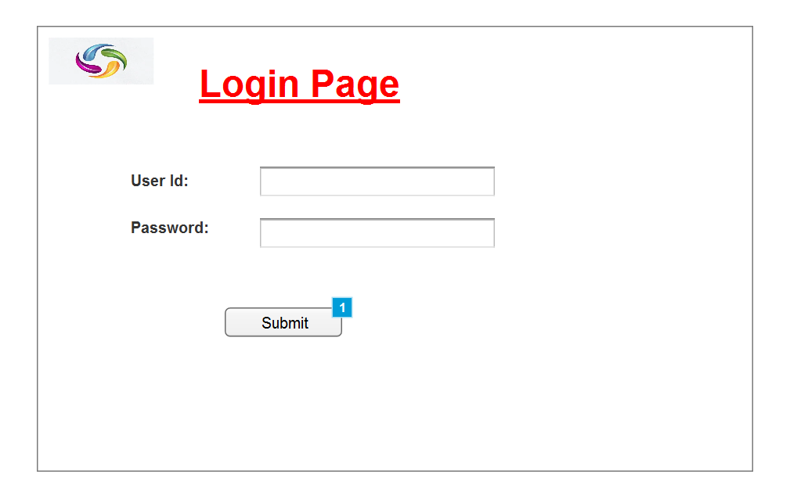
Product details:
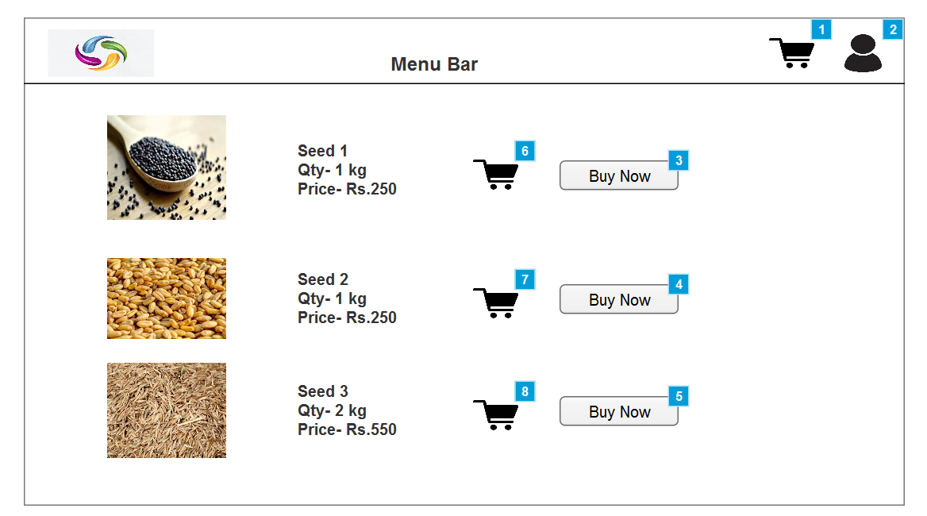

Cart details:
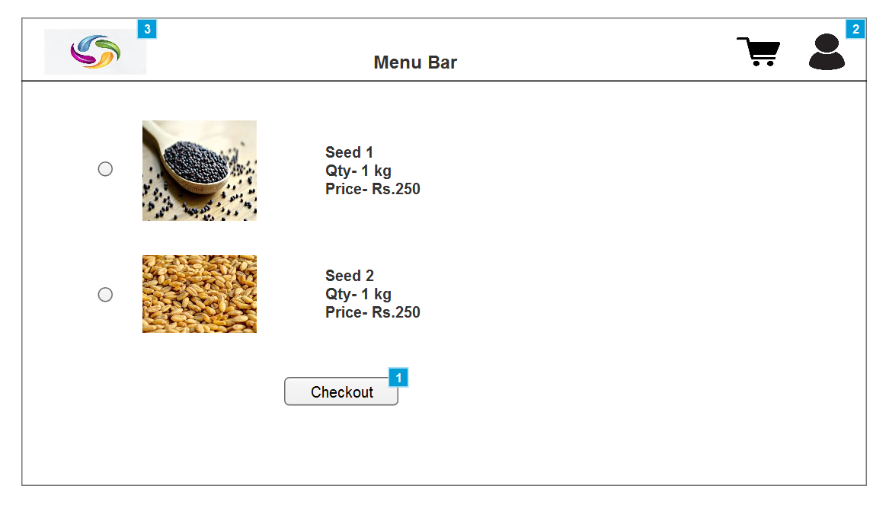
Payment page:
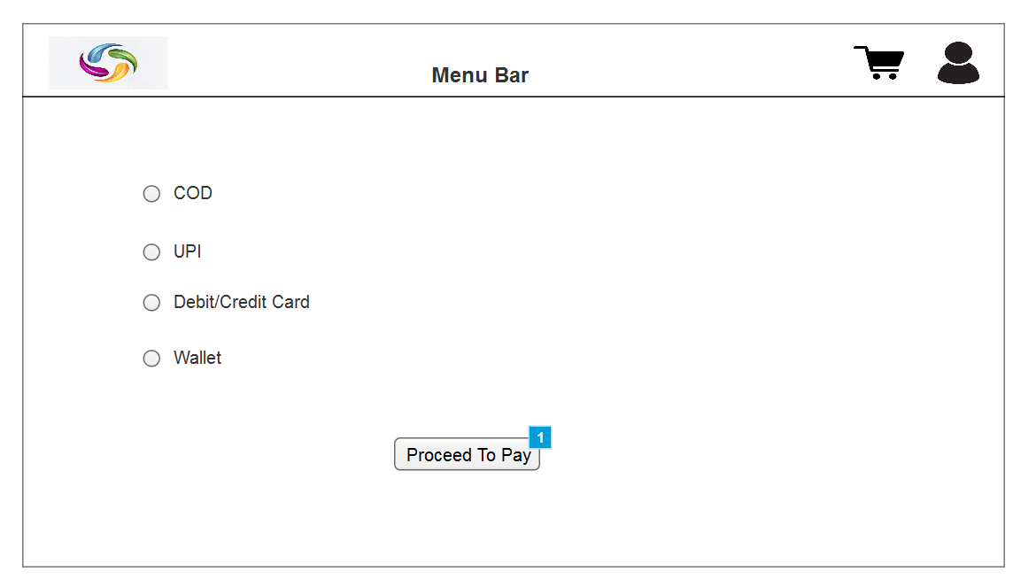
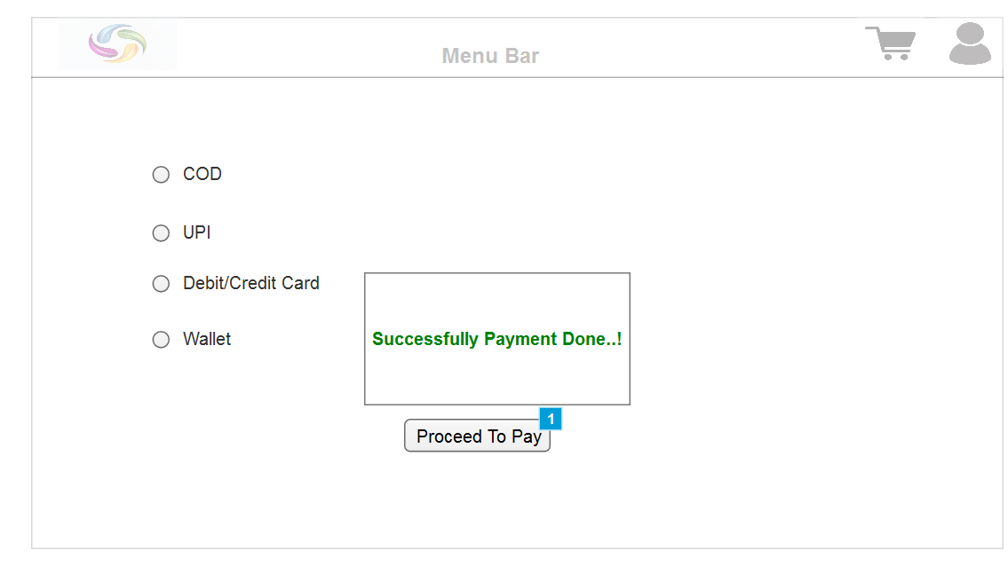

Question 3: Explain tools like visio, balsamiq, axure?
Answer:
- Microsoft Visio:
- What it is:- It is a diagramming tool used to create diagrams flowcharts and other visual representations of complex information.
- Purpose:- helps business analysts, system architects and IT team to show how a system or process works.
- Used for:- system architecture diagram, activity diagram, use case diagram, flowchart.
- Axure:
- What it is:- It is a prototyping tool used to create interactive wireframes and mockups with logic.
- Purpose:- Useful for building clickable prototypes that shows how buttons, menus or screens will behave.
- Used for:- complex UI/UX design, stakeholder presentation and clickable demos.
- Balsamiq:
- What it is:- It is a wireframing tool used to create rough, sketch-like design of UI.
- Purpose:- to create low- fidelity wireframes & mockups quickly and easily.
- Used for:-brainstorming UI design, early-stage prototyping.

Question 4: Prepare RTM?
Answer:
Requirement Traceability Matrix(RTM) is a document or table used to track the requirements throughout the project life cycle from its origin to its implementation and testing. It ensures nothing is missing and every requirement is verified and validated.
Req ID | Req Name | Req Description | Design | Code | UT(unit testing) | CT(complete testing) | UAT
FR001 | User registration | The system should allow new farmers & manufacturers to register with email and password. | Complete | Complete | Complete | Complete | Incomplete
FR002 | User login | The system should allow registered users to log in using their credentials. | Complete | Complete | Complete | Complete | Incomplete
FR003 | Role-based access | The system should distinguish roles and grant access. | Complete | Complete | Complete | Complete | Incomplete
FR004 | Add product | The system should only allow manufacturers to add products with details. | Complete | Complete | Complete | Incomplete | Incomplete
FR005 | View product catalogue | The system should display a catalog of fertilizers, seeds & pesticides for farmers to browse. | Complete | Complete | Complete | Complete | Incomplete
FR006 | Product search | The system should allow farmers to search products using keywords. | Complete | Complete | Complete | Complete | Incomplete
FR007 | Product details | The system should allow users to view detailed information about a product. | Complete | Complete | Incomplete | Incomplete | Incomplete
FR008 | Add to cart | The system should allow farmers to add selected products to a cart. | Complete | Complete | Complete | Complete | Incomplete
FR009 | Modify cart | The system should allow user to update quantity or add or remove items from cart. | Complete | Complete | Complete | Complete | Incomplete
FR010 | Checkout process | The system should provide a checkout process for farmers to place order. | Complete | Complete | Incomplete | Incomplete | Incomplete

Question 5: Prepare 10 test cases?
Answer:
A test case is a set of conditions or steps used to verify whether a functionality or feature of an application works as expected by tester.
Test Case ID | Test Case Name | Description | Precondition | Test Steps
TC_001 | User login with valid credentials | Verify users can log in with valid email & password | User already registered | - Go to the login page.  - Enter valid credentials.  - Click login.
TC_002 | User login with invalid credentials | Verify login fails with invalid credentials | None | - Go to the login page.  - Enter invalid credentials.  - Click login.
TC_003 | New user registration | Verify user can register with email & password | User not registered | - Go to Register.  - Enter email & password.  - Submit
TC_004 | Product catalog load | Check if catalog of fertilizer, seeds, pesticides loads | User is logged in | - Login.  - Navigate to product catalog.
TC_005 | Product search by keyword | Verify search functionality for products | User is logged in | - Login.  - Enter product name in search bar.  - Click search.
TC_006 | Add product to cart | Verify farmers can add a product to cart. | User is logged in | - Login.  - Browse product.  - Click “Add to cart” on any item.
TC_007 | Place order with UPI Payment | Verify order placement with UPI payment | 1. User is logged in.  2. Cart contains items. | - Login.  - Go to the cart.  - Proceed to check out.  - Choose payment method ”UPI”.  - Complete payment.
TC_008 | Place order with COD Payment | Verify order placement with COD payment | 1. User is logged in.  2. Cart contains items. | - Login.  - Go to the cart.  - Proceed to check out.  - Choose payment method ”COD”.  - Complete payment.
TC_009 | Place order with Debit/Credit Payment | Verify order placement with Debit/Credit payment | 1. User is logged in.  2. Cart contains items. | - Login.  - Go to the cart.  - Proceed to check out.  - Choose payment method ” Debit/Credit”.  - Complete payment.
TC_010 | Email confirmation after order | Verify order confirmation email is sent | 1. User is logged in.  2. Order is successfully placed. | - Login.  - Complete an order.  - Check email with order details.

Question 6: DB schema and entity relationship diagram?
Answer:
- A database schema is the structure or blueprint of a database that defines how data is organized, including: tables, columns, data type, relationships between tables and constraints like primary key & foreign key.
- An ERD is a visual representation of entities like tables in a database and their relationships. It depicts the entities(tables), attributes(field or column in that table) and relationships between them.
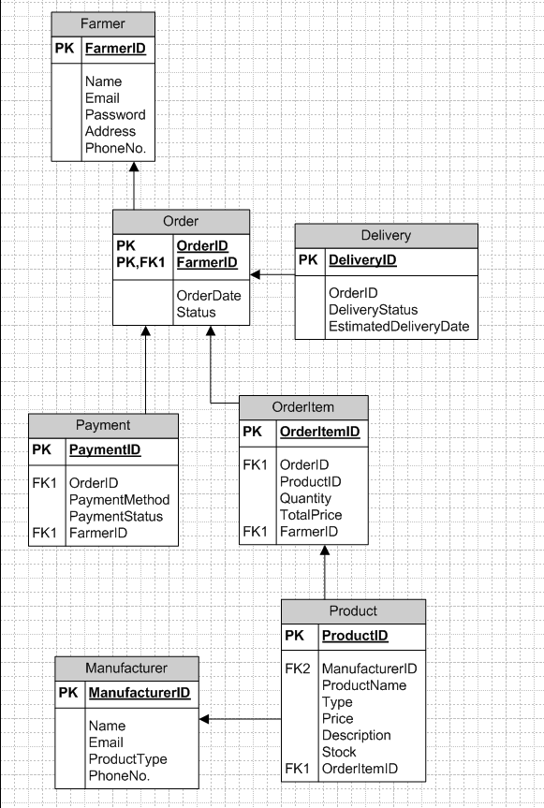
Question 7: Data flow diagram?
Answer:
A data flow diagram is a visual representation of how data moves through a system. It visually shows how data moves from one process to another, how it’s stored and where it ends.
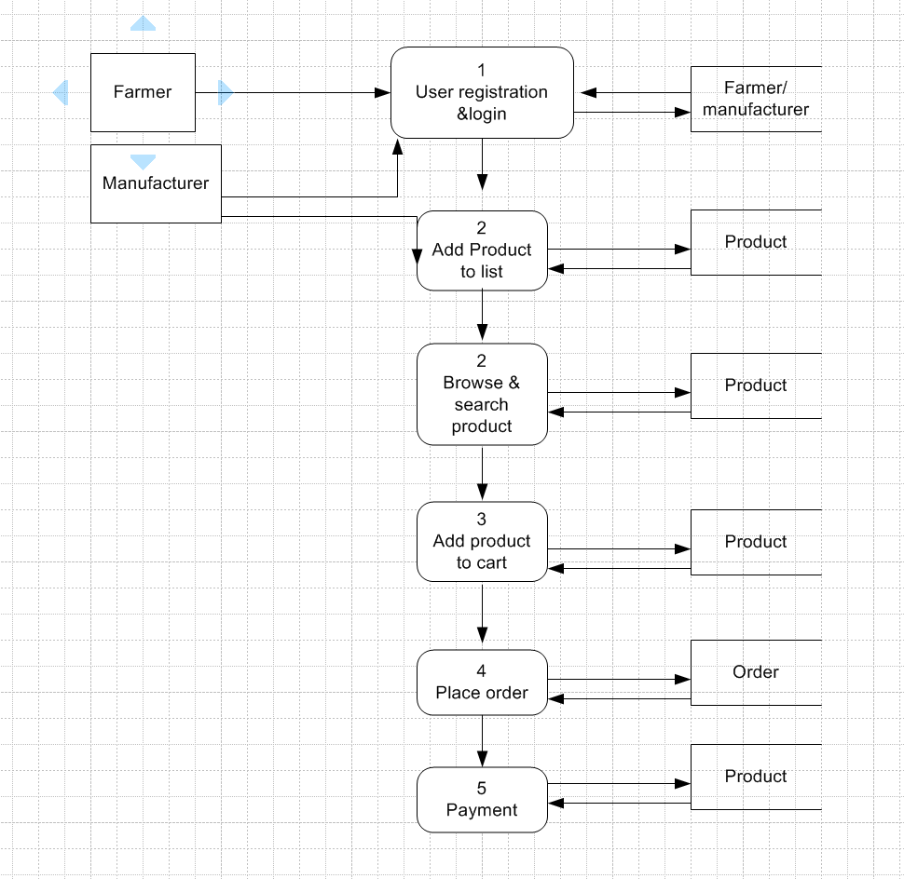

Question 8: What is Change Request? What is Enhancement? Change Request vs. Enhancement?
Answer:
- Change Request – A change request is a formal proposal to modify some aspects of a project. This could involve changing scope, adding new functionality, modifying existing features, changing design, timeline or cost.
- Enhancement – An enhancement is a type of change request which typically suggests improvement to the existing system or application. It helps to add more value or refine usability or performance.
- Steps to handle change request:
- Log the request using a change request document or tracking system.
- Conduct meeting with stakeholders to understand the change and its impact.
- Analyze impact on: scope, time, cost, dependencies, resources and risk.
- Document the change including its description and other details.
- Seek approval from sponsors and stakeholders for the CR.
- Communicate the change request to impacted parties including dev team and testers.

Question9 : What is UAT?
Answer:
User Acceptance Testing is the final phase of the software testing process where the end user or client validates the software whether it meets their business requirements and is ready for production. It ensures that:
- The system works as expected.
- Business needs have been fulfilled.
- No major defects remain before go-live.
UAT process steps:
- Planning: A blueprint are made in this step to implement UAT. This involves clearly defining the objectives, scope, stakeholders, schedule and resource required for UAT.
- Test case: To prepare test cases based on business scenarios.
- UAT tester: A team of end users execute test cases, verify functionality and report any issues.
- Log defects: If bugs or mismatches are found they are logged and sent back to dev team.
- Bug fixing: The bugs found in UAT should be fixed by dev team and make application errors free.
- Sign-off: When the user approves the system, they give a UAT Sign-Off for production release.

Question10 : What is project closure document?
Answer:
- A Project Closure Document is a formal report that marks the official completion of a project.
- It summarizes the entire project lifecycle, confirms that all agreed-upon deliverables have been completed and accepted, and ensures that all contractual, financial, and administrative matters are finalized.
- Project closure document includes:
- Project overview: It briefly describes the summary of the project, business objectives, scope and key stakeholders.
- Deliverables summary: list of all completed deliverables.
- Milestones and achievements: summary of key milestones achieved and major accomplishments.
- Open issues or pending items: any unresolved issues.
- Lesson learned: key takeaways like what went well, what didn’t, what could be improved.
- Risk management: overview of risk encountered and how they were managed/
- Client Sign-off: formal sign-off with client approval, date and remark if any.

