Name: Deepika
ID: DGI290424D_03

COEPD – Prep Exam 3 –Part ½
Case Study 1 (Q1-Q6 → 24 Marks)
A customer can make a payment either by Card or by Wallet or by Cash or by Net banking.
Q1. Draw a Use Case Diagram - 4 Marks

ANS
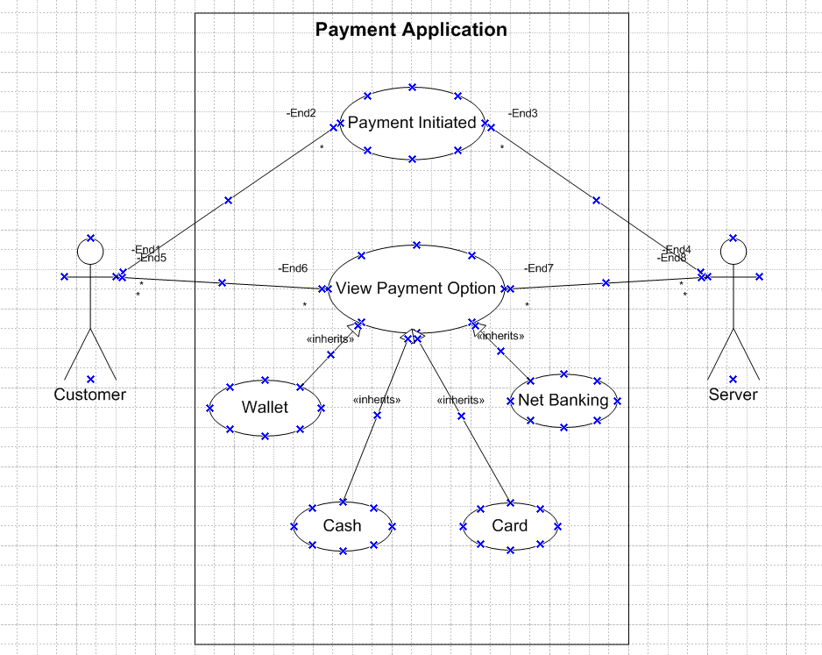

Q2. Derive Boundary Classes, Controller classes, Entity Classes. - 4 Marks
﻿


Boundary Class - used to handle interactions between the system and external actors Ex: PaymentOptionBoundary
CardPaymentBoundary

Controller Class - act as intermediaries between boundary and entity classes. Ex: PayementintiatedController
CardPaymentController
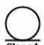
Entity Class - represent the core data and business logic of the application.
• Ex: Customer
Payment

Boundary Classes | PaymentOptionBoundary  CardPaymentBoundary  WalletPaymentBoundary  CashPaymentBoundary  NetBankingPaymentBoundary
Controller Classes | PaymentInitiatebController  CardPaymentController  CashPaymentController  NetBankingPaymentController  WalletPaymentController
Entity Classes | Customer  Payment  Card  Wallet  Bank Account  Server

Q3. Place these classes on a three tier Architecture. - 4 Marks

Application Layer
PaymentMethodSelectionBoundary
CardPaymentBoundary
WalletPaymentBoundary
CashPaymentBoundary
NetBankingPaymentBoundary
Business Logic Layer
PaymentController
CardPaymentController
WalletPaymentController
CashPaymentController
NetBankingPaymentController
Data Layer
Customer (Entity Class)
Payment (Entity Class)
Card (Entity Class)
Wallet (Entity Class)
Bank Account (Entity Class)

Q4. Explain Domain Model for Customer making payment through Net Banking - 4 Marks
ANS
DOMAIN MODEL FOR CUSTOMER MAKING PAYMENT THROUGH NET BANKING:
Domain model is a conceptual model of the domain that incorporates both behavior and data. It is a system of abstractions that describes selected aspects. The model that can be used to resolve problems related to that domain. Domain model for a scenario where a customer makes a payment through net banking. A domain model is a visual representation of the conceptual classes or real-world objects in a specific domain, along with their relationships.
Key Elements in the Domain Model
- Customer: Represents the person making the payment.
- Payment: Represents the payment being made by the customer.
- BankAccount: Represents the customer's bank account used for the net banking transaction.
- Transaction: Represents the transaction details associated with the payment.
- Bank: Represents the bank handling the net banking transaction.
- PaymentGateway: Represents the intermediary that processes the net banking payment.
Relationships
- Customer makes Payment: A customer initiates a payment.
- Payment uses BankAccount: The payment is made using the customer's bank account.
- Payment processed by PaymentGateway: The payment gateway processes the payment.
- BankAccount associated with Bank: The bank account belongs to a bank.
- Transaction records Payment: A transaction is recorded for each payment.

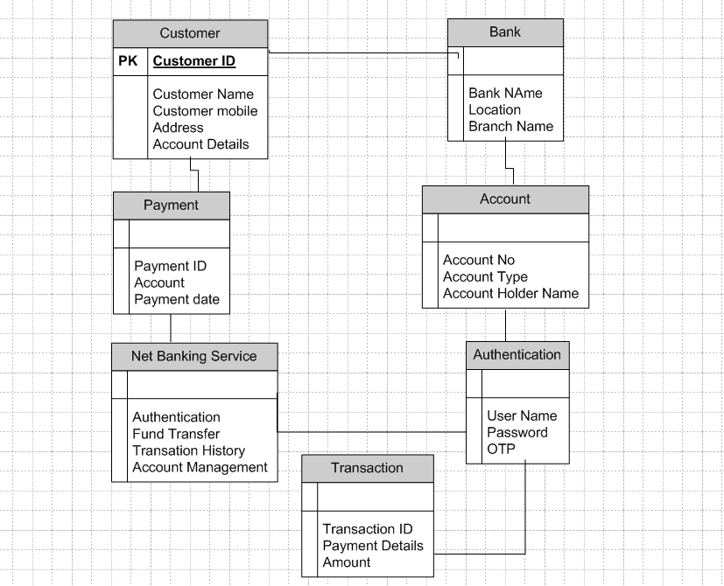
Q5. Draw a sequence diagram for payment done by Customer Net Banking - 4 Marks
ANS
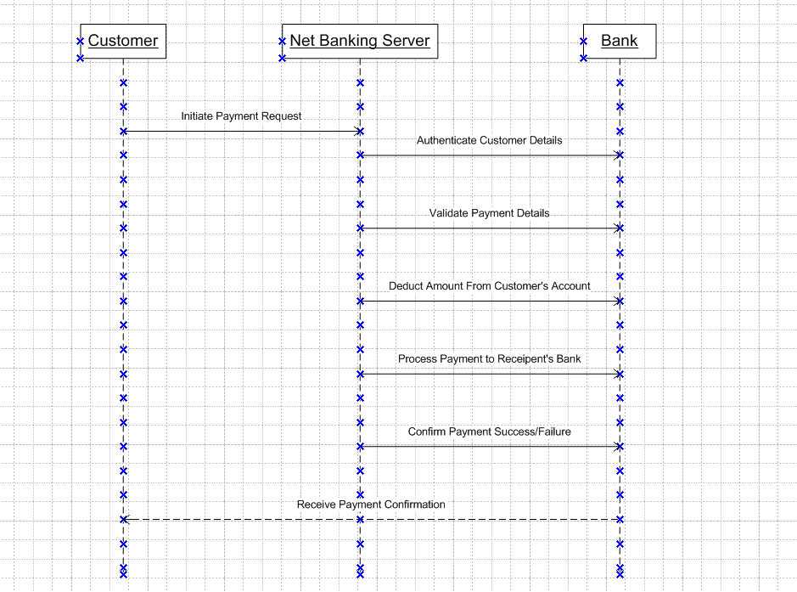

Q6. Explain Conceptual Model for this Case - 4 Marks
Ans:
﻿A conceptual model is a high-level representation of a system that helps in understanding,
visualizing, and communicating the essential aspects of a domain.
Its Provides a clear and simplified view of the domain, making it easier to understand.
Key Elements of a Conceptual Model:
1. Entities Customer, Product, Order & Payment
2. Attributes - customerId, name, email, phoneNumber.
3. Relationships - For example, a Customer places an Order.

Q7. What is MVC architecture? Explain MVC rules to derive classes from use case diagram and guidelines to place classes in 3-tier architecture - 8 Marks

Ans: MVC, Model-View-Controller is a design pattern used to separate the concerns of a software application into three interconnected components:
- Model: Represents the data and the business logic of the application. It directly manages the data, logic, and rules of the application. For instance, it could be a database or any form of data storage that the application uses.
- View: Represents the UI of the application. It displays the data to the user and sends user commands to the controller. It is concerned with how data is presented to the user.
- Controller: Acts as an intermediary between Model and View. It listens to the input from the View, processes it (possibly interacting with the Model to retrieve or update data), and returns the output display to the View.
MVC architecture rules:
- Combination of one actor and an use case result in one boundary class.
- Combination of two actors and and an use case result in two boundary classes.
- Combination of three actors and an use case result in three boundary classes and so on.
Only one primary actor is to be considered with a use case.
- Use case will result in a controller class.
- Each actor will result in one entity class.
Guidelines to place classes in 3-Tier Architecture.
A 3-tier architecture typically consists of:
- Application Layer (UI Layer)- This is the topmost layer and is responsible for displaying information to the user and collecting user input.
- Business Logic Layer This middle layer processes data based on the business rules. It acts as an intermediary between the presentation and data layers.
- Data Access Layer (Data Layer)- This bottom layer is responsible for managing data storage and retrieval.
Placing- classes derived from use cases into these three layers-
- Presentation Layer:
- Boundary Class- Classes that handle user interaction should be placed in the presentation layer. These include forms, dialogs, and any UI elements that users interact with. E.g. Login Form, Customer View, Order Page
- Business Logic Layer:
- Control Classes- These classes handle the main application logic, orchestrating the flow between the UI and the data. They contain methods that enforce business rules and manipulate data before sending it to the presentation layer or data layer. E.g. Login controller, Order Processor, Custom Manager.
- Data Access Layer:
- Entity Classes- These classes represent the business data and are responsible for data persistence. They include methods for storing, retrieving, updating, and deleting data in the database. E.g. Customer, Order, Product

Q8. Explain BA contributions in project (Waterfall Model – all Stages) – 8 Marks
Ans:
Stages | Activities | Artifacts and Resources
Pre Project | Stakeholder Identification-Identify and engage key stakeholders  Business Case Development- Assist in developing the business case to justify the project.  Preliminary Analysis- Conduct initial research to understand the problem domain and high-level requirements | Stakeholder Register, RACI Matrix  Business Case Document, Feasibility Study  Preliminary Analysis Report, Initial Requirements Document
Planning and Estimations and Assessment | Project Scope Definition-Define the scope of the project in collaboration with stakeholders.  Effort Estimation- Assist in estimating the effort required for requirements gathering and analysis.  Risk Assessment- Identify potential risks and develop mitigation strategies. | Project Scope Statement, Scope Management Plan  Estimation Models, Resource Plan  Risk Register, Risk Management Plan
Requirements Gathering | Requirements Elicitation- Conduct interviews, workshops, surveys, and observations to gather detailed requirements from stakeholders.  Requirements Documentation- Document the gathered requirements in a structured format.  Requirements Review- Facilitate review sessions with stakeholders to validate and refine requirements. | Interview Guides, Workshop Agendas, Survey Questionnaires  Business Requirements Document (BRD), User Stories  Review Meeting Minutes, Updated Requirements Document
Requirements Analysis | Requirements Prioritization- Prioritize requirements based on business value and feasibility.  Gap Analysis- Identify gaps between current capabilities and desired future state.  Requirements Modeling- Create visual models to represent requirements and their relationships. | Prioritized Requirements List, MoSCoW Analysis  Gap Analysis Report, Current vs. Future State Diagrams  Use Case Diagrams, Activity Diagrams, Process Flowcharts
Design | Solution Design- Collaborate with architects and developers to design solutions that meet the requirements.  Prototyping- Develop prototypes or mock-ups to visualize the solution and gather feedback.  Design Review- Conduct design review sessions with stakeholders to ensure alignment with requirements. | Solution Design Document, Architectural Diagrams  Prototypes, Wireframes, Mock-up Screens  Design Review Meeting Minutes, Updated Design Documents
Coding | Support Development Team- Provide clarifications and additional information to developers as needed.  Continuous Collaboration- Participate in daily stand-ups, sprint planning, and retrospective meetings to ensure ongoing alignment. | Clarification Logs, Updated Requirements Document  Meeting Minutes, Sprint Backlogs
Testing | Test Planning- Assist in developing test plans and test cases based on requirements.  User Acceptance Testing (UAT)- Coordinate and facilitate UAT sessions with end-users to validate the solution against requirements.  Defect Management- Track and manage defects and issues reported during testing. | Test Plan, Test Cases, Traceability Matrix  UAT Plan, UAT Test Cases, UAT Feedback Logs  Defect Logs, Issue Tracking Tools
Deployment and Implementation | Training and Support- Develop training materials and conduct training sessions for end-users.  Change Management- Assist in managing changes to scope, requirements, and deliverables during deployment.  Post-Implementation Support- Provide post-implementation support to address any issues and gather feedback for future improvements. | Training Manuals, User Guides, Training Session Agendas  Change Request Forms, Change Management Plan  Support Logs, Post-Implementation Review Report

Q9. What is conflict management? Explain using Thomas – Kilmann technique – 6 Marks

Ans: Conflict management refers to the process of handling and resolving conflicts or disagreements that arises between individuals or group within an organization.
The Thomas-Kilmann conflict mode instrument (TKI) is a widely used technique for understanding and managing conflict The Thomas-Kilmann technique helps individuals understand their preferred conflict handling styles and provides insight into when each mode might be appropriate.Effective conflict management involves recognizing the existence of conflicts, actively listening to the concerns of all parties involved, seeking common ground, and working towards collaborative solutions that meet the needs of everyone.
The Thomas-Kilmann Conflict Mode Instrument (TKI) is a widely used framework that identifies five conflict-handling styles based on two dimensions: assertiveness and cooperativeness.

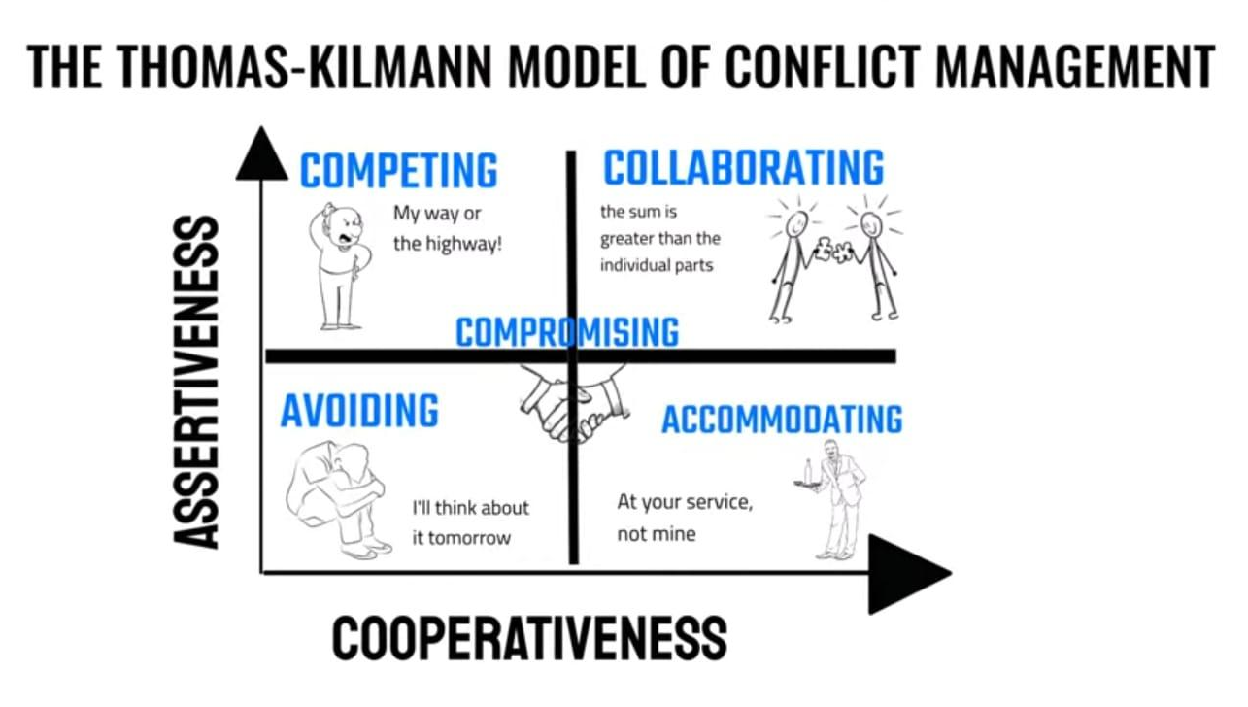
X axis (cooperativeness) : Indicates the extent to which a person tries to satisfy the concerns of others.
Y axis ( Assertiveness): Indicates the extent to which a person tries to satisfy their own concerns.
The TKI model defines five conflict-handling styles.
Competing
Collaborating
Compromising
Avoiding
Accommodating

Q10. List down the reasons for project failure – 6 Marks
ANS
- Improper Requirement Gathering:
This occurs when project requirements are not clearly defined, documented, or understood. It leads to misunderstandings and mismatched expectations between stakeholders and the project team. As a result, the final product may not meet the users' needs or solve the intended problem.

- Continuous Change in Requirements:
Frequent changes to project requirements can disrupt the workflow and cause delays. It can also lead to scope creep, where the project's scope expands beyond its original objectives, often without corresponding increases in resources or time. This can result in incomplete or substandard deliverables.

- Lack of User Involvement:
When end-users or key stakeholders are not involved in the project, their needs and expectations may not be accurately captured. This can result in a product that is not user-friendly or does not address the actual problems users face. User involvement is crucial for validating requirements and ensuring the solution fits the intended purpose.

- Lack of Executive Support:
Executive support is critical for securing the necessary resources, making timely decisions, and providing strategic direction. Without it, a project may struggle to get the required attention and funding, leading to delays, reduced scope, or even project cancellation.

- Unrealistic Expectations:
Setting goals or timelines that are not achievable can lead to project stress, cutting corners, and poor-quality outcomes. Unrealistic expectations often stem from a lack of understanding of the project's complexity or from pressure to deliver results quickly. This can demotivate the team and compromise the project's success.

- Improper Planning:
Poor planning can result in inadequate resource allocation, missed deadlines, and budget overruns. Effective planning involves defining the project scope, setting realistic timelines, identifying risks, and allocating resources appropriately. Improper planning can lead to confusion, wasted efforts, and project failure.
Addressing these issues requires careful attention to project management practices, stakeholder engagement, and realistic assessment of project constraints and capabilities.
Q11. List the Challenges faced in projects for BA – 6 Marks
ANS:
1. Ambiguous or Changing Requirements
- Ambiguous Requirements:
  - Definition: Stakeholders might not have a clear vision of their needs, leading to vague or incomplete requirements.
  - Impact: This can result in misaligned expectations, rework, and potential project delays.
  - Mitigation: Use techniques like interviews, workshops, prototyping, and requirement modeling to clarify and refine requirements.
- Changing Requirements:
  - Definition: Requirements can evolve due to changing business needs, regulatory updates, or market conditions.
  - Impact: This can lead to scope creep, increased costs, and extended timelines.
  - Mitigation: Implement a robust change management process with clear procedures for evaluating, approving, and integrating changes.
2. Stakeholder Management
- Definition: Effectively identifying and engaging all relevant stakeholders throughout the project lifecycle.
- Impact: Poor stakeholder management can lead to missed requirements, lack of buy-in, and project failure.
- Mitigation: Conduct thorough stakeholder analysis, maintain regular communication, and manage expectations through transparent reporting and feedback mechanisms.
3. Lack of Stakeholder Involvement
- Definition: Insufficient participation from stakeholders in the requirements gathering and validation process.
- Impact: Results in incomplete requirements, misalignment with business needs, and potential project rework.
- Mitigation: Schedule regular meetings, use collaborative tools, and ensure stakeholders understand the importance of their involvement and contributions.
4. Unclear Project Objectives
- Definition: Project goals and objectives are not clearly defined or communicated.
- Impact: Leads to confusion, misaligned efforts, and difficulty in measuring success.
- Mitigation: Develop a clear project charter, define SMART (Specific, Measurable, Achievable, Relevant, Time-bound) objectives, and ensure all team members and stakeholders understand and agree on the project goals.
5. Managing Conflicts and Negotiations
- Definition: Conflicts can arise between stakeholders with differing priorities and interests.
- Impact: Can cause delays, reduced team morale, and suboptimal project outcomes.
- Mitigation: Employ conflict resolution techniques, facilitate open communication, and use negotiation strategies to find mutually beneficial solutions.
6. Project Communication
- Definition: Ensuring timely and effective communication among all project participants.
- Impact: Poor communication can lead to misunderstandings, missed deadlines, and increased risks.
- Mitigation: Develop a communication plan outlining the frequency, methods, and responsibilities for communication. Use various tools (email, meetings, project management software) to keep everyone informed.
7. Time and Resource Constraints
- Definition: Limited availability of time and resources (human, financial, technical) to complete the project.
- Impact: Can lead to rushed work, compromised quality, and unmet project deadlines.
- Mitigation: Prioritize tasks, allocate resources efficiently, and use project management techniques like critical path analysis and resource leveling to optimize schedules.
8. Resistance to Change
- Definition: Stakeholders and team members may resist changes to existing processes, systems, or roles.
- Impact: Can hinder project progress and adoption of new solutions.
- Mitigation: Implement change management strategies, communicate the benefits of the change, provide training and support, and involve stakeholders in the change process to build buy-in and reduce resistance.
By understanding and addressing these challenges, Business Analysts can improve the chances of project success and deliver solutions that meet stakeholder need effectively.

Q12. Write about Document Naming Standards – 4 Marks
ANS
Document naming standards are essential for maintaining organization, consistency, and clarity in document management within a project. These standards help ensure that documents are easily identifiable, searchable, and retrievable. A well-defined naming convention can prevent confusion, reduce errors, and improve collaboration among team members.
Based on the image provided, the document naming standard can be broken down as follows:
Format: [ProjectID][Document Type]V[X]D[Y].ext
Here's an explanation of each component:
- [ProjectID]:
  - This part of the name should include a unique identifier for the project. It helps in categorizing documents according to the projects they belong to. For example, if the project ID is "12345," it would appear as 12345.
- [Document Type]:
  - This segment specifies the type of document. Examples of document types could be requirements, design, test cases, user manuals, etc. This makes it clear what kind of information the document contains. For example, if it's a requirements document, it might be abbreviated as REQ.
- V[X]:
  - This represents the version of the document. Versioning is crucial for tracking the evolution of a document. The "X" here would be replaced with the version number. For example, V1 for version 1.
- D[Y]:
  - This denotes the draft number of the document. Draft numbering helps in tracking iterative changes within the same version. The "Y" here would be replaced with the draft number. For example, D2 for the second draft.
- .ext:
  - This is the file extension, indicating the format of the document. Common extensions include .docx for Word documents, .xlsx for Excel files, .pdf for PDF files, etc.

Q13. What are the Do’s and Don’ts of a Business analyst – 6 Marks
ANS
Sr.No. | DO'S | DON'TS
1 | Consult an SME for clarifications in requirements. | Never say NO to the client.
2 | Go to the client with a plain mind with no assumptions. Listen carefully and completely until the client is done, and then you can ask queries. | There is no work as "By default".
3 | Try to extract maximum leads to the solution from the client himself. | Never imagine anything in terms of GUI..
4 | Concentrate on the important requirements. | Don't interrupt the client when he is giving you the problem.
5 | Question the existence of existence/Question Never try to give solutions to the client straight away everything. | With your previous experience and assumptions.

Q14. Write the difference between packages and sub-systems – 4 Marks
Ans
Aspect | Packages | Sub-Systems
Scope | Code organization within a project | Functional component within a larger system
Purpose | Enhance modularity and reusability | Manageable, independent units of functionality
Granularity | Smaller, specific functionalities | Larger, comprehensive functional components
Containment | Classes, interfaces, sub-packages | Packages, modules, components, sub-systems
Interaction | Typically internal within a project | Interacts with other sub-systems via interfaces/APIs
Dependency Management | Managed at package level; tools like Maven, pip | Managed at system level; involves coordination with other sub-systems
Usage Context | Programming languages (Java, Python) | System architecture and design

Q15. What is camel-casing and explain where it will be used- 6 Marks
Ans
CamelCasing is a naming convention used in programming, particularly in languages like Java, C#, and JavaScript, among others. In CamelCasing, compound words are joined together without spaces, and each word within the compound, except the first one, begins with a capital letter. This naming convention resembles the humps on a camel's back, hence the name "CamelCasing."
Here's an example:

- CamelCasing: firstName, numberOfStudents, calculateTotalAmount
- Not CamelCasing: first name, number_of_students, calculate_total_amount

Where it is Used:
- Variable Names: CamelCasing is commonly used for naming variables in programming languages. It helps make variable names more readable and understandable, especially for longer or compound names.
- Function and Method Names: Similar to variables, function and method names are often CamelCased. This convention improves code readability and consistency across a codebase.
- Property Names: In object-oriented programming, properties of objects are typically named using CamelCasing. This applies to both public and private properties.
- Parameter Names: Parameters passed to functions or methods are often named using CamelCasing, especially in languages where explicit parameter types are not declared separately.
- File Names: In some cases, CamelCasing may also be used for naming files, especially in projects where naming consistency is important. However, this practice may vary depending on the specific coding conventions of a project or organization.

Q16. Illustrate Development server and what are the accesses does business analyst has? -6 Marks
ANs
A Business Analyst (BA) typically does not require deep access to the development server but needs sufficient access to facilitate their role effectively. Here’s what a BA might access and interact with on a development server:
- Access to the Source Code Repository:
  - Read Access: To view and understand the codebase, project structure, and documentation.
  - Issue Tracking: To report bugs, request features, and track the status of development tasks.
- Access to Development and Testing Environments:
  - Test Builds: Access to build artifacts or test versions of the application to validate requirements.
  - Testing Tools: Ability to view and interpret results from automated tests or user acceptance testing (UAT).
- Documentation and Collaboration Tools:
  - Wiki/Documentation: Access to project documentation, design documents, user stories, and requirements specifications.
  - Collaboration Tools: Platforms like Confluence, Slack, or Microsoft Teams for communication and collaboration with the development team.
- Access to Databases:
  - Read-Only Access: To query and view data structures, sample data, and validate data-related requirements.
- Monitoring and Logging Tools:
  - Log Access: To view application logs and understand issues reported by testers or stakeholders.
  - Monitoring Dashboards: To get insights into application performance, error rates, and other metrics relevant to the business requirements.

Q17. What is Data Mapping 6 Marks

Data mapping is the process of linking data fields from one source to a target, defining how data should be transformed and transferred between systems, databases, or applications. It's a crucial step in data integration, migration, and synchronization projects.
Process of Data Mapping
- Identification of Data Sources and Targets:
  - Identify the source systems or databases containing the data to be mapped.
  - Determine the target systems or databases where the data will be transferred or synchronized.
- Analysis of Data Structures:
  - Analyze the structure, format, and schema of the source data.
  - Understand the structure and requirements of the target data.
- Field Matching:
  - Match fields or attributes between the source and target data sets.
  - Determine which fields are equivalent or represent the same information.
- Transformation Rules:
  - Define transformation rules for converting data from the source format to the target format.
  - Address differences in data types, formats, units, and structures between source and target fields.
- Data Mapping Design:
  - Create a mapping document or schema that outlines the mappings between source and target fields.
  - Use diagrams, tables, or visualization tools to represent the mappings.
- Validation and Testing:
  - Validate the data mapping design to ensure accuracy, completeness, and consistency.
  - Conduct testing to verify that data is correctly transformed and transferred according to the mapping rules.
- Deployment and Execution:
  - Deploy the data mapping configurations to the appropriate systems or integration platforms.
  - Execute data mapping processes to transfer or synchronize data between source and target systems.

Q18. What is API. Explain how you would use API integration in the case of your application Date format is dd-mm-yyyy and it is accepting some data from Other Application from US whose Date Format is mm-dd-yyyy 10 Marks
Ans
An API, or Application Programming Interface, is a set of rules and protocols that allows different software applications to communicate and interact with each other. It defines the methods and data formats that applications can use to request and exchange information. APIs are commonly used for integrating different systems, enabling them to work together seamlessly. In the case of an application that deals with date formats, such as one that accepts data from another application with a different date format, API integration can be used to facilitate the conversion of dates between formats.
