CAPSTONE PROJECT 1 – PART 2/3

QUESTION 1 – AUDITS
4 Quarterly Audits of the project
QUERTERLY 1 AUDIT REPORT
STAGE | REQUIREMENT GATHERING PHASE
COMPLETED | 10 weeks ( week 1 to week 10)
CHECKLIST | BRD Template
 | Elicitation results report
 | Duplicate requirements report
 | Grouping functionality and client signoff
 | Email communication – to CC,BCC

QUERTERLY 2 – AUDIT REPORT
STAGE | REQUIREMENT ANALYSIS PHASE
COMLETED | 7 weeks ( week 18 to week 24)
Check list | UML diagrams
 | Business functional requirement mapping
 | Client sign off documents
 | E-mail communication – To CC,BCC

QUERTERLY 3 AUDIT REPORT
STAGE | DESIGN AND DEVELOPMENT PHASE
COMLETED | 21 weeks (Week 33 to week 54)
Check list | Utilization of tools
 | Documents evidence on client communication
 | JAD Session report
 | End user preparation document
 | BA and developer MOM
 | E-mail communication To CC,BCC

QUERTERLY 4 AUDIT REPORT

STAGE | TESTING PHASE
COMLETED | 18 weeks (Week 52 TO Week 70)
Check list | Test case summary
 | Training report to end users
 | Lesson learnt document
 | Email – communication To CC,BCC

QUESTION 2 – BA APPROACH STRATEGY

Wha are the elicitation techniques to apply
There are many types of elicitation techniques we have in the business strategy some of the elicitation that might useful to the online agricultural product application are the brain storming
Document analysis, interviews, focus group, survey and questionnaire
-The brainstorming can be done either in individually or group and we can collect the ideas during the session and it is effective way to generate the lots of ideas to the project
- the document analysis might be helpful after gathering the requirement and reading the document and understanding the product process and the project this might be an good option to understand do move the project forward
-the focus groups as it means elicit ideas and attitudes about a specific product services and this will use the project in the future . they will shows how the project is been and helps to do better activities for next stage.
- the survey / questionnaire is been useful for obtain the requirement details from the users and stakeholders who have minor input and geographically remote interacting with the areas can be done in the surveys it would be very helpful to us in this project.
- how to do stakeholder analysis
The stakeholder analysis can be done by using the RACI matrix involve for the identification of stake holders and defining their roles and responsibilities with in the project
Responsible | Mr juhi | Developer of the project
 | Mr Tyson | Developer of the project
 | Mr luice | Developer of the project
 | Mr bravo | Developer of the project
 | Mr Jason | Who does testing
 | Mr alekya | Who does testing
Accountable | Mr vandanam | Who handles project from start to end as project manger
 | Mr Pradeep | Who handles project from start to end as business analyst
Consulted | Mr mike | Handles the network infrastructure

What document should to write
We should write the business requirement document which gives the overall idea about the project and next functional requirement document and the use case document it makes easy to understand in detailed of project and test case document.
What is the process to follow to sign on the project
the sign off can be taken on the SRS as it is an primary and the important document, so the sign off can be taken by using E-mail conformation from the client
How to take the approval from the client
we should establish the meeting with the client we should inform whatever progress we have made and get the feedback from them
What Communication channels to establish and implement
We should do the regular meeting and weekly status meetings and monthly stakeholder updates through this meetings we can communicate and know about the project that how we are doing the project.
How to handle change request-
The stake holders will fill the change request form and then they will do the impact analysis about how far the change request is impact the project will the done in time and budget in this way we should do the impact analysis and we should take approval from
the Mr Vandanam.
How to update the progress of the project to the stakeholders
We can update the progress of the project to the stakeholders by the weekly status reports monthly review meeting about the project
How to take signoff on the UAT client project acceptance form
Firstly we have to prepare the UAT preparation and next we have to conduct the UAT after that we have to fix the issues and acceptance form and final review meeting and we can obtain signoff

QUESTION 3 – 3 TIER ARCHITECTURE
The illustrate 3- tier architecture will divide the application into three layers
1 Application layer
2 business logic layer
3 Database layer

-Application layer
This is the top most layer pf the architecture and this layer is also known as the presentation layer
It will handles the user interface components such as the screens pages etc.. for our project the users should buy the agricultural products so the fertilizers, pesticides this are been shown in the screen in easy way for the better understanding to the customers for example e-commerce website .

-Business logic layer
This business logic layer is the middle layer of the architecture and it acts a intermediary between the presentation layer and the data storage layer and this layer contains the core logic of the application and depends on the third party for our project the conformation and the payments receipt are been through messages and email depends on the client.
-Data base layer
This is the bottom most layer of the architecture and this is responsible for the storing the retrieving the data and this top layer data is been stored here by the help of storing the data the customers get the exact information in the front end by the data base layer for example its like data base servers

-Question 4
BA STARTEGY FOR FRAMING THE QUESTIONS
WE HAVE THE MANY APPROACH STARTEGY FOR THE FRAMING WE SHALL DISCUSS about some of them
5W1H
This 5W1H is a useful tool for the gathering the information and understanding a situations by answering the questions about who,what ,when,where,why and how for example
- Who are the stakeholders of the project
- What kind of requirement are needed
- When should be the project completed
- Where the project should reach
- Why the project is initiated
- How we can resolve the current problems

SMART
The SMART technique can also help to create the questions
And it stands for Specific, Measurable, Attainable, Relevant and Time bond
- The project goal and object should be specific as we should deliver the product to the rural areas. it is an specific goal of the project
- Can we complete the project and we also say we are able to complete it or not. this is an measurable
- In attainable we should have that can we complete the project in the budget and time frame is been done in this technique
- In relevant exact team to and requirement to complete the project
- Well the project can be done in the time frame or not.

Questions 5 elicitation techniques
There are many types of elicitation techniques
-Brainstorming
The brainstorming can be done either individually or in groups the ideas collected during the brainstorming sessions are reviewed.
The brainstorming is very effective way to generate the lot many ideas on a specific issue and we should determine which idea is the best solution in the brainstorming
-Document Analysis –
Document analysis is done through reading the document and understanding the project process and the product.
-JAD
The JAD stands for joint application Development and this application developed through JAD has the higher customer satisfaction and less number of errors because the users are been directly involved in the development process.
Reverse engineering
Reverse engineering is also called as the back engineering it is the process of extracting knowledge or design information from anything man made and reproduction it or we can also say reproducing anything based on the extracted information
The process often involves disassembling something and analysing its components and working in details mostly used in migration.
FOCUS Groups
The focus groups means to elicit ideas and attitudes about the specific product,services and opportunity in the interactive group and it shows how the project is been in future and helps with giving the better solution to the project
OBSERVATIONS
Observing , shadowing users are doing a part of there job ,can provide information existing processes
Inputs and output in simple words understanding the activities by the observations
Workshops
The requirement workshop is a structured approach to capture requirement , A workshop can be used to scope ,discover define prioritize and the reach closure on the requirement for the target system that is practical in nature aim to completeness.
Interviews-
The interview of a user and stakeholder is very important to creating the software and the interviews is a systematic approach where in interview is going on to ask relevant questions related to the software and documenting the responses.
Prototyping-
Prototyping is an alternative idea for complicated and large system for which there is no manual process or existing system to help determine the requirement
Survey/questionaries
Questionnaire can be useful for obtaining limited systems requirement details from the users stakeholders who have the minor inputs and geographically remote interacting with the areas are been done in the surveys

QUESTION 6 This project Elicitation techniques
In this I chose the prototyping and the brainstorming
Prototyping
-The reason why I selected the prototyping because we can shoe the sample of the working model generally the prototyping will start with the reference of the client ,by seeing that they will get an idea they can assume how should they get the application by this we can shoe the activity diagrams and flow charts
- As the business requirement as been told by peter kevin and ben as key stakeholders they are been expecting some things in the project and Mr Hendry stated expecting to have a login for all users and farmer should able to browse through the product catalog and once they visit the website they need to have the search option the all are been possible to shown in the the activity diagrams so the prototyping elicitation would be the priority option in our case

Brainstorming
The reason I have selected the brainstorming technique is very effective way to generate the many ideas on a specific issue and we should determine which idea is the best solution , as kevin,peter beven
Expectation on the application should get login screen and also should have the search option to search the product and the farmer should have to browse the application very easily so by the groups of brainstorming we can get more greater ideas how the application should be very ease to use to the people from the rural areas email conformation , cash on delivery so the manufacture company should also accept the request and by the group discussions we can generate the better ideas so this is the reason I have selected the brainstorming.

QUESTION 7
BUSINESS REQUIRMENTS
REQUREMENT ID | REQUIREMENT DISCRIPTION
BR001 | LOGIN SHOULD BE FOR ALL THE USERS
BR002 | A PRODUCT CATLOG OF FERTILIZERS SEEDS PESTICIDES AND ALL AGRICULTURAL PRODUCTS
BR003 | USERS SHOULD EASILY ABLE TO BROWSE THROUGH THE PRODUCT CATALOG
BR004 | A SEARCH OPTION TO SEARCH THE PRODUCTS
BR005 | NEW USER CAN CREATE THE NEW ACCOUNT WITH THE HELP OF MOBILE NUMBER AND EMAIL ID
BR006 | CUSTOMER SHOULD RECOGNISE THE BRAND OF THE PRODUCT
BR007 | USERS SHOULD GET EMAIL CONFORMATION REGARDING THE ORDER STATUS
BR008 | USER SHOULD HAVE ORDER TRACKING DETAILS
BR009 | CUSTOMER SHOULD HAVE INDICATIONS TO HOW TO BOOK THE PRODUCT AND MAKE THE PAYMENTS
BR010 | UPI PAYMENTS , CARDS PAYMENTS SHOULD BE ACCEPTED ALONG WITH THE (COD) CASH ON DELIVERY IS MUST IN THE PAYMENT ACCEPTENCE

Question 8-
List out the assumptions
ASSUMPTION 1 : a user can login through phone number OTP
ASSUMPTION 2 – the online trends are increasing in new trends he prefers the online get satisfy
ASSUMPTION 3 – the application should be design in such way every user should easily understand ever grow the application
ASSUMPTION 4 – payments should be done in secure way as online payments are also available
ASSUMPTION 5 – products available in online may increase the flow of sale
ASSUMPTION 6- farmer can get needy products from this applications which is not available in there towns
ASSUMPTION 7- Rural areas get awareness about the E-commerce
ASSUMPTION 8- manufacturing company might do increase in production of products

QUESTION 9
THIS PROJECT REQUIREMENT PRIORITY
REQUIREMENT ID | REQUIREMENT NAME | REQUIREMENT DESCRIPTION | PRIORITY
BR001 | LOGIN | ALL USER SHOULD ABLE TO LOGIN IN THE APLLICATION | 10
BR002 | UPLOAD AND DISPLAY | A PRODUCT CATLOG OF FERTILIZERS SEEDS PESTICIDES AND ALL AGRICULTURAL PRODUCTS | 07
BR003 | BROWSE | USERS SHOULD EASILY ABLE TO BROWSE THROUGH THE PRODUCT CATALOG | 06
BR004 | SEARCH | THERE SHOULD BE SEARCH OPTION TO SEARCH THE PRODUCTS | 09
BR005 | RESGITRSATION | THE NEW USER CAN CREATE THE NEW ACCOUNT WITH THE HELP OF MOBILE NUMBER AND EMAIL ID | 05
BR006 | MANUFACTURE | CUSTOMER SHOULD RECOGNISE THE BRAND OF THE PRODUCT | 02
BR007 | CONFORMATION | THE USERS SHOULD GET EMAIL CONFORMATION REGARDING THE ORDER STATUS | 03
BR008 | ORDER TRACKING | THE USER SHOULD HAVE ORDER TRACKING DETAILS | 04
BR009 | INSTRUCTIONS | THE CUSTOMER SHOULD HAVE INDICATIONS TO HOW TO BOOK THE PRODUCT AND MAKE THE PAYMENTS | 01
BR010 | PAYMENTS | THE UPI PAYMENTS , CARDS PAYMENTS SHOULD BE ACCEPTED ALONG WITH THE (COD) CASH ON DELIVERY IS MUST IN THE PAYMENT ACCEPTENCE | 08

Question 10
USE CASE DIAGRAM FOR ONLINE AGRICULTURE APPLICATION UC004
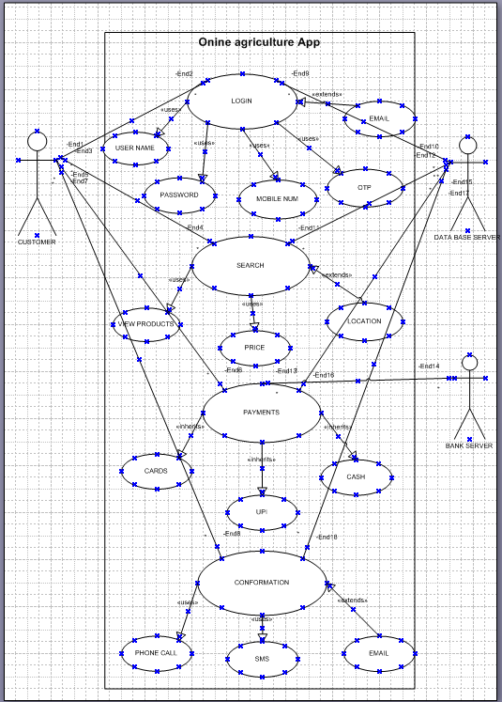

QUESTION 11 WRITE THE USE CASE
USE CASE ID | UC0004
Use case name | Online agricultural product
Created by | Apt it solutions
Date created | 06/07/2025
Actor | Customers
Description | The use case describes how we should purchase the product through online
Pre- condition | Customer should be registered to book the online product
Post condition | Should be deliver the product to the customers
Normal flow of happy path | -the customer should register if he can login or he should create an new account  -after login the customer can view the items and by search he can find the products  -user can purchase the product or he can add it to the cart  -if the customer purchase he should select the payment mode .  -Then the order is been placed  -Once the order is placed he will receive an conformation
ALTERNATIVE FLOWS | If the customer cannot login again it takes to the registration page  - if OTP is invalid it takes to registration again  -if the user cant get the product he can raise concern to customer care.  -if the user select the online payment mode and payment is not done .it will again take you to view items screen  -If the conformation is not received you can raise the request.
FREQUENCY OF USE | The frequency of use is high
Assumption | -The user can login through the mobile phone  - the farmer might buy all the products by knowing about the applications

12-DRAW THE ACTIVITY DIAGRAMS FOR ONLINE AGRICULTURE APPLICATION

- 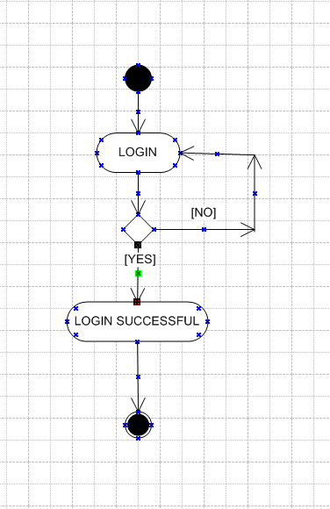

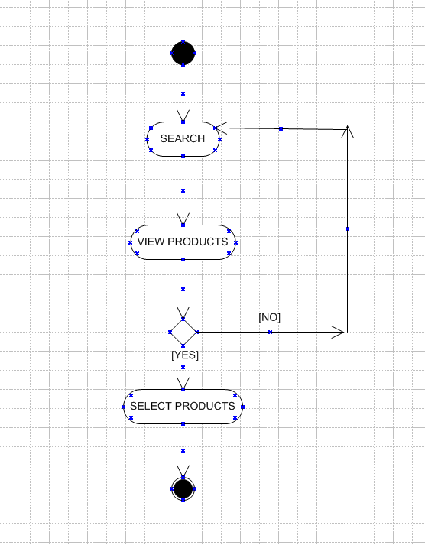

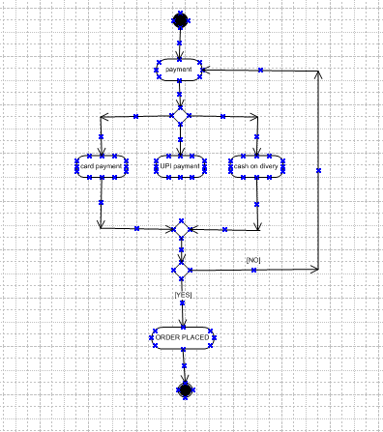

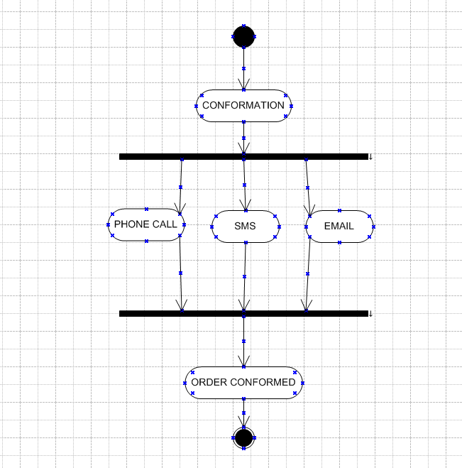

END.

