Waterfall Model Documents

Document 1- Business case document template
➢ Why is this project initiated?
This project is initiated to reduce vendor dependency on the Kastle system, which is currently used for loan operations at PNB Housing Finance Ltd. By building an internal Loan Operating System (LOS) identical to Kastle, the organization will have full ownership, control, and flexibility for future customizations, cost optimization, and compliance with evolving RBI/NHB regulations.
➢ What are the current problems?
- Vendor Dependency: Heavy reliance on external vendor for enhancements, upgrades, and support.
- High Licensing Costs: Recurring licensing and maintenance fees add to operational expenses.
- Customization Limitations: Delays and restrictions in adapting Kastle to new business needs.
- Integration Challenges: Difficulty in seamless integration with LOS front-end, GL, Payment Gateways, and DMS.
- Regulatory Gaps: New RBI/NHB reporting requirements often need costly vendor development.
➢ With this project how many problems could be solved?
- 100% ownership of LOS, reducing vendor lock-in.
- Cost optimization, with savings on licensing and long-term maintenance.
- Faster customization & enhancements as business requirements evolve.
- Improved integrations with existing enterprise systems (LOS front-end, GL, Payment Gateways, DMS).
- Automated compliance & reporting, reducing manual work and audit risks.
➢ What are the resources required?
People:
- Project Sponsor (Operations Head)
- Project Manager, BA
- IT Development Team
- QA & Testing Team
- Business SMEs (Operations, Risk, Compliance, Finance)
- Trainers & Change Management Team
Technology:
- Application Development Environment
- Database & Middleware
- Infrastructure (Servers/Cloud, Security Tools)
- Integration APIs
Financial:
- Development & Testing Costs
- Hardware/Software Procurement
- Training & Change Management Budget

➢ How much organizational change is required to adopt this technology?
- Minimal process change: The new LOS will replicate Kastle, so workflows remain the same.
- Medium-level IT readiness: Internal IT team will need to adapt to maintaining and enhancing the system.
- User training required: End users will need training to use the new interface and reporting tools, though the experience will be familiar.
- Change management focus: Users must be reassured that the system functions identically to Kastle to avoid resistance.
➢ Time frame to recover ROI?
- Initial Investment Recovery: Within 2–3 years due to savings in license fees, vendor support costs, and improved operational efficiency.
- Long-term ROI: Ongoing cost savings, reduced downtime, and faster regulatory compliance will ensure sustained value over 4-5 years.
➢ How to identify Stakeholders?
Stakeholders will be identified through business process mapping and consultation across departments:
- Primary Stakeholders: Operations, Finance, Risk, Compliance, IT (direct system users).
- Secondary Stakeholders: Senior Management, Internal Audit, Regulatory Reporting Teams.
- External Stakeholders: RBI/NHB (regulatory compliance), Technology Vendors (if engaged for build/support).

Document 2: BA Strategy
As a Business Analyst, my approach will ensure that requirements are correctly gathered, documented, validated, and signed-off by all stakeholders. The strategy aligns with the Waterfall model where each phase is clearly defined, documented, and approved before moving to the next stage.
Elicitation Techniques to Apply
- Interviews & Workshops with Business, IT, Risk, Finance, and Compliance to define detailed business and system requirements by mapping Kastle functionality
- Document Analysis of Kastle system workflows, policies, and RBI/NHB guidelines.
- Observation – Actively observing the workflow with the loan officers and operations staff.
- Questionnaires/Surveys for wider user feedback across Pan India staff.
- Prototyping to validate requirements with the interactive software.

Stakeholder Analysis (RACI Matrix)
Stakeholders | Requirement Gathering | Requirement Analysis | Design | Development & Coding | Testing | UAT Delivery | Deployment & Implementation
Business Analyst (BA) | Responsible | Responsible/ Accountable | Consulted | Informed | Consulted | Consulted | Informed
Project Manager (PM) | Accountable | Accountable | Accountable | Accountable | Accountable | Accountable | Accountable
Business Users / Operations | Consulted | Consulted | Consulted | Informed | Informed | Responsible | Consulted
IT Development Team | Informed | Consulted | Responsible | Responsible/ Accountable | Consulted | Consulted | Responsible
Quality Assurance (QA) Team | Informed | Informed | Consulted | Consulted | Responsible/ Accountable | Consulted | Informed
Compliance / Risk Team | Consulted | Consulted | Informed | Informed | Informed | Consulted | Consulted
Senior Management / Sponsor | Informed | Informed | Informed | Informed | Informed | Accountable | Accountable

Documents to be Prepared by BA
Document | Purpose
BRD (Business Requirements) | High-level business needs and and objectives for a project which is to achieved considering the expectations for all stakeholders
FRD (Functional Requirements) | Detailed system behaviour and features, Specific Functionalities and capabilities a product or system must possess. It details how the software should behave , including user interactions, data handling , and system behaviour
Use Case / User Story Docs | End-to-end flows with acceptance criteria
RTM (Traceability Matrix) | All the requirements are mapped to test case verifying that each requirement is properly tested
MoMs | Track meetings and decisions
CR Log | Track change requests in overall Product life Cycle, their status, details and impact. Log helps to manages changes effectively , ensuring they are properly evaluated, approved and implemented while minimizing disruption
UAT Plan & Sign-off Forms | Testing readiness and client approval. UAT plan outlines the scope, objectives, and strategy for user Acceptance Testing and Sign off forms document the completion and approval of the testing process
Sign-off & Approval Process
- Draft document BRD /FRD to be circulated to SMEs and stakeholders.
- Review meetings held to clarify doubts.
- Track comments & incorporate updates.
- Final document issued for formal sign-off via email/Project Acceptance Form.
Approvals from the Client
Client approval required before moving to next Waterfall phase for all deliverables (BRD, FRD, UAT) .Clearly define the deliverables, communicate proactively and provide the structured path for feedback and revision . Establish a formal meeting with the clients to keep them informed and get continuous feedback .
Maintain a version control system for transparency and audit readiness.
Store all signed documents on SharePoint/Confluence.
Communication Channels
Communication Type | Tool | Frequency
Requirement Reviews | Zoom / Google Meet | As needed
Project Updates | Email, MS Teams | Weekly
Document Sharing | Share Point/Confluence | Ongoing
Status Reporting | PPT/Excel via Email | Bi-weekly
Committee Meetings | Zoom + MOM Documentation | Monthly

Handling Change Requests
- All change requests logged in Change Request Register.
- Impact analysis (scope, time, cost, risk).
- Present to Change Control Board (CCB) for decision.
- Approved changes reflected in updated documents & RTM
Process:
- CR raised → Logged in Change Request Log
- BA captures impact on:
  - Requirements
  - Timeline / Budget
  - Dependencies
- PM and Developer Team analyse effort
- Approval required from if cost is involved
- Upon approval:
  - Update BRD/FRD/RTM
  - Inform Dev/Test teams
Progress Reporting
- Weekly Status Reports to stakeholders.
- Monthly Steering Committee meetings.
- Weekly or Monthly BA Reports to PM and Business including:
  - Completed elicitation activities
  - Pending reviews
  - Identified risks or blockers
  - Next week’s plan
- Update status indicators for scope, time, cost.
- Use Dashboard or Excel Format shared via email and discussed in weekly meetings.
UAT & Final Acceptance
- Facilitate UAT sessions with business users.
- Prepare UAT Plan and get it signed off by Committee.
- Coordinate test cycles with:
  - Testers
  - Business Users
- Capture defects, feedback, and fixes.
- Submit UAT Report to Committee.
- Final version of product shared for validation and Obtain formal Client Project Acceptance Form (Sign-off) after successful UAT.
Document 3- Functional Specifications
Field | Details
Project Name | Internal Loan Management System (Similar to Kastle)
Customer Name | PNB Housing Finance Limited
Project Version | v1.0
Project Sponsor | Senior Management, PNB Housing Finance Ltd.
Project Manager | [Name to be assigned by Team]
Project Initiation Date | 08-09-2025
Functional Requirement specifications:
Req ID | Req Name | Req Description | Priority
FR0001 | Login | User should be able to log in to the application securely using role-based access. | 10
FR0002 | Customer Onboarding | System should capture customer KYC details, loan application data, and documents. | 10
FR0003 | Loan Application Processing | Users should be able to create, edit, and submit loan applications for approval. | 9
FR0004 | Loan Eligibility Check | System should automatically validate applicant eligibility based on pre-set rules. | 9
FR0005 | Document Management | Upload, store, and retrieve loan-related documents securely. | 8
FR0006 | Loan Sanction & Approval | Multi-level approval workflow for loan sanctioning with audit trail. | 7
FR0007 | EMI & Repayment Schedule | System should generate EMI schedules and repayment plans for sanctioned loans. | 7
FR0008 | Payment Integration | Integrate with payment gateways for EMI collection and loan disbursement. | 7
FR0009 | Reports & Dashboards | Generate MIS reports, loan portfolio reports, and dashboards for management. | 6
FR0010 | Notifications & Alerts | Trigger SMS/Email alerts for due dates, approvals, and payment reminders. | 6
FR0011 | User Management | Admin should be able to create, manage, and deactivate users and roles. | 5
FR0012 | Audit & Compliance | System should maintain logs for compliance, risk, and audit purposes. | 5
Document 4- Requirement Traceability Matrix
Req ID | Req Name | Req Description | Design | D1 | T1 | D2 | T2 | UAT
FR0001 | Login | User must be able to login to access the application securely | Yes | Pending | No | Yes | Yes | Yes
FR0002 | Customer Onboarding | Capture customer KYC details, loan application data, and documents | Yes | Yes | Pending | Yes | No | Yes
FR0003 | Loan Application Processing | Create, edit, and submit loan applications for approval | Yes | Yes | Yes | Pending | Yes | Yes
FR0004 | Loan Eligibility Check | System validates applicant eligibility based on pre-set rules | Yes | Pending | No | Yes | Yes | Yes
FR0005 | Document Management | Upload, store, and retrieve loan-related documents securely | Yes | Yes | Yes | No | Yes | Pending
FR0006 | Loan Sanction & Approval | Multi-level approval workflow for loan sanctioning with audit trail | Yes | Yes | Pending | Yes | No | Yes
FR0007 | EMI & Repayment Schedule | Generate EMI schedules and repayment plans | Yes | Pending | Yes | Yes | Yes | Pending
FR0008 | Payment Integration | Integrate with payment gateways for EMI collection/disbursement | Yes | Yes | Yes | Yes | Pending | Yes
FR0009 | Reports & Dashboards | Generate MIS reports and dashboards for management | Yes | Pending | No | Yes | Yes | Pending
FR0010 | Notifications & Alerts | Trigger SMS/Email alerts for due dates, approvals, reminders | Yes | Yes | Pending | Yes | Yes | Yes
FR0011 | User Management | Admin should manage users, roles, and permissions | Yes | Yes | Yes | Pending | Yes | Yes
FR0012 | Audit & Compliance | Maintain logs for compliance, risk, and audits | Yes | Pending | Yes | Yes | No | Yes

Document 5- BRD Template
Project Name : Internal Loan Operating System (Similar to Kastle)
Project ID : PNBHFL-LOS-2025-001
Version ID : 1.0
Author : [Shrimi Rastogi / Business Analyst]
1. Document Revisions
Date | Version Number | Document Changes
08-09-2025 | 0.1 | Initial Draft
09-09-2025 | 0.2 | Added Functional Requirements section
09-09-2025 | 0.3 | Updated Non-Functional Requirements
10-09-2025 | 0.4 | Incorporated stakeholder feedback
11-09-2025 | 1 | Final Approved Version

2. Approvals
Role | Name | Title | Signature | Date
Project Sponsor | Mr. R Mehta | Senior VP – PNB Housing Finance | RM | 08-09-2025
Business Owner | Ms. N Kapoor | Head – Business Operations | NK | 08-09-2025
Project Manager | Mr. A Sharma | IT Project Manager | AS | 09-09-2025
System Architect | Mr. S Iyer | Enterprise Architect | SI | 09-09-2025
Development Lead | Ms. P Nair | Technical Lead | PN | 10-09-2025
User Experience Lead | Mr. A Verma | UX/UI Designer | AV | 11-09-2025
Quality Lead | Ms. S Gupta | QA/Test Lead | SG | 11-09-2025
Content Lead | Mr. K Bhatia | Documentation Specialist | KB | 11-09-2025

3. RACI Chart for This Document
Name | Position | * | R | A | S | C | I
Mr. R Mehta | Senior VP – PNB Housing Finance (Project Sponsor) | Authorize |  |  |  |  | ✔
Ms. N Kapoor | Head – Business Operations (Business Owner) | Authorize |  |  |  | ✔ | ✔
Mr. A Sharma | IT Project Manager |  |  | ✔
Mr. S Iyer | Enterprise Architect |  | ✔
Ms. P Nair | Technical Lead (Development) |  | ✔
Mr. A Verma | UX/UI Designer (UX Lead) |  | ✔
Ms. S Gupta | QA/Test Lead (Quality Lead) |  | ✔
Mr. K Bhatia | Documentation Specialist |  | ✔
Business Users | End-Users/Operations Team |  |  |  |  | ✔ | ✔

4. Introduction
4.1. Business Goals
- The purpose of this project is to design, develop, and implement an internal Loan Operating System (LOS) that is identical to Kastle in terms of functionality, business rules, and workflows.
- Ensuring continuity of operations while reducing dependency on third-party vendors.
Need: Replace or enhance the current Kastle Loan Management System with an internal, customized system for better control, compliance, and scalability.
4.2. Business Objectives
To provide an IT solution for:
- End-to-end Loan Origination, Approval, and Disbursement
- Loan Servicing (EMI, repayments, prepayments)
- Mobile App access for staff and customers (Android & iOS)
- Automated alerts & reporting for compliance
4.3. Business Rules
- Loan sanction must comply with RBI & NHB guidelines.
- KYC mandatory for all customers.
- Role-based access control must be enforced.
4.4. Background
- PNB Housing Finance Ltd. currently uses the Kastle system for loan origination and management. While Kastle has supported business operations for many years.
- Reliance on an external vendor has introduced challenges in customization, integration, licensing costs, and long-term scalability.
- To address this, the organization has an opportunity to build an internal Loan Operating System (LOS) that replicates Kastle’s existing functionality exactly, while giving PNBHFL full ownership, control, and flexibility for future enhancements.
4.5. Project Objective
Develop a robust, scalable, and secure loan operating system aligned with PNB Housing Finance’s business objectives.
- Solution selection and design aligned with Kastle’s existing workflows, loan lifecycle features, and compliance requirements.
- Solution prototyping and testing to validate replication of account creation, loan disbursement, EMI scheduling, collections, NPA handling, and closure.
- Data migration from Kastle to the new LOS with complete reconciliation of balances and schedules.
- Training, user adoption, and transition to ensure smooth migration without disrupting business operations
- Integration with Kastle front-end, Payment Gateways, Document Management Systems (DMS), and regulatory reporting tools.
4.6. Project Scope
4.6.1. In Scope Functionality
- Loan Origination
- Loan Sanction & Approval Workflow
- EMI & Repayment Schedules
- Document Management
- Payment Gateway Integration
- Audit & Compliance Reporting
- Customer Notifications (SMS/Email)

4.6.2. Out of Scope Functionality
- Integration with external CRM (Phase 2)
- AI/ML-based credit scoring (future roadmap)
- Third-party marketing modules
5. Assumptions
- Availability of Business Users – Business users and stakeholders will be available on time for requirement gathering, clarifications, and approvals.
- Stable Business Policies – Regulatory and compliance guidelines (RBI/NHB rules, KYC, AML, etc.) will remain stable during the course of project development.
- IT Infrastructure Readiness – Required servers, storage, network bandwidth, and database licenses will be made available by the IT department before development starts.
- Data Availability – Legacy system (Kastle) data required for migration (customer profiles, loan accounts, repayment history) will be available, accurate, and accessible.
- Timely Decision Making – Steering Committee and project sponsors will provide timely approvals on key design and requirement changes to avoid delays.
- Vendor/Third-party Integration – APIs and services (e.g., payment gateway, SMS/Email notifications, credit bureau checks) will be available and stable for integration.
- User Training & Adoption – End users (operations staff, managers, auditors) will undergo proper training and adapt to the new system within the planned timeline.
6. Constraints
- Budgetary Constraint – Total project expenditure (hardware, software, services, and training) must not exceed the approved budget.
- Timeline Constraint – The project must be completed within the planned duration (e.g., 8–10 months) to align with business and regulatory deadlines.
- Regulatory Compliance – The solution must strictly comply with RBI, NHB, and other financial regulatory guidelines (KYC, AML, Data Privacy).
- Resource Availability – Limited availability of skilled IT staff, subject matter experts, and vendor resources may impact timelines.
- Data Migration Constraint – Data from the legacy Kastle system must be migrated with high accuracy and minimal downtime during cutover.
7. Risks
A risk is something that could affect the success or failure of a project. Risks are analyzed regularly as the project progresses. While every risk cannot be eliminated, its impact can be minimized by planning. Each risk below is documented with likelihood, impact, and mitigation strategy.
7.1 Technological Risks
- Risk: Integration issues with third-party systems (payment gateway, credit bureau, SMS/email).
  - Likelihood: Medium
  - Impact: High
  - Mitigation Strategy: Conduct early API testing with vendors; establish fallback communication methods; keep buffer time for integrations.
- Risk: System performance issues due to high loan transaction volumes.
  - Likelihood: Medium
  - Impact: High
  - Mitigation Strategy: – perform load/stress testing; ensure scalable infrastructure.
7.2 Skills Risks
- Risk: Lack of skilled developers or loan domain experts.
  - Likelihood: High
  - Impact: Medium to High (delayed development)
  - Mitigation Strategy: – Early identification of resource gaps; arrange training sessions; engage external consultants if required.
- Risk: Delay in knowledge transfer from Kastle system experts.
  - Likelihood: Medium
  - Impact: Medium
  - Mitigation Strategy: Transfer – ensure vendor for knowledge handover.
7.3 Political Risks
- Risk: Change in organizational priorities or leadership may deprioritize the project.
- Likelihood: Low
- Impact: Medium
- Mitigation Strategy: Secure written executive sponsorship and periodic Steering Committee reviews.
- Risk: Vendor conflicts or dependency on a single vendor.
  - Likelihood: Medium
  - Impact: High
  - Mitigation Strategy: Transfer – Establish Service Level Agreements (SLAs); keep alternate vendors in pipeline.
- Risk: Change in RBI/NHB guidelines can impact the project.
  - Likelihood: Medium
  - Impact: Medium
  - Mitigation Strategy: Keep a regular track on changes in RBI/NHB guidelines and stay updated
7.4 Business Risks
- Risk: Failure to achieve ROI in planned timeframe.
  - Likelihood: Medium
  - Impact: High
  - Mitigation Strategy: – define measurable KPIs; monitor benefits post-go-live.
- Risk: User resistance to adopting the new system.
  - Likelihood: High
  - Impact: High
  - Mitigation Strategy: – Conduct change management sessions, early training, and phased rollouts
7.5 Requirements Risks
- Risk: Incomplete or misunderstood requirements during requirement gathering.
  - Likelihood: High
  - Impact: High
  - Mitigation Strategy: use RTM (Requirement Traceability Matrix); conduct walkthroughs; obtain formal sign-offs.
7.6 Other Risks
- Risk: Data migration issues from Kastle (loss or corruption of loan/customer data).
  - Likelihood: Medium
  - Impact: High
  - Mitigation Strategy: – perform mock migrations, validate with reconciliation reports, keep backups.
- Risk: Project delays due to external audits or compliance checks.
  - Likelihood: Low
  - Impact: Medium
  - Mitigation Strategy: Accept/Mitigate – factor buffer time in project plan.
8. Business Process Overview
8.1. Legacy System (AS-IS)
The current Kastle Loan Management System being used at PNB Housing Finance Limited has been operational for several years. While it supports basic loan origination, repayment tracking, and reporting, the system faces challenges:
- Manual dependency: Multiple processes (loan approval, KYC verification, repayment rescheduling) require manual intervention.
- Limited integration: Minimal integration with external APIs such as credit bureaus, core banking, and mobile applications.
- Performance bottlenecks: Frequent delays in loan disbursement approvals and batch processing of EMI collections.
- User experience issues: Outdated UI leading to lower adoption by business users.
- Reporting limitations: Static MIS reports with little real-time analytics.
AS-IS Flow (Simplified):
- Loan application is received manually/through limited online input.
- Documents are uploaded and verified manually.
- Credit team reviews application and performs external checks.
- Loan approval/rejection decision recorded.
- Loan account created in system.
- EMI schedules generated and repayments tracked.
- Monthly MIS prepared manually.

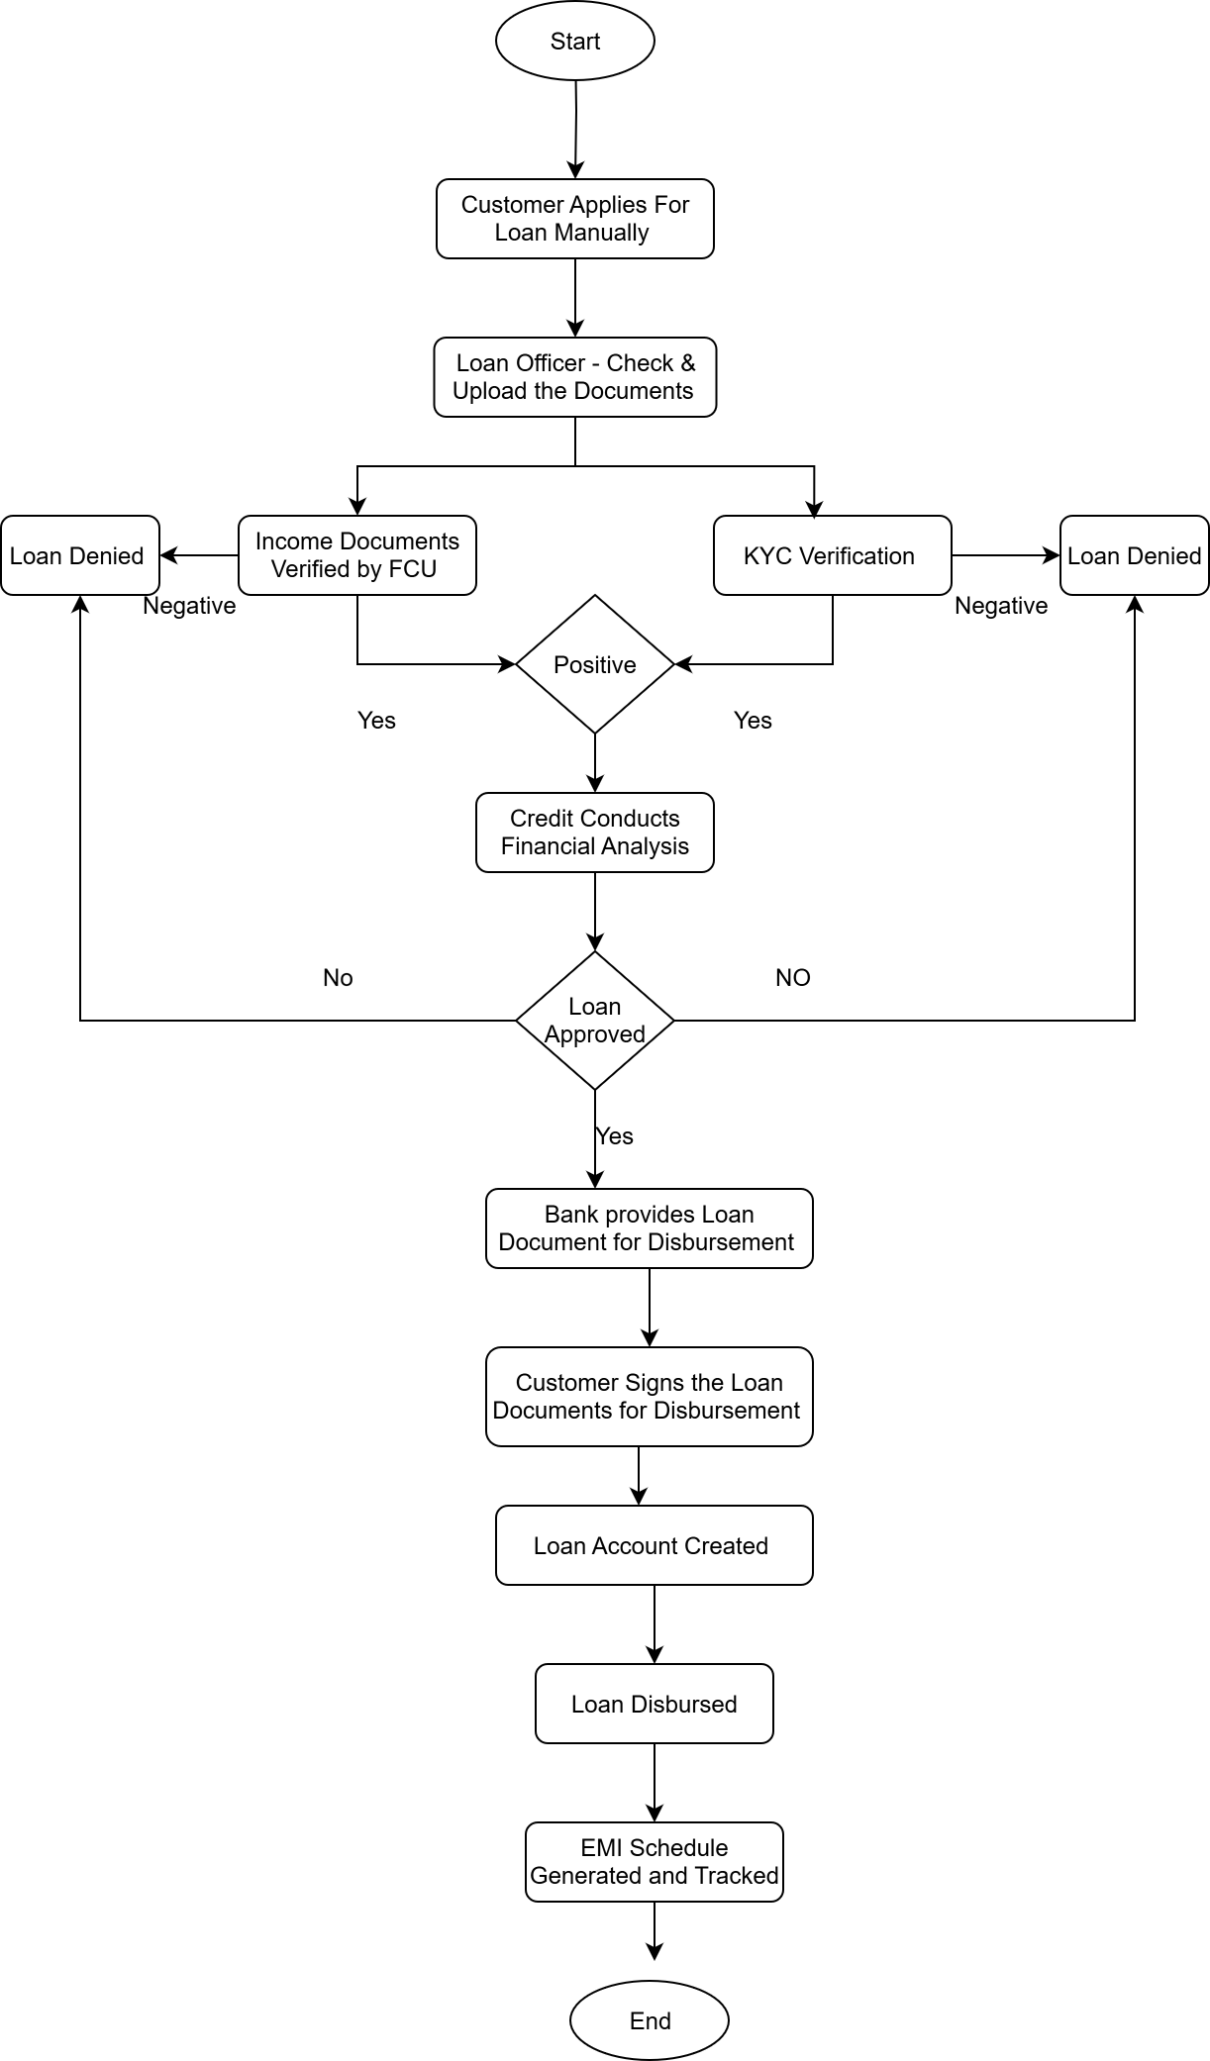
8.2. Proposed Recommendations (TO-BE)
The new Loan Operating System (LOS) will replicate the functionalities of Kastle but with enhanced automation, scalability, and user experience.
Key Recommendations:
- Automated Loan Origination: Online loan application forms with built-in validations, automated credit bureau checks, and AI-driven risk scoring.
- Integrated Document Management: OCR and e-sign support for faster document verification.
- End-to-End Digital Workflow: Seamless integration between operations, risk, compliance, and finance departments with minimal manual intervention.
- Improved Customer Experience: Mobile app and web portal for real-time loan status tracking, EMI schedules, and self-service options.
- Advanced Analytics & Reporting: Real-time dashboards for management, predictive analytics for NPAs.
- Regulatory Compliance: Built-in compliance checks with RBI/Housing Finance regulations.
TO-BE Flow (Simplified):
- Customer applies digitally via web/app.
- KYC and credit checks triggered automatically via integrated APIs.
- Loan application routed through workflow engine for approvals.
- Automated initial decision-making engine assigns approval/rejection based on rules.
- Files moves to Credit Team for final decision for Approval/Rejection
- Loan account generated and disbursement done digitally if approved.
- EMI schedules generated, auto-debit integration enabled.
- Real-time dashboards and reports accessible to management.

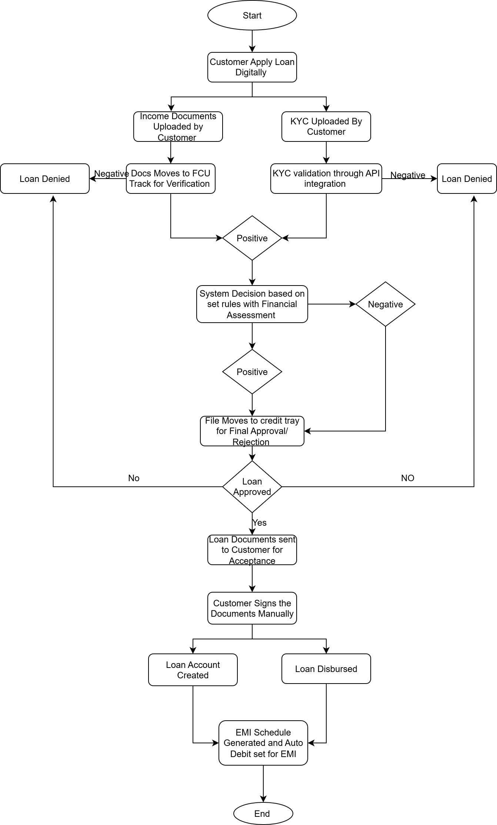

Process Step | AS-IS (Legacy – Kastle) | TO-BE (Proposed – New System) | Improvement
Loan Application | Collected manually or through partial digital forms. | Fully digital via web & mobile app. | Faster onboarding, reduced manual data entry.
Document Verification | Manual verification of KYC, income, property papers. | Automated KYC validation, OCR, integration with government portals & credit bureau. | Reduced errors, faster verification.
Credit Review | Manual checks by Credit Team. | Automated Credit Bureau API + Decision Engine. | Standardized risk scoring, reduced bias.
Approval/Rejection | Human approval after long review cycles. | Initially Automated decision workflow with configurable rules. Them move to credit team for final decision with basic workings | Reduced turnaround time (TAT).
Loan Account Creation | Manual entry into core banking system. | Integrated system auto-creates loan account. | Eliminates redundancy.
EMI Schedule | Generated manually and sent by email. | Auto-generated & auto-debit enabled. | Improves accuracy & reduces defaults.
Repayment Tracking | Manual monitoring by operations team. | Real-time repayment monitoring dashboard. | Better transparency & efficiency.
Reporting & MIS | Monthly reports generated manually. | Automated real-time dashboards and reports. | Management gets instant insights.
9. Business Requirements
Functional Business Requirements (FBRs)
- FBR001 – Secure Login & User Management
The system must allow secure login with role-based access (Loan Officer, Manager, Auditor, Admin) and support multi-factor authentication.
- FBR002 – Customer Onboarding & KYC
The system must capture and verify customer details (Aadhaar, PAN, income proofs, employment documents) as per RBI/NHB guidelines.
- FBR003 – Loan Application Management
Users must be able to create, update, track, and manage loan applications with statuses like New, In-progress, Approved, Disbursed, Rejected.
- FBR004 – Document Management System
The system must allow upload, validation, storage, and retrieval of all loan-related documents in digital format with audit history.
- FBR005 – Credit Bureau Integration
The system must integrate with credit bureaus (CIBIL, Experian, etc.) to automatically fetch credit scores for risk assessment.
- FBR006 – Loan Approval Workflow
A configurable multi-level approval process must be provided (e.g., Loan Officer → Credit Manager → Senior Manager).
- FBR007 – Loan Disbursement & Account Integration
The system must process and track loan disbursements (partial or full) with integration to core banking/payment systems.
- FBR008 – Repayment & EMI Tracking
The system must generate repayment schedules, track EMI collections, flag overdue payments, and send automated reminders.
- FBR009 – Reporting & MIS Dashboards
The system must generate standard and ad-hoc reports (loan book, NPAs, disbursement trends) for management decision-making.
- FBR010 – Notifications & Alerts
The system must send SMS/Email/Push notifications to customers for loan status updates, EMI reminders, and overdue alerts.
Non-Functional Business Requirements (NFRs)
- NFBR001 – Performance
The system must support at least 5,000 concurrent users with an average response time <2 seconds.
- NFBR002 – Security & Compliance
The system must comply with RBI/NHB/PNB Housing Finance policies, ensuring encryption, secure access, and audit logs.
- NFBR003 – Availability & Uptime
The system must provide at least 99.9% uptime (excluding planned maintenance).
- NFBR004 – Scalability
The system must scale to support double the loan application volume within the next 5 years.
- NFB005 – Disaster Recovery
Daily backups and the ability to restore operations within 4 hours in case of system failure.
10. Appendices
10.1. List of Acronyms
- PNB – Punjab National Bank
- KYC – Know Your Customer
- UAT – User Acceptance Testing
- NPA – Non Performing Assets
- CRM- Customer relationship Management
- API- Application Programming Interface
10.2. Glossary of Terms
- Loan Origination → Process of initiating a loan application
- Sanction → Approval of a loan by authorized users
- CIBIL/Experian →Credit bureaus that provide credit score and history of borrowers
- Change Management→ The process of preparing, supporting, and training users to adopt the new system.
- UAT (User Acceptance Testing) →Final phase of testing performed by business users to validate that the system meets requirements.
- Disbursement→ The process of releasing loan funds (partial or full) to the borrower’s bank account.
10.3. Related Documents
- Project Charter – Loan Management System
Outlines project objectives, scope, stakeholders, and high-level milestones.
- Business Case Document
Provides justification for initiating the project, including cost-benefit analysis, ROI, and resource planning.
- Functional Requirement Specification (FRS)
Detailed description of system functionalities and business requirements.
- Non-Functional Requirement Specification (NFRS)
Defines system performance, availability, security, and scalability requirements.
- Requirement Traceability Matrix (RTM)
Maps requirements to design, development, testing, and UAT deliverables.
- Process Flow Diagrams (AS-IS and TO-BE)
Illustrates the current process in Kastle and the proposed process in the new LMS.
- Change Management Plan
Outlines user training, communication, and adoption strategy for smooth transition.
- Regulatory Compliance Documents
RBI/NHB circulars, PNB Housing Finance internal compliance guidelines relevant to loan processing.

