WATERFALL DELIVERABLES PART 2/2
Document 6

Please prepare a Use case diagram, activity diagram and a use case specification document.
Use Case Diagram:
A Use Case Diagram is a UML (Unified Modelling Language) diagram that shows:
- Who interacts with a system (actors)
- What they can do with the system (use cases)
It focuses on functional requirements of a system in a simple visual way.
Key Components/Features:
- Actor- People, systems, or external entities interacting with the system. Represented as stick figures.
- Use Cases- Functions or actions the system perform for actors. Represented as Ovals.
- System Boundary- A rectangle that encloses all use cases- defines the system’s scope.
- Relationships- Connect actors and use cases.
- Association- Line connecting actor to a use case.
- Include- One use case always uses another. Represented as dashed arrow with <<include>>.
- Extend- Optional or conditional use case. Represented as a dashed arrow with <<extend>>

Activity Diagram:
An Activity Diagram is a type of UML (Unified Modelling Language) diagram used to represent workflow or business processes. It shows the sequence of activities and decision points in a process, similar to a flowchart but more formalized for system modelling.
Key Components/Features:
Activities- Represented by rounded rectangles. Each activity is a step in the process.
Start (Initial Node) - A solid black circle, shows where the process begins.
End (Final Node) – A solid black circle inside a hollow circle, shows process completion.
Decision- A diamond shape, shows, point where the flow splits based on a condition.
Fork/Join- Horizontal or vertical bars, Fork splits a flow into parallel activities, Join synchronizes parallel flows.
Transitions/Edges- Arrows, shows the flow from one activity to another.
Swimlanes- Divides activities by actor or department, shows who does what in the process.
Object Nodes- Shows objects/ data that are input or outputs of activities (Optional).

Use Case Diagram:
Activity Diagram:

1. Login Page

2. AI-driven Insights

3. Unified RM Workbench:

4. Mobile CRM with geo-tagging:

5. BM Dashboard:

6. Compliance & Life-Cycle triggers:

Use case specification document:

1.Use case name | AI-driven Insights
Description | System suggests next best product & tracks customer sentiment
Actors | Primary- Relationship Manager(RM)
 | Secondary- CRM system
Pre- Conditions | Customer data available
Post- Conditions | Insights displayed on customer profile
Basic Flow | RM opens customer profile→ System shows recommendations & sentiment
Alternate Flow | No product found→Show “No recommendation available”
Exceptional Flow | System error→ show “unable to fetch insights”
Assumptions | AI trained on sufficient data
Constraints | Must follow RBI/ICICI compliance rules
Dependency | Data sync with CRM database
Input/output | Input→ Customer data, Output→ Product suggestions, sentiment score
Business Rules | Do not recommend already owned products
Misc. Info. | Results should load within 3 seconds

2.Use case name | Unified RM Workbench
Description | Single screen for sales, service, reports
Actors | Primary- RM
Pre- Conditions | RM login successfully
Post- Conditions | RM can manage all activities in one dashboard
Basic Flow | RM logs in→ Accesses workbench→ Manages leads, service, report
Alternate Flow | Module not available→Show “Service temporarily unavailable”
Exceptional Flow | Wrong role access→ Deny access, show error
Assumptions | RM has required role permissions
Constraints | Role- based access only
Dependency | Integration with all CRM modules
Input/output | Input→ RM actions; Output→ Updated records, reports
Business Rules | Data changes must be logged
Misc. Info. | Easy navigation UI

3.Use case name | Mobile CRM with Geo-tagging & Offline Mode
Description | RM uses mobile app with geo-tagging & offline sync
Actors | RM, Customer
Pre- Conditions | CRM mobile app installed
Post- Conditions | Data updated in CRM after sync
Basic Flow | RM opens mobile app→ Checks nearby customers → Updates records (offline/online)
Alternate Flow | No internet→ Work offline → Sync later
Exceptional Flow | Location not enabled→ Prompt for GPS access
Assumptions | Device supports GPS & offline storage
Constraints | Geo-data stored securely
Dependency | Internet required for sync
Input/output | Input→ Customer interaction data; Output→ Synced CRM record
Business Rules | Only authorized users can update customer data
Misc. Info. | Offline mode auto-sync when online

4.Use case name | Branch Manager Dashboard
Description | BM views branch performance & team productivity in real-time
Actors | BM
Pre- Conditions | BM login with manager role
Post- Conditions | Dashboards updated in real-time
Basic Flow | BM logs in → Accesses dashboard→ Reviews branch KPIs, team metrics, pending issues
Alternate Flow | No data available→ Show “Data not available”
Exceptional Flow | Server timeout→ Show error message
Assumptions | Data pipelines update regularly
Constraints | Dashboard refresh within 5 minutes
Dependency | Sales & service modules must be integrated
Input/output | Input→ CRM data feeds; Output→ Real-time dashboard charts
Business Rules | BM can only view assigned branch data
Misc. Info. | Dashboard export to PDF/Excel

5.Use case name | Automated Compliance & Lifecycle Triggers
Description | System sends compliance alerts & customer lifecycle notifications
Actors | RM, BM, External Compliance System
Pre- Conditions | Customer data must exist in CRM
Post- Conditions | Alerts sent to RM/BM
Basic Flow | CRM runs compliance check → Detects rule/event→ Sends notification (e.g., KYC renewal, churn risk)
Alternate Flow | No compliance issue found→ No alerts generated
Exceptional Flow | External compliance service unavailable→ Show “Compliance check failed”
Assumptions | Rules engine updated with latest RBI/ICICI policies
Constraints | Alerts must be timely & accurate
Dependency | Integration with compliance system & notification service
Input/output | Input→ Customer events, compliance rules; Output→ Alerts, reminders
Business Rules | All alerts must be logged with timestamp
Misc. Info. | Supports SMS, Email, CRM notifications

Document-7
Screen and Pages

1. CRM Login Page
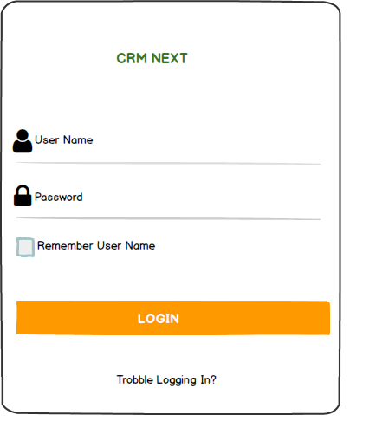

2. AI-driven Insights

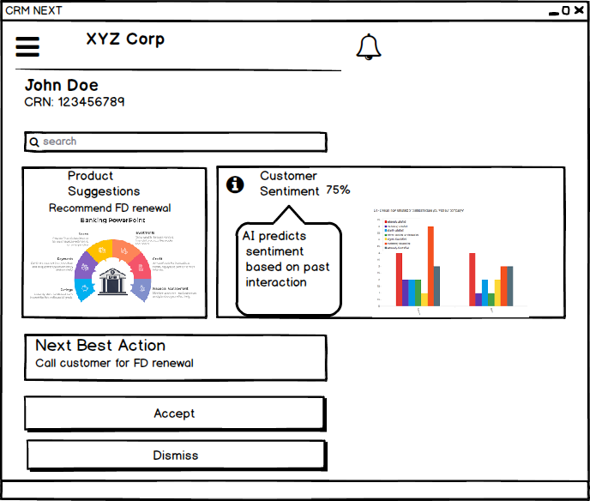

3. Mobile CRM with Geo-tagging

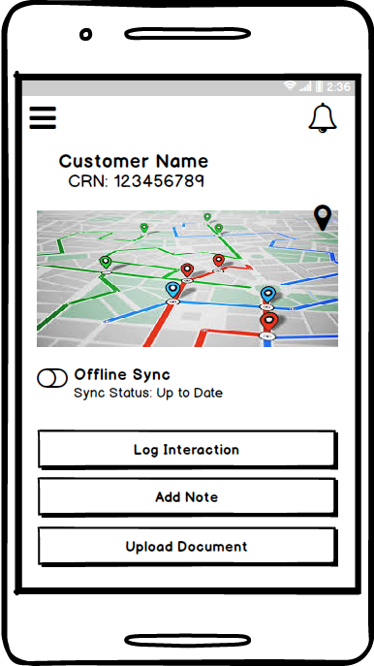

4. BM Dashboard:

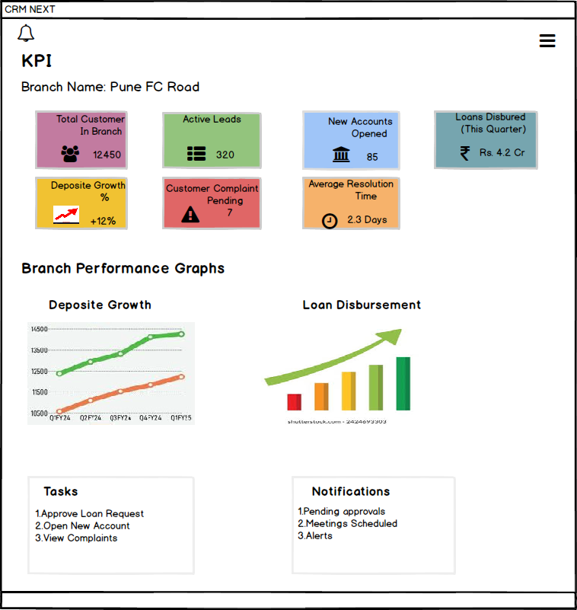

5. Compliance & Lifecycle Triggers:

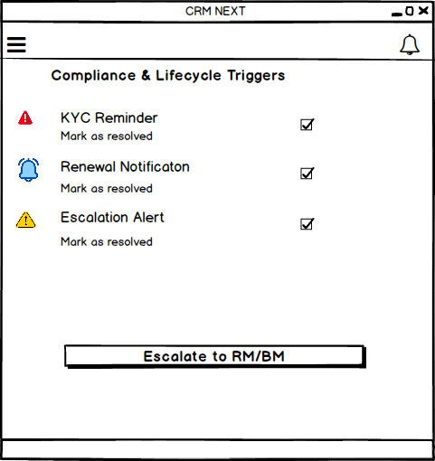
6. Notification Center:
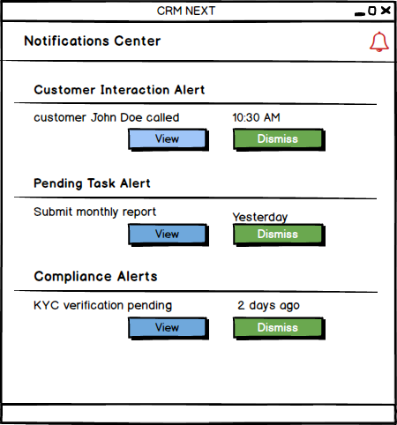
Document-8
Tools Visio and Axure

Tools-Visio and Axure Write a paragraph on your experience using Visio and Axure for the project.
While working on the CRM enhancement project, I found VISIO and AXURE RP to be extremely useful tools that helped me transform abstract requirements into clear, visual representations. With VISIO, I was able to prepare process flows, activity diagrams, and use case diagrams that mapped both the existing process and the improved workflows. These diagrams made it easier for business stakeholders, who were not always technical, to quickly grasp the changes and identify gaps. VISIO also gave structure to my requirement discussions, because once the flow was visible, it became easier to point out inefficiencies and propose improvements.

On the other hand, AXURE RP is a tool to create wireframes, prototypes, and mockups of websites and applications. It like a digital sketchpad where we can design how a screen or app will look and behave before it’s actually built. Instead of just showing a static picture, AXURE allows to add buttons, menus, links, and interactions, so when someone clicks, it can navigate to another page or show a popup- just like a real app.

Overall, using VISIO and AXURE together created a strong balance. VISIO brought clarity and precision to process mapping, while AXURE added interactivity and user experience design. These tools not only made deliverables more professional but also made workshops and presentations more engaging, because stakeholders could see both the process logic and the system design side by side. I believe they significantly improved collaboration across teams and ensured that the proposed CRM enhancements were aligned with real user needs before moving into the build phase.

Document-9
BA experience:
My experience as BA in following phases:-

1. Requirement gathering:
- During the Requirement Gathering phase, my role as a Business Analyst was to ensure that the client’s needs were captured clearly and accurately. I applied the MoSCoW technique (Must have, Should have, Could have, Won’t have), which helped in prioritizing features and focusing on the most critical aspects of the solution first.
- One of the challenges I faced was that the client was not consistently available during this phase. To address this, I reached out to alternate points of contact from the client’s side, ensuring that the flow of information was not interrupted and that project timelines were not delayed.
- Once the requirements were collected, I used the FURPS model (Functionality, Usability, Reliability, Performance, and Supportability) to validate and cross-check them against quality parameters. This helped in identifying gaps or missing details early on.
- I identified duplicate requirements and worked with stakeholders to remove them, ensuring a clear and streamlined set.
- Additionally, I used prototyping as a tool to make requirements more specific and to help stakeholders visualize the system better. This not only reduced ambiguity but also helped in securing quicker feedback and approvals.
Overall, my approach in this phase to ensure that requirements were not only gathered systematically but also validated, prioritized, and refined before moving ahead.

2. Requirement Analysis:
- During the Requirement Analysis phase, I focused on converting the collected requirements into clear visual and documented formats. I used UML and activity diagrams to represent the requirements and process flows, making them easier for both technical and non-technical team members to understand.
- After sharing these diagrams with the team, I received valuable feedback, as some members had different perspectives or suggested improvements. As a BA, I carefully considered their inputs and refined the diagrams accordingly.
- Along with this, I prepared the Business Requirement Specification (BRS) and the Software Requirement Specification (SRS), ensuring that all requirements were clearly documented, validated, and aligned with stakeholder expectations.
3. Design:
- In the Design phase, I worked on translating use case diagrams into detailed test cases, ensuring that every requirement was covered.
- I also coordinated with the client to review the design and solution documents, making sure their expectations must aligned with the proposed approach.
- I prepared both positive and negative test cases to account for real-world scenarios and avoid gaps that could affect the project later.
- To support testing, I created appropriate test data and continuously updated the Requirement Traceability Matrix (RTM), which helped verify that each requirement was addressed and nothing was missed.

4. Development:
- During the Development phase, I played a key role in bridging communication between the technical team and the client. I organized JAD sessions to align on requirements and design, and whenever the tech team had queries during coding, I clarified them promptly.
- At times, some members were hesitant or disagreed during sessions, so I handled the situation through one-on-one discussions, explaining the impact of their actions and fostering a healthy, collaborative environment.
- I also ensured the development process should closely tied to the design by referring to the prepared diagrams for coding.
- Conduct regular meetings with both the technical team and client were challenging due to availability issues, so I made it a point to record sessions, share them with those who missed, and follow up individually to keep everyone aligned.
5. Testing:
- During the Testing phase, I prepared detailed test cases based on use cases and performed high-level testing to ensure functionality matched requirements.
- I coordinated with the client to request and validate test data, while also keeping the RTM updated to maintain traceability.
- Once the testing outcomes were validated, I facilitated client signoff and guided them in preparing for UAT by ensuring they understood the test scope, process, and expected outcomes.
6. Deployment:
- During the Deployment phase, I ensured that all closure activities must completed smoothly. I shared the finalized RTM with the client, attaching it to the project closure documentation to confirm that all requirements had been addressed.
- I coordinated with the team to prepare and share comprehensive end-user manuals, making sure they were easy to follow and covered all critical functionalities.
- In addition, I planned and organized training sessions for the users, taking care of scheduling, communication, and logistics. I made sure all intended participants attended the training so that they were fully prepared to use the system confidently after go-live. This phase was crucial in building user confidence and ensuring a seamless transition into the production environment.

