Capstone Project 3 Part 1

Q.1 – A customer can make payment either by card or by wallet or by cash or by net banking. Draw a Use case diagram.
Ans. –
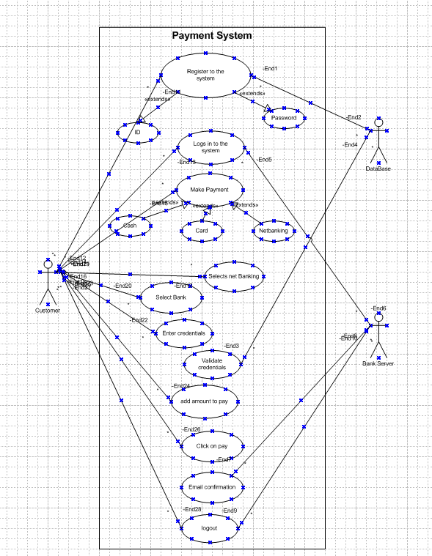
Q.2 – Derive Boundary classes, Controller classes, Entity classes.
Ans. – Boundary Classes – Boundary class are type of class in software design, particularly in Object-oriented Analysis and Design, which acts as intermediaries between the system and external entities. These external entities could be users, external systems and devices. The role of a Boundary class is to handle the interaction between the system and the outside world. Character of Boundary classes -
- Interface Handler – They manage inputs to and output from the system, such as user interface elements, API endpoints or file I/O.
- Interaction Focus – They focus solely on the interaction logic, leaving Business logic to other classes (usually entity classes).
- Transient – Typically short lived and only active during specific interaction
- Decoupling – They decuple the external system, or user interfaces form the internal business logic.
- Example – payment option Boundary, card payment Boundary. In a class diagram, there are cases that are shown by the icon

Class 2
Controller Classes – Controller classes are a type of class in object-oriented analysis and design (OOAD) that handle the flow of control and manage the interaction between Boundary classes (responsible for system interface) and Entity Classes (responsible for data and business logic). Their primary role is to process incoming requests, coordinate activities and direct data between other components of the system. Characteristics of Controller class are -
- Orchestrators – They do not perform business logic directly but delegate it to entity classes and manage the overall process flow.
- Interaction coordinates – Facilitate communication between Boundary class (e.g. user interface, APIs) and entity class.
- Independent of UI and data – They are designed to be decoupled from specific user interfaces or data structure, making them reusable and adaptable.
- Transient – Typically instantiated during specific use cases execution and disposed of afterward.
- Examples – Payment initiated controller, card payment controller. In the class diagram, there are cases that are shown by the following icon

Class 3
Entity Class – Entity Classes are a type of class of in software design, particularly in object-oriented analysis and design (OOAD) that represents the core business object of a system, these classes encapsulate the data and logic (business rules) that operates on that data. Characteristics of Entity classes are -
- Core Domain representation – represent real world concepts, business processes or system components.
- Data Centric – Store data attributes that describe business object.
- Business Logic – Contain methods to enforce business rules and ensure data integrity.
- Persistent – Typically persist in database or other storage system.
- Reusable – Can be used across various use cases and workflow because they model core system concepts.
- Examples – Customer, Payment. In a class diagram there are cases that are shown by the following icon

Class 1
Boundary Class (All use case)  [combination of 1 actor and a use case is one boundary class]  [combination of 2 actors and a use case is two boundary class]  [combination of 3 actors and a use case is three boundary class] and so on  And those actors should be primary actors.  Primary actors mean the actors who initiate the use cases and interact with the system | Customer registration  Customer login  Bank server login  Customer logout  Bank server logout
Controller Class (handle user input and process the data)  Use cases will be considered as the controller class. | Registration controller  Login Controller  Payment controller  Credential Controller  Net banking controller  Email controller  Logout controller
Entity Class (All Actors)  Each Actor will be considered as one entity | Customer  Bank server  Cash  Card  Net banking
Q.3 – Place these classes on a three tier Architecture.
Ans. – Three– Tier Architecture – Three tier architecture is a hierarchical software architecture with three distinct, independent tiers or layers. Three-tier architecture is comprised of the following tiers: Presentation Tier (Client layer), Business Tier (Business Logic Layer) and Data Access (Data Layer). The Main job of the Architecture is to enable software applications to efficiently and quickly respond to user request or inputs.
Presentation Tier – This layer is also called client layer and is responsible for accepting inputs or request form the user and displaying data for the user in a user-friendly format.
Business Tier - It acts as a middle layer between the client and the database server which is used to exchange partially processed data.
Database Tier – In this layer data or information stored.
Application Layer | Customer registration  Customer Login  Bank server Login
Business Logic Layer | Customer  Bank server
Data Layer | Customer, cash, card  Bank server, net banking

Q.4 – Explain Domain model for customer making payment through Net Banking.
Ans. – Domain model is similar to the entity relationship diagram. The tables are connected to each other.
In the diagram below, the customer table is connected to the bank table, which is why the customer is able to make payments. Customer table is also connected to payment table, because he should make payments. Now the payment is done by net banking, so payment table is connected to net banking table. The account is in the bank, so the account table is connected to the bank table.
The Authentication table is connected to both the net banking table and the bank table, because authentication is performed here. Also, the authentication table is connected to the transaction table because authentication will be done during the transaction.

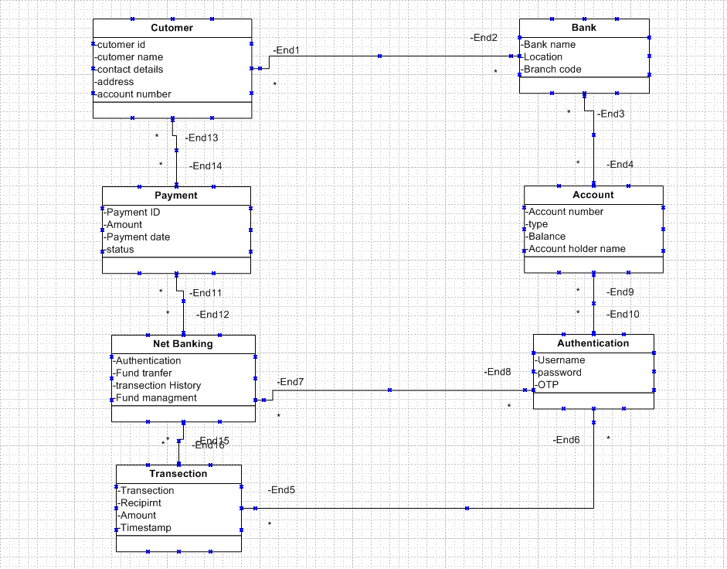

Q.5 – Draw a sequence diagram for payment done by customer net banking.
Ans. – Sequence Diagram for payment done by customer net banking:

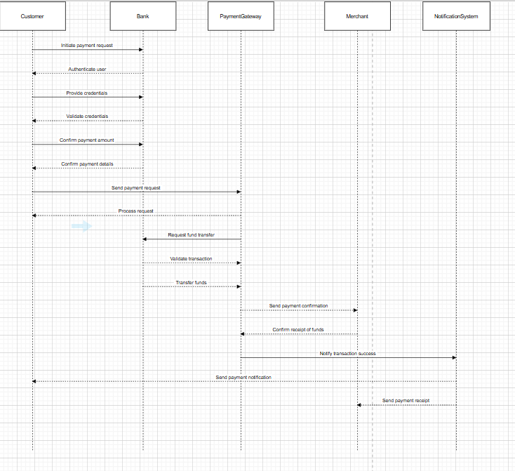

Q.6 – Explain conceptual model for this case.
Ans. – The conceptual model helps in understanding the key concepts, their relationship and the overall structure of the net banking system. It serves as a foundation for designing the database schema, defining the application architecture and implementing the necessary functionalities within the system.
The relationship between these entities can be described as follows:
- Customer – This node represents the customer or user of net banking services.
- Service Awareness – Customer should be aware of the available net banking services and their features.
- Privacy of Data – The important/ significance of this node is to protect the privacy and confidentiality of customer data in the context of net banking.
- Technology Awareness – The significance of this node is that customer should be aware and comfortable with the underlying technologies used in net banking.
- Trust and Support – This node indicate that the bank provide such good service that it will help to enhance the customer trust.
- Bank – This node represents a service provider responsible for offering net banking services.
- Marchant – This node represents a recipient of fund which is initiate by customer through bank service.
- Online Information – This aspect highlights the information of providing thr accurate and up-to-date information about the net banking services to the customer.
- Security and services – The bank should adapt the security policies which will help the customer to keep their data related to their transection secure and private.
- Infrastructure – This component suggests that the underlying technologies infrastructure, including hardware and software system, plays a important role in enabling net banking services.

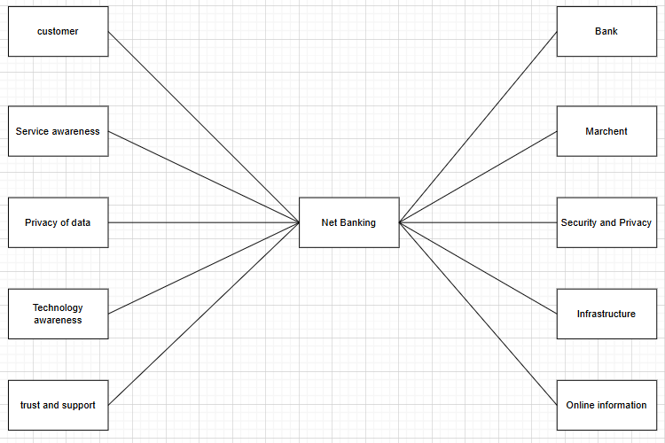

Q.7 – What is MVC architecture? Explain MVC rules to derive cases from use case diagrams and guidelines to place classes in three-tier architecture.
Ans. – MVC Architecture – MVC (Model-View-Controller) architecture is a software design pattern that separates an application into three interconnected components’ Model, which manages the application data and business logic; the view, which handles the user interface and presentation of data and the controller, which processes user input, update the Model, and determine how information is displayed in the view. This separation of concerns improves modularity, scalability, and maintainability by allowing each component to be developed, tested and modified independently while cohesively handling user interaction and system workflows:

3 parts of MVC architecture are described below-
- Model –
- Represents the application’s core logic and data.
- Responsible for retrieving, storing and processing data (e.g. through database or APIs)
- Independent of user interface.

Entity

- View –
- Representation of the presentation layer or the user interface.
- Display data from the model to the user and send the user input to the controller.
- Examples: Web pages, mobile app screens, or desktop GUIs.

Boundary

- Controller –
- Acts as the intermediary between the Model and the View.
- Handles user input, processes it and determines the appropriate response.
- Update the Model or View as needed.

Control

Advantages of MVC –
- MVC has feature of scalability, which in turn help the growth of Application.
- The components are easy to maintain.
- A model can be used by multiple views that provide reusability of code.
- By using MVC, the application becomes more manageable.
- As all three layers are different and independent, they are maintained separately.
Rules to derive the classes from Use case diagram –
- Combination of one actor and a use case results in one boundary classes.
- Combination of two actors and a use case results in two boundary classes.
- Combination of three actors and a use case results in three boundary classes.
- Use case will result in a controller class.
- Each actor will result in one Entity class.
For Example, we take scenario of customer making payment either by card or wallet or by cash or net banking –
- Model classes – Customer, Payment, Net Banking, card, cash
- View Classes – Login view, Payment option view, net banking view, bank selection view, credential view, payment amount view, payment confirmation view, logout view
- Controller Classes – Login controller, payment option controller, net banking controller, bank selection controller, credential controller, payment amount controller, payment confirmation controller, logout controller

Guidelines to place MVC class in a 3 tier Architecture –
- Place all entity classes on DB layer.
- Place primary actor associated boundary class in Application layer
- Place controller class in application layer
- If Governing body influence or reusability is there with any of the remaining Boundary class place them in Business logic layer or else place them in Application layer.

Q. 8 – Explain BA contribution in Project (Waterfall model – all stages)
Ans. – Waterfall Model – The Waterfall model is a traditional software development methodology that follow a linear and sequential approach. The process is divided into distinct phases: Requirements Gathering, Requirements Analysis, Design, Development, Testing, Deployment, Implementation and maintenance with each phase completed before moving to the next. Progress flows in one direction, like a waterfall, making it best suited for project with well-defined and unchanging requirements. While the Waterfall model provides structure and simplicity, it is less flexible in accommodating changes, which can make it less effective for dynamic or complex projects.

Waterfall model has following stages and corresponding Business Analyst responsibilities have also been describes –
- Requirements Gathering –
- First the stakeholders are identified.
- In this phase, all requirements are gathered from stakeholders.
- Business analysts and project managers participated in this phase.
- After completing this phase BRD will be generated.

- Requirements Analysis –
- The requirements are analyzed to understand the scope of the project.
- Analyzing means the Business analyst will check all the requirements, if he founds conflicting requirements then Business analyst will talk to the concerned stakeholders to clear it, remove the ambiguous requirements.
- BA will prepare functional requirements.
- The documents which contain the functional requirements is called FRS (Functional requirements specification)
- The technical team will prepare non-functional requirements
- The document which contains the non-functional requirements is called SSD (supplementary support document)
- BA will combine FRS and SSD to form SRS (solution requirement specification)
- BA will prepare RTM by referring SRS.

- Design –
- After the requirements are cleared, the design phase starts.
- This has detailed design documents that outline the software architecture, user interface and system components.
- HDD and solution documents will generate here.
- BA collaborates with designers, architects, and developers to translate requirements into system design.
- BA ensures that the design aligns with the documented requirements and addresses stakeholders’ needs.

- Development –
- The development phase includes implementation
- It Involves coding the software based on the specification
- Programmers or developers are involved in this phase
- Here BA acts as mediator between the development team and the stakeholders
- BA clarifies the requirements, checking if the development is going on the right track or not.
- BA also participates in scrum meetings.

- Testing –
- In the testing phase, the software is tested and approved, that it meets the requirements and is free from defects
- Testers are involved in this phase
- Test documents are generated here
- BA works with the testing team to ensure that the solution meets the requirements
- BA facilitates UAT
- BA helps the users to know the functionality of the system and also helps them to use the system

- Deployment –
- Once the software has been tested and approved it is deployed to the production environment
- BA ensures that there is smooth transition from the development phase to production phase

- Implementation –
- This is the final stage of the waterfall
- It involves running the code for the very first time in the production phase
- Release managers handle this phase
- BA will update documentation and requirements specification to reflect changes in the system over time

- Maintenance –
- Maintenance is provided once the whole deployment for any unforeseen issues
- This is done by supporting team.

Q.9 – What is Conflict Management? Explain using Thomas – Kilmann techniques
Ans. – Conflict Management – Conflict management is the process if identifying, addressing and resolving disagreements or disputes in a constructive manner to prevent escalation and maintain productive relationship. It involves techniques and strategies to handle conflicts in a way that minimizes negative outcomes while fostering collaboration, understanding and growth among individuals or teams.

Key Objective of conflict management are –
- Resolve Disputes Constructively – Focus on solution that satisfy all parties involved.
- Maintain Relationship – Preserve trust and respect between individuals and teams
- Improve Collaboration – Use conflict as an opportunity to generate new ideas and better understanding
- Enhance Productivity – Minimize disruption caused by unresolved conflicts
- Promote healthy communication – Encourage open dialog and mutual respect.

Thomas Killman Technique – The Thomas – Kilmann conflict management model is a framework developed by Kenneth W. Thomas and Ralph H. Kilmann that identifies five primary styles of handling conflict based on two dimensions: assertiveness (the degree to which a person to seek to satisfy their own concerns) and cooperativeness (the degree to which a person to seek to satisfy the concern of others). This model emphasizes that there is no one-size-fits-all approach, and the choice of style depends on the situation and goals.

Assertiveness Competing collaborating
>Pursues own concerns at others experience >works together for a mutual beneficial solution
>Assertive and non-cooperative >Assertive and cooperative

compromising
>seeks a middle ground, partially satisfy both parties

Avoiding Accommodating
>Avoid addressing conflict >Prioritize others concerns
>unassertive and uncooperative >Unassertive but cooperative

Cooperativeness

There are 5 conflicts management styles as per the Thomas Kilmann technique –
- Competing (High Assertiveness, Low cooperativeness) –
- Description – The individual pursues their own interest at the expense of other.
- Use case – Best for quick, decisive action or when a outcome is critical, such as during emergency.
- Examples – Enforcing a strict deadline despite objections.

- Accommodating (Low assertiveness, High cooperativeness) –
- Description – The individuals put the other parties need above their own
- Use case – Best when maintaining relationship is more important than the issue at hand or when the issue is trivial to you.
- Examples – Agreeing to a colleague suggestion to avoid conflict.

- Avoiding (Low Assertiveness, Low cooperativeness) –
- Description – The individuals sidestep or postpones the conflict without addressing it directly.
- Use case – Best when the issue is minor, emotions are high or there is a need to gather more information
- Example – Delaying a heated discussion until emotions cool down

- Compromising (Moderate Assertive and Moderate Cooperativeness) –
- Description – Both parties make concessions to reach a mutually acceptable solution.
- Use case – Best when a quick temporary solution needed or both parties have equally strong positions.
- Example – Splitting resources evenly between two departments.

- Collaborating (High assertiveness, High cooperativeness) –
- Description – The Individual works with the other parties to find a win-win solution that fully satisfy both sides.
- Use cases – Best when the issue is important to both parties and requires a creative, long-term solution.
- Example – Jointly designing a new project strategy that incorporates everyone’s ideas.

Benefits of Thomas Kilmann Technique –
- Flexibility – Encourage using different styles depending on situations.
- Awareness – Helps individuals understand their natural conflicts management tendencies
- Resolution Oriented – Provide a structured approach to handle conflicts effectively

Q.10 – List down the reason for project failure.
Ans. – Project can fail for a variety of reason, often due to poor planning, mismanagement or unforeseen circumstances. Below is a list of common factors that contribute to project failure:
- Poor Project Planning
- Lack of clear goals and objectives.
- Insufficient details in project plan.
- Unrealistic timeline and resource estimates.
- Failure to identify and address potential risk.

- Inadequate Requirements Management
- Misunderstanding and incomplete requirement.
- Frequent changes in requirement without proper change control.
- Lack of stakeholder involvement in defining the requirement.

- Weak Leadership and Governance
- Inexperienced or unengaged project managers
- Lack of executive sponsorship or support
- Poor decision-making or lack of accountability

- Ineffective communication
- Breakdown in communication between stakeholders and team members.
- Unclear or inconsistent instruction and update
- Failure to share critical information in a timely manner

- Resource Constraint
- Insufficient funding or budget overrun
- Shortage of skilled personnel or key personnel
- Overloading team members with unrealistic workload

- Scope Creep
- Uncontrolled expansion of project scope without adjusting resources, time or budget.
- Lack of formal process to manage change in scope.

- Poor Risk Management
- Failure to identify, assess and mitigate risk.
- Ignoring potential threats to the project ‘s success.
- Underestimating the impact of external factors like market change or economic conditions.

- Unrealistic Expectations
- Overpromising to stakeholders or customers.
- Setting unachievable goals without proper analysis.

- Lack of Stakeholder Engagement
- Failure to involve key stakeholders in decision-making.
- Misalignment between stakeholder expectation and project deliverables.
- Resistant to change from stakeholder or team members.

- Inadequate Project management
- Insufficient testing or quality assurance.
- Deliverables that do not meet the agreed upon standards.
- Neglecting customer or end user feedback.

- Technology Issue
- Reliance on outdated or incompatible technologies
- Technical failure or bugs that disrupt progress.
- Underestimating the complexity of technical requirement.

- Organizational Challenges
- Lack of alignment between project goals and organizational strategy.
- Internal politics or power struggle affecting decision making
- Resistance to new Processes or system within the organization.

- External Factors
- Changes in Regulatory requirements or Compliance issue
- Economic downturns, market shifts or supply chain disruption
- Natural disaster or other unforeseen events.

- Failure to Monitor and Control
- Inadequate tracking of project progress against the plan.
- Ineffective use of tools and metrics of project management

- Cultural and team Issue
- Lack of collaboration or teamwork.
- Conflict within the team is not resolved effectively.
- Cultural differences lead to miscommunication or misunderstanding.

Q.11 – Lists the challenges faced in a project for BA.
Ans. – Business Analyst (BA) play a critical role in bridging the gap between stakeholders and technical teams. However, they often face challenges that can impact project success. Here is a list of common challenges faced by Bas in projects:
- Unclear or Evolving Requirements – Stakeholders may not fully understand or articulate their need, Frequent changes in requirements disrupts planning development, Lack of clarity in requirements documentation.

- Managing Stakeholders – Identifying and engaging all relevant stakeholders, handling conflicting stakeholder priorities or expectations. Gaining the buy-in for decisions or deliverables.

- Communication Barriers – Bridging the gap between technical team and non-technical stakeholders, overcoming misunderstanding due to jargon or different perspective, Lack of timely feedback from stakeholders or team members.

- Time Constraints – Tight deadlines to gather, document and validate requirements, Pressure to complete tasks quickly, compromising quality, Balancing Multiple projects or competing priorities.

- Lack of Stakeholder involvement – Stakeholder not dedicating enough time to the project, Delayed decision or inputs from stakeholders, Resistance from stakeholders to change existing processes or systems.

- Handling Scope creep – Managing unplanned changes or additions to project scope, Lack of proper change control mechanism, Difficulty maintaining focus on core project objectives.

- Insufficient Domain Knowledge – Difficulty in understanding complex or unfamiliar business domain, limited access to subject matter experts (SME) for clarification, need to quickly learn an adept to industry specific terminologies or practices.

- Conflict Resolution – Mediating conflict between stakeholders and differing priorities, resolving disputes within the project team, such as developer’s vs testers, Balancing the interest of multiple department or business units.

- Technical Constraints – Aligning business needs with existing technologies limitation, understanding technical jargon and constraint imposed by development teams, Ensuring compatibility with legacy system or third-party integration.

- Unrealistic Expectations – Stakeholders expecting quick solutions for complex problems, Pressure to deliver beyond the project scope or capabilities, Unrealistic assumptions about technologies capability or timeline.

Q. 12 – Write about Document naming standards.
Ans. – File naming standards are used to save the file with particular name or format. This is important in sharing and keeping track of data files.
The following are the best standard in Naming conventions –
- It should be named Consistently.
- File name should be short (<25 characters)
- Avoid special characters or spaces in a file name.
- Use Capital and underscores instead of spaces and slashes.
- Use date format as ISO 8601: YYMMDD
- Include a version number.
- Write down naming convention.

We must consider following naming conventions –
- Date of creation
- Short description
- Work
- Location
- Project Name or Number
- Sample
- Analysis
- Version Number

For Example – We have a project with ID “PROJ456BANK” and we are working with Requirements specification Document then –
Project ID - PROJ456BANK
Document type – REQ
Version – 1.0
Date – 2025-07-07

Then the naming convention of the document will be “PROJ456BANK-REQ-1.0-2025-07-07”

Q. 13 – What are the DO’s and Don’ts of a Business Analyst.
Ans. – Do’s and Don’ts of a Business Analyst are describing below –

S No | DO’s | Don’ts
1 | Consult a SME for clarification in Requirements | Never say ‘NO’ to client
2 | Go to the client with plain mind with no assumptions, listen carefully and completely until the client is done and then you can ask queries | There is no word “BY DEFAULT”
3 | Try to extract maximum leads to the solution from the client himself | Never imagine anything in terms of GUI
4 | Concentrate on important requirements | Don’t interrupt the client when he is giving you the problem
5 | Question the existence of existence or question everything | Never try to give solution to the client straight away with your previous experience and assumptions

Q. 14 – Write the difference between packages and sub-system.
Ans. – Package – Packages are the collection of components which are reusable in nature. A Package is a grouping and organizing element in which other elements reside, which must be uniquely named. In the UML package are used a manner similar to the way directories and folders in an operating system group and organize file. Example – Application development companies work on Packages.

Sub-System – Sub systems are collection of components which are reusable in nature. Recall that a system is an organized collection of elements that may be recursively decomposed into smaller subsystems and eventually into a non-decomposable primitive element. Example – Product development companies work on sub system.

Difference between Package and Sub-system are described below –

Aspect | Package | Sub-System
Definition | A collection of relative functionalities or components bundled together for a specific purpose | A self-contained unit within a larger system, consisting of multiple components or packages
Scope | Focused on specific, narrow functionality | Covers broader and more integrated business functions
Complexity | Generally simple and less complex | Larger and more complex due to integration of multiple components
Purpose | Provide specific features or services | Represent a significant part of a larger system’s functionality
Size | Smaller in size and scope | Larger, often consisting of several packages or modules
Components | May consist of a single module or component | Comprised of multiple components, potentially including package
Integration | Typically needs to be integrated with other packages or system | Operates as a part of a larger system often with complex interdependencies
Example | Payment Processing module, Reporting package | Inventory management system, CRM system

Q.15 – What is Camel-casing and explain where it will be used.
Ans. – Camel Casing – Camel casing is a style of writing where multiple words are combined without spaces, and each word after the first starts with an uppercase letter. The first word is written in lowercase. It is called camel casing because the capital letter in the middle of the word resembles the humped of a camel.

- Example – firstName, userProfile, calculateTotalAmount, isValidInput

Where camel casing is used –
- Programming (variables/ Functions Name) – Camel casing is commonly used in programming for naming variables, functions, methods, and objects particularly in language like Java, and c#. It helps to improve readability while adhering to the language’s naming conventions. Example – totalPrice, getUserInfo (), isValidUser ()

- API Endpoints – Camel casing is often used in naming of API endpoints or URLs to maintain consistency and improve readability. Example - /getUserDetails, /createNewProduct

- Class/ Method Naming (in certain language like JAVA) – In some programming language camel casing is used for method names and class names, though class names may also use Pascal casing (a variation where the first letter is also capitalized). Example – calculateTax (), setUserPreferences ()

- CSS/ HTML class names (in some conventions) – While hyphenated names (kebab case) are more common in CSS, some developers use camel casing for class names, especially in JavaScript like React. Example – myComponent, navBarltem.

- File and Folder Naming – Some development environment and framework use camel casing to file and folder names. Example – userProfile.js, createUserFolder.

Benefits of Using Camel Casing –
- Readability – Helps in distinguishing the words easily when spaces are not allowed.
- Consistency – Adhering to a consistent naming conventions across the codebase improves maintainability.
- Convention – Many programming language and framework have adopted camel casing as a standard, making it widely accepted practice.

Q.16 – Illustrate development server and what are the access does Business Analyst has?
Ans. – Development Server – A development server is a computer or environment where developer build, test, and deploy software application or services. It is a dedicated machine or instance used for development purposes, often run on local or remote servers. A development server allows developers to code and test their application before moving them to production.
A Business Analyst can have the following types of access based on the needs -
- Read only access – BA may be granted with read-only access to the development server. This will allow them to view the user interface of the application navigate through the feature and also they will be able to observe the behavior of the application.
- Limited Access – Depending upon the project need, the BA will be granted limited access to the specific modules in the application.
- Limited Configuration Access – Means BA have the authority to make changes in certain area of application where they have the access.

Q. 17 – What is Data Mapping.
Ans. - Data Mapping - Data Mapping is a process of establishing relationships between two distinct data models. It is the technique used to link data from one system, database or format to another, ensuring that the data is correctly interpreted and transferred. This process is crucial when integrating different systems, migrating data or transforming data between formats for analysis or reporting.

Types of Data Mapping –
- One-to-one mapping – Each field in the source correspond to a single field in the target. Example- A field “firstName” in the source database maps directly to the “firstName” field in the target database.
- One-to-Many Mapping – One field in the source maps to multiple fields in the target. Example – A “Full Address” field in the source could map to multiple field such as “street”, “city”, “state” and “zip code” in the target.
- Many-to-one Mapping – Multiple fields in the source are combined or consolidated into a single field in the target. Example – First name and last name from the source system could be combined into a single “FullName” field in target system.
- Many-to-Many Mapping – Multiple fields in the source are mapped to multiple fields in the target. This is often used when integrating system with complex data relationships. Example – Multiple product categories in the source system could map to various sub-categories in target system.

Uses of Data Mapping –
- Data Integration – When combining data from different system, application, or database data mapping ensures that data from multiple sources is merged into single coherent dataset.
- Data Migration – When moving data from one system to other (e.g. upgrading database, moving to the cloud-based platforms) data mapping ensure the data fits in the new system’s structure.
- ETL (Extract, transform, Load) Processes – In ETL, data is extracted from various sources transformed (by mapping), and loaded into data warehouse or reporting system.
- API data Transfer – Data Mapping is used when data is transferred between different API, ensuring that the formats and structure between sending and receiving systems are aligned.
- Reporting and Analysis – When preparing data for reporting or analysis, data mapping helps align the source data with the required formats from dashboards, visualization or business intelligence tool.
Benefits of Data Mapping –
- Improved Data Accuracy – Ensure that data is consistently transferred and interpreted correctly between system.
- Efficient Data Integration – Facilitates the seamless combination of data from different sources, making it easier to generate reports and insights.
- Time and Cost saving – Automates the process of transforming and mapping data, reducing the manual work and errors.
- Data Quality Assurance – Identifies discrepancies and inconsistencies in data early in the process, improving the quality of data being transferred.

Q.18 – What is API? Explain how you would use API integration in case of your application Date format is dd-mm-yyyy and it is accepting some data from other applications from US whose date format is mm-dd-yyyy.
Ans. – Application Programming Interface or API – Application Programming Interface (API) is a set of rules, protocols, tools that allow different software application to communicate and interact with each other. APIs defines how different software components should interact, enabling one system or service to access features or data from another without needing to understand the internal workings of the other system.

Key components of API are describing below –
- API endpoint – A specific URL or URI (uniform resource identifiers) that represents a specific function or resources available via API. Example- HTTPS://api.example.com/user (endpoint to fetching user data).
- HTTP Method (verb) – These methods define the type of operation to be performed on the resource.
GET: retrieve data from API
POST: send data to API, usually to create new resources
PUT: updating a existing resource
DELETE: remove a resource
- Request Headers – Metadata sent along with the request, such as authentication token, content type and session ID.
- Request Body – Data sent along with the request, usually in JASON or XML format, that contains the necessary information for API to process.
- Response Body – The data return by the API after processing the request, typically in a structure format like JASON or XML.
- Authentication and Authorization – Many APIS require security mechanism to verify the identity of the user or system making the request (e.g. via API keys, OAUTH, or JWT tokens)

API are used in the third-party integration, mobile and web applications, cloud services, IoT (Internet of things) Automation and workflow.

Benefits of API –
- Efficiency – API allow business and developers to reuse the existing software, components or services, speeding the development time.
- Scalability – APIs enable system to scale by allowing new services or components to be added easily without disrupting existing system.
- Integration – APIs aloe for the seamless integration of external services, platform or data sources enabling system to communicate and share information across different environment.
- Security – APIs can offer controlled access to services or data, enabling security features like authentication, rate limiting, and encryption to ensure safe data transmission.
- Modularity – APIs promote modular design by allowing application to be broken down into smaller, independent services which can be updated or replaced without affecting the whole system.

For the above scenario we can follow below procedure –
- Establish API communication – set up API communication between your application and other application to exchange data.
- Do Data formatting – While sending the data from one application to other, convert the date format from dd-mm-yyyy to mm-dd-yyyy.
- While receiving the data from another application, parse the data and extract the date month and the year and rearrange them accordingly.
- Perform data validation and ensure that the converted data remains in a valid format.

