Please make a BRD which can be presented to the client along with complete development and resource plan.

ANSWER:-
Project Overview:- The client is a leading manufacturer of ice cream and milk products with manufacturing units and warehouses across the country. To ensure streamlined operations and enhanced customer satisfaction, the client intends to develop a centralized software system with the following objectives:
- Efficient Inventory Management across plants and warehouses.
- Fast and Optimized Customer Delivery using intelligent route and order dispatch mechanisms.
Problem:-
- Difficulty in tracking perishable inventory (milk, ice cream) across multiple warehouses and manufacturing plants in real time
- Milk and ice-cream having a short life it is very difficult to store these item for ling time
- Customer required a fresh milk and ice –cream
- It is affecting on quality of the item
- Day by day negative review are increasing
- It lead to wastage, stock out and over stock
- Effected on time delivery
Business Objectives:-
- Reduce product wastage due to poor stock tracking.
- Ensure real-time visibility of inventory at all locations.
- Deliver products to customers in the shortest possible time.
- Automate order dispatch based on stock availability.
- Customer satisfaction
- Avoid the wastage and overstock
- Disconnected systems or manual tracking between plants, warehouses, and central offices.
Opportunity:-
- After the implementation only fresh and quality product will be delivery
- According to the city we set the min time for delivery
- Customer will be happy
- Increase the positive feedback and it will be effected on the business revenue
- It will save the cost of the storage
- The inventory will be on track

Goal :-
- Inventory should be on track
- All the inventory and tracking will be centralised
- Take a minimum time for product delivery
- Fresh and quality item will be provided
- Customer satisfaction
- Increase the positive publicity
- Generate the business revenue
Functional requirement :-
Req ID | Req Name | Req Description | Priority
FR0001 | Inventory | Maintain stock levels of products at all locations | 10
FR002 | Inventory | Alert when stock falls below reorder level | 9
FR003 | Orders |  | 8
  Customers can place orders via web portal
FR004 | Orders | Auto-assign nearest warehouse with available stock | 10
FR005 | Delivery | Optimize delivery route based on customer location | 8
FR006 | Admin | Role-based access (Admin, Warehouse Staff, Delivery Staff) | 8
FR007 | Reports | Generate stock, sales, and delivery performance reports | 10
FR008 | Tracking | Centralised tracking for delivery boy | 9

Non-Functional Requirements :-
Req ID | Req Name | Req Description | Priority
NFR0001 | Performance | Inventory update should reflect in under 2 seconds | 10
NFR002 | Scalability | System should handle data from 100+ warehouses | 9
NFR003 | Availability | 99.9% uptime required | 8
NFR004 |  | Role-based access control and audit logs | 10
  Security
NFR005 | Usability | User-friendly UI with responsive design | 9

Assumption:-
- Internet connectivity is available at all warehouse and plant locations.
- Logistics API (Google Maps, Delivery) will be available for integration.
- End-users are trained to use web applications.
Constraints:-
- Delivery tracking depends on third-party GPS services.
- Real-time updates depend on network reliability at remote locations.
- Mobile application (if needed) is not included in this phase.
In-Scope:
- Web-based inventory management dashboard.
- Customer order management system.
- Delivery module with GPS-based routing and delivery tracking.
- Admin panel with user role management.
- Reporting module (stock, orders, delivery time, etc.)
Out-of-Scope:
- Manufacturing process control system.
- Customer billing and invoicing.
- In-app customer payments.
Stakeholder :-
Stakeholder | Role | Responsibility
Client Sponsor | Mr. Ramesh Sharma | Budget, high-level approvals
Product Owner | Ms. Anita Desai | Requirement validation
Warehouse Manager | Various | Daily inventory operations
Logistics Manager | Mr. Ajay Verma | Delivery and dispatch operations
Business Analyst | Shruti parashar | Requirement gathering and documentation
Development Team | Internal | System development
QA Team | Internal | Testing and quality assurance

We used the Agile methodology in this project

Requirement Gathering:-
Goal: Understand the client’s full business process and document everything clearly before development starts.
Duration: 2 Weeks
- Meet stakeholders (manufacturing heads, warehouse managers, logistics team).
- Understand product flow: raw material → plant → warehouse → customer.
- Gather functional and non-functional requirements.
- Identify pain points in the current manual system.
Requirement Analysis:-
- Prepare the documentation
- Prepare the epic from the gather requirement
- Prepare use cases (Create Order", "Update Stock", "Dispatch Product")
- Breakdown the epic in to smaller user stories

Design:-
Goal: Design the look and feel of the system to ensure it is user-friendly and visually clear.
Duration: 2 Weeks
- Create Wireframes for each screen (inventory dashboard, order form, delivery tracking, etc.).
- Build Mock-ups with colour, icons, and branding.
- Get feedback from real users (warehouse staff, delivery team) before finalizing.
- Design for both desktop (admin) and mobile (delivery staff) interfaces.
Development :-
Goal:- Develop core system features like inventory management, order processing, and delivery dispatch.
Duration: 6 Weeks
Sprint 1 (3 weeks):-
- Develop inventory module:
- Add/Update stock
- Reorder alert logic
- Stock view by location
- Setup backend API
- Create basic frontend screens
Sprint 2:-
- Develop order management:
- Order creation
- Order status update
- Develop delivery module:
- Warehouse selection logic
- Assign driver and track delivery
- Add real-time data sync with the database
- Functional backend services
- Responsive frontend screens for admin and warehouse users

- Real-time inventory and order flows

Testing :-
Goal: Ensure the system works as expected without bugs or logic errors.
Duration: 2 Weeks
Quality Assurance (QA) Testing:
- Functional testing (each button and field)
- Integration testing (check if modules work together)
- Performance testing (speed under load)
User Acceptance Testing (UAT):
- Real users (warehouse staff, delivery team) use the system and give feedback
- Fix any final issues before go-live

Training :-
- Goal: Launch the system in a live environment and train end-users to use it confidently.
- Conduct training sessions:
- For warehouse managers (inventory features)
- For delivery staff (mobile delivery module)
- For admins (reporting, settings)
- Provide user manuals, cheat sheets, and help videos
Final outcome –
- A centralized inventory system across plants and warehouses
- An order & delivery module with automatic routing
- A live application ready to be used by warehouse and delivery teams
- A trained team with documentation and tech support

Resource Plan :-

Role | Quantity | Involved in
Business Analyst | 1 | Requirement phase
UI/UX Designer | 1 | Design phase
Backend Developers | 2 | Development phase
Frontend Developers | 2 | Development phase
QA Engineers | 1 | Testing & UAT
DevOps Engineer | 1 | Deployment
Project Manager | 1 | Full duration
Warehouse Manager | 3 | Requirement phase
3rd party tool | 2 | Design phase

2. Prepare process flow diagram using your imagination.

Answer:-
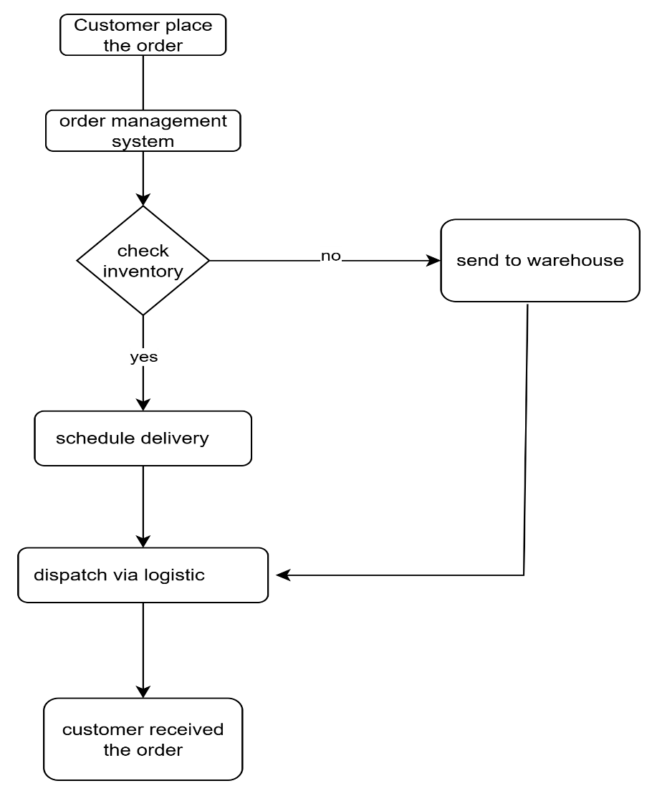

Assignment 2 :-

Write an introduction letter to a client introducing yourself as a business analyst in charge of working with the client and his team to start the business understanding process.

ANSWER:-
Subject: Introduction & Kick-off of Business Understanding Phase
Dear Mayank Paliwal
I hope this message finds you well.
My name is Shruti Parashar, and I am pleased to introduce myself as the Business Analyst assigned to your project regarding the development of a software solution to manage inventory and enable the quickest delivery of your ice cream and milk products across the country.
I will be working closely with you and your team to gather detailed business requirements, understand your operational goals, and ensure that the final solution aligns with your expectations and business vision.
Our initial focus will be on:
- Understanding your current processes in inventory management and delivery.
- Identifying areas of improvement and automation.
- Collaborating with stakeholders across your manufacturing plants, warehouses, and distribution channels.
- Defining clear, actionable, and prioritized business requirements to guide our design and development phases.
Over the next few days, I would like to schedule a kick-off meeting with you and key members of your team to start the business understanding and requirement gathering process. I will be sharing an agenda shortly for your review.
Please feel free to share any documents, system overviews, or process flows that could help me get a head start on understanding your operations.
Looking forward to a successful collaboration and delivering a solution that supports your business growth and customer satisfaction goals.
Warm regards,
[Shruti Parashar]
Business Analyst
[Infosys company]
[Shruti.p0991 @infosis.co]
9222888834

Q 2.Prepare a brief BRD and SRS for a project- Horoscope or Ticketing system or online store.
ANSWER:-
PROJECT TITLE – BOOK MY SHOW
Business Objective:- The Online Ticketing System aims to provide a centralized platform for users to book tickets for concerts, movies he system will simplify ticket purchasing, cancellation, and customer service interactions.

Business Objectives :-
- Digitize and streamline the ticket booking process.
- Allow customers to view real-time availability and pricing.
- Reduce the manual workload on ticket counters and helplines.
- Provide secured digital payment gateways.
- Ensure customer satisfaction with smooth refund/cancellation policies.
Scope of the Project
- In Scope:-
- User registration and login
- Browsing events/travel options
- Seat selection and price display
- Online payments (credit card, UPI, wallets)
- Ticket confirmation via email/SMS
- Admin panel to manage listings

Out of Scope:
- Offline (physical) booking process
Stakholders:-
Role | Stakeholder Name
Sponsor | PVR
Project Manager | BOOK MY SHOW
Business Users | Customers
Admin Users | staff
Developers | ABC IT Solutions Team

Business requirements :-
ID | Requirement Description
BR-1 | The system shall allow users to sign up and log in securely.
BR-2 | The user shall be able to search and filter tickets.
BR-3 | The user shall be able to book and cancel tickets.
BR-4 | The system shall send confirmation via SMS and email.
BR-5 | Admin shall manage events, prices, and seat availability.

SRS:-

FUNCTIONAL REQUIRMENT:-
Req ID | Req Name | Req Description | Priority
FR0001 | login | The system must allow user registration and login with password encryption. | 10
FR002 | booking | The system must allow booking with seat selection and fare calculation. | 9
FR003 | payments |  | 8
  The system must support digital payments through secure APIs.
FR004 | Confirmation | The system must send ticket confirmations via email and SMS. | 9
FR005 | Edit | Admin must be able to add, update, and remove event/travel listing | 8
FR006 | Admin | Users must be able to cancel bookings and request refunds | 8
NON- FUNCIONAL REQUIRMENT:-
Req ID | Req Name | Req Description | Priority
NFR0001 | service | The system should respond within 3 seconds per request. | 10
NFR002 | Timing | The system should be available 99.5% of the time | 9
NFR003 | Availability | The platform should support up to 10,000 concurrent users. | 8
NFR004 |  | System should be compatible with mobile and desktop. | 10
  Usability

Q 3.Make an ERD of creating a support ticket/Ticketing life cycle.
ANSWER:-

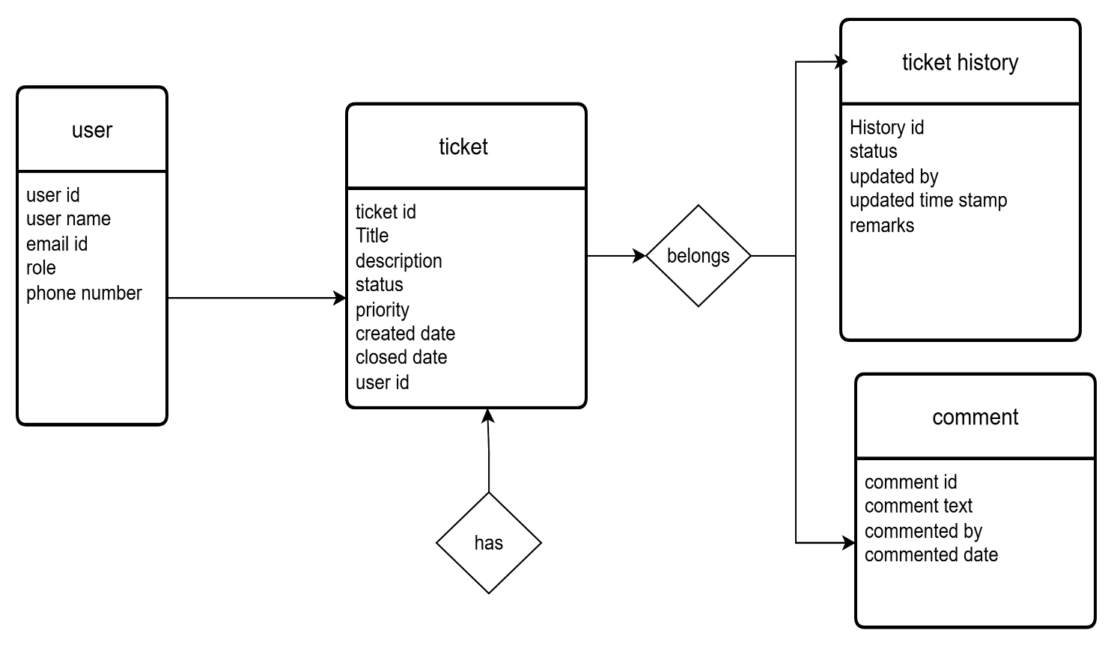

Q4 .User story of shopping from ecommerce
ANSWER:-

USER STORY 1 | TASK -Browse Products |  | PRIORITY- HIGHEST
As a customer,
I want to browse products by category,
So that I can easily find the items I’m interested in.
BV-9 |  | CP-2
ACCEPTANCE CRITERIA

- Products are grouped into categories like clothe jewellery, cosmetics
- User can filter by brand, price, rating, etc.
- User can search by product name or keyword.

USER STORY 2 | TASK -Add to Cart |  | PRIORITY- medium
As a customer,
I want to add products to my shopping cart,
So that I can purchase multiple items at once
BV-8 |  | CP-2
ACCEPTANCE CRITERIA
- Product gets added to cart with selected quantity.
- Cart updates total price in real time.
- User can remove or change quantity from cart.
.

USER STORY 3 | TASK -Place Order |  | PRIORITY- medium
As a customer,
I want to checkout using my saved address and payment method,
So that I can complete my purchase easily.
BV-8 |  | CP-2
ACCEPTANCE CRITERIA
- User sees a summary of items and total price.
- User can select address or enter a new one.
- Multiple payment options available (COD, UPI, Card).
- User receives order confirmation after successful payment.

.

USER STORY 4 | TASK -Track My Order |  | PRIORITY- medium
As a customer,
I want to track the delivery status of my order,
So that I know when to expect it..
BV-8 |  | CP-5
ACCEPTANCE CRITERIA
- Order status updates: Ordered → Packed → Shipped → Out for Delivery → Delivered.
- Delivery estimated date and tracking ID is visible.
- SMS/email notification sent at each stage.
.

.

USER STORY 5 | TASK - Review Product |  | PRIORITY- medium
As a customer,
I want to review and rate the product I purchased,
So that I can help others make informed choices.
BV-8 |  | CP-5
ACCEPTANCE CRITERIA
- User can add star rating (1–5).
- Optional comment box for feedback.
- Only customers who purchased can review.
.

.

