Business Requirements Document (BRD)
Project Name: Ice Cream & Milk Products Inventory and Delivery Management System
Prepared by: Kalyani Bhavsar– Business Analyst
Date: 01/07/2025

1. Introduction
The company operates multiple manufacturing plants and warehouses across the country, producing ice creams and milk products. Currently, inventory tracking and delivery scheduling are partially manual, resulting in stock mismatches, delays, and wastage of perishable goods.
The goal is to develop a centralized software solution that manages inventory in real time and ensures quickest delivery to customers, retailers, and distributors.

2. Objectives
- Automate inventory management across manufacturing plants and warehouses.
- Minimize wastage of perishable products by accurate stock monitoring.
- Provide quickest delivery routes and real-time order tracking.
- Integrate order processing, payment, and customer feedback into one platform.

3. Scope

In-Scope:
Inventory tracking at all warehouses and manufacturing plants.
Real-time stock updates when production or dispatch occurs.
Customer order management with payment gateway integration.
Route optimization for quickest delivery.
Role-based dashboards for Admin, Warehouse Manager, Delivery Staff, and Customers.
Notifications for delivery status and inventory alerts.

Out-of-Scope:
External vendor billing system integration (future phase).
Integration with 3rd party ERP (future phase).

4. Stakeholders
- Internal:
  - Operations Head
  - Manufacturing Plant Manager
  - Warehouse Manager
  - Delivery Staff
  - IT Team
- External:
  - Distributors
  - Retailers
  - End Customers

5. Business Requirements
- Inventory Management
  - The system shall update inventory in real-time when production is completed.
  - Warehouse managers shall receive automatic stock alerts when levels fall below threshold.
  - System shall check nearest warehouse availability for fulfilling orders.
- Order Management
  - Customers can browse products (ice creams, milk products) and add them to cart.
  - System shall allow multiple payment methods (COD, Credit/Debit Card, UPI).
  - Orders must be automatically routed to the nearest warehouse with stock.
- Delivery Management
  - System shall generate a picklist for the warehouse staff after payment confirmation.
  - Delivery staff shall receive optimized routes for faster delivery.
  - Customers shall get live tracking and email/SMS notifications.
- Customer Engagement
  - System shall collect customer feedback after successful delivery.
  - Notifications for promotions and inventory updates shall be sent to customers.

6. Functional Requirements (High-Level)
- FR1: User Registration & Login (Customer, Admin, Manager).
- FR2: Browse & Search Products.
- FR3: Add to Cart & Checkout.
- FR4: Payment Processing & Confirmation.
- FR5: Real-Time Inventory Sync.
- FR6: Order Allocation to Nearest Warehouse.
- FR7: Delivery Route Optimization & Tracking.
- FR8: Customer Feedback Collection.

7. Non-Functional Requirements
- Performance: Inventory updates should reflect within 2 seconds.
- Availability: System uptime must be at least 99.5%.
- Security: All payment transactions must be encrypted (PCI DSS compliant).
- Scalability: System must handle at least 1000 concurrent orders.

8. Assumptions
- All warehouses have stable internet connectivity.
- Product SKUs are standardized across all warehouses and plants.
- Delivery staff have smartphones for live tracking.

9. Constraints
- System must integrate with existing manufacturing database.
- Limited initial budget; phase-wise rollout required.

10. Risk
- Incorrect stock data due to delayed updates.
- Delivery delays due to external traffic/weather conditions.
- Payment gateway downtime affecting order confirmation.

11. Resource Plan

Team Structure:
- 1 Business Analyst
- 1 Project Manager
- 2 Backend Developers
- 2 Frontend Developers
- 1 Database Administrator
- 1 QA Engineer
- 1 UI/UX Designer

Timeline (High-Level):
- Requirement Gathering: 3 weeks
- Design & Architecture: 2 weeks
- Development: 8 weeks
- Testing: 3 weeks
- Deployment: 1 week

Technology Stack:
- Backend: Java / Node.js
- Frontend: React / Angular
- Database: Oracle / PostgreSQL
- Mobile App: Flutter / React Native
- Hosting: AWS / Azure

12. Approval
Business Owner: Rakesh Sharma – Head of Operations
Project Sponsor: Ms. Priya Mehta – Chief Technology Officer (CTO)
Date:01/07/2025

2. Process flow diagram:

Assignment 2:
1. Write an introduction letter to a client introducing yourself as a business analyst in charge of working with the client and his team to start the business understanding process.
2. Prepare a brief BRD and SRS for a project- Horoscope or Ticketing system or online store. 3. Make an ERD of creating a support ticket/Ticketing life cycle.
4. User story of shopping from ecommerce.

- Introduction letter to a client introducing as a business analyst in charge of working with the client and his team to start the business understanding process
To: client@gmail.com
CC: projectmanager@gmail.com
Subject: Introduction - Business Analyst for Business Understanding Process
Dear [Client's Name],
I hope this email finds you in good health and high spirits. My name is Kalyani Bhavsar, and I am delighted to introduce myself as the Business Analyst assigned to work closely with you and your esteemed team. I am eager to embark on this journey together and facilitate the process of understanding your business requirements and objectives.
As a Business Analyst, my primary role is to bridge the gap between business goals and technical solutions. I specialize in analysing and interpreting complex business processes, identifying areas for improvement, and designing effective strategies to drive growth and success. With a strong background in business analysis and a passion for problem-solving, I am committed to facilitating a smooth and productive collaboration.
Throughout my career, I have had the privilege to work with diverse clients across various industries, enabling me to gain valuable insights into different business models and challenges. This exposure has equipped me with a broad knowledge base and a comprehensive understanding of best practices in the field of business analysis.
My approach to business analysis is centred around active listening and effective communication. I believe in building strong relationships with clients and stakeholders, as it forms the foundation for a successful partnership. By thoroughly understanding your unique business requirements, I aim to provide tailored solutions that align with your goals and objectives.
During our engagement, I will work closely with you and your team to conduct comprehensive business analysis. This will include activities such as process mapping, requirements gathering, and requirements analysis. I will strive to ask the right questions, challenge assumptions, and explore innovative approaches to help you achieve your desired outcomes.
I am genuinely enthusiastic about the opportunity to collaborate with you and contribute to the growth and success of your business. I am confident that my skills, experience, and dedication will add value to our partnership and pave the way for fruitful results.
I kindly request a meeting to discuss further details and define a roadmap for our collaboration. Please let me know your availability so that we can schedule a convenient time to connect.
Thank you for your time and consideration. I am eager to embark on this journey with you and your team.
Best regards,
Kalyani Bhavsar
(Business Analyst)

2. BRD AND SRS
Business Requirements Document (BRD):
Project Name: Online Ticketing System
Prepared By: Kalyani Bhavsar – Business Analyst
Date: 01/07/2025

1. Executive Summary
The company requires the development of a centralized Online Ticketing System to facilitate seamless event ticket booking for customers and efficient event management for organizers. This platform will handle high-volume transactions, provide real-time seat allocation, integrate multiple payment gateways, and generate instant e-tickets.

2. Business Objectives
- Enable customers to search, book, and pay for tickets conveniently.
- Automate real-time seat availability to eliminate double booking.
- Provide a robust backend for event organizers to manage events and analyze sales.
- Ensure a scalable, secure, and user-friendly platform accessible via web and mobile devices.

3. Project Scope

In-Scope:
- Web and mobile applications for customers.
- Real-time seat selection and inventory management.
- Integration with secure payment gateways.
- QR/barcode-based e-ticket generation.
- Admin panel for event organizers and company staff.

Out-of-Scope:
- Third-party travel or hotel booking integration.
- Automated refund system (manual in phase one).
- Integration with external loyalty programs (future phase).

4. Stakeholders
- Internal:
  - Project Sponsor – Priya Mehta (CTO)
  - Business Owner – Rakesh Sharma (Head of Operations)
  - Development Team
  - QA & Testing Team
  - Customer Support Team
- External:
  - Event Organizers
  - Customers
  - Payment Gateway Providers

5. Business Requirements
- Event Management:
  - Organizers can create, edit, and delete events.
  - Set pricing tiers and seat layouts.
- Ticket Booking:
  - Customers can view events, select seats, and book tickets.
  - Seats must be locked during checkout for 10 minutes.
- Payments:
  - Support multiple payment modes (Credit/Debit Cards, UPI, Wallets).
  - Generate tickets only after successful payment confirmation.
- E-Ticket Delivery:
  - Generate QR/barcode-based e-tickets instantly.
  - Send tickets via email and SMS automatically.
- Analytics:
  - Admin panel to generate reports on sales, occupancy, and revenue.

6. Business Rules
- Tickets are non-transferable between accounts.
- Refunds can only be initiated 24+ hours before the event.
- Payment failure releases locked seats back into inventory immediately.

7. Assumptions & Dependencies
- Internet connectivity is available for all customers and organizers.
- Payment gateways provide instant callback on transaction status.
- Seat maps are provided by event organizers before event listing.

8. Risks
- Payment failures impacting user trust.
- Peak-hour traffic may cause server load issues.
- Incorrect seat layouts from organizers causing booking errors.

9. Resource & Timeline Plan
- Project Team:
  - 1 Project Manager
  - 1 Business Analyst
  - 2 Backend Developers
  - 2 Frontend Developers
  - 1 Mobile App Developer
  - 1 Database Administrator
  - 1 QA Engineer
- Timeline:
  - Requirement Gathering: 2 weeks
  - Design & Architecture: 2 weeks
  - Development: 8 weeks
  - Testing & UAT: 3 weeks
  - Deployment: 1 week

10. Approval
- Business Owner: Rakesh Sharma – Head of Operations
- Project Sponsor: Priya Mehta – CTO
- Date: 01/07/2000

Software Requirements Specification (SRS)
Project Name: Online Ticketing System
Prepared By: Kalyani Bhavsar – Business Analyst
Date: 01/07/2025

1. Purpose
This document defines the detailed functional and non-functional requirements for the Online Ticketing System. It will ensure accurate seat allocation, secure payments, and instant ticket delivery while providing an admin panel for event organizers to manage bookings and generate reports.

2. System Overview
- Platform: Web and Mobile
- Users: Customers, Event Organizers, Admins
- Key Features:
  - Event browsing & search
  - Seat selection with real-time locking
  - Payment gateway integration
  - QR/barcode e-ticket generation
  - Admin dashboards with reports

3. Functional Requirements

FR1 – User Account Management
- Register/login using email or phone.
- Social login via Google/Facebook.
- View past bookings and e-tickets.

FR2 – Event Browsing
- Search and filter events by location, category, and date.
- Display detailed event info: pricing, venue, seat layout.

FR3 – Ticket Booking
- Select seat type and quantity.
- Lock seats during checkout (10-minute window).

FR4 – Payment Processing
- Support multiple payment methods.
- Trigger ticket generation after successful payment.

FR5 – E-Ticket Generation
- Generate QR/barcode-based e-tickets.
- Send tickets via email and SMS instantly.

FR6 – Admin/Event Management
- Organizers can create/manage events.
- Admin dashboard for sales and revenue analytics.

FR7 – Cancellations
- Allow cancellations 24 hours before the event.
- Manual refund initiation in phase one.

4. Non-Functional Requirements
- Performance: Handle 10,000 concurrent users with <2s response time.
- Availability: 99.9% uptime.
- Security: PCI DSS compliance; all data encrypted via SSL/TLS.
- Scalability: Support 100+ events simultaneously.
- Usability: Mobile-first, user-friendly UI.

5. System Architecture
- Frontend: React/Angular (Web), Flutter/React Native (Mobile).
- Backend: Java/Spring Boot or Node.js.
- Database: PostgreSQL/Oracle.
- Hosting: AWS/Azure cloud.
- Payment Integration: Razorpay/Stripe/PayPal.

6. Database Entities
- User: User_ID, Name, Email, Phone, Password, Role.
- Event: Event_ID, Title, Location, Date, Price, Seat_Map.
- Ticket: Ticket_ID, Event_ID, User_ID, Seat_No, Status.
- Payment: Payment_ID, Ticket_ID, Amount, Status, Timestamp.

7. Interfaces
- Customer UI: Event search, booking, payment, and ticket download.
- Organizer/Admin UI: Event creation, reports, user management.
- Payment Gateway API: Secure transaction handling.

8. Acceptance Criteria
Users can book tickets end-to-end without manual intervention.
Payment failures release locked seats automatically.
E-tickets are delivered instantly upon successful payment.
Admin dashboard reflects real-time sales data.

3. ERD

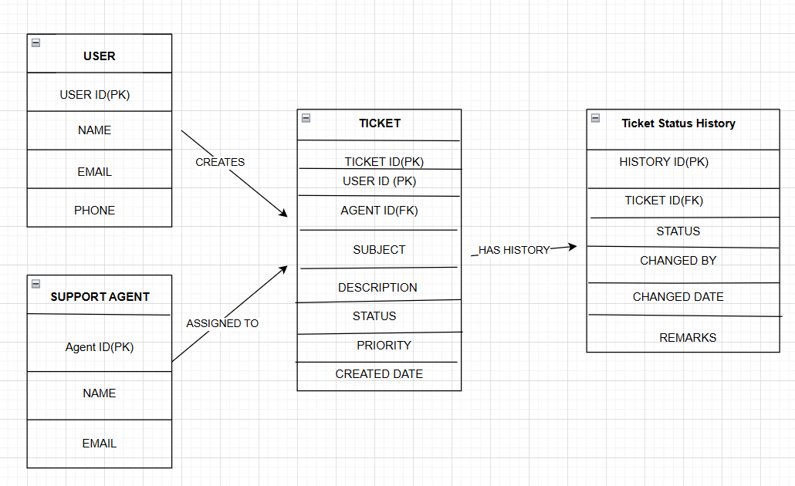
4. User stories

User Account Management
- As a customer, I want to create an account so that I can save my personal details and shop easily.
- As a customer, I want to log in securely so that my account and data are protected.
- As a customer, I want to reset my password so that I can regain access if I forget it.
- As a customer, I want to update my profile details so that I can keep my account information current.
- As an admin, I want to manage user accounts so that I can maintain platform security.

Product Browsing & Search
- As a customer, I want to browse products by category so that I can quickly find items of interest.
- As a customer, I want to search for products using keywords so that I can locate specific items.
- As a customer, I want to view detailed product information so that I can make informed purchasing decisions.
- As a customer, I want to see product images so that I know what I am buying.
- As a customer, I want to filter products by price, brand, and rating so that I can narrow my options.

Cart Management
- As a customer, I want to add products to my cart so that I can buy multiple items at once.
- As a customer, I want to remove products from my cart so that I can modify my order.
- As a customer, I want to update the quantity of items in my cart so that I can adjust my purchase.
- As a customer, I want to view the total cost in my cart so that I can manage my budget.
- As a customer, I want my cart to be saved when I log out so that I don’t lose my selected items.

Checkout & Payments
- As a customer, I want to enter my shipping details during checkout so that my order is delivered to the correct address.
- As a customer, I want to choose my preferred payment method so that I can pay conveniently.
- As a customer, I want to see an order summary before payment so that I can review my purchase.
- As a customer, I want to receive payment confirmation so that I know my order is placed.
- As a customer, I want multiple payment options (credit card, debit card, UPI, COD) so that I can pay easily.

Order Tracking & History
- As a customer, I want to track my order status so that I know when it will be delivered.
- As a customer, I want to view my past orders so that I can reorder products.
- As a customer, I want to cancel an order before shipping so that I can avoid unwanted purchases.
- As a customer, I want to get notifications for order updates so that I am informed of every stage.
- As a customer, I want to download my invoices so that I can keep purchase records.

Reviews & Ratings
- As a customer, I want to rate products so that other buyers know about product quality.
- As a customer, I want to write product reviews so that I can share my experience.
- As a customer, I want to view ratings and reviews so that I can make better purchase decisions.
- As an admin, I want to moderate reviews so that inappropriate content is removed.
- As a seller, I want to respond to reviews so that I can engage with customers.

Wishlist & Recommendations
- As a customer, I want to add items to my wishlist so that I can buy them later.
- As a customer, I want personalized product recommendations so that I can discover relevant items.
- As a customer, I want to share my wishlist with friends so that they can buy me gifts.
- As a customer, I want to move items from my wishlist to my cart so that I can purchase them easily.
- As a customer, I want to get alerts when my wishlist items are on sale so that I can buy at a discount.

Support & Returns
- As a customer, I want to raise a support ticket for an order issue so that it can be resolved quickly.
- As a customer, I want to request a return or refund so that I can get my money back for defective items.
- As a customer, I want live chat support so that I can get immediate help.
- As a customer, I want FAQs available so that I can find answers quickly.
- As a customer, I want to contact customer care by email or phone so that I have multiple support options.

