1. Agile Manifesto
The Agile Manifesto is a set of four core values and twelve principles for agile software development. The four values are:
- Individuals and interactions over processes and tools.
- Working software over comprehensive documentation.
- Customer collaboration over contract negotiation.
- Responding to change over following a plan.

PRODUCT VISION
-Meeting - Discussion – Document -
Scrum Project Name : Scrum Foods
Venue : Hyderabad
Date : 17.09.2025 Start Time : 9 am End Time : 3 pm Duration : 6 hours
Client: COEPD IT Solutions
Stakeholder List:
1.Bussiness Owner
2.Administrator
3.Regional Administrator
4.Restaurant
5.Delivery Boy
6.Customer
Scrum Team

Scrum Master: Satya
Product Owner : Me
Scrum Developer 1: Linesh vegad
Scrum Developer 2: Yogender
Scrum Developer 3: Gowri
Scrum Developer 4: A.laxmi
Scrum Developer 5: Madhuri
Scrum Developer 6: shanti
Scrum Developer 7: Rakesh
Scrum Developer 8: Rajeesh

Vison What is vision,your overarching goal for creating the product
Target Group  Which market segment does the product address?  Who are the target users and customers? | Needs  What problem does the product solve?  Which benefit does it provide? | Product  What product is it?  What makes it desirable and special?  Is it feasible to develop the product? | Value  How is the product going to benefit the company?  What are the business goals?  What is the business model?

VISION: Customers of any age group who want to have top-rated delicious food in one -go at their doorstep with lighting fast delivery,24/7 availability and reliable services are SCRUM FOODS. Unlike any other food delivery app in market, our top most priority is customer need and customer satisfaction which makes us stand out of any other food delivery app in this industry
Online food delivery industry is our target segment  Users/customers:  People who want food deliveries within stipulated time at their required place | Scrum foods provide guaranteed safe food delivery ,in one-go of top rated licenced restaurants  Customers can receive with safe packaged food within expected time to clear their hunger | Scrum foods will be on mobile ,tablets and desktop applications  Real time tracking and providing 24/7 services and customer support  Product feasibility  Can be complex and require attention in very aspect | Open up revenue stream  Be leading online food delivery app in country  Create reputed brand image for other business opportunities

PRODUCT VISION -DESCRIPTION -NOTES

Customer : Registration ,login ,and search and view restaurants ,view restaurants menu ,Order food ,payment , tracking ,cancel order ,feedback & rating and logout.
Delivery Boy : Registration ,login, view orders ,select and accept orders, order pickup and delivery ,status updates ,payment (COD) , view feedback ,raise issues ,view deliveries report and revenue generated ,logout.
Restaurants : Registration, login ,view orders ,delivery boy verification ,payment ,view feedback ,raise issues ,view revenue generated through scrum food app ,logout.
Regional Admin : Admin login ,tracking/status , customer feedback ,managing regional delivery boys and restaurant ,view regional revenue , refunds ,view payment made to regional restaurant and logout.
Admin : login ,managing regional admin ,issues ,customer feedback ,approval/rejections privileges on restaurants ,delivery boy, restaurants and regional admin requests, resolve issues and logout.
Business owner: Login ,issues ,reports ,update payments for restaurants and deliver boys and logout.

2. User Stories, Acceptance Criteria, BV & CP
Here are 40 sample user stories for the Scrum Foods project, including their Acceptance Criteria, Business Value (BV), and Complexity Points (CP). The BVs are estimated by stakeholders and CPs by scrum developers.

User Story No:1 | Task : 2 |  | Priority :Highest
As a Delivery Boy, I want to register in Scrum Foods so that I can deliver orders.
BV:500 |  | CP:02
Acceptance Criteria: Registration screen with text boxes for user name, password, national ID, mobile no., email, address, and phone number. Click on Register button. Send successful notification to the user.

User Story No:2 | Task : 2 |  | Priority :Highest
As a Restaurant Owner, I want to view orders so that I can view the list of orders.
BV:500 |  | CP:02
Acceptance Criteria: Display list of orders in tabular form

User Story No:3 | Task : 2 |  | Priority :Highest
As a Customer, I want to add the address so that I can get the order to my address..
BV:500 |  | CP:02
Acceptance Criteria: Text box to enter address. Business rule: Within a 5 km radius.

User Story No:4 | Task : 2 |  | Priority :Highest
As a Customer, I want to select the payment mode so that I can make payment of my choice.
BV:500 |  | CP:03
Acceptance Criteria: Display payment modes, radio buttons to select them, and a payments button. Business rule: Can select only one payment mode.

User Story No:5 | Task : 2 |  | Priority :Highest
As a Customer, I want to select the payment mode so that I can make payment of my choice.
BV:500 |  | CP:03
Acceptance Criteria: Display payment modes, radio buttons to select them, and a payments button. Business rule: Can select only one payment mode.

User Story No:6 | Task : 2 |  | Priority :Highest
As a Customer, I want to view the price so that I can order the food.
BV:500 |  | CP:01
Acceptance Criteria: Display price in the list of menu items.

User Story No:7 | Task : 2 |  | Priority :Highest
As a Customer, I want to view the contact number of the delivery boy so that I can contact the delivery boy for the status.
BV:500 |  | CP:01
Acceptance Criteria: Display delivery boy's mobile number, name in the tracking field, and picture.

User Story No:8 | Task : 2 |  | Priority :Highest
As a Restaurant Owner, I want to provide time slots so that a customer can check opening and closing hours.
BV:100 |  | CP:02
Acceptance Criteria: Click on the restaurant dashboard. Add "from" and "to" times. Click on submit and display "updated successfully" message.

User Story No:9 | Task : 2 |  | Priority :Highest
As a Business Owner, I want to view restaurant revenue reports so that I can view the restaurant's revenue.
BV:200 |  | CP:03
Acceptance Criteria: Select Reports, then Revenue Reports. Select "to" and "from" dates. Select region (or all). Generate and download the report in Excel.

User Story No:10 | Task : 2 |  | Priority :Highest
As a Regional Admin, I want to manage regional restaurants so that I can track the performance of regional restaurants.
BV:200 |  | CP:03
Acceptance Criteria: Click on "Performance of Restaurants." Select from and to dates. Click on "Generate Report" which includes restaurant ID, name, and revenue. Click on "Download Report" in Excel.

User Story No:11 | Task : 2 |  | Priority :Highest
As an Admin, I want to see the regional revenue reports so that I can view the regional performance.
BV:100 |  | CP:03
Acceptance Criteria: Select regional dropdown. View performance of each restaurant in that region in a tabular form, including the restaurant name and revenue. Download in Excel or PDF.

User Story No:12 | Task : 2 |  | Priority :Highest
As a Customer, I want to chat with a Regional Admin so that I can request a refund.
BV:200 |  | CP:02
Acceptance Criteria: All fields must be mandatory. Text box fields for description. Display order ID. Submit button. Generate issue ID. Display "successful" message.

User Story No:13 | Task : 2 |  | Priority :Highest
As a Customer, I want to search for restaurants so that I can find a place to order food.
BV:500 |  | CP:02
Acceptance Criteria: Search bar with autocomplete functionality. Display a list of restaurants based on keywords. Filter by ratings, cuisine, or delivery time.

User Story No:14 | Task : 2 |  | Priority :Highest
As a Customer, I want to view a restaurant's menu so that I can decide what to order.
BV:500 |  | CP:02
Acceptance Criteria: Display a list of food items with photos and descriptions. Ability to click on an item to view details.

User Story No:15 | Task : 2 |  | Priority :Highest
As a Customer, I want to add items to my cart so that I can place an order.
BV:500 |  | CP:02
Acceptance Criteria: A "plus" button to add items to the cart. Cart icon updates with the number of items.

User Story No:16 | Task : 2 |  | Priority :Highest
As a Customer, I want to view and edit my cart so that I can confirm my order.
BV:500 |  | CP:02
Display a list of selected items, quantities, and prices. Buttons to increase/decrease quantity or remove an item.

User Story No:17 | Task : 2 |  | Priority :Highest
As a Customer, I want to apply a discount coupon so that I can save money on my order.
BV:500 |  | CP:02
Acceptance Criteria: Text box for coupon code. "Apply" button to validate and update the total cost. Display error message for invalid codes.

User Story No:18 | Task : 2 |  | Priority :Highest
As a Customer, I want to track my order in real-time so that I know when it will arrive.
BV:100 |  | CP:02
Acceptance Criteria: Display a map showing the delivery boy's location. Estimated time of arrival (ETA) updates automatically.

User Story No:19 | Task : 2 |  | Priority :Highest
As a Customer, I want to give feedback and a rating to a restaurant and delivery boy so that I can share my experience.
BV:200 |  | CP:02
Acceptance Criteria: Rating system with 1-5 stars. Text box for comments. Ability to submit feedback after an order is completed.

User Story No:20 | Task : 2 |  | Priority :Highest
As a Customer, I want to cancel my order so that I can stop an unwanted delivery.
BV:100 |  | CP:02
Acceptance Criteria: A "cancel order" button with a confirmation popup. Rules for cancellation window and refund eligibility.

User Story No:21 | Task : 2 |  | Priority :Highest
As a Delivery Boy, I want to view new orders in my area so that I can accept them.
BV:100 |  | CP:02
Acceptance Criteria: Display a list of new orders with a button to "accept" or "decline". Order details include restaurant and customer locations.

User Story No:22 | Task : 2 |  | Priority :Highest
As a Delivery Boy, I want to see a map for pickup and delivery so that I can follow the most efficient route.
BV:500 |  | CP:03
Acceptance Criteria: Integrated GPS map with directions from current location to the restaurant and then to the customer.

User Story No:23 | Task : 2 |  | Priority :Highest
As a Delivery Boy, I want to view my earnings report so that I can keep track of my income.
BV:200 |  | CP:02
Acceptance Criteria: Dashboard displaying daily, weekly, and monthly earnings. Breakdown of earnings per delivery.

User Story No:24 | Task : 2 |  | Priority :Highest
As a Restaurant Owner, I want to update my menu so that I can add or remove food items
BV:200 |  | CP:02
Acceptance Criteria: Dashboard with options to "add item", "edit item", or "delete item". Fields to enter item name, description, price, and photo.

User Story No:25 | Task : 2 |  | Priority :Highest
As a Restaurant Owner, I want to mark an order as "ready for pickup" so that the delivery boy knows to come
BV:500 |  | CP:02
Acceptance Criteria: Dashboard with options to "add item", "edit item", or "delete item". Fields to enter item name, description, price, and photo.

User Story No:26 | Task : 2 |  | Priority :Highest
As a Restaurant Owner, I want to view my revenue reports so that I can track my sales
BV:200 |  | CP:02
Acceptance Criteria: Dashboard with charts and tables showing revenue over time. Ability to filter by date range.

User Story No:27 | Task : 2 |  | Priority :Highest
As a Regional Admin, I want to manage delivery boys so that I can track their performance and issues.
BV:200 |  | CP:02
Acceptance Criteria: Dashboard to view a list of delivery boys, their status, and performance metrics. Ability to suspend an account.

User Story No:28 | Task : 2 |  | Priority :Highest
As a Regional Admin, I want to view customer feedback for my region so that I can address issues..
BV:200 |  | CP:02
Acceptance Criteria: A centralized log of customer feedback and ratings for the region. Filter by restaurant or delivery boy..

User Story No:29 | Task : 2 |  | Priority :Highest
As an Admin, I want to approve or reject new restaurant and delivery boy registrations so that I can control who joins the platform
BV:500 |  | CP:02
Acceptance Criteria: Dashboard with pending requests. Options to view details and approve or reject with a reason.

User Story No:30 | Task : 2 |  | Priority :Highest
As an Admin, I want to manage Regional Admins so that I can control user access.
BV:200 |  | CP:02
Acceptance Criteria: Dashboard to add, edit, or remove Regional Admin accounts and their permissions..

User Story No:31 | Task : 2 |  | Priority :Highest
As a Business Owner, I want to view reports on overall business performance so that I can make strategic decisions.
BV:500 |  | CP:03
Acceptance Criteria: Dashboard with high-level metrics like total orders, total revenue, and customer acquisition rate.

User Story No:32 | Task : 2 |  | Priority :Highest
As a Business Owner, I want to manage payments to restaurants and delivery boys so that they are paid accurately and on time..
BV:500 |  | CP:03
Acceptance Criteria: Dashboard to view and process payment transfers. Ability to generate payment reports.

User Story No:33 | Task : 2 |  | Priority :Highest
As a Customer, I want to view my order history so that I can re-order or refer to past orders.
BV:100 |  | CP:01
Acceptance Criteria: A list of all past orders with details like date, restaurant, items, and total cost.

User Story No:34 | Task : 2 |  | Priority :Highest
As a Customer, I want to save my favorite restaurants so that I can find them easily later
BV:50 |  | CP:01
Acceptance Criteria: A "favorite" button on the restaurant page. A separate section to view all favorited restaurants.

User Story No:35 | Task : 2 |  | Priority :Highest
As a Delivery Boy, I want to raise an issue to the Regional Admin so that I can get help with a problem
BV:50 |  | CP:01
Acceptance Criteria: Form with a subject and description fields. A "submit" button to send the issue to the Regional Admin

User Story No:36 | Task : 2 |  | Priority :Highest
As a Restaurant Owner, I want to raise an issue to the Regional Admin so that I can get help with a problem
BV:50 |  | CP:01
Acceptance Criteria Form with a subject and description fields. A "submit" button to send the issue to the Regional Admin.

User Story No:37 | Task : 2 |  | Priority :Highest
As a Business Owner, I want to get notifications for critical issues so that I can respond quickly.
BV:200 |  | CP:02
Acceptance Criteria: Email or in-app notifications for issues like a server outage or a failed payment

User Story No:38 | Task : 2 |  | Priority :Highest
As a Customer, I want to register with my social media account so that the process is faster.
BV:200 |  | CP:03
Acceptance Criteria: Buttons for "Log in with Google," "Log in with Facebook," etc

User Story No:39 | Task : 2 |  | Priority :Highest
As a Regional Admin, I want to view payments made to restaurants so that I can track financial transactions in my region.
BV:100 |  | CP:02
Acceptance Criteria: Dashboard showing a list of payments, the date, and the amount for each restaurant

User Story No:40 | Task : 2 |  | Priority :Highest
As a Delivery Boy, I want to view my deliveries report so that I can track my performance.
BV:100 |  | CP:02
Acceptance Criteria: Dashboard showing the number of deliveries, average delivery time, and tips received

3. Epics
An Epic is a large user story that cannot be completed in a single sprint. It is typically broken down into smaller, more manageable user stories.
Two Epics for Scrum Foods:
- Payment and Billing System: This epic would include all the user stories related to handling payments, such as a customer selecting a payment mode, applying a coupon, and the system managing payments to restaurants and delivery boys. It's too big for one sprint and would be broken down into smaller user stories like "As a customer, I want to select a payment mode," and "As a business owner, I want to manage payments to restaurants."
- Order and Delivery Management: This epic covers the entire workflow of an order, from a customer placing it to a delivery boy delivering it. It would include user stories like "As a customer, I want to track my order in real-time," "As a restaurant owner, I want to view orders," and "As a delivery boy, I want to view new orders."

4. Difference between BV and CP
- Business Value (BV): This represents how important a feature is to the business. It's not a measure of cost or complexity. Business stakeholders, like the client, estimate it using "Scrum Currency Notes". The values are in denominations like Rs. 10, Rs. 20, Rs. 50, Rs. 100, Rs. 500, and Rs. 1000.
- Complexity Points (CP): Also known as Story Points, CP is the effort required by the development team to build a feature. It's an estimate of the time and complexity involved in coding, not a direct measure of hours. Scrum developers use poker cards with values like 1, 2, 3, 5, 8, etc., to estimate CP.

5. Sprint
A sprint is a time-boxed period during which a Scrum team works to complete a set of tasks or a "sprint goal". For this project, the sprint duration is
2 weeks. Sprints are at the heart of the Scrum framework, providing a rhythm for the team to consistently deliver working software.

6. Product Backlog and Sprint Backlog
- Product Backlog: This is a prioritized, dynamic list of all the features, functions, and enhancements needed for the product. It's a single source of truth for all work to be done. The product owner manages this backlog.
- Sprint Backlog: This is a subset of the Product Backlog. It contains the specific user stories and tasks the team has committed to completing during a single sprint. The team selects items from the product backlog during the sprint planning meeting to create the sprint backlog.

7. Impediments Log and Two Impediments
An impediments log is a record of all the challenges or roadblocks the Scrum team faces while working on a sprint. The purpose of this log is to help the team and the Scrum Master identify and address these issues to ensure the project stays on track.
Two sample impediments for "Scrum Foods":
- Linesh's Unavailability: One of the Scrum Developers, Linesh, is an expert on the database backend. However, he's unexpectedly out sick for three days, halting progress on the user stories that require his specific expertise.
- API Integration Delays: The development team needs to integrate a third-party payment gateway for "Select Payment Mode" user story, but the documentation is incomplete, and they haven't received the necessary access keys from the vendor. This is a roadblock because they can't complete the user story without it.

8. Velocity of the Team
Velocity is a measure of the amount of work a Scrum team can complete in a single sprint. It is measured in Complexity Points (CP) covered in a sprint. It helps the team and product owner forecast how many user stories can be realistically completed in future sprints.

9. Sprint and Product Burndown Charts
- Sprint Burndown Chart: This chart tracks the remaining work (in Complexity Points) in a single sprint. The x-axis represents time (e.g., days of the sprint), and the y-axis represents the remaining work. A healthy chart shows a downward trend, ideally reaching zero by the end of the sprint.

- Product Burndown Chart: This chart tracks the total remaining work (in Complexity Points) for the entire product. The x-axis represents time (sprints), and the y-axis represents the total remaining work. It provides a high-level view of the project's progress and helps forecast the project completion date.

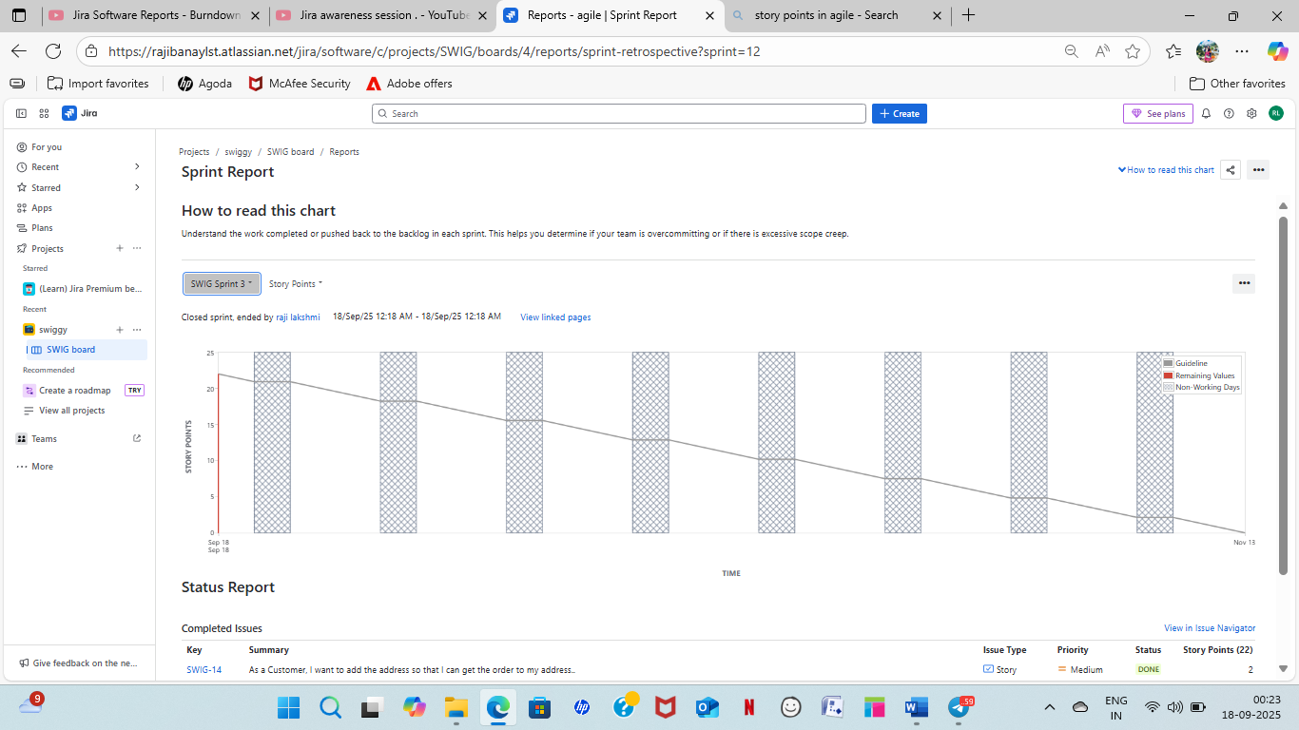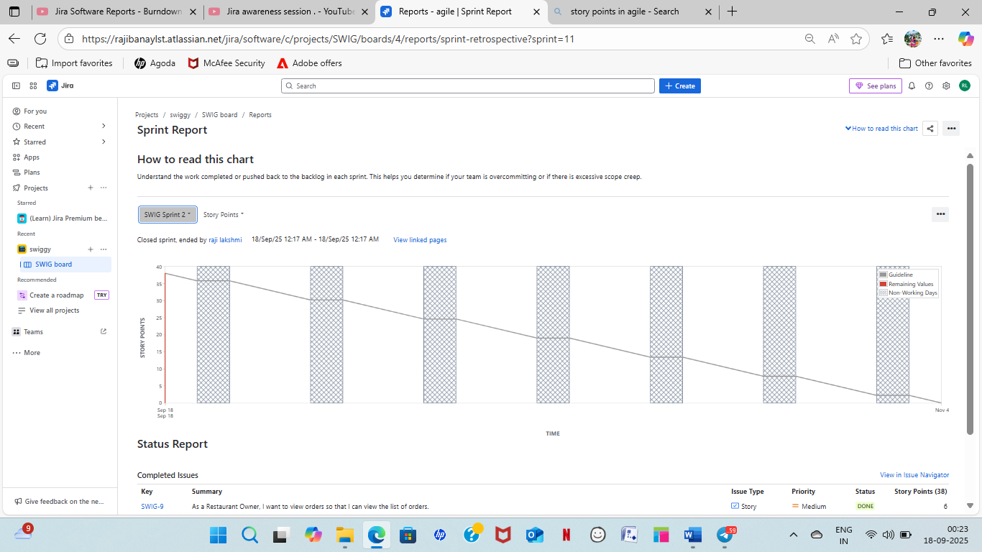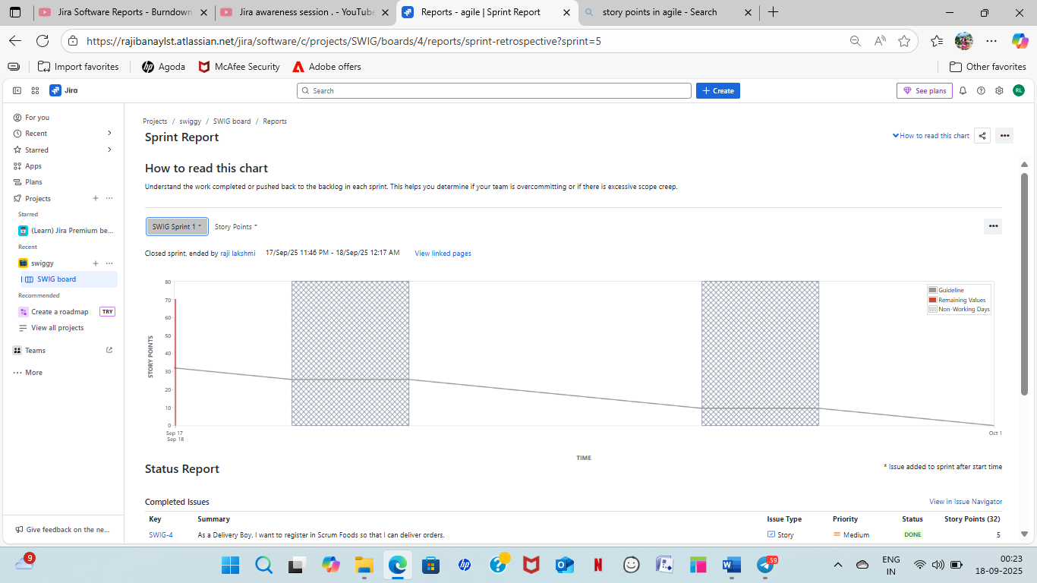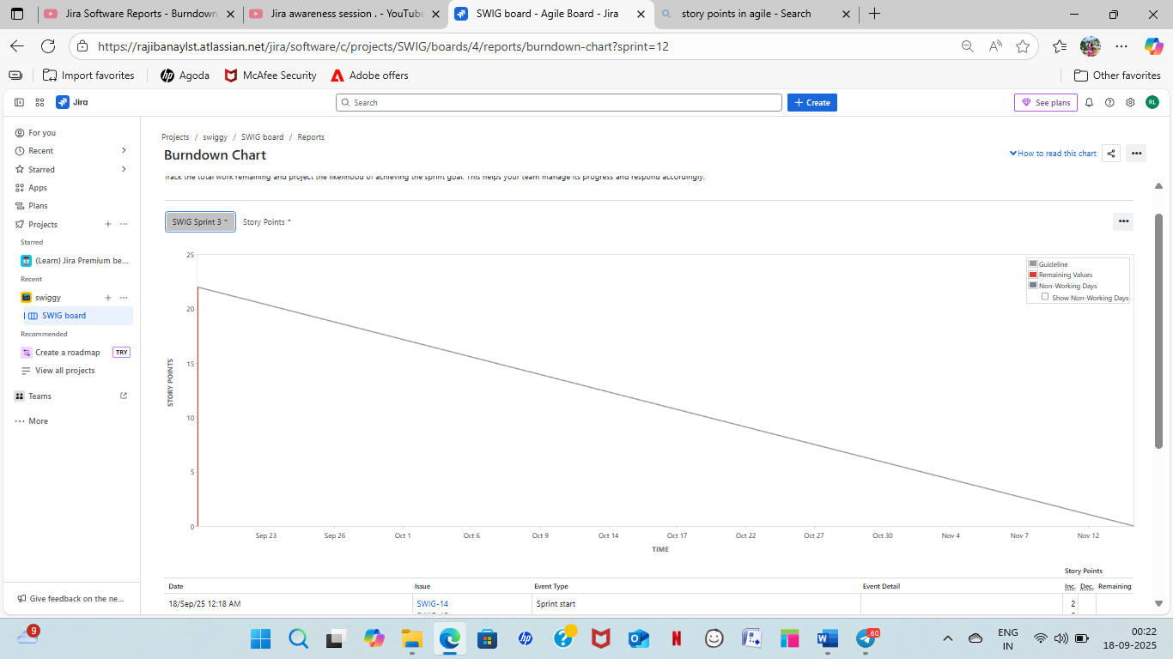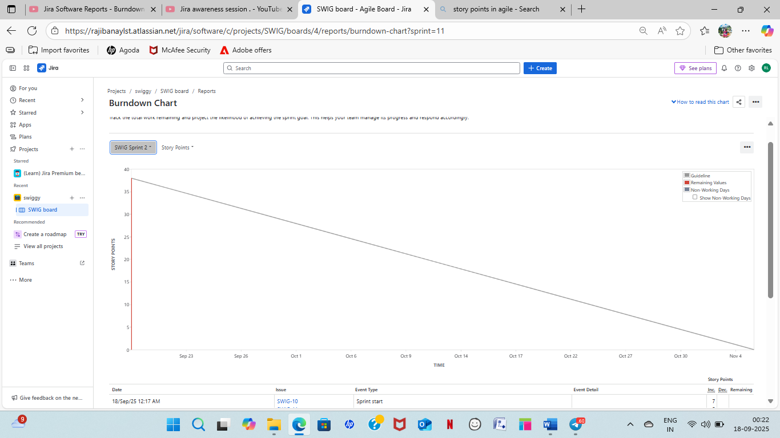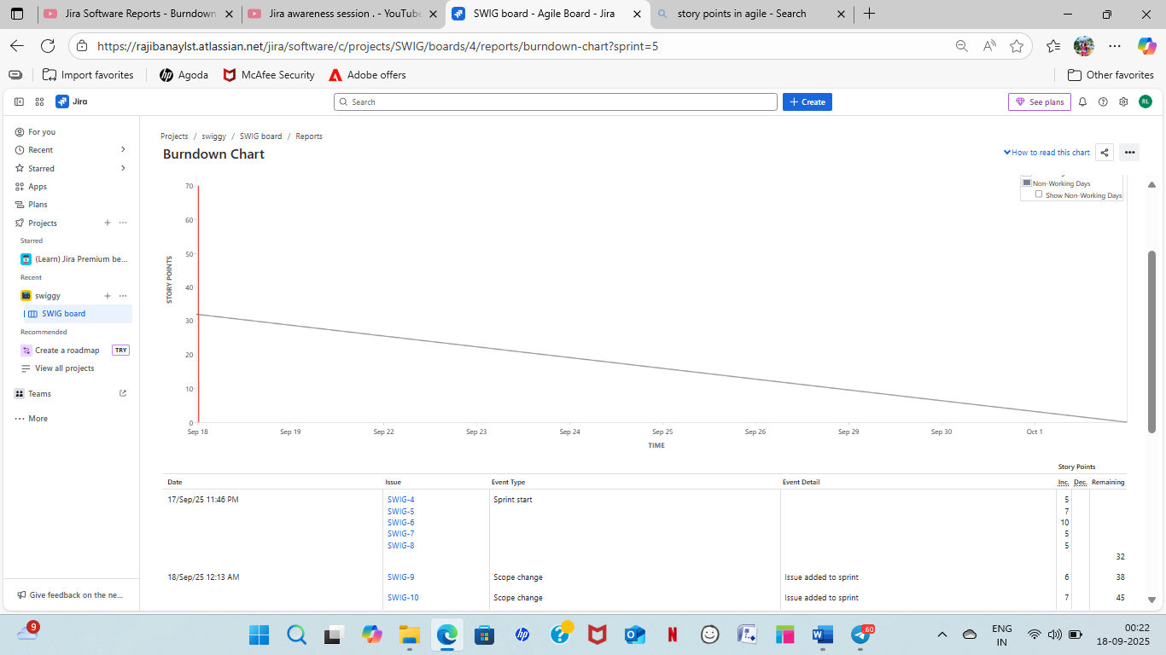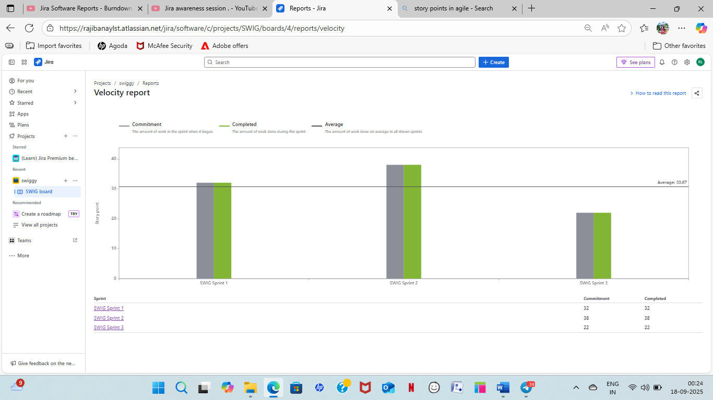

10. Product Grooming
Product grooming, also known as backlog refinement, is a continuous process where the Scrum team and Product Owner work together to ensure the product backlog is detailed, estimated, and prioritized. The team discusses the user stories to clarify requirements and split large epics into smaller, manageable items. This process ensures the product backlog is ready for future sprints.

11. Roles of Scrum Master and Product Owner
- Scrum Master: The Scrum Master is a servant-leader for the Scrum team. Their primary role is to ensure the team follows Scrum principles and practices. They facilitate meetings, remove impediments, and coach the team to improve their performance.
- Product Owner: The Product Owner is responsible for maximizing the value of the product. They manage the Product Backlog, defining the product vision, and prioritizing user stories based on business value.

12. Meetings Conducted in a Scrum Project
- Sprint Planning Meeting: Held at the beginning of a sprint, the Scrum team, Product Owner, and Scrum Master gather to select user stories from the Product Backlog to be completed in the upcoming sprint and create the Sprint Backlog.
- Scrum Meeting (Daily Stand-up): A short, daily meeting where Scrum Developers answer three questions: "What task did you work on?", "What task will you work on next?", and "Any challenges or impediments?". This ensures the team is aligned and identifies roadblocks early.
- Sprint Review Meeting: Held at the end of a sprint, the Scrum team demonstrates the completed work (product increment) to all stakeholders. They discuss velocity, burndown charts, and product insights for future improvements.
- Sprint Retrospective Meeting: This meeting follows the sprint review and is attended only by the Scrum team. The team discusses what went well, what could be improved, and creates an action plan to enhance their processes for the next sprint.

13. Sprint Size and Scrum Size
- Sprint Size: The duration of a sprint. For the Scrum Foods project, the sprint duration is
2 weeks.
- Scrum Size: The duration of a daily Scrum Meeting. For the Scrum Foods project, the scrum duration is
1 day. It's a small unit of work for a single developer in a single day.

14. DOR and DOD
- Definition of Ready (DOR): This is a set of criteria a user story must meet before it can be pulled into a sprint. A user story is "ready" when it's clear, feasible, and can be worked on without any blockers.
- Definition of Done (DOD): This is a shared understanding of what it means for work to be considered "complete" on a user story or product increment. The DOD ensures quality and consistency, typically including criteria like coding, testing, and documentation.

15. Prioritization Techniques and MVP
- Prioritization Techniques:
  - MoSCoW Method: A technique for prioritizing features as Must-have, Should-have, Could-have, and Won't-have.
  - High Business Value / Low Complexity Points: This technique prioritizes user stories that provide the most value to the business while requiring the least effort to develop. This helps achieve quick wins and deliver value early.
- Minimum Viable Product (MVP): An MVP is a version of a new product with just enough features to satisfy early customers and provide feedback for future development. For Scrum Foods, the MVP would be the essential features needed to launch the app, such as customer registration, searching, ordering, and payment.

16. Difference between Business Analyst and Product Owner
Business Analyst (BA) | Product Owner (PO)
Focuses on understanding and documenting business needs and requirements for stakeholders. | Focuses on maximizing the value of the product by managing the Product Backlog.
Acts as a bridge between business stakeholders and the development team. | Represents the voice of the customer and stakeholders.
A BA can work on multiple projects and may not be a dedicated team member. | A PO is a dedicated member of the Scrum team.

17. Sample Resume for a 3-Year Experienced Product Owner
Product Owner [Raji] [8106625094] | [raji.pechetti5@gmail.com]
Summary Results-driven Product Owner with over three years of experience in Agile Scrum environments. Proficient in managing product backlogs, prioritizing user stories based on business value, and collaborating with cross-functional teams to deliver high-quality software. Proven ability to translate stakeholder needs into actionable product requirements and foster continuous improvement.
Experience Product Owner Scrum Foods Project August 2022 - Present
- Managed and prioritized the product backlog for a food delivery application, ensuring alignment with the product vision and business goals.
- Led Sprint Planning sessions, guiding the development team to select user stories based on velocity and complexity points.
- Collaborated with stakeholders (Business Owner, Restaurant Owners, Customers, etc.) to define user stories and acceptance criteria.
- Facilitated daily Scrum meetings, identifying and removing impediments to maintain team progress.
- Conducted Sprint Review meetings to showcase product increments to stakeholders and gather feedback.
Key Achievements:
- Successfully prioritized and delivered the Minimum Viable Product (MVP), including essential features like customer registration, order placement, and real-time tracking.
- Improved team velocity by 15% in the first two sprints through effective backlog grooming and impediment resolution.
Skills
- Agile & Scrum: Product Backlog Management, User Story Writing, Sprint Planning, Daily Scrum, Sprint Review, Sprint Retrospective, Velocity Tracking, Burndown Charts.
- Tools: JIRA,MS Visio
- Techniques: MoSCoW Prioritization, Business Value (BV) & Complexity Points (CP) Estimation.
- Communication: Stakeholder Management, Team Facilitation, Requirements Gathering.

