Document 6- Please prepare a use case diagram, activity diagram and a use case specification document.
1. Use case Name
2. Use case Description
3. Actors Primary Actors Secondary actors
4. Basic Flow
5. Alternative Flow
6. Exceptional flows
7. Pre- Conditions
8. post-conditions
9. Assumptions
10. Constraints
11. Dependencies
12. Inputs and Outputs
13. Business Rules
14.Miscellaneous Information

Ans: USE CASE DIAGRAM – use case diagram noting it is geographical description how user interact with the system, A use case diagram describes the functional requirements of a system by showing the interactions between users (actors) and the system. It identifies the different use cases (tasks or services) the system offers. This diagram helps in understanding what the system should do from the user's perspective. It is useful for capturing high-level functionalities and relationships
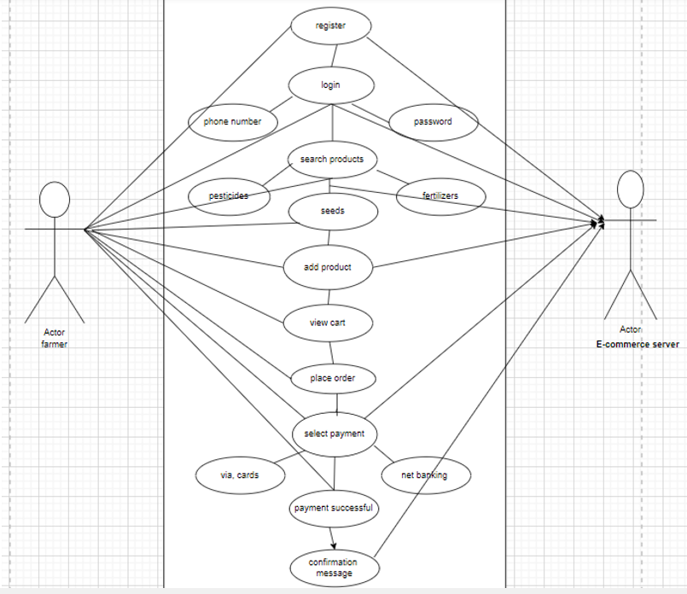

Activity Diagram - activity diagram describes the flow of actions or processes in a system from start to end. It shows how users interact with the system through various activities like registration, product search, and checkout. It helps visualize decision points, parallel processes, and the overall logic of user behaviour
Use Case Specification Document
Use case 1
Use case name | User registration/login
Use case description | This use case allows a user to create a new account or log in to the system to access its features.
Actors | Customer
Basic flow | - The user enters registration details or login credentials.  - The system validates the information.  - The system grants access to the user dashboard.
Alternative flow | If registration details are incomplete, the system prompts the user to fill all fields.
Exceptional flow | If login credentials are incorrect, the system displays an error message and allows retry.
Preconditions | The user must have a valid email address.
Post conditions | The user is successfully registered or logged in.
Business rules | Password must be at least 8 characters long.
Requirements | R001, R002
Use case 2
Use case name | Browse products
Use case description | This use case describes how a user searches and filters product based on preferences
Actors | Customer
Basic flow | The user search for specific tour (products, quality, price package)  The system displays the matching products
Alternative flow | If no products are matched for the customer preferences then system shows the similar products
Exceptional flow | None
Preconditions | product data must be up to date
Post conditions | A list of products displayed to the customers
Business rules | The system must display results with in 5 seconds
Requirements | R004
Use case 3
Use case name | Order products
Use case description | This use case allows user to order selected products
Actors  Primary actors  Secondary actors | Customer  Payment gateway
Basic flow | - The user selects a products and enters confirmation details.  - The system calculates the total cost and redirects to the payment gateway.  - Payment is processed and confirmed.  - A confirmation email is sent to the user
Alternative flow | If payment fails the system allows retry a different method
Exceptional flow | product availability may change during order
Preconditions | The user must be login
Post conditions | User receives the confirmation of products order
Business rules | Payment must be processed securely
Requirements | R006, R007, R008
Use case 4
Use case name | Cancel order
Use case description | This use case allows the user to cancel the order and receive refund
Actors  Primary actors  Secondary actors | Customer  Payment gateway
Basic flow | - The user selects a order to cancel.  - The system confirms the cancellation and processes a refund (if applicable).  - A confirmation email is sent to the user.
Alternative flow | If the cancellation time has expired, the system informs the user and denies the request.
Exceptional flow | None
Preconditions | The user must have an active ordering
Post conditions | The order is canceled and refund is initiated
Business rules | Cancellation of product is allowed up to 72hours before the tour date
Requirements | R009
Use case 5
Use case name | View product details
Use case description | This use case allows the users to view the details of their product
Actors | Customers
Basic flow | The system navigates to my product section like seeds and others  The system displays the details of their product information
Alternative flow | If no products are there the system suggest the users to order a product
Exceptional flow | None
Preconditions | The user must have an active booking
Post conditions | The product details are viewed
Business rules | Only orders products can be viewed
Requirements | R003

Document 7- Screens and pages Please follow the following steps to create the mock-ups
1. Kindly use balsamic or Axure.
2. Always start with a home page of an application.
3. Take a feature and follow it to the end
a. Eg: Home page of SCRUM Foods
b. Select Login- Create a login page
c. Let’s assume, you want to search a restaurant
d. Search page- Type the restaurant name and select the dish
e. Add to cart page
f. Payment Page
g. Log out page
ANS:
Home page


Login page
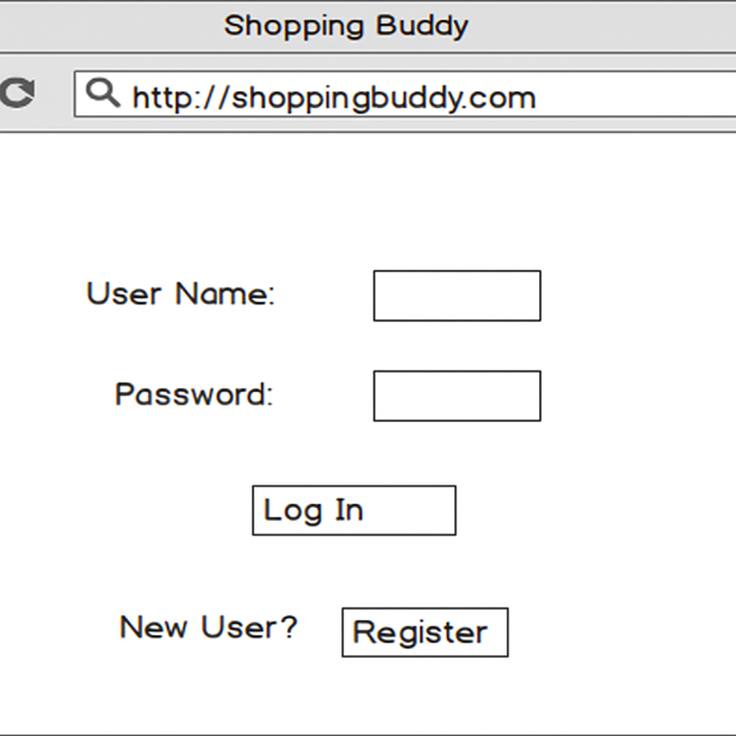

Search page
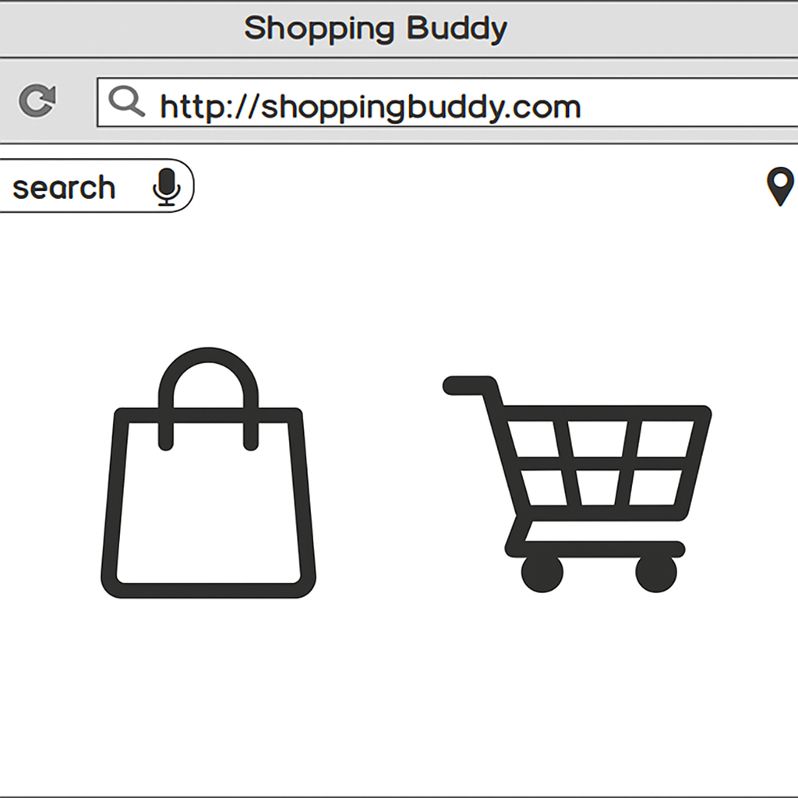

Add to cart:
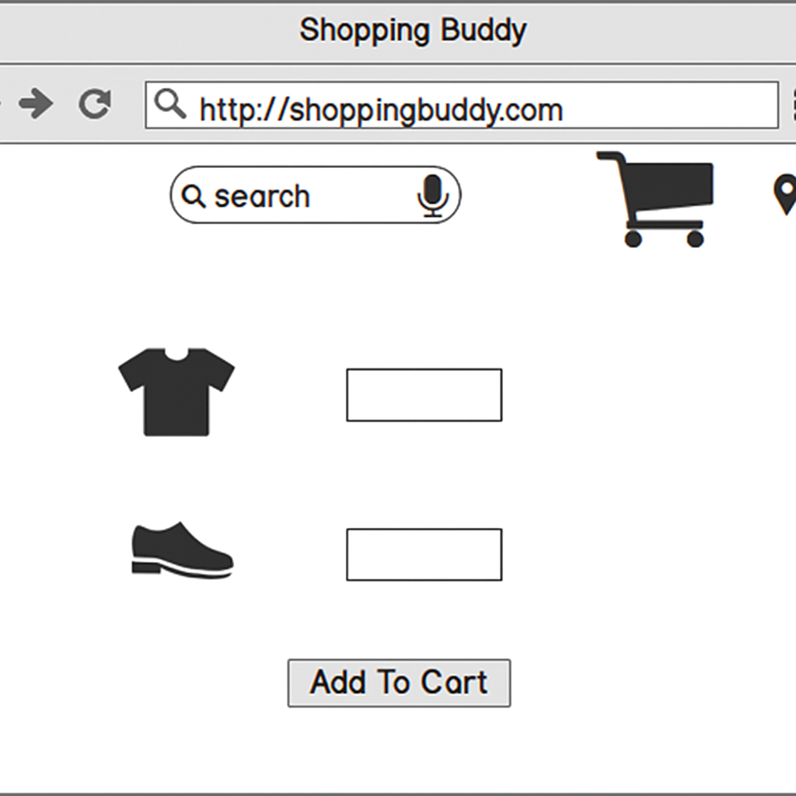

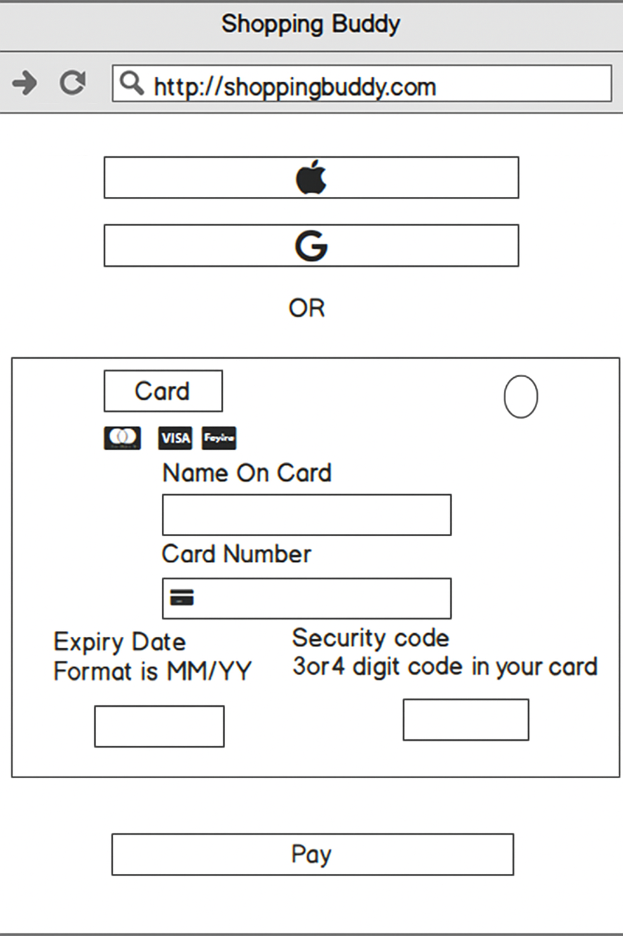

Payment page:

Logout Page
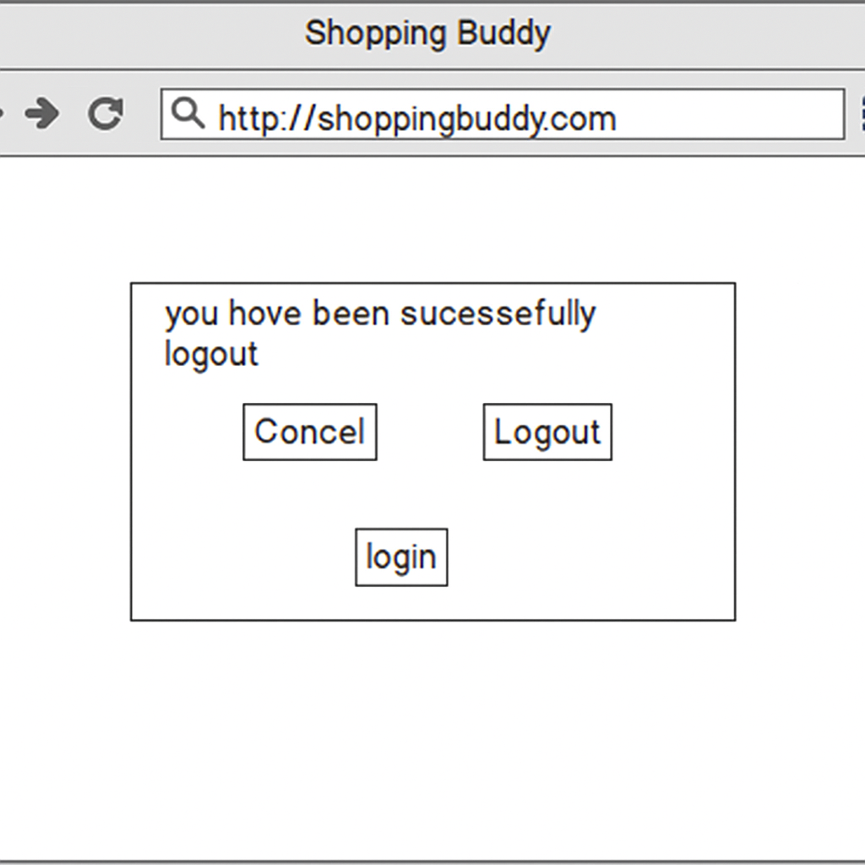

Document8- Tools-Visio and Axure
Write a paragraph on your experience using Visio and Axure for the project.
Ans:
Visio: I have used Microsoft Visio to draw use case diagram and activity diagram. In Visio, there are various static and dynamic diagrams. For drawing use case diagram, select UML use case where we can find various diagrams such as use case, actor, uses, communication lines, extends etc. For drawing activity diagram, select UML activity where we can find various diagrams such as initial state, final state, action state, control flow, decision box etc.
Axure: I have used Axure for prototyping the website. In Axure, we can create multiple webpages as per requirement. There are various icons for various purposes. We can select suitable icons/images to represent various activities. Once prototype is ready same can be used to represent to the stakeholder
Document9- BA experience
1.Requirement Gathering:
As a BA Conducted interviews with the stakeholders(client) to gather the requirements. By organizing focus group sessions to understand the visitor’s needs and preferences.
Review existing system and documents to gather additional information. Conduct surveys and questionnaire to gather the customer perspective.
Used MOSCOW technique to prioritize the requirements based on their importance and urgency
For validating the requirements FURPS technique used
By grouping the requirements removed the duplicated or repeated requirements
Using prototypes to filter and clarify requirements enhances the accuracy and alignment with stakeholder expectations.
2. Requirement Analysis:
By using MS VISIO created the USECASE diagram and ACTIVITY diagram
Where use case diagram gives the visual representation of the system and activity diagrams are give represents the process flow of system
Shared the use case and activity diagrams with the team members and gather their feedback and made the changes based on the discussion with them
Created a requirement document (RD) to outline the functional and Non-functional requirements of the project. Later created the BRD document to provide detailed description of the project objectives, scope and deliverables
3.Design
After the requirements are cleared, Design phase starts. This has a detailed design document that outlines the software architecture, user interface, and system components’, ADD and solution document will be generated here. [High-level Design Doc.] As a BA Collaborate with designers, architects, and developers to translate requirements into system design. Ensure that the design aligns with the documented requirements and addresses stakeholder needs.
Defined the overall architecture of the system including major components, modules and their interactions. Developed high level diagrams like data flow diagrams and system flow charts
Communicated with the client to review the design and solution document for the system
Prepared the both positive and negative test cases to ensure no test case was missed otherwise it might have huge impact on project development in later stages
Prepared the data for testing and used RTM matrix to track the requirements whether the requirements completed or not and the requirements met the project goals
4.Development:
Conducted the JAD session with stakeholders in development process to extract high inputs and minimize the errors.
The Development phase include implementation. It involves coding the software based on the design specifications. Programmers or developer are involved in this phase. Here as a BA, acts as a mediator between the development team and the stakeholders and clarifies the requirements, checks if the development is going on right track or not and also participates in scrum meetings.
5.Testing:
In the testing phase, the software is tested as a whole to ensure that it meets the requirements and is free from defects. Testers are involved in this phase
Test case documents are created from use case diagrams. BA works with the testing team to ensure that the solution meets the requirements.BA facilitate UAT.BA helps the users to know the functionality of the system and also helps them to use the system.
After the completion of testing obtained signoff from the client that the project meets all preferences of the client. Based on the changes updated the RTM
6.Deployment:
Plan the release of the software, considering factors such as the deployment schedule, potential downtime, and communication strategies for informing stakeholders about the release
RTM Forwarding: Sharing the RTM with clients as part of the project closure document ensures transparency.
End-User Manuals: Coordinating the creation and distribution of end-user manuals aids in user adoption.
Training Sessions: Planning and organizing training sessions ensures users are equipped to utilize the system effectively.
Attendance Assurance: Ensuring all candidates attend training sessions is crucial for effective knowledge transfer.
Post-Deployment Testing:
Conduct post-deployment testing to ensure that the software functions as expected in the production environment. This may include additional testing to verify performance, security, and overall system stability.
Feedback Collection:
Gather feedback from end-users and stakeholders after deployment. This feedback is valuable for identifying any unforeseen issues and for making further improvements in future releases

