1 Question
Audits - 5 Marks 4 Quarterly Audits are planned Q1 , Q2, Q3, Q4 for this Project What is your knowledge on how these Audits will happen for a BA ?
An audit is done to see if the project is healthy, meaning it’s on time, on budget, and meeting requirements.
Audit team checks documents, processes, and deliverables to make sure everything is done correctly and as per standards.
In the Online Agriculture Product Store Project, audits will ensure:
- Requirements are properly gathered from stakeholders (farmers, manufacturers).
- BA documents (like BRD, SRS, Use Case, etc.) are complete and approved.
- Communication with developers, testers, and clients is clear.
- Traceability and change management are maintained.
Q1 Audit – Requirement Gathering & Documentation Audit
- Focus: Verifying elicitation process, stakeholder analysis, and BRD creation.
- BA Role:
  - Present elicitation notes, meeting minutes, and stakeholder RACI matrix.
  - Ensure all business and stakeholder requirements are clearly captured and approved.
  - Show evidence of sign-off emails from Mr. Henry and the committee.
  - 1 – 6 week
Q2 Audit – Requirement Analysis & Sign-off Audit
- Focus: Review if requirements are properly analyzed and signed off.
- BA Role:
  - Submit finalized Business Requirement Document (BRD) and System Requirement Specification (SRS).
  - Provide traceability matrix (RTM) linking business → functional → technical requirements.
  - Ensure change requests (CRs) are logged and documented.
  - 7 – 12 week
Q3 Audit – Design & Testing Readiness Audit
- Focus: Ensure that requirements are translated correctly into design & test cases.
- BA Role:
  - Verify Use Case Diagrams, Use Case Specs, and Activity Diagrams are aligned with approved requirements.
  - Confirm BA has supported testers in requirement understanding sessions.
  - Participate in walkthroughs and defect triage meetings for clarification.
  - 13 – 58 week
Q4 Audit – UAT & Closure Audit
- Focus: Business acceptance and closure readiness.
- BA Role:
  - Present UAT Scenarios, Client Acceptance Form, and Sign-off emails.
  - Ensure all business objectives are met and verified by the client
  - Participate in retrospective meetings to record BA learnings and improvements.
  - 59 – 74 week
Quarter | Audit Type | BA Responsibilities
Q1 | Requirement Gathering | Elicitation docs, Stakeholder Matrix, BRD draft
Q2 | Requirement Analysis | Final BRD, SRS, RTM, CR log
Q3 | Design & Testing | Use Cases, Activity Diagrams, Traceability
Q4 | UAT & Closure | UAT Docs, Sign-offs, Lessons learned
Each audit ensures that the BA has maintained accurate, approved, and traceable documentation, ensuring smooth communication between stakeholders and the project team, leading to a successful UAT and project closure.

2 Question
– BA Approach Strategy - 6 Marks Before the Project is going to Kick Start, The Committee asked Mr Karthik to submit BA Approach Strategy
Write BA Approach strategy (As a business analyst, what are the steps that you would need to follow to complete a project –
What Elicitation Techniques to apply,
how to do Stakeholder Analysis RACI/ILS,
What Documents to Write,
What process to follow to Sign off on the Documents,
How to take Approvals from the Client,
What Communication Channels to establish n implement,
How to Handle Change Requests,
How to update the progress of the project to the Stakeholders,
How to take signoff on the UAT- Client Project Acceptance Form )
BA has to make a strategy on how to take the project smoothly from idea → requirements → UAT sign-off.
The project is about building an Online Agriculture Product Store connecting farmers and manufacturers.
BA must make sure all business needs (login, product catalog, payment, delivery tracking, etc.) are correctly understood, documented, and implemented.
Elicitation Techniques to Apply
Elicitation = Gathering information from stakeholders to understand needs.
Technique | Full Form / Meaning | Why Used in This Project
Brainstorming | Group idea discussion | With Mr. Henry’s committee to define project scope and features.
Interview | One-on-one question session | With farmers (Peter, Kevin, Ben) to understand real farming problems.
Document Analysis | Study of existing process docs | To analyze how farmers currently buy seeds or fertilizers offline.
Prototyping | Create mock screens or sample UI | To show how app/web will look and confirm with farmers for ease of use.
Workshop | Group meeting of all key members | To finalize requirements and confirm feasibility.

Stakeholder Analysis & RACI/ILS
Stakeholder Analysis:
Identify who is involved, what they care about, and how much power/influence they have.
Stakeholder | Role | Interest | Influence
Mr. Henry | Project Sponsor | Funding & Vision | High
Mr. Pandu | Financial Head | Budget Control | High
Mr. Dooku | Project Coordinator | Coordination | Medium
Peter, Kevin, Ben | Farmers | App usability | Medium
Mr. Vandanam | Project Manager | Delivery | High
Developers/Testers/Admins | Technical Team | Implementation | Medium

RACI Matrix:
RACI = Responsible, Accountable, Consulted, Informed
Task | Responsible | Accountable | Consulted | Informed
Gather Requirements | BA | PM | Stakeholders | Tech Team
Approve BRD | BA | Client | PM | Team
Development | Developers | PM | BA | Stakeholders
UAT Testing | Client | PM | BA | Team

ILS:
ILS = Involvement Level Sheet
It defines how much each stakeholder should be involved – e.g.,
- High Involvement: Mr. Henry, PM, Farmers, BA
- Medium Involvement: Developers, Testers
- Low Involvement: Network Admin (only during setup)

Documents to Write
Document | Full Form | Purpose
BRD | Business Requirement Document | What the business wants (features, scope, goals).
SRS | System Requirement Specification | How the system will meet BRD needs technically.
Use Case Diagram | Visual map of user-system interaction | To show how farmers/manufacturers use the system.
Use Case Specification | Step-by-step description of use case | Example: Login, Product Search, Order Placement.
Activity Diagram | Flow of process | Example: Farmer selects → adds to cart → pays.
RTM | Requirement Traceability Matrix | Links each business need to a system and test case.
Change Request Log | Record of any new requests | Tracks what changed and why.
UAT Plan | User Acceptance Test Plan | Defines how client will test and approve.
Client Project Acceptance Form | Final sign-off document | Confirms delivery and acceptance.

Process to Follow for Document Sign-off
Sign-off = Formal client approval that requirements are correct.
Steps:
- BA prepares BRD & SRS drafts.
- Review internally with PM and dev team.
- Share with Mr. Henry and committee for feedback.
- Make revisions and finalize.
- Get email approval or digital signature on final versions.
- Store signed copies in repository (e.g., SharePoint / Jira).

Approvals from Client (Permission to Continue 🏁)
- Always communicate approvals in writing (email or official platform).
- Each milestone (BRD, SRS, UAT) must have client sign-off before moving to next phase.
- Client = Mr. Henry / Committee.
- Track approval dates in an Approval Register for audit.

Communication Channels to Establish & Implement
Objective: Keep everyone connected and informed.
Type | Tool | Frequency | Participants
Status Meeting | MS Teams | Weekly | PM, Client, BA
Internal Team Sync | Teams | Twice a Week | BA, Dev, Tester
Email Updates | Outlook | Weekly | All stakeholders
Change Request Meeting | Virtual / In-person | As needed | PM, Client, BA
Documentation Sharing | SharePoint / Confluence | Ongoing | Team & Client

Handling Change Requests
Change Request (CR): A new or modified requirement after sign-off.
Steps to Handle CRs:
- Log the request in Change Request Form (date, reason, impact).
- Do Impact Analysis → Check effect on cost, time, scope.
- Discuss with Project Manager and Client.
- If approved, update BRD, SRS, and RTM.
- Communicate changes to all stakeholders.
Updating Project Progress to Stakeholders
BA Responsibilities:
- Send Weekly Status Reports with:
  - Work completed
  - Pending items
  - Issues/risks
  - Next steps
- Conduct Review Meetings with PM and Client.
- Use visual trackers (Excel, Jira Dashboards).
- Keep stakeholders informed on requirement progress and change impacts.

UAT Sign-off & Client Project Acceptance
UAT = User Acceptance Testing → Final testing by client before go-live.
Steps:
- BA prepares UAT Scenarios (based on BRD).
- Coordinate testing with farmers (Peter, Kevin, Ben) and client team.
- Log feedback and confirm fixes.
- Once client confirms all requirements are met:
  - Get UAT Sign-off Form and Client Acceptance Form signed by Mr. Henry.
- Archive all final documents for closure audit.

Phase | What BA Does
Elicitation | Gather requirements
Stakeholder & RACI | Identify roles
Documents | Prepare BA artefacts
Sign-off | Approvals
Communication | Keep updates clear
Change Request | Handle new needs
Progress Updates | Weekly reports
UAT Sign-off | Final approval

Maintain a Version Control System (so each document change is tracked).
Keep Meeting Minutes (MoM) after every discussion.
Use Traceability Matrix (RTM) to ensure every business goal has been delivered.

Question 3
3-Tier Architecture - 5 Marks Explain and illustrate 3-tier architecture?
Definition:
3-Tier Architecture is a software design structure that divides an application into three independent layers that communicate with each other in a sequence.
It improves clarity, maintainability, security, and scalability.
Each layer has its own responsibility and connects only to the layer next to it.
Layer | Meaning / Role | Function
Application Layer | The user’s entry point — where they interact with the system. | Takes input from user, sends it to business logic, and shows results back to the user.
Business Logic Layer | The brain of the system — where rules, calculations, and decisions happen. | Processes input data, applies logic, coordinates between application and data layers.
Data Layer | The storage — where data is saved and retrieved. | Stores all records (users, orders, products, etc.) and returns information to the business logic layer.

Application Layer (Top Layer – EmpLogin Boundary Class)
Meaning:
The Application Layer is the interface that users interact with — it collects input (like login, search, and payment) and displays outputs (like order confirmation or delivery tracking).
In This Project:
- Farmers and manufacturers use the web or mobile app to log in, browse products, and place orders.
- The UI sends user inputs (login details, selected products) to the Business Logic Layer for processing.
Example:
- Farmer enters email and password → App (Application Layer) sends it to Login CC for validation.
Business Logic Layer (Middle Layer – Login Control Class)
Meaning:
The Business Logic Layer (also called Application Logic or Control Layer) contains all the rules, validations, and decision-making functions.
In This Project:
- It checks login credentials, verifies product availability, and applies rules for payments and discounts.
- It communicates between the Application Layer (top) and Data Layer (bottom).
Example:
- When a farmer logs in, this layer checks the details with the database.
- When a farmer orders seeds, it validates stock quantity and payment details before confirming the order.

Data Layer (Bottom Layer – Entity Class)
Meaning:
The Data Layer (Entity Class in diagram) stores and manages all the data used by the system — such as farmer profiles, manufacturer info, product details, and order records.
In This Project:
- Stores all product, farmer, and manufacturer data securely in the database.
- Sends requested information to the Business Logic Layer upon request.
Example:
- When Login CC requests farmer details → Emp EC retrieves them from the database and sends them back.
- When Order CC sends a new order → Emp EC saves it into the order table.
How the Layers Work Together in the Project
Farmer opens the app → enters login → goes to Application Layer (EmpLogin BC).
The app sends data to Business Logic Layer (Login CC) for verification.
The Business Logic Layer calls Data Layer (Emp EC) to fetch user info from the database.
Emp EC returns the data → Login CC validates it → sends result back to the Application Layer → “Login Successful” message appears.
So, the data always flows top → middle → bottom → back up, just like the direction in your diagram.
Advantages for This Project
Advantage | How It Helps Here
Security | Farmers never directly access the database — prevents data theft.
Easy Maintenance | UI, logic, and database are independent — one can be changed without affecting others.
Reusability | Same business logic layer works for both web and mobile versions.
Scalability | Can add new features like weather info or crop advisory easily.
Better Collaboration | Developers, testers, and database teams work in parallel.

Team Role Mapping
Layer | Handled By
Application Layer | Frontend Developers
Business Logic Layer | Java Developers
Data Layer | Database Admin

Question 4
BA Approach Strategy for Framing Questions – 10 Marks
Business Analyst should keep What points in his/her mind before he frames a Question to ask to the Stakeholder
5W 1H SMART RACI 3 Tier Architecture
Use Cases Use case Specs
Activity Diagrams Models Page designs

5W + 1H Technique
Question Type | Meaning | Example for This Project (Online Agriculture Product Store)
Who | Identify stakeholders or users | Who will use the system — farmers, manufacturers, or delivery agents?
What | Clarify the need | What features do farmers need most — product catalog, delivery tracking, etc.?
Why | Understand the reason behind it | Why do farmers prefer COD (Cash on Delivery) instead of UPI?
When | Define timing or priority | When should the delivery tracking feature go live — in phase 1 or 2?
Where | Identify the location or channel | Where will farmers use the app — mobile or desktop?
How | Understand process or method | How should manufacturers upload product details? Via web or Excel import?
people, purpose, time, and method.

SMART Technique
Every question should lead to answers that are:
S – Specific, M – Measurable, A – Achievable, R – Relevant, T – Time-bound
Principle | Meaning | Example Question
Specific | Clear and focused | “Should the payment module include UPI, card, and COD?”
Measurable | Can be verified | “How many farmers are expected to register in 3 months?”
Achievable | Realistic goals | “Can we start with English versions initially?”
Relevant | Adds real business value | “Will adding feedback ratings help improve product sales?”
Time-bound | Linked to timeline | “By when should the testing of farmer login be completed?”
SMART ensures your questions and resulting requirements are practical and trackable.

RACI (Responsible, Accountable, Consulted, Informed)
Before you frame or ask a question, know who to ask.
RACI Role | Meaning | Who in Project | Question Example
R (Responsible) | Executes the task | Developers, Testers | “How will the login module connect to DB?”
A (Accountable) | Owner of the task | Project Manager | “When will the next sprint deliverables be ready?”
C (Consulted) | Gives input or feedback | Farmers, Committee | “Which payment method is most preferred?”
I (Informed) | Needs updates | Finance Head | “Do you need weekly progress summaries?”
Asking the right question to the right person saves time and prevents confusion.
3-Tier Architecture Reference
Before framing technical questions, the BA should know which layer the question belongs to:
Layer | Type of Questions to Ask | Example for This Project
Application Layer | UI / UX questions | “Should the app be mobile responsive?”
Business Logic Layer | Rules & processing | “How is delivery fee calculated?”
Data Layer | Storage & data questions | “What farmer details must be stored — address, soil type, etc.?”
This ensures your questions are targeted — UI questions go to UI team, data questions to DB admin.

Use Cases & Use Case Specifications
Before framing questions, the BA should visualize user-system interactions.
Concept | Purpose | Question Example
Use Case | Describes how a user interacts with the system | “What happens when a farmer clicks ‘Add to Cart’?”
Use Case Specification | Step-by-step detail of the interaction | “Should the system allow multiple products in one cart?”
Use cases help ensure your questions cover every step of the process.

Activity Diagrams & Models
- These are visual flowcharts of how tasks move from start to finish.
- Before you question stakeholders, identify missing steps or unclear transitions in the flow.
Example:
In “Order Placement” activity, ask —
- “What should happen if payment fails?”
- “Can a farmer edit the cart after confirming?”
Visual models help spot gaps that need clarifying questions.

Page Designs (Mockups / Wireframes)
Once you have visual screens, you can ask:
- “Is this button name clear for farmers?”
- “Should we show product ratings on the homepage or after clicking the product?”
Mockups make communication clear — especially for non-technical stakeholders like farmers.

Step | BA Activity | Example in Agriculture Project
1 | Identify information gap | Farmers want an easier order flow, but details unclear.
2 | Choose technique (5W1H / SMART) | Use “How” and “What” questions to find missing logic.
3 | Match stakeholder using RACI | Ask business questions to Mr. Henry, technical ones to Dev Team.
4 | Align question to architecture layer | UI → Application layer; logic → Business; data → Database.
5 | Use visuals (Use Case, Activity Diagram, Mockup) | Validate understanding through visuals.
6 | Summarize findings | Prepare minutes of meeting (MoM) & update BRD.

As a Business Analyst, before framing questions, I ensure every question is structured, purposeful, and stakeholder-focused using tools like 5W1H and SMART.
I align each question to the right RACI role and 3-tier layer (Application, Business Logic, Data).
I visualize processes using Use Cases, Activity Diagrams, and Page Designs to find missing information.
This systematic approach ensures clarity, avoids miscommunication, and produces accurate, complete business requirements for the Online Agriculture Product Store project.

Question 5
Elicitation Techniques - 6 Marks As a Business Analyst, What Elicitation Techniques you are aware of? ( BDRFOWJIPQU)
Letter | Full Form / Technique Name
B | Brainstorming
D | Document Analysis
R | Reverse Engineering
F | Focus Group
O | Observation / Job Shadowing
W | Workshops / JAD (Joint Application Design)
J | JAD (Joint Application Development)* — often combined with Workshops
I | Interviews
P | Prototyping
Q | Questionnaires / Surveys
U | Use Case / Use Case Modelling

Technique | Meaning (Simple Explanation) | When / Why Used
Brainstorming | Group idea-sharing session | To generate ideas, explore new features, or solve a problem collectively.
Document Analysis | Studying existing docs, reports, or systems | To understand the current process and identify gaps.
Reverse Engineering | Analyzing an existing system to understand its functions | When no documentation exists but old software is available.
Focus Group | Small, diverse group giving feedback | To understand user expectations and reactions to ideas.
Observation (Job Shadowing) | Watching users perform their daily work | To discover real challenges users may not verbalize.
Workshops / JAD | Joint session of client, users, and IT | To finalize requirements faster and align all views.
Interviews | One-on-one discussions with stakeholders | To gather in-depth information from key people.
Prototyping | Creating mock screens or demo models | To visualize ideas and validate requirements.
Questionnaires / Surveys | Written or digital form with structured questions | To collect feedback from a large or dispersed audience.
Use Case Modelling | Describing user-system interactions | To understand step-by-step how a process works.

Applying Each Technique to This Project (Online Agriculture Product Store)
Technique | Why / How Used in This Project
Brainstorming | Used with Mr. Henry, committee, and farmers to list key features like product search, payment, and delivery tracking.
Document Analysis | Used to study existing offline product purchase process, invoices, and supplier registration forms.
Reverse Engineering | ❌ Not used — no old system exists; this is a new CSR initiative.
Focus Group | Used with small farmer groups to get feedback on prototype usability and payment preferences.
Observation | BA observes farmers purchasing products offline to design an easier digital process.
Workshops / JAD | Used with all stakeholders (farmers, committee, developers) to finalize requirement priorities.
Interviews | Used for detailed understanding of problems faced by farmers (Peter, Kevin, Ben) and business goals of Mr. Henry.
Prototyping | Used to create sample web and mobile screens to show farmers how they will interact with the app.
Questionnaires / Surveys | Used (limited) to collect feedback on internet usage, preferred language, and payment options from wider farmer groups.
Use Case Modelling | Used to define actions like “Login”, “Search Products”, “Make Payment”, and “Track Delivery”.

As a Business Analyst, I use multiple elicitation techniques summarized as BDRFOWJIPQU —
Brainstorming, Document Analysis, Reverse Engineering, Focus Groups, Observation, Workshops, JAD, Interviews, Prototyping, Questionnaires, and Use Cases.
In the Online Agriculture Product Store project, techniques like Brainstorming, Interviews, Document Analysis, Workshops, and Prototyping were most effective, as they helped gather complete and accurate requirements from both technical and rural stakeholders.
These methods ensured that the final solution is practical, user-friendly, and aligned with the farmers’ real needs.

Question 6
This project Elicitation Techniques - 5 Marks Which Elicitation Techniques can be used in this Project and Justify your selection of Elicitation Techniques? Prototyping Use case Specs Document Analysis Brainstorming
BR001 – Farmers should be able to search for available products in fertilizers, seeds, pesticides
BR002 – Manufacturers should be able to upload and display their products in the application
In elicitation — collect all needed details from different sources before we start development.
Elicitation Techniques Used and Justification

Technique | Short Meaning | How It Was Used in This Project (with Justification)
Brainstorming | Group idea-sharing session among client and stakeholders. | Used in initial meeting with Mr. Henry (Client) and stakeholders (Peter, Kevin, Ben) to gather broad ideas. Helped identify key modules: login, product catalog, search, payment, and delivery tracker.  Justification: Effective for generating quick ideas from multiple stakeholders and identifying overall project scope.
Document Analysis | Studying existing records or processes. | Used to study how farmers and manufacturers currently exchange product data (via Excel sheets or offline forms). Helped define what data fields are required (e.g., product name, price, quantity, manufacturer info).  Justification: Gave accurate reference for designing product upload and catalog features.
Prototyping | Creating sample screens or mockups to visualize requirements. | Used to show farmers and manufacturers how the login, product catalog, and payment gateway would look. Farmers gave feedback such as adding COD and UPI options for ease of use.  Justification: Beneficial because users like farmers found it easier to express opinions when they could see the screen layout.
Use Case Specifications | Defining how users interact with the system step by step. | Used to describe specific user flows, such as:  → “Farmer logs in → searches fertilizer → adds to cart → makes payment → tracks order.”  → “Manufacturer uploads new product → visible to farmer catalog.”  Justification: Ensures all functional steps are covered; helps developers and testers understand exact interactions and dependencies.

Identified Business & Stakeholder Requirements
Requirement | Elicitation Techniques Used | Benefit Achieved
BR001 – Farmer Product Search | Brainstorming + Document Analysis + Prototyping + Use Case Specs | Captured real farmer needs, simplified UI, ensured accurate search fields and data integration.
BR002 – Manufacturer Product Upload | Brainstorming + Document Analysis + Prototyping + Use Case Specs | Reduced manual effort, matched existing data formats, clarified upload and approval workflow.

Why These Techniques Were the Best Fit
Reason | Explanation (Project-Specific)
Multiple user types | Farmers and manufacturers required techniques understandable to both technical and non-technical users.
Visual clarity needed | Prototyping helped bridge the communication gap.
Existing offline data | Document Analysis made it easy to design realistic database fields. Table details- columns rates products etc
Requirement confirmation | Use Case Specs captured process-level clarity for both login and product flow.
Idea convergence | Brainstorming ensured everyone agreed on core features quickly.

Business Requirement 1 (BR001):
“Farmers should be able to search for available products in fertilizers, seeds, and pesticides.”
🔹 1️⃣ Brainstorming
- Who was involved: Mr Henry (client), Peter, Kevin, Ben (farmer reps), and BA team.
- Objective: Understand how farmers currently look for products and what search options they need online.
- Activity:
  - A group session was conducted at Soony CSR office.
  - Everyone was asked: “If you were searching for a product online, what information would help you find it quickly?”
  - Farmers suggested filters by type (fertilizer/seed/pesticide), brand, price range, and availability.
  - PM added that the search must support multilingual keywords (e.g., English + Hindi names).
- Outcome: A prioritized list of search criteria to include in the design.
🔹 2️⃣ Document Analysis
- What was reviewed: Old paper catalogs and Excel sheets from manufacturers listing product details (name, brand, NPK value, price per kg, stock status).
- Purpose: Identify mandatory database fields that make the search accurate.
- Finding: Each record needed product ID, category, manufacturer name, price, stock quantity.
- Outcome: The BA documented these attributes for the data model and shared them with the DB team.
🔹 3️⃣ Prototyping
- Action: Created a mock-up of a Search Page showing:
  - Search bar at the top.
  - Drop-down filters (type, brand, price range).
  - List view of products with small images.
- Who tested it: Kevin and Ben (farmers) → They said the page must be simple with fewer words and large icons.
- Result: Prototype updated with icon-based filters and “Search by Voice” option for rural users.
🔹 4️⃣ Use Case Specification
- Title: “Search for Product”
- Primary Actor: Farmer
- Precondition: Farmer is logged in.
- Main Flow:
  - Farmer enters a keyword (e.g., ‘urea’).
  - System searches in the product database.
  - System displays list of matches.
  - Farmer applies filters and views details.
- Alternate Flow: If no match → system shows “No product found” + suggested alternatives.
- Post-Condition: Farmer can add the chosen product to the cart or wishlist.
- Outcome: Developers clearly knew each interaction step for BR001.

Business Requirement 2 (BR002):
“Manufacturers should be able to upload and display their products in the application.”
🔹 1️⃣ Brainstorming
- Participants: Mr Henry, Manufacturer Representatives, BA team.
- Objective: Find the simplest way for manufacturers to upload product data.
- Discussion Points:
  - Upload through web portal vs Excel import.
  - Mandatory fields: product name, composition, quantity, price, expiry date.
  - Approval process before product goes live.
- Outcome: Consensus to build a “Product Upload” module with Excel import option + manual entry form.
🔹 2️⃣ Document Analysis
- What was reviewed: Sample manufacturer product catalogs, Excel templates, and invoice formats.
- Purpose: Identify what columns manufacturers already maintain.
- Result: Defined the structure for the product master table (e.g., ProductID, Category, Brand, Unit, Price, Stock, Image URL).
- Outcome: Database fields matched existing manufacturer records, minimizing data entry effort.
🔹 3️⃣ Prototyping
- Action: Designed a “Product Upload” Screen Prototype showing:
  - Upload button for Excel sheet.
  - Manual entry form with field validations.
  - “Preview before Submit” feature.
- Feedback:
  - Manufacturers liked Excel upload.
  - Mr Henry requested an approval workflow before display to farmers.
- Result: Prototype updated → “Pending Approval” status added for new products.
🔹 4️⃣ Use Case Specification
- Title: “Upload Product by Manufacturer”
- Primary Actor: Manufacturer
- Precondition: Logged in as manufacturer role.
- Main Flow:
  - Manufacturer logs in → navigates to Product Upload.
  - Selects Excel file or fills form.
  - Clicks Submit.
  - System validates fields and stores data in product table.
  - Product status = ‘Pending Approval’.
  - Admin approves → product visible to farmers.
- Alternate Flow: Invalid data → system shows error message.
- Post-Condition: Product appears in catalog after approval.
- Outcome: Developers and QA had a clear workflow for the upload process.

For the Online Agriculture Product Store project, the most suitable elicitation techniques were Brainstorming, Document Analysis, Prototyping, and Use Case Specifications.
These were chosen because they effectively combined idea generation (Brainstorming), reference from existing processes (Document Analysis), visual validation (Prototyping), and precise functional detailing (Use Case Specs).
Together, they helped capture complete, accurate business requirements like BR001 (Farmer product search) and BR002 (Manufacturer product upload), ensuring that both stakeholders’ expectations and system capabilities were aligned clearly before development.

Question 7
10 Business Requirements- 10 Marks Make suitable Assumptions and identify at least 10 Business Requirements
Req ID | Business Requirement Description | Category | Stakeholder Source | Elicitation Technique Used
BR001 | Farmers should be able to search for available products (fertilizers, seeds, pesticides) by category, brand, or keyword. | Product Search | Kevin (Farmer Rep) | Interview, Brainstorming, Prototyping
BR002 | Manufacturers should be able to upload and display their products (fertilizers, seeds, pesticides) to the online catalog. | Product Upload | Mr. Henry, Manufacturers | Document Analysis, Use Case, Prototyping
BR003 | All users (farmers and manufacturers) should be able to create accounts and log in securely using email and password. | User Access | Peter (Farmer Rep) | Interview, Prototyping
BR004 | Farmers should be able to add products to cart or buy-later list after login. | Order Management | Kevin (Farmer Rep) | Interview, Use Case
BR005 | The system should provide a secure payment gateway that supports COD, Credit/Debit Card, and UPI. | Payment | Ben (Farmer Rep) | Workshop, Prototype
BR006 | The system should send automatic email confirmation after every successful order. | Communication | Kevin (Farmer Rep) | Brainstorming, Document Review
BR007 | Farmers should be able to track delivery status (e.g., dispatched, in transit, delivered). | Delivery Tracking | Ben (Farmer Rep) | Interview, Prototype
BR008 | The Admin should be able to add, edit, or delete manufacturer accounts to ensure data quality. | Admin Control | Mr. Henry (Client) | Workshop, Document Analysis
BR009 | The Admin should be able to generate reports on sales, product performance, and farmer registrations. | Reporting | Mr. Henry (Client) | Brainstorming, Document Analysis
BR010 | The system should maintain support English, for farmers in rural areas. | Language Support | BA Assumption (Based on region) | Interview, Prototype Validation
BR011 | Farmers should be able to cancel order | Order cancel | Ben (Farmer Rep) | Interview, Use Case

Question 8
Assumptions- 5 Marks List your assumptions

In Business Analysis, assumptions are the facts or conditions that we accept as true temporarily, even though they are not yet confirmed.
They help us move forward in requirement gathering when some information is uncertain or not provided by the client.

No. | Assumption Statement | Category
A1 | All farmers and manufacturers will have basic internet access through smartphones or computers. | Technical
A2 | The platform will be developed as a web application initially, with a mobile version planned later. | Technical
A3 | The system will support language – English in the first release. | Functional
A4 | User authentication will be done through email ID and password only (no OTP for now). | Security / Functional
A5 | Product categories are limited to fertilizers, seeds, and pesticides as per initial CSR scope. | Business
A6 | Payment Gateway will support COD, Credit/Debit Cards, and UPI only. | Functional
A7 | Delivery and logistics will be managed by a third-party vendor integrated via API. | Operational
A8 | Email notifications (not SMS) will be used to confirm orders and delivery updates. | Communication
A9 | Data storage and backup will be maintained on a secure cloud server managed by SOONY IT team. | Technical / Security
A10 | The Admin (Mr. Henry’s CSR team) will approve new manufacturer accounts and monitor product uploads. | Administrative

Question 9
This project Requirements Priority –

Factors Considered for Prioritization
- Stakeholder urgency (what the client and farmers want first)
- System dependency (which features must exist before others can work)
- Business value (how important it is to core CSR goals)
- Risk and complexity (easier, high-impact ones get priority)

Req ID | Requirement Name | Description (Summary) | Priority (1–10) | Justification / Reason for Priority
BR001 | Farmer Search for Products | Farmers should be able to search for available products (fertilizers, seeds, pesticides). | 10 | Core functionality; the system is built around enabling farmers to find products easily.
BR002 | Manufacturers Upload Products | Manufacturers should upload and display products in the app. | 9 | Essential for the catalog to exist; dependent on manufacturer participation.
BR003 | User Login / Registration | Farmers and manufacturers can create accounts and log in securely. | 9 | Mandatory for personalized access and order tracking.
BR004 | Add to Cart / Buy Later | Farmers can add products to a shopping cart or wish list. | 8 | Important for shopping flow; comes after search and login.
BR005 | Payment Gateway (COD, Card, UPI) | Secure payment processing for all users. | 8 | Critical for completing orders; must be secure and verified.
BR006 | Email Confirmation | System sends email confirmation after every successful order. | 7 | Needed for user communication; can be developed after payment.
BR007 | Delivery Tracking | Farmers can track the delivery status of orders. | 7 | Important for customer satisfaction; depends on order completion and logistics API.
BR008 | Admin Manage Manufacturers | Admin can add, edit, or delete manufacturer accounts. | 6 | Important for data quality but can come after core farmer modules are working.
BR009 | Generate Reports | Admin can generate reports on sales, registrations, and performance. | 5 | Useful for analytics and CSR reporting; can be added post go-live.
BR010 | Support English – or additional languages | Farmers can view the system English. | 6 | Improves usability; can be released in later phases once core system is stable.

Priority Level | Requirements | Meaning
High (9–10) | BR001, BR002, BR003 | Must be delivered in Phase 1 (Core platform functionality).
Medium (7–8) | BR004, BR005, BR006, BR007 | Important for Phase 2 (Ordering, payment, and delivery flow).
Low (5–6) | BR008, BR009, BR010 | Supportive features (Admin, reporting, and multilingual support).

Question 10
Use Case Diagram - 10 Marks Draw use case diagram

A Use Case Diagram is part of UML (Unified Modelling Language).
It shows who (actors) interacts with the system and what actions (use cases) they perform.

Identify Actors and Use Cases

Actor Type | Actor Name | Role in System
Primary Actors | Farmer, Manufacturer | End users of the system (buyers and sellers).
Supporting Actor | Admin | Controls and monitors platform data.
External Actor | Payment Gateway, Delivery Service, Email System | External systems integrated via APIs.

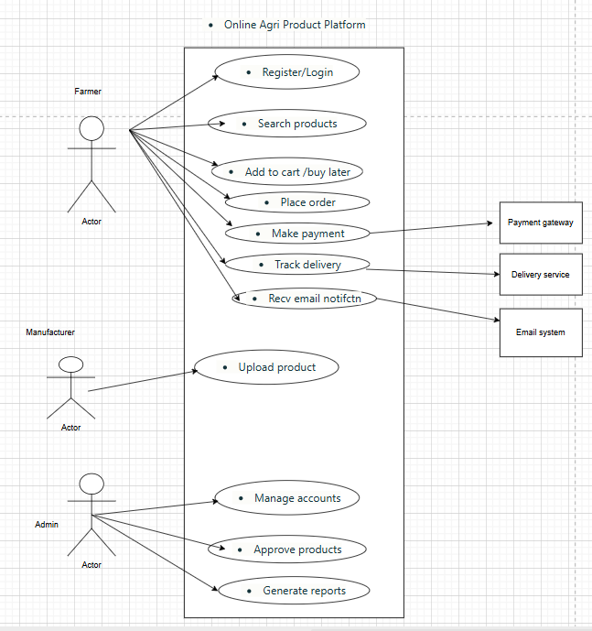

Question 11
(minimum 5) Use Case Specs - 15 Marks Prepare use case specs for all use cases

Use Case Specification (UCS) is a detailed description of how each use case works —
who triggers it, what steps occur, what alternate paths exist, and how it ends.

It defines the main flow
alternate flows
exceptions
and business rules
for each functional requirement.

UC001 – Register / Login
Field | Description
Primary Actor | Farmer / Manufacturer
Goal | To allow new users to register and existing users to log in securely.
Pre-Conditions | User has access to internet and a valid email ID.
Post-Conditions | User successfully logged in; homepage displayed.
Main Flow | 1️⃣ User selects Register/Login → 2️⃣ Enters email and password → 3️⃣ System verifies credentials → 4️⃣ Redirects to dashboard.
Alternate Flow | Invalid credentials → show error; Forgot Password → reset link sent.
Exceptions | Server or database down.
Business Rules | Password ≥ 8 chars; unique email required.

UC002 – Search Products
Field | Description
Primary Actor | Farmer
Goal | To search for fertilizers, seeds, and pesticides by name, brand, or category.
Pre-Conditions | User is logged in.
Post-Conditions | Relevant product list displayed.
Main Flow | 1️⃣ User enters keyword or selects filter → 2️⃣ System queries database → 3️⃣ Displays results with price and stock.
Alternate Flow | No results → suggest similar products.
Exceptions | Search service not responding.
Business Rules | Display only approved and in-stock items.

UC003 – Add to Cart / Buy Later
Field | Description
Primary Actor | Farmer
Goal | To allow user to add selected items to cart or wishlist.
Pre-Conditions | User logged in; catalog visible.
Post-Conditions | Cart or wishlist updated in system.
Main Flow | 1️⃣ User selects product → 2️⃣ Clicks “Add to Cart” or “Buy Later” → 3️⃣ System stores product in user’s cart table.
Alternate Flow | If stock unavailable → “Out of Stock” message.
Exceptions | Session timeout or database error.
Business Rules | Cart data saved for 30 days.

UC004 – Make Payment
Field | Description
Primary Actor | Farmer
Supporting Actor | Payment Gateway
Goal | To process payment via COD, Credit/Debit Card, or UPI.
Pre-Conditions | Items added to cart; total calculated.
Post-Conditions | Payment successful; order marked “Paid.”
Main Flow | 1️⃣ User chooses payment option → 2️⃣ Gateway authenticates → 3️⃣ System updates payment status → 4️⃣ Confirmation message displayed.
Alternate Flow | Payment failed → user retries or chooses COD.
Exceptions | Gateway timeout or declined card.
Business Rules | All transactions SSL-secured; log payment ID.

UC005 – Track Delivery
Field | Description
Primary Actor | Farmer
Supporting Actor | Delivery Service
Goal | To check real-time delivery status of purchased items.
Pre-Conditions | Order must be placed and dispatched.
Post-Conditions | Status displayed (“Dispatched”, “Delivered”).
Main Flow | 1️⃣ User selects “Track Delivery” → 2️⃣ System requests status from API → 3️⃣ Status displayed.
Alternate Flow | API delay → show “Awaiting Update.”
Exceptions | API unreachable.
Business Rules | Status auto-refreshed every 4 hours.

UC006 – Receive Email Notification
Field | Description
Primary Actor | System
Supporting Actor | Email Server
Goal | To send order confirmation and updates to users.
Pre-Conditions | Payment completed; email ID verified.
Post-Conditions | Email sent successfully and logged.
Main Flow | 1️⃣ Order confirmed → 2️⃣ System generates email → 3️⃣ Email server sends message to user.
Alternate Flow | Email fails → retry queue for resend.
Exceptions | SMTP server down.
Business Rules | Email template includes order ID and tracking link.

UC007 – Upload Product
Field | Description
Primary Actor | Manufacturer
Goal | To upload product details (name, price, category, stock, image).
Pre-Conditions | Manufacturer account approved by Admin.
Post-Conditions | Product stored in catalog as “Pending Approval.”
Main Flow | 1️⃣ Manufacturer logs in → 2️⃣ Clicks “Upload Product” → 3️⃣ Enters details → 4️⃣ Submits → 5️⃣ System stores record.
Alternate Flow | Missing fields → validation error.
Exceptions | Server error during image upload.
Business Rules | Max 5MB per image; all products need admin approval.

UC008 – Manage Accounts
Field | Description
Primary Actor | Admin
Goal | To create, update, or delete manufacturer accounts.
Pre-Conditions | Admin logged in.
Post-Conditions | Account status updated.
Main Flow | 1️⃣ Admin selects “Manage Accounts” → 2️⃣ Views list → 3️⃣ Adds/Edits/Deletes record.
Alternate Flow | Unauthorized user → access denied.
Exceptions | Database connection error.
Business Rules | Only admin role can modify account details.

UC009 – Approve Products
Field | Description
Primary Actor | Admin
Goal | To review and approve products uploaded by manufacturers.
Pre-Conditions | Product pending approval exists.
Post-Conditions | Product becomes visible in farmer catalog.
Main Flow | 1️⃣ Admin reviews product details → 2️⃣ Clicks Approve/Reject → 3️⃣ System updates status.
Alternate Flow | Admin rejects product → reason recorded.
Exceptions | Server delay updating product status.
Business Rules | All approvals logged with timestamp and admin ID.

UC010 – Generate Reports
Field | Description
Primary Actor | Admin
Goal | To generate sales, registration, and performance reports.
Pre-Conditions | System data available.
Post-Conditions | Report generated and downloadable.
Main Flow | 1️⃣ Admin selects report type → 2️⃣ System compiles data → 3️⃣ Displays summary and export options.
Alternate Flow | No data → show “No records found.”
Exceptions | Query timeout due to large data volume.
Business Rules | Reports downloadable as PDF/CSV; limited to 90-day data range.

Use Case ID | Name | Primary Actor(s) | Goal / Function
UC001 | Register / Login | Farmer, Manufacturer | Secure access to system
UC002 | Search Products | Farmer | Browse products by category
UC003 | Add to Cart / Buy Later | Farmer | Prepare for purchase
UC004 | Make Payment | Farmer, Payment Gateway | Complete order transaction
UC005 | Track Delivery | Farmer, Delivery API | Track shipment progress
UC006 | Receive Email Notification | System, Email Server | Confirm order & updates
UC007 | Upload Product | Manufacturer | Add new items to catalog
UC008 | Manage Accounts | Admin | Maintain manufacturer records
UC009 | Approve Products | Admin | Review & publish listings
UC010 | Generate Reports | Admin | View system performance

Question 12
(minimum 5) Activity Diagrams - 15 Marks Activity diagrams

An Activity Diagram (part of UML) shows the step-by-step workflow of a process — like a flowchart for system behavior.

Start node = starting point of the activity.
Actions = tasks performed by user or system.
Decisions = where choices happen (Yes/No).
End node = process completion.

Activity Diagram 1 – Register / Login
🧩 Purpose
To allow Farmers and Manufacturers to securely log into the application or create new accounts.

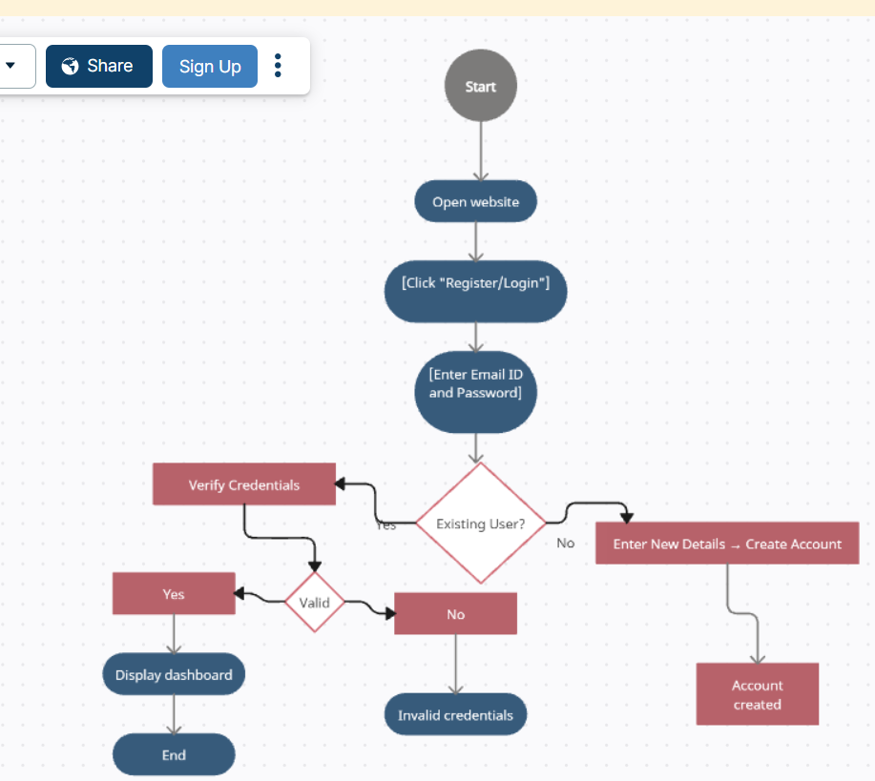

Detailed Description
- Purpose: Enables secure access to the system for all users.
- Main Flow: Existing users log in; new users register.
- Alternate Flow: Wrong password leads to “Invalid Login” message.
- Business Rule: Password must be 8+ characters, email must be unique.
- End Result: User reaches their personal dashboard successfully.

🌾 ACTIVITY 2 – Search Products
Farmer searches for products using keywords.

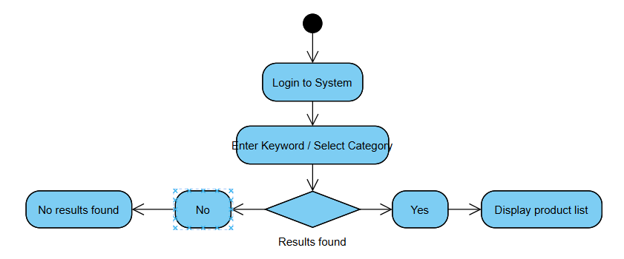

🧺 ACTIVITY 3 – Add to Cart / Buy Later

Farmer adds product to cart or wishlist.

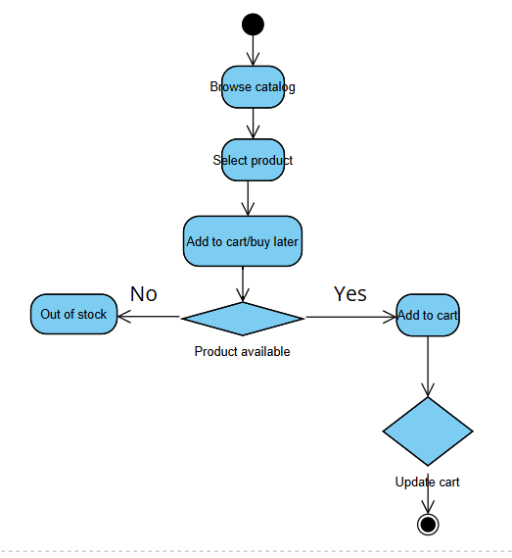

ACTIVITY 4 – Make Payment
Farmer makes payment using Gateway.

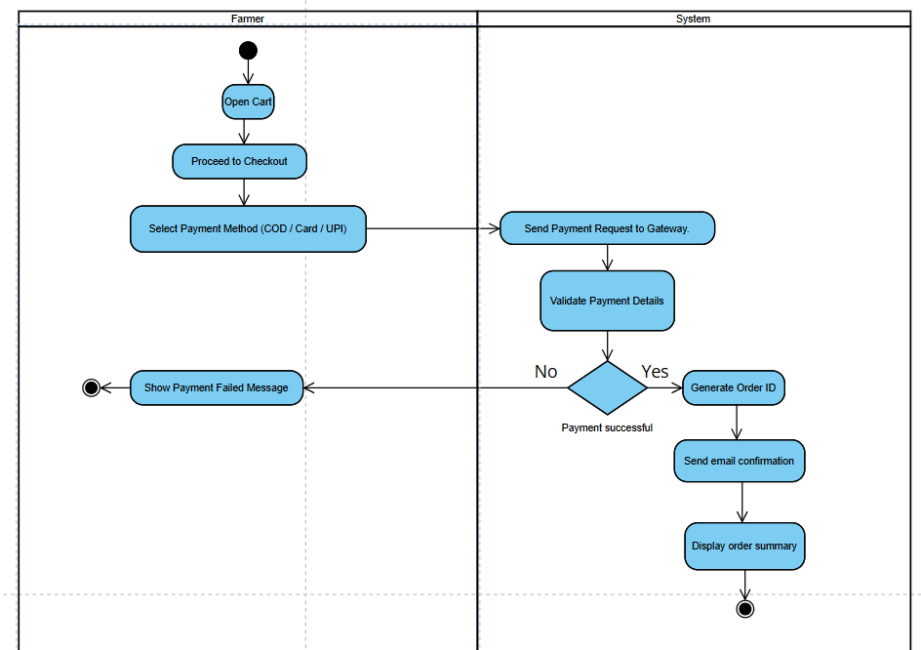

Activity Diagram 5 – Track Delivery
To model how a Farmer checks delivery status of an order through the system, which communicates with an external Delivery Service API and updates the farmer.

