Question 1 – Audits
4 Quarterly Audits are planned Q1 , Q2, Q3, Q4 for this Project What is your knowledge on how these Audits will happen for a BA ?
Q1 | Initiation & Requirements Gathering | Q2 | Analysis & Design
Time Frame | 4 weeks 30-Jun-25 to 25-Jul-25 | Time Frame | 3 weeks 28-Jul-25 to 15-Aug-25
Task Done | Project Approval | Task Done | Functional Requirements Document (FRD)
Task Done | Stakeholder List & RACI Matrix | Task Done | Use Case Diagrams
Task Done | Requirements Elicitation Records (interview notes, workshops, surveys) | Task Done | Requirements Traceability Matrix (BRD → FRD)
Task Done | Business Requirements Document (BRD) – draft & final with approvals | Task Done | Change Requests Log – documented, analyzed, approved
Task Done | Document – signed off from client | Task Done | Functional design sign-offs from SMEs/stakeholders
 |  | Task Done | Non-Functional Requirements captured

Q3 | Development & Testing Preparation | Q4 | UAT, Closure & Handover
Time Frame | 9 weeks 18-Aug-25 to 17-Oct-25 | Time Frame | 5 weeks 20-Oct-25 to 21-Nov-25
Task Done | UAT Test Scenarios/Test Cases | Task Done | User Acceptance Test Report & Feedback
Task Done | UAT Preparation (plans, data, environment readiness) | Task Done | Requirements vs. Delivery Validation
Task Done | Defects mapped back to requirements | Task Done | Post-Go-Live Support Documentation
Task Done | User Review Feedback incorporated | Task Done | Lessons Learned Document

Question 2 - Business Analyst Approach Strategy
1. BA Planning & Initiation
Conduct a Kick-off Meeting with stakeholders (Mr. Henry, Mr. Pandu, Mr. Dooku, Peter, Kevin, Ben)
Define BA roles and responsibilities as per RACI matrix
Prepare Stakeholder Register
Finalize tools: Confluence (Documentation), JIRA (Change/Tracking), MS Teams (Communication), Email (Formal approvals)
2. Stakeholder Analysis & RACI
Identify Primary & Secondary stakeholders (Committee, Farmers, Manufacturers)
Create RACI Matrix
Responsible: BA, PM
Accountable: Mr. Henry (Client Sponsor)
Consulted: Farmers (Peter, Kevin, Ben), SMEs
Informed: Dev & QA Teams
3. Elicitation Techniques
Apply appropriate methods:
Workshops – with committee & farmers for requirements
Interviews – with SMEs (Peter, Kevin, Ben)
Observation – farm visits for process understanding
Document Analysis – existing farming product workflows
Questionnaires – optional for wider farmer input
4. Requirements Documentation
Deliverables:
Document Purpose
BRD (Business Requirements Document): High-level business needs
FRD (Functional Requirements Document): Detailed system behavior
RTM (Requirements Traceability Matrix) Track requirements → design → testing
Use Case & Process Flow Diagrams (UML/BPMN) Visual representation of flows
NFR Document Captures system quality expectations
Change Request Log Track any scope/requirement changes
5. Document Review & Sign-off Process
Circulate documents via Confluence or Email
Conduct walkthroughs with stakeholders
Allow review time (3–5 working days)
Capture feedback & update docs
Obtain email confirmation or signed PDF as formal sign-off
6. Change Request Handling
All CRs logged in JIRA/CR Register
Evaluate impact on scope, time, cost
Present to committee for approval
Update BRD/FRD/RTM accordingly
Maintain version control
7. Communication Strategy
Method Frequency Audience
Email Updates Weekly Client & Committee
Team Standups Daily Internal Team
Project Status Meetings Bi-weekly PM, BA, Client
Documentation Reviews As needed SMEs & Stakeholders
8. Progress Reporting
Update status using Project Tracker Sheet
Maintain a BA Dashboard (Requirements status, CRs, risks)
Share weekly summary with PM and Client
9. UAT & Client Acceptance
Prepare UAT Plan and share test cases mapped from FRD
Coordinate UAT with Mr. Jason & Ms. Alekya (Testers)
Capture issues and ensure closure
Obtain Client Sign-off on UAT Completion
Document: Client Project Acceptance Form
Format: Signed hard/soft copy via Email
10. Collaboration with Technical Team
Provide clarifications during development
Participate in design walkthroughs
Ensure RTM is aligned with test cases
Question 3 3-Tier Architecture – Explanation & Illustration
3-tier architecture is a well-structured software design pattern that organizes applications into three logical layers:
- Presentation Tier (Client Layer)
- Application Tier (Business Logic Layer)
- Data Tier (Database Layer)
Each tier is independent and interacts with the others via defined interfaces.
+----------------------------+
| Presentation Tier | ← Web/Mobile App (Farmer UI)
|----------------------------|
| HTML / React / Android |
+----------------------------+
↓
+----------------------------+
| Application Tier | ← Java / Spring Backend (APIs & Logic)
|----------------------------|
| Business Logic, Controllers|
+----------------------------+
↓
+----------------------------+
| Data Tier | ← Database (MySQL, PostgreSQL)
|----------------------------|
| Product, Order, User Tables|
+----------------------------+
Question 4 – BA Approach Strategy for Framing Questions
To ensure every question asked to the stakeholder is structured, purposeful, and aligned with the project’s technical and business context.
1. Apply the 5W1H Framework
Element | Purpose
What | What is the functionality or requirement?
Why | Why is this needed (business value)?
When | When is it expected (timing, frequency)?
Where | Where does it apply (module/system)?
Who | Who will use it or be impacted?
How | How should it work (rules, flow)?
Example:
“How will the farmer track the order status after payment is done?”
2. Use SMART Criteria for Questions
Ensure each question leads to clear and actionable requirements.
SMART | Description
Specific | Clear and direct
Measurable | Can be tracked or validated
Achievable | Within project scope and budget
Relevant | Aligned to business objectives
Time-bound | Has a timeline or deadline
3. Consider RACI Roles
Frame questions based on the role of the stakeholder.
Stakeholder | Focus
Responsible | Execution details
Accountable | Approval and business goals
Consulted | Expert input
Informed | Awareness, no decisions needed
🔸 Tailor technical/functional depth based on stakeholder's RACI level.
4. Keep 3-Tier Architecture in Mind
Ask questions according to the layer impacted:
Tier | Example Questions
Presentation | What fields should be shown on the product detail page?
Application | What business rules apply when placing an order?
Data | What data needs to be stored when a user registers?
5. Use Case Thinking
Think in terms of system interactions:
- Actor: Who is interacting?
- Goal: What is the user trying to accomplish?
- Flow: What steps are involved?
Frame questions to build:
- Use Case Specs: "What happens if payment fails?"
- Activity Diagrams: "What are the steps to cancel an order?"
- Wireframes/Page Designs: "What fields are mandatory on the product form?"
Question 5 – Elicitation Techniques
Elicitation Techniques (BDRFOWJIPQU)
Code | Technique | Description
B | Brainstorming | Used for generating a wide range of ideas from stakeholders in a group setting. Helps in identifying possible solutions or requirements.
D | Document Analysis | Reviewing existing documents, process flows, manuals, and reports to extract relevant information and requirements.
R | Reverse Engineering | Understanding existing systems by analyzing current applications to derive business rules and functionality.
F | Focus Groups | A guided discussion with a group of stakeholders having common interests to gather opinions, feedback, and expectations.
O | Observation (Job Shadowing) | Watching users perform tasks in their environment to understand actual workflows and identify pain points.
W | Workshops (Requirement Workshops) | Structured sessions with multiple stakeholders to collaboratively define requirements, resolve conflicts, or design processes.
J | Joint Application Development (JAD) | Intensive workshops involving users, developers, and BAs to speed up requirement gathering and validation.
I | Interviews | One-on-one discussions with stakeholders to capture detailed insights, preferences, and pain points.
P | Prototyping | Creating visual mockups or low/high-fidelity prototypes to gather feedback and validate requirements.
Q | Questionnaires / Surveys | Written sets of questions shared with a larger audience to gather input efficiently, especially when time is limited.
U | User Task Analysis | Studying the steps a user performs to complete a task to identify usability or functional requirements.
✅ When to Use Which:
- Early Phase: Interviews, Document Analysis, Observation
- Mid Phase: Workshops, JAD, Brainstorming, Focus Groups
- Validation: Prototyping, Questionnaires, Reverse Engineering
Question 6 – This project Elicitation Techniques
Selected Techniques and Justification
Technique | Justification
1. Document Analysis | Reviewed existing processes, regulatory inputs, or prior proposals shared by SOONY and stakeholders (Peter, Kevin, Ben) to understand current farming challenges, login flows, and catalog needs. Helped define initial BRs like BR001 & BR002.
2. Interviews | Conducted one-on-one sessions with Mr. Henry (Sponsor) and farmers (Peter, Kevin, Ben) to capture expectations and pain points directly. This enabled the identification of key functional needs like login, product catalog, search, payment methods, and delivery tracking.
3. Brainstorming | Held collaborative sessions with internal teams (PM, Devs, QA, BA) to ideate on user-friendly features (search filters, secure login, buy-later list, multiple payment options). Enabled convergence on feasible technical solutions aligned with 3-tier architecture.
4. Prototyping | Created screen mock-ups for login, search, catalog, and payment flows. Shared with stakeholders for validation, ensuring the UI/UX expectations of rural farmers are met. Helped refine unspoken requirements (e.g., order confirmation email, easy checkout).
5. Use Case Specifications | Developed use case specs for:
🔹 Login/Registration
🔹 Browse Product Catalog
🔹 Place Order and Payment
🔹 Delivery Tracking
This structured documentation ensures clear handover to design, development, and testing teams.
Identified Business Requirements
BR ID | Requirement Description
BR001 | Farmers should be able to search for available products in fertilizers, seeds, pesticides
BR002 | Manufacturers should be able to upload and display their products in the application
BR003 | Users (farmers/manufacturers) must be able to register/login using email ID and password
BR004 | Farmers must have access to an easy-to-use payment gateway (COD, card, UPI)
BR005 | Users must receive email confirmation after placing an order
BR006 | Farmers should be able to track order delivery status in real-time
Conclusion:
The selected techniques — Document Analysis, Interviews, Brainstorming, Prototyping, Use Case Specifications — were chosen based on:
- Nature of stakeholders (non-technical, rural users)
- Need for clarity in UX design
- Functionality-heavy scope
- Technical solution alignment with 3-tier architecture
Question 7 – 10 Business Requirements
BR ID | Business Requirement Description
BR001 | Farmers should be able to search and browse available products (fertilizers, seeds, pesticides).
BR002 | Manufacturers should be able to upload, update, and manage their product listings.
BR003 | All users (farmers and manufacturers) should be able to register and log in using their email ID and password.
BR004 | New users should be able to create an account by submitting email ID, creating a password, and verifying via email.
BR005 | Farmers should be able to add products to a “Buy Later” or wishlist section for future purchase.
BR006 | Farmers should be able to make payments using COD, Credit/Debit card, or UPI methods.
BR007 | Farmers should receive automated email confirmation after placing an order.
BR008 | Farmers should be able to track their orders through a delivery tracking module.
BR009 | Admin users should be able to manage product categories, users, and monitor system activity. (Assumed for backend control)
BR010 | The system should support role-based access control for farmers, manufacturers, and administrators. (Assumed for access security)
Assumptions Made:
- Admin module is required for managing users and content.
- System must support role-based access to control views and actions.
- Email verification is mandatory during new user registration.
- Wishlist (Buy Later) is a user-centric feature expected in modern applications.
- The platform must handle multiple payment gateways to increase adoption.
Question 8 –Assumptions
No. | Assumption
A1 | All users (farmers and manufacturers) will have access to basic internet connectivity.
A2 | Manufacturers will manage their own product catalog (add/update/delete products).
A3 | The application will support both web and mobile interfaces.
A4 | Product categories (fertilizers, seeds, pesticides) will be pre-defined and managed by the admin.
A5 | Farmers and manufacturers will use email ID for login and communication.
A6 | Email and SMS integration is feasible for order confirmations and notifications.
A7 | Secure payment gateway integration (UPI, debit/credit cards, COD) will be provided by certified third parties.
A8 | Delivery and logistics will be handled by third-party providers or manufacturer tie-ups.
A9 | Admin users will be responsible for system monitoring and resolving disputes.
A10 | The application will follow standard 3-tier architecture: Presentation Layer, Business Logic Layer, and Data Layer.
Question 9 – This project Requirements Priority
Requirements Priority Table
Req ID | Req Name | Req Description | Priority (1-10)
BR001 | Farmer Search for Products | Farmers should be able to search for available products in fertilizers, seeds, pesticides. | 8
BR002 | Manufacturers Upload Products | Manufacturers should be able to upload and display their products in the application. | 8
BR003 | User Registration & Login | Users (farmers/manufacturers) should register and log in securely. | 10
BR004 | Product Catalog Browsing | Users should be able to browse the product catalog by category. | 9
BR005 | Add to Cart / Buy Later List | Users can add selected items to cart or save for later. | 7
BR006 | Payment Gateway Integration | Application should support UPI, Debit/Credit Card, and COD payment options. | 10
BR007 | Order Confirmation Email | Send email notifications to users after successful order placement. | 7
BR008 | Delivery Tracking | Enable users to track delivery status of their orders. | 9
BR009 | Product Rating & Reviews | Farmers should be able to rate and review purchased products. | 6
BR010 | Admin Panel for Monitoring | Admin should be able to manage users, disputes, and monitor activity. | 8
Question 10 – Use Case Diagram
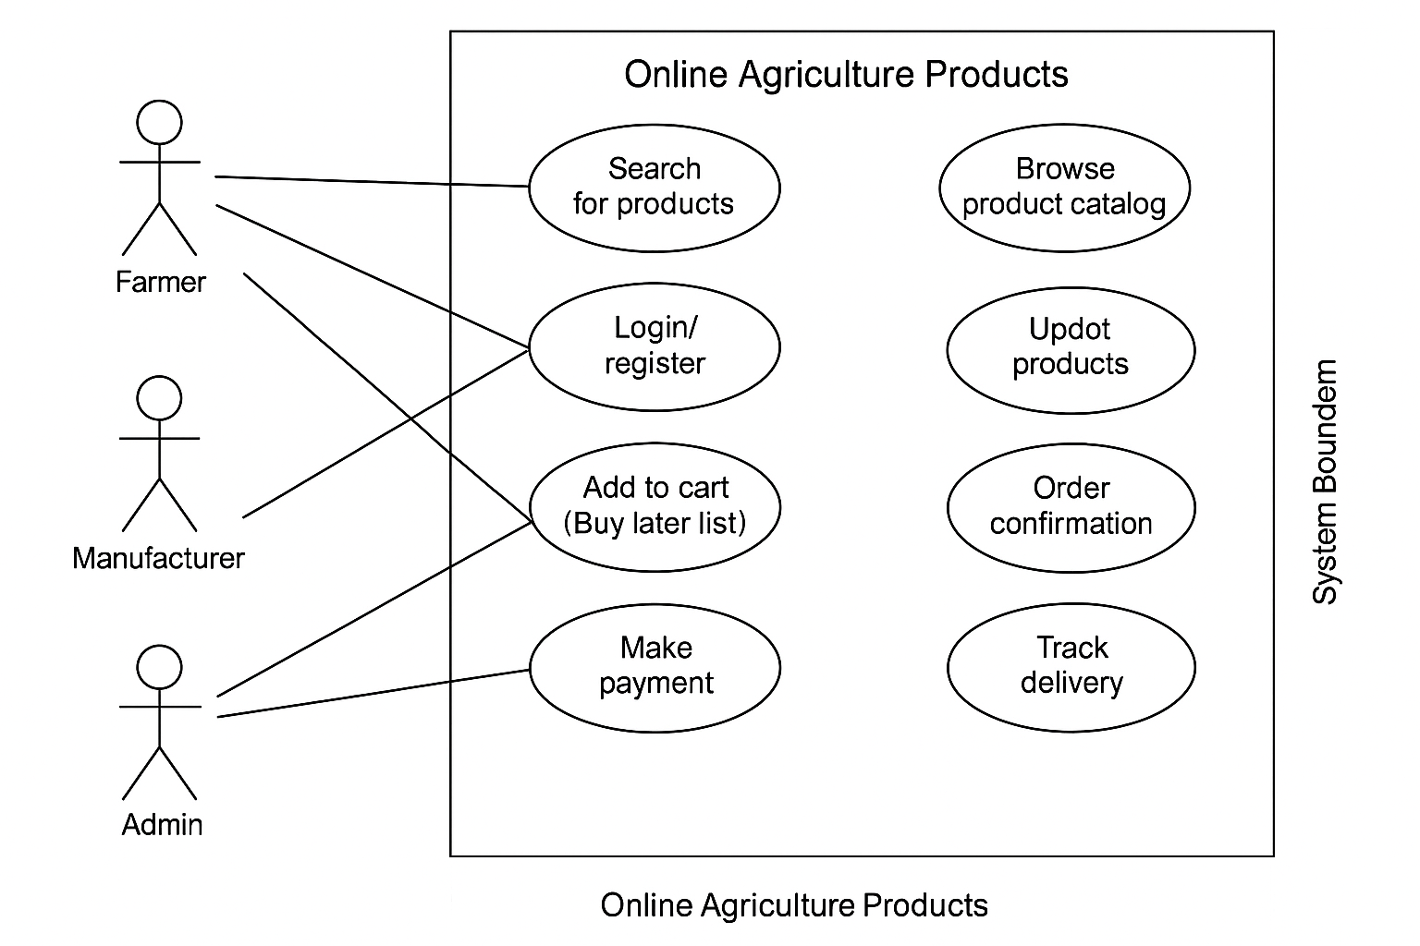
Question 11 – (minimum 5) Use Case Specs
Use Case 1: User Registration and Login
- Use Case ID: UC001
- Actor(s): Farmer, Manufacturer
- Precondition: User is not logged in
- Postcondition: User is authenticated and redirected to dashboard
- Basic Flow:
  - User clicks on register/login
  - Enters credentials
  - System verifies
  - User redirected to home page
- Exception: Invalid credentials or duplicate registration
- Priority: High
Use Case 2: Browse Product Catalog
- Use Case ID: UC002
- Actor(s): Farmer
- Precondition: User is logged in
- Postcondition: Products displayed
- Basic Flow:
  - User selects product category
  - System displays list of products
- Exception: No products available
- Priority: High
Use Case 3: Search for Products
- Use Case ID: UC003
- Actor(s): Farmer
- Precondition: User is logged in
- Postcondition: Matching products shown
- Basic Flow:
  - User enters search term
  - System fetches and displays results
- Exception: No match found
- Priority: High
Use Case 4: Upload Product Details
- Use Case ID: UC004
- Actor(s): Manufacturer
- Precondition: Manufacturer is logged in
- Postcondition: Product added to catalog
- Basic Flow:
  - Manufacturer enters product info
  - System validates and saves data
- Exception: Invalid data or upload error
- Priority: High
Use Case 5: Add to Cart / Buy Later
- Use Case ID: UC005
- Actor(s): Farmer
- Precondition: User is browsing products
- Postcondition: Product added to cart or saved
- Basic Flow:
  - User clicks "Add to Cart" or "Buy Later"
  - System confirms action
- Exception: Session timeout
- Priority: Medium
Question 12 – (minimum 5) Activity Diagrams
