Document 6- Please prepare a use case diagram, activity diagram and a use
case specification document.
1. Use case Name
2. Use case Description
3. Actors Primary Actors Secondary actors
4. Basic Flow
5. ALTERNATE FLOW
6. Exceptional flows
7. Pre- Conditions
8. post-conditions
9. Assumptions
10. Constraints
11. Dependencies
12. Inputs and Outputs
13. Business Rules
14.Miscellaneous Information
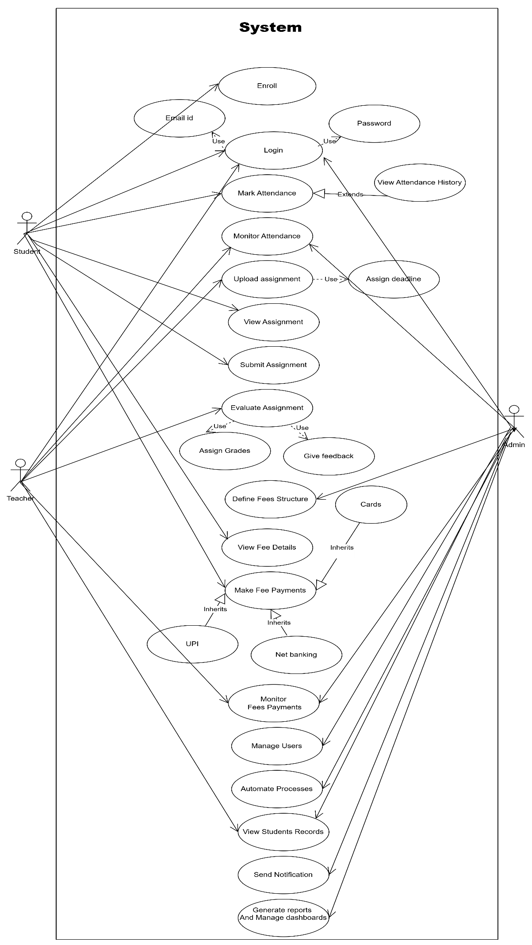
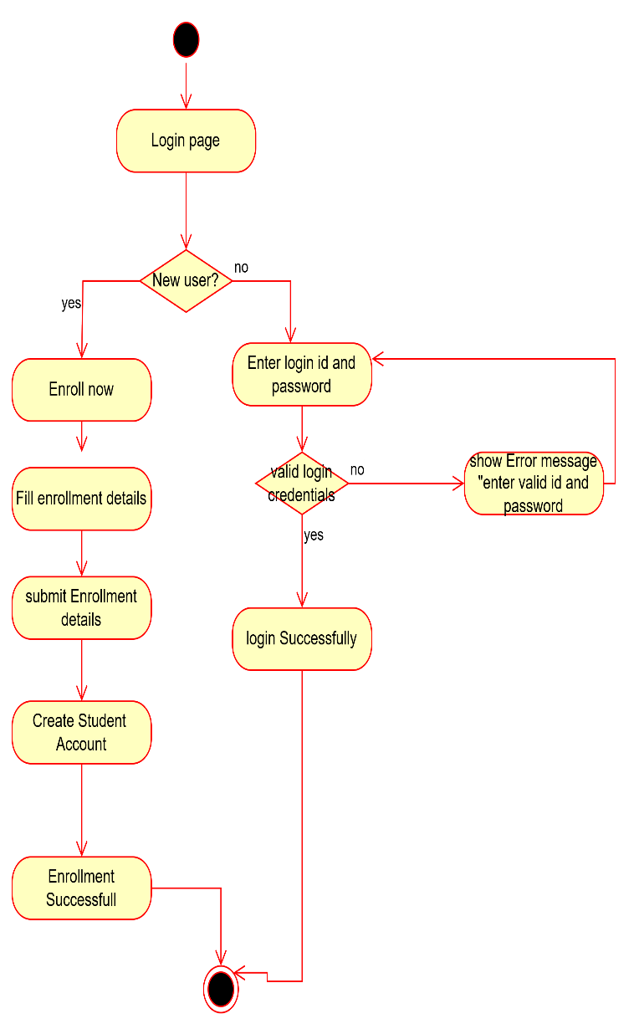
1] Student login & Enrollment 2] Student marking attendance
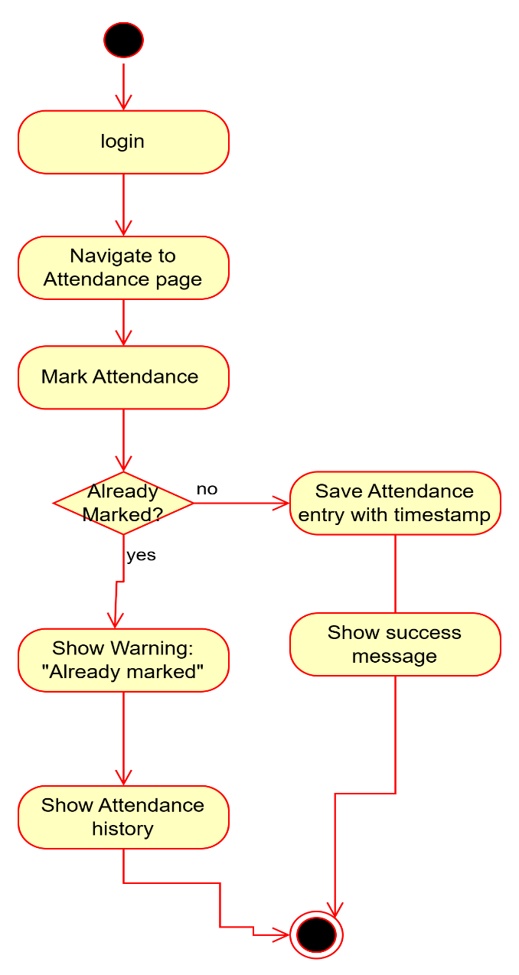

3] Teacher uploading Assignment
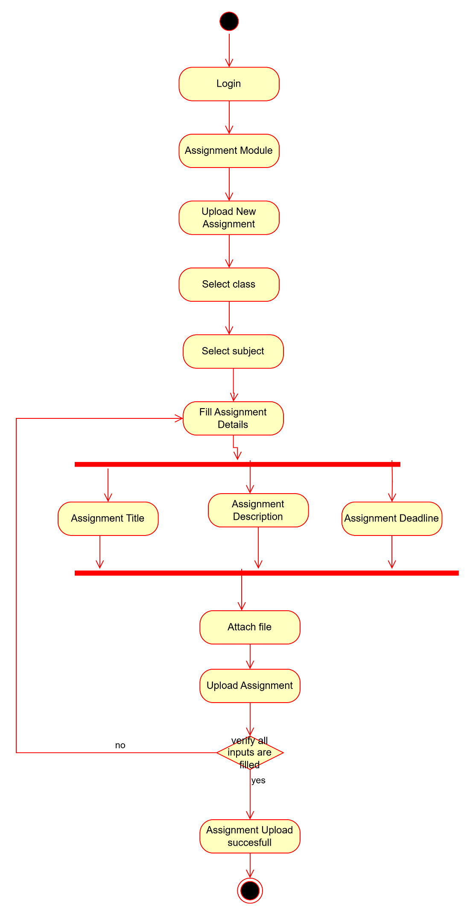
4] Student submitting assignment
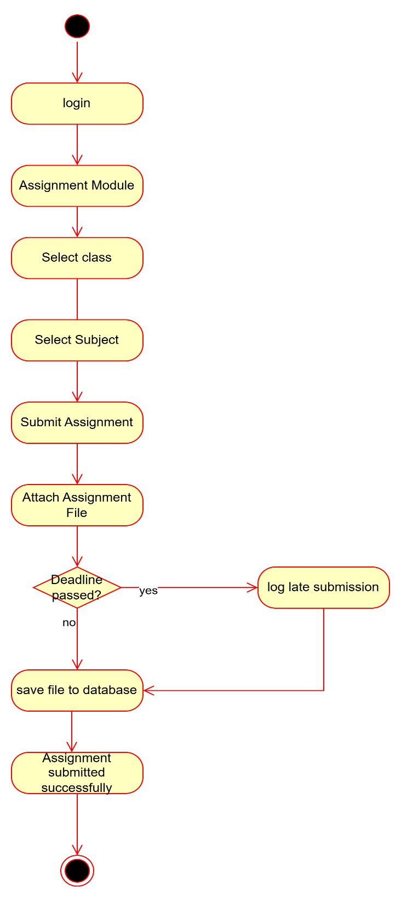

5] Student making fees payment
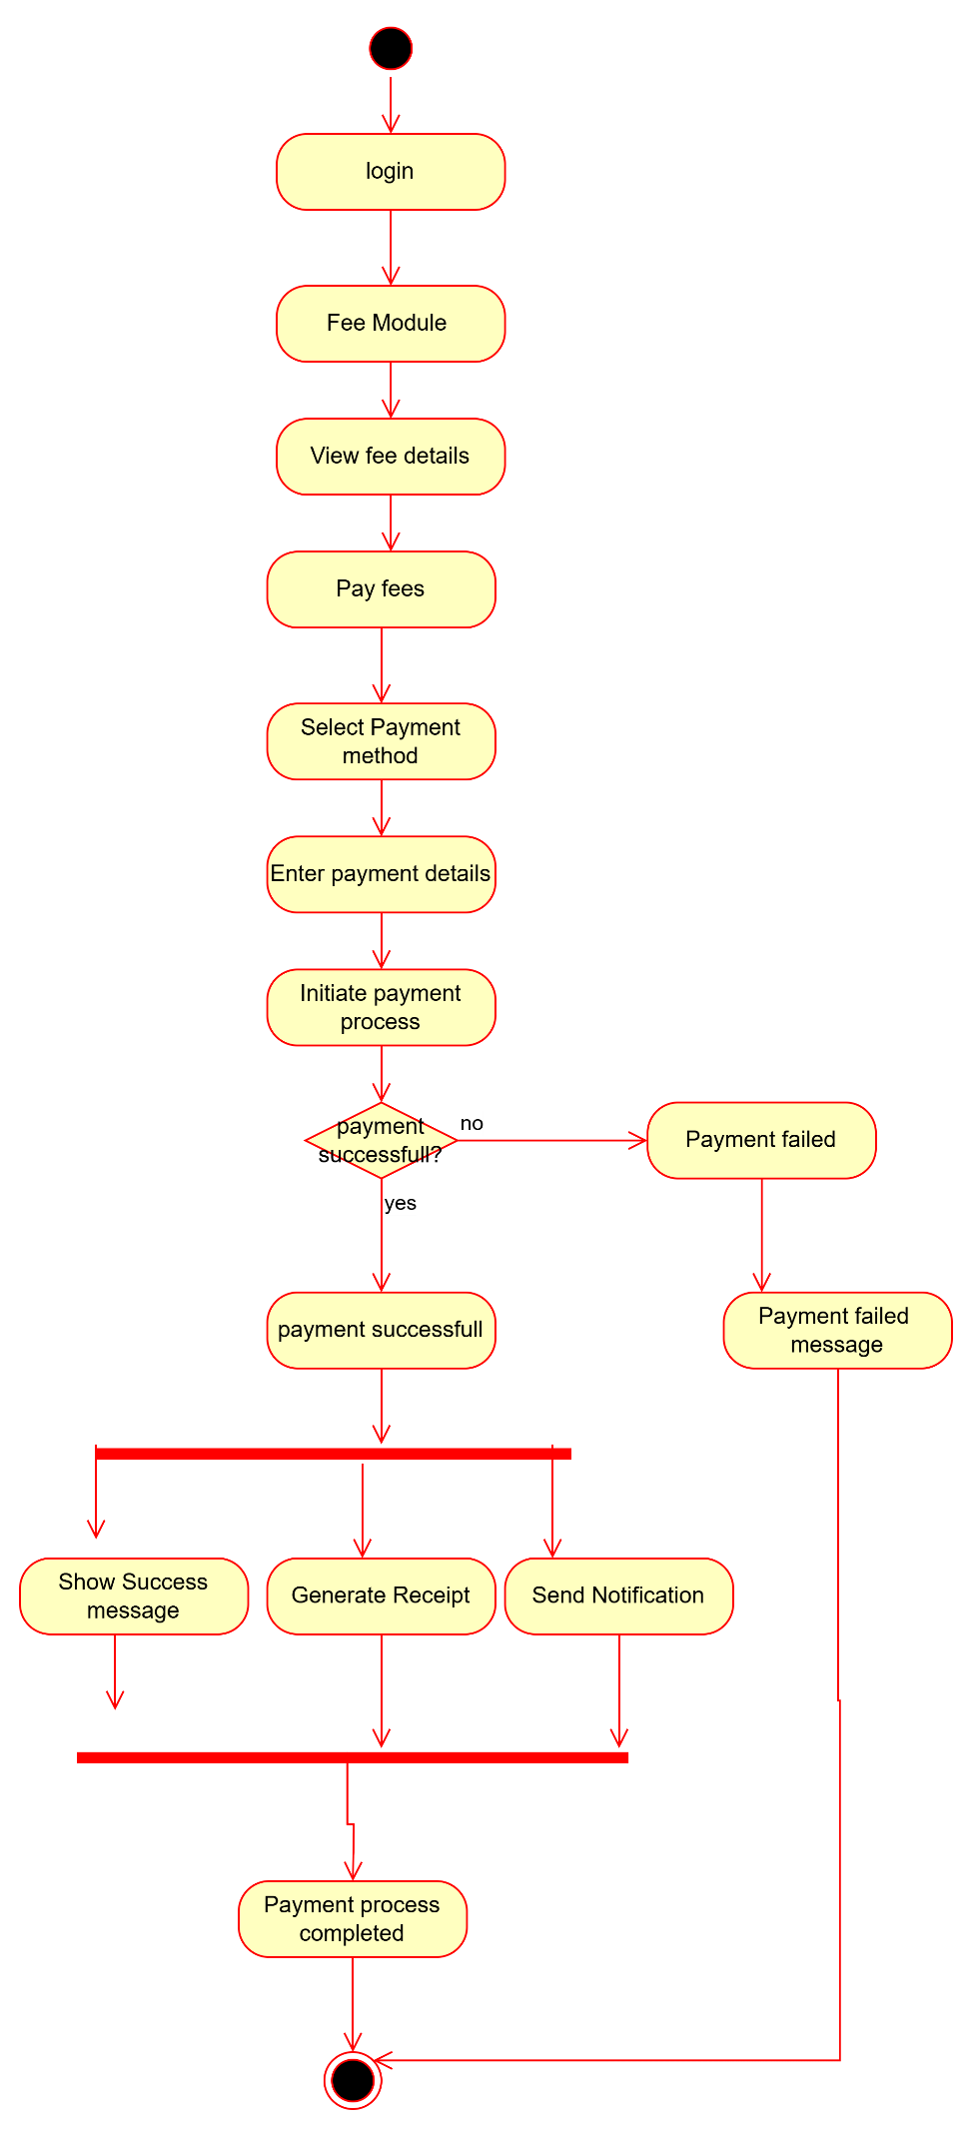

Use case specification document.
- User Login and Enrollment
Use Case Name: User Login and Enrollment

Actor | Primary Actor: Student  Secondary Actor: System (performs validation, account creation)
Description | This use case allows students to either log in using existing credentials or enroll if they are new. New users must register by filling out enrollment details, after which an account is created and they are logged in. Existing users can log in directly using their credentials.
Basic Flow | 1)User accesses the login page.  2) System asks if the user is new.  1]If new:  a. Click "Enroll now".  b. Fill in enrollment details.  c. Submit the form.  d. System creates a student account.  e. Enrollment successful → User logged in.  2]If existing:  a. Enter login ID and password.  b. System validates credentials.  c. If valid → Login successful.
Alternative flows | 1] Already enrolled (skip enrollment):  If the user clicks “no” to "New user?" prompt, they go directly to the login process.
Exceptional Flows: | 1] Invalid login credentials:  System shows an error message: “Enter valid ID and password” and prompts user to try again.  2] Incomplete enrollment form:  System shows a validation message and prevents form submission.
Pre-conditions: | - The user has internet access and reaches the login page.  - For login: User account must already exist.  - For enrollment: Valid input data is provided.
Post-conditions: | - The user is successfully logged in and redirected to the dashboard.
Assumptions: | - Users know whether they are new or existing.  - Credentials and enrollment data are valid.
Constraints: | - Mandatory fields must be filled during enrollment.  - Only registered users with valid credentials can log in.  - Input format rules (e.g., email format, password strength).
Dependencies: | - Database for storing and retrieving user data.  - Email service for optional confirmation.  - UI page routing logic.
Inputs and Outputs: | Inputs:  - Login: ID and Password  - Enrollment: Name, Email, Course Info, etc.  Outputs:  - Success or error messages  - Student account creation confirmation  - Redirect to dashboard
Business Rules: | - One email ID per user  - Password must meet minimum security standards  - Retry login limited to 3 attempts
Miscellaneous Information: | - The login process should log all attempts (successful and failed) for security audit.  - Optionally, CAPTCHA can be added to prevent bots.

- Student mark Attendance
Use Case Name: Student mark Attendance

Actor | Primary Actor: Student  Secondary Actor: System (validates, stores timestamp, handles messages)
Description | This use case allows a logged-in student to mark their attendance. If the attendance for the day is not already marked, the system saves the entry with a timestamp and confirms success. If already marked, the system warns the student and displays the attendance history.
Basic Flow | - Student logs into the system.  - Student navigates to the Attendance page.  - Student clicks Mark Attendance.  - System checks if attendance is already marked.  - If not already marked:  a. System records timestamped attendance entry.  b. System displays success message.  c. Student is redirected or shown confirmation.
Alternative flows | 1] Already marked attendance:  a. System detects previous entry.  b. Displays warning message: "Already marked."  c. Displays attendance history to the student.
Exceptional Flows: | 1]System error while saving:  a. Database failure or timeout.  b. System displays error message: "Unable to save attendance. Please try again."  2]Not logged in:  a. Access denied to attendance page.  b. Redirect user to login screen.
Pre-conditions: | - Student must be authenticated (logged in).  - Attendance page is accessible.
Post-conditions: | - Attendance is either recorded or the user is notified of previous entry.  - Confirmation or warning is displayed.  - History is optionally available.
Assumptions: | - Students are required to mark attendance daily.  - Each student can mark attendance only once per day.
Constraints: | - Attendance must be marked within a specific time window (e.g., between 8 AM and 12 PM).  - One entry per student per date.  - Clock must be synced (server timestamp used).
Dependencies: | - Attendance database table.  - User authentication system.  - Server-side time and date service
Inputs and Outputs: | - Inputs: click action.  - Outputs:  - Success message  - Warning message  - Attendance history (view)
Business Rules: | - No duplicate attendance entries.  - System time is authoritative.  - History view is sorted by date (descending).  - Attendance marked outside permitted time is invalid.
Miscellaneous Information: | - Optional: Location/IP can be logged to prevent misuse.  - Optionally notify Teacher/admin if attendance fails multiple times.

  - Upload Assignment

Use Case Name: Upload Assignment
Actor | Primary Actor: Teacher  Secondary Actor: System
Description | This use case enables a teacher to upload a new assignment for a selected class and subject. The teacher must provide necessary details (title, description, deadline) and attach a file. The system verifies the completeness of input before confirming the upload.
Basic Flow | - Teacher logs into the system.  - Navigates to the Assignment Module.  - Selects Upload New Assignment.  - Chooses the Class and Subject.  - Fills in the Assignment Details:  Title, Description, Deadline  - Attaches the assignment file.  - Clicks Upload Assignment.  - System verifies all required fields are filled.  - If verification passes, the system saves the assignment.  - System confirms with message: "Assignment upload successful."
Alternative flows | - Missing Required Fields:  - If title, description, deadline, or file is missing:  a. System redirects back to the assignment form.  b. Highlights missing fields.  c. Prompts teacher to complete input before re-submitting.
Exceptional Flows: | - 1) System Error During Upload:  - If a file fails to upload due to server or network error:  - Show error message: “File Upload failed, try again later.”  - 2) Session Timeout / Not Logged In:  - If the session expires before submission, prompt teacher to log in again.
Pre-conditions: | - Teacher must be logged in.  - Assignment module must be active and available.
Post-conditions: | - Assignment is saved and associated with the selected class and subject.  - Students in that class will be able to view and submit the assignment.
Assumptions: | - Teachers have permissions to upload assignments for specific classes.  - File formats and size limits are predefined.
Constraints: | - Mandatory fields: title, description, deadline, and file.  - File size must not exceed system-defined limits (e.g., 20 MB).  - Deadline cannot be a past date.
Dependencies: | - Assignment module must be operational.  - Storage/database service must be available.  - Class and subject lists must be pre-defined in the system.
Inputs and Outputs: | Inputs:  - Class, Subject  - Assignment Title, Description, Deadline  - File upload  Outputs:  - Assignment saved confirmation  - Error messages (if any)
Business Rules: | - One assignment per class/subject per date allowed.  - Teachers can update or delete their assignments after upload.  - Uploaded files are virus scanned and stored securely.
Miscellaneous Information: | - Optionally notify students via in-app notification or email once assignment is uploaded.  - Logs may be maintained for upload actions for auditing.

  - Use Case Name: Submit Assignment
Actor | Primary Actor: Student  Secondary Actor: System
Description | This use case describes the process for a student to submit an assignment for a specific class and subject. The system logs late submissions if the deadline has passed and ensures the assignment file is stored correctly.
Basic Flow | - Student logs into the system.  - Navigates to the Assignment Module.  - Selects the Class.  - Selects the Subject.  - Clicks Submit Assignment.  - Attaches the assignment file.  - System checks if the submission deadline has passed.  - If the deadline has not passed:  - Save the file to the database.  - Display the message: "Assignment submitted successfully."
Alternative flows | 1) Late Submission Flow:  - If the deadline has passed:  a. System logs the late submission.  b. Proceeds to save the file to the database.  c. Shows: "Assignment submitted successfully (Late submission logged)."
Exceptional Flows: | 1) File Not Attached:  - System displays: "No file attached. Please upload your assignment."  - User is prompted to try again.  2)System Error While Saving File:  - System shows: "Submission failed due to a system error. Please try again later."  - Submission is aborted.
Pre-conditions: | - Student must be logged into the system.  - Assignment for the selected subject and class must be active.  - Deadline information must be available.
Post-conditions: | - Assignment file is saved to the system database.  - Submission is marked as on-time or late depending on the timestamp.
Assumptions: | - The assignment deadline is stored and correctly maintained in the system.  - Each student can submit one assignment per subject per class.  - The file upload process is secure and supports allowed formats.
Constraints: | - File formats accepted: PDF, DOCX (or institution-defined).  - File size limit (e.g., max 20MB).  - Deadline is enforced using the server’s system time.
Dependencies: | - Assignment metadata (deadline, subject, class) must exist and be accurate.  - The file storage system and backend database must be operational.  - Authentication system must confirm valid student session.
Inputs and Outputs: | - Inputs:  - Class and Subject selection  - Assignment file  - Outputs:  - Confirmation message  - Optional late submission log
Business Rules: | - Late submissions must be logged for teacher visibility.  - Students can’t submit assignments for past closed subjects.  - Resubmissions (if allowed) overwrite previous ones and update the timestamp.
Miscellaneous Information: | - A notification may be sent to the teacher about a new or late submission.  - An audit log can be maintained for academic integrity purposes.

  - Make fee payment
Use Case Name: Make fee payment
Actor | Primary Actor: Student  Secondary Actor: System, Admin
Description | This use case outlines the process through which a student makes a fee payment using the student management system. It includes viewing fee details, selecting a payment method, entering payment credentials, and completing the payment. The system also handles payment failures and provides notifications.
Basic Flow | - Student logs into the system.  - Navigates to the Fee Module.  - Views their Fee Details.  - Clicks on Pay Fees.  - Selects a Payment Method.  - Enters Payment Details.  - Initiates the Payment Process.  - Payment is successful.  - System:  - Shows a Success Message  - Generates and allows the user to Print Receipt  - Sends Notification of payment confirmation  10. System marks the Payment Process as Completed.
Alternative flows | 1 ) Payment Failed Flow:  - If the payment fails:  a. System shows "Payment Failed" screen  b. Displays error message  c. Option to retry or exit
Exceptional Flows: | 1] Invalid Payment Details:  - System detects invalid or incomplete input  - Shows validation error message  - Prompts user to correct and retry  2] Network or Processing Error:  - If timeout or gateway error occurs  - System displays a failure message and logs the event  - User can retry the process
Pre-conditions: | - Student is logged in.  - Fee is due and displayed in the system.  - Payment system is operational.
Post-conditions: | - Fee is marked as paid  - Payment receipt is stored and available to user  - Notification is sent confirming the transaction
Assumptions: | - Student has access to the internet and valid payment credentials  - The payment gateway is integrated and functional  - Student has sufficient funds or credit limit
Constraints: | - Only approved payment methods can be used  - Fee amount is fixed and cannot be changed by the student  - Payment details must be securely encrypted
Dependencies: | - External payment gateway  - Notification system (email/SMS)  - Printing subsystem or PDF generator for receipt
Inputs and Outputs: | Inputs:  - Login credentials  - Payment method and details  Outputs:  - Payment success/failure status  - Payment receipt  - Confirmation or error notification
Business Rules: | - Students must pay full outstanding fees unless partial payment is allowed  - Each payment attempt is logged for security and audit  - A receipt must be generated for every successful payment  - Duplicate transactions must be prevented
Miscellaneous Information: | - Unique transaction/reference ID is generated for each payment  - Admins may be notified of high-value payments or repeated failures  - Payment status can be reviewed in student’s financial records

Document 7- Screens and pages
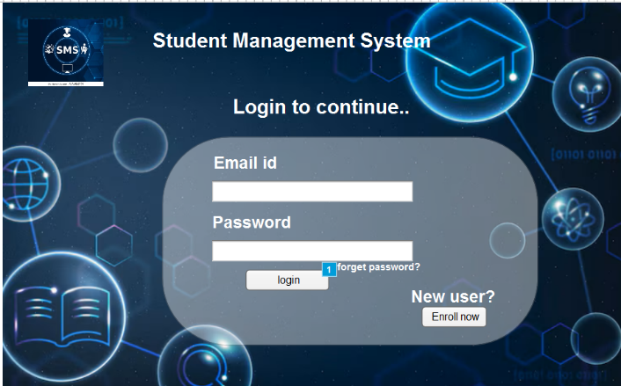
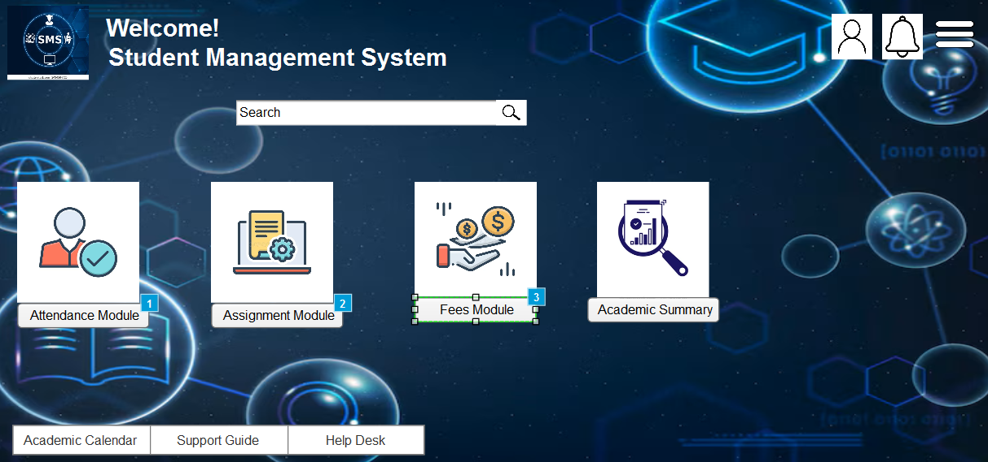

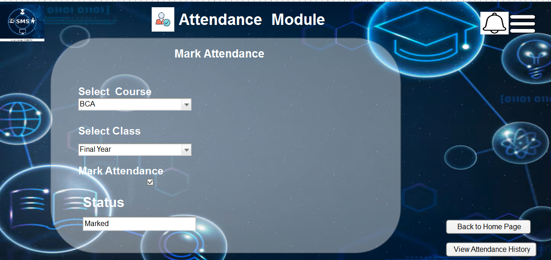

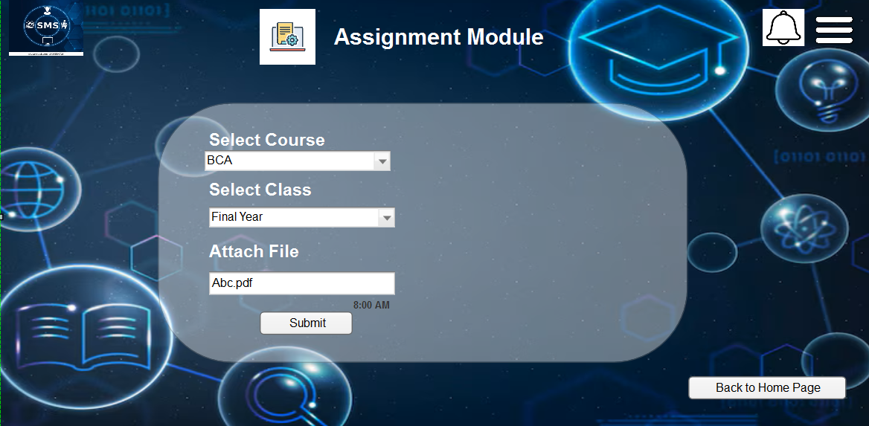

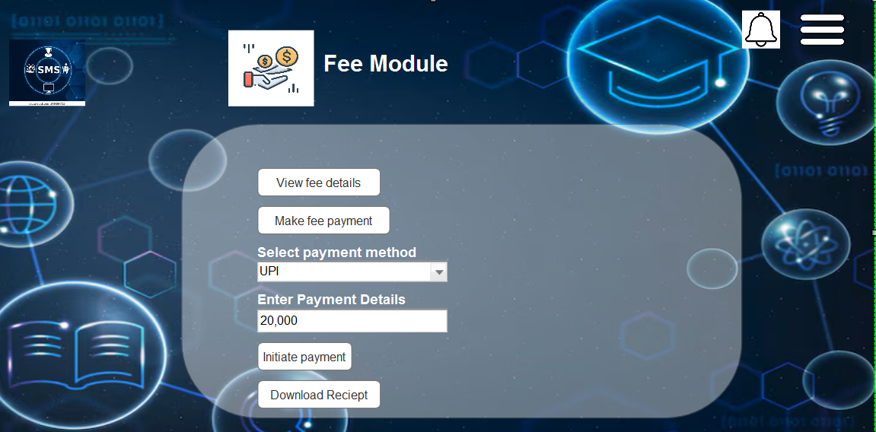

Document 8- Tools-Visio and Axure
Write a paragraph on your experience using Visio and Axure for the project.
Answer-
During the SMS (Student Management System) project, I utilized Microsoft Visio to create various visual artifacts such as use case diagrams and activity diagrams. These diagrams helped in effectively communicating system functionality and process understanding to stakeholders and development teams. Visio’s intuitive interface allowed me to quickly design and update diagrams based on evolving requirements. In parallel, I used Axure RP to build interactive wireframes and prototypes for key modules like attendance, assignment submission, and fee payment. These prototypes enabled early validation of UI/UX with clients and end-users, reducing potential rework during development. Axure’s features like dynamic panels, conditions, and page linking allowed me to replicate real-time behaviors, making the mockups more realistic. Both tools played a crucial role in requirement validation, stakeholder alignment, and improving communication across teams during the project lifecycle.

Document 9- BA experience
Answer-
My experience as BA in following phases:
1.Requirement Gathering
As a Business Analyst, I initiated the Student Management System (SMS) project by conducting a comprehensive understanding of institutional processes through kick-off meetings with primary stakeholders including school administrators, academic coordinators, finance personnel, IT support teams, and faculty members. The goal was to identify key pain points such as manual attendance tracking, fragmented fee management, lack of real-time student performance updates, and inefficient communication between departments.
To ensure effective elicitation of requirements, I used multiple techniques:
- Workshops with academic and administrative staff to understand end-to-end workflows—like attendance management, fee collection, assignment tracking, and report card generation.
- Observation (Job Shadowing) of clerical and teaching staff to capture practical challenges in maintaining student records, communicating with parents, and processing payments.
- Document Analysis of admission forms, attendance sheets, fee receipts, assignment templates, and exam reports to identify redundant data capture and process inconsistencies.
- Surveys and Questionnaires distributed to teachers, parents, and students to gather feedback on existing systems and understand expectations from a digital solution.
- Prototyping was employed early to build low-fidelity mockups of critical modules like the stu attendance page, assignment submission flow, and fee payment screen. These prototypes helped clarify unclear requirements and align stakeholder expectations.

2. Requirement Analysis – During the requirement analysis phase of the Student Management System, I created UML and activity diagrams to clearly represent system workflows like attendance, assignments, and fee payments. These visuals helped the team understand the process and identify gaps. I conducted review sessions with developers and stakeholders to refine the diagrams and requirements. Based on this, I prepared the Business Requirements Specification (BRS) and Software Requirements Specification (SRS) to ensure clear documentation and alignment with project goals.

3. Design – In the design phase, I collaborated with UI/UX designers and developers to create wireframes and mockups for key SMS modules like the assignment module, attendance module, and fee payment module. I derived test cases from use case diagrams, covering both positive and negative scenarios. These designs were reviewed with stakeholders for approval. I also ensured all requirements were mapped in the Requirements Traceability Matrix (RTM) to maintain alignment between design and functional needs.

4. Development: During the development phase of the SMS project, I led JAD sessions to align the technical team and stakeholders. I clarified module-specific queries (attendance, assignments, fees) and resolved internal conflicts through one-on-one discussions. I ensured UML diagrams guided development effectively. Despite scheduling challenges, I maintained regular sync-ups, sharing recordings and follow-ups to keep everyone aligned.
5. Testing: During the testing phase of the SMS project, I prepared detailed test cases based on use cases and coordinated high-level testing activities. I gathered necessary test data from the client, ensured the RTM was updated to maintain requirement traceability, and facilitated client sign-off. I also guided the client team through UAT preparation to ensure readiness for final validation.
6. Deployment: During the deployment phase of the SMS project, I shared the updated RTM with the client as part of the project closure documentation. I coordinated the creation and distribution of end-user manuals, organized role-specific training sessions, and ensured all relevant users attended the sessions for a smooth system handover and adoption.

