Assignment 1:

A company is having manufacturing plants and warehouses in various parts of the country. They manufacture ice-cream and milk products. They want to build software to achieve two goals.
- Manage the inventory
- Quickest delivery to the customers

- Please make a BRD which can be presented to the client along with complete development and resource plan.
Answer:

Business Requirement Document (BRD)
Project Name: Inventory & Delivery Management System
Project ID: IDMS-001
Version ID: 1.0
Author: Kunal Kadambande

- Document Revisions

Date | Version Number | Document Changes
20/08/2025 | 0.1 | Initial draft created with business goals and high-level objectives
22/08/2025 | 0.2 | Added ROI analysis, stakeholder mapping, and key requirements
24/08/2025 | 0.3 | Refined scope and business rules based on supply chain team feedback
26/08/2025 | 0.4 | Integrated project constraints, risks, and process flows
28/08/2025 | 0.5 | Final review formatting for client submission

2. Approvals
Role | Name | Title | Signature | Date
Project Sponsor | Amit Shah | Director (Operations) | TBD | 22/08/2025
Business Owner | Meena Rao | Supply Chain Head | TBD | 23/08/2025
Project Manager | Vickykumar Sancheti | Project Manager | TBD | 24/08/2025
System Architect | Neha Kulkarni | Solution Architect | TBD | 25/08/2025
Development Lead | Saurabh Patil | Lead Developer | TBD | 26/08/2025
User Experience Lead | Rucha Mehta | UI/UX Designer | TBD | 26/08/2025
Quality Lead | Arvind Rao | QA Lead | TBD | 27/08/2025
Content Lead | Pooja Iyer | Documentation Lead | TBD | 27/08/2025

3. RASCI Chart for This Document

RASCI Chart:
Name | Position | R | A | S | C | I
Kunal Kadambande | Business Analyst | X |  |  | X
Vickykumar Sancheti | Project Manager |  | X | X | X | X
Amit Shah | Project Sponsor |  |  |  |  | X
Saurabh Patil | Development Lead | X |  |  | X
Arvind Rao | QA Lead |  |  |  | X | X
Meena Rao | SCM Head |  |  |  | X | X

4. Business Goals
Need:
The company requires a centralized software system to manage inventory across multiple plants and warehouses, and to ensure the quickest delivery of ice-cream and milk products to customers.
4.1 Goals
- Real-time tracking of inventory levels at all plants/warehouses.
- Automate replenishment to avoid stockouts/wastage.
- Route orders to the nearest warehouse for quickest delivery.
- Reduce manual dependency in logistics.
- Enable management reporting for sales, demand, and wastage.
- Improve customer satisfaction via faster delivery and order visibility.

4.2 Business Objectives
- Automate inventory tracking for plants & warehouses.
- Implement delivery optimization based on geolocation.
- Provide dashboards for managers (stock, pending orders, expiry alerts).
- Automate alerts for perishable stock nearing expiry.
- Ensure role-based access (Admin, Warehouse Manager, Delivery Partner).
- Generate real-time reports in Excel/PDF formats.

4.3 Business Rules
- Orders must always be assigned to the nearest warehouse with available stock.
- Expiry alerts for milk products = 7 days before expiry; for ice-cream = 15 days before expiry.
- Deliveries must be dispatched within 2 hours of order placement.
- Customers can only view their orders, not warehouse data.
- Records must be archived for 5 years for audit purposes.

4.4 Background
Currently, the company uses manual tracking with spreadsheets, leading to:
- Delays in order fulfilment.
- Stock wastage due to expiry.
- Poor coordination between warehouses.
- Customer dissatisfaction due to late deliveries.
The new Inventory & Delivery Management System (IDMS) will solve these issues by centralizing inventory visibility and automating delivery routing.

4.5 Project Objective
To build a secure, web-based application that:
- Tracks real-time stock levels.
- Automates order assignment to nearest warehouse.
- Integrates with logistics providers for delivery updates.
- Sends alerts for low stock and expiring products.
- Provides dashboards and reports for management.

4.6 Project Scope
In Scope:
- Web-based inventory management.
- Delivery optimization module (nearest warehouse logic).
- Order tracking (customer, warehouse, logistics partner).
- Alerts for expiry & low stock.
- Dashboards & reporting (Excel/PDF).
Out of Scope:
- Integration with third-party e-commerce platforms.
- Payment gateway integration.
- Mobile offline access.
- Flight/cold storage booking APIs.

5. Assumptions
- All warehouses have internet access.
- Logistic partners provide tracking APIs or manual update portal.
- Admin team provides initial stock & warehouse data for migration.
- Users will participate in UAT before go-live.

6. Constraints
- Budget limited to ₹1,20,000.
- Timeline = 5 months.
- 1 Developer + 1 Tester only available full-time.
- Hosting will be internal (no cloud integration).

7. Risks
- Technological Risks: Server integration issues → Mitigation: Use standard hosting tech.
- Skill Risks: Limited resources → Mitigation: Agile sprint-based delivery.
- Business Risks: Customer dissatisfaction if delays continue → Mitigation: Early pilot testing.
- Change Resistance: Warehouse staff used to Excel → Mitigation: Training & awareness.
- Data Risks: Incorrect migration of stock data → Mitigation: Double validation during UAT.

8. Business Process Overview
8.1 AS-IS (Current)
- Orders handled manually via phone/email.
- Admin forwards orders to nearest warehouse manually.
- Stock updated on Excel sheets.
- Delivery tracking is ad-hoc.

AS-IS FLOWCHART -

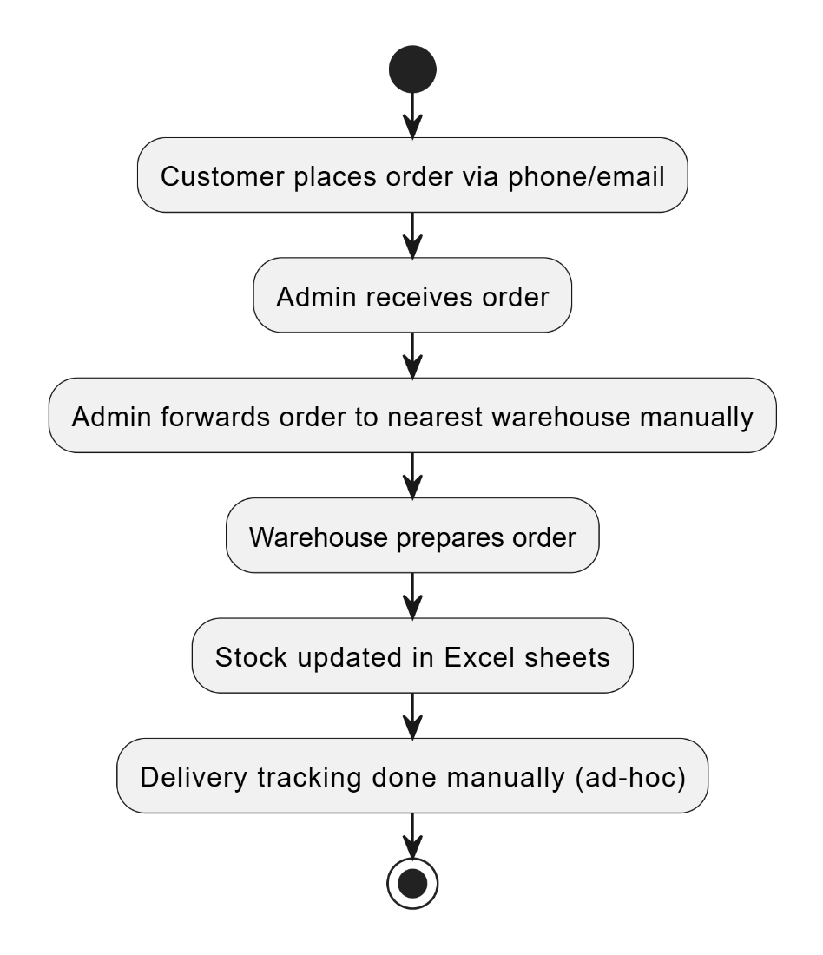

8.2 TO-BE (Proposed)
- Customers place orders in the system.
- System auto-assigns nearest warehouse with stock.
- Warehouse dispatches order.
- Logistics partner updates delivery status.
- Customers & Managers view real-time updates on dashboard.

TO-BE FLOWCHART -

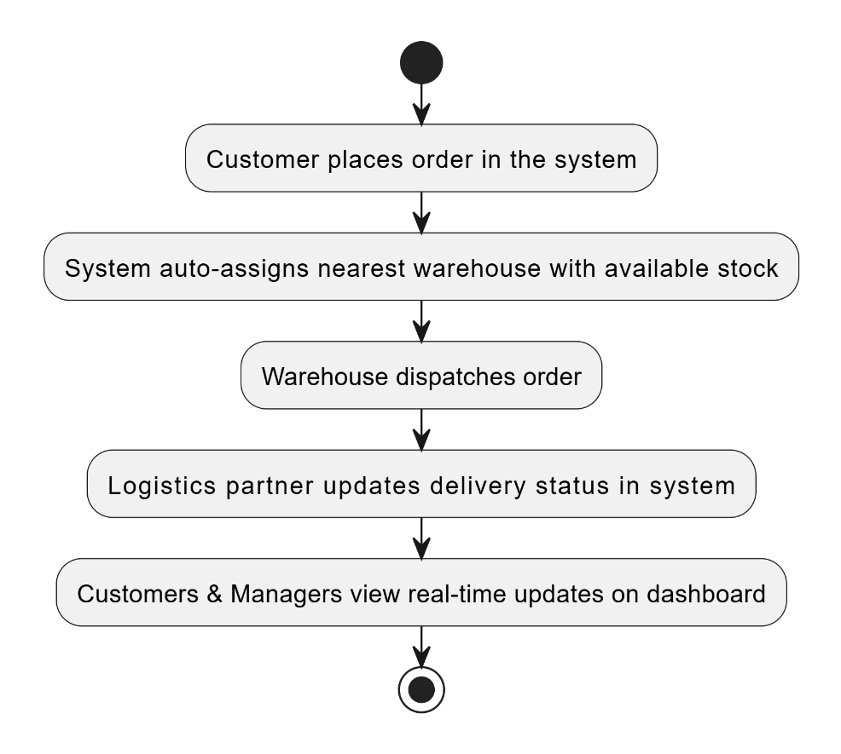

9. Business Requirements

Req ID | Requirement Description | Type | Priority | Source
BR001 | Role-based login for Admin, Warehouse Manager, Customer, Delivery Partner | Functional | High | Workshop
BR002 | System must track real-time stock at each warehouse | Functional | High | SCM Feedback
BR003 | Orders must auto-assign to nearest warehouse with stock | Functional | High | Logistics
BR004 | Expiry alerts: 7 days (milk), 15 days (ice-cream) | Functional | Medium | QA Input
BR005 | Dashboards for Managers (stock, pending orders, wastage) | Functional | Medium | Stakeholders
BR006 | Reports exportable to PDF/Excel | Functional | Low | Management
BR007 | Notifications for order placement, dispatch, delivery | Functional | High | Customer Service
BR008 | Data backup weekly | Non-Functional | Medium | Risk Plan
BR009 | System uptime must be 99.5% | Non-Functional | High | IT Team
BR010 | RBAC for secure access | Non-Functional | High | Security Policy

10. Appendices
10.1 Acronyms
- SCM: Supply Chain Management
- RBAC: Role-Based Access Control
- UAT: User Acceptance Testing
- BRD: Business Requirement Document
10.2 Glossary
- Inventory: Stock of products available at warehouse.
- Warehouse: Storage unit from where orders are dispatched.
- Delivery Optimization: Assigning orders to the nearest available stock point.
10.3 Related Documents
- SRS (System Requirement Specification)
- RTM (Requirement Traceability Matrix)
- UAT Plan & Test Cases
- Change Request Log

2. Prepare process flow diagram using your imagination
Answer:
Process Flow Chart:
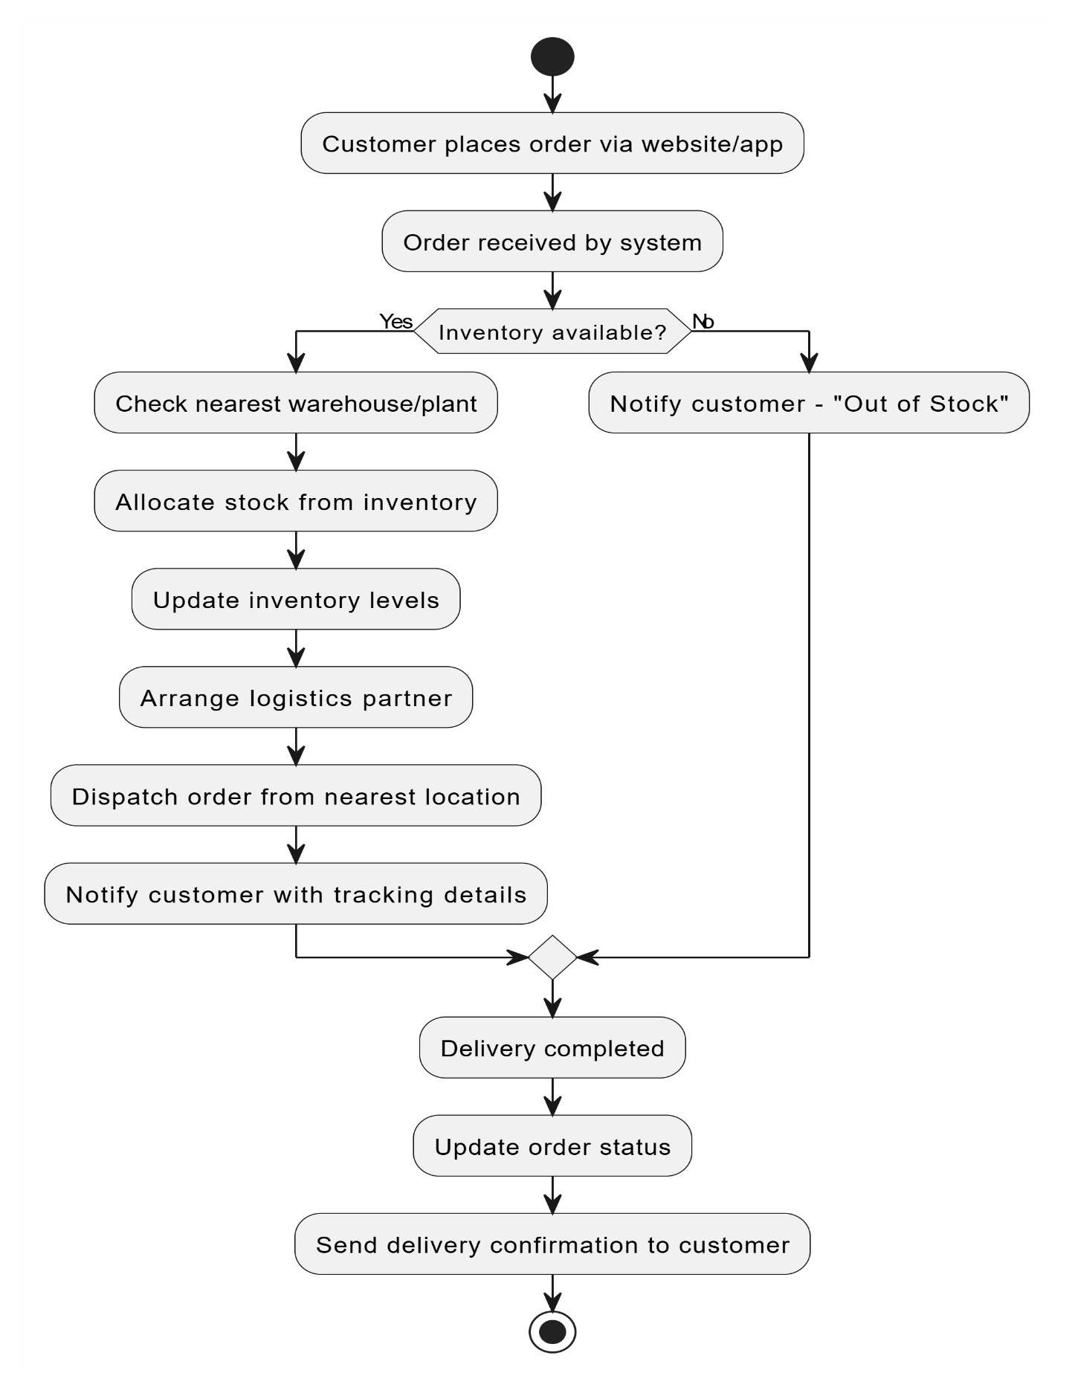
Assignment 2:
1. Write an introduction letter to a client introducing yourself as a business analyst in charge of working with the client and his team to start the business understanding process.
Answer:

Subject: Excited to Partner with You as Your Business Analyst
Dear Sir,
I am delighted to introduce myself – my name is Kunal Kishor Kadambande, and I’ll be your Business Analyst for this project. My role is to be the bridge between your business vision and the solution we deliver.
Over the coming weeks, I will work closely with you and your team to:
- Understand your goals, challenges, and expectations.
- Translate your ideas into clear, actionable requirements.
- Ensure the solution is designed to bring real value to your business.
I believe every successful project starts with strong collaboration and open communication. Together, we will not only build the right solution but also the best-fit solution for your needs.
I would love to set up an initial discussion to kick-start the business understanding process and align on priorities. Please let me know a convenient time for you and your team.
Looking forward to an exciting journey of collaboration and success with you!
Warm regards,
Kunal Kishor Kadambande
(Business Analyst)

2. Prepare a brief BRD and SRS for a project- Ticketing System
Answer:
Business Requirement Document (BRD) – Ticketing System
1. Introduction
The client requires a Ticketing System to manage customer service requests, technical issues, and general inquiries in an efficient, transparent, and trackable manner.
The system should allow customers to raise tickets, support staff to manage and resolve them, and management to monitor service performance.

2. Business Objectives
- Centralize customer issue reporting.
- Reduce ticket resolution time.
- Improve transparency and customer satisfaction.
- Enable data-driven decisions through reporting and analytics.

3. Scope
In Scope
- Ticket creation by customers.
- Ticket assignment to agents.
- Ticket status tracking (Open, In Progress, Resolved, Closed).
- Notifications & updates to customers.
- Admin dashboard with reports.
Out of Scope
- Integration with external CRM (Phase 2).
- AI/Chatbot-based ticket responses.

4. Stakeholders
- Customers → Raise and track tickets.
- Support Agents → Work on and resolve tickets.
- Admin/Manager → Monitor SLAs, generate reports, and manage resources.

5. Business Requirements (High-Level)
- Customers should be able to log tickets via portal/email.
- Each ticket must have a unique ID.
- Tickets should be categorized (e.g., Technical, Billing, General).
- Agents must update ticket progress.
- SLA (Service Level Agreement) alerts must notify delays.
- Reports should be available for ticket volume, response time, and resolution rate.

6. Assumptions & Constraints
- System will be web-based and mobile responsive.
- Support available in English initially.
- SLA for resolution will be defined by client.

Software Requirement Specification (SRS)

Project: Ticketing System
Client: TechServe Solutions Pvt. Ltd.
Prepared by: Business Analyst

1. Introduction
The Ticketing System will allow TechServe Solutions to manage and resolve IT support issues efficiently. The system will enable employees to raise tickets, track progress, and receive timely resolutions. Admins and support agents will manage tickets, assign tasks, and monitor SLA compliance.

2. Objectives
- Provide a centralized platform to log and track support tickets.
- Ensure quick assignment and resolution of issues.
- Improve customer satisfaction through timely updates and SLA monitoring.
- Generate reports for performance and issue analysis.

3. Scope
The Ticketing System will include:
- User Portal: Raise, view, and track tickets.
- Agent Dashboard: Manage, assign, and resolve tickets.
- Admin Module: Configure users, SLAs, categories, and generate reports.
- Notifications: Email/SMS alerts for ticket status updates.

4. Functional Requirements
- Users must be able to log in securely.
- Users can create tickets with issue details (category, priority, attachments).
- Tickets must be auto-assigned to available support agents based on rules.
- Agents can update status: Open, In-Progress, Resolved, Closed.
- System must notify users about ticket status changes.
- Admins can configure SLA timelines for each priority level.
- Reporting feature to generate monthly/weekly performance reports.

5. Non-Functional Requirements
- Performance: System must handle 500 concurrent users.
- Availability: 99.9% uptime.
- Security: Role-based access control; data encryption in transit & rest.
- Usability: Simple and responsive UI (desktop & mobile).

6. Users & Roles
- End Users (Employees): Raise and track tickets.
- Support Agents: Manage and resolve tickets.
- Admin: Configure system, manage users, generate reports.

7. Assumptions & Constraints
- Users must have internet access to use the system.
- Integration with company’s email server is required for notifications.
- Phase 1 will cover IT support only (future expansion possible).

8. Deliverables
- Web-based Ticketing System (with mobile responsive design).
- User manual & training materials.
- Reports & analytics module.

3. Make an ERD of creating a support ticket/Ticketing life cycle.
Answer:

ERD for Ticketing Life Cycle:

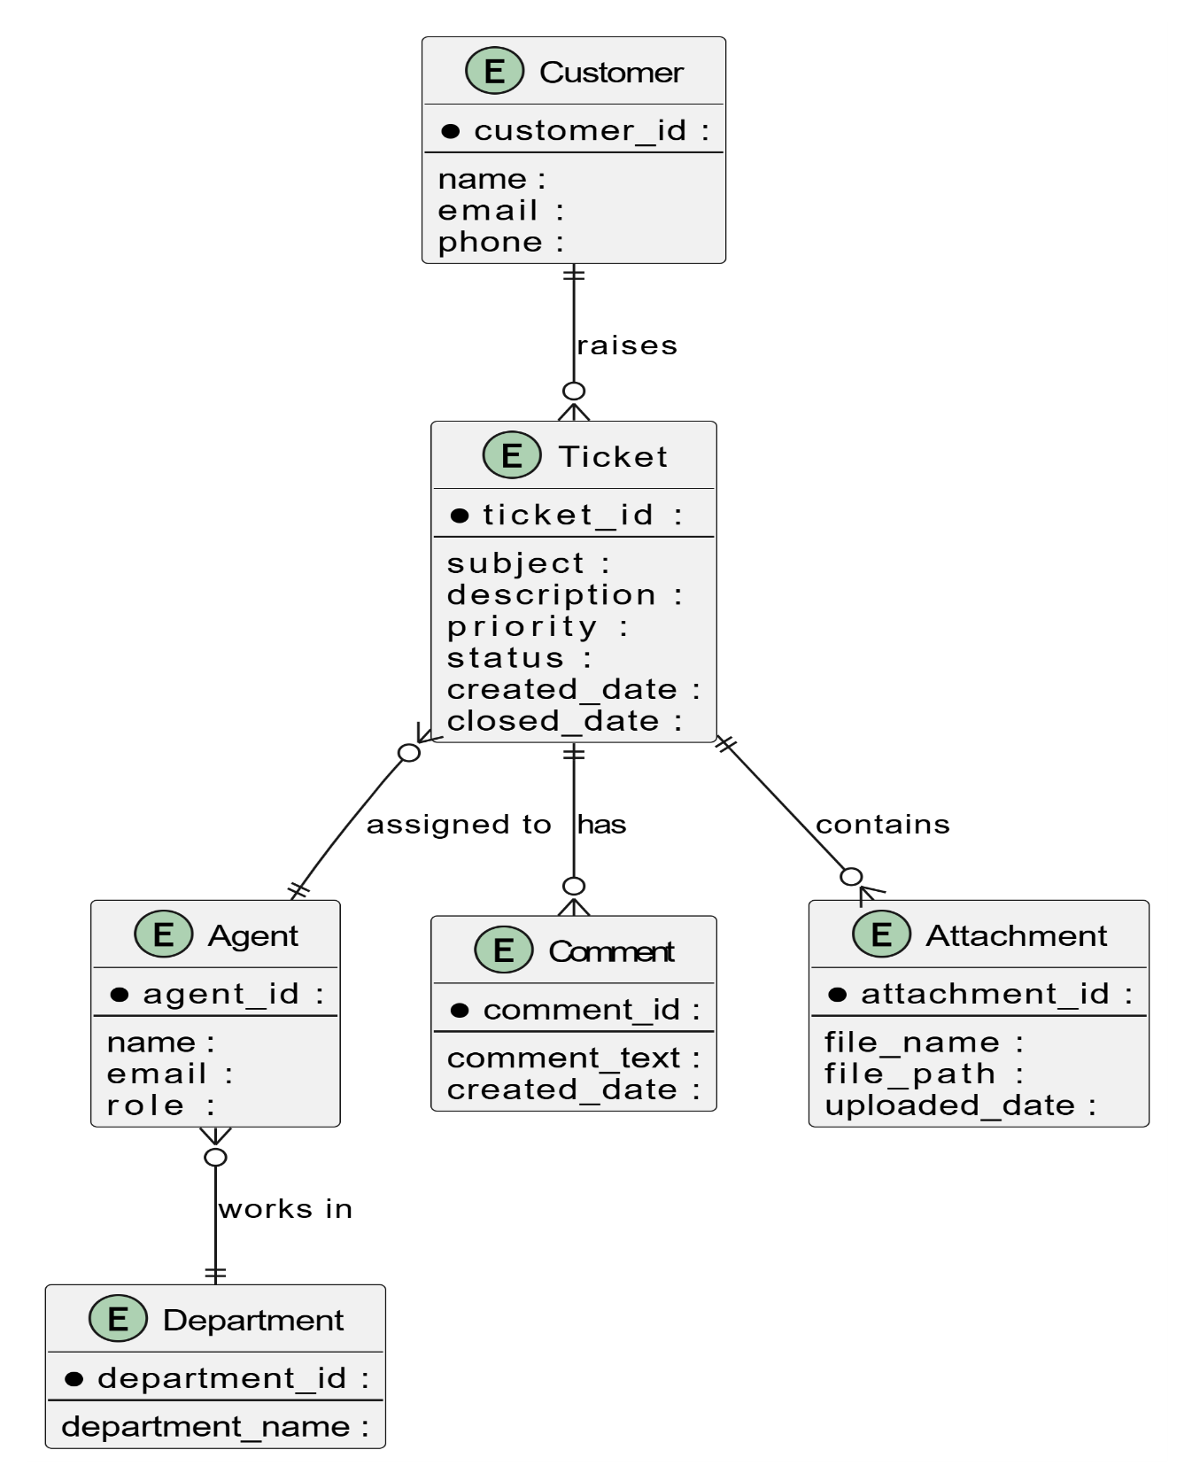

4. User story of shopping from ecommerce.
Answer:

User Story No: 1 | Tasks: 5 | Priority: High
As a customer
I want to browse and purchase products online
So that I can shop conveniently from home and get items delivered quickly
BV: 500 | CP: 05
Acceptance Criteria:

- User can search products by name, category, or price range
- Product details page shows description, price, stock availability, and reviews
- User can add items to cart and update quantities before checkout
- Multiple payment options available (UPI, card, COD, wallet, etc.)
- Order confirmation email/SMS is sent with tracking link

User Story No: 2 | Tasks: 4 | Priority: High
As a customer
I want to use advanced search and filters
So that I can find relevant products quickly
BV: 500 | CP: 04
Acceptance Criteria:

- Filters available by category, price, brand, rating
- Sort option by price, popularity, latest
- Search bar with auto-suggestions
- Results update dynamically without full page reload

User Story No: 3 | Tasks: 4 | Priority: High
As a customer
I want to register and login securely
So that I can save my profile, wishlist, and order history
BV: 400 | CP: 04
Acceptance Criteria:

- User can sign up using email, phone, or social login
- Strong password enforcement
- OTP/email verification for account activation
- Secure login with error messages for invalid attempts

User Story No: 4 | Tasks: 3 | Priority: Medium
As a customer
I want to add products to my wishlist
So that I can purchase them later
BV: 300 | CP: 03
Acceptance Criteria:

- Wishlist button available on product page
- User can view, remove, or move items from wishlist to cart
- Wishlist persists across sessions

User Story No: 5 | Tasks: 5 | Priority: High
As a customer
I want to manage items in my shopping cart
So that I can control what I purchase
BV: 500 | CP: 05
Acceptance Criteria:

- Add/remove products in cart
- Update product quantities
- Show subtotal and taxes dynamically
- Save cart for logged-in users
- Proceed to secure checkout

User Story No: 6 | Tasks: 3 | Priority: Medium
As a customer
I want to checkout without creating an account
So that I can place orders quickly
BV: 300 | CP: 03
Acceptance Criteria:

- Option to checkout as guest
- Minimal details required (name, address, phone, email)
- Guest receives confirmation email with tracking

User Story No: 7 | Tasks: 4 | Priority: High
As a customer
I want multiple payment options
So that I can pay using my preferred method
BV: 500 | CP: 04
Acceptance Criteria:

- UPI, debit/credit card, wallet, COD supported
- Secure encryption for transactions
- Payment gateway timeout/retry handling
- Success/failure notification

User Story No: 8 | Tasks: 3 | Priority: High
As a customer
I want to track my order status
So that I know when to expect delivery
BV: 400 | CP: 03
Acceptance Criteria:

- Order status: placed, packed, shipped, out for delivery, delivered
- Tracking link in email/SMS
- Real-time updates on dashboard

User Story No: 9 | Tasks: 4 | Priority: High
As a customer
I want to request returns and refunds
So that I feel confident in purchasing
BV: 500 | CP: 05
Acceptance Criteria:

- Return request option within return window
- Auto-generated return pickup request
- Refund initiated after product verification
- Refund updates shared via email/SMS

User Story No: 10 | Tasks: 03 | Priority: Medium
As a customer
I want to review and rate products
So that I can share my experience with others
BV: 300 | CP: 03
Acceptance Criteria:

- Rating system (1–5 stars)
- Text reviews with images allowed
- Reviews moderated for spam/inappropriate content

\
User Story No: 11 | Tasks: 4 | Priority: Medium
As a customer
I want personalized product suggestions
So that I can discover items matching my preferences
BV: 300 | CP: 04
Acceptance Criteria:

- Recommendations based on browsing/purchase history
- “You may also like” section on product page
- Recently viewed items displayed
- Machine-learning based suggestions

User Story No: 12 | Tasks: 3 | Priority: Medium
As a customer
I want to use discount codes and offers
So that I can save money on purchases
BV: 400 | CP: 03
Acceptance Criteria:

- Promo code input at checkout
- Discount applied instantly
- Validity check for expired/invalid codes

User Story No: 13 | Tasks: 3 | Priority: Medium
As a customer
I want to receive order updates and offers
So that I stay informed
BV: 300 | CP: 03
Acceptance Criteria:

- Push/email/SMS notifications for order updates
- Alerts for new offers and discounts
- Option to unsubscribe from marketing notifications

User Story No: 14 | Tasks: 4 | Priority: Medium
As a customer
I want to manage my personal details securely
So that my information stays updated
BV: 300 | CP: 03
Acceptance Criteria:

- Edit/update profile details (address, phone, etc.)
- Change password with OTP verification
- Save multiple addresses for faster checkout
- GDPR-compliant data privacy

User Story No: 15 | Tasks: 4 | Priority: Low
As a customer
I want to shop in my preferred language and currency
So that I can understand prices and details easily
BV: 200 | CP: 04
Acceptance Criteria:

- Option to change site language
- Prices displayed in selected currency
- Automatic location-based currency detection
- Payment supported in selected currency

User Story No: 16 | Tasks: 3 | Priority: Medium
As a customer
I want to compare products side by side
So that I can make better purchase decisions
BV: 300 | CP: 03
Acceptance Criteria:

- Compare button on product pages
- Side-by-side display of features/specifications
- Add/remove items from comparison list

User Story No: 17 | Tasks: 4 | Priority: Medium
As a customer
I want to earn loyalty points on purchases
So that I can redeem them for discounts later
BV: 350 | CP: 04
Acceptance Criteria:

- Loyalty points awarded on each purchase
- Points balance shown in profile
- Option to redeem points at checkout
- Expiration reminders for unused points

User Story No: 18 | Tasks: 3 | Priority: High
As a customer
I want quick access to customer support
So that my issues get resolved fast
BV: 400 | CP: 03
Acceptance Criteria:

- Live chat option on site/app
- Support ticket generation for issues
- Help center/FAQs easily accessible

User Story No: 19 | Tasks: 3 | Priority: Low
As a customer
I want to get notified when out-of-stock items are available
So that I don’t miss buying them
BV: 250 | CP: 03
Acceptance Criteria:

- “Notify me” option on out-of-stock products
- Email/SMS sent when item is restocked
- Direct link to add to cart from alert

User Story No: 20 | Tasks: 4 | Priority: High
As a customer
I want a mobile-friendly experience
So that I can shop seamlessly on my phone
BV: 500 | CP: 04
Acceptance Criteria:

- Mobile-optimized UI and navigation
- Quick load time for product pages
- One-click checkout on app
- Push notifications for offers/orders

