Document 6- Please prepare a use case diagram, activity diagram and a use case specification document.
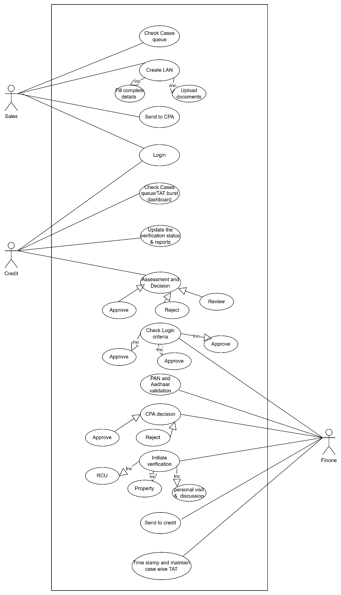

1. Use Case Name:
Submit and Process Home Loan Application
2. Use Case Description:
This use case describes the end-to-end process of logging a home loan application in the FinOne system, performing credit pre-assessment (CPA), validating documents, and processing the application through credit review, leading to a system-generated or manual decision.
3. Actors:
- Primary Actors: Sales Team, Credit Officer
- Secondary Actors: FinOne System, CIBIL API, Document Management System
4. Basic Flow (Main Success Scenario):
- Sales team enters customer details and uploads required documents into FinOne.
- FinOne performs CPA checks (CIBIL score, profile, location).
- Initiate the mandatory verifications like RCU , Property Legal and technical verifications.
- Validated applications are routed to the credit officer.
- Credit officer reviews the application within the system.
- Credit officer ensure the verifications are +ve and updated in system within TAT.
- FinOne tracks TAT and SLA for the application.
- Credit officer makes a decision basis on the assessment within system.
- Final decision is stored digitally and communicated to the applicant.
5. Alternate Flow:
- If customer CIBIL score is low or profile is restricted, the system flags the application and stops further processing.
- If documentation is incomplete at CPA stage , the system sends it back to the sales team for correction.
6. Exceptional Flows:
- If system integration with CIBIL or DMS fails, the application is held in a pending state.
- If FinOne crashes during login or review, the application status is not updated until restart.
7. Pre-Conditions:
- FinOne system is accessible.
- Sales team has valid login credentials.
- Customer data is available and documents are ready for upload.
8. Post-Conditions:
- Application is either approved, declined, or sent for relook.
- Status and decision are recorded in the system with time stamp.
- Audit trail is created for compliance.
9. Assumptions:
- CPA rules are pre-configured in FinOne.
- All actors are trained on using FinOne.
- Internet and system uptime is available during the process.
10. Constraints:
- Sales cannot proceed if mandatory fields or documents are missing.
- CPA checks cannot be bypassed.
- Review cases also have to be decisioned within TAT , joint responsibility of sales and credit.
- Decisioning must occur within SLA timelines.
11. Dependencies:
- Integration with CIBIL score API.
- Document upload access via Document Management System.
- Role-based access control in FinOne.
12. Inputs and Outputs:
- Inputs: Customer personal data, financial documents, property documents
- Outputs: Decision outcome (Approve/Reject/Hold), TAT report, audit logs, Sanction Letter.
13. Business Rules:
- Minimum CIBIL score for login is 700.
- Restricted profiles or locations flagged during CPA.
- Certain Profiles are restricted such as Lawyer, Police, Builder.
- All mandatory documents must be uploaded to proceed to credit review.
14. Miscellaneous Information:
- Application data is stored securely and is audit-compliant.
- Notifications are triggered to stakeholders at each status change.
Activity Diagram:-

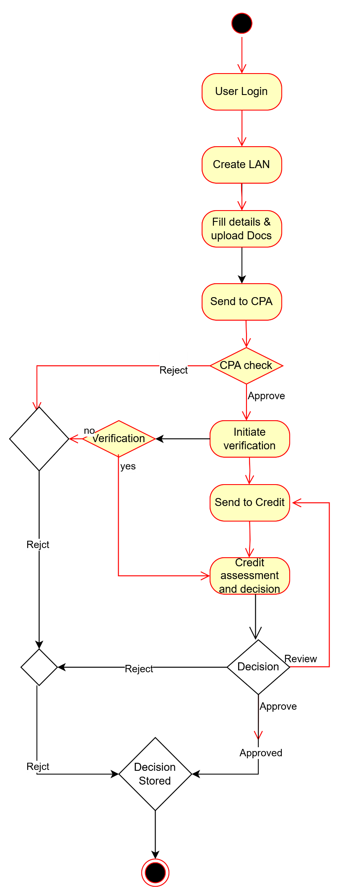

Document 7- Screens and pages
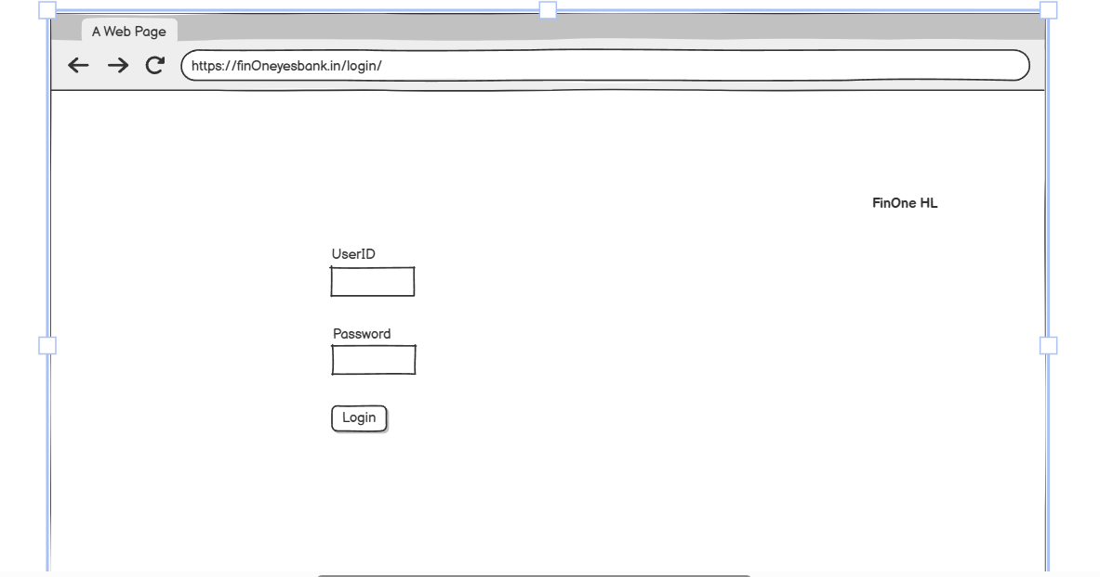

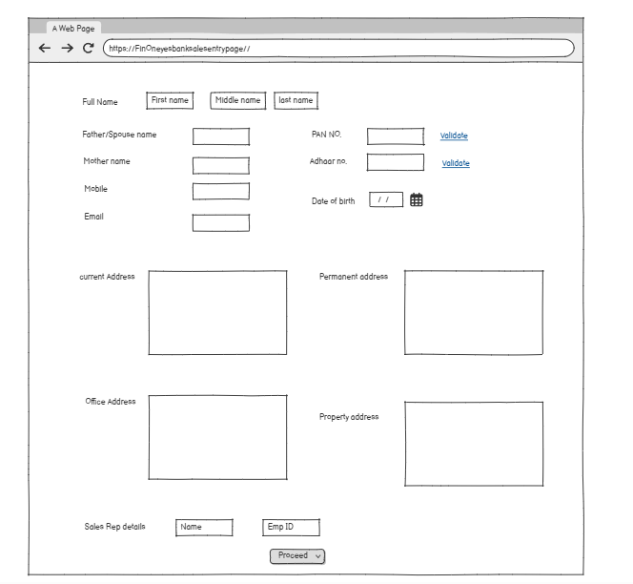
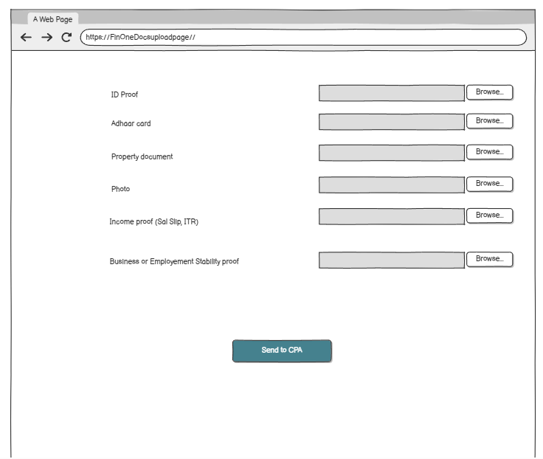

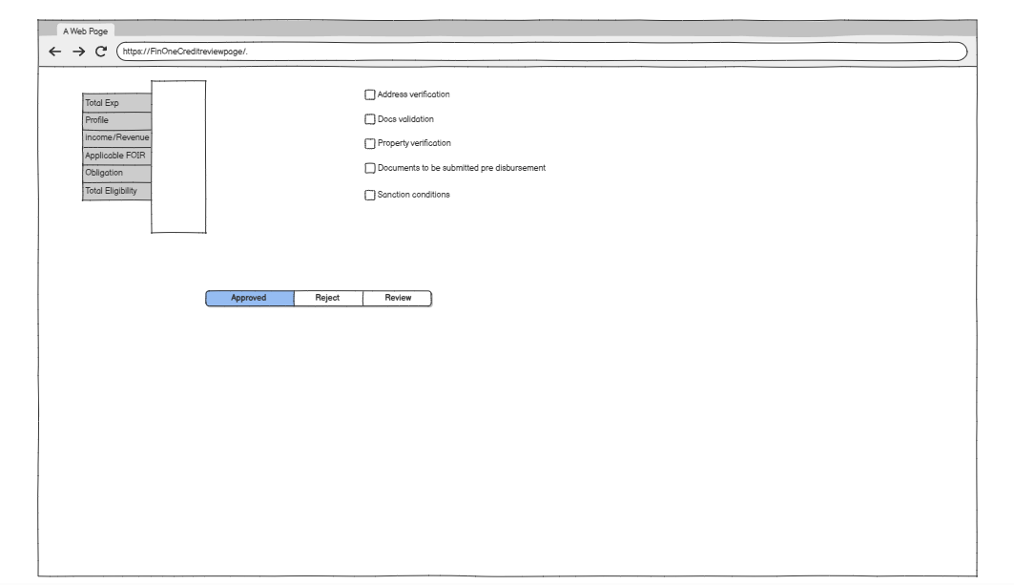
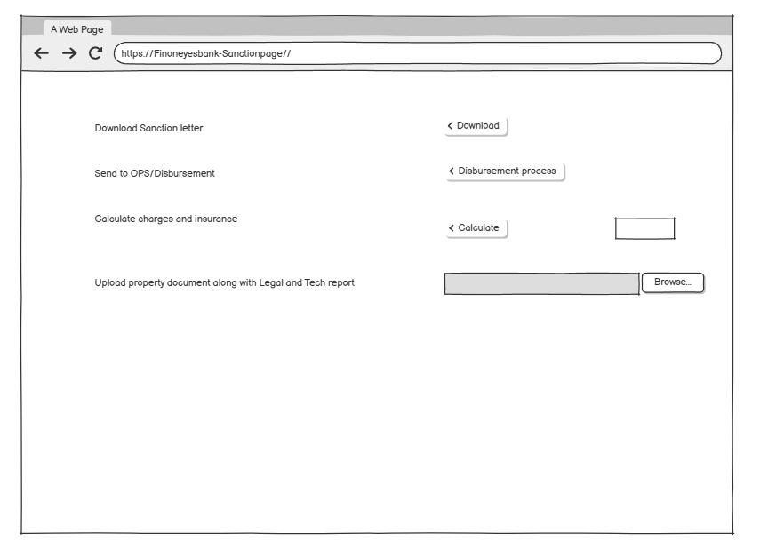
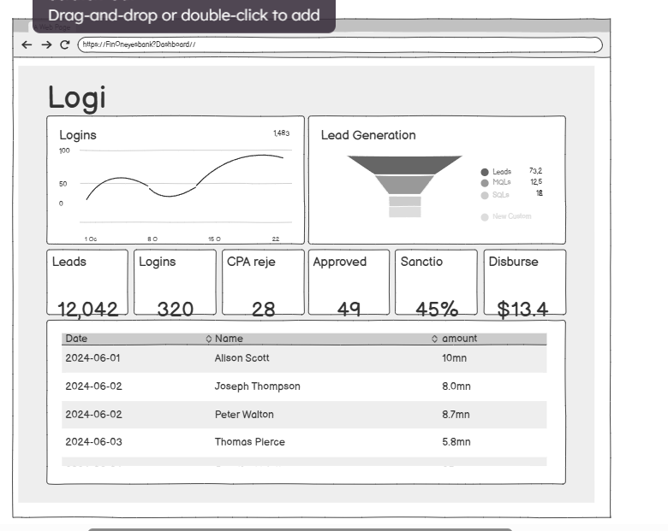

Document 8- Tools-Visio and Axure
1. Balsamiq
🔹 What is it?
Balsamiq is a low-fidelity wireframing tool used to create quick and rough mock-ups of user interfaces.
🔹 Key Features:
- Sketch-style visuals ideal for early-stage design discussions
- Drag-and-drop UI components (buttons, forms, tables, etc.)
- Focuses on structure, not detailed design
- Fast and beginner-friendly
🔹 Use for BAs:
- Ideal for initial prototyping with stakeholders
- Helps in brainstorming sessions to visualize ideas
- Commonly used for storyboarding user journeys and validating screen flows
🔹 Best For:
- Early-stage prototyping.
- Presenting conceptual UI to non-technical stakeholders
- Projects where speed is more important than precision
2. Axure RP
🔹 What is it?
Axure is a high-fidelity wireframing and prototyping tool that allows BAs to design interactive and functional user interfaces.
🔹 Key Features:
- Dynamic content, conditional logic, and page interactions
- Supports creation of fully clickable prototypes
- Detailed UI components with ability to simulate real behavior
- Supports documentation and annotation directly on designs
🔹 Use for BAs:
- Designing and demonstrating detailed system flows and interactions
- Sharing realistic simulations with developers or clients
- Creating annotated wireframes for Functional Requirement Documents (FRDs)
🔹 Best For:
- Projects requiring advanced interactions (e.g., dropdown logic, form validation)
- Demonstrating business workflows visually
- Functional testing of user journeys before development

3. Microsoft Visio
🔹 What is it?
Visio is a diagramming tool from Microsoft used to create flowcharts, process diagrams, and system architecture diagrams.
🔹 Key Features:
- Templates for use case diagrams, swimlanes, ERDs, and more
- Easy to create flowcharts, RACI matrices, and data flow diagrams
- Integration with Microsoft Office tools
- Offers clear formatting for documentation inclusion
🔹 Use for BAs:
- Mapping As-Is and To-Be processes
- Creating Use Case Diagrams, Activity Diagrams, and System Flows
- Preparing clean and professional documentation visuals
🔹 Best For:
- Business process mapping
- BRD/FRD visual support
- Stakeholder presentations

Document 9- BA experience
My experience as BA in following phases:

As a BA I was involved in different activities through all the phases of the project.

1.Pre Project: - In Pre Project we performed the Enterprise analysis, SWOT analysis and GAP analysis We performed Market research about the mortgage product in industry. Feasibility study, Root cause analysis, strategy analysis, Enterprise architectural framework, Project scope and business case writing and risk analysis.
2. Planning estimation and assessment: -
- Understand assumptions and constrains along with business rules and business goals.
- Understand the project plan from PM.
- BA conduct stakeholder analysis
- Plan BA approach strategy (Req Gathering, Documents to follow, Tools to use, Change request handling)
Requirement Gathering
- We Identified the stakeholder and categorize them using RASCI matrix.
- Engaged with key stakeholders from Sales, Credit, Risk, and Operations departments to capture business needs.
- Conducted interviews, document analysis, and process walkthroughs to understand the existing manual decisioning process.
- Sort the gathered requirement (Remove redundant req , grp into small functionality or module)
- Priorities the requirement using MOSCOW technique.
- Validate requirements using FURPS.
- Created and reviewed the Business Requirements Document (BRD).
Requirement Analysis
Draw UML diagrams (Usecase and activity diagram).
Prepare functional requirement from the business requirement
All architects come up with SSD (Supplementary support documents).
Prepare SRS (Software requirement specification)
Take signoff on SRS document.
Prepare RTM from SRS document , This is used through out the project for tracing the requirement.

Design
- Created detailed process flow diagrams, use case diagrams, and screen mock-ups using tools like Visio and Axure.
- Communicate with the client on the design and solution documents.(Make them understand how the solution would look like)
- Initiate the preparation of end user manuals.
- Update RTM

Development Support
- Facilitated requirement walkthrough sessions with developers to ensure clear understanding of business logic.
- Organise JAD sessions.
- Acted as a bridge between business and technical teams for clarification during system configuration and rule setup.
- Ensured that all requirements were traced and matched in design and development artifacts.
Testing
- Created test cases and UAT scenarios based on approved FRD and business use cases.
- Performed high level testing.
- Supported System Integration Testing (SIT) by working with QA teams and validating expected outcomes.
- Coordinated and participated in User Acceptance Testing (UAT) with business users, logging issues and ensuring timely resolution.
- Requested test data from the client.
- Update end user manuals.
- Validated key workflows such as CPA logic, document completeness checks, and duplicate login detection.
- Take signoff from the client-on-client project acceptance form.
Deployment & Go-Live
- Forward RTM to client or the PM which should be attached to the project completion documents.
- Coordinate to complete and share the end user manual.
- Assisted in go-live readiness activities including end-user training sessions, creation of user manuals, and system rollout planning.
- Facilitated user onboarding and ensured proper access control configurations.
- Managed post-deployment feedback and logged initial change requests for future sprints.

Tools Used:
- Microsoft Visio – Process flows, swimlane diagrams
- Axure RP – Wireframes and screen mockups
- MS Excel / JIRA – Traceability Matrix, Issue Tracking
- MS Word / PowerPoint – Documentation and stakeholder presentations

