
Nurturing Process - Capstone Project1 - Part -2/3 V2D2- August 2024
Online Agriculture Products Store
Mr. Henry, after being successful as a businessman and has become one of the wealthiest persons in the city. Now, Mr. Henry wants to help others to fulfil their dreams. One day, Mr. Henry went to meet his childhood friends Peter, Kevin and Ben. They live in a remote village and do farming. Mr. Henry asked his friends if they are facing any difficulties in their day-to-day work.
Peter told Mr. Henry that he is facing difficulties in procuring fertilizers which are very important for
farm. Kevin said that he is also facing the same problem in-case of buying seeds for farming certain
crops. Ben raised his concern on lack of pesticides which could help in greatly reducing pests in
crops.
After listening to all his friends’ problems, Mr. Henry thought that this is a crucial problem faced not only by his friends but also by so many other farmers. So, Mr. Henry decided to make an online
agriculture product store to facilitate remote area farmers to buy agriculture products. Through this Online Web / mobile Application, Farmers and Companies (Fertilizers, seeds and pesticides
manufacturing Companies) can communicate directly with each other.

The main purpose to build this online store is to facilitate farmers to buy seeds, pesticides, and
fertilizers from anywhere through internet connectivity. Since new users are involved, Application should be user friendly.
This new application should be able to accept the product (fertilizers, seeds, pesticides) details from
the manufacturers and should be able to display them to the Farmers. Farmers will browse through
these products and select the products what they need and request to buy them and deliver them to
farmers location.

Mr. Henry has given this project through his Company SOONY. In SOONY Company, Mr Pandu is
Financial Head and Mr Dooku is Project Coordinator. Mr. Henry , Mr Pandu , and Mr Dooku formed
one Committee and gave this project to APT IT SOLUTIONS company for Budget 2 Crores INR and
18 months Duration under CSR initiative. Peter, Kevin and Ben are helping the Committee and can be considered as Stakeholders share requirements for the Project.
Mr Karthik is the Delivery Head in APT IT SOLUTIONS company and he reached out to Mr Henry
through his connects and Bagged this project. APT IT SOLUTIONS company have Talent pool
Available for this Project. Mr Vandanam is project Manager, Ms. Juhi is Senior Java Developer, Mr
Teyson, Ms Lucie, Mr Tucker, Mr Bravo are Java Developers. Network Admin is Mr Mike and DB
Admin is John. Mr Jason and Ms Alekya are the Tester. And you joined this team as a BA.

Question 1 - Audits - 5 Marks
4 Quarterly Audits are planned Q1 , Q2, Q3, Q4 for this Project.
What is your knowledge on how these Audits will happen for a BA ?
Answer:
- Q1 Audit – Project Initiation & Requirement Phase:
Focus areas:
- Requirement gathering and elicitation methods used.
- Stakeholder analysis and RACI matrix.
- Business case, feasibility study, GAP analysis, BRD/FRD preparation.
Auditors review:
- Whether all stakeholders are identified and involved.
- Approval and version control of requirement documents.
- Traceability from business goals to requirements.

- Q2 Audit – Design & Early Development Phase:
Focus areas:
- Requirement sign-off.
- Participation in solution design and walkthrough.
- Change request handling process.
Auditors review:
- Consistency between requirements and design documents.
- Impact analysis for any change raised post sign-off.
- BA collaboration with UI/UX team, developers, and architects.

- Q3 Audit – Testing& UAT:
Focus areas:
- Review of test scenarios, text cases traceability to requirements.
- UAT planning, coordination with users
- Defect evaluation and requirement clarification.
Auditors review:
- Ensure that all requirements are covered in test cases.
- How efficiently BA are resolving gaps in test cycles.
- Involvement in UAT facilitation.

- Q4 Audit – Deployment Readiness & Post-Implementation:
Focus areas:
- Support during go-live, training material preparation.
- Post-Implementation review with handover documents and closure report.
Auditors review:
- Quality and completeness of user training materials.
- Final requirements traceability and change tracking.
- Closure report and client feedback alignment with defined objectives.

Question 2 - BA Approach Strategy - 6 Marks
Before the Project is going to Kick Start, The Committee asked Mr Karthik to submit BA Approach
Strategy
Write BA Approach strategy (As a business analyst, what are the steps that you would need to
follow to complete a project - What Elicitation Techniques to apply, how to do Stakeholder Analysis RACI/ILS, What Documents to Write, What process to follow to Sign off on the Documents, How to take Approvals from the Client, What Communication Channels to establish n implement, How to Handle Change Requests, How to update the progress of the project to the Stakeholders, How to take signoff on the UAT- Client Project Acceptance Form )

Your Team
Project Manager - Mr Vandanam Senior
Java Developer - Ms. Juhi
Java Developers - Mr Teyson, Ms Lucie, Mr Tucker, Mr Bravo
Network Admin - Mr Mike
Testers - Mr Jason and Ms Alekya
BA - You

Technical Team have assembled to discuss on the Project approach and have finalised to follow 3-tier architecture for this project.
Answer:
- Requirement planning & strategy setup:
- Define BA scope and understand stakeholder expectations and align on goals.
- Conduct initial discussions with stakeholders to understand high-level needs.
- Coordinate with PM to set milestones and timeline.
- Identify core business goals, constraints and expected outcomes.
- Stakeholder analysis:
- Internal: PM, Developers, Testers, Network & DB Admins.
- External: Sponsor, End User, Mr. Karthik (account lead).
- RACI matrix:
Task | Responsible | Accountable | Consulted | Informed
Requirement Gathering | BA | PM | End user,sponsor | Dev/Test Team
Document Sign-off | BA | Sponsor | PM, End User | Dev Team
UAT & Client Acceptance | BA | Sponsor | Tester, PM | Praject Team

- Elicitation techniques:
- Workshop/Brainstorming – with farmers, end users and sponsor.
- Interview – with Peter, Kevin, Ben to understand their buying pain points.
- Surveys/Questionnaires – to collect inputs from a broader farmer base.
- Observation – of current farming procurement process.
- Document Analysis – review any existing procurement logs/records.
- Documentation to be prepared:
- Business Requirements Document (BRD) – capturing high-level needs and objectives.
- Functional Requirements Specification (FRS) – detailing functional workflow.
- Process Diagrams (BPMN/UML) – for clear process mapping.
- Requirement Traceability Matrix (RTM) – for tracking throughout SDLC
- Use Cases/User – to support Agile understanding.
- UAT Plan & Scenarios – mapped to business goals.
- Requirement sign-off process:
- Submit documents to Sponsor and PM for review.
- Conduct requirement walkthrough session with stakeholder.

- Collect formal approval via email or sign-off sheet.
- Lock the scope post sign-off and log any changes as CRs.
- Client approval & change management:
- Get formal approval on requirement documents via email or signed documents.
- Any new or changed requirements are managed using a Change Request (CR) form.
- Evaluate each CR for impact on cost, time, and scope.
- Only proceed after the client approves the CR.
- Communication plan:
- Use tools like Email, Zoom and MS teams for regular updates,
- Send weekly status reports to Sponsor and the PM.
- Conduct daily stand-ups with the internal team for tracking process.
- Progress reporting:
- Use RTM and project tracking tools like jira, excel, etc.
- Weekly progress emails or dashboard to Sponsor and committee.
- Align with PM for milestone reviews.
- UAT & Client project acceptance:
- Prepare a UAT plan with test scenarios based on real farmer workflows.
- Capture feedback and track bug/improvement and coordinate with tester for execution.
- After UAT is pass share UAT Sign-Off form with sponsor and obtain formal Client Project Acceptance confirmation.
- BA involvement across 3-tier architecture:
- Presentation Tier – Ensure user centric requirements and validate wireframes/mockups.
- Business Logic Tier – Document logic clearly in FRS and align use cases with dev input.
- Data Tier – collaborate with DB admin for data structure clarity and define data flow, validation, and CRUD operation.

Question 3 - 3-Tier Architecture - 5 Marks
Explain and illustrate 3-tier architecture?
Answer:
- Presentation Layer – user interface where user interacts with the systems.
For example: farmers app/web interface to place order
- Business Logic Layer – processes user request and applies rules.
For example: validates product availability and processes order.
- Data Layer – Manages database operations like storing and retrieving data.
For example: stores product, order and user data.
Presentation Layer
Web/Mobile app UI
(Used by Farmers)

Business Logic Layer
Java APIs & services
(Process orders, rules)

Data Layer
Database (MySQL/Oracle
(Stores users, orders)

Question 4 - BA Approach Strategy for Framing Questions - 10 Marks
Business Analyst should keep What points in his/her mind before he frames a Question to ask to the Stakeholder
( 5W 1H - SMART - RACI - 3 Tier Architecture - Use Cases, Use case Specs, Activity
Diagrams, Models, Page designs)
Answers:
- 5W 1H (who, when, where, why, what, how) :
- Who is the stakeholder their roles, decision power?
- What is the information needed?
- When is it required based on timeline and urgency?
- Where is this process used?
- Why is the information important?
- How is the process currently done?
- SMART (specific, measurable, achievable, relevant, time-bound):
- Specific – avoid vague questions.
- Measurable – understand outcomes and KPIs.
- Achievable – Focus on realistic expectations.
- Relevant – align with business goals.
- Time-bound – know deadlines or scheduling needs.
- RACI Awareness:
- Ask Responsible stakeholders detailed operational questions.
- Ask Accountable stakeholders for approval or decision.
- Consulted stakeholders provide expert input.
- Keep Informed stakeholders updated.
- 3-Tier Architect:
- Presentation Layer – ask about user interface needs and user experience.
- Business Logic Layer – clarity rules, validation, workflow.
- Data Layer – understand data storage, retrieval, reporting needs.
- Use Casee & Use Case Specification:
- Ask questions that help define actors, system behavior and interaction flow.
- Understand the normal and alternate flow accuracy.
- Activity Diagram & Model:
- Visual models help in identifying missing scenarios or process bottlenecks.
- Frame questions to fill gaps or validate flow accuracy.
- Page Design:
- Use mockups to ask UI/UX related questions.
- Helps stakeholders visualize and respond better to form or navigation concerns.

Question 5 - Elicitation Techniques - 6 Marks
As a Business Analyst, What Elicitation Techniques you are aware of? ( BDRFOWJIPQU)
Answer:
- B – Brainstorming:
- Used to generate a large number of ideas or solution in a short time from stakeholders or subject matter experts.
- D – Document analysis:
- Reviewing existing documents like SOPs, reports, system manuals to extract useful information.
- R – reverse Engineering:
- Analyzing an existing system to understand its components and function when documentation is missing.
- F – Focus Groups:
- A structured discussion with a selected group of stakeholders to gather diverse perspectives quickly.
- O – Observation:
- Watching users in their actual work environment to understand their tasks, tools and challenges.
- W – Workshop:
- Interactive session involving multiple stakeholders to collaboratively define, refine and prioritize requirements.

- J – Job Shadowing:
- Closely following a user during their workday to gain deep insight into business processes.
- I – Interview:
- One-on-one or group session to gather detailed information or clarify doubts directly from stakeholders.
- P – Prototyping:
- Creating sample UI design or mockups to help stakeholders visualize the final system and refine their requirements.
- Q – Questionnaire:
- Sending structured questions to a larger audience to gather information quickly.
- U – User Stories:
- Capturing requirements from the end user perspective in the specific format.
Question 6 - This project Elicitation Techniques - 5 Marks
Which Elicitation Techniques can be used in this Project and Justify your selection of Elicitation Techniques?
Prototyping
Use case Specs
Document Analysis
Brainstorming
Answer:
Selected Elicitation Technique: Prototyping
Justification:- Prototyping is the most suitable method for this project because the key stakeholders like farmers and manufacturers may not be very familiar with technical terminologies or system functionalities.
By using visual mockups of the application such as login page, product catalog, search option, payment gateway and delivery tracking screens it becomes easier for them to:
- Understand how the system will work.
- Provide accurate feedback early in the development.
- Suggest improvements in layout or features.
- Validate if the system align with their expectations.
This technique reduces the risk of miscommunication and helps in identifying missing or unclear requirements at the early stages hence it is an ideal choice for this project.

Fertilizers, seeds, pesticides details from the manufacturers and should be able to display them to the
Farmers.
To gather the business requirements from the client, you went to SOONY and met Mr. Henry. When Mr.
Henry was asked about the project and what are they expecting from the project, Mr. Henry stated that he is
expecting to have a login for all its users (fertilizers, seeds, pesticides manufacturers and Farmers) , a product
catalog of fertilizers, seeds, pesticides, a search option to search for products, payment process, and delivery
tracking.
After doing the stakeholder analysis, you have found out that Peter, Kevin, Ben are the key stakeholders and
you have scheduled an appointment to meet them. After meeting with them and trying to gather the
stakeholder requirements, Kevin said that, a Farmer should be able to browse through the products catalog
once they visit the website and need to have a search option so that they can search for any product they
need. Peter said that, if a farmer wants to buy any product or add them to buy-later list, they need to login first using their email id and password. If it is a new user, then they can create a new account by submitting their email ID and creating a secure password. Ben added saying that, Farmers needs to have an easy-to-use payment gateway which should include cash-on-delivery (COD), Credit/Debit card and UPI options so that the user’s experience should be better. Kevin mentioned that, a user gets an email confirmation regarding their order status. A delivery tracker to track the whereabouts of their order.
Identify Business Requirements (which includes Stakeholder Requirements)
BR001 - Farmers should be able to search for available products in fertilizers, seeds, pesticides
BR002 - Manufacturers should be able to upload and display their products in the application

Question 7 - 10 Business Requirements- 10 Marks
Make suitable Assumptions and identify at least 10 Business Requirements.
Answer:
ID | Business Requirement | Stakeholder
BR001 | The system should allow farmers to register and log in using email/mobile number and password. | Farmers, project team, UI/UX team, tester
BR002 | The system should allow manufacturers to register, login, and manage their product listing. | Manufacturers, dev team, tester, admin
BR003 | Farmers should be able to browse and search for products based on category, brand and keywords | Farmers, dev team, BA, UI/UX team
BR004 | The platform should support multiple payment options-UPI, credit/debit card and COD. | Farmers, payment gateway provider, dev, tester
BR005 | The system should send email/SMS confirmation for order placement, shipping and delivery. | Farmers, dev team
BR006 | The system should provide and order tracking feature for farmers. | Farmers, logistic partner, dev team, tester
BR007 | The application should support multiple languages. | Farmers, UI/UX team, dev team
BR008 | The platform should have a user dashboard for farmer to view their order history and saved items. | Farmers, dev team, tester
BR009 | Admin should be able to manage user, review products before publishing and monitor transaction. | Admin, BA, dev team
BR010 | The system should be responsive and lightweight for both mobile and web, optimized for rural areas. | Farmers, dev team, UI/UX team, tester

Question 8 -Assumptions- 5 Marks
List your assumptions
Answer:
- The application will be available as both a web and mobile application.
- There will be 2 different user roles: Farmers and Manufacturers.
- The platform will support multilingual interface to cater rural user.
- The system must ensure secure authentication and data handling.
- The admin team will monitor and manage product catalog and users.
- Delivery partners will be integrated or managed by the platform.
- The project is funded by CSR and has a fixed timeline and budget.
- Internet connectivity may be limited in remote village.
- Notifications will be essential to guide users.
- The product should be scalable for future enhancements like crop advisory or weather updates.

Question 9 - This project Requirements Priority - 8 Marks
Give Priority 1 to 10 numbers ( 1 being low priority - 10 being high priority) to these Requirements after discussions with the stakeholders
Req ID | Req Name | Req Description | Priority
BR001 | Farmer Search  for Products | Farmers should be able to search for available  products in fertilizers, seeds, pesticides | 8
BR002 | Manufacturers  upload their  Products | Manufacturers should be able to upload and display  their products in the application | 8

Once the requirements are finalized, as a business analyst, one of the major roles is to act as a
liaison between the client and the project team. To gather the requirements correctly from the
client side and then to deliver those requirements to the project team in a way they understand. To make the project team understand the requirements, you need to convert those requirements into UML diagrams and screen mock-ups
Answer:
- MoSCoW Technique (Must, Should, Could, Won’t):
MoSCoW is a prioritization technique used in business analysis, project management, and software development to classify requirements based on their importance and urgency.
- FURPS (Functionality, Usability, Reliability, Performance, Supportability):
FURBS is a model used to classify software requirements and quality attributes into categories that define how well a system should perform.

ID | Business Requirement | Stakeholder | Priority
BR001 | The system should allow farmers to register and log in using email/mobile number and password. | Farmers, project team, UI/UX team, tester | 10
BR002 | The system should allow manufacturers to register, login, and manage their product listing. | Manufacturers, dev team, tester, admin | 9
BR003 | Farmers should be able to browse and search for products based on category, brand and keywords | Farmers, dev team, BA, UI/UX team | 10
BR004 | The platform should support multiple payment options-UPI, credit/debit card and COD. | Farmers, payment gateway provider, dev, tester | 9
BR005 | The system should send email/SMS confirmation for order placement, shipping and delivery. | Farmers, dev team | 8
BR006 | The system should provide and order tracking feature for farmers. | Farmers, logistic partner, dev team, tester | 8
BR007 | The application should support multiple languages. | Farmers, UI/UX team, dev team | 6
BR008 | The platform should have a user dashboard for farmer to view their order history and saved items. | Farmers, dev team, tester | 7
BR009 | Admin should be able to manage user, review products before publishing and monitor transaction. | Admin, BA, dev team | 7
BR010 | The system should be responsive and lightweight for both mobile and web, optimized for rural areas. | Farmers, dev team, UI/UX team, tester | 6

Question 10 - Use Case Diagram - 10 Marks Draw use case diagram
Answer:
A use case diagram is a behavioural diagram that shows the interaction between user and the system illustrating what the system does.
- Identified Use Case:
- Register account.
- Login.
- Add Product catalog
- Browse product catalog.
- Add to cart
- Make payment.
- Track delivery.

Question 11 - (minimum 5) Use Case Specs - 15 Marks Prepare use case specs for all use cases
Answer:
Use Case 1: User Registration
- Use Case ID: UC001
- Actor: Farmer, Manufacturer
- Description: Enables a new user to create an account using email and password.
- Precondition: User is not registered.
- Postcondition: New user account is created.
- Basic Flow:
- User selects “Register”.
- System prompts for email and password.
- User enters required details and submits.
- System verifies and creates user account.
- Confirmation is sent via email.
- Alternative Flow:
If email already exists, system displays an error.
- Exceptions:
Invalid email format, password not meeting criteria.

Use Case 2: User Login
- Use Case ID: UC002
- Actor: Farmer, Manufacturer
- Description: Allows an existing user to login using valid credentials.
- Precondition: User must be registered.
- Postcondition: User is granted access to the platform.
- Basic Flow:
- User clicks on “Login”.
- User enters email and password.
- System authenticates the user.
- On success, user id redirected to dashboard.
- Alternative Flow:
On wrong credentials system shows error and prompt re-entry.

Use Case 3: Search Product
- Use Case ID: UC003
- Actor: Farmer
- Description: enables farmer to search for available products like fertilizer, seeds, pesticides.
- Precondition: User must be logged in.
- Postcondition: Matching products are displayed.
- Basic Flow:
- User enters search keyword in the search bar.
- System fetches matching product.
- Results are displayed in the catalog view.
- Alternative Flow:
If no product found, system shows error and displays “No product found”.

Use Case 4: Place Order
- Use Case ID: UC004
- Actor: Farmer
- Description: Allows the farmer to place an order for selected products.
- Precondition: User is logged in, cart is not empty.
- Postcondition: Order is created and confirmation sent.
- Basic Flow:
- User adds products to cart.
- Proceeds to checkout.
- Enters delivery address and payment details.
- Confirms order.
- System processes and confirm order via email.
- Alternative Flow:
On Invalid payment details show error and prompt re-entry details.

Use Case 5: Track Order
- Use Case ID: UC005
- Actor: Farmer
- Description: Enables the farmer to track the delivery status of their order.
- Precondition: User must be logged in and must have an existing order.
- Postcondition: Current status of the order is shown.
- Basic Flow:
- User navigates to “My Orders”.
- Selects a specific order.
- System displays real-time tracking status.
- Alternative Flow:
If order not found system shows error message “Order not found”.

Question 12 - (minimum 5) Activity Diagrams - 15 Marks Activity diagrams
Answer:
Register New User:
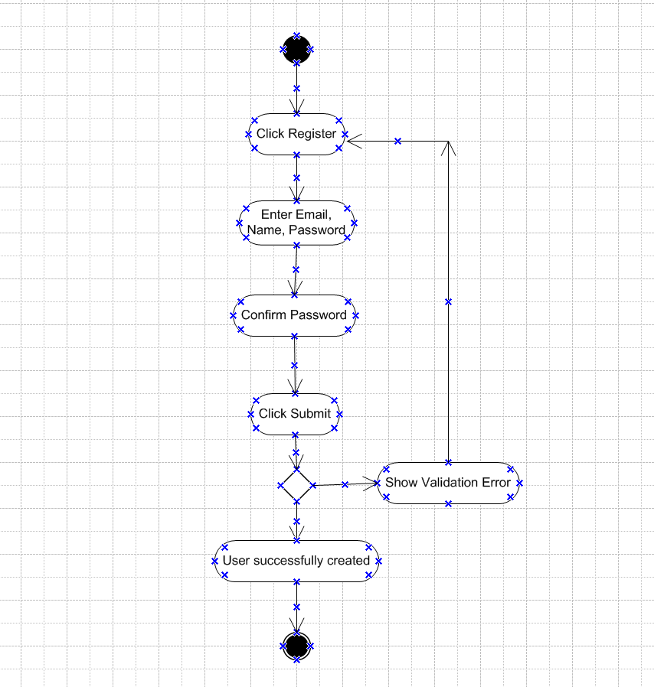

Login:
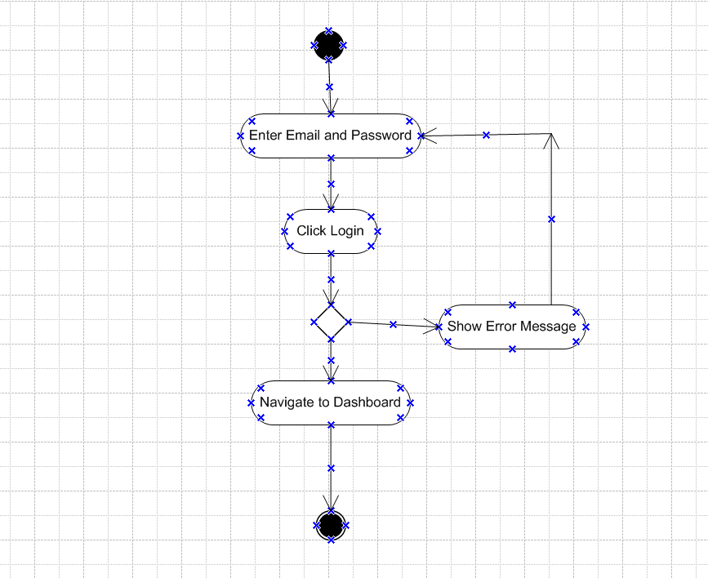

Search Products:

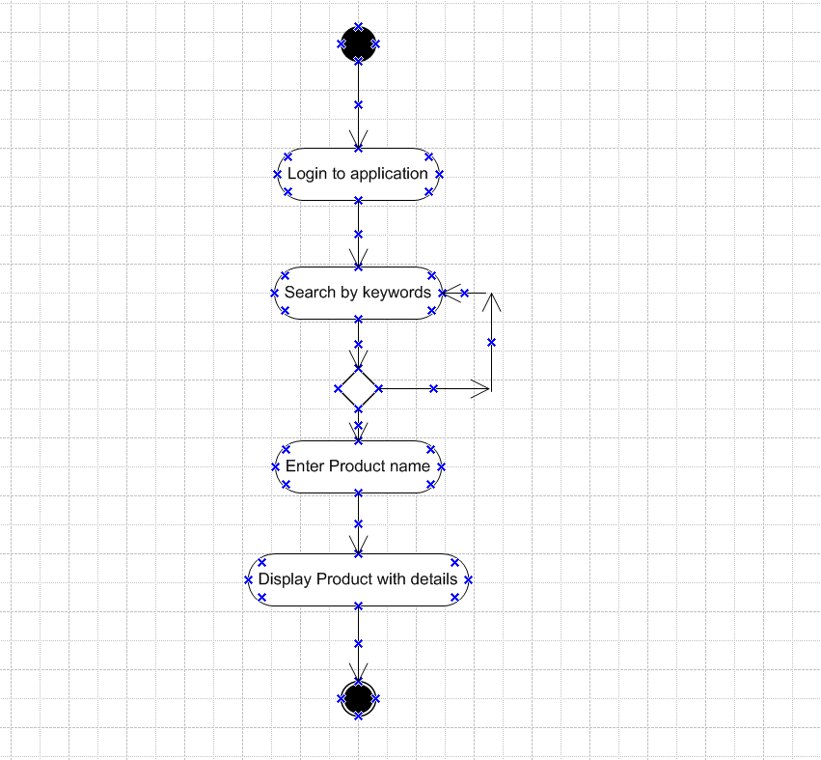

Make Payment:
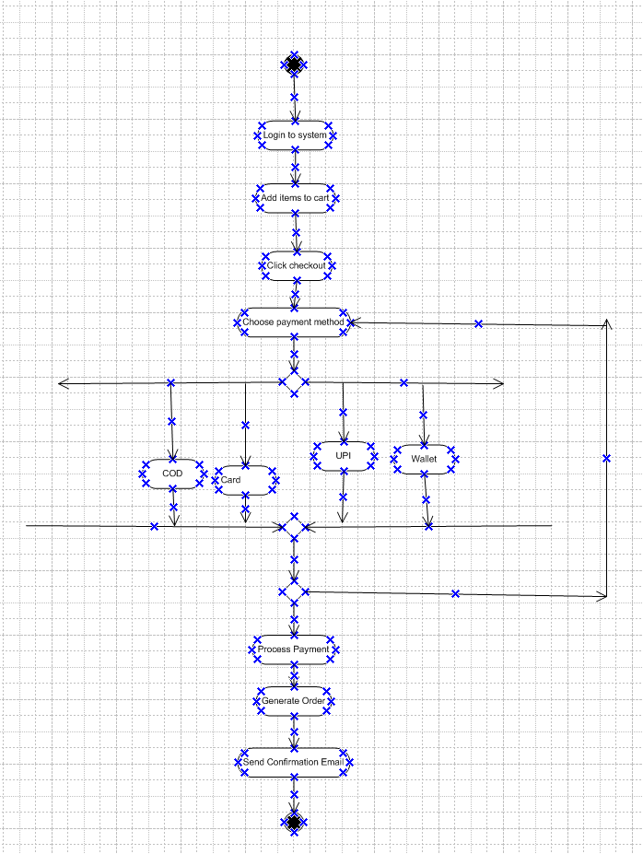

Order Delivery:
