Project Name: Inventory & Delivery Management System (IDMS)

Business Requirements Document (BRD)

Prepared by: Ms. Yamini Chavhan
Prepared for: Inventory & Delivery Management System (IDMS)
Date Submitted: 5th Sep 2025

Project Sponsor: XYZ Ltd.
Client Acceptor:
Project Manager:

Document Number: Project Number /BRD
Version: 0.1

Last Updated:
Creation Date:

Index:

Assignment 1: IDMS

BRD (Complete, Detailed, Formal)
Sections included:
1. Introduction
1.1 Document Purpose
1.2 Intended Audience
1.3 Project Background
1.4 Purpose of the Business Requirements
2. Business Goals & Objectives
3. Benefits
4. Stakeholders
4.1 RACI Matrix
5. Dependencies, Assumptions, Constraints
5.1 References
5.2 Assumptions
5.3 Constraints
6. As-Is vs To-Be Business Process
7. Requirements Scope
7.1 In-Scope Business Functionality
7.2 Out-of-Scope Business Functionality
7.3. Functional Requirements (Use Case format with Actors, Preconditions, Business Rules)
7.3.1 Actor Profiles Specification
7.3.2. Essential Use Case Diagram
7.3.3. Essential Use Case Specifications
7.3.4. Business Rules
8. Data Requirements
8.1 Data Architecture
8.1.1 Domain Class Diagram
8.1.2 Entity Relationship diagram
8.2 Data Definition Reports
8.2.1. Domain Class Definition Report
8.2.2. Entity Definition Report
9. Non-Functional Requirements
9.1. Security Requirements
9.1.1. Authentication
9.1.2. Authorization and Access Controls
9.2. Availability Requirements
9.3. Usability Requirements
9.4. System Help Requirements
9.5. Performance Requirements
9.6. Scalability Requirements
9.6.1 User Scalability
9.6.2 Application Scalability
10. Interface Requirements (User + System)
10.1 User Interface Requirements
10.2 System Interface Requirements
11. Risks & Mitigation Techniques
12. Traceability Matrix
13. Process Flow Diagram
14. Change Management Strategy (Phased Rollout, User Training, Adoption Support)
15. Success Metrics / KPIs (Key Performance Indicators)
16. Glossary
17. Development & Resource Plan (Agile approach, roles, timeline, budget estimate)
18. Revision Log
19. Approval

1. Introduction

  - Document Purpose

The purpose of this document is to describe the business requirements of the Inventory & Delivery Management System (IDMS) completely, accurately, and unambiguously in a technology-independent manner.
This document uses business-oriented terminology while minimizing technical jargon. It serves as the official agreement between the business stakeholders and the IT team to ensure that the proposed solution addresses the defined requirements.
The system’s primary goals are:
To manage the inventory of ice-cream and milk products across multiple plants and warehouses in real-time.
To enable the quickest delivery to customers using optimized warehouse selection and delivery route planning.

1.2 Intended Audience

The main intended audience for this document includes:
Business Owners / Sponsors - to validate that business needs have been captured correctly.
Plant Managers& Warehouse Managers - to confirm operational and inventory-related requirements.
Logistics & Delivery Team - to ensure delivery processes are accurately represented.
Application/Technical Architects- to design solutions that address the requirements.
Data Architects - to design the underlying data model based on documented needs.
End-users (warehouse operators, delivery agents) -to comprehend requirements from a functional point of view.
Since requirements are written in a technology-independent manner, all stakeholders (technical and non-technical) should be able to understand them easily.
.
1.3 Project Background

The company manufactures ice-cream and milk products at several plants and warehouses located across different regions of the country.

Currently, inventory management is handled in a manual or semi-automated manner (spreadsheets and disconnected systems). This leads to:

Inventory mismatches between plants and warehouses.

High wastage of perishable goods due to lack of real-time visibility.

Delayed deliveries caused by inefficient warehouse assignment and route planning.

To address these challenges, management has decided to initiate the IDMS project, with the goals of providing a centralized inventory management system and enabling quickest possible deliveries to customers through automation and optimization.

1.4 Purpose of the Business Requirements

The purpose of these Business Requirements is to clearly define the functional and non-functional needs of the organization for managing inventory and enabling the quickest possible deliveries of perishable products. These requirements will serve as the basis for solution design, vendor discussions (if applicable), development, testing, and implementation.

This document will ensure that:
All stakeholders have a common understanding of the project scope and objectives.
The solution developed will meet business needs without ambiguity.
The requirements remain technology-independent, providing flexibility in design and implementation.

Business Requirement Type:
- Business requirements for major enhancements to an existing application.
✅ Business requirements for new application development.
- Business requirements for replacement application development.
- Business requirements for a request for proposals (RFP).

The IDMS is a new application development initiative, designed to integrate with existing ERP systems but built as a standalone centralized solution for inventory and delivery optimization.

2. Business Goals/Objectives to be achieved

The Inventory & Delivery Management System (IDMS) is being implemented with the following major goals and objectives:

- Centralized Inventory Management:
- Provide real-time visibility of stock levels across all plants and warehouses.
- Reduce discrepancies in inventory data.

- Optimized Delivery Operations:
- Automatically assign the nearest warehouse with available stock.
- Use intelligent route optimization to ensure the quickest deliveries.

- Minimize Wastage of Perishable Products:
- Implement First-Expiry-First-Out (FEFO) practices.
- Generate alerts for products nearing expiry.

- Enhanced Customer Satisfaction:
- Improve delivery timelines and accuracy of orders.
- Provide real-time order tracking and notifications.

- Operational Efficiency:
- Automate manual processes to reduce errors and dependency on paper-based systems.
- Provide dashboards and reports for better decision-making.

- Compliance & Traceability:
- Maintain records of inventory movement in compliance with food safety regulations.
- Enable audit trails for product batches and deliveries.

3. Benefits / Rationale

Implementation of the Inventory & Delivery Management System (IDMS) will deliver the following key benefits:

Operational Benefits:
- Real-time inventory visibility across all plants and warehouses.
- Faster order fulfillment through automated warehouse allocation and optimized delivery routing.
- Reduction in manual errors caused by spreadsheet-based processes.
- Improved coordination between plants, warehouses, and logistics teams.

Financial Benefits:
- 20% reduction in wastage of perishable items due to expiry tracking and alerts.
- Lower logistics costs through efficient route planning.
- Higher revenue from improved customer satisfaction and repeat orders.

Customer Benefits:
- Quicker deliveries with accurate ETAs.
- Improved transparency with real-time order tracking and status updates.
- Higher trust and loyalty due to consistent service quality.

Strategic Benefits:
- Provides a scalable foundation for expanding distribution operations nationwide.
- Strengthens the company’s competitive advantage in the dairy and ice-cream market.
- Improves compliance with food safety and traceability regulations.

4. Stakeholders

The following stakeholders have a vested interest in the Inventory & Delivery Management System (IDMS) and their requirements, expectations, and constraints must be considered throughout the project:

Business Stakeholders:
- Business Owner / Sponsor - Provides funding, strategic direction, and final approval of the system.
- Plant Managers - Ensure production data is accurately reflected in the system and align inventory with demand.
- Warehouse Managers - Oversee stock levels, dispatch operations, and daily warehouse activities.
- Logistics / Delivery Managers - Responsible for route planning, vehicle assignments, and ensuring timely deliveries.

Operational Stakeholders:
- Delivery Agents -Use the mobile application to receive orders, follow optimized routes, and confirm deliveries.
- Customers -Indirect stakeholders who benefit from timely delivery and accurate order fulfillment.

Technical Stakeholders:
- IT Department / System Administrators -Responsible for system setup, maintenance, integration with ERP, and security.
- Database Administrators (DBA)-Ensure smooth operation, data security, and high performance of the IDMS database.
- Support Team-Provides helpdesk and technical support for users.

Project Stakeholders:
- Project Manager -Manages timelines, resources, and overall delivery of the project.
- Business Analyst -Gathers requirements, documents them (this BRD), and ensures business needs are met.
- Development Team -Implements the software solution (frontend, backend, mobile app developers).
- Quality Assurance (QA) Team -Ensures the system meets business and functional requirements through testing.

4.1 RACI Matrix
Legend:
- R (Responsible): The person(s) who perform the task.
- A (Accountable): The person who is ultimately answerable for the task.
- C (Consulted): People whose input is required.
- I (Informed): People kept updated on progress.
Activity / Deliverable | Business Owner | Project Manager | Business Analyst | Dev Team | QA Team | Warehouse Manager | Delivery Agents | IT / DBA | Customers
Define Business Requirements | A | C | R | I | I | C | I | I | I
Approve Business Requirements (BRD) | A | R | C | I | I | C | I | I | I
System Design & Architecture | C | A | C | R | I | I | I | R | I
Development of IDMS Modules | I | A | C | R | I | I | I | C | I
Data Integration with ERP | C | A | C | R | I | I | I | R | I
Inventory Management Module Testing | I | C | C | C | R | C | I | I | I
Delivery Route Optimization Testing | I | C | C | C | R | I | C | I | I
User Acceptance Testing (UAT) | C | R | C | I | R | C | C | I | A
Training & Change Management | C | R | R | I | C | C | C | I | I
Go-Live Approval | A | R | C | I | C | C | I | I | I
Post-Go-Live Support | C | A | C | R | R | I | I | R | I

5. Dependencies on Existing Systems
The Inventory & Delivery Management System (IDMS) will not function in isolation. It will depend on integrations with several existing applications and systems to ensure smooth operations:

1. ERP System (Enterprise Resource Planning)
- Dependency: IDMS must integrate with the company’s ERP to fetch master data (products, pricing, customers, suppliers) and update order & inventory transactions.
- Rationale: Ensures data consistency between ERP and IDMS.

2. GPS & Maps API Services
- Dependency: IDMS requires integration with third-party map services (e.g., Google Maps API, Mapbox) for route optimization and delivery tracking.
- Rationale: Enables efficient delivery planning and provides ETAs to customers.

3. Warehouse Management Systems (if any existing)
- Dependency: For warehouses already using localized WMS modules, IDMS must synchronize stock movement data.
- Rationale: Prevents duplication of data entry and ensures real-time visibility.

4. Authentication & Identity Management Systems
- Dependency: Integration with corporate Single Sign-On (SSO) or identity management system.
- Rationale: Provides secure login and role-based access control.

5. Notification Systems
- Dependency: SMS gateway and Email service integration.
- Rationale: Used to send order confirmation, delivery updates, and alerts to customers and internal users.

5.1 References

The following documents, communications, and standards have been referred to during the preparation of this Business Requirement Document (BRD):
1. Company ERP Documentation – Internal ERP system process manuals (Inventory, Sales & Distribution modules).
2. Warehouse Operations SOPs – Standard Operating Procedures for warehouse management and stock handling.
3. Logistics Guidelines – Internal logistics process documentation covering delivery routes and service-level agreements (SLAs).
4. Food Safety & Compliance Regulations – National Dairy and Food Products Regulatory Standards related to traceability, cold-chain management, and product shelf-life.
5. Meeting Minutes & Email Correspondence – Discussions held with Business Owners, Plant Managers, and Logistics Teams during requirement-gathering sessions (July–August 2025).
6. Industry Best Practices – References to standard practices in supply chain optimization and perishable goods management.

5.2 Assumptions

The following assumptions were made during the gathering and documentation of the business requirements for the Inventory & Delivery Management System (IDMS):

1. Connectivity – All warehouses and delivery agents will have reliable internet or mobile network connectivity to enable real-time data synchronization.
2. ERP Integration – The existing ERP system will provide accurate and up-to-date master data (products, customers, pricing) for integration with IDMS.
3. Technology Infrastructure – Adequate IT infrastructure (servers, databases, network capacity) will be provisioned before deployment.
4. User Readiness – Plant managers, warehouse staff, and delivery agents will be trained and available to adopt the new system without resistance.
5. Data Accuracy – Initial inventory and customer data provided by business teams will be clean and validated before migration to IDMS.
6. Third-Party Services – GPS/Maps APIs, SMS gateway, and email servers will remain accessible and reliable during the project lifecycle.
7. Regulatory Compliance – Business rules will comply with national food safety and cold-chain management regulations, and no sudden legislative changes are expected during development.
8. Project Funding & Timeline – Budget approval and stakeholder commitment will remain consistent throughout the project duration.

5.3 Constraints

The following constraints will impact the design, development, and deployment of the Inventory & Delivery Management System (IDMS):

1. Perishable Product Handling
- Ice-cream and milk products have a short shelf-life and require cold-chain compliance.
- Any system downtime or delivery delays may result in financial loss and product wastage.

2. Budget Limitations
- The allocated budget for the project is fixed and must cover software development, integration, infrastructure, training, and support.
- Cost overruns are not acceptable and strict budget controls will be applied.

3. Timeline Restrictions
- The system must be delivered within 5 months (3 months for MVP, 2 months for rollout).
- Delays may affect seasonal demand cycles (e.g., summer peak for ice-cream sales).

4. Integration Dependencies
- IDMS relies on integration with ERP, GPS/Maps APIs, and notification gateways.
- Any delays or failures in these external systems will impact IDMS performance.

5. Resource Availability
- Limited availability of subject matter experts (SMEs), warehouse staff, and delivery managers for requirement validation and UAT.

6. Regulatory Compliance
- IDMS must comply with national food safety, quality assurance, and traceability regulations.
- Non-compliance can result in penalties or operational shutdowns.

7. Technology Scope
- The system will be developed as a new application, but must remain compatible with existing ERP systems and IT infrastructure.

6. As-Is vs To-Be Business Process

As-Is (Current State):
AS-IS process (current state) — Inventory & Delivery Management is manual/semi-automated. Orders arrive (ERP or phone), staff use spreadsheets and disconnected systems to check stock, decide a warehouse manually, plan routes, and use paper-based PODs. This produces delays, inventory mismatches, FEFO violations, increased wastage and poor KPIs.
- Pain points (explicit):
- Manual order capture or delayed ERP sync → latency in allocation.
- Inventory checks via spreadsheets → stale stock data and errors.
- No FEFO enforcement → expiry-related wastage.
- Manual route planning and paper PODs → longer delivery times, lost proof of delivery.
- Poor reporting/dashboards → delayed decisions.
As is Business Process flow diagram-

- 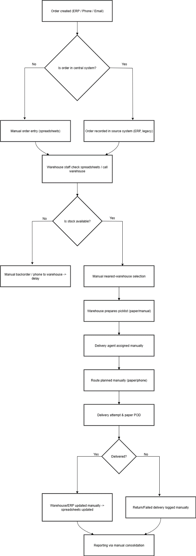

To-Be (Future State with IDMS):

Orders are synced from ERP in real time to IDMS. IDMS performs automatic inventory checks across warehouses, applies FEFO logic, assigns optimal warehouse (nearest + inventory health), generates digital picklists, assigns delivery agents, calls a Maps API for optimized routing, and captures POD digitally. Alerts update dashboards and trigger expiry/low-stock workflows. This reduces wastage, improves SLA adherence and enables real-time KPIs.
Key TO-BE benefits:
- Real-time stock visibility & FEFO enforcement → reduced wastage.
- Automated warehouse allocation → faster fulfillment.
- Optimized routing → improved ETA and fuel cost savings.
- Digital POD & audit trail → reduced disputes and better compliance.
- Real-time dashboards → faster decision-making and SLA monitoring

To be Business Process flow diagram-
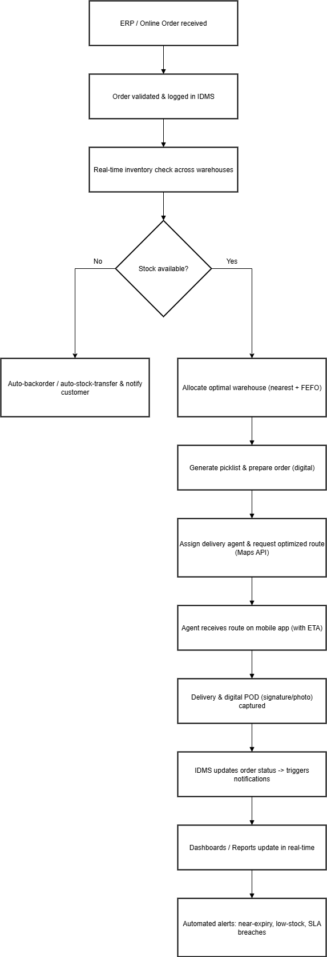

7. Requirements Scope

The scope of the Inventory & Delivery Management System (IDMS) is to automate and optimize inventory tracking and delivery processes for ice-cream and milk products across the company’s plants and warehouses.

The following functionality is considered in-scope and out-of-scope for this implementation:

7.1 In-Scope Business Functionality

1. Inventory Management
- Real-time stock updates across all plants and warehouses.
- Batch and expiry tracking (First-Expiry-First-Out – FEFO).
- Stock movement (inbound, outbound, transfers).

2. Order Management
- Order capture from ERP system.
- Automated warehouse allocation based on location and stock availability.

3. Delivery & Logistics Management
- Route optimization using Maps/GPS APIs.
- Assignment of orders to delivery agents/vehicles.
- Proof of Delivery (POD) capture via mobile application.

4. Notifications & Alerts
- Order confirmations and delivery updates to customers.
- Alerts for low stock, delayed orders, and near-expiry products.

5. Reporting & Dashboards
- Inventory reports (stock levels, wastage, expiry trends).
- Delivery performance reports (on-time %, route efficiency).
- Executive dashboards for real-time decision-making.

6. User & Role Management
- Secure login and access controls.
- Roles: Admin, Warehouse Manager, Delivery Agent, Customer.

7.2 Out-of-Scope Business Functionality

The following functionality is explicitly out-of-scope for the current release of IDMS:

- Payroll, HR, and employee management.
- Customer Relationship Management (CRM) functions (e.g., marketing campaigns, loyalty programs).
- Financial accounting, invoicing, and billing functions (handled by ERP).
- Manufacturing process automation (plant production tracking is excluded; only inventory post-production is included).
- Vendor management and procurement functions.
- Integration with third-party e-commerce platforms (future enhancement).

Note: Out-of-scope requirements may be considered for future phases of IDMS but are not part of the current project timeline.

Future Enhancements / Out-of-Scope

Out-of-scope items are excluded from the current release but noted for future consideration. This ensures project boundaries remain clear while giving a vision for long-term growth.

CRM Integration (Future Phase):
- Customer Relationship Management features such as loyalty programs, personalized offers, or marketing campaigns.
- Not needed for immediate inventory/delivery management, but beneficial once IDMS stabilizes.
Plant Production Automation:
- Current scope starts post-production (inventory onwards).
- Future integration with manufacturing systems (MES/IoT sensors in plants) can provide end-to-end visibility from production → inventory → delivery.
E-commerce Platform Integration:
- Current orders come via ERP.
- Future integration with B2C portals, marketplaces, and mobile ordering apps will allow direct consumer orders to flow into IDMS.

7.3. Functional Requirements

7.3.1 Actor Profiles Specification

Actor | Description
Business Owner | Approves requirements, monitors KPIs through dashboards.
Project Manager | Oversees implementation, ensures timely delivery.
Warehouse Manager | Manages stock levels, batch/expiry, inbound & outbound movements.
Delivery Agent | Receives delivery orders on mobile app, follows optimized routes, confirms POD.
Customer | Places orders (via ERP or integrated system), receives notifications, and tracks delivery.
System Admin (IT/DBA) | Maintains the application, user accounts, security, and integrations.
ERP System | External system providing master data and receiving updates on inventory and orders.
Maps API | External service providing route optimization and delivery tracking.

7.3.2. Essential Use Case Diagram

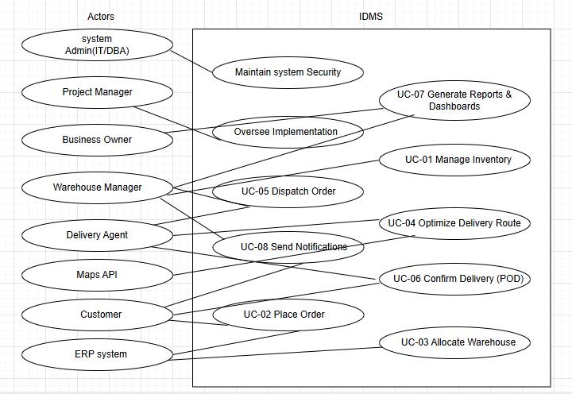

7.3.3. Essential Use Case Specifications

Use Case Id: UC-01 Manage Inventory

Use Case Name |  | Manage Inventory
Description |  | Allows Warehouse Managers to add, update, and track inventory in real-time, including SKU, batch, and expiry details.
Actors |  | 1.Warehouse Manager (Primary)  2.IDMS System (Supporting)
Business Rules |  | BR-01: All stock entries must include SKU, batch number, and expiry date.  BR-02: Expired stock cannot be dispatched.
Basic Flow |  | Alternate Flows
1. Warehouse Manager logs into IDMS.  2. Selects “Add/Update Stock.”  3. Inputs SKU, quantity, batch, expiry date.  4. System updates central inventory database.  5. Confirmation displayed. |  | AF-01: If SKU not found → System prompts to create new SKU.  AF-02: If duplicate batch entered → System rejects entry.
Non-Functional Requirements |  | 1. Data entry should update within 2 seconds.  2. Mobile responsive for tablet use in warehouse.
Pre-Conditions |  | Warehouse Manager authenticated with valid role.
Post-Conditions |  | Inventory database updated.  Alerts triggered if stock below threshold.
Extension Points | Extension Condition |  | Extending Use Case
EP-01. | Expiry Alert |  | Extends UC-01 when expiry date is near.
List of <<included>> use cases | List of <<extended>> use cases |  | List of “inherited from (parent)” use cases
None | UC-08 Send Notifications |  | None

Use Case Id: UC-02: Place Order

Use Case Name |  | Place Order
Description |  | Captures customer order from ERP and sends it to IDMS for processing.
Actors |  | 1.Customer (via ERP)  2.ERP System (Primary)  3.IDMS (Supporting)
Business Rules |  | BR-03: Orders must be validated for stock availability.  BR-04: Delivery address must be complete before processing.
Basic Flow |  | Alternate Flows
1. Customer places order in ERP.  2. ERP validates basic order details.  3. Order transmitted to IDMS.  4. IDMS logs order for allocation. |  | AF-01: If stock unavailable → order flagged for backorder.  AF-02: If delivery address invalid → order rejected.
Non-Functional Requirements |  | Order sync between ERP and IDMS must occur within 1 minute.
Pre-Conditions |  | ERP system active.
Post-Conditions |  | Order available in IDMS for allocation.
Extension Points | Extension Condition |  | Extending Use Case
EP-02 | Order Confirmation |  | Extends UC-02
List of <<included>> use cases | List of <<extended>> use cases |  | List of “inherited from (parent)” use cases
UC-08 Send Notifications | UC-03 Allocate Warehouse |  | None

Use Case Id: UC-03: Allocate Warehouse

Use Case Name |  | Allocate Warehouse
Description |  | System allocates optimal warehouse based on stock availability and delivery location.
Actors |  | IDMS (Primary)
Business Rules |  | BR-05: Nearest warehouse with sufficient stock must be allocated.  BR-06: Allocation must consider expiry dates (FEFO).
Basic Flow |  | Alternate Flows
1. IDMS receives order from ERP.  2. System checks stock across warehouses.  3. Allocates nearest warehouse with sufficient stock.  4. Updates order status. |  | AF-01: If no warehouse has full stock → split order between warehouses.  AF-02: If warehouse offline → reallocate.
Non-Functional Requirements |  | Allocation engine must respond in <5 seconds.
Pre-Conditions |  | Order exists in IDMS.
Post-Conditions |  | Warehouse assignment completed.
Extension Points | Extension Condition |  | Extending Use Case
EP-03 | Stock Transfer (if reallocation needed).
List of <<included>> use cases | List of <<extended>> use cases |  | List of “inherited from (parent)” use cases
UC-01 Manage Inventory | UC-04 Optimize Delivery Route |  | None

Use Case Id: UC-04: Optimize Delivery Route

Use Case Name |  | Optimize Delivery Route
Description |  | Uses Maps API to determine fastest delivery route and assigns it to Delivery Agent.
Actors |  | 1.Delivery Agent (Primary)  2.Maps API (Supporting)
Business Rules |  | BR-07: Routes must prioritize shortest time, not just distance.  BR-08: Delivery must consider traffic and time windows.
Basic Flow |  | Alternate Flows
1. Warehouse confirms dispatch.  2. IDMS sends delivery address to Maps API.  3. Optimized route generated.  4.Delivery Agent receives route on mobile app. |  | AF-01: If API unavailable → fallback to default route.
Non-Functional Requirements |  | Route optimization response time <10 seconds.
Pre-Conditions |  | Order allocated and dispatch confirmed.
Post-Conditions |  | Optimized route available.
Extension Points | Extension Condition |  | Extending Use Case
EP-04 | Traffic Re-Route |  | Extends UC-04 if delays occur
List of <<included>> use cases | List of <<extended>> use cases |  | List of “inherited from (parent)” use cases
None | UC-05 Dispatch Order |  | None

Use Case Id: UC-05: Dispatch Order

Use Case Name |  | Dispatch Order
Description |  | Enables warehouse to prepare and hand over orders to Delivery Agents.
Actors |  | 1.Warehouse Manager (Primary)  2.Delivery Agent (Primary)
Business Rules |  | BR-09: Orders must be verified before dispatch.  BR-10: Delivery Agent must be assigned a route before leaving.
Basic Flow |  | Alternate Flows
1. Warehouse Manager selects order for dispatch.  2. Delivery Agent assigned.  3. Order handed over.  4. Dispatch status updated. |  | AF-01: If Agent unavailable → reassign.
Non-Functional Requirements |  | Dispatch confirmation updates within 30 seconds.
Pre-Conditions |  | Warehouse allocation complete.
Post-Conditions |  | Order marked as “In Transit.”
Extension Points | Extension Condition |  | Extending Use Case
EP-05 | Vehicle Breakdown |  | Extends UC-05
List of <<included>> use cases | List of <<extended>> use cases |  | List of “inherited from (parent)” use cases
UC-04 Optimize Delivery Route | UC-06 Confirm Delivery |  | None

Use Case Id: UC-06: Confirm Delivery (Proof of Delivery)

Use Case Name |  | Confirm Delivery (Proof of Delivery)
Description |  | Delivery Agent captures proof of delivery and updates system.
Actors |  | 1.Delivery Agent (Primary)  2.Customer (Supporting
Business Rules |  | BR-11: POD must include signature or photo.  BR-12: Failed delivery must be recorded with reason
Basic Flow |  | Alternate Flows
1. Agent arrives at customer location.  2. Captures POD (signature/photo).  3. Updates IDMS.  4. Customer receives delivery confirmation. |  | AF-01: If customer unavailable → order marked as “Failed Delivery.”
Non-Functional Requirements |  | POD upload time <5 seconds.
Pre-Conditions |  | Order marked as “In Transit.”
Post-Conditions |  | Order marked “Delivered” or “Failed Delivery.”
Extension Points | Extension Condition |  | Extending Use Case
EP-06 | Failed Delivery |  | Extends UC-06
List of <<included>> use cases | List of <<extended>> use cases |  | List of “inherited from (parent)” use cases
UC-08 Send Notifications | None |  | None

Use Case Id: UC-07: Generate Reports & Dashboards

Use Case Name |  | Generate Reports & Dashboards
Description |  | Allows managers to view inventory and delivery performance reports.
Actors |  | 1.Business Owner (Primary)  2.Warehouse Manager (Supporting)
Business Rules |  | BR-13: Reports must show real-time data.  BR-14: Only authorized users can access dashboards.
Basic Flow |  | Alternate Flows
1. User logs in.  2. Selects report type.  3. IDMS generates report/dashboards.  4. Data displayed/exported. |  | AF-01: If no data available → system shows “No records.”
Non-Functional Requirements |  | Reports must generate within 10 seconds.
Pre-Conditions |  | Data available in system.
Post-Conditions |  | Reports generated and visible/exportable.
Extension Points | Extension Condition |  | Extending Use Case
EP-07 | Scheduled Report Delivery |  | Extends UC-07
List of <<included>> use cases | List of <<extended>> use cases |  | List of “inherited from (parent)” use cases
None | None |  | None

Use Case Id: UC-08: Send Notifications

Use Case Name |  | Send Notifications
Description |  | System sends SMS/Email notifications for key order lifecycle events.
Actors |  | 1.IDMS System (Primary)  2.Customer (Supporting)  3.Warehouse Manager (Supporting)
Business Rules |  | BR-15: Notifications must be triggered for order confirmation, dispatch, and delivery.  BR-16: Failed notifications must be logged.
Basic Flow |  | Alternate Flows
1. Order lifecycle event occurs.  2. IDMS triggers notification.  3. SMS/Email sent to stakeholders.  4. Delivery confirmed. |  | AF-01: If SMS gateway fails → fallback to email only.
Non-Functional Requirements |  | Notifications delivered within 1 minute.
Pre-Conditions |  | Event triggered.
Post-Conditions |  | Stakeholders notified.
Extension Points | Extension Condition |  | Extending Use Case
EP-08 | Escalation Alert |  | Extends UC-08 for delayed orders
List of <<included>> use cases | List of <<extended>> use cases |  | List of “inherited from (parent)” use cases
All core use cases (UC-01 to UC-06) | None |  | None

7.3.4. Business Rules

Business Rule Id | Rule Name | Rule Description | Rule Source
BR-01 | Mandatory Stock Entry Fields | All stock entries must include SKU, batch number, and expiry date. | Warehouse SOPs, SME Inputs
BR-02 | No Expired Dispatch | Expired stock cannot be dispatched to customers. | Food Safety Regulations
BR-03 | Order Stock Validation | Orders must be validated for stock availability before allocation. | ERP Integration Rules
BR-04 | Valid Delivery Address | Delivery address must be complete and valid before an order is processed. | Logistics Guidelines
BR-05 | Nearest Warehouse Allocation | Orders must be allocated to the nearest warehouse with sufficient stock. | Strategic Decision (Operations)
BR-06 | FEFO Rule | Allocation must prioritize stock with earliest expiry (First-Expiry-First-Out). | Industry Best Practice
BR-07 | Route Optimization Criteria | Delivery routes must prioritize shortest time considering traffic and distance. | Logistics Strategy, Maps API
BR-08 | Time Window Delivery | Deliveries must comply with customer-specified time windows where applicable. | Customer Service Policy
BR-09 | Order Verification Before Dispatch | Orders must be verified by warehouse staff before dispatch. | Warehouse SOPs
BR-10 | Route Assignment Before Dispatch | Delivery Agent must be assigned a route before leaving warehouse. | Logistics Guidelines
BR-11 | Proof of Delivery (POD) Required | A valid POD (signature or photo) must be captured for every completed delivery. | Customer Service Policy
BR-12 | Failed Delivery Logging | All failed deliveries must be logged with valid reason codes. | Operations Policy
BR-13 | Real-time Reporting | Reports and dashboards must display real-time or near real-time data. | Business Owner Requirement
BR-14 | Authorized Access Only | Only authorized users may view inventory, order, or delivery data. | IT Security Policy
BR-15 | Mandatory Notifications | Notifications must be sent for order confirmation, dispatch, and delivery events. | Customer Engagement Policy
BR-16 | Notification Logging | All failed notifications (SMS/Email) must be logged for troubleshooting. | IT/Support Guidelines

8. Data Requirements

This section describes the data requirements of the Inventory & Delivery Management System (IDMS), focusing on the information model required to support inventory and delivery operations.

8.1 Data Architecture

The IDMS requires a conceptual data architecture that supports real-time stock tracking, order processing, delivery management, and reporting. The architecture will capture entities, their attributes, and relationships.

Conceptual Classes & Key Attributes:

Product
- Attributes: Product ID, SKU, Name, Category, Batch No, Expiry Date, Unit Of Measure
- Associations: Linked to Inventory, Order Item
Inventory
- Attributes: Inventory ID, Product ID, Ware house ID, Quantity, Available Qty, Status
- Associations: Tracks stock per Warehouse
Warehouse
- Attributes: Warehouse ID, Name, Location, Capacity, Region
- Associations: Holds Inventory, Linked to Deliveries
Order
- Attributes: Order ID, Customer ID, Date Placed, Status, Total Amount
- Associations: Contains Order Items, Linked to Delivery
Order Item
- Attributes: Order Item ID, Order ID, Product ID, Quantity, Unit Price
- Associations: Belongs to Order, references Product
Delivery
- Attributes: Delivery ID, Order ID, Ware house ID, Agent ID, Route Details, Status, POD
- Associations: Linked to Order, Warehouse, Delivery Agent
Customer
- Attributes: Customer ID, Name, Contact, Email, Address, Region
- Associations: Places Orders
User
- Attributes: User ID, Name, Role, Credentials, Contact
- Associations: Admin, Manager, Delivery Agent roles
Notification
- Attributes: Notification ID, Event Type, Recipient, Status, Sent On
- Associations: Tied to Order or Delivery events

Domain Class Diagram

The Domain Class Diagram models the conceptual data architecture of the Inventory & Delivery Management System (IDMS). It captures real-world entities (conceptual classes), their attributes (fields), and operations (behaviors/methods), along with the relationships (associations, aggregations, generalizations) between them.

This is not a software design diagram, but rather a business domain model that reflects how the core business concepts relate to each other.

Conceptual Classes & Attributes
Product
- Attributes: Product ID, Name, Category, Batch No, Expiry Date, Quantity, Unit
- Operations: Check Availability(), Update Quantity(), Check Expiry()
Inventory
- Attributes: Inventory ID, Warehouse ID, Stock Level, Last Updated
- Operations: Update Stock(), Generate Alert()
Warehouse
- Attributes: Ware house ID, Location, Capacity, Contact Details
- Operations: Allocate Stock(), Dispatch Order()
Order
- Attributes: Order ID, Customer ID, Date Placed, Status
- Operations: Create Order(), Cancel Order(), Track Order()
OrderItem
- Attributes: Order Item ID, Order ID, Product ID, Quantity
- Operations: Add Item(), Remove Item()
Customer
- Attributes: Customer ID, Name, Contact, Address
- Operations: Place Order(), Track Order()
Delivery
- Attributes: Delivery ID, Order ID, Delivery Agent ID, Route Details, ETA, Status
- Operations: Assign Route(), Update Status()
DeliveryAgent
- Attributes: Agent ID, Name, Contact, Vehicle Details
- Operations: Deliver Order(), Update Location()
Manager/Admin
- Attributes: Manager ID, Name, Role, Contact
- Operations: Monitor Inventory(), Generate Reports()

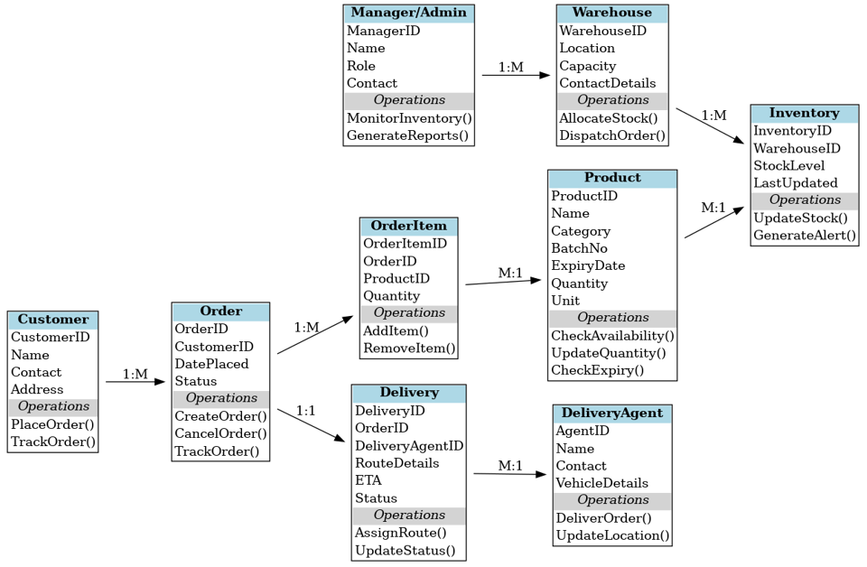

8.1.2. Entity Relationship Diagram

This section depicts the Data Architecture in the form of an Entity Relationship Diagram (ERD), applicable to the Oracle Designer approach. The ERD models the conceptual data architecture by identifying the entities, attributes, and relationships required to satisfy the business requirements of the Inventory & Delivery Management System (IDMS).

Unlike the Domain Class Diagram, which focuses on conceptual classes and operations, the ERD concentrates on data entities, their primary/foreign keys, and relationships.

Entities & Attributes
1. Customer
- Customer ID (PK)
- Name
- Contact
- Address
2. Order
- Order ID (PK)
- Customer ID (FK → Customer. Customer ID)
- Date Placed
- Status
3. Order Item
- Order Item ID (PK)
- Order ID (FK → Order. Order ID)
- Product ID (FK → Product. Product ID)
- Quantity
4. Product
- Product ID (PK)
- Name
- Category
- Batch No
- Expiry Date
- Unit
5. Inventory
- Inventory ID (PK)
- Product ID (FK → Product. Product ID)
- Ware house ID (FK → Ware house .Ware house ID)
- Stock Level
- Last Updated
6. Warehouse
- Ware house ID (PK)
- Location
- Capacity
- Contact Details
7. Delivery
- Delivery ID (PK)
- Order ID (FK → Order .Order ID)
- Delivery Agent ID (FK → Delivery Agent .Agent ID)
- Route Details
- ETA
- Status
8. Delivery Agent
- Agent ID (PK)
- Name
- Contact
- Vehicle Details
9. Manager/Admin
- ManagerID (PK)
- Name
- Role
- Contact

Relationships:
Customer (1) — (M) Order: A customer can place many orders.
Order (1) — (M) Order Item: Each order can contain multiple order items.
Order Item (M) — (1) Product: Multiple order items can reference the same product.
Product (M) — (1) Inventory: Each product’s stock is tracked in inventory for a warehouse.
Warehouse (1) — (M) Inventory: A warehouse manages multiple product inventories.
Order (1) — (1) Delivery: Each order has exactly one delivery.
Delivery (M) — (1) Delivery Agent: A delivery is handled by one agent; an agent may manage multiple deliveries.
Manager/Admin (1) — (M) Warehouse: Each manager supervises multiple warehouses.

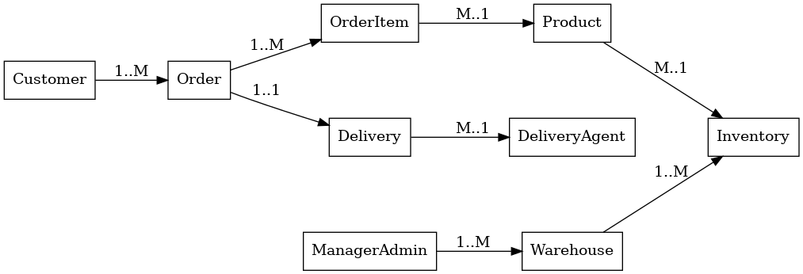

8.2 Data Definition Reports

This section provides detailed descriptions of the data model elements represented in the UML Class Diagram and Entity Relationship Diagram These definitions ensure clarity on the attributes, keys, and relationships that form the basis of the Inventory & Delivery Management System (IDMS).

Domain Class Definition Report

Domain Class Definition Report

Class Name | Description | Attributes | Operations (Methods)
Product | Represents manufactured ice-cream and milk products available for inventory and order processing. | Product ID, SKU, Name, Category, Batch No, Expiry Date | Add Product(), Update Product(), Check Expiry()
Inventory | Represents stock levels of products across warehouses. | Inventory D, Product ID, Warehouse ID, Quantity, Status | Update Stock(), Check Availability()
Order | Represents a customer’s purchase request. | Order ID, Customer ID, Date Placed, Status | Place Order(), Cancel Order(), Track Order()
Order Item | Line items within an order, linked to specific products. | Order Item ID, Order ID, Product ID, Quantity | Add Item(), Update Item()
Delivery | Represents dispatch and delivery details for each order. | Delivery ID, Order ID, Warehouse ID, Agent ID, Route Details, POD | Assign Agent(), Track Delivery(), Confirm Delivery()
Warehouse | Represents a physical storage location. | Warehouse ID, Name, Location, Capacity | Allocate Stock(), Check Capacity()
Customer | Represents the buyer placing orders. | Customer ID, Name, Contact, Address | Register Customer(), Update Profile()
User (Agent/Admin) | Represents system users such as delivery agents and admins. | User ID, Name, Role, Contact | Login(), Update Profile()
Notification | Represents messages sent to customers/agents regarding order and delivery events. | Notification ID, Event Type, Recipient, Status | Send Notification(), Update Status()

8.2.2. Entity Definition Report

Entity Name | Primary Key (PK) | Foreign Keys (FK) | Attributes | Description
Product | Product ID | – | SKU, Name, Category, Batch No, Expiry Date | Master list of products manufactured.
Inventory | Inventory ID | Product ID, Warehouse ID | Quantity, Status | Stock records per warehouse for products.
Order | Order ID | Customer ID | Date Placed, Status | Customer order header information.
Order Item | Order Item ID | Order ID, Product ID | Quantity | Individual line items per order.
Delivery | Delivery ID | Order ID, Warehouse ID, Agent ID | Route Details, POD | Dispatch and delivery details for each order.
Warehouse | Warehouse ID | – | Name, Location, Capacity | Locations where products are stored.
Customer | Customer ID | – | Name, Contact, Address | Customers placing orders.
User | User ID | – | Name, Role, Contact | System users (agents/admins).
Notification | Notification ID | Order ID, Delivery ID | Event Type, Recipient, Status | Notifications sent for order/delivery events.

9. Non-Functional requirements

This section defines the non-functional requirements of the Inventory & Delivery Management System (IDMS). Unlike functional requirements that describe what the system does, non-functional requirements define how well the system performs and under what conditions. They include quality attributes, standards, and constraints that the system must adhere to.

Security Requirements

9.1.1. Authentication

Authentication is the process of verifying the genuineness of claims that a person/group makes to establish identity or eligibility for access to services. Different use cases of the Inventory & Delivery Management System (IDMS) require different authentication levels, depending on the sensitivity of the data and the criticality of the transaction.

The following levels are defined in line with Government Core Policy Manual:

Level 0: Anonymous transaction – Public or informational, no authentication needed.
Level 1: Pseudonymous transaction – Contact without identification (email, inquiry, etc.).
Level 2: Identified transaction – Requires explicit identification of the user.
Level 3: Verified transaction – Requires strong verification, audit trails, and non-repudiation.

Authentication Matrix

Use Case / Business Function Name | Transaction Type Triggered
View Product Catalog (Customer) | Level 0 – Anonymous (anyone can browse products without login)
Customer Registration | Level 2 – Identified (requires name, contact, address, etc.)
Customer Login | Level 2 – Identified (requires ID + password; MFA optional)
Place Order | Level 3 – Verified (requires customer login; digital invoice generated as evidence)
Track Order Status | Level 2 – Identified (requires login to view one’s orders)
Warehouse Staff Login | Level 2 – Identified (restricted access to warehouse data)
Update Inventory (Warehouse Staff) | Level 3 – Verified (requires strong authentication and audit logs)
Delivery Agent Login | Level 2 – Identified (agent login with unique ID)
Confirm Delivery / Upload POD | Level 3 – Verified (requires delivery agent authentication + evidence record)
Admin Login (System Administrator) | Level 3 – Verified (strong authentication + MFA + audit trails)
Generate Reports (Admin/Manager) | Level 3 – Verified (sensitive business data access)
Send Notification (System Function) | Level 1 – Pseudonymous (system sends updates via email/SMS without requiring explicit identity verification of sender)
View Help/FAQs | Level 0 – Anonymous (open access, no login needed)

Authorization and Access Controls

Authorization is the process of determining if a user, once authenticated, has the appropriate permissions to access a resource or perform a given function.
In the Inventory & Delivery Management System (IDMS), access control is enforced using Role-Based Access Control (RBAC).

The following table illustrates the level of access (CRUD) different roles/actors have on key business entities.

Actor / Business Unit | Entity: Product | Entity: Inventory | Entity: Order | Entity: Order Item | Entity: Delivery | Entity: Warehouse | Entity: Customer | Entity: User | Entity: Notification
Customer | R | – | C, R (own) | C, R (own) | R (own) | – | C, R, U (own profile) | – | R (own)
Warehouse Staff | R | C, R, U | R | R | R | R, U | – | – | –
Delivery Agent | R | R | R (assigned) | R (assigned) | U (assigned: confirm POD, update status) | – | – | – | –
System Admin | C, R, U, D | C, R, U, D | C, R, U, D | C, R, U, D | C, R, U, D | C, R, U, D | C, R, U, D | C, R, U, D | C, R, U, D
Manager / Supervisor | R | R | R | R | R | R | R | – | R
System (Automated) | – | U (auto stock sync) | U (status updates) | U | U (dispatch tracking) | – | – | – | C, R, U (trigger customer/agent notifications)

Legend:
C = Create
R = Read
U = Update
D = Delete
(Own) → Access limited to user’s own records (e.g., Customer can update only their own profile).
(Assigned) → Access limited to records assigned to the user (e.g., Delivery Agent can only update their assigned deliveries).

9.2. Availability Requirements
System availability refers to the degree to which the Inventory & Delivery Management System (IDMS) must be accessible for different business functions. Since the company deals with perishable products like ice-cream and milk, high availability is critical to ensure accurate inventory updates and timely deliveries.

The following table outlines the availability requirements for key business functions:
Use Case / Business Function | Availability Requirements
View Product Catalog (Customer) | 24×7 (accessible anytime for customers)
Customer Registration & Login | 24×7 (customers must be able to sign up or log in anytime)
Place Order (Customer) | 24×7 (orders can be placed anytime)
Track Order Status (Customer) | 24×7 (real-time tracking required)
Customer Notifications (Email/SMS) | 24×7 (must be sent instantly on order/delivery events)
Update Inventory (Warehouse Staff) | Regular Work Hours (stock updates typically during warehouse operations)
Warehouse Staff Login | Regular Work Hours (restricted to business hours)
Delivery Agent Login | 24×7 (deliveries may happen outside business hours)
Confirm Delivery & Upload POD | 24×7 (critical to confirm deliveries in real-time)
System Admin Login | 24×7 (for monitoring, troubleshooting, and urgent interventions)
Generate Reports (Managers/Supervisors) | Regular Work Hours (analytical/reporting tasks are daytime functions)
Automated Stock Synchronization | 24×7 (system sync must happen in near real time across warehouses)

9.3. Usability Requirements

The Inventory & Delivery Management System (IDMS) must be designed with a strong focus on usability to ensure that different user groups (customers, warehouse staff, delivery agents, managers, administrators) can perform their tasks efficiently with minimal training and errors.

The following usability requirements are applicable:

General Usability Requirements
Ease of Learning:
- The system shall be intuitive and easy to learn for new users with minimal training.
- Basic operations (placing an order, checking delivery status, updating inventory) should be learnable in less than 30 minutes of guided use.

Ease of Use:
- Navigation shall be consistent across all modules.
- Common actions (search, filter, confirm, cancel) should be available within two clicks/taps.
- Forms must use simple field labels and provide inline validation (e.g., error shown immediately if data is invalid).

Responsiveness & Accessibility:
- The application shall support responsive design for use on desktops, tablets, and smartphones.
- Interfaces shall comply with WCAG 2.1 accessibility standards to accommodate visually impaired users (screen readers, contrast, and keyboard navigation).

Multilingual Support:
- The system shall support English, Hindi, and other regional languages as required by the business.
- Customers shall be able to select their preferred language during login or onboarding.

Error Prevention & Recovery:
- The system shall provide clear error messages and corrective guidance (e.g., “Please enter a valid email address”).
- Undo options should be available where possible (e.g., cancel order within 5 minutes of placement).

Consistency:
- The same terminology and icons shall be used consistently across modules.
- Buttons shall follow standard conventions: Save, Cancel, Submit, and Update.

Training & Documentation:
- Online tutorials, FAQs, and tooltips shall be embedded for customer-facing functions.
- Quick reference guides shall be provided to warehouse staff and delivery agents.

System Help Requirements

System help features ensure that users can easily understand and operate the Inventory & Delivery Management System (IDMS) without requiring constant external support. Different types of help (field-level, screen-level, online, and offline) must be provided depending on the complexity of the business function.

Help Requirements Matrix

Use Case / Business Function | Help Requirements
Customer Registration & Login | Field-level tooltips (e.g., “Password must be 8+ characters”), Screen-level guidance, FAQ section
View Product Catalog (Customer) | Screen-level help (explaining product filters & categories), Online help link
Place Order (Customer) | Field-level help (e.g., for payment details), Screen-level walkthrough, Printable quick-order guide
Track Order Status (Customer) | Screen-level help, Help chat bot for real-time order queries
Customer Notifications (Email/SMS) | Online FAQ (explaining notification preferences), Printable guide
Update Inventory (Warehouse Staff) | Field-level validation (e.g., “Quantity must be numeric”), Screen-level instructions, Offline operations manual
Warehouse Staff Login & Dashboard | Screen-level help, Quick Reference Card (offline)
Delivery Agent Login | Screen-level guidance, Field-level validation for delivery IDs
Confirm Delivery & Upload POD | Field-level tooltips (e.g., “Upload file must be PDF/JPG”), Screen-level tutorial, Mobile quick reference guide (offline)
System Admin Dashboard | Context-sensitive screen-level help, Detailed operations manual (offline), Admin FAQ knowledge base
Generate Reports (Manager/Supervisor) | Screen-level help (explain filters), Option to print help guide, Online tutorial video

9.5. Performance Requirements

The performance requirements define the expected response times and system throughput for key business functions in the Inventory & Delivery Management System (IDMS). These requirements are critical for ensuring high customer satisfaction and operational efficiency.

Performance Requirements Matrix

Use Case / Business Function / Transaction | Performance Requirement (Response Time)
Customer Login / Authentication | ≤ 2 seconds for successful login validation
View Product Catalog | ≤ 3 seconds to display product listings
Search Product (by SKU/Name/Category) | ≤ 2 seconds for query results
Place Order (Customer Checkout Process) | ≤ 5 seconds to confirm order & generate invoice
Track Order Status (Customer Dashboard) | ≤ 2 seconds to fetch and display status
Customer Notification (Email/SMS on Order/Delivery) | Triggered & sent within 1 minute of event
Update Inventory (Warehouse Staff) | ≤ 3 seconds for stock update confirmation
System-wide Inventory Synchronization (across warehouses) | ≤ 30 seconds for synchronization
Delivery Agent Login | ≤ 2 seconds for authentication
Confirm Delivery / Upload Proof of Delivery (POD) | ≤ 5 seconds for upload and acknowledgment
Generate Reports (Manager / Admin) | ≤ 10 seconds for standard reports; ≤ 30 seconds for complex reports
Admin Dashboard Load Time | ≤ 3 seconds
System Response Under Peak Load (1000 concurrent users) | Average response time ≤ 3 seconds for 95% of requests

9.6. Scalability Requirements

Scalability requirements ensure that the Inventory & Delivery Management System (IDMS) can handle increasing business demands without performance degradation. The system must be able to expand seamlessly in terms of user load and application functionality while maintaining high availability and performance.

User Scalability

The system shall support:
- Up to 100,000 registered customers without performance degradation.
- At least 1,000 concurrent users (customers, delivery agents, warehouse staff, administrators).

As business grows, the architecture should scale horizontally (e.g., adding more servers/nodes) to handle increased traffic.

User growth must not require major architectural redesign; scaling shall be achievable with load balancers and clustering.

The system must allow onboarding of new warehouses, delivery agents, and customer accounts without downtime.

Peak seasonal demand (e.g., summer months for ice-cream demand) must be handled with elastic scaling in cloud infrastructure.

Application Scalability
The application shall be developed using a 3-tier architecture (Presentation, Application/Business Logic, and Data Layer) to enable modular scaling.

New modules (e.g., AI demand forecasting, IoT-based cold storage monitoring, advanced route optimization) can be added without impacting existing modules.

The application shall support API-based integrations with third-party logistics, payment gateways, and CRM systems.

Micro services-based architecture is recommended to isolate services (Order, Inventory, Delivery, and Notification) and allow independent scaling of each.

The system shall support distributed caching to reduce database load and improve response times under heavy traffic.

Data-intensive operations (e.g., generating large reports) should be processed asynchronously to prevent system slowdowns.

10. Interface Requirements

This section describes the interface requirements for the Inventory & Delivery Management System (IDMS). Interfaces ensure that users can interact with the application effectively (User Interfaces), and that the application can interact with external systems (System Interfaces).

10.1 User Interface Requirements

The system shall provide a web-based responsive interface accessible via desktop, tablet, and mobile devices. The following requirements apply:

General UI Requirements:
- Consistent look and feel across all modules.
- Use of intuitive icons, buttons, and navigation menus.
- Multilingual support (English, Hindi, regional languages).
- Accessibility compliance with WCAG 2.1 standards.

Role-Specific UI Dashboards:
Customer Dashboard:
- Browse product catalog.
- Place orders and track delivery status.
- Manage profile and view notifications.

Warehouse Staff Dashboard:
- Update and manage inventory levels.
- Generate stock reports.
- Receive restock alerts.

Delivery Agent Dashboard (Mobile-Friendly):
- View assigned deliveries.
- Confirm deliveries and upload Proof of Delivery (POD).
- Real-time route and status updates.

Admin Dashboard:
- User management (Customers, Agents, Warehouse staff).
- Business reports (Inventory, Orders, and Deliveries).
- System configuration and notifications management.

UI Performance:
- Page load time ≤ 3 seconds under normal load.
- Mobile app UI (if developed) must function with offline caching for areas with poor internet connectivity.

10.2 System Interface Requirements

The IDMS must integrate with both internal systems (warehouses, delivery tracking) and external systems (payment, notifications, government compliance).

Internal System Interfaces
- Warehouse Management Module: For real-time inventory updates.
- Order Processing Module: Connects order placement with warehouse allocation and delivery scheduling.
- Delivery Tracking Module: Updates order status as delivery progresses.

External System Interfaces
Payment Gateway Integration:
- Support UPI, Credit/Debit cards, Net Banking, and Wallets.
- Ensure PCI-DSS compliance for secure payment transactions.

SMS/Email Notification Systems:
- Automated updates to customers and agents on order/delivery events.
- Support integration with bulk messaging APIs.

GPS / Map Integration:
- Enable delivery route optimization and live tracking.

Government/Regulatory Systems (optional):
- Provide compliance reports (e.g., product traceability, food safety regulations).

11. Risks & Mitigation Techniques

All Risk Types
- Technical (e.g., integration failures, data migration issues)
- Operational (delivery delays, cold-chain breakdown)
- Organizational (resistance to adoption)
- Compliance (regulatory non-compliance)
- Security (cyber threats)
- Strategic (vendor dependency)
- Each with mitigation techniques.

Risk | Type/Impact | Mitigation Technique
ERP/GPS API integration failures | Technical – Order processing or route planning blocked | Use fallback logic, cache last known data, retry mechanisms
Cold-chain breakdown | Operational – Spoilage of perishable goods | IoT sensors with alerts, backup refrigerated vehicles
Data migration issues | Technical – Inaccurate stock at go-live | Data cleansing, dry-runs before migration
Delivery delays | Operational – Customer dissatisfaction, wastage | Alternate routing, SLA monitoring, escalation alerts
Resistance to adoption | Organizational – Low user adoption | Role-based training, change champions, phased rollout
Budget/time overruns | Project – Delay in benefits realization | Agile delivery, strict scope control, contingency reserve
Cybersecurity threats | Security – Data breach, compliance fines | Encryption, RBAC, penetration testing, audits
Regulatory non-compliance | Compliance – Legal penalties, fines | Adhere to FSSAI & dairy regulations, compliance audits
Vendor dependency | Strategic – Dependency on single vendor | Diversify vendors, SLAs, fallback contracts

12. Traceability Matrix (Business Goals → Functional Requirements → Use Cases)

Ensures every business goal is supported by system features and tested via use cases. It prevents scope creep and missing requirements.
Traceability Matrix for IDMS:
- It ensures no business objective is left unsupported.
- It prevents scope creep by checking that every requirement aligns with a goal.
- It guarantees test coverage, since use cases derived from requirements can be validated.

Business Goal | Functional Requirement(s) | Use Case(s) | Relevant User Stories
Reduce wastage of perishable products | - Expiry alerts- FEFO (First-Expire-First-Out) allocation- Quarantine expired stock | UC-01 Manage InventoryUC-03 Allocate Warehouse | #16, #17, #37
Improve delivery timelines | - Route optimization- Real-time POD (Proof of Delivery)- Offline route access for agents | UC-04 Optimize Delivery RouteUC-06 Confirm Delivery | #3, #4, #5, #6, #36
Enhance customer satisfaction | - Order notifications- Real-time order tracking- Customer support chat- Easy cancellation & feedback | UC-02 Place OrderUC-08 Send NotificationsUC-09 Manage Customer Support | #11, #12, #13, #14, #15, #35, #39
Centralized visibility for management | - Dashboards & KPIs- Inventory & wastage reports- SLA monitoring- Predictive analytics | UC-07 Generate Reports & DashboardsUC-10 Predictive Demand Analytics | #20, #22, #23, #24, #38
Ensure compliance & traceability | - Batch & expiry tracking- Cold-chain monitoring alerts- Audit logs for transactions | UC-01 Manage InventoryUC-05 Dispatch Order | #17, #28, #33, #34
Maintain business continuity | - Automated backups- Disaster recovery (restore data)- Network uptime monitoring | UC-11 Manage DatabaseUC-12 Monitor Network | #31, #32, #33
Improve operational efficiency | - Automated task assignment- SLA alerts for delivery- Warehouse allocation automation | UC-03 Allocate WarehouseUC-13 Assign Project Tasks | #18, #19, #25, #26, #27, #40
13. Process Flow Diagram

14. Change Management Strategy (Phased Rollout, User Training, Adoption Support)

Even if a system is technically successful, if users don’t adopt it properly, the project can fail. Change management ensures smooth transition from the old way of working (manual/spreadsheet-based) to the new IDMS system.
Strategy Components:
Phased Rollout:
- Roll out the system in stages (pilot → phased locations → full rollout).
- Start with 1–2 warehouses for a pilot implementation, gather feedback, and fix issues.
- Extend to other warehouses/plants in waves, reducing risk of widespread disruption.
User Training:
- Role-based training: Warehouse staff (inventory management), Delivery agents (mobile app, POD), Managers (dashboards/reports), Admins (system configuration).
- Training methods: workshops, hands-on sessions, e-learning modules, quick reference guides.
- Continuous support: refresher training for new hires, updated guides when system features evolve.
Adoption Support:
- Establish a helpdesk/first-line support during rollout.
- Identify “super users” (champions) in each warehouse/plant to help colleagues.
- Regular feedback loops: collect adoption challenges and resolve them quickly.
- Communication plan: newsletters, success stories, and progress updates to motivate adoption.

15. Success Metrics / KPIs (Key Performance Indicators)

KPIs measure the business value achieved after implementation. For IDMS, focus on efficiency, waste reduction, and customer experience.

1. Delivery SLA Adherence (%):
- Definition: % of deliveries made within the committed SLA (Service Level Agreement) time.
- Formula: (On-time Deliveries ÷ Total Deliveries) × 100.
- Target: ≥ 95%.
- Why: Ensures customers get fresh dairy/ice cream in promised time.

2. Inventory Accuracy (%):
- Definition: % match between system inventories vs. physical stock.
- Formula: (Accurate Records ÷ Total Records) × 100.
- Target: ≥ 98%.
- Why: Accurate stock prevents shortages, overstocking, and reduces financial leakage.

3. Wastage Reduction (%):
- Definition: % reduction in expired/damaged products compared to baseline (pre-IDMS).
- Formula: ((Baseline Wastage – Current Wastage) ÷ Baseline Wastage) × 100.
- Target: 15–20% reduction in first year. Why: Direct cost savings due to better expiry tracking and FEFO compliance.

4. Customer Satisfaction Index:
- Derived from customer feedback surveys (delivery experience, freshness, communication).
- Can use Net Promoter Score (NPS) or simple 1–5 star ratings.
- Target: ≥ 4.5/5 average rating within 6 months.
- Why: Directly ties to repeat business and brand trust.

16. Business Glossary

The following glossary defines the business terms, acronyms, and system concepts used throughout this Business Requirements Document (BRD) for the Inventory & Delivery Management System (IDMS):

Term | Definition
Product | An ice-cream or milk product manufactured by the company and available for sale.
Inventory | The stock of products available at a given warehouse.
Warehouse | A storage location where finished products are held before delivery.
Order | A purchase request placed by a customer for one or more products.
Order Item | A line item within an order, representing a product and quantity.
Delivery | The process of transporting an order from the warehouse to the customer.
POD (Proof of Delivery) | A signed receipt or digital confirmation uploaded by the delivery agent confirming successful delivery.
Customer | A buyer who places orders through the system.
User | A system participant (Customer, Warehouse Staff, Delivery Agent, Admin).
Notification | An automated message (SMS/Email/App alert) sent to a customer or agent about order or delivery updates.
RBAC (Role-Based Access Control) | Security model controlling access to system functions based on user roles.
Uptime | The percentage of time the system is available for use.
Scalability | The ability of the system to handle increasing load (users, transactions) without degradation.

APMS Update

APMS update required? ☑ Yes ☐ No
APMS updated/to be updated on (date): [Insert Date]
Comments: BRD for IDMS project requires entry in APMS for tracking and audit purposes.

17. Development & Resource Plan

17.1 Approach

The development of IDMS will follow the Agile Scrum framework, focusing on iterative delivery of prioritized features. The system will be developed in increments (sprints), ensuring continuous stakeholder feedback and alignment with business goals.

Key Agile principles:
- Incremental delivery of working software.
- Close collaboration with stakeholders and users.
- Prioritization of features based on business value (BV) and complexity points (CP).
- Adaptability to evolving business needs.

17.2 Roles and Responsibilities

Role | Responsibilities
Product Owner (Business Stakeholder) | Defines product vision, prioritizes backlog, and ensures business value delivery.
Scrum Master | Facilitates Agile ceremonies, removes blockers, ensures adherence to Scrum practices.
Business Analyst  (Ms. Yamini Chavhan) | Gather and document requirements, write user stories, define acceptance criteria, act as bridge between business and IT.
Solution Architect | Defines system architecture (centralized inventory DB, warehouse integration, route optimization engine).
Developers (Backend + Frontend) | Implement core modules (inventory, order management, delivery optimization, dashboards).
QA/Testers | Validate user stories, ensure functionality, performance, and compliance with requirements.
DevOps Engineer | CI/CD pipelines, deployment automation, system monitoring.
UI/UX Designer | User interface design, customer and admin dashboards, ensuring usability.
Project Manager | Oversees progress, manages resources, and monitors budget and timeline.

17.3 Agile Development Timeline

Estimated project duration: 6–7 months (with 2-week sprints).

Phase 1 – Planning (Sprint 0 – 2 weeks)
Requirements gathering (BRD, FRD, SRS)
Prioritized Product Backlog creation
Architecture & Infrastructure setup

Phase 2 – Development (Sprints 1–8)
Sprint 1–2: Core Inventory Management (real-time updates, FEFO logic, expiry alerts)
Sprint 3–4: Warehouse Selection & Order Management (auto-assignment, stock validation)
Sprint 5–6: Delivery Route Planning & Dispatching (geo-optimization, driver assignment, ETA tracking)
Sprint 7: Reporting & Dashboards (inventory levels, delivery performance, and compliance)
Sprint 8: Integration & Refinement (order tracking, notifications, and final UAT fixes)

Phase 3 – Testing & Deployment (Sprints 9–10)
System Integration Testing (SIT)
User Acceptance Testing (UAT)
Go-Live & Production Deployment

Phase 4 – Post-Go-Live (Sprint 11)
Hypercare support (2 weeks)
Knowledge transfer & documentation

17.4 Resource Estimate
Role | Count | Duration (Months) | Effort (FTE)
Product Owner | 1 | 6 | Part-time
Scrum Master | 1 | 6 | Full-time
Business Analyst | 1 | 6 | Full-time
Solution Architect | 1 | 3 | Part-time
Developers (Backend) | 3 | 6 | Full-time
Developers (Frontend/UI) | 2 | 6 | Full-time
QA/Testers | 2 | 5 | Full-time
DevOps Engineer | 1 | 4 | Part-time
UI/UX Designer | 1 | 3 | Part-time
Project Manager | 1 | 6 | Part-time

17.5 Budget Estimate
Human Resources Cost: ~ ₹1.2–1.5 Cr (6–7 months, blended rates for dev/test/PM/BA/UI/UX).
Infrastructure & Tools: ~ ₹15–20 Lakhs (servers, cloud hosting, CI/CD tools, testing environments).
Training & Change Management: ~ ₹5–10 Lakhs.
Contingency Reserve: ~10% of total cost.
Estimated Total Budget: ~ ₹1.5–1.8 Crores (approx. $180K–$220K).

18. Revision Log

Date | Version | Change Reference | Reviewed by
[Insert Date] | v1.0 | Initial draft of BRD | [Reviewer’s Name]
[Insert Date] | v1.1 | Added Data Requirements & Non-Functional Requirements | [Reviewer’s Name]
[Insert Date] | v1.2 | Incorporated client feedback | [Reviewer’s Name]

19. Approval

This document has been approved as the official Business Requirements Document (BRD) for the Inventory & Delivery Management System (IDMS) project.
Following approval, changes will be governed by the project’s Change Management Process, including impact analysis, reviews, and approvals under the control of the Master Project Plan and PSO policy.

Prepared by | Signature | Date
[Author’s Name] | _____________ | [Insert Date]
[Title]
[Organization]
Approved by | Signature | Date
[Client Acceptor’s Name] | _____________ | [Insert Date]
[Title]
[Organization]

Project Name: Ticketing System

Business Requirements Document (BRD)

Prepared by: Ms. Yamini Chavhan
Prepared for: Ticketing System
Date Submitted: 5th Sep 2025

Project Sponsor: XYZ Ltd.
Client Acceptor:
Project Manager:

Document Number: Project Number /BRD
Version: 0.1

Last Updated:
Creation Date:

Index:
Assignment 2

1. Introduction Letter (BA introduction)

2. Brief BRD & SRS for (Ticketing System or Horoscope/Online Store –Ticketing)
2.1. Document Revisions
2.2 Approvals
2.3. Stakeholders
2.4. RACI Chart
2.5. Introduction
2.5.1 Business Goals
2.5.2 Business Objectives
2.5.3 Business Rules (top examples)
2.5.4 Background
2.5.5 Project Objective
2.6 Project Scope
2.6.1 in Scope Functionality (MVP)
2.6.2 Out of Scope (MVP)
2.7 Assumptions
2.8. Constraints
2.9. Risks
2.9.1 Technological Risks
2.9.2 Skills Risks
2.9.3 Political / Stakeholder Risks
2.9.4 Business Risks
2.9.5 Requirements Risks
2.9.6 Other Risks (Legal / Compliance / Operational / External)
2.10 Business Process Overview
2.10.1 Legacy System (AS-IS)
2.10.2 Proposed Recommendations (TO-BE)
2.11 Business Requirements (high level)
2.11.1 Functional Requirements (summary)
2.11.2 Non-Functional Requirements (summary)
2.11.3 Requirements Traceability Matrix (RTM)
2.12. Appendices
2.12.1 List of Acronyms
2.13 Glossary of Terms
Software Requirements Specification (SRS) — Ticketing System (detailed)
2.14. Name: Support Ticketing System
2.14.1. System Overview
2.14.2 Detailed Functional Requirements (key use cases)
2.14.3. Data Model
2.14.4. Non-Functional Requirements
2.14.5. Interfaces
2.14.6. Acceptance Criteria / Test Cases (high level)
2.14.7. Security, Privacy & Compliance
2.14.8. Operational & Deployment Considerations
2.14.9. Data Migration & Cutover Strategy (high-level)
2.14.10. Traceability & Deliverables

3. ERD (Ticket lifecycle: Create → Assign → Resolve → close)
3.1 Entities and Attributes
3.2 Relationships
3.3 Visual ERD – Ticket Lifecycle

4. 40 User Stories for E-commerce

1. Introduction Letter (BA Introduction)

Subject: Introduction – Business Analyst for Upcoming Project

Dear Sir/Madam,

Greetings!

I am pleased to introduce myself as the Business Analyst assigned to collaborate with you and your team on the upcoming project. My role will be to work closely with stakeholders to:

Understand and document your business needs,

Translate requirements into functional and technical specifications,

Ensure that the final solution aligns with your business goals.

Over the next few weeks, I will facilitate workshops, gather requirements, and provide clear documentation (BRD, SRS, Use Cases, and Diagrams). I look forward to working together to achieve a successful implementation.

Kind regards,
Yamini Chavhan
Business Analyst

2. Business Requirements Document (BRD) – Ticketing System

2.1. Document Revisions
Date | Version Number | Document Changes
05-09-2025 | 0.1 | Initial Draft
25-09-2025 | 0.2 | Updated sections, e.g., Added Business Objectives
05-10-2025 | 1 | Final Version for Sign-off

2.2 Approvals
Role | Name | Title | Signature | Date
Project Sponsor
Business Owner
Project Manager
System Architect
Development Lead
User Experience Lead
Quality Lead
Content Lead

2.3. Stakeholders

Stakeholder | Role | Interest
Customers | Create tickets, track resolution, and approve closures. | Quick resolution, transparency.
Support Agents | Work assigned tickets, provide resolutions. | Manageable workload, performance tracking.
Managers | Monitor SLAs, approve escalations, and analyze reports. | SLA compliance, customer satisfaction.
System Administrators | Manage user roles, configure categories, and maintain system uptime. | Secure and reliable operations.

2.4. RACI Chart
Code | Meaning
R | Responsible – Creates or updates the document
A | Accountable – Final authority; approves and authorizes the document
S | Supportive – Provides assistance in the document creation
C | Consulted – Provides input (e.g., interviews, workshops)
I | Informed – Needs to be kept updated about document changes

Activity / Deliverable | Business Owner | Project Manager | Business Analyst | Dev Team | QA | IT / SysAdmin
Define BRD scope | A | R | C | I | I | I
Document authoring | I | C | R | I | I | I
Approve BRD | A | C | I | I | I | I
SRS sign off | A | R | C | C | I | I
UAT sign off | I | R | C | I | A | I

2.5. Introduction
2.5.1 Business Goals
Provide a centralized support platform to log, triage, assign, resolve, and close tickets.
Improve response time and SLA adherence for support issues.
Provide auditable ticket history and analytics for continuous improvement.

2.5.2 Business Objectives
Reduce mean time to first response (MTTR) by 30% within 6 months.
Achieve ≥95% SLA compliance for critical tickets.
Reduce ticket reopen rate by 20% in the first year.

2.5.3 Business Rules (top examples)
BR-T1: All tickets must have Title, Category, Priority, and Requester contact details.
BR-T2: Critical priority tickets must be acknowledged within 15 minutes.
BR-T3: SLA breach triggers automatic escalation to manager.
BR-T4: Closed tickets are archived and retrievable for at least 7 years.

2.5.4 Background
Support work is currently handled by email/phone/spreadsheets (or legacy tool) causing delays, duplicate work and poor metrics. A centralized Ticketing System will reduce manual errors, provide SLA monitoring and enable richer reporting.

2.5.5 Project Objective
Design, build, test and deliver a cloud-ready Ticketing System (web + mobile-friendly) with: ticket lifecycle management, rule-based assignment, SLA tracking, notifications, reporting and APIs for integration.

2.6 Project Scope
2.6.1 in Scope Functionality (MVP)
- Ticket creation (portal, email-to-ticket, mobile).
- Category/priority taxonomy, attachments, comments, status history.
- Rule-based auto-triage & auto-assignment; manual override.
- SLA timers, automatic escalations, manager dashboards.
- Email/SMS notifications and web hook support for integrations.

2.6.2 Out of Scope (MVP)
- AI auto-resolution/Chabot (phase 2).
- Knowledge base integration (phase 2).
- Workforce management (shift scheduling) — future enhancement

2.7 Assumptions
- Organization will supply categories, SLAs and escalation rules during requirements workshops.
- SSO (SAML/OIDC) will be available for integration.
- Email gateway and SMS provider accounts will be provided.
- Legacy ticket data (if any) will be provided in agreed format for migration.

2.8. Constraints
- Budget and timeline fixed for MVP.
- Must integrate with corporate identity provider (SSO).
- Offline mobile behavior limited in MVP (basic caching only).

2.9. Risks
- Technological: Email gateway/API outages — mitigation: retry logic and fallback queues.
- Skills: Limited SME availability — mitigation: scheduled workshops and recordings.
- Business: Change resistance from agents — mitigation: phased rollout + champions program.
- Requirements: Scope creep — mitigation: strict change control and backlog prioritization.
2.9.1 Technological Risks
Risk Description | Likelihood | Impact | Strategy | Comments
Integration challenges with legacy systems (ERP/IDMS/HRMS) | Medium | High | Mitigate | Early integration spike/POC, API contracts, adapters, dedicated integration sprint.
Email/SMS gateway outages or misconfiguration (inbound/outbound) | Medium | High | Mitigate | Use provider failover, retries, DLQ, monitor delivery metrics and test sends.
Downtime or data loss during data migration | Low | High | Avoid | Full back up, migration dry-runs, staged migration, rollback procedures and cutover window.
SSO (SAML/OIDC) integration issues (attribute mapping, JIT) | Medium | Medium | Mitigate | Early SSO integration testing with test tenant, mapping doc, fallback local-login.
Scaling failures under peak loads (queues, DB contention) | Medium | High | Mitigate | Load testing, auto scaling policies, queue backpressure, caching, DB indexing.
Security vulnerabilities (injection, XSS, broken auth) | Medium | High | Mitigate | Threat model, secure coding, pen testing, dependency scanning, WAF and monitoring.
Third-party API changes or deprecations (CRM/ERP/webhooks) | Medium | Medium | Transfer / Mitigate | Contract SLAs, versioned integrations, monitoring of third-party changes, modular adapter layer.
Mobile app compatibility with older OS / browsers | High | Medium | Mitigate | Define supported versions, graceful degradation, and device/browser test matrix.

2.9.2 Skills Risks
Risk Description | Likelihood | Impact | Strategy | Comments
Limited availability of subject matter experts (SMEs) | High | High | Mitigate | Pre-schedule SME workshops, record sessions, assign proxies, add time buffers.
Insufficient cloud / micro services / infra expertise on team | Medium | High | Mitigate | Hire/contract specialists, training, pair-programming, run design reviews.
Lack of automated testing / QA automation skills | Medium | Medium | Mitigate | Allocate time for automation, train QA, and adopt test frameworks early.
Limited security / compliance expertise (GDPR, audit) | Low | High | Mitigate / Transfer | Engage security consultant, include compliance reviews in milestones.
Operational/runbook knowledge gaps (on-call, DR) | Medium | Medium | Mitigate | Build runbooks, run drills, shadowing and on-call rotas prior to production.

2.9.3 Political / Stakeholder Risks
Risk Description | Likelihood | Impact | Strategy | Comments
Stakeholder misalignment on scope or priorities | Medium | High | Mitigate | Regular steering meetings, documented sign-offs, change control process.
Sponsor or budget changes mid-project | Medium | High | Accept / Mitigate | Prioritise backlog (MVP), re-baseline scope, provide cost/benefit to sponsors.
Resistance to process change from support teams | High | Medium | Mitigate | Change management plan, pilot groups, training and champions program.
Political changes in client organisation (reorgs) causing delays | Medium | Medium | Mitigate | Maintain multiple stakeholder contacts, track approvals, escalate when needed.

2.9.4 Business Risks
Risk Description | Likelihood | Impact | Strategy | Comments
Scope creep causing schedule/budget overruns | High | High | Mitigate | Strong change control, prioritized backlog, time-boxed change evaluation.
Low user adoption of the new ticketing system | Medium | High | Mitigate | UX focus, pilot programs, training, incentives, monitor adoption KPIs.
Inaccurate or incomplete business requirements | Medium | High | Mitigate | Iterative requirements, prototypes, acceptance criteria, UAT cycles.
Delays in third-party vendor deliveries (SMS, Email, SSO) | Medium | Medium | Transfer / Mitigate | Contract SLAs, backup vendors, integration contingency plans.
Operational costs higher than projected (infra, SMS costs) | Medium | Medium | Mitigate | Cost forecasting, run-rate monitoring, optimize usage (batching, compression).

2.9.5 Requirements Risks
Risk Description | Likelihood | Impact | Strategy | Comments
Ambiguous or conflicting requirements from stakeholders | High | High | Mitigate | Clarify via workshops, write unambiguous acceptance criteria, and create traceability.
Frequent requirement changes during development | High | High | Mitigate | Freeze for sprints, backlog grooming, impact analysis & re-estimation.
Missing integration requirements discovered late | Medium | High | Mitigate | Early discovery sessions with integration owners, interface specs and contracts.
Poor quality or inconsistent legacy data for migration | Medium | High | Mitigate | Data profiling, cleansing plan, mapping rules, sample migrations.
Test cases not aligned to requirements (coverage gap) | Medium | Medium | Mitigate | RTM maintained, test-case reviews tied to acceptance criteria, traceability.

2.9.6 Other Risks (Legal / Compliance / Operational / External)
Risk Description | Likelihood | Impact | Strategy | Comments
Regulatory or legal changes impacting data handling (e.g., privacy laws) | Low | High | Mitigate / Avoid | Legal review, configurable retention/policy engine to adapt to new rules.
Data breach or unauthorized access to PII | Low | High | Mitigate | Encryption, least privilege, audit logs, incident response plan.
Vendor insolvency or discontinuation of key service | Low | High | Transfer / Mitigate | Multi-vendor strategy, backup providers, contractual protections.
Key personnel turnover during critical phases | Medium | Medium | Mitigate | Knowledge transfer, documentation, overlap/handover periods.
Procurement or contract delays (licenses, infra) | Medium | Medium | Mitigate | Early procurement engagement, buffer in schedule, parallel tasks where possible.
Natural disasters or major outages affecting data centre / cloud region | Low | High | Accept / Mitigate | Use multi-region/cloud redundancy, DR plan, test restores.

2.10 Business Process Overview
2.10.1 Legacy System (AS-IS)

Support is handled ad-hoc through phones, emails and spreadsheets or a legacy tool. There is no unified queue, no automated triage, manual assignment, and SLA monitoring is informal. This causes delayed responses, lost/duplicated requests, poor reporting and limited auditability.

Actors (roles)
- End Customer / User — reports issue via phone/email.
- Helpdesk/Triage Agent — receives incoming contacts and manually records them.
- Support Agent — works on assigned issues (often communicated via email/phone).
- Support Manager — monitors performance using spreadsheets and ad-hoc reports.
- IT/Operations — maintain legacy systems and spreadsheets.

Typical AS-IS process steps (detailed)
- Issue reported — customer calls or emails support address.
- Manual intake — triage agent receives call/email, reads content, and manually creates a record in a spreadsheet or legacy tool (may omit fields).
- Manual categorization & priority — triage agent decides category and priority by judgment; no formal rules.
- Manual assignment — triage agent notifies an agent by phone/email or adds the ticket to a spreadsheet column “Assigned To.” No formal workload balancing.
- Work & updates — agent works on the issue and updates the spreadsheet/legacy tool intermittently; updates may not be visible to others in real time.
- Resolution & confirmation — agent resolves and may notify the customer by email/phone; confirmation is not always captured.
- Closure & retrospective reporting — manager or BA compiles spreadsheets to measure metrics; this is periodic and error-prone.

Data & systems involved
- Email inbox (support@...)
- Phone logs (manual notes)
- Spreadsheets (Excel/Google sheets) or simple legacy ticket tool
- Ad-hoc shared drives for attachments and manuals

Key pain points (concrete)
- No single source of truth → duplicate tickets, lost updates.
- Inconsistent metadata (missing category, priority) → poor routing and SLA tracking.
- Manual assignment → uneven agent load and slow responses.
- No audit trail → hard to show who did what and when (compliance issue).
- Poor analytics → KPIs are delayed and often inaccurate because of manual consolidation.
- Human error & data quality problems → mis-typed fields, missing attachments.
- Limited automation → repeated manual tasks (notifications, escalations).
- Low visibility for stakeholder’s → managers can’t monitor real-time backlog or SLA breaches.

AS-IS KPIs (current/target baseline collection)
- Average time to acknowledge: (often > 1 business day)
- Mean time to resolution (MTTR): variable, often high
- SLA compliance: low / unknown
- Ticket reopen rate: unknown
- Percentage of lost/untracked requests: measurable via spot audits

Common exceptions & failure modes
- Email thread breaks (replies not linked to the ticket) → duplication
- Attachments lost in email forwarding → missing evidence
- Agent offline/unavailable → no auto-reassignment → SLA breach

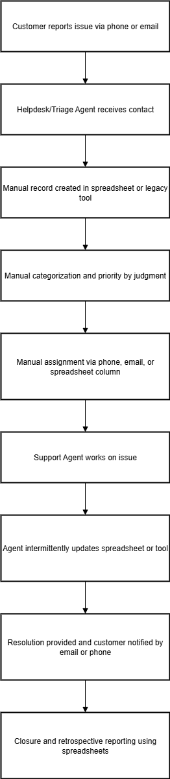

2.10.2 Proposed Recommendations (TO-BE)
Introduce a centralized Ticketing System (web + mobile), with automated intake, rules-based triage, auto-assignment, SLA timers, escalation, audit trail and dashboards. This standardizes workflows, reduces manual work, improves SLAs and provides reliable analytics.
Actors (roles)
- End Customer / User — creates ticket via portal, email, or mobile.
- System (Ticketing Platform) — handles intake, triage, assignment, SLA, notifications and audit.
- Triage Bot / Agent — optional human in the loop for rule failures.
- Support Agent — works tickets via agent workspace (web/mobile).
- Support Manager — monitors dashboards, responds to escalations.
- Admin / SysAdmin — configures categories, SLAs, rule engine and integrations.

TO-BE process steps
1. Unified intake
- Customer submits ticket via portal, mobile app, or sends email to support address.
- Email gateway converts inbound emails into ticket entries (threading by Message-ID).
- Required fields enforced (title, category or tag, contact, priority).

2. Automated validation & enrichment
- System validates fields, sanitizes inputs, virus-scans attachments.
- Enrichment layers add context: SSO identity, account/customer data lookup, recent activity, relevant order/ERP reference.

3. Auto-triage (rules engine)
- Configurable rules (keywords, regex, sender domain, auto-tags) set the category and initial priority.
- If multiple rules match, ordered evaluation and tie-breaker logic apply.
- If no confident rule match, ticket flags for manual triage queue.

4. Assignment (auto + manual)
- Assignment engine uses skill tags, current workload, business hours, and rota to auto-assign.
- Configurable policies: round-robin, least-loaded, skill-match, location.
- Managers can override or reassign with immediate effect; assignment history is recorded.

5. Agent workspace & work execution
- Agent receives notification (email/app) and opens ticket in the agent workspace.
- Workspace shows complete context: ticket history, attachments, linked customer info (360), suggested knowledge base articles, linked ERP/order data.
- Agents add public replies/internal notes, attach files, escalate or request additional info. Internal notes are hidden from customers.

6. SLA timers & escalations
- SLA timers start on ticket creation (or other configurable trigger).
- System generates warnings as thresholds approach and executes escalation actions on breach (notify manager, reassign to higher tier, or open an incident).
- SLA events are tracked for reporting.

7. Resolution & confirmation
- Agent marks ticket Resolved with resolution notes and closure code.
- System notifies customer and requests confirmation (optional).
- If no reply within configurable period, system auto-closes per retention policy. Tickets can be reopened with full history preserved.

8. Closure & audit
- Ticket enters closed state; audit trail finalised and archived per retention policy and legal-hold settings.
- Dashboards and reports update in near real time. KPIs adjust automatically.

9. Reporting & continuous improvement
- Managers review dashboards for SLA compliance, agent performance, and category volumes.
- Insights feed rule tuning, training needs and process improvements (feedback loop).

Systems & data flows
SSO/IDP — user authentication & role mapping.
Email gateway — inbound/outbound email processing.
SMS provider — optional notifications.
CRM / ERP / IDMS — enrich tickets with customer/order/inventory data.
Knowledge base — suggested articles to agents (reduce resolution time).
Monitoring / Logging — Prometheus/Grafana/ELK for ops metrics and alerts.
SaaS tools / Webhooks — for downstream integrations (CRM, Slack, BI).

Key TO-BE KPIs to monitor
- Time to first response (avg / % within SLA)
- Time to resolution (MTTR)
- SLA compliance rate (by priority & category)
- Ticket volume by category, channel
- Agent productivity (tickets/day, resolution rate)
- Reopen rate
- Average assignment latency (time from creation to assignment)

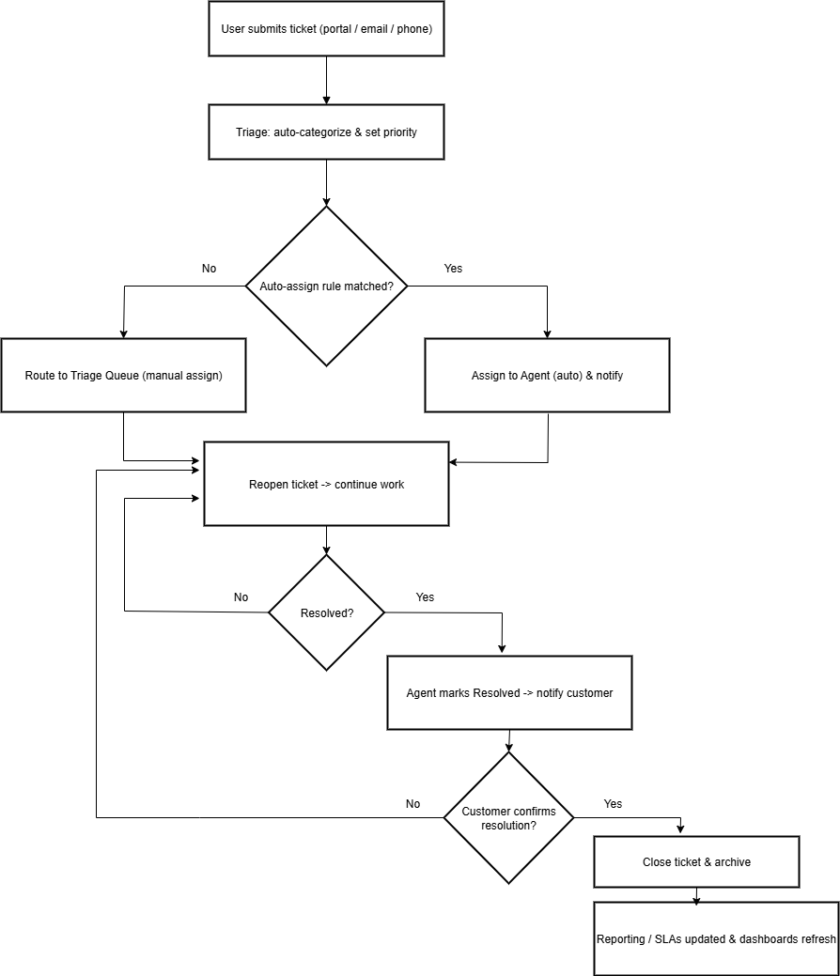

Acceptance Criteria
- All new tickets created via portal/email appear in the system and receive a Ticket ID within 5 seconds.
- Auto-triage rules successfully categorize ≥95% of rule-covered tickets in pilot tests.
- Auto-assignment assigns eligible agent within configured SLA target; assignment history captured.
- SLA timers start correctly and escalations occur per configuration during test scenarios.
- Agent workspace loads ticket + history in ≤2 seconds (normal load).
- Audit log records every ticket event and admin action and is exportable.
- Rollout pilot meets KPI improvement targets (example: first response time reduced by ≥20% vs. baseline).

  - Business Requirements (high level)

2.11.1 Functional Requirements (summary)
- Ticket creation- web, email-to-ticket, mobile; attachments; required fields validation.
- Triage & categorization- rules engine for keyword/category mapping and priority setting.
- Assignment- auto-assignment by skills/availability; manual override; assignment history.
- Work & Collaboration- internal notes, public comments, attachments, status changes and audit trail.
- Resolution & Closure -resolution notes, customer confirmation, auto-close after no response.
- SLA tracking & escalation -per-priority timers, automatic escalation workflows.
- Notifications- configurable email/SMS/app notifications for lifecycle events.
- Reporting & Dashboards -real-time KPIs, SLA breaches, agent productivity.

Req ID | Requirement Description | Category | Priority | Use Case Reference
FR-001 | The system shall allow users to create tickets via web portal, mobile app and email, generating a unique TicketID and acknowledgement. | Ticketing Intake | High | UC-01_CreateTicket
FR-002 | The system shall auto-triage incoming tickets using configurable rules (keyword, sender attributes, regex) to assign category/priority. | Rules Engine / Triage | High | UC-02_AutoTriage
FR-003 | The system shall auto-assign tickets to agents based on skill-tags, workload and availability and allow manual reassignments; assignment history recorded. | Assignment Engine | High | UC-03_AssignTicket
FR-004 | The system shall provide an agent workspace to view tickets, add public replies/internal notes, change status, attach files and escalate; internal notes hidden from customers. | Agent Workspace | High | UC-04_WorkTicket
FR-005 | The system shall support resolution workflow where agents mark tickets Resolved, notify customers, auto-close after configurable days and allow reopen with audit trail. | Ticket Lifecycle | High | UC-05_ResolveClose
FR-006 | The system shall implement per-priority SLA timers (acknowledgement & resolution) and trigger configured escalations on breach. | SLA Management | High | UC-06_SLA_Escalation
FR-007 | The system shall send configurable notifications (email/SMS/in-app) for lifecycle events using template placeholders and multi-language variants. | Notifications | Medium | UC-07_Notifications
FR-008 | The system shall provide real-time dashboards and ad-hoc reports for SLA compliance, ticket volumes and agent KPIs with export capability. | Reporting & Analytics | Medium | UC-08_Reporting
FR-009 | Admins shall create/update/deactivate users, manage roles and skill-tags, and perform bulk CSV import/export of users. | Admin / User Mgmt | High | UC-Admin_01_UserMgmt
FR-010 | Admins shall define roles and fine-grained permissions; changes to roles apply immediately and protected from deletion if in use. | Admin / RBAC | High | UC-Admin_02_RoleMgmt
FR-011 | Admins shall configure categories, priorities and SLA templates (with versioning and optional retroactive application). | Admin / Config | High | UC-Admin_03_SLAConfig
FR-012 | Admins shall author/manage triage & assignment rules (orderable) and perform dry-run testing before activation. | Rules Engine / Admin | High | UC-Admin_04_RuleMgmt
FR-013 | Admins shall create/edit notification templates (email/SMS/in-app) with placeholders and multi-language support and preview functionality. | Admin / Notifications | Medium | UC-Admin_05_TemplateMgmt
FR-014 | The system shall record every ticket event and admin action to an immutable, append-only audit store (actor, timestamp, IP) exportable by admins. | Audit & Compliance | High | UC-Audit_01_EventStore
FR-015 | Admins shall configure data retention policies per category and apply legal-hold to prevent archival/deletion. | Data Retention / Legal | High | UC-Retention_01
FR-016 | The system shall integrate with corporate SSO (SAML/OIDC), support JIT provisioning and attribute-to-role mapping; emergency local login available. | Integrations / SSO | High | UC-Integrations_01_SSO
FR-017 | The system shall support email gateway integration for inbound email-to-ticket parsing (threading) and outbound SMTP delivery with retries & bounce handling. | Integrations / Email | High | UC-Integrations_02_Email
FR-018 | The system shall integrate with SMS providers for notifications with provider failover, test-send, and throttling controls. | Integrations / SMS | Medium | UC-Integrations_03_SMS
FR-019 | The system shall provide REST/webhook integration to push/pull events with signing (HMAC), mapping rules and dead-letter/retry handling. | Integrations / CRM-ERP | Medium | UC-Integrations_04_Webhooks
FR-020 | The system shall expose a secure public REST API (ticket CRUD, search, events) with OpenAPI spec, OAuth2/JWT auth, pagination and rate limiting. | API / Developer | High | UC-API_01_PublicAPI
FR-021 | The system shall support configurable outbound webhooks for selected events with signing, retries (exponential backoff) and dead-letter queue. | Integrations / Webhooks | High | UC-Webhooks_01
FR-022 | The system shall provide migration/import tools (CSV/JSON) to import legacy tickets, history and attachments with validation and preview. | Data Migration | Medium | UC-Migration_01
FR-023 | The system shall provide scheduled backup and documented restore/disaster recovery procedures, with admin-triggered test restores and RBAC protection. | Backup & DR | High | UC-DR_01
FR-024 | The system shall expose secured health and metrics endpoints and provide monitoring dashboard showing queue lengths, worker health and error rates. | Monitoring & Ops | High | UC-Monitoring_01
FR-025 | The system shall record and expose an admin audit trail for configuration changes (before/after values) searchable and exportable to privileged roles. | Admin Audit | High | UC-AdminAudit_01
FR-026 | The system shall optionally support multi-environment and/or multi-tenant logical separation with tenant-scoped configs and RBAC enforcement. | Multi-Tenant / Environments | Low | UC-Tenant_01
FR-027 | The system shall provide user, admin and developer documentation, a developer portal with OpenAPI docs, sample payloads and release notes. | Documentation | Medium | UC-Docs_01

2.11.2 Non-Functional Requirements (summary)
- Security: SSO, RBAC, TLS, encryption at rest.
- Availability: 24x7 with 99.9% uptime SLA.
- Performance: ticket create/update <5s; retrieve <2s under normal load.
- Scalability: support 50k active tickets; horizontal scaling.
- Audit: immutable event history for every ticket.

Req ID | Requirement Description | Category | Priority | Use Case Reference
NFR-001 | The system shall provide 99.9% availability for core ticketing functions (create/update/assign/resolve) measured monthly. | Availability | High | UC-NonFunc_01
NFR-002 | Average response time for ticket create/update shall be ≤ 3 seconds and for search/list operations ≤ 2 seconds under normal load. | Performance | High | UC-NonFunc_02
NFR-003 | The system shall scale horizontally to support at least 50,000 active tickets and grow capacity with auto scaling policies. | Scalability | High | UC-NonFunc_03
NFR-004 | All data in transit must use TLS 1.2+ and sensitive data at rest must be encrypted (AES-256 or equivalent). | Security / Encryption | High | UC-NonFunc_04
NFR-005 | Authentication shall support SSO (SAML 2.0 / OIDC) and authorization shall enforce RBAC; admin accounts must support MFA. | Security / Auth | High | UC-NonFunc_05
NFR-006 | The system shall retain closed tickets and related audit logs for 7 years (configurable per policy) and support legal-hold to prevent deletion. | Data Retention / Compliance | High | UC-NonFunc_06
NFR-007 | Backups of database and attachments shall run daily; documented RTO ≤ 4 hours and RPO ≤ 1 hour for critical systems with quarterly test restores. | Backup & Disaster Recovery | High | UC-NonFunc_07
NFR-008 | Every ticket event, assignment and admin change shall be recorded in an immutable audit store (actor, timestamp, IP) that is exportable. | Audit & Logging | High | UC-NonFunc_08
NFR-009 | System logs and metrics must be retained for at least 1 year for application logs and 2 years for security/audit logs (or per legal requirement). | Logging / Retention | High | UC-NonFunc_09
NFR-010 | The system shall expose health and metrics endpoints (e.g., /health, /metrics) and integrate with monitoring/alerting (Prometheus/Grafana or equivalent). | Observability | High | UC-NonFunc_10
NFR-011 | The platform shall support 2,000 concurrent active users (agents + managers) and sustain 10,000 requests/minute during peak loads with degraded-graceful behavior. | Capacity / Throughput | High | UC-NonFunc_11
NFR-012 | Public REST APIs shall support 200 RPS sustained with documented rate limits, return 429 when exceeded, and provide paginated responses. | API Performance | Medium | UC-NonFunc_12
NFR-013 | Exports and reports containing PII must apply data masking based on role and include an approval step for privileged exports. | Privacy / Data Protection | High | UC-NonFunc_13
NFR-014 | The system shall implement retry and dead-letter queue mechanisms for external integrations (webhooks/email/SMS) with exponential backoff. | Reliability / Integrations | High | UC-NonFunc_14
NFR-015 | Web UI shall meet WCAG 2.1 AA accessibility where applicable and page-interactive views shall render within 2 seconds on supported browsers. | Usability / Accessibility | Medium | UC-NonFunc_15
NFR-016 | All APIs and data interchange formats shall use JSON (REST) and the platform shall publish an OpenAPI specification for developer integration. | Interoperability | Medium | UC-NonFunc_16
NFR-017 | The system shall support multi-locale UI (English + configurable locales), with templates and notifications selectable per user locale. | Localization | Medium | UC-NonFunc_17
NFR-018 | Supported browsers: latest two stable versions of Chrome, Firefox, Edge and Safari; UI shall be responsive for mobile devices (agent mobile app or responsive web). | Compatibility / Client Support | Medium | UC-NonFunc_18
NFR-019 | Attachment policy: maximum 25 MB per file, maximum 200 MB per ticket (configurable); attachments must pass virus scanning before association. | Data / Storage | Medium | UC-NonFunc_19
NFR-020 | Encryption keys and secrets shall be managed via a Key Management Service (KMS) with key rotation at least every 90 days and access audited. | Security / Key Management | High | UC-NonFunc_20

2.11.3 Requirements Traceability Matrix (RTM)

Req ID | Requirement Description | Design Ref | Test Case ID | Implemented (Y/N) | Remarks
FR-001 | The system shall allow users to create tickets via web portal, mobile app and email, generating a unique Ticket ID and acknowledgement. | DR-001 | TC-001 | N | Pending development
FR-002 | The system shall auto-triage incoming tickets using configurable rules (keyword, sender attributes, and regex) to assign category/priority. | DR-002 | TC-002 | N | Requirements approved
FR-003 | The system shall auto-assign tickets to agents based on skill-tags, workload and availability and allow manual reassignments; assignment history recorded. | DR-003 | TC-003 | N | Pending design
FR-004 | The system shall provide an agent workspace to view tickets, add public replies/internal notes, change status, attach files and escalate; internal notes hidden from customers. | DR-004 | TC-004 | N | Under development
FR-005 | The system shall support resolution workflow where agents mark tickets Resolved, notify customers, auto-close after configurable days and allow reopen with audit trail. | DR-005 | TC-005 | N | Pending development
FR-006 | The system shall implement per-priority SLA timers (acknowledgement & resolution) and trigger configured escalations on breach. | DR-006 | TC-006 | N | Design in progress
FR-007 | The system shall send configurable notifications (email/SMS/in-app) for lifecycle events using template placeholders and multi-language variants. | DR-007 | TC-007 | N | Template approval pending
FR-008 | The system shall provide real-time dashboards and ad-hoc reports for SLA compliance, ticket volumes and agent KPIs with export capability. | DR-008 | TC-008 | N | Report specs pending
FR-009 | Admins shall create/update/deactivate users, manage roles and skill-tags, and perform bulk CSV import/export of users. | DR-009 | TC-009 | N | Requirements approved
FR-010 | Admins shall define roles and fine-grained permissions; changes to roles apply immediately and protected from deletion if in use. | DR-010 | TC-010 | N | Pending design
FR-011 | Admins shall configure categories, priorities and SLA templates (with versioning and optional retroactive application). | DR-011 | TC-011 | N | Requirements approved
FR-012 | Admins shall author/manage triage & assignment rules (orderable) and perform dry-run testing before activation. | DR-012 | TC-012 | N | Design in progress
FR-013 | Admins shall create/edit notification templates (email/SMS/in-app) with placeholders and multi-language support and preview functionality. | DR-013 | TC-013 | N | Pending localization
FR-014 | The system shall record every ticket event and admin action to an immutable, append-only audit store (actor, timestamp, IP) exportable by admins. | DR-014 | TC-014 | N | Security review pending
FR-015 | Admins shall configure data retention policies per category and apply legal-hold to prevent archival/deletion. | DR-015 | TC-015 | N | Compliance review pending
FR-016 | The system shall integrate with corporate SSO (SAML/OIDC), support JIT provisioning and attribute-to-role mapping; emergency local login available. | DR-016 | TC-016 | N | SSO config pending
FR-017 | The system shall support email gateway integration for inbound email-to-ticket parsing (threading) and outbound SMTP delivery with retries & bounce handling. | DR-017 | TC-017 | N | Integration design pending
FR-018 | The system shall integrate with SMS providers for notifications with provider failover, test-send, and throttling controls. | DR-018 | TC-018 | N | Provider selection pending
FR-019 | The system shall provide REST/web hook integration to push/pull events with signing (HMAC), mapping rules and dead-letter/retry handling. | DR-019 | TC-019 | N | Mapping rules pending
FR-020 | The system shall expose a secure public REST API (ticket CRUD, search, events) with Open API spec, OAuth2/JWT auth, pagination and rate limiting. | DR-020 | TC-020 | N | Open API draft pending
FR-021 | The system shall support configurable outbound webhooks for selected events with signing, retries (exponential backoff) and dead-letter queue. | DR-021 | TC-021 | N | Dead-letter handling in design
FR-022 | The system shall provide migration/import tools (CSV/JSON) to import legacy tickets, history and attachments with validation and preview. | DR-022 | TC-022 | N | Import mapping pending
FR-023 | The system shall provide scheduled backup and documented restore/disaster recovery procedures, with admin-triggered test restores and RBAC protection. | DR-023 | TC-023 | N | DR plan draft
FR-024 | The system shall expose secured health and metrics endpoints and provide monitoring dashboard showing queue lengths, worker health and error rates. | DR-024 | TC-024 | N | Monitoring config pending
FR-025 | The system shall record and expose an admin audit trail for configuration changes (before/after values) searchable and exportable to privileged roles. | DR-025 | TC-025 | N | Audit retention rules pending
FR-026 | The system shall optionally support multi-environment and/or multi-tenant logical separation with tenant-scoped configs and RBAC enforcement. | DR-026 | TC-026 | N | Optional — deferred
FR-027 | The system shall provide user, admin and developer documentation, a developer portal with OpenAPI docs, sample payloads and release notes. | DR-027 | TC-027 | N | Drafting docs

2.12. Appendices
2.12.1 List of Acronyms
SLA- Service Level Agreement
SSO-Single Sign On
RBAC- Role-Based Access Control
POD - Proof of Delivery (not used in ticketing but kept for cross-project glossary)

2.13 Glossary of Terms
Ticket: A support request record.
Triage: Initial classification & priority selection.
Assignment: Action of assigning a ticket to an agent.
Resolution: Final solution recorded; pending customer confirmation.

Software Requirements Specification (SRS) — Ticketing System (detailed)

2.14. Name: Support Ticketing System

Scope: Web + mobile-enabled ticketing platform providing centralized intake, auto-triage, automated assignment, agent workspace, SLA management, notifications, analytics and integrations (SSO, email gateway, CRM/ERP, SMS). Exposes REST APIs for external systems and web hooks for event-driven integrations.

Primary users: End customers, Support Agents, Triage Agents, Support Managers, Administrators, Integrators (CRM/ERP).

2.14.1. System Overview

A web and mobile-enabled ticketing application with REST APIs for integrations (SSO, email gateway, monitoring). Key modules: Inbound (ticket intake), Triage Engine, Assignment Engine, Agent Workspace, SLA Manager, Notifications, Reporting.

Key modules:
- Inbound / Intake (portal, email-to-ticket, API)
- Triage Engine (rules-based classification & enrichment)
- Assignment Engine (skill/workload/rota-based)
- Agent Workspace (work, comments, attachments, KB suggestions)
- SLA Manager (timers, warnings, escalations)
- Notifications (email, SMS, in-app)
- Reporting & Dashboards (real-time KPIs)
- Admin Console (roles, rules, categories, SLAs, templates)
- Audit & Retention (immutable event store, legal-hold)

High-level constraints & assumptions: SSO (SAML/OIDC) will be available; Email/SMS providers will be procured; target baseline capacity: 50k active tickets, 1k–2k concurrent users.

2.14.2 Detailed Functional Requirements (key use cases)
UC-01-Create Ticket
ID: UC-01_CreateTicket
Actors: Customer (external via portal/mobile), System (email gateway), Agent (occasionally create on behalf)
Preconditions:
- For authenticated flows: user authenticated via SSO.
- For email flows: email parser configured and can map sender to account (or create anonymous ticket when unknown).
Main Flow (happy path):
- User opens portal/mobile app or sends email to support address.
- User completes ticket form (Title, Description, Category [or choose to be auto-categorized], Priority, Contact info) and attaches files if required.
- Client-side validation ensures required fields.
- System submits ticket to In bound service.
- Inbound service sanitizes inputs, virus-scans attachments, persists ticket record and generates unique ticket id.
- System returns confirmation to user with ticket id and estimated SLA/ETA.
- Ticket is forwarded to Triage queue / Rules Engine for categorization and assignment actions.
Alternate Flows:
- A1: Attachment too large → show error and suggest upload alternatives (cloud link).
- A2: Email parsing cannot map sender → create anonymous ticket with parsed content and flag for manual enrichment.
Post conditions: Ticket persisted; acknowledgement sent; ticket visible in triage queue.
Acceptance Criteria: Ticket appears in triage queue within 5 seconds, confirmation sent to requester, all attachments saved and scanned.
Related FRs: FR-001 (Ticket Creation), FR-017 (Email integration), FR-019 (API).

UC-02- Auto-Triage & Categorize
ID: UC-02_AutoTriage
Actors: Rules Engine (System), Triage Agent
Preconditions: Rules exist and are enabled; ticket available in triage queue.
Main Flow:
- Rules Engine evaluates ticket content (title, description, and attachments metadata), sender attributes, and any enrichment data (customer type, order reference).
- Applies ordered rules (keyword matches, regex, sender domain, ML tag, account-based rules).
- Sets category, sub-category (optional), initial priority, and adds tags.
- Logs rule match event to ticket event (for traceability).
- If rule confidence low or no rule matches, ticket is flagged to Manual Triage queue and notification sent to triage agents.
Alternate Flows:
- A1: Multiple rules match → rule priority/tiebreaker logic decides; store all matched rule ids for audit.
- A2: Rule-enabled enrichment fails → fallback to manual triage.
Acceptance Criteria: Rules engine correctly assigns category/priority for ≥95% of known rule-covered test cases. All triage decisions logged.
Related FRs: FR-002, FR-012.

UC-03-Auto-Assign / Manual Assign
ID: UC-03_AssignTicket
Actors: Assignment Engine (System), Support Manager, Agent
Preconditions: Agent pool and skill-tags populated; working hours/rota defined.
Main Flow:
- Assignment Engine evaluates eligible agents by skill match, availability, current workload (concurrency limit), and location/time zone.
- Applies configured policy (least-loaded / round-robin / skill priority).
- Assigns ticket: creates assignment record with assigned at and agent_id.
- Notifies assigned agent (email/in-app/SMS).
- Assignment event recorded in ticket event.
Manual Flow: Manager may reassign via Admin UI or Agent Workspace; manual reassign creates a new assignment entry and unassigned at set for previous assignment.
Acceptance Criteria: Assigned agent receives notification and ticket appears in their queue within 5 seconds of assignment; assignment history entries exist for every assign/reassign.
Related FRs: FR-003, FR-009, and FR-012.

UC-04- Work on Ticket
ID: UC-04_WorkTicket
Actors: Assigned Agent, System
Preconditions: Ticket assigned (or agent picks from queue).
Main Flow:
- Agent opens ticket in Agent Workspace; system displays full history, related customer 360 data and KB suggestions.
- Agent adds a public reply, internal note (visible only to staff), or attachments.
- Agent updates status (e.g., In Progress, Pending Info, and Resolved).
- Each action creates a ticket event (actor, timestamp, change).
Acceptance Criteria: All changes visible to authorized roles; internal notes hidden from customers; audit records created with timestamps and actor IDs.
Related FRs: FR-004, FR-014.

UC-05- Resolve & Close
ID: UC-05_ResolveClose
Actors: Agent, Customer, System
Preconditions: Agent has performed necessary steps and marked ticket resolved.
Main Flow:
- Agent marks the ticket Resolved and enters resolution notes and resolution code.
- System sends resolution notification to customer with CTA to confirm.
- If customer confirms within configurable window N days → system moves ticket to close and archives per retention.
- If no confirmation within N days → system auto-closes (if auto-close configured) and records auto close reason.
- If customer replies “not resolved” → ticket reopens and assignment pattern resumes.
Acceptance Criteria: Resolution text persisted; SLA metrics updated; ticket closure archived; reopen preserves full history.
Related FRs: FR-005, FR-006.

UC-06 -SLA Escalation
ID: UC-06_SLA_Escalation
Actors: System, Manager
Preconditions: SLA templates configured and attached to ticket category/priority.
Main Flow:
- SLA Manager starts timers (acknowledgement SLA, resolution SLA) when ticket created or triggered.
- SLA Manager emits warnings at pre-defined thresholds (e.g., 75% elapsed).
- On breach, SLA Manager executes configured escalation actions (notify manager, escalate priority, reassign to escalation group, open incident).
- All SLA events logged in SLA table and ticket event.
Acceptance Criteria: Escalation actions executed when SLA breached in test scenarios; SLA timestamps recorded.
Related FRs: FR-006, FR-011.

2.14.3. Data Model

Class ER Diagram

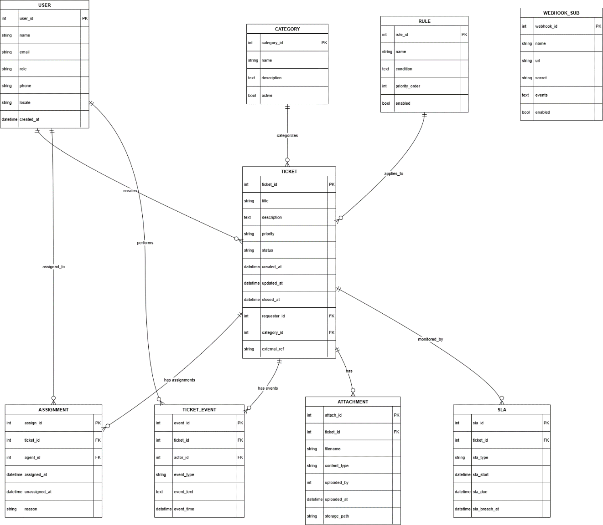

Data Dictionary (key fields):
- ticket_id - PK, system generated unique ticket identifier (string or int).
- Status- enum: New, Open, In Progress, Pending, Resolved, Closed, and Reopened.
- Priority-enum: Critical, High, Medium, And Low.
- Assignment -historical table capturing every assignment/re-assignment.
- ticket_event - audit trail of all ticket-level actions.
- Sla -per-ticket SLA tracker with start/due/breach timestamps.
- Rule -triage/assignment rule definitions (store condition as expression/JSON/DSL).
- webhook_sub -outbound webhook definitions with events filter and secret.

2.14.4. Non-Functional Requirements
Security & Authentication
- NFR-Sec-01: Support SSO (SAML 2.0 / OIDC) with attribute mapping for roles. Acceptance: SSO login successful for test IdP with mapped roles; JIT provisioning creates user profile when enabled.
- NFR-Sec-02: Admin accounts must use MFA. Acceptance: Admin login requires second factor during test.
- NFR-Sec-03: All traffic TLS 1.2+; sensitive data at rest encrypted AES-256; keys managed via KMS with rotation every 90 days. Acceptance: TLS enforced; sample data at rest encrypted; KMS logs show rotation.

Availability & Reliability
- NFR-Avail-01: 99.9% monthly availability for core ticketing APIs. Acceptance: Monitoring shows uptime ≥99.9% in test month.
- NFR-Rel-01: Dead-letter queues and exponential backoff for external integrations (webhooks/email/SMS). Acceptance: Failed webhook retries recorded in DLQ with retry logs.

Performance & Scalability
- NFR-Perf-01: Ticket create/update ≤ 5s under normal load (95th percentile). Acceptance: Load tests show ≤5s for create/update at baseline load.
- NFR-Perf-02: Ticket retrieval / search ≤ 2s for common queries. Acceptance: Indexing & queries validated in perf tests.
- NFR-Scale-01: System must support 50,000 active tickets and 2,000 concurrent active users with autoscaling. Acceptance: Load tests validate horizontal scaling and SLA adherence.

Audit, Retention & Compliance
- NFR-Audit-01: All ticket events and admin actions written to an append-only audit store (immutable). Acceptance: Audit entries cannot be edited/deleted via UI/API and export works.
- NFR-Retention-01: Retain closed tickets & audit logs for 7 years (configurable) and support legal-hold. Acceptance: Archive test demonstrates retention and legal-hold prevents purge.

Observability & Monitoring
- NFR-Obs-01: Expose /health and /metrics endpoints, integrate with Prometheus/Grafana. Acceptance: Metrics visible on Grafana dashboard; alerts for queue length > threshold.
- NFR-Logs-01: Application logs retained 1 year; security/audit logs 2 years (or per legal). Acceptance: Log store query returns entries per retention windows.
Usability & Accessibility
- NFR-UX-01: Agent workspace renders within 2s on supported browsers under normal load. Acceptance: UX perf test passes.
- NFR-Acc-01: Web UI at WCAG 2.1 AA compliance. Acceptance: Accessibility audit reports AA compliance.
Backup & DR
- NFR-DR-01: Daily DB backup; RTO ≤ 4 hours and RPO ≤ 1 hour for critical services; quarterly restore tests. Acceptance: Restore test within RTO/RPO.

2.14.5. Interfaces
- Inbound: Email gateway -> ticket parser; REST API for external systems to create tickets.
- Outbound: Email/SMS notifications; web hooks for integration into CRM/monitoring.
- Admin UI: Category, SLA, rule, and user management screens.

2.14.5.1 Inbound Interfaces
2.14.5.1.1 Email Gateway → Ticket Parser
Description: Inbound SMTP or provider webhook to parse emails into tickets. Threading using Message-ID and References.
Inputs: Raw email (headers, body, attachments).
Processing: Parse subject/body to extract title/description; extract attachments; extract sender email → map to requester_id; heuristics for order id or external refs.
Errors: Unparseable emails go to quarantine queue with admin notification.

2.14.5.1.2 REST API (Inbound ticket create)
Endpoint:
Request Body:
Response:
Auth: OAuth 2.0 client credentials or API key (scoped). Rate limit and 429 on excess.

2.14.5.2 Outbound Interfaces
5.2.1 Notifications (email/SMS/in-app)
Templated notifications with placeholders. Admins configure providers and templates. Support retry and bounce handling.

2.14.5.2.2 Webhooks / Outbound events
Events: ticket.created, ticket.updated, ticket.assigned, sla.breach, ticket.closed
Delivery: Signed HMAC payloads, retries with exponential backoff, DLQ on permanent failure.
Payload: JSON with ticket_id, status, priority, assignee, timestamp, and change summary.

2.14.5.3 Admin UI Interfaces
Category, Priority, SLA templates management screens.
Rule editor with dry-run.
User/Role management UI with bulk import.
Audit export & retention config pages.

2.14.6. Acceptance Criteria / Test Cases (high level)
- Create ticket (web & email) -> verify TicketID and notification.
- Auto-assign -> verify assignment respects workload.
- SLA breach -> validate escalation triggers.
- Reopen/resolution loop -> ensure metrics update.
- SSO login & RBAC -> validate permitted/forbidden pages.

TC-001- Create Ticket (Web)
Precondition: System up, API & DB available.
Steps: 1) Submit create ticket form with attachments; 2) Observe response.
Expected: HTTP 201 / ticket_id returned; ticket visible in triage queue within 5s; attachment exists in storage.

TC-002 -Create Ticket (Email)
Precondition: Email gateway configured.
Steps: 1) Send email to support address; 2) Check parsed ticket.
Expected: Ticket created, requestor mapped, attachment saved, message thread linked.

TC-003- Auto-Triage Rule Match
Precondition: Rule set loaded with test rules.
Steps: 1) Create ticket with content matching rule keywords; 2) Observe category/priority.
Expected: Correct category/priority applied; ticket_event logged with rule_id.

TC-004 -Auto-Assign Respects Workload
Precondition: Two agents with differing workloads.
Steps: 1) Submit multiple tickets; 2) Observe assignments.
Expected: Assignment engine assigns to least-loaded eligible agent per policy; notifications sent.

TC-005 -SLA Breach & Escalation
Precondition: SLA configured (short durations for test).
Steps: 1) Create ticket; 2) Wait for SLA breach; 3) Observe escalation actions.
Expected: Escalation executed (notify manager/reassign); SLA breach logged.

TC-006- Reopen / Resolution Loop
Precondition: Ticket resolved and pending customer confirmation.
Steps: 1) Agent marks resolved; 2) Customer replies “not resolved.”
Expected: Ticket reopens; history preserved; SLA restarted if configured.

TC-007 -SSO & RBAC
Precondition: SSO test IdP configured and RBAC roles defined.
Steps: 1) Attempt login as agent/manager/admin; 2) Validate role-based access pages.
Expected: SSO login works; unauthorized pages blocked; admin pages require MFA.

TC-008 -API Rate Limiting
Precondition: API rate limit configured.
Steps: 1) Send >limit requests; 2) Observe responses.
Expected: 429 returned when exceeded.

2.14.7. Security, Privacy & Compliance
- Authentication: SSO (SAML/OIDC) + OAuth2 for APIs; local emergency accounts allowed with strict audit.
- Authorization: RBAC with resource-level permissions (view internal notes, perform reassign).
- Transport & Storage: TLS 1.2+ in transit; AES-256 encryption at rest; attachments scanned for malware.
- Secrets & Keys: KMS for keys with rotation every 90 days; limited IAM roles for access.
- Audit & Forensics: Immutable event store with actor/time/IP; admin export with access control.
- Data Protection: PII minimization, data masking in exports, data subject request support (erasure/export) per legal.
- Pen testing & Vulnerability Scans: Quarterly scans and remediation SLAs.
- Incident Response: Documented IR plan and SOC integration for monitoring.

2.14.8. Operational & Deployment Considerations
- Environments: dev, test, staging, prod (isolated).
- Deployment model: Containerized micro services (Kubernetes) with auto scaling, blue/green or canary deployments.
- Backup & Restore: Daily backups; periodic integrity checks; test restore quarterly.
- Monitoring: Prometheus metrics, Grafana dashboards, alerting on queue growth, error rate, SLA breaches.
- Logging: Centralized structured logs (ELK / Loki), retention policies as per NFRs.
- DR Plan: Multi-region or multi-zone deployment; documented RTO/RPO.

2.14.9. Data Migration & Cutover Strategy (high-level)
- Discovery: Profile legacy data for completeness, duplicates, mapping gaps.
- Cleansing: Run data quality scripts and resolve high-impact issues.
- Mapping: Map legacy fields → new taxonomy (category/priority/status).
- Dry-run: Perform sample imports and validate with stakeholders.
- Cutover: Run migration in window (low traffic), validate sample tickets, and keep legacy system read-only for rollback.
- Post-cutover: Reconcile counts, provide support & bug fixes in hyper care period.

2.14.10. Traceability & Deliverables
Traceability: Each FR maps to UC IDs and Test Cases (e.g., FR-001 → UC-01 → TC-001). Maintain RTM for change control.
Deliverables: BRD, SRS, API docs (OpenAPI), Deployment Playbook, Test Plans, UAT sign-off, Production runbook.

3. ERD – Ticket Lifecycle

The Entity Relationship Diagram (ERD) defines the data architecture and relationships required to support the Ticketing System. The system manages the lifecycle of a support ticket from creation through assignment, resolution, and closure.

3.1 Entities and Attributes
Ticket
- Ticket ID (PK) – Unique identifier for each ticket
- Title – Short summary of the issue
- Description – Detailed problem statement
- Priority – Low / Medium / High / Critical
- Status – New / Assigned / In-Progress / Resolved / Closed
- Created Date – Date/time ticket was logged
- Closed Date – Date/time ticket was closed
User
- User ID (PK) – Unique identifier for each system user
- Name – Full name of the user
- Role – Customer, Agent, Manager, Admin
- Contact – Email/Phone
Assignment
- Assign ID (PK) – Unique assignment identifier
- Ticket ID (FK) – References the Ticket being assigned
- Agent ID (FK) – References the Agent (User) handling the ticket
- Assigned Date – Date/time of assignment
Resolution
- Resolution ID (PK) – Unique resolution identifier
- Ticket ID (FK) – References the Ticket being resolved
- Agent ID (FK) – References the Agent resolving the issue
- Resolution Text – Solution details
- Resolution Date – Date/time of resolution

3.2 Relationships
- User ↔ Ticket (1: M)
A user (customer) can create multiple tickets. Each ticket is created by one user.
- Ticket ↔ Assignment (1:1)
each ticket must be assigned to exactly one agent.
- Ticket ↔ Resolution (1:1)
each ticket can have one resolution recorded.
- User ↔ Assignment (1: M)
A support agent (user) may be assigned multiple tickets.
- User ↔ Resolution (1: M)
A support agent (user) may resolve multiple tickets.

3.3 Visual ERD – Ticket Lifecycle

Here is the ERD diagram representing the Ticket Lifecycle:
ERD Diagram:

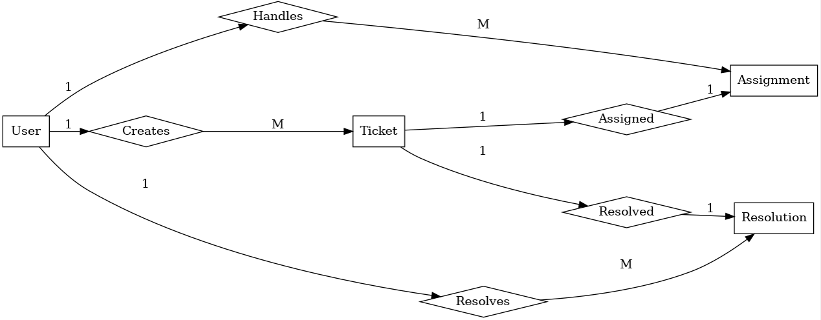

Class ERD diagram:
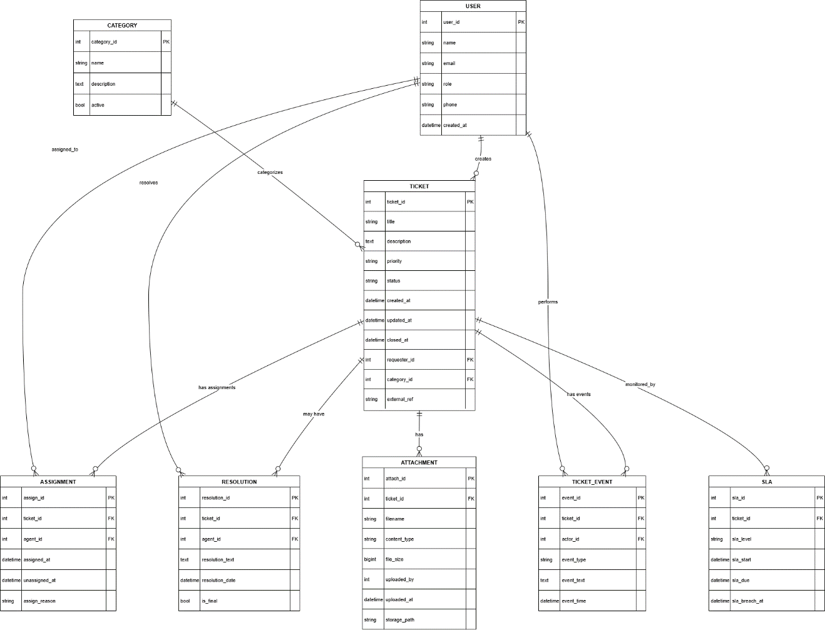

4. User Story – E-commerce Shopping

User Story No. 1 | Task:2 |  | Priority: Highest
AS A CUSTOMER,
I WANT TO REGISTER WITH EMAIL/PHONE
SO THAT I CAN CREATE AN ACCOUNT.
BV:200 |  | CP:02
ACCEPTANCE CRITERIA:
-Registration screen with fields: Username, Password, Mobile No, Email, Address.
-"Register" button submits the form.
-Successful registration triggers a confirmation notification.

User Story No. 2 | Task:2 |  | Priority: Highest
AS A CUSTOMER,
I WANT TO LOGIN SECURELY
SO THAT I CAN ACCESS MY ACCOUNT.
BV:500 |  | CP:03
ACCEPTANCE CRITERIA:
-Login screen with Username/Email & Password fields.
-"Login" button authenticates credentials.
-Incorrect login attempts show an error.

User Story No. 3 | Task:4 |  | Priority: Highest
AS A CUSTOMER,
I WANT TO RESET MY PASSWORD
SO THAT I CAN RECOVER ACCESS IF FORGOTTEN.
BV:500 |  | CP:03
ACCEPTANCE CRITERIA:
“Forgot Password” option available.
Reset link sent to email/phone.
New password replaces old after confirmation.

User Story No. 4 | Task:5 |  | Priority: Highest
AS A CUSTOMER,
I WANT TO BROWSE PRODUCTS BY CATEGORY
SO THAT I CAN FIND RELEVANT ITEMS EASILY.
BV:500 |  | CP:05
ACCEPTANCE CRITERIA:
-Categories displayed on home screen.
-Selecting a category shows all relevant products.
-User can navigate back to home.

User Story No. 5 | Task:6 |  | Priority: Highest
AS A CUSTOMER,
I WANT TO SEARCH PRODUCTS BY KEYWORD
SO THAT I CAN QUICKLY FIND ITEMS.
BV:500 |  | CP:05
ACCEPTANCE CRITERIA:
-Search bar present on all pages.
-User can enter keywords and hit “Search.”
-Matching products are displayed instantly.

User Story No. 6 | Task:7 |  | Priority: Medium
AS A CUSTOMER,
I WANT TO FILTER PRODUCTS BY PRICE
SO THAT I CAN VIEW AFFORDABLE OPTIONS.
BV:100 |  | CP:03
ACCEPTANCE CRITERIA:
-Filter option for min & max price.
-When applied, products display within range.
-Reset filter option available.

User Story No. 7 | Task:8 |  | Priority: Medium
AS A CUSTOMER,
I WANT TO SORT PRODUCTS BY RATING
SO THAT I CAN SEE THE BEST REVIEWED ITEMS.
BV:200 |  | CP:03
ACCEPTANCE CRITERIA:
-Sort option “Highest Rated” available.
-Products reorder based on rating.
-Default sorting remains by relevance.

User Story No. 8 | Task:9 |  | Priority: Highest
AS A CUSTOMER,
I WANT TO VIEW PRODUCT DETAILS
SO THAT I CAN UNDERSTAND SPECIFICATIONS.
BV:500 |  | CP:05
ACCEPTANCE CRITERIA:
-Clicking a product opens details page.
-Page shows description, images, price, and stock.
-Option to add to cart or wishlist.

User Story No. 9 | Task:10 |  | Priority: High
AS A CUSTOMER,
I WANT TO SEE PRODUCT REVIEWS
SO THAT I CAN MAKE INFORMED DECISIONS.
BV:500 |  | CP:03
ACCEPTANCE CRITERIA:
-Product page displays customer reviews.
-Average star rating is shown.
-Customers can filter by latest or highest rated.

User Story No. 10 | Task:11 |  | Priority: Highest
AS A CUSTOMER,
I WANT TO ADD ITEMS TO CART
SO THAT I CAN PURCHASE THEM LATER.
BV:500 |  | CP:05
ACCEPTANCE CRITERIA:
-“Add to Cart” button visible on product page.
-Cart updates item count instantly.
-Confirmation message displayed.

User Story No. 11 | Task:12 |  | Priority: Highest
AS A CUSTOMER,
I WANT TO UPDATE ITEM QUANTITY IN CART
SO THAT I CAN ADJUST BEFORE CHECKOUT.
BV:500 |  | CP:05
ACCEPTANCE CRITERIA:
-Quantity field editable in cart.
-Total price updates automatically.
-Invalid quantities not accepted.

User Story No. 12 | Task:13 |  | Priority: Medium
AS A CUSTOMER,
I WANT TO REMOVE ITEMS FROM CART
SO THAT I CAN MANAGE MY SELECTION.
BV:200 |  | CP:03
ACCEPTANCE CRITERIA:
-“Remove” button available in cart.
-Item disappears after removal.
-Cart total recalculates.

User Story No. 13 | Task:14 |  | Priority: High
AS A CUSTOMER,
I WANT TO APPLY DISCOUNT COUPONS
SO THAT I CAN SAVE MONEY.
BV:500 |  | CP:05
ACCEPTANCE CRITERIA:
-Coupon code field available in cart.
-Valid coupons apply discount instantly.
-Invalid coupons show error message.

User Story No. 14 | Task:15 |  | Priority: Medium
AS A CUSTOMER,
I WANT TO SEE ESTIMATED DELIVERY DATE
SO THAT I KNOW WHEN TO EXPECT ITEMS.
BV:500 |  | CP:03
ACCEPTANCE CRITERIA:
-Checkout page shows estimated delivery date.
-Based on product type and location.
-Updated if delivery slot changes.

User Story No. 15 | Task:16 |  | Priority: Highest
AS A CUSTOMER,
I WANT TO SELECT A DELIVERY ADDRESS
SO THAT MY ITEMS REACH ME.
BV:500 |  | CP:05
ACCEPTANCE CRITERIA:
-Saved addresses listed at checkout.
-Option to select or add new address.
-Selected address stored in order details.

User Story No. 16 | Task:17 |  | Priority: Medium
AS A CUSTOMER,
I WANT TO ADD MULTIPLE ADDRESSES
SO THAT I CAN CHOOSE DURING CHECKOUT.
BV:200 |  | CP:03
ACCEPTANCE CRITERIA:
-Profile allows multiple saved addresses.
-Users can mark one as default.
-Addresses editable anytime.

User Story No. 17 | Task:18 |  | Priority: Highest
AS A CUSTOMER,
I WANT TO CHOOSE A PAYMENT METHOD
SO THAT I CAN PAY CONVENIENTLY.
BV:500 |  | CP:08
ACCEPTANCE CRITERIA:
-Options: Card, UPI, Wallet, Net Banking.
-Secure authentication required.
-Successful payment redirects to confirmation.

User Story No. 18 | Task:19 |  | Priority: High
AS A CUSTOMER,
I WANT TO VIEW ORDER SUMMARY
SO THAT I CAN CONFIRM DETAILS BEFORE PAYMENT.
BV:500 |  | CP:03
ACCEPTANCE CRITERIA:
-Order summary shows items, prices, and delivery.
-Final payable amount displayed clearly.
-Back button allows changes.

User Story No. 19 | Task:20 |  | Priority: Highest
AS A CUSTOMER,
I WANT TO RECEIVE ORDER CONFIRMATION
SO THAT I KNOW MY ORDER IS PLACED.
BV:500 |  | CP:03
ACCEPTANCE CRITERIA:
-Confirmation page displayed after payment.
-SMS & Email notification sent.
-Order ID generated.

User Story No. 20 | Task:21 |  | Priority: High
AS A CUSTOMER,
I WANT TO TRACK MY ORDER
SO THAT I KNOW ITS CURRENT STATUS.
BV:500 |  | CP:05
ACCEPTANCE CRITERIA:
-Order status updates in real-time.
-Status levels: Processing, Dispatched, Out for Delivery, Delivered.
-Tracking link shared with customer.

User Story No. 21 | Task:22 |  | Priority: High
AS A CUSTOMER,
I WANT TO RECEIVE SMS/EMAIL NOTIFICATIONS
SO THAT I STAY INFORMED ABOUT ORDER UPDATES.
BV:500 |  | CP:03
ACCEPTANCE CRITERIA:
-SMS & Email triggered for order confirmation, dispatch, and delivery.
-Notifications are real-time.
-User can opt in/out of notifications.

User Story No. 22 | Task:23 |  | Priority: Highest
AS A CUSTOMER,
I WANT TO CANCEL MY ORDER BEFORE SHIPMENT
SO THAT I CAN CHANGE MY MIND.
BV:500 |  | CP:05
ACCEPTANCE CRITERIA:
-“Cancel Order” button visible until shipment.
-On cancel, status updates to “Cancelled.”
-Refund initiated automatically.

User Story No. 23 | Task:24 |  | Priority: Highest
AS A CUSTOMER,
I WANT TO RETURN ITEMS FOR REFUND
SO THAT I CAN CLAIM MONEY FOR DEFECTIVE PRODUCTS.
BV:500 |  | CP:08
ACCEPTANCE CRITERIA:
-“Return” option available in order history.
-Pickup request generated.
-Refund processed after return approval.

User Story No. 24 | Task:25 |  | Priority: Medium
AS A CUSTOMER,
I WANT TO RATE PURCHASED PRODUCTS
SO THAT I CAN SHARE MY FEEDBACK.
BV:200 |  | CP:03
ACCEPTANCE CRITERIA:
-Option to give star rating & text review.
-Only available for delivered orders.
-Reviews shown on product detail page.

User Story No. 25 | Task:24 |  | Priority: High
AS A CUSTOMER,
I WANT TO REORDER PAST PURCHASES
SO THAT I CAN SAVE TIME BUYING FREQUENT ITEMS.
BV:200 |  | CP:03
ACCEPTANCE CRITERIA:
-“Reorder” button on order history.
-Selected items added to cart instantly.
-Confirmation message displayed.

User Story No. 26 | Task:27 |  | Priority: Medium
AS A CUSTOMER,
I WANT TO SAVE ITEMS TO WISHLIST
SO THAT I CAN PURCHASE THEM LATER.
BV:500 |  | CP:03
ACCEPTANCE CRITERIA:
-“Add to Wish list” button visible on product.
-Items stored in wish list page.
-Option to move items to cart.

User Story No. 27 | Task:28 |  | Priority: High
AS A CUSTOMER,
I WANT TO VIEW MY PURCHASE HISTORY
SO THAT I CAN TRACK MY PAST ORDERS.
BV:500 |  | CP:03
ACCEPTANCE CRITERIA:
-History page lists all orders with date & status.
-Filter by month/year.
-Option to download invoice.

User Story No. 28 | Task:29 |  | Priority: High
AS A CUSTOMER,
I WANT TO CHAT WITH SUPPORT
SO THAT I CAN RESOLVE ISSUES QUICKLY.
BV:500 |  | CP:05
ACCEPTANCE CRITERIA:
-Live chat option in help section.
-Bot available for FAQs.
-Escalation to human agent possible.

User Story No. 29 | Task:30 |  | Priority: Highest
AS A CUSTOMER,
I WANT TO RAISE A SUPPORT TICKET
SO THAT I CAN ESCALATE MY PROBLEMS.
BV:500 |  | CP:05
ACCEPTANCE CRITERIA:
-Ticket form with issue details.
-Ticket assigned to support agent.
-Status updates: New → In Progress → Resolved → Closed.

User Story No. 30 | Task:31 |  | Priority: High
AS A CUSTOMER,
I WANT TO RECEIVE REFUND STATUS
SO THAT I KNOW THE PROGRESS OF MY CLAIM.
BV:500 |  | CP:05
ACCEPTANCE CRITERIA:
-Refund requests tracked in account section.
-Statuses: Pending, Approved, Processed.
-Notification sent for each status change.

User Story No. 31 | Task:33 |  | Priority: Medium
AS A CUSTOMER,
I WANT TO UPDATE MY PAYMENT METHOD
SO THAT I CAN USE A NEW CARD OR UPI.
BV:200 |  | CP:03
ACCEPTANCE CRITERIA:
-Editable fields: Name, Email, Mobile, Address.
-Save button updates data instantly.
-Confirmation message displayed.

User Story No. 32 | Task:33 |  | Priority: Medium
AS A CUSTOMER,
I WANT TO RECEIVE REFUND STATUS
SO THAT I KNOW THE PROGRESS OF MY CLAIM.
BV:500 |  | CP:05
ACCEPTANCE CRITERIA:
-Option to add/edit/remove payment methods.
-Default payment method selectable.
-Secure validation applied.

User Story No. 33 | Task:34 |  | Priority: High
AS A CUSTOMER,
I WANT PERSONALIZED RECOMMENDATIONS
SO THAT I CAN DISCOVER RELEVANT PRODUCTS.
BV:500 |  | CP:08
ACCEPTANCE CRITERIA:
-Recommendations shown on homepage.
-Based on browsing & purchase history.
-Dynamic updates after each order.

User Story No. 34 | Task:35 |  | Priority: Medium
AS A CUSTOMER,
I WANT TO RECEIVE PROMOTIONAL OFFERS
SO THAT I CAN GET DEALS.
BV:500 |  | CP:03
ACCEPTANCE CRITERIA:
-Promo offers sent via email/app notification.
-Users can opt out of offers.
-Offer validity clearly shown.

User Story No. 35 | Task:36 |  | Priority: High
AS A CUSTOMER,
I WANT TO SELECT PREFERRED DELIVERY TIME
SO THAT I RECEIVE ITEMS AT MY CONVENIENCE.
BV:500 |  | CP:05
ACCEPTANCE CRITERIA:
-Time slots displayed during checkout.
-Users can choose available slot.
-Delivery scheduled accordingly.

User Story No. 36 | Task:37 |  | Priority: Medium
AS A CUSTOMER,
I WANT TO BUY GIFT CARDS
SO THAT I CAN SEND THEM TO OTHERS.
BV:500 |  | CP:05
ACCEPTANCE CRITERIA:
-Gift card option available in store.
-User selects amount & recipient email.
-Digital card sent after payment.

User Story No. 37 | Task:38 |  | Priority: Medium
AS A CUSTOMER,
I WANT TO REDEEM GIFT CARDS
SO THAT I CAN USE THEM FOR PURCHASES.
BV:200 |  | CP:03
ACCEPTANCE CRITERIA:
-Field to enter gift card code at checkout.
-Valid card reduces payable amount.
-Balance shown for partial redemption.

User Story No. 38 | Task:39 |  | Priority: Highest
AS A CUSTOMER,
I WANT TO OPT-IN FOR SUBSCRIPTION AUTO-ORDERS
SO THAT I NEVER RUN OUT OF ESSENTIALS.
BV:500 |  | CP:08
ACCEPTANCE CRITERIA:
-Subscription option available for eligible products.
-User selects frequency (weekly/monthly).
-Orders auto-generated as per schedule.

User Story No. 39 | Task:40 |  | Priority: Low
AS A CUSTOMER,
I WANT TO VIEW FAQs
SO THAT I CAN SOLVE COMMON QUERIES.
BV:200 |  | CP:05
ACCEPTANCE CRITERIA:
-FAQ section lists common questions.
-Search bar to find topics quickly.
-Answers expandable/collapsible.

User Story No. 40 | Task:41 |  | Priority: High
AS A CUSTOMER,
I WANT TO CONTACT CUSTOMER CARE
SO THAT I CAN ESCALATE ISSUES QUICKLY.
BV:500 |  | CP:03
ACCEPTANCE CRITERIA:
-Contact options: phone & email visible in support.
-Working hours displayed.
-Clicking call/email initiates contact.

