RM Implementation
4.1.5 Restructure of Policy Status Outputs – CRM - Functional Specs V2.1

Document History

Version | Date | Author | Description
2.0 | 07/27/2010 | Dawn Avila | Translation into Functional Specs 2nd time around.

Approvals
Date | Name | Role

Reviewers
Date | Name | Role

Table of Contents

Document History 2
Approvals 2
Reviewers 2
Overview 4
1. Dashboard/Views/Reports 5
1.1. Policy Dashboard 5
1.2. Phase List View 7
1.3. Status Reason List View 8
1.4. My Policy Summary 9
1.5. My Pending List View 10
1.6. My Active List View 11
1.7. My Policies with Outstanding Requirements List View 12
1.8. Team Phase List View Error! Bookmark not defined.
1.9. Team Status Reason List View Error! Bookmark not defined.
1.10. Team Pending List View 13
1.11. Team Active List View 14
1.12. Team Policies with Outstanding Requirements List View 14
1.13. UW Requirements List View on Policy 15
1.14. Policy Detail Report 16
1.15. Disposition Summary & Detail Report 18
2. Frequency/Scheduling 19
3. Output Generation Trigger 19
4. Security/Access 19
5. Data Glossary 19
6. Appendices 24
Appendix A: Policy Phase/Agent Action/CRM Policy Status Mapping 24

Overview
The current case reporting does not provide clarity to the key points in the lifecycle or where agent action is required. The data is made available as a whole, but further refinement is required to drive agents to the tasks which need to be worked.

Status mapping is changing which will allow for a greater granularity of tracking where agent action is required.

Dashboard/Views/Reports

Policy Dashboard
Traceability | 3.1.1 | 60
Requirement | Create a dashboard to provide an overview of policies by phase and policy status reason for a given agent/hierarchy. The summary page should be an on screen display and will not require printing. It should be located in CRM under Workplace (on the left navigator) and positioned below Agent Desktop. The agents should be able to drill down into a particular phase and view a list of policies currently in that phase. If possible, the agents should also be able to drill down into a particular policy status reason and view a list of the policies with that status reason as well.  - Summarized view of policy data containing counts broken out by Policy Phases and Policy Status Reasons.  - Page should contain drop down select boxes for filter criteria.  - Once filters are selected by the user, the page should automatically refresh.  - Page should contain Agent Action icons for each Policy Status Reason. (See Appendix A)  - The Policy Phases and Policy Status Reasons should be a link to the applicable list view, including selected filter criteria.  - Page should contain legend for Agent Action icon.  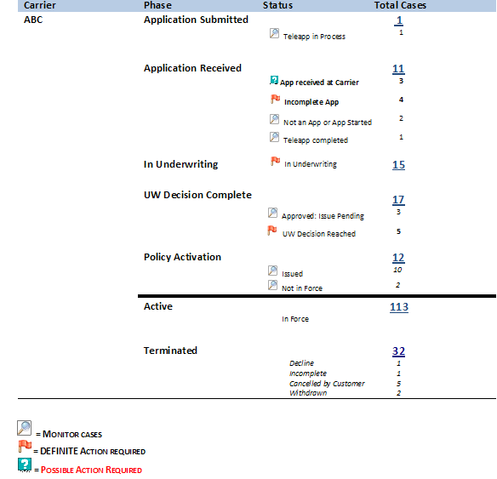
Location | - Link located below "Agent Desktop" under Workplace in CRM
Title | - Policy Dashboard
Fields/Column Headers | - Carrier  - Policy Phase  - Policy Status Reason  - Totals
Filters | - Dropdown selection list:  - Secondary Dropdown - Carrier [Use a Carrier List to select specific carrier]  - My Policies  - Team Policies
Selection Criteria | - Should contain counts of policies by Phase and Policy Status Reason based on filter criteria entered by the user.
Sort | - Carrier  - Policy Phase in the following order:  - Application Submitted  - Application Received  - In Underwriting  - UW Decision Complete  - Policy Activation  - Active  - Terminated  - Within each phase, sort by Policy Status Reason.
Grouping / Sub-Totals | - Group By:  - Carrier  - Policy Phase  - Policy Status Reason  - Totals:  - Policy Phase  - Sub-Totals:  - Policy Status Reason
Assumptions | - Standard CRM Audits  - We are assuming that there will be dropdown for the carrier and the above screenshot will show the data for that carrier from where the user can drill down, if you want to change the carrier, the carrier will be changed from the dropdown and the screen will refresh to display the data of the selected carrier.  - It would be better if a sample of how the screen should look like is provided.
Security Roles
Questions

Phase List View
Traceability | 3.1.2 | 8
Requirement | The Phase List View should contain a list of policies in a particular phase, based on the phase selected by the user from the Policy Dashboard.
Location | - Via Policy Dashboard in CRM
Title | - My Policies by Phase
Fields/Column Headers | - App Date  - Action Required  - Carrier  - Client Name  - Policy Number  - Policy Status  - Policy Status Reason  - Issue Date  - Effective Date
Filters | - None
Selection Criteria | - Should contain list of policies based on:  - Phase selected on Policy Dashboard AND  - Filter criteria entered by the user on Policy Dashboard
Sort | - Agent Name  - Policy Phase  - Policy Status Reason
Assumptions | - Use standard CRM grid/list view.  - ( why is this assumption here?)  - Clicking on the Phase name in the dashboard will let the user to see this View
Security Roles
Questions

Status Reason List View
Traceability | 3.1.3 | 6
Requirement | The Status Reason List View should contain a list of policies with a particular policy status reason, based on the status reason selected by the user from the Policy Dashboard.
Location | - Via Policy Dashboard in CRM
Title | - My Policies by Status Reason
Fields/Column Headers | - App Date  - Action Required  - Carrier  - Client Name  - Policy Number  - Policy Status  - Policy Status Reason  - Issue Date  - Effective Date
Filters | - None
Selection Criteria | - Should contain list of policies based on:  - Status Reason selected on Policy Dashboard AND  - Filter criteria entered by the user on Policy Dashboard
Sort | - Agent Name  - Policy Phase  - Policy Status Reason
Assumptions | - Use standard CRM grid/list view.  - ( why is this assumption here?)
Security Roles
Questions | - Why do we need this sorting critiera itself when it will is already filtered when the user is in this VIEW  - What is the need for Agent Name field to be sorted?

My Policy Summary
Traceability | 3.1.4 | 8
Requirement | This is a group of links on the Agent Desktop. The entries in this section of the Desktop should be Pending policies, Policies with Outstanding Requirements and Active policies.  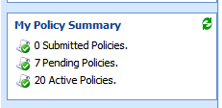  Links to list views:  - My Pending Policies  - My Active Policies  - My Policies with Outstanding Requirements  - Team Pending Policies  - Team Active Policies  - Team Policies with Outstanding Requirements  Add ability to see drop down containing all policy views.  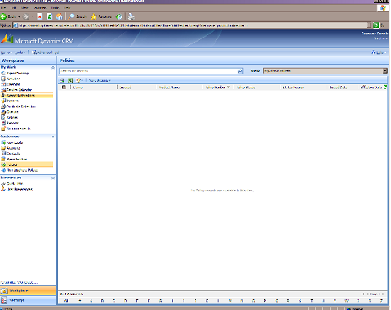
Location | - On "Agent Desktop" page in CRM (exists today)
Title
Fields/Column Headers
Filters
Selection Criteria
Sort
Assumptions
Security Roles
Questions

My Pending List View
Traceability | 3.1.5 | 0
Requirement | This view should contain a list of pending policies for a particular agent.
Location | - Via My Policy Summary in CRM
Title | - My Policies - Pending
Fields/Column Headers | - App Date  - Action Required  - Carrier  - Client Name  - Policy Number  - Policy Status  - Policy Status Reason  - Issue Date  - Effective Date
Filters | - None
Selection Criteria | - Should contain a list of policies where:  - Policy Status = Pending AND  - User is the owner of the policy
Sort | - Agent Name  - Policy Phase  - Policy Status Reason
Assumptions | - Use standard CRM grid/list view.  - Standard CRM Audits
Security Roles
Questions | - What is the need for Agent Name to be sorted? This is a My Pending List View

My Active List View
Traceability | 3.1.6 | 0
Requirement | This view should contain a list of active policies for a particular agent.
Location | - Via My Policy Summary in CRM
Title | - My Policies - Active
Fields/Column Headers | - App Date  - Action Required  - Carrier  - Client Name  - Policy Number  - Policy Status  - Policy Status Reason  - Issue Date  - Effective Date
Filters | - None
Selection Criteria | - Should contain a list of policies where:  - Policy Status = Active AND  - User is the owner of the policy
Sort | - Agent Name  - Policy Phase  - Policy Status Reason
Assumptions | - Use standard CRM grid/list view.  - Standard CRM Audits
Security Roles
Questions | - What is the need for Agent Name to be sorted? This is a My Active List View

My Policies with Outstanding Requirements List View
Traceability | 3.1.7 | 6
Requirement | This view should contain a list of pending policies with outstanding UW requirements for a particular agent.  - Expand Activity Description column.  - Wrap the text in the Activity Description column. (This is needed so that all comments for the UW Notes are visible.)
Location | - Via My Policy Summary in CRM
Title | - My Policies with Outstanding UW Requirements
Fields/Column Headers | - Policy Number  - App Date  - Carrier  - Client Name  - Policy Status  - Policy Status Reason
Filters | - None
Selection Criteria | - Should contain a list of outstanding requirements for policies where:  - Policy Status = Pending AND  - UW Requirements Activity Status Category = Outstanding AND  - User is the owner of the policy
Sort | - Policy Status Date in ascending order.  - Policy number
Assumptions | - Use standard CRM grid/list view.  - Assuming that all other fields that are mentioned above is part of the Policy entity and will be pushed from VUE to CRM
Security Roles
Questions

Team Pending List View
Traceability | 3.1.8 | 0
Requirement | This view should contain a list of all pending policies for the user and their downline hierarchy.
Location | - Via My Policy Summary in CRM
Title | - Team Policies - Pending
Fields/Column Headers | - Agent Name  - App Date  - Action Required  - Carrier  - Client Name  - Policy Number  - Policy Status  - Policy Status Reason  - Issue Date  - Effective Date
Filters | - None
Selection Criteria | - Should contain a list of policies where:  - Policy Status = Pending AND  - Policy owner is in user's hierarchy
Sort | - Agent Name  - Policy Phase  - Policy Status Reason
Assumptions | - Use standard CRM grid/list view.
Security Roles | - The user's security in CRM should determine whether the user is eligible to see other agents' policies or only their own.
Questions

Team Active List View
Traceability | 3.1.9 | 0
Requirement | This view should contain a list of all active policies for the user and their downline hierarchy.
Location | - Via My Policy Summary in CRM
Title | - Team Policies - Active
Fields/Column Headers | - Agent Name  - App Date  - Action Required  - Carrier  - Client Name  - Policy Number  - Policy Status  - Policy Status Reason  - Issue Date  - Effective Date
Filters | - None
Selection Criteria | - Should contain a list of policies where:  - Policy Status = Active AND  - Policy owner is in user's hierarchy
Sort | - Agent Name  - Policy Phase  - Policy Status Reason
Assumptions | - Use standard CRM grid/list view.  - Assuming that all other fields that are mentioned above is part of the Policy entity and will be pushed from VUE to CRM
Security Roles | - The user's security in CRM should determine whether the user is eligible to see other agents' policies or only their own.
Questions

Team Policies with Outstanding Requirements List View
Traceability | 3.1.10 | 4
Requirement | This view should contain a list of all pending policies with outstanding UW requirements for the user and their downline hierarchy.  - Expand Activity Description column.  - Wrap the text in the Activity Description column. (This is needed so that all comments for the UW Notes are visible.)
Location | - Via My Policy Summary in CRM
Title | - Team Policies with Outstanding UW Requirements
Fields/Column Headers | - Agent Name  - Policy Number  - App Date  - Carrier  - Client Name  - Policy Status  - Policy Status Reason
Filters | - None
Selection Criteria | - Should contain a list of outstanding requirements for policies where:  - Policy Status = Pending AND
Sort | - Policy Status Date in ascending order.  - Policy number
Assumptions | - Use standard CRM grid/list view.
Security Roles | - The data visible to the user should mimic the existing user's security in CRM.
Questions

UW Requirements List View on Policy
Traceability | 3.1.11 | 8
Requirement | This view should contain a list of all pending policies with outstanding UW requirements for the user and their downline hierarchy. The data visible to the user should mimic the existing user's security in CRM.  - Make the Outstanding Requirements stand out from the others. (Suggestion: Either bold or change font color for requirements where the Activity Status Category = Outstanding or add an Icon such as “!”)  - Expand Activity Description column.  - Wrap the text in the Activity Description column. (This is needed so that all comments for the UW Notes are visible.)
Location | - Via Policy Summary in CRM
Title | - UW Requirements on Policy
Fields/Column Headers | - Activity code  - Activity Status  - Activity Type  - Requested Date  - Date Received  - Description / Comment
Filters | - Use a drop down list to select UW Requirements Status Category
Selection Criteria | - Should contain a list of all UW Requirements (regardless of status) for a particular policy.  - Policy owner is in user's hierarchy
Sort | - UW Requirements Activity Status Category, with Outstanding listed first.  - Created On in descending order.
Assumptions | - Use standard CRM grid/list view.  - u  - Although the title of the requirement shows as “List VIEW”, but in actual it will be a separate tab in the Policy Screen where all the underwriter requirements will be shown as per the requirement above.  - 4.1.3 should already be in model. This will take care of highlighting the UW Requirements.
Security Roles
Questions

Policy Detail Report
Traceability | 3.2.1 | TBD
Requirement | The Policy Detail report will provide an overview of the entire pending case including outstanding and completed UW Requirements, as well as UW Notes. It should be an aggregate view of all case activity in an easily read and printable report, allowing the user to view/print multiple policies at once. This should be a print function within CRM and function similar to the Lead Card functionality.  Printable report containing aggregate view of all policy activity that currently exists on the Policy entity in CRM, including UW requirements and UW Notes.  DETAIL PENDING POLICY REPORT  as of Friday, May 21, 2010  ABC Insurance Company  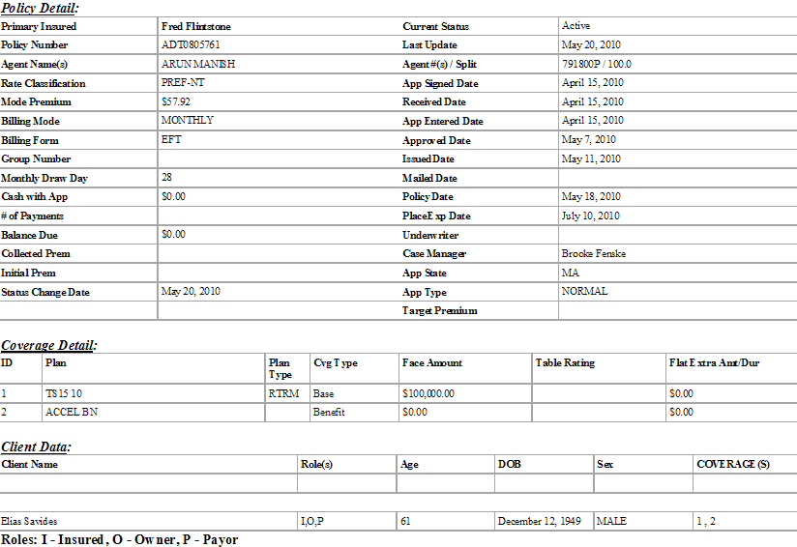  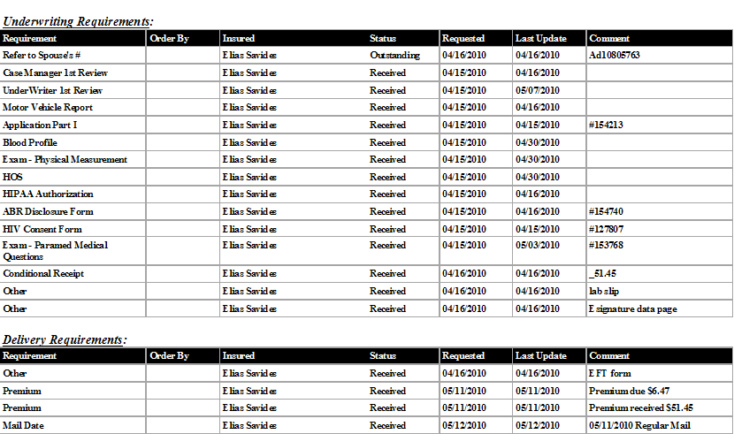  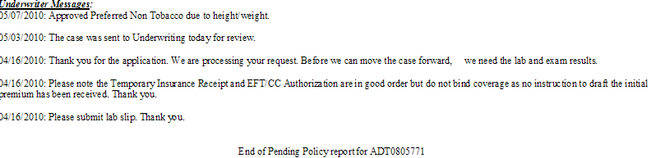
Location | - Via any policy list view in CRM
Title
Fields/Column Headers
Filters | - Dropdown selection list:  - Carrier [Use a Carrier List to select specific carrier]
Selection Criteria | - Should contain all policies where:  - Policy Status = Pending AND  - Filter criteria entered by the user
Sort
Assumptions | - The report will be pulled from VUE Directly and shown in CRM as per the above requirement ( there is a possibility that if at an stage where the policy in VUE is not in synch with CRM) then the data that is available in VUE will be displayed in the report.
Security Roles
Questions | - What kind of grouping is required?  - What kind of sorting is required?  - What does client data means?  - What do we need to show under the Underwriting Message section?

Disposition Summary & Detail Report
Traceability | 3.2.2 | TBD
Requirement | The purpose of the decisions summary report will be to provide the agent visibility to cases which are Active>issued, Pending>Approved, or terminated within a given window. This will enable the agent to either isolate the cases where further action is required to support activation or declination activities or gain insight into recently activated cases ready for comp.  Summarized view of policies that have been "dispositioned" within a particular timeframe.
Location | May be report in RC or Advanced Find in CRM.  - Creation of a CRM view may be sufficient. Needs further research/discussion.
Title
Fields/Column Headers
Filters | - Dropdown selection list:  - Secondary Dropdown - Carrier [Use a Carrier List to select specific carrier]  - My Policies  - Team Policies  - Policy Status  - Date Range
Selection Criteria | - Should contain policies where:  - Policy Status Date is within date range selected by the user
Sort
Assumptions
Security Roles
Questions | - Dev team still thinking on this.

Frequency/Scheduling
The output will be generated upon arrival to the appropriate screen in CRM. No scheduling will be required. The data will be populated based on the existing VUE IP to CRM daily load schedule.

Output Generation Trigger
Upon arrival on screen that houses output, the output should populate.

Security/Access
The following users should have access to the dashboards/views/reports/, based on existing CRM/Resource Center security:
Note: "Wrote" (as being used below) refers to the agent tied to the policy in VUE and the Owner of the policy in CRM.
# | User | CRM User Role | Access
1. | Agent | - Insphere Agent | - Ability to see policies he/she wrote (set as default)
2. | Sales Assistant | - Insphere Administrative Assistant  - Insphere New Business Specialist | - Ability to see policies he/she wrote (set as default)  - Ability to see policies written by hierarchy
3. | Sales Leader | - Insphere Sales Manager | - Ability to see policies he/she wrote (set as default)  - Ability to see policies written by hierarchy
4. | Agency Manager | - Insphere Agency Manager | - Ability to see policies he/she wrote (set as default)  - Ability to see policies written by hierarchy
5. | Zone Manager | - Insphere Zone Manager | - Ability to see policies he/she wrote (set as default)  - Ability to see policies written by hierarchy
 | Intouch Team | - Insphere National Sales Support | - Ability to see all policies.
 | Insphere Corporate User | - Insphere Corporate User | - Ability to see all policies.

Data Glossary
The following table contains a list of data elements, definitions and business rules required to populate one or more of the new reports requested in section 3.

Note: Not all of the data elements listed below are available. The requirement for 3.2.1 Policy Detail Report is to include the data that is currently available for a policy.

Data Term | Definition | Field Name in VUE | Field Name in CRM | Rules
Activity Source |  | Activity Source | Activity Source
Admin Fee |  |  | Admin Fee
Admin Fee Base
Agent | The first and last names of the agent tied to an application/policy. | First Name, Last Name | Agent
Agent Action | Based on the Policy Status Reason, identifies the type of action required for a policy in an effort to assist the agent with managing his business. | Does not exist | Does not exist | Derived field in VUE based on Policy Status Reason. Data is then passed to CRM.  Available options are:  - Definite Action Required  - Possible Action Required
Agent Hierarchy | Management structure for the agent tied to an application/policy.  The hierarchy consists of the following levels:  - Zone  - Agency Manager  - Sales Leader  - Agent
Agent ID | Unique number assigned to an agent for identification purposes. | Agent Code
Annual Premium |  | Annual Premium | Annual Premium
Application Date | The date the application was signed by the applicant. | Application Date | Application Date
Application Number |  | Application Number | Application Number
Carrier | (Insurance Carrier) - Organization that develops and offers Insurance related products. | Carrier Name | Carrier
Carrier Status Reason | Identifies the current "state" of an application/policy as provided by the Carrier.
Case Manager |  |  | Case Manager - Being added in 4.2.1 project.
Client | The name of the person(s) who applied for Insurance Coverage. | Customer ID | Insured
County
Created On
Currency
Effective Date | The date the application/policy becomes active and effective, as provided by the Carrier. | Effective Date | Effective Date
Exchange Rate
Face Amount |  |  | Face Amount
Insured Type |  | Customer Type | Insured Type
Issue Date |  | Issued Date | Issued Date
Line of Business (LOB) | Category of products based on market segment.  Values consist of:  - Health  - Life  - Disability  - LTC | LOB | Line of Business
Modal Premium
Modified By |  |  | Modified By
Name
Originating Application
Originating Opportunity |  |  | Originating Opportunity
Payment Mode |  | Payment Mode | Payment Mode
Policy Expiration Date
Policy Number | Unique account number assigned to an application/policy.  (This number is provided to VUE via a Carrier policy file.) | Policy Number | Policy Number
Policy Phases | Steps an application/policy goes through in the policy lifecycle process. Specific application/policy statuses make up each phase. There are currently 7 phases identified. | Does not exist | Does not exist | Derived field in VUE, based on Policy Status Reason. Data is then passed to CRM.  See Appendix A - Policy Phase / Agent Action / CRM Policy Status Mapping
Policy State | This is the state in which the applicant lived when they applied for Coverage and/or currently lives as provided by the Carrier. (2 digit state code) | State | State
Policy Status | Identifies the current "state" of an application/policy. | Status | Policy Status
Policy Status Date | The date in which the current policy status was loaded in VUE for an application/policy. | Status Date | Status Date
Policy Status Reason | Further identifies the current "state" of an application/policy. | Status Reason | Status Reason
Policy Status Reason Date |  | Status Reason Date | Status Reason Date
Premium Amount Quoted |  |  | Premium Amount Quoted
Product | The type of Insurance Coverage. Products roll up into specific Lines of Business. | Product Code | Product
Product Name |  | Product Name | Product Name
Requested By & Necessary Before (MN Life only) |  |  | "Necessary Before" is being added under INS-2121 & INS-2165. CR's are not assigned to a release. "Requested By" is not currently available in CRM.
Requested Date |  | Requested Date | Requested Date
Requirement Status | Currently, the following statuses may be provided from the various carriers:  - Approved  - Cancelled  - Closed  - Declined  - Received  - Waived  - Active  - Null  - Outstanding  - Pending  - Sent to Client  - Submitted | Activity Status | Activity Status | *See UW Requirements Activity Status Category
Split Agent Code |  |  | Agent
Split Percentage |  | Split Percentage | Split %
Status Detail |  |  |  | This field should be hidden and all associated workflows removed.
Submitted Date |  | Submitted Date | Submitted Date
Target Amount |  |  | Target Amount
UW Requirement Description |  | Req Details | Concatenated columns: Activity Description and Comments | The following columns should be concatenated in VUE and CRM as one is applicable for UW Requirements and the other for UW Notes, but both provide the same information:  - Activity Description  - Comments
UW Requirement Name |  | Req Code | Activity Code?
UW Requirements Activity Status Category |  | Does not exist | Does not exist | Derived field in VUE based on UW Requirements Activity Status, which is then passed to CRM. The statuses are grouped into the following 3 categories:  - ALL - Contains all UW Requirements, regardless of status.  - Closed - Contains UW Requirements in the following statuses:  - Approved  - Cancelled  - Closed  - Declined  - Received  - Waived  - Outstanding - Contains UW Requirements in the following statuses:  - Active  - Null  - Outstanding  - Pending  - Sent to Client  - Submitted  *Note: The business includes ALL UW Notes in the "Outstanding" bucket as they do not have a status.

Appendices

Appendix A: Policy Phase/Agent Action/CRM Policy Status Mapping
Policy Status | Policy Status Reason | Policy Phase | Agent Action Identifier | CRM Policy Statuses
ACTIVE | Re-instated | Active | Monitor Cases
ACTIVE | Replacement Conversion | Active | Monitor Cases
ACTIVE | Suspended | Active | Monitor Cases
ACTIVE | InForce | Active | Monitor Cases
ACTIVE | Issued, Not InForce | Policy Activation | Possible Action Required
PENDING | App Received By Carrier | Application Received | Possible Action Required
PENDING | Issued, Not InForce | Policy Activation | Possible Action Required
PENDING | Underwriting Decision Complete | UW Decision Complete | Monitor Cases
PENDING | Approved, Issue/Activation Pending | UW Decision Complete | Possible Action Required
PENDING | In Underwriting | In Underwriting | Possible Action Required
PENDING | Teleapp In Process | Application Submitted | Possible Action Required
PENDING | Not an App or App Started | Application Received | Monitor Cases
PENDING | Teleapp Interview Complete | Application Received | Monitor Cases
PENDING | Incomplete App | Application Submitted | Definite Action Required
PENDING | Submitted to Carrier | Application Submitted | Monitor Cases
PENDING | Delivery Receipt Outstanding | In Underwriting | Definite Action Required
PENDING | App Received | Application Received | Possible Action Required
TERMINATED | Withdrawn | Terminated | No Action Required
TERMINATED | Term After Issue | Terminated | No Action Required
TERMINATED | Deceased | Terminated | No Action Required
TERMINATED | Cancelled by Customer | Terminated | No Action Required
TERMINATED | Decline | Terminated | No Action Required
TERMINATED | Closed (Incomplete) | Terminated | No Action Required
TERMINATED | Expired | Terminated | No Action Required
TERMINATED | Replaced | Terminated | No Action Required
TERMINATED | Duplicate App | Need to exclude policies in this status. | N/A

