CRM
(Re-Design)

Scope of Work (Draft)

racking History
Date | Author | Version | Action | Notes
xxxxx | Mujtaba Soofi | Draft 1.0 | Created | First draft created based on the discussion at the New Orleans office.
xxxx | Mujtaba Soofi | Draft 1.1 | Modified | Modified based on the meeting at New Orleans office on Sept 30th
xxxxxxxxxx | Mujtaba Soofi | Draft 1.2 | Modified | Modified the Reports section based on David Buck and David Lewis content.
xxxxxxxxx | Mujtaba Soofi | Draft 1.3 | Modified | Modified Contacts section to include some from STEI and keep only one contact from CSSI.
xxxxx | Mujtaba Soofi | Draft 1.3 | Modified | Updated the document with the comments from the meeting held on October 8th with the SSE’s
Table of Contents
1.0 Project Overview 4
1.1 Objectives 4
1.2 Project Contacts 5
2.0 Scope Summary 6
2.1 CRM Sales Activity Portal 6
2.1.1: Launching the Sales Activity Portal 7
2.1.2: Open Activities List 7
2.1.3: List Contacts 9
2.1.4: Contact 10
2.1.6: Phone Call 13
2.1.7: Email 15
2.1.8: Letter 16
2.1.9: Activities Results 17
2.1.10: Sale Completed Process 18
2.1.11: Access & Privileges. 19
2.1.12: Assumptions 20
2.2 CRM Alterations 21
2.2.1: Existing Entities 21
2.2.1.1 Leads 21
2.2.1.2 Contacts 21
2.2.1.3 Opportunities 21
2.2.1.4 Campaigns & Campaign Responses 21
2.2.1.5 Appointment & Phone call 21
2.2.1.6 Sales Contract 21
2.2.2: Imports 22
2.2.3: Workflows 22
2.2.4: Processes 22
2.2.5: View 23
2.2.6: Laserfiche Sales Contracts Integration 23
2.2.7: Assumptions 23
2.3 AFT Integration 24
2.3.1: AFT Contract created in CRM. 24
2.4 Reports 25
2.4.1: CAPS Reports 25
2.4.2: Sales Forecast Reports 26
2.4.3: Campaign Effectiveness Report. 27
2.4.4: Sales by Lead Source Report. 27
2.4.5: Neglected Contacts Report. 28
3.0 General Assumptions 28
4.0 Open Questions 28

1.0 Project Overview

The CRM Application currently in production is used by some of the locations of Stewart, the set of features currently available in the system is more specific to the locations in use and there is a need to standardize the application such that it can be used throughout the organization. This document provides scope summary for the new modules to be added and the changes required to re-design the existing system.

1.1 Objectives
Below is a review of the objectives:

- Provide a simple and easy way to create contacts and activities for the sales counselors.
- Make Contact as the primary entity for the data to be captured for a prospect.
- Standardize the sales contract entity and pull the sales contract data from the main system, instead of creating the contract within CRM.
- Standardize the reports across the organization which would provide appropriate information of the Contacts, appointments that resulted into a sale.

1.2 Project Contacts

Some of the contacts involved in this project are listed as under:

Contact | Title | Email Id | Company

2.0 Scope Summary
In current Implementation, the scope is focused on standardizing the system throughout the organization and provides a simple to use interface to the counselors who can view or create their contacts and activities with minimal effort. At the same time the system should provide detailed and accurate reports to the mangers of the counselors to assess the counselor’s productivity in terms of volume of sales made against the appointments made.

2.1 CRM Sales Activity Portal
The CRM Sales Activity portal is an easy to use web interface that will let the counselor’s view/create/update their contacts and their activities, which will eventually be saved in the Main CRM database, thus letting the managers query the data and reports created by their respective counselors. The following diagram depicts a high level overview of how the portal and CRM are setup.

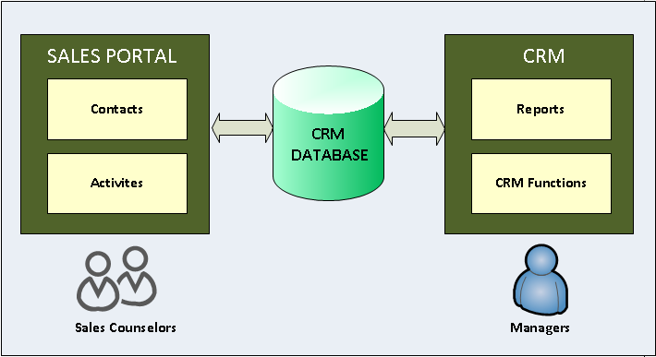

2.1.1: Launching the Sales Activity Portal

The Sales Activity Portal, although will be a separate website which will interact with the CRM Database, but it will be hosted within the current AFT SharePoint site, such that if the user is already logged into the AFT site, then it’s just a matter of clicking a link from the left navigation to start using the features of the sales portal.

2.1.2: Open Activities List

One of the links from the sales navigation portal will allow the Sales Counselors to view the open activities which are assigned for to the counselor logged in. the following mockup provides an insight of data elements present.

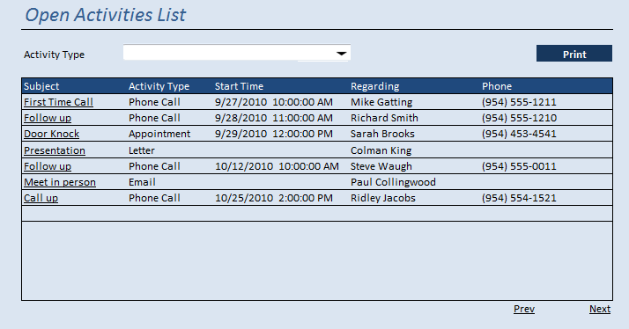

- The list of activities displayed will be either a ”Phone Call”,“Appointment”, Letter or Email.
- The user can filter the activities through the “Activity Type” dropdown present at the top of the screen.
- All the Open activities will be listed in ascending order of the start time.
- Any Activities which are still open and passed due will be shown in a red color.
- Clicking on the subject link of the Activity will let the user drill down the respective activity and modify it or set the outcome/result for the activity.
- If the phone number of the contact exists then even for an appointment activity, it will show up in the grid.
- Clicking on the print button for the Activity List will print the open activities in a detailed format as shown below for each of the activity, which can be printed by the counselor before they go out in the field.

Date: |  |  |  | Time: |  |  |  | Activity Location:
Activity Type
Counselor Name: |  |  |  |  |  |  |  |  |  |  |  | Address:
Primary Contact  Full Name: |  |  |  |  |  |  |  |  |  |  |  | City:
Home Phone: |  |  |  |  |  |  |  |  |  |  |  | State:
Cell Phone: |  |  |  |  |  |  |  |  |  |  |  | Zip:
 |  |  |  |  |  |  |  |  |  |  |  | Email:
AFTERCARE: Additional Information Needed
Deceased Name: |  |  |  |  |  | Date of Death: |  |  |  |  |  |  | Date of Service:
Type of Service |  |  |  |  |  | Location:
- RESULTS
Family Home/Showed? (Yes or No) |  |  |  |  |  |  |  |  | NO SALE Result:
Presentation Made? (Yes or No) |  |  |  |  |  |  |  |  | Unfunded
Sale? (Yes or No) |  |  |  |  |  |  |  |  | Cancelled Appt
Cemetery  Contract Number(s): |  |  |  |  |  |  |  |  | Rescheduled Appt
 |  |  |  |  |  |  |  |  | Not Interested
 |  |  |  |  |  |  |  |  | Wrong Address
Funeral  Contract Number(s): |  |  |  |  |  |  |  |  | Has Plan Already  (Please indicate  PNFS or P&M or Both)
 |  |  |  |  |  |  |  |  | Didn’t Schedule Appt
 |  |  |  |  |  |  |  |  | Do Not Call/Do Not Mail
Notes:

2.1.3: List Contacts

Similar to the list of open activities the user will have a link from the left navigation to view the list of contacts that are assigned to the Sales Counselor. The following screenshot provides a view of the contacts list.

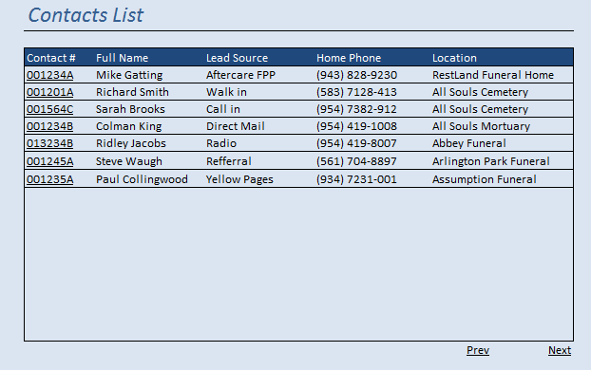

- The list of contacts will be sorted based on the “Date of Assignment” with the latest assigned record at the top.
- The contacts listed here will either be Contacts created by the Counselor or the contacts that were assigned to this counselor by their manager.
- A Contact that has already been verified and marked as “Do Not Call” will be shown in a different color with some indicator.

2.1.4: Contact

Contact is the core entity in the system and some of the fields that are captured from the portal are depicted in the following screenshot.

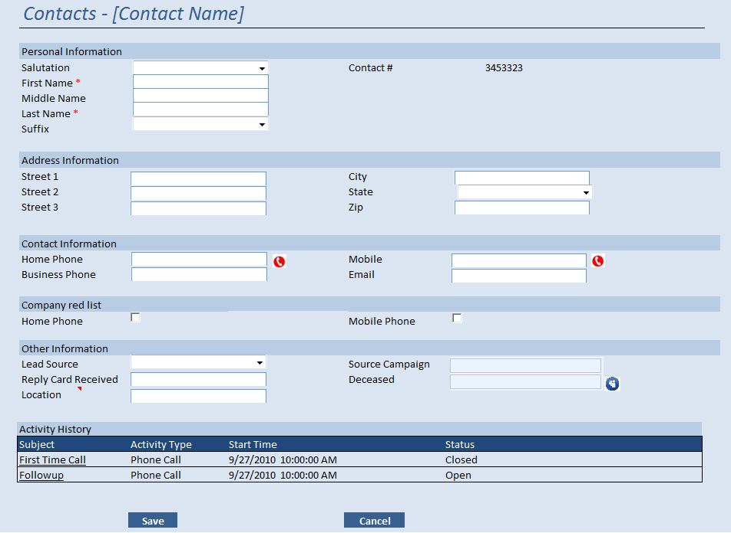

- Contact # is an auto generated field which is read-only and serves as the primary ID of the contact record.
- First Name, Last Name and the Location are the fields that are required for a contact to be created.
- Source Campaign information will be populated only in case of edit mode if they already existed and the record was assigned to the counselor, also these fields are read-only, and are not provided when the record is getting created from the portal.
- When the contact record is created it is automatically assigned to the loggedin counselor.
- The moment a contact is assigned to a counselor, an opportunity is automatically created for the same.
- Activity History provides the list of open and closed activities on the open opportunity of the said contact.
- The Phone icon against the Home phone, lets the user to check the given phone number against the DNC on real time, and if the number is found to be DNC then that field will be flagged, depicting it as a Do Not Call Number.
- The checkboxes under the “Company Red List” section allows the user to mark the number as Company Do Not call and adds it to the red list, so that whenever other contacts using this phone number are listed will automatically get the flag checked.
- When a new contract is entered in the system by the counselor from the portal, it status will be flagged as “Pending Review” by default, so that the manger can look at those records and change the status to “Reviewed”. A Contact will not be listed on the Sales Counselor’s list unless its status it changed to “Reviewed”
- While creating the contact, the sales counselor can create the Activity too on that particular contact, even though it is in “Pending Review Status”, but again the activities will not show up on the “Activity list” if the contact’s status is “Pending Review”
- If already deceased information is present then the deceased field will get populated and the icon beside that field will let the user see the details of the deceased in a popup, if the field is blank and the user wants to enter the deceased information, the same icon can be used to enter the deceased information. ( note that while entering the deceased information there will not be any duplicate checks made).
- The screen that can be used to add/update the deceased information is as follows

- 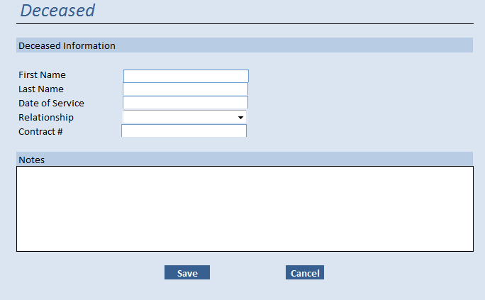

2.1.5: Appointments

This appointment screen will be used either to create a new appointment for an existing contact or edit an existing activity when the user is navigated from the “Open Activity List” View.

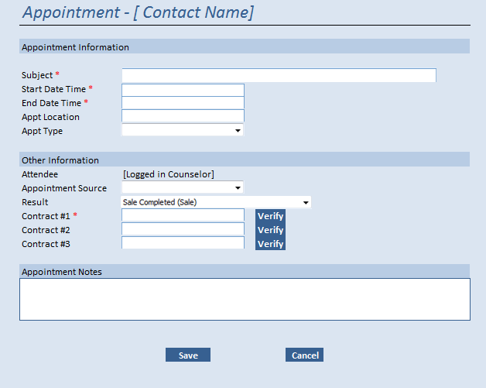

- Subject, Start date time and End date time are the required fields while creating an appointment
- The appointment will not be created independently but rather will be created from within the Contacts screen and the name of the contact against which the appointment is created will be displayed at the top along with the caption.
- The fields for Contract Number are visible and one of them is mandatory only when the results field confirms that a sale is made (further details on how the result field and its behavior are discussed in the section “Activities Result and Outcomes”).
- The subject line will be a free text and cannot increase more than 250 characters
- Appt type, identifies an appointment as Funeral or Cemetery.
- Appointment source will determine whether the appoint was through telemarketing or internal, the possible values for this field are
  - Telemarketing
  - Counselor

Verify Button:

  - This button will be visible only when the result of the appointment creates a sale
  - The “Verify” button adjacent to the Sales Contract number will let the user to preview the Sales Contract, and it is necessary for the user to verify the Sales contract before saving the appointment.
  - Verification may result in any one of the following scenario
    - Invalid Contract# / Contract Pending: In this case the Sales Contract number could not locate the record due to the fact that the Contract # entered was invalid or the contract number is still pending
    - Contract already in use: In this case Sales Contract is already in use by another opportunity and appropriate message will be prompted to the user.
    - Contract Found: In case of match found the following screenshot will show the user with the contract details.

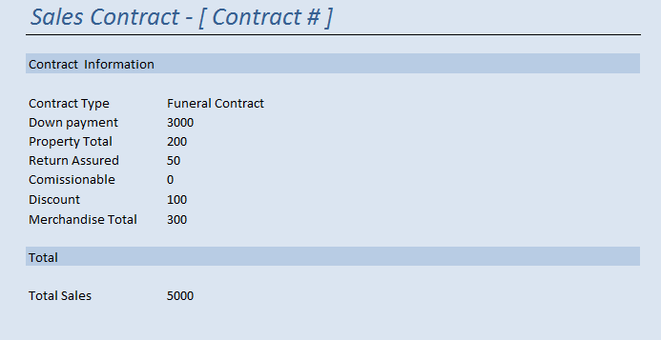

2.1.6: Phone Call

This Phone call screen will be used either to create a new Phone call for an existing contact or edit an existing phone call activity when the user is navigated from the “Open Activity List” View.

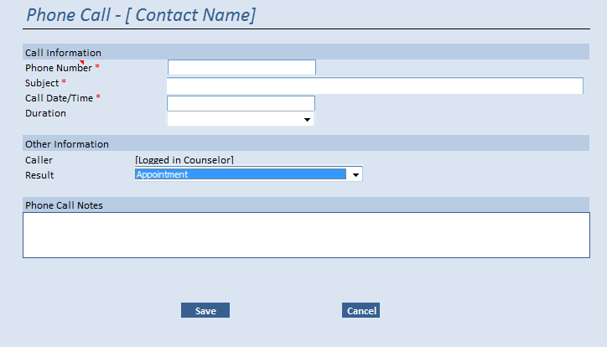

- Subject, Call date time and phone number are the required fields while creating a phone call activity.
- The phone call will not be created independently but rather will be created from within the Contacts screen and the name of the contact against which the phone call is created will be displayed at the top along with the caption.
- The phone number will be pre-populated form the “Home Phone” field of the contact if the value in the Home Phone exists; user is allowed to edit this field in the phone call activity.
- The subject line will be a free text and cannot increase more than 250 characters
- Result will close the existing activity and may or may not create another activity (More details can be found in the “Activities Result” section”

2.1.7: Email

This Email Activity screen will be used either to create a new email for an existing contact or edit an existing open email activity when the user is navigated from the “Open Activity List” View.

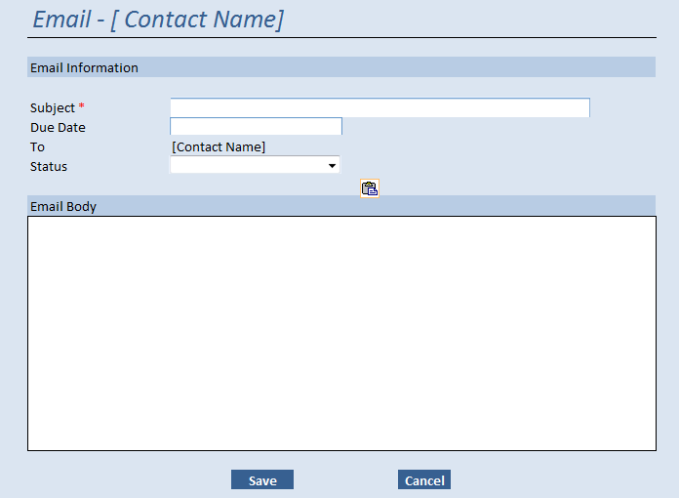

- Subject is the required field
- Due date is the data on which this activity should be performed on or before, this date does not mean that it is scheduled for that day
- Status can be one of the following
  - Draft
  - Send
- The email body entered will be a plain text, and will not have the features of entering any rick text like Bold, Italics etc.

2.1.8: Letter

This Letter screen will be used either to create a new letter activity for an existing contact or edit an existing letter activity when the user is navigated from the “Open Activity List” View.

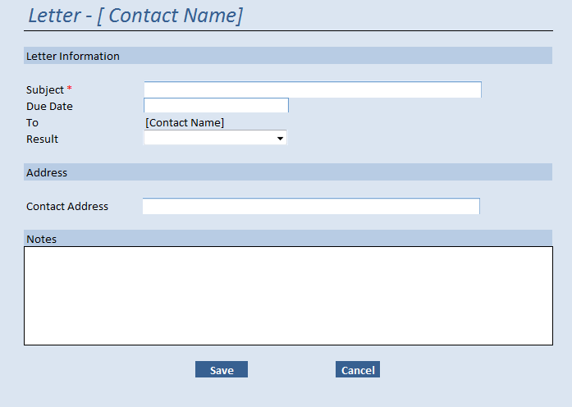

- Subject is the mandatory field and is a free text
- Due date is the date on which this activity should be completed on or before.
- Address field will be pre-populated based on the address of the contact for which the letter activity is being created, the user has the option to change this address as required
- Notes will be the free text notes that are related to this letter.
- The values for the result and the action performed based on the selected result is discussed under the Activities results section.

2.1.9: Activities Results

The phone call or the Appointment activity will close once the result field is set to a specific value, the following table explains the different type of results and the outcome it generates, and it also depicts which results are applicable to either of the entities.
PC | APPT | LTR | Result | Action
 |  |  |  | Current Activity | Opportunity | Other
 |  |  | Sale Completed (Sale) | Close | Close (won) | Opportunity is pending if contract is not validated
 |  |  | Sale Pending | Open | Open
 |  |  | Unfunded (Unfund) | Close | Open | Create phone call
 |  |  | Proposal | Close | Open | Create Phone call
 |  |  | Service Activity Completed | Close | Open | Prompt to create an appt, phone call or reassign
 |  |  | Customer Cancelled Appointment (CAN) | Close | Open | Prompt to create an appt, phone call or reassign
 |  |  | Reschedule Appointment (Reset) | Close | Open | Prompt to create an appt, phone call or reassign
 |  |  | Not Interested (NI) | Close | Open | Prompt to create an appt, phone call or reassign
 |  |  | No Show (NS) | Close | Open | Create Phone call
 |  |  | Wrong Address (WA) | Close | Close (Lost) | Notify Manager of result
 |  |  | Has Plan Already (HPA) | Close | Close(Lost) | Prompt to create an appt, phone call or reassign
 |  |  | Didn’t Schedule Appointment (DSA) | Close | Open | Prompt to create an appt, phone call or reassign
 |  |  | Waiting on Customer Decision | Open | Open
 |  |  | Do Not Call/Do Not Mail | Close | Open | Mark contact as DNC
 |  |  | Re-assign Lead | Close | Close (Lost) | Notify Manager of result
 |  |  | Call back | Close | Open | Create Phone Call
 |  |  | Appointment | Close | Open | Create Appointment
 |  |  | Disconnected | Close | Close (Lost) | Notify Manager of result
 |  |  | Mailed out Materials | Close | Open | Create Phone Call
 |  |  | Follow-up | Close | Open | Prompt to create a door knock appt, phone call or reassign
 |  |  | Do not mail | Close | Open | Mark contact as Do not Mail

Notes:
- In case of “Sales Pending” as the result selected, the sales contract will be created but the opportunity will still be kept as open and the opportunity closes only if the sales are completed.

2.1.10: Sale Completed Process

The Sales process is said to be completed if an appointment results in a “Sales Completed” outcome which triggers an opportunity to be closed as “Won” and one or more sales contracts are created and attached to the opportunity being closed before being marked as won.

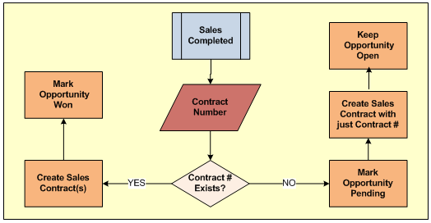

Nightly Process: To check for the Sales pending on the opportunities, a nightly process is scheduled which performs the following tasks

- Keeps checking for the “Pending Opportunities
- Grabs the Contract numbers already saved and fetches the sales contract data from Coding Coversheet / HMIS.
- The moment it finds the contract information it updates the Sales Contract information in CRM and changes opportunity status and mars the opportunity as won.

2.1.11: Access & Privileges.

The access and privileges for the portal is controlled through the CRM by the System Administrator.

- A sales Manager will have to be created in CRM through the user entity and the role should be assigned as Stewart Sales Counselor
- While creating the user, the System Administrator has to setup the access level for the different privileges of the portal through the “Portal Privileges” tab of the users screen as shown in the below screen shot.
- Access privileges can be set on basic operations related to Contacts, Phone calls, Emails, Appointments and Letters
- The different level of access that can be provided for each of the modules will be
  - Read
  - Create
  - Edit
  - Delete
- By default read privileges will be present for all the modules

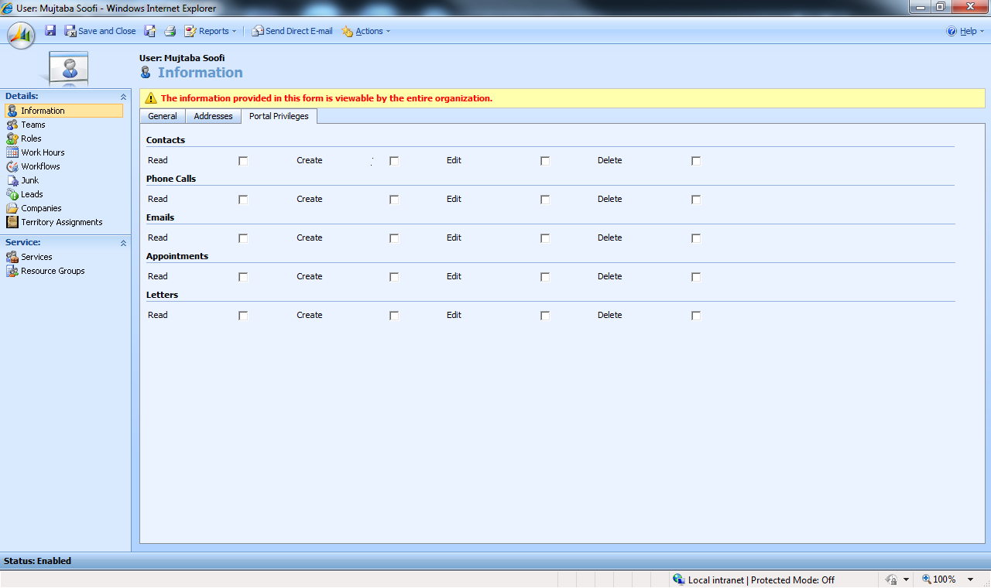

2.1.12: Assumptions
- The users of the Sales Activity Portal will be “Sales Counselors” only, The managers will have to perform their operations from CRM, they may not be having access to the portal
- It is assumed that the opportunity will be won and a sale will result always through the outcome of an appointment activity.
- The owner of the activity or the contact being created through the portal will be the logged in Sales Counselor.
- An opportunity will be created on the contact automatically, when a counselor is assigned on that particular contact
- At a given time only one opportunity will be open on a given contact, if another opportunity needs to be created, then the current opportunity will have to be closed.
- Even through the sale is being made to the same house hold, the existing opportunity if closed will not be opened, in fact a new opportunity will have to be created for this new sale.
- A Closed opportunity should not be re-opened, if need be, a new opportunity has to be created for that contact.
- The “Potential Duplicate” Contacts created by the Sales Counselors will have to be resolved or merged by the respective sales manager of the counselor, until then a counselor cannot be assigned on that contact.
- When a closed activity is viewed, it will be shown as read-only.
- During the creation of the contact itself if the counselor creates an appointment with the status as “Sales Pending” or “Sales Completed”, the sales contract will still be created, but the opportunity will not close until the Contact is converted into the “Reviewed” Status.
- The different kind of activities that can be created on a contact from the portal are Phone call, Appointment, Letter and email. In case of Letter and email
- The Letter activity will just be created in CRM and there will not be any provision from the portal to perform any kind of “Mail merge”
- The Email activity will just be created in CRM, when created from portal, there will not be any provision to choose any specific “Email Template”.

2.2 CRM Alterations

2.2.1: Existing Entities

2.2.1.1 Leads
- Currently this entity is no more in use so any references to this in other entities that are currently used will have to be removed
- Hiding the Leads links from CRM so that users does not gets confused

2.2.1.2 Contacts
- Whatever fields that were currently used in Leads will have to be moved to Contacts, a detailed analysis has to be done and the fields need to be identified.
- Generate the “Contact #” using the same algorithm, that is used for lead generation and create a read-only field called for this new field.
- Remove any references to Originating leads.
- Link the source campaign directly to the Contacts.
- Create the new fields that were in use in the lead entity and are required on the contact entity.
- Create the duplicate detection rules on the lead entity similar to the one we that were present on the lead entity
- A new field called “Assignment Date” will have to be added, this date will be updated automatically, whenever there is an assignment/re-assignment.

A View will be created, that will list all the contacts which are in the “Pending Review” status and the name of the view will be “Contacts Pending Review”, such that the manger can access these contacts easily through this View for all the contacts that needs to be reviewed.2.2.1.3 Opportunities
- Modify the entity to include a status called “Pending” to be used by the sales completion process.
- Making sure that all the activities are created on opportunity as long as it is open

2.2.1.4 Campaigns & Campaign Responses
- No Changes identified so far

2.2.1.5 Appointment & Phone call
- Modify the values of the Result dropdown to reflect the new values
- Apply the business rules and the creation of new activities based on the result selected.

2.2.1.6 Sales Contract
- Modify the entire Sales Contract entity by removing all the tabs and make it simple read-only entity, such that none of the entries for the sales contract are made from CRM
- Change the re-calculate and rollup plug-in to roll over the contract values to the opportunity level.
- Provide a link for Laserfiche integration on the contract form.
- The Funeral and Cemetery tabs in the sales contract form will be removed and added in one single tab
- All the existing detailed fields will be left as it is, but the fields that are mapped with HMIS/Coding sheet will be made readonly, such that they will not be modified from CRM
- There won’t be any calculations involved any more in the sales contract form.

2.2.2: Imports
- Change the Aftercare Import to create the values in Contact instead of creating in Leads
- Change nightly Aftercare Import logic to point to Contact.

2.2.3: Workflows
- Change all the existing workflows that are connected to leads to point to Contacts and scrap the ones that are not required
- Create a new workflow to create the opportunity on assignment/re-assignment of assigned counselors.

2.2.4: Processes
- Change the bulk conversion process from campaign responses to convert to Contact only, instead of converting it to lead and opportunity.
- Re-visit the weekly DNC Process.

2.2.5: View
- Create a View for the sales Contracts that are in “Pending” state for the last 7 days.
- Create a View to provide the list of contacts whose activities were closed with the following “Results”
  - Not Interested
  - Has Plan Already
  - Disconnected
  - Wrong Number

2.2.6: Laserfiche Sales Contracts Integration

Currently all the contracts that are created are digitally signed and stored in the repository of the Laserfiche database, as part of the current scope the Sales contract form in CRM will be provided with a link on the sales contract screen that will allow the user to preview the scanned sales contracts stored in the Laserfiche database.

2.2.7: Assumptions
- It is assumed that the Laserfiche API provides some parameters through which the contract number or some other information can be passed to uniquely identify a contract and pull that from the Laserfiche Software.

2.3 AFT Integration

2.3.1: AFT Contract created in CRM.

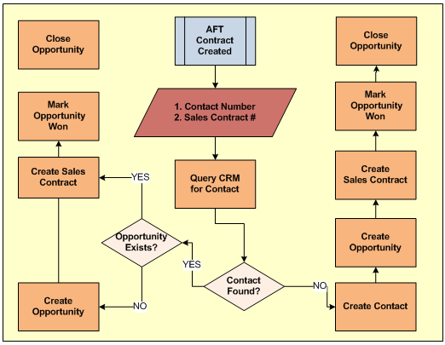
2.4 Reports

2.4.1: CAPS Reports

The centrally important report has always been the LAPS report or its many equivalents; all location managers want to observe the progression from lead through sale because this is a simple, obvious assessment of sales effectiveness.

We will be providing a CAPS report since we have settled on Contacts as our primary bucket for customer information.

Definition: For a counselor, group of counselors, location, or larger entity such as region, and during a specific time span, the CAPS report visualizes the number of contacts (C) assigned, the number of appointments (A) scheduled (whether or not an outcome has yet been entered), the number of presentations (P) made, where “presentation” means an appointment for which the outcome has been entered and indicates a presentation was made, and the sales volume (S) total for presentations that resulted in a sale.

It is important to understand that defined this way, the report does not meaningfully indicate the share of contacts assigned that progress to appointments, or the share of appointments that result in presentations. This is because many appointments during a specific time span may relate to contacts assigned prior to that time span, and some presentations may occur to customers who at the time of the presentation do not yet exist in CRM at all. Nor does it meaningfully indicate the portion of presentations that result in a sale, because the sale may result from a presentation made in an earlier time span, or may not have occurred yet (it may occur in a subsequent time span).

Key Basis Data | Notes
date contact assigned to counselor | report counts all contacts with this date falling within the given time span
date an appointment is scheduled | report counts all appointments with a record creation date (not appointment date) within the given time span
appointment outcome ( = presentation? ) | report counts all appointments with an appointment date within the given time span, for which an outcome exists, and the outcome is a presentation
sales volume only for contacts | report counts all sales for contacts with an appointment that (1) has an appointment date within the given time span and (2) has an appointment outcome indicating a presentation was made

Following is a sample snapshot of how the report will look like and the parameters it would accept to run the report.

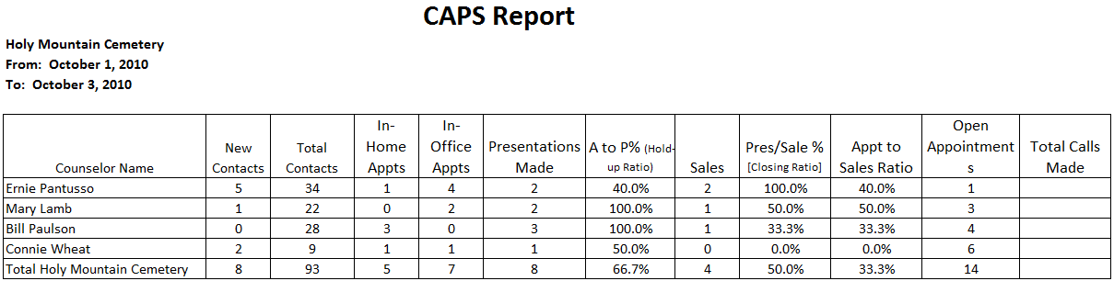

Criteria:
- Location name
- Lead Source
- Start date
- End date

Reports Columns:

- New Contacts: This is the number of contacts a counselor obtained for the respective period. A contact is a name and at least 1 piece of contact information (address, phone # or e-mail) for someone you intend to pursue for an appointment.
- Total Contacts: This is the total number of assigned contacts a counselor has as of the ending period date.
- In-Home Appointments: This is the number of appointments in the family's home for the respective time period.
- In-Office Appointments: This is the number of appointments in the office for the respective time period.
- Presentations Made: A presentation is a meeting with a prospect(s) where you actually helped a family select goods and services, gave a written proposal with price/payment options and asked the prospect(s) to enroll in our program.
- Sales: This is the number of presentations that resulted in a sale(s). For the purposes of this report, a presentation that results in multiple contracts is one sale.
- Volume: This is the total dollar amount of the all contracts net of discounts written during the respective period.
- Open Appointments: The number of appointments where no outcome has been entered. They are either appointments that have not taken place yet or appointments that have taken place but no outcome has been entered. This should be a future indicator for presentations and sales.
- Volume: This is the total dollar amount of the all contracts net of discounts written during the respective period.

2.4.2: Sales Forecast Reports

The Sales Forecast Reports (often referred to as sales pipeline reports) indicate likely revenue in a specific forthcoming time span, based on (1) the relationship between the number of open contacts, open appointments, and presentations made (for which a sale had not yet occurred) at the beginning of a previous similar time span, and the total revenue earned by the end of that time span, and (2) the current number of open contacts, appointments, and presentations made.

In this definition, “open contacts” refers to contacts for which there has been an activity record assigned within the last nn days.

Key Basis Data | Notes
at beginning of reference time span, number of open contacts | determined by counting contacts for which an activity record had been created or updated within xx days prior to the beginning of the reference time span
at the beginning of the reference time span, number of appointments for which no outcome had yet been entered
at the beginning of the reference time span, the number of presentations made that were associated with a contact that did not then have sales activity on or later than the date of the presentation
current number of open contacts | contacts for which an activity has been assigned or updated within the past nn days
current number of appointments open | meaning no outcome entered yet
current number of presentations made, associated with contacts that do not have sale activity dated on or later than the presentation date

2.4.3: Campaign Effectiveness Report.

This falls to Marketing. We have this pretty well covered, except that identifying the way the field must handle campaign responses, in a way they will grasp readily enough to consistently enter the data, will be essential.

2.4.4: Sales by Lead Source Report.

This report should provide the sales volume information grouped by lead source.

This is an easy report to generate: select all records with sales, total the sales, and group by the source entry for the contact.

2.4.5: Neglected Contacts Report.

This report should list contacts for which, during the entirety of a given time span before the present, the contact (1) had an entry already present in the assigned counselor field but (2) did not have activity updates.

The report would exclude unassigned contacts.

Key Basis Data | Notes
number of assigned contacts | exclude contacts with an assignment date later than the beginning of the time span
activity dates | select contacts lacking activity records with creation dates within the given time span

3.0 General Assumptions
- Microsoft’s suggest internet explorer to be used as the browser to use the web application and hence it is assumed that any browser other than Microsoft may not be used for CRM, therefore the same will hole for CRM as well.

4.0 Open Questions

- While creating the contract in CRM from AFT, how should the following scenarios is handled?
  - No contact exists
  - Contact Exists, Opportunity does not exist
  - Contract exists, Opportunity exists, Activity does not exist
  - Contract exists, Opportunity exists, Activity exists

I it is assumed the Contract # and the Contact # will be provided from AFT to match the appropriate contract in AFT.

- How should the Unfunded Proposal be handled?
- What should happen from Portal, in case of counselor termination?
- While creation of contact the duplicate check is done internally by the system using the existing duplicate detection rules and if the contact is found to be duplicate it is flagged as “Potential Duplicate” and not assigned to any counselor, such that it does not appear on the sales counselor list, what about the scenario, in case if the duplicate contact already has the counselor assigned?
- Is there a requirement to see the Sales contract from the Sales portal for the contract that was already sold for a contact?
- If a manager tries to close an opportunity as won from CRM, Should they be allowed, because in regular case, the opportunity is closed automatically through the appointment activity result.
- What is the significance of the “Estimated Revenue” fields in the opportunity entity and how are they used?
- The functionality of email and letter from Portal is limited, needs more discussion on this

